**Techno India NJR Institute of Technology**

**Course File**

**Factor of Human Interactions (8AN6-60.2)**

**Faculty Name –** Samina Firoz Wagla Wala

Assistant Prof.

Department of Basic Science and Humanities.

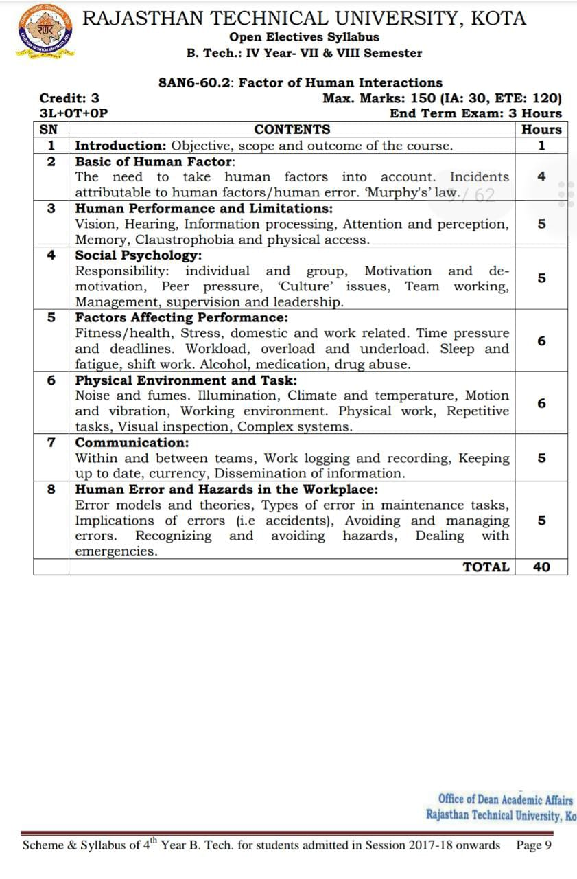

**Course Overview –**

Students will be learning about various workplace errors which are usually neglected and may cause irreversible damages at workplace. This course aims to eliminate the cognitive and physical barriers and delay and prevent mishaps at the workplace. This course covers all the aspects of an ideal workplace and is relevant to all the streams of engineering – tech and non-tech.

Additionally, this course also enables the students to understand the significance of various alarm systems, work recording and also teaches them to keep into account various aspects related to ergonomics and anthropometry which will enable them to define the workplace according to the needs and requirements of the employees also so as to ensure maximum productivity and managerial skills.

**Course Outcomes –**

1. Students will be able to understand the various fundamental factors to be taken into account while aiming for measures to ensure minimum accidents and workplace mishaps. They will be able to become aware of Murphy’s Laws.
2. Students will acclimatise with various barriers and limitations attributable to human performance like vision, hearing, cognition, attention etc.
3. Students will be aware of the social psychology and various anthropological factors affecting workplace environment.
4. Students will be able to learn new and wide applications of good communication at workplace and the significance of work logging, recording, workplace currency, ergonomics, anthropometry, 9-95th percentile etc.
5. Students will be able to learn about various workplace hazards and human errors and also will be able to recognise and learn about various emergency alarm systems and various error models and theories.

**Course Outcome Mapping with Program Outcome –**

PO1 PO2 PO3 PO4 PO5 PO6 PO7 PO8 PO9 PO10 PO11 PO12

0 1 1 0 1 2 2 1 2 3 1 3

0 0 0 0 0 0 0 0 1 2 0 2

0 0 0 0 0 0 0 1 1 2 0 2

0 1 1 0 1 1 1 1 2 3 1 2

1 – Slight (low)

2 – Moderate (medium)

3 – Substantial (high)

**Course Module Lecture-wise –**

|  |  |  |
| --- | --- | --- |
| Lecture No. | Unit | Topic |
| 1 | 1 | Introduction: objective, scope and outcome of the course. |
| 2 | 1 | Basics of Human Factors, Murphy’s Law. |
| 3 | 1 | Human Performance and Limitations – vision, hearing, information processing, attention. |
| 4 | 1 | Human Performance and Limitations – perception, memory, claustrophobia and physical access. |
| 5 | 2 | Social Psychology –Responsibility (individual and group), motivation and demotivation, peer pressure. |
| 6 | 2 | Social Psychology – Culture issues, team working, management, supervision and leadership. |
| 7 | 3 | Factors affecting Performance –Fitness/health, stress, time pressure, deadlines |
| 8 | 3 | Factors affecting Performance –Workload (overload and underload), sleep and fatigue. |
| 9 | 3 | Factors affecting Performance –Shift work, alcohol, medication and drug abuse. |
| 10 | 4 | Physical Environment and Task –Noise and fumes, illumination, climate and temperature. |
| 11 | 4 | Physical Environment and Task –Motion and vibration, working environment, physical labour. |
| 12 | 4 | Physical Environment and Task –Repetitive tasks, visual inspection, complex systems. |
| 13 | 4 | Communication – Within and between teams, work logging and recording. |
| 14 | 4 | Communication – Keeping up-to-date, workplace currency, dissemination of information, human information processing. |
| 15 | 5 | Hazards in workplace –Error models and theories. |
| 16 | 5 | Hazards in workplace – Types of errors in maintenance tasks, implications of errors (i.e., accidents). |
| 17 | 5 | Hazards in workplace – Avoiding and managing errors, recognising and avoiding hazards, dealing with emergencies (alarm and warning systems). |
| 18 | 5 | Ergonomics and Anthropometry, 9-95th percentile, manual material handling. |

**Text/Reference Books –**

1. Advances in Human Factors and System Interactions by Isabel L Nunes.
2. Handbook of Standards and Guidelines in Human Factors and Ergonomics by Anna Szopa, Waldemar Karwowski, Marcelo M. Soarez.
3. Aviation Safety – The Human Factor by Robert A. Alkov.

**Assessment Methodology –**

1. Online quiz through Google forms after every chapter.
2. Practical exam in lab where they can be given various machines, tools and equipment to practice with how to deal with this equipment in real-time situations.
3. Assignments – 1 from each unit.
4. Midterm subjective paper where they have to learn various theories and laws relating to human factors and human information processing.
5. Final paper at the end of the semester subjective.

**Teaching and Learning Resources unit-wise –**

**Unit – 1**

Online reading:<https://drive.google.com/file/d/1zMxBnqBGVgg4zGT1moVIqNLPhTaAP7wE/view?usp=drive_web&authuser=0>

<https://www.hse.gov.uk/humanfactors/introduction.htm>

Video Tutorials:<https://www.youtube.com/watch?v=aGZz3w5Hy8Y>

<https://www.youtube.com/watch?v=PFOqnPeMLcY>

Sample Quiz:<https://www.researchgate.net/topic/Human-Factors>

**Unit – 2**

Online Reading:<https://online.maryville.edu/online-bachelors-degrees/psychology/what-is-social-psychology/>

<https://nobaproject.com/modules/an-introduction-to-the-science-of-social-psychology>

Video Tutorials:<https://www.youtube.com/watch?v=cw3e_XFIeQI>

<https://www.youtube.com/watch?v=FuIQAVPtCf8>

Sample Quiz:<https://www.khanacademy.org/test-prep/mcat/behavior/social-psychology/e/social-psychology-questions>

<https://study.sagepub.com/fiskeandtaylor3e/student-resources/chapter-1/multiple-choice-quizzes>

**Unit – 3**

Online Reading: <https://www.emerald.com/insight/content/doi/10.1108/IJPPM-01-2018-0012/full/html>

<https://blog.sage.hr/5-critical-factors-affecting-employee-productivity-at-work/>

Video Tutorials:<https://www.youtube.com/watch?v=MqOKkDQr0yc>

<https://www.youtube.com/watch?v=rFV6dFWtIMY>

Sample Quiz:<https://study.com/academy/practice/quiz-worksheet-factors-that-influence-performance-on-tests.html>

<https://treeo.ufl.edu/media/treeoufledu/waterwastewater/student-resources/Management-Quiz-1.docx>

**Unit – 4**

Online Reading: <https://www.sciencedirect.com/science/article/pii/S1877705811029730>

<https://drive.google.com/file/d/1fPH5GnwHSQuaK593FP7rGCG3lxVe958V/view?usp=drive_web&authuser=0>

<https://drive.google.com/file/d/1s31LBo9zOf8PNK__4ZYVhBTdz7AXwM99/view?usp=drive_web&authuser=0>

Video Tutorials:<https://www.youtube.com/watch?v=bdFYYtVdSeM>

<https://www.youtube.com/watch?v=fxSnEDpvvsw>

<https://us.anteagroup.com/news-events/blog/6-hilarious-workplace-safety-videos-every-ehs-professional-will-love-cherish>

Sample Quiz:<https://www.remindercall.com/blog/ideal-work-environment/>

<https://mcqlearn.com/science/g6/physical-environment-mcqs.php>

**Unit – 5**

Online Reading:<https://www.ncbi.nlm.nih.gov/pmc/articles/PMC1117770/>

<https://drive.google.com/file/d/1b-2_lKufvdv3dkzbhufFqGGVZ4fzGj7I/view?usp=drive_web&authuser=0>

<https://www.workplacetesting.com/definition/1580/95th-percentile-ergonomics>

<https://drive.google.com/file/d/1Na_dTIdTbGjF4X597OwR97n7Kj10Wj1_/view?usp=drive_web&authuser=0>

<https://www.intechopen.com/chapters/72416>

Video tutorials: <https://www.youtube.com/watch?v=KND5py-z8yI>

<https://www.youtube.com/watch?v=s-lUxrvsEEw>

<https://www.youtube.com/watch?v=JRCMxfBULB4>

Sample Quiz: <https://docs.google.com/document/d/1Y1cgS7tmngblmk7GK49e9fyigH04jW2t1fXfbw3o5TA/edit?usp=drive_web&authuser=0>

<https://www.proprofs.com/quiz-school/story.php?title=topic-6-product-design>

<https://scholarexpress.com/multiple-choice-questions-mcq-on-ergonomics-work-place-design/>

