**Techno India NJR Institute of Technology**



**Course File**

**Session 2021-22**

**TOM (4ME-07)**

Abhishek Sharma

(Assistant Professor)

**Department of ME**

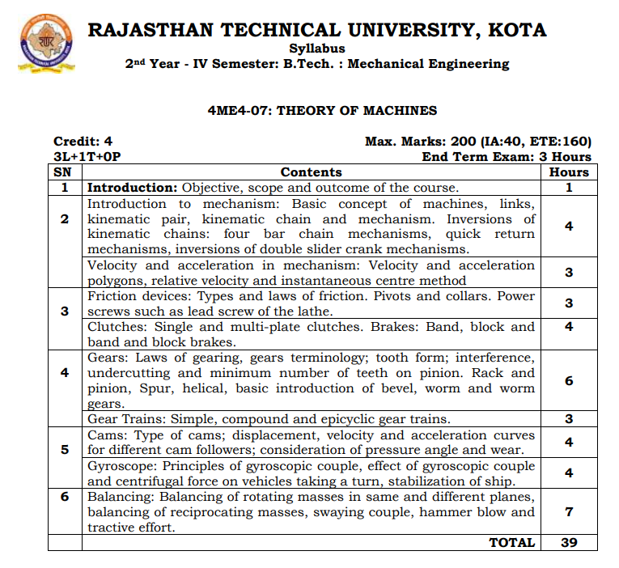

**Course Overview:**

To introduce the approaches and mathematical models used in kinematic and dynamic analysis of machinery. To give basic knowledge on kinematic and dynamic design of machinery. To give basic knowledge on mechanical vibrations.

**Course Outcomes:**

|  |  |  |
| --- | --- | --- |
| **CO. NO.** | **Cognitive Level** | **Course Outcome** |
| 1 | Analysis | Understand the principles of kinematic pairs, chains and their classification, DOF, inversions, equivalent chains and planar mechanisms. |
| 2 | Synthesis | Analyze the planar mechanisms for position, velocity and acceleration. |
| 3 | Synthesis | Synthesize planar four bars and slider crank mechanisms for specified kinematic conditions. |
| 4 | Synthesis | Evaluate gear tooth geometry and select appropriate gears for the required applications. |
| 5 | Synthesis | Design cams and followers for specified motion profiles. |

**Prerequisites:**

1. Basic Knowledge about Free Body Diagram
2. Must have completed the course on Engineering Mechanics.

**Course Scheme -**

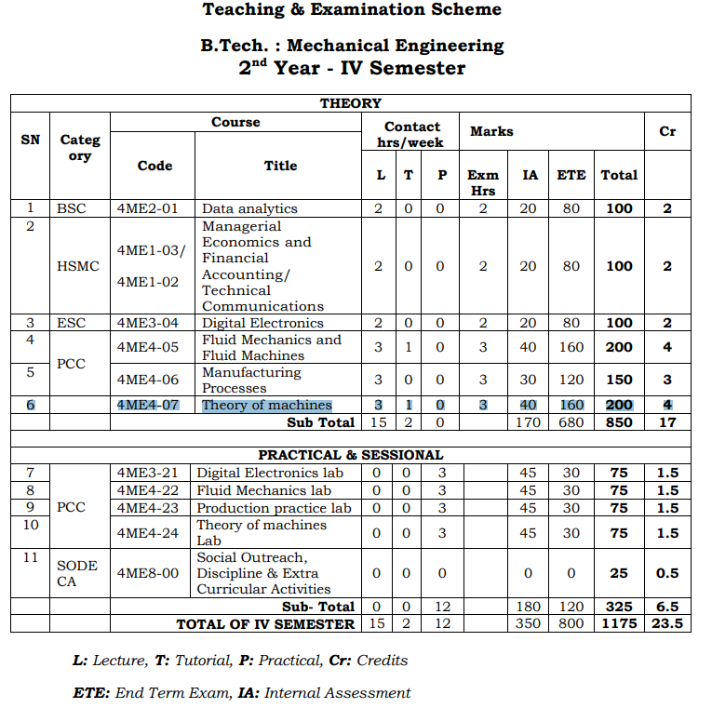

**Course Outcome Mapping with Program Outcome:**

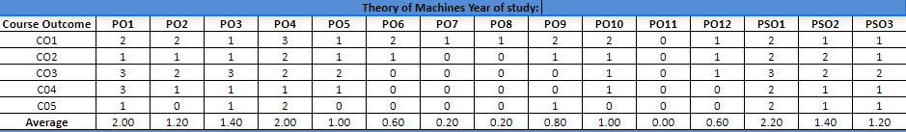

**Course Coverage Module Wise:**

|  |  |  |
| --- | --- | --- |
| **Lecture  No.** | **Unit** | **Topic** |
| 1 | **1** | **INTRODUCTION:** Objective, scope and outcome of the course |
| 2 | **2** | **INTRODUCTION TO MECHANISM**: Basic concept of machines, links. |
| 3 | 2 | Kinematic pair, kinematic chain |
| 4 | 2 | Mechanism. Inversions of kinematic chains: four bar chain mechanisms. |
| 5 | 2 | Inversions of kinematic chains: Single slider mechanisms. |
| 6 | 2 | Inversions of kinematic chains: Single slider mechanisms. |
| 7 | 2 | inversions of double slider crank mechanisms. |
| 8 | 2 | Velocity Diagram or polygons.. |
| 9 | 2 | Acceleration Diagram or polygons. |
| 10 | 2 | Relative velocity and instantaneous centre method |
| 11 | **3** | **FRICTION DEVICES**: Types and laws of friction |
| 12 | 3 | Pivots and collars |
| 13 | 3 | Power screws such as lead screw of the lathe. |
| 14 | 3 | Clutches: Single -plate clutches. |
| 15 | 3 | multi-plate clutches. |

|  |  |  |
| --- | --- | --- |
| 16 | 3 | Brakes: Band brake and numerical problem. |
| 17 | 3 | Block brake and numerical problem. |
| 18 | 3 | band and block brakes and numerical problem. |
| 19 | **4** | **GEARS:** Introduction, classification of gear |
| 20 | 4 | Gears: Laws of gearing |
| 21 | 4 | gears terminology; tooth form of gear. |
| 22 | 4 | Tooth form : Involutes Profile. |
| 23 | 4 | interference, undercutting and minimum number of teeth on pinion |
| 24 | 4 | interference, undercutting and minimum number of teeth on gear. |
| 25 | 4 | interference, undercutting and minimum number of teeth on Rack and pinion. |
| 26 | 4 | Length of path contact, Length of arc of contact and contact ratio. |
| 27 | 4 | Spur, helical, basic introduction of bevel, |
| 28 | 4 | Worm and worm gears. |
| 29 | 4 | Gear Trains: Simple, compound |
| 30 | 4 | Gear Trains : Reverted Gear train |
| 31 | 4 | Gear Trains : epicyclic gear trains. |
| 32 | 5 | **CAMS:** Introduction and Type of cams |
| 33 | 5 | Cams: displacement, velocity and acceleration curves for Knife edge  follower. |
| 34 | 5 | Cams: displacement, velocity and acceleration curves for roller follower. |
| 35 | 5 | Cams: displacement, velocity and acceleration curves for flat follower. |
| 36 | 5 | Gyroscope: Principles of gyroscopic couple. |
| 37 | 5 | Effect of gyroscopic couple and centrifugal force on two wheel vehicles  taking a turn. |
| 38 | 5 | Effect of gyroscopic couple and centrifugal force on four wheel vehicles  taking a turn.stabilization of ship. |
| 39 | 6 | **BALANCING:** Balancing of rotating masses in same |
| 40 | 6 | Balancing: Balancing of rotating masses in different planes |
| 41 | **6** | Balancing of reciprocating masses, |
| 42 | 6 | Swaying couple, hammer blow and tractive effort. |

**TEXT/REFERENCE BOOKS**

1. RATTAN, S.S., “THEORY OF MACHINES”, 2ND ED., TATA MCGRAW  HILL

2. BEVAN, T., “THEORY OF MACHINES”, PEARSON EDUCATION.

**Teaching and Learning resources:**

* **MOOC (NPTEL): -**

<https://drive.google.com/drive/u/1/folders/1gimy5aZo207_Oja05Hw6JE2qNjyotPOz>.

YouTube Videos Link –

<https://www.youtube.com/c/TECHNICALCLASSES_TC>

* **Assessment Methodology:**

1. Two Midterm exams where student have to showcase subjective learning.
2. Final Exam (subjective paper) at the end of the semester.
3. Surprise Test

**Last Year Paper.**



