**Techno India NJR Institute of Technology**

**Course File**

**Technical Communication (3ME1-02/4ME1-02)**

**Faculty Name –** Danish Paliwal

Techno India NJR

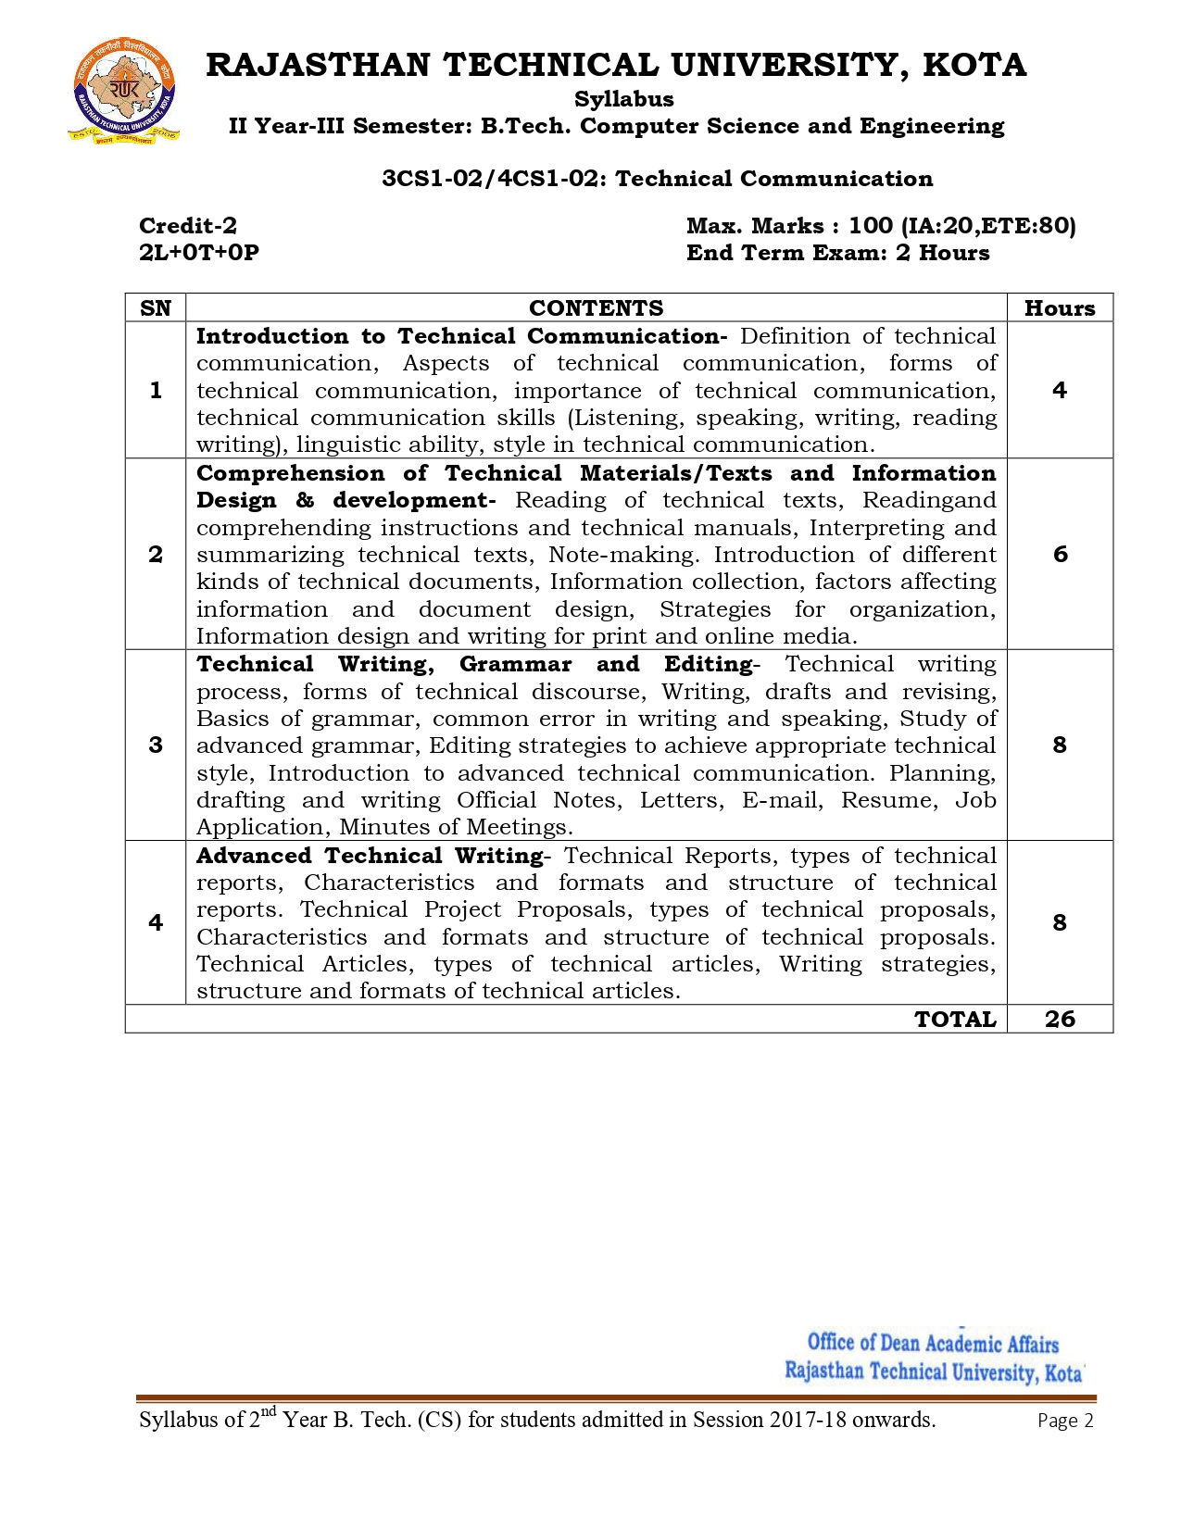

**Course Overview –**

Students will be able to learn and understand how to follow the various stages of writing process like prewriting, writing and rewriting and apply them to technical and workplace writing. Students will understand the basics components of definitions, descriptions, process explanations, and other common technical writings. Students will be able to read, understand and interpret material on technology. They will have appreciation for some of the ideas, issues and problems involved in writing about technology and in workplace writing. Students will be able to get an in-depth knowledge of technical communication used in professional life by getting to know all the forms and aspects of technical communication. Students will be able to express themselves better in technical writing by understanding the concept, style and methodology used in technical communication.

**Course Outcomes –**

1. Recall and identify four basic LSRW skills for learning technical communication.
2. Read, understand and summarize the technical texts and documents.
3. Apply technical style in writing and note making.
4. Compose official notes, letters, emails, resume, job applications and MOM with the usage of advanced grammar.
5. Design, analyse and evaluate technical reports, articles and proposal in proper format.

**Course Outcome Mapping with Program Outcome –**

|  |  |  |  |  |  |  |  |  |  |  |  |  |  |  |  |
| --- | --- | --- | --- | --- | --- | --- | --- | --- | --- | --- | --- | --- | --- | --- | --- |
|  | **PO1** | **PO2** | **PO3** | **PO4** | **PO5** | **PO6** | **PO7** | **PO8** | **PO9** | **PO10** | **PO11** | **PO12** | **PSO1** | **PSO2** | **PSO3** |
| **CO1** | 0 | 1 | 0 | 0 | 0 | 1 | 0 | 2 | 3 | 3 | 1 | 3 | 0 | 0 | 2 |
| **CO2** | 0 | 1 | 0 | 1 | 0 | 1 | 0 | 2 | 3 | 3 | 1 | 3 | 0 | 0 | 2 |
| **CO3** | 0 | 1 | 0 | 1 | 0 | 1 | 0 | 2 | 3 | 3 | 1 | 3 | 0 | 0 | 2 |
| **CO4** | 1 | 1 | 0 | 1 | 0 | 1 | 0 | 3 | 3 | 3 | 2 | 3 | 0 | 0 | 2 |
| **CO5** | 1 | 2 | 0 | 1 | 0 | 1 | 0 | 2 | 3 | 3 | 2 | 3 | 0 | 0 | 2 |

1 – Slight (low)

2 – Moderate (medium)

3 – Substantial (high)

**Course Module Lecture-wise –**

|  |  |  |
| --- | --- | --- |
| **Lecture No.** | **Unit** | **Topic** |
| 1 | 1 | Introduction: Technical Communication, meaning of technical communication. |
| 2 | 1 | Modes of Communication – Bifurcations of different modes of communication. |
| 3 | 1 | Barriers to Communication. |
| 4 | 1 | Interpersonal Barriers -. Information Gap Principle. |
| 5 | 1 | Basics of TC. Levels of TC. |
| 6 | 1 | Communication Networks. |
| 7 | 1 | Visual Aids in TC – tables and graphs. Types of graphs and tables. Uses of visual aids. |
| 8 | 2 | Active Listening – Introduction and Reasons for poor listening. |
| 9 | 2 | Listening Modes – Traits of a good listener. Types of listening. |
| 10 | 2 | Barriers to Effective listening. |
| 11 | 2 | Phonetics – Introduction. Basic Sounds of English. |
| 12 | 2 | Phonetic transcription. Rules of Pronunciation. Problem Sounds. |
| 13 | 2 | Syllables. Word Stress – weak forms. |
| 14 | 2 | Sentence Stress – sentence rhythm. Intonation. |
| 15 | 2 | General uses of tone. |
| 16 | 2 | Effective Speaking – Introduction. Paralinguistic Features. |
| 17 | 2 | Manipulating Paralinguistic features. Barriers to Speaking. |
| 18 | 2 | Types of Speaking – Persuasive Speaking and Public Speaking. |
| 19 | 2 | Drafting the speech. |
| 20 | 2 | Listening and Speaking – Conversations and types of conversations. |
| 21 | 2 | Conversation practices. |
| 22 | 2 | Telephonic Conversation and Etiquettes. |
| 23 | 2 | Dialogue Writing – Situational Dialogues. |
| 24 | 2 | Effective Presentation Strategies – Introduction and Planning. |
| 25 | 2 | Outlining and Structuring. Speech Delivery – Introduction. |
| 26 | 2 | Nuances of Delivery. Guidelines for effective speech delivery. |
| 27 | 2 | Controlling nervousness and stage fright. Visual Aids in presentation. |
| 28 | 2 | Applications of MS – PowerPoint. |
| 29 | 2 | Interviews – Introduction, Objective and Types. |
| 30 | 2 | Job Interviews. Stages of Interview. |
| 31 | 2 | Factors responsible for failure in Interviews. |
| 32 | 2 | Overcoming nervousness – The Rowboat Technique. Telephonic Interview. |
| 33 | 2 | Media Interviews, Press Conferences. |
| 34 | 2 | Group Communication – Introduction, Forms and use of body language in GD. |
| 35 | 2 | Discussions and Counselling. |
| 36 | 2 | Group Discussions – Organizational GDs |
| 37 | 2 | GD – As a part of selection process. Approach to topics and case studies. |
| 38 | 2 | Meetings – Purposes, Preparation and participation. |
| 39 | 2 | Conferences, Symposia, Seminars, Conflict Resolutions. |
| 40 | 2 | Negotiations. |
| 41 | 3 | Reading – Reading and Interpretation. Inferring Meanings – lexical and contextual. |
| 42 | 3 | Intensive and Extensive Reading. Critical Reading. |
| 43 | 3 | Reading Comprehension. |
| 44 | 3 | Reading Techniques – Techniques for good comprehension. Predicting the Content. Understanding the gist. SQ3R Reading Technique. |
| 45 | 3 | Technical Writing – Introduction and Language. |
| 46 | 3 | Elements of Style. Techniques for good Technical Writing. |
| 47 | 3 | Words, phrases and sentences – Introduction. Right words and phrases. |
| 48 | 3 | Sentence – Types and construction of sentences. |
| 49 | 3 | Paragraphs and Essays – Introduction. Paragraph Construction. Paragraph Length. |
| 50 | 3 | Paragraph Patterns and Types. Writing the first draft. |
| 51 | 3 | Essays – Types and Characteristics. |
| 52 | 3 | The Art of Condensation – Introduction. Precis Writing – Steps. |
| 53 | 3 | Letters, memos and e-mail – Introduction. |
| 54 | 3 | Elements and Formats of Letters, memos and e-mail. |
| 55 | 3 | Types of Letters – Layout and Format. |
| 56 | 3 | Resume – Elements, layout. |
| 57 | 3 | Memos and e-mails. |
| 58 | 3 | Reports – Introduction, characteristics and categories. |
| 59 | 3 | Reports – Format, Prewriting and Structure. |
| 60 | 3 | Technical Proposals. |
| 61 | 3 | Research Paper Writing. |
| 62 | 3 | Dissertation and Thesis Writing. |
| 63 | 3 | Instructions, Manuals and Technical Descriptions. |
| 64 | 3 | Referencing and Styling – Bibliography, Referencing, Style Manuals, Indexing and  Footnotes. |
| 65 | 4 | Modern Communication Media – Introduction. |
| 66 | 4 | Technology based Communication Tools. |
| 67 | 4 | Positive and Negative Impacts of Tech-based Communication. |
| 68 | 5 | Vocabulary – Synonyms and Antonyms. Confusable words. |
| 69 | 5 | One-word substitutes, homophones, eponyms, phrasal verbs. |
| 70 | 5 | English Grammar – Basics. |

**Text/Reference Books –**

1. Technical Communication – Principles and Practice, 2nd edition, Meenakshi Raman, Sangeeta Sharma, Oxford Publications.
2. Communication Techniques – Dr. N Padmasree, Dr. Leela Vyas, Mukesh Yadav, Neelkanth Publications.
3. Business Communication – Harvard Business Essentials. Harvard Business Publishing.

**Assessment Methodology –**

1. Online quiz through Google forms after every chapter.
2. Practical exam in lab where they have to write various formal documents at a very basic level like formal e-mail, analytical reports, descriptive reports, manuals, articles, sample research articles etc. once a week.
3. Assignments – 1 from each unit.
4. Midterm subjective paper where they have to write sample formal e-mail, analytical reports, descriptive reports, manuals, articles, sample research articles.
5. Final paper at the end of the semester subjective.

**Teaching and Learning Resources unit-wise –**

**Unit – 1**

Online reading: <https://www.skillsyouneed.com/ips/interpersonal-communication.html>

<https://pressbooks.bccampus.ca/technicalwriting/part/techcomm/>

<http://www.technicalreportwriting.org/visual-aids-3289>

Video Tutorials: <https://www.youtube.com/watch?v=rCaHCG2ETZA>

<https://www.youtube.com/watch?v=RIzGQKxfYsI>

<https://www.youtube.com/watch?v=j6LufgcHq9g>

Sample Quiz: <https://courses.lumenlearning.com/interpersonalcommunicationxmaster/chapter/quizzes/>

<https://www.techamitraj.com/2021/07/technical-communication-mcq-question.html>

**Unit – 2**

Online Reading: <https://www.experis.com/en/insights/articles/2021/05/25/20-tips-for-great-job-interviews>

<https://www.liquidplanner.com/blog/10-tips-to-make-the-most-out-of-your-business-meetings/>

<https://authorservices.taylorandfrancis.com/academic-conference-tips/>

Video Tutorials: <https://www.youtube.com/watch?v=JMOOG7rWTPg>

<https://www.youtube.com/watch?v=Qp4HjYuy56g>

<https://www.youtube.com/watch?v=YY2yjEEoB3U>

Sample Quiz: <https://www.sanfoundry.com/professional-communication-questions-answers-group-discussions/>

<https://quizizz.com/admin/quiz/5c6d7922210b61001bd4271e/minutes-of-meetings>

<https://researchautism.org/quiz-test-your-interview-skills/>

**Unit – 3**

Online Reading: <https://success.oregonstate.edu/learning/reading>

<https://www.aresearchguide.com/4format.html>

<https://www.researchgate.net/publication/308786787_A_Manual_for_Referencing_Styles_in_Research>

Video Tutorials: <https://www.youtube.com/watch?v=h1u7C6bMNnk>

<https://www.youtube.com/watch?v=S47RIVkr978>

<https://www.youtube.com/watch?v=ALhp6vCauVo>

Sample Quiz: <https://www.english-exam.org/IELTS/ielts_reading/>

<https://www.proprofs.com/quiz-school/story.php?title=writing-research-papers>

**Unit – 4**

Online Reading: <https://pscnotes.in/modern-means-of-communication-full-list/>

<https://www.proofhub.com/articles/team-communication-tools>

<https://technicaltoday.in/impact-of-technology-on-communication/>

Video Tutorials: <https://www.youtube.com/watch?v=2eYhdds5OnQ>

<https://www.youtube.com/watch?v=HVFpvtjTHXQ>

<https://www.youtube.com/watch?v=D3mNn0btW6s>

Sample Quiz: <https://quizizz.com/admin/quiz/5bea7a3ab292ff001ab0b331/modern-communication>

<https://quizizz.com/admin/quiz/5d22531da54b3a001d959170/obj-48-identify-communication-tools>

<https://global.oup.com/us/companion.websites/9780199859931/student/chapter7/stests/quiz/>

**Unit – 5**

Online Reading: <https://byjus.com/govt-exams/synonyms-and-antonyms-list/>

<http://prhs.pasoschools.org/jmount/handouts/Grammar/confusables.pdf>

<https://www.englishclub.com/vocabulary/phrasal-verbs-list.htm>

Video tutorials: <https://www.youtube.com/watch?v=bBWm3-mxL1U>

<https://www.youtube.com/watch?v=w1FlZIwy1CM>

<https://www.youtube.com/watch?v=e7tZSwasnR0>

Sample Quiz: <https://www.britannica.com/quiz/antonyms-and-synonyms>

<http://guidetogrammar.org/grammar/quizzes/notorious3.htm>

<https://www.espressoenglish.net/can-you-pass-this-phrasal-verbs-quiz/>

