**Techno India NJR Institute of Technology**

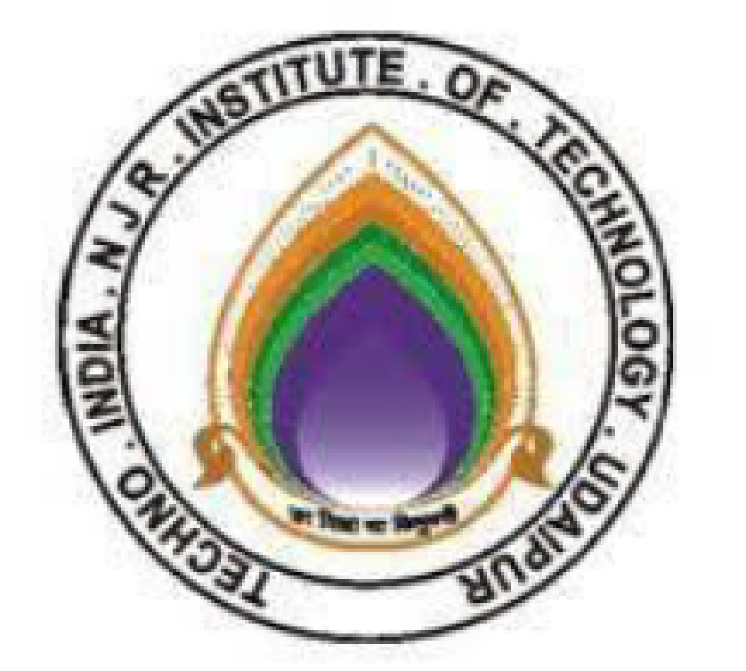

**Course File**

**Heat transfer (5ME4-02)**

Shambhu P. Choubisa

(Assistant Professor)

**Department of Mechanical**

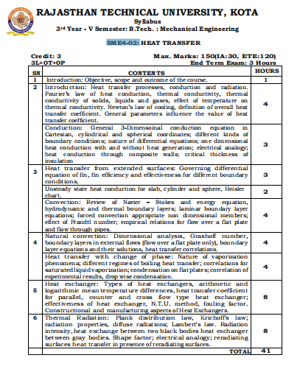

**Course Overview:**

This course is an introduction to the principal concepts and methods of heat transfer. The objectives of this integrated subject are to develop the fundamental principles and laws of heat transfer and to explore the implications of these principles for system behavior; to formulate the models necessary to study, analyze and design heat transfer systems through the application of these principles; to develop the problem-solving skills essential to good engineering practice of heat transfer in real-world applications.

**Course Outcomes:**

|  |  |  |
| --- | --- | --- |
| **CO. NO.** | **Cognitive Level** | **Course Outcome** |
| 1 | Synthesis&Design | Understand the basic modes of heat transfer & Determine Thermal Conductivity. |
| 2 | Synthesis & Design | Compute temperature distribution in steady-state and unsteady-state heat conduction & Determine Stefan Boltzmann Constant. |
| 3 | Synthesis & Design | Understand and analyse heat transfer through extended surfaces. &Estimate heat transfer coefficient & Measure heat transfer coefficient in free convection |
| 4 | Synthesis & Design | Interpret and analyze forced and free convection heat transfer &To Study and Compare LMTD and Effectiveness |
| 5 | Synthesis & Design | Understand the principles of radiation heat transfer and basics of mass transfer |
| 6 | Synthesis & design | Design heat exchangers using LMTD and NTU methods & Analyze rates of heat transfer for different materials |

.

**Course Outcome Mapping with Program Outcome:**

|  |  |  |
| --- | --- | --- |
| **Course Outcome** | **Program Outcomes (PO’s)** | |
| **CO. NO.** | **Domain Specific (PSO)** | **Domain Independent (PO)** |

|  |  |  |  |  |  |  |  |  |  |  |  |  |
| --- | --- | --- | --- | --- | --- | --- | --- | --- | --- | --- | --- | --- |
| **Course Outcome** | **PO1** | **PO2** | **PO3** | **PO4** | **PO5** | **PO6** | **PO7** | **PO8** | **PO9** | **PO10** | **PO11** | **PO12** |
| CO1 | 3 | 2 | 2 | 3 | 1 | 0 | 0 | 0 | 1 | 1 | 0 | 1 |
| CO2 | 3 | 3 | 2 | 3 | 1 | 0 | 0 | 0 | 1 | 0 | 0 | 1 |
| CO3 | 3 | 2 | 2 | 3 | 1 | 0 | 0 | 0 | 1 | 1 | 0 | 1 |
| C04 | 3 | 2 | 2 | 3 | 1 | 0 | 0 | 0 | 1 | 1 | 0 | 1 |
| C05 | 2 | 1 | 2 | 2 | 1 | 0 | 0 | 0 | 1 | 0 | 0 | 1 |
| C06 | 2 | 2 | 2 | 3 | 1 | 0 | 0 | 0 | 1 | 1 | 0 | 1 |
| **Average** | 2.67 | 2.00 | 2.00 | 2.83 | 1.00 | 0.00 | 0.00 | 0.00 | 1.00 | 0.67 | 0.00 | 1.00 |

|  |  |  |
| --- | --- | --- |
| Lecture No. | Unit | Topic |
| 1 | **1** | Introduction: Objective, scope and outcome of the course. |
| 2 | **2** | Introduction: Heat transfer processes, conduction and radiation |
| 3 | 2 | Fourier’s law of heat conduction, thermal conductivity, thermal conductivity of solids, liquids and gases |
| 4 | 2 | effect of temperature on thermal conductivity. Newton’s law of cooling |
| 5 | 2 | definition of overall heat transfer coefficient. General parameters influence the value of heat transfer coefficient.. |
| 6 | 2 | Conduction: General 3-Dimensoinal conduction equation in Cartesian, cylindrical and spherical coordinates; |
| 7 | 2 | different kinds of boundary conditions; nature of differential equations; one dimensional heat conduction with and without heat generation; |
| 8 | 2 | electrical analogy; heat conduction through composite walls; critical thickness of insulation |
| 9 | 2 | Numerical |
| 10 | **2** | Numerical |
| 11 | 2 | Numerical |
| 12 | 3 | Heat transfer from extended surfaces: Governing differential equation of fin |
| 13 | **3** | fin efficiency and effectiveness for different boundary conditions |
| 14 | **3** | Unsteady state heat conduction for slab, cylinder and sphere, Heisler chart |
| 15 | 3 | Convection: Review of Navier – Stokes and energy equation, hydrodynamic and thermal boundary layers; |
| 16 | 3 | laminar boundary layer equations; forced convection appropriate non dimensional num. |
| 17 | 3 | effect of Prandtl number; empirical relations for flow over a flat plate and flow through pipes. |
| 18 | **3** | Numericals |
| 19 | 3 | Numericals |
| 20 | 3 | Numericals |
| 21 | 4 | Natural convection: Dimensional analysis, Grashoff number, boundary layers in external flows (flow over a flat plate only) |
| 22 | 4 | layer equations and their solutions, heat transfer correlations |
| 23 | 4 | Heat transfer with change of phase: Nature of vaporization phenomena; |
| 24 | 4 | different regimes of boiling heat transfer; correlations for saturated liquid vaporization |
| 25 | 4 | Condensation on flat plates; correlation of experimental results, drop wise condensation. |
| 26 | 4 | Numericals |
| 27 | 4 | Numericals |
| 28 | 4 | Numericals |
| 29 | 5 | Heat exchanger: Types of heat exchangers, arithmetic and logarithmic mean temperature differences, |
| 30 | 5 | heat transfer coefficient for parallel, counter and cross flow type heat exchanger; |
| 31 | 5 | effectiveness of heat exchanger, N.T.U. method, |
| 32 | 5 | , fouling factor. Constructional and manufacturing aspects of Heat Exchangers |
| 33 | 5 | Numericals |
| 34 | 5 | Numericals |
| 35 | 5 | Numericals |
| 36 | 5 | Numericals |
| 37 | 6 | Thermal Radiation: Plank distribution law, Krichoff's law; radiation |
| 38 | 6 | properties, diffuse radiations; Lambert's law. Radiation intensity, |
| 39 | 6 | , heat exchange between two black bodies heat exchanger between gray bodies |
| 40 | 6 | Shape factor; electrical analogy |
| 41 | 6 | reradiating surfaces heat transfer in presence of reradiating surfaces. |
| 42 | 6 | Numericals |
| 43 | 6 | Numericals |
| 44 | 6 | Numericals |
| 45 | 6 | Numericals |

**Course Coverage Module Wise:**

**TEXT/REFERENCE BOOKS**

1. Heat transfer, Cengel Yunus A.
2. Heat transfer, domkundwar
3. Heat transfer, D.s.Kumar
4. Heat Transfer, R.K.Rajput

**Course Level Problems (Test Items):**

|  |  |
| --- | --- |
| **CO.NO.** | **Problem description** |
| **1** | 1. Study the basics modes of heat transfer 2. Differentiate thermodynamics & heat transfer with practical application 3. Attempt numerical on conduction |
| **2** | 1. Application of fourier equation in cartesian , cylindrical & speherical coordinate system. 2. Explain & derive critical thickness of insulation 3. Attempt numerical on conduction through plane wall. |
| **3** | 1. Explain fins & its applications 2. Derive heat transfer through infineetly long fin , fin insulated at the tip and efficency & effectiveness of the fin. 3. Impoertance of fins and how we improve the efficency oof fine by practical approach |
| **4** | 1. Study unsteadty heat transfer and its practical approach 2. Explain dimensionless number and their importance 3. Attempt numerical approach to unsteady state problems. |
| **5** | 1. Explain heat exchanger & their applications 2. Explain N.T.U and L.M.T.D approach with practical examples 3. Attempt numericals on LM.T.D approach |
| **6** | 1. Expalin radiation concept and relate with practical life 2. Exlain different radiation laws and relate with practical life. |

**Assessment Methodology**

1. Practical exam in lab where they have to prepare practical model related to thermodynamic laws .(Once in a week)
2. Assignments one from each unit.
3. Midterm subjective paper where they have to attempt numericals.
4. Final paper at the end of the semester subjective.

**Teaching and Learning resources unit-wise:**

**Unit-1**

Basics of heat transfer

1. Conduction. Convection & Radiation

Video Tutorials:https://www.youtube.com/watch?v=sieo7oZGsWQ

Theory concepts: <https://nptel.ac.in/courses/112/108/112108149/>

Sample Quiz: https://engineeringinterviewquestions.com/heat-transfer-mechanical-engineering-multiple-choice-questions-and-answers/

**Unit-2**

1. Fourier equation and its application

Video Tutorials: <https://www.youtube.com/watch?v=hZ5cCrGNS1U>

Theory concepts:https://nptel.ac.in/courses/112/108/112108149/

Sample Quiz: https://engineeringinterviewquestions.com/heat-transfer-mechanical-engineering-multiple-choice-questions-and-answers/

1. Critical thickness of insulation

Video Tutorials: <https://www.youtube.com/watch?v=5P5S_MzdcS4>

Theory concepts: <https://nptel.ac.in/courses/112/108/112108149/>

Sample Quiz: https://engineeringinterviewquestions.com/heat-transfer-mechanical-engineering-multiple-choice-questions-and-answers/

**Unit-3**

1. Heat transfer from extended surfaces

Video Tutorials:https://www.youtube.com/watch?v=SNnd0f3xXlg

Theory concepts: https://nptel.ac.in/courses/112/108/112108149/

Sample Quiz: https://engineeringinterviewquestions.com/heat-transfer-mechanical-engineering-multiple-choice-questions-and-answers/

B. Unsteady state heat transfer

Video Tutorials: https://www.youtube.com/watch?v=ztZlwcHUL7k

Theory concepts: <https://nptel.ac.in/courses/112/108/112108149/>

Sample Quiz:https://engineeringinterviewquestions.com/heat-transfer-mechanical-engineering-multiple-choice-questions-and-answers/

**Unit-4**

1. Heat flow, laminar & turbulent

Video Tutorials: <https://www.youtube.com/watch?v=uvREDOh0X2s>

Theory concepts: https://nptel.ac.in/courses/112/108/112108149/

Sample Quiz: https://engineeringinterviewquestions.com/heat-transfer-mechanical-engineering-multiple-choice-questions-and-answers/

1. Heat transfer with change of phase: Nature of vaporization phenomena;

Video Tutorials: <https://www.youtube.com/watch?v=FEr6mFQj37U>

Theory concepts: <https://nptel.ac.in/courses/112/108/112108149/>

Sample Quiz: https://engineeringinterviewquestions.com/heat-transfer-mechanical-engineering-multiple-choice-questions-and-answers/

1. different regimes of boiling heat transfer; correlations for saturated liquid vaporization

Video Tutorials: <https://www.youtube.com/watch?v=NaSMTsscEao>

Theory concepts: <https://nptel.ac.in/courses/112/108/112108149/>

Sample Quiz: https://engineeringinterviewquestions.com/heat-transfer-mechanical-engineering-multiple-choice-questions-and-answers/

**Unit-5**

1. Heat exchanger: Types of heat exchangers, arithmetic and logarithmic mean temperature differences,

Video Tutorials:https://www.youtube.com/watch?v=gDaLG16op_Y

Theory concepts: <https://nptel.ac.in/courses/112/108/112108149/>

Sample Quiz: https://engineeringinterviewquestions.com/heat-transfer-mechanical-engineering-multiple-choice-questions-and-answers/

1. LMTD & NTU approach

Video Tutorials:https://www.youtube.com/watch?v=MSZwREBCXTs

Theory concepts:https://nptel.ac.in/courses/112/108/112108149/

Sample Quiz:<https://engineeringinterviewquestions.com/heat-transfer-mechanical-engineering-multiple-choice-questions-and-answers/>

**Unit-6**

1. Radiation and its basic concepts

Video Tutorials: https://www.youtube.com/watch?v=3bAEipA5ZpI

Theory concepts: <https://nptel.ac.in/courses/112/108/112108149/>

Sample Quiz: https://engineeringinterviewquestions.com/heat-transfer-mechanical-engineering-multiple-choice-questions-and-answers/

B Variation radiation laws and their practical approach

Video Tutorials:https://www.youtube.com/watch?v=JzcFdwEscPU

Theory concepts:https://nptel.ac.in/courses/112/108/112108149/

Sample Quiz: https://engineeringinterviewquestions.com/heat-transfer-mechanical-engineering-multiple-choice-questions-and-answers/

Previous Year Question Papers:

