Etabs Software Training
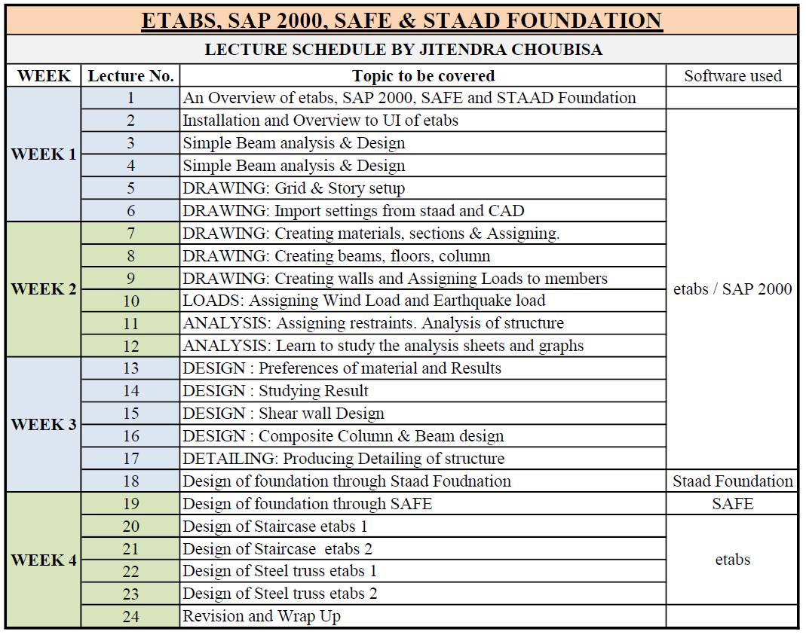
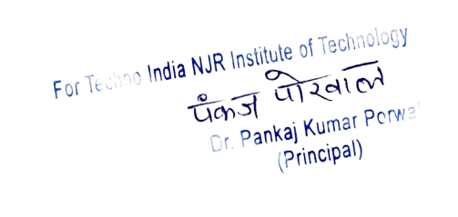
Dr. Pankaj Porwal
Principal and Head,
Department of Civil Engineering and Mechanical Engineering
CC: 1. The Director
2. The Principal
3. CE Dept. File
4. All student notice boards

