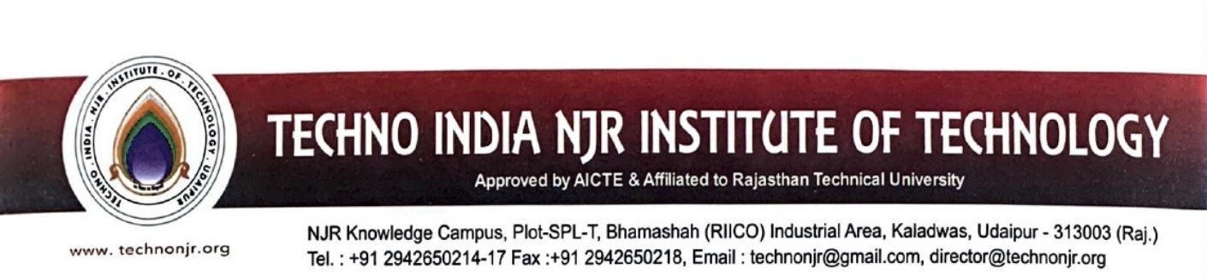

**To whomsoever it may concern**

This is to declare that Techno INDIA NJR institute of technology has signed a Non disclosure agreement with JIO Tesseract project. Where the institute has received SDK (Software Development Kit) to develop 3D models, prototype for testing and publishing on the JIOGLASS platform. Supporting document of the same are attached herewith.

Following faculty members & students are participating and coordinating the project: -

1. Aditya Maheshwari – Principal Investigator.

2. Jitendra Choubisa – Project Coordinator 1

3. Nishit Jain – Project Coordinator 2

4. Ekansh Jain- Student

5. Jayesh Kugsiya –Student

6. Mehul Joshi – Student

7. Ravindra Pratap Singh - Student