**Techno India NJR Institute of Technology**

**Course File**

**Human Values (1FY1-05/ 2FY1-05)**

**Faculty Name –** Mrs. Promiti Dutta Choudhury

Assistant Prof.

Department of Basic Science and Humanities.

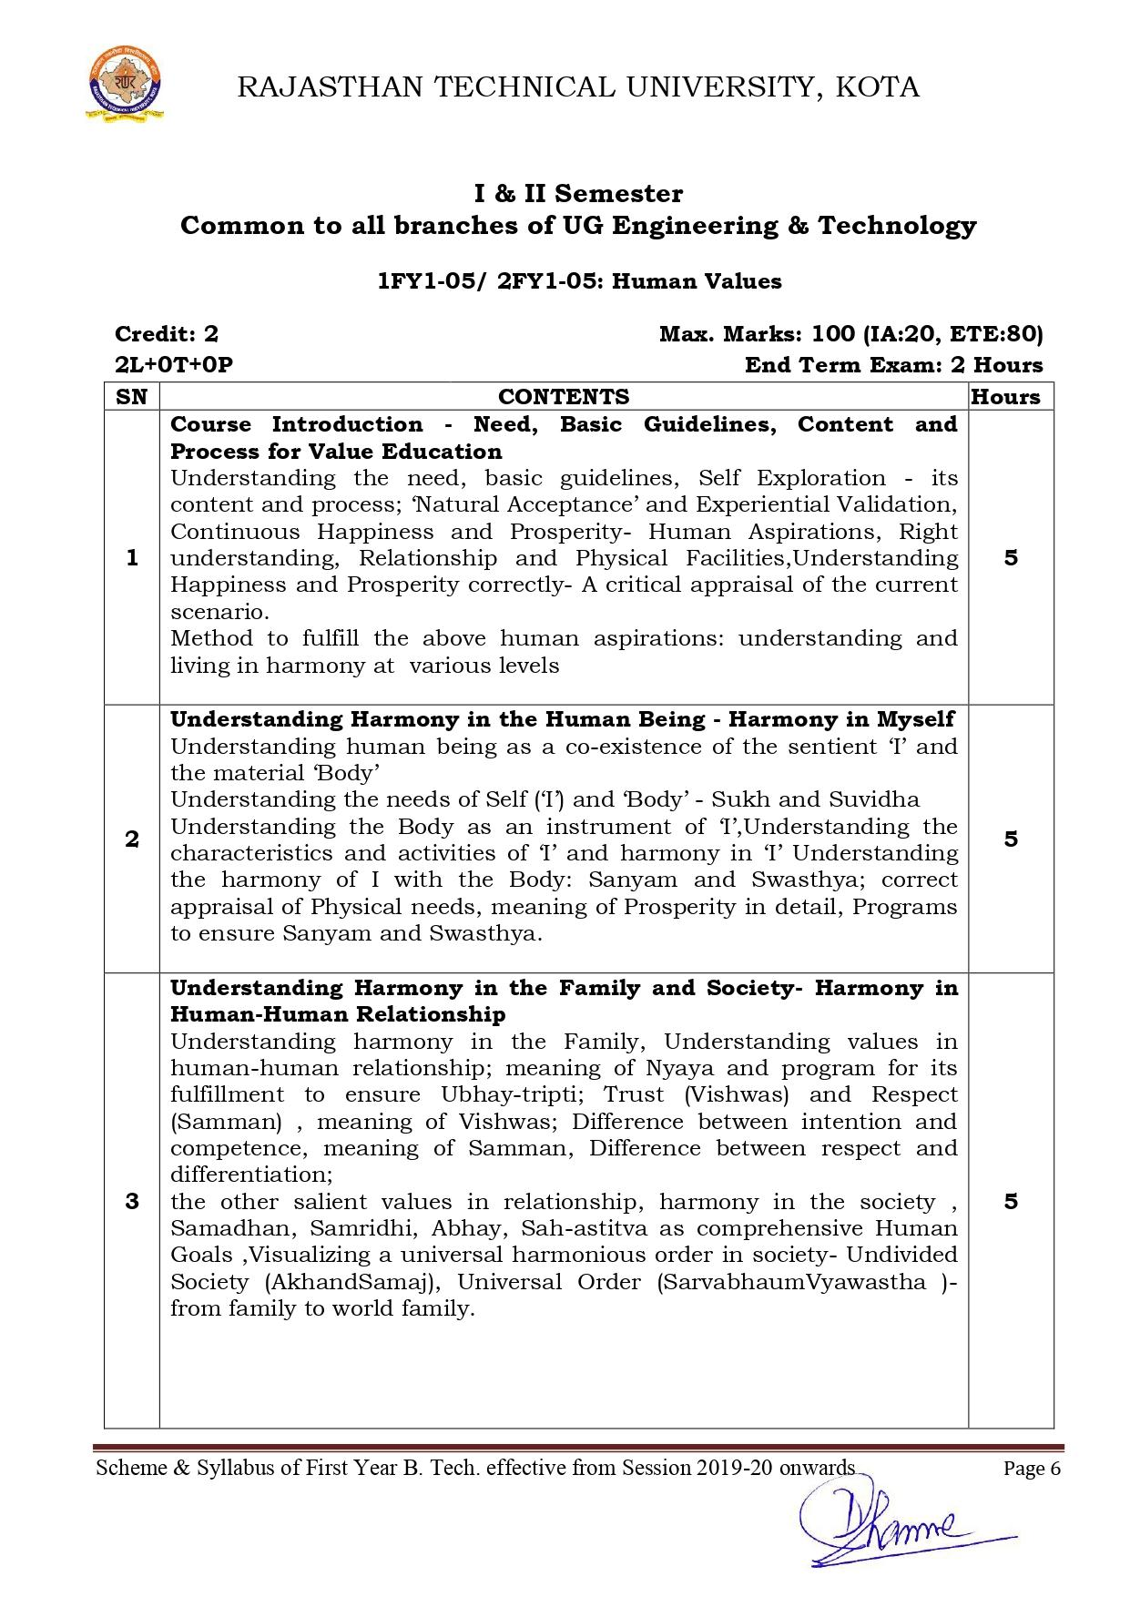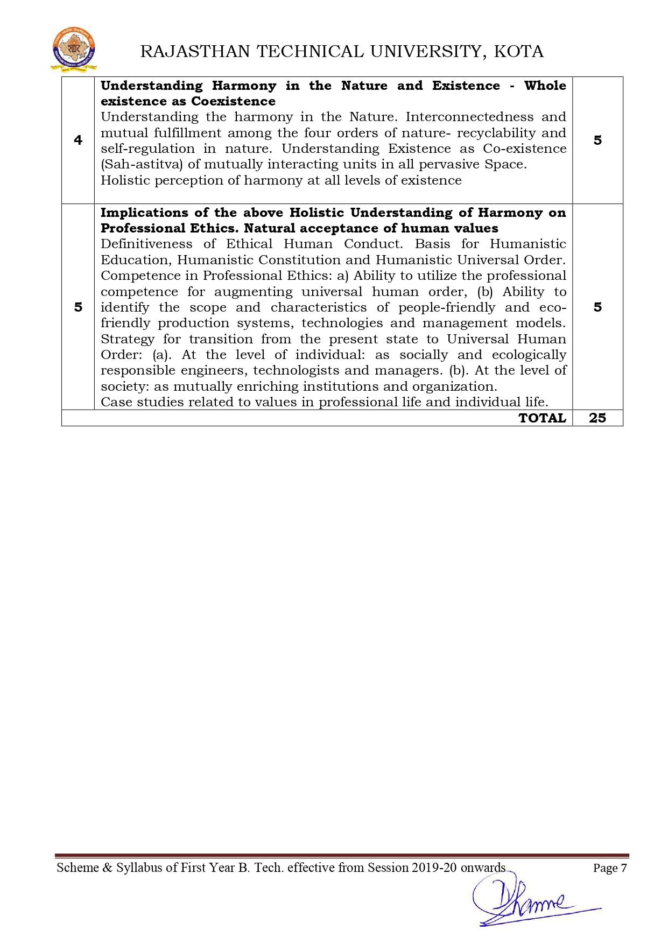

**Course Overview –**

The course deals with understanding the values and ethics present in the individual and also how to uphold these values and ethics in general life as well as at workplace. Students will understand the importance of happiness through identification of human values and skills. Students will understand the role of basic human aspirations in self and people around them. Students will understand about the harmony in family, in society and practically understand the importance of trust and respect as foundational value of relationship Students will understand the interconnectedness among the four orders of nature, recyclability, coexistence and harmony at all level of existence

Students will understand to be prepared for humanistic education, professional competence with ethics and humanistic universal order.

**Course Outcomes –**

1. Students will understand the importance of happiness through identification of human values and skills.
2. Students will understand the role of basic human aspirations in self and people around them.
3. Students will understand about the harmony in family, in society and practically understand the importance of trust and respect as foundational value of relationship
4. Students will understand the interconnectedness among the four orders of nature, recyclability, coexistence and harmony at all level of existence
5. Students will understand to be prepared for humanistic education, professional competence with ethics and humanistic universal order.

**Course Outcome Mapping with Program Outcome –**

PO1 PO2 PO3 PO4 PO5 PO6 PO7 PO8 PO9 PO10 PO11 PO12

0 0 1 1 0 2 2 2 2 2 1 2

0 0 1 1 0 2 2 2 2 2 1 2

0 0 2 1 0 2 2 1 0 2 1 2

0 0 2 1 0 2 2 1 2 2 1 2

0 0 2 1 0 2 2 2 2 2 2 2

1 – Slight (low)

2 – Moderate (medium)

3 – Substantial (high)

**Course Module Lecture-wise –**

| Lecture No. | Unit | Topic |
| --- | --- | --- |
| 1 | 1 | Understanding the need, basic guidelines, content and process for Value Education Self Exploration–what is it? - its content and process; ‘Natural Acceptance’ and Experiential Validation- as the mechanism for self-exploration. |
| 2 | 1 | Continuous Happiness and Prosperity- A look at basic Human Aspirations |
| 3 | 1 | Right understanding, Relationship and Physical Facilities- the basic requirements for fulfilment of aspirations of every human being with their correct priority |
| 4 | 1 | Understanding Happiness and Prosperity correctly- A critical appraisal of the current scenario |
| 5 | 1 | Method to fulfil the above human aspirations: understanding and living in harmony at various levels |
| 6 | 2 | Understanding human being as a co-existence of the sentient ‘I’ and the material ‘Body’ |
| 7 | 2 | Understanding the needs of Self (‘I’) and ‘Body’ - Sukh and Suvidha |
| 8 | 2 | Understanding the Body as an instrument of ‘I’ (I being the doer, seer and enjoyer) |
| 9 | 2 | Understanding the characteristics and activities of ‘I’ and harmony in ‘I’ Understanding the harmony of I with the Body: Sanyam and Swasthya; correct appraisal of Physical needs, meaning of Prosperity in detail |
| 10 | 2 | Programs to ensure Sanyam and Swasthya |
| 11 | 3 | Understanding harmony in the Family- the basic unit of human interaction Understanding values in human-human relationship; meaning of Nyaya and program for its fulfillment to ensure Ubhay-tripti; |
| 12 | 3 | Trust (Vishwas) and Respect (Samman) as the foundational values of relationship Understanding the meaning of Vishwas; Difference between intention and competence |
| 13 | 3 | Understanding the meaning of Samman, Difference between respect and differentiation; the other salient values in relationship |
| 14 | 3 | Understanding the harmony in the society (society being an extension of family): Samadhan, Samridhi, Abhay, Sah-astitva as comprehensive Human Goals |
| 15 | 3 | Visualizing a universal harmonious order in society- Undivided Society (AkhandSamaj), Universal Order (Sarvabhaum Vyawastha )- from family to world family! |
| 16 | 4 | Understanding the harmony in the Nature |
| 17 | 4 | Interconnectedness and mutual fulfillment among the four orders of nature- recyclability and self-regulation in nature |
| 18 | 4 | Understanding Existence as Co-existence (Sah-astitva) of mutually interacting units in all-pervasive space |
| 19 | 4 | Holistic perception of harmony at all levels of existence |
| 20 | 5 | Natural acceptance of human values |
| 21 | 5 | Definitiveness of Ethical Human Conduct Basis for Humanistic Education, Humanistic Constitution and Humanistic Universal Order |
| 22 | 5 | Competence in Professional Ethics: a) Ability to utilize the professional competence for augmenting universal human order, b) Ability to identify the scope and characteristics of people-friendly and eco-friendly production systems, technologies and management models |
| 23 | 5 | Case studies of typical holistic technologies, management models and production systems |
| 24 | 5 | Strategy for transition from the present state to Universal Human Order: a) At the level of individual: as socially and ecologically responsible engineers, technologists and managers |

**Text/Reference Books –**

1. R R Gaur, R Sangal, G P Bagaria, A Foundation Course in Human Values and Professional Ethics, Excel Books, 2009. ISBN: 978-9-350-62091-5

2. Ivan Illich, 1974, Energy & Equity, The Trinity Press, Worcester, and Harper Collins, USA

3. E.F. Schumacher, 1973, Small is Beautiful: a study of economics as if people mattered, Blond & Briggs, Britain.

4. R. Subramanian, Professional Ethics includes Human Values, Oxford Univ. Press.

5. Sussan George, 1976, How the Other Half Dies, Penguin Press. Reprinted 1986, 1991

6. Donella H. Meadows, Dennis L. Meadows, Jorgen Randers, William W. Behrens III, 1972, Limits to Growth – Club of Rome’s report, Universe Books.

7. A Nagraj, 1998, Jeevan Vidya Ek Parichay, Divya Path Sansthan, Amarkantak.

8. P L Dhar, RR Gaur, 1990, Science and Humanism, Commonwealth Publishers.

9. A N Tripathy, 2003, Human Values, New Age International Publishers. 10.SubhasPalekar, 2000, How to practice Natural Farming, Pracheen (Vaidik) Krishi TantraShodh, Amravati.

11.E G Seebauer & Robert L. Berry, 2000, Fundamentals of Ethics for Scientists & Engineers, Oxford University Press

12.M Govindrajran, S Natrajan & V.S. Senthil Kumar, Engineering Ethics (including Human Values), Eastern Economy Edition, Prentice Hall of India Ltd.

13.B P Banerjee, 2005, Foundations of Ethics and Management, Excel Books.

14.B L Bajpai, 2004, Indian Ethos and Modern Management, New Royal Book Co., Lucknow. Reprinted 2008

**Assessment Methodology –**

1. Online quiz through Google forms after every chapter.
2. Practical lab wherein they are given situation-based questions relating to human values and ethics.
3. Assignments – 1 from each unit.
4. Midterm subjective paper where they have to solve situational questions and define the basic terminologies and definitions relating to human values.
5. Final paper at the end of the semester subjective.

**Teaching and Learning Resources unit-wise –**

**Unit – 1**

Online reading: <https://www.merriam-webster.com/dictionary/self-exploration>

<http://www.jnkvv.org/PDF/0805202015151185201131.pdf>

Video Tutorials: <https://www.youtube.com/watch?v=x3TweIkAZt8>

<https://www.youtube.com/watch?v=fjlnKGdy9J8>

Sample Quiz: <https://windmillways.com/8-fun-personality-quizzes-for-self-discovery/>

<https://sites.google.com/site/drrajdeepdeb/mcq_hvpe>

**Unit – 2**

Online Reading: <https://fdp-si.aicte-india.org/download/FDPTeachingMaterial/3-days%20FDP-SI%20UHV%20Teaching%20Material/Day%201%20Handouts/UHV%203D%20D1-S3%20Und%20Human%20Being%20-%20Self%20_%20Body.pdf>

<http://www.tattvagyan.com/hi/jain-stotra/uttaradhyayana-sutra/restraint-happiness/>

Video Tutorials: <https://www.youtube.com/watch?v=AoJGq7EGMoM>

<http://jinavachan.blogspot.com/2020/09/sanyam-che-sukh-bharpur-lyrics-jain.html>

Sample Quiz: <https://www.healthshots.com/quiz/are-you-body-positive-take-this-quiz-to-know-if-youre-truly-your-favourite/>

<https://studylib.net/doc/25449000/uhv-question-set-1>

**Unit – 3**

Online Reading: <https://ccsuniversity.ac.in/bridge-library/pdf/btech-me-harmony-in-family-and-society.pdf>

<https://www.askdifference.com/competence-vs-intention/>

Video Tutorials: <https://www.youtube.com/watch?v=fYbLzYUdo68>

<https://www.youtube.com/watch?v=3temr56No4U>

Sample Quiz: <https://sites.google.com/site/drrajdeepdeb/unit-1_satq-hvpe>

<https://brainly.in/question/12498400>

**Unit – 4**

Online Reading: <http://www.harmonywithnatureun.org/>

<https://www.thecoexistence.org/program/key-concepts/the-key-components-of-the-courses/holistic-perspective-of-harmony/>

Video Tutorials: <https://www.youtube.com/watch?v=1HR-QB2mCF0>

<https://www.youtube.com/watch?v=Bsf0MYwoBDY>

Sample Quiz: <https://quizizz.com/admin/quiz/5fdd7f072771cd001c6cdf99/harmony-in-nature>

**Unit – 5**

Online Reading: <https://www.skedsoft.com/books/human-values-prof-ethics-1/natural-acceptance-and-experiential-validation>

<https://fdp-si.aicte-india.org/download/FDPTeachingMaterial/8-day%20UHV%20FDP%20Teaching%20Material/TUT%20-%20Natural%20Acceptance.ppt>

<https://innerjourneytowardstruth.home.blog/2018/11/09/holistic-technologies-production-systems-management-model/>

Video tutorials: <https://www.youtube.com/watch?v=wsHM9EH-1DQ>

<https://www.youtube.com/watch?v=jIic_CVmyWM>

**TECHNO INDIA NJR INSTITUTE OF TECHNOLOGY, UDAIPUR**

**B. TECH 1 ST – YEAR (I SEM.)**

**Human Values (2FY105)**

**Assignment 1**

1. Define the term “communication?
2. Explain the characteristics of Written communication .
3. What is the difference between intension and competence?
4. Define “Crosswise communication”
5. What is Written communication?
6. What is the meaning of human values?

**Assignment 2**

1. Explain in detail the importance of Oral communication. What is Corporate Social Responsibility? Expalin with examples.
2. Write a note on the use of sound signals clearly distinguishing its kinds and uses
3. Explain the importance of Upward Communication- Its Advantages and Limits.

TECHNO INDIA NJR INSTITUTE OF TECHNOLOGY, UDAIPUR

B. TECH 1 ST – YEAR (I SEM.) – MT-II

Human Values (2FY105)

Time: 2 Hr Max. Marks: 70

Instructions to the Candidates:

Part A- Short answer type questions (up to 25 words)

Part B- Analytical/Problem solving questions

Part C- Descriptive /analytical/problem solving questions.

**PART -A**

Attempt all five questions (5x2=10)

1. What is your present vision of a happy and prosperous life?

2. Differentiate between respect and differentiation

3. State any four attributes of Space and Unit.

4. What are the basic guidelines for value education?

5. What is the importance of justice in our life?

**PART- B**

Attempt any three questions (8x4=30)

1. Give your understanding of the term ‘Trust’.

2. Values &amp; Skills complement each other. Elaborate.

3. State the four orders of nature? Explain them.

4. Explain the feelings of gratitude, care and glory.

5. Indicate a few feasible steps to promote harmony in the society and co-existence with

nature.

6. What do you understand by the term ‘Respect’? Illustrate with examples regarding the

present scenario related to respect.

**PART- C**

Attempt any two question (14x2=30)

1. “The problem today is that the desires thoughts &amp; expectations are largely set by pre-

conditionings or sensations”. Critically examine the statement.

2. ‘Human beings are co-existence of the self and the body’. Elaborate.

3. Critically examine the attitude of humans today towards the other three orders of nature. Give few examples.

**TECHNO INDIA NJR INSTITUTE OF TECHNOLOGY, UDAIPUR**

**B. TECH 1st – YEAR (I SEM.) – MT-I   
Technical Communication** **(Subject Code)**

**Time: 2 Hr Max. Marks: 70  
Note:**

1) The paper is divided into 2 parts: Part-A and, Part-B.

2) Part-A contains 10 questions and carries 2 mark each.

3) Part-B contains 5 questions. Each question is having two options and carries 10 marks each.

**Part- A (20 Marks)**

| **A.** Kindly grant me a week’s leave- change into passive voice | CO1 |
| --- | --- |
| B. He tried to secure good marks- change into passive voice | CO1 |
| C. Bring a glass of water- change into passive voice | CO1 |
| D. He says, “I am writing letters” – change into indirect speech | CO1 |
| E. She said to her mother, “I have prepared breakfast” – change into indirect speech | CO2 |
| F. She said, “you should give-up smoking” – change into indirect speech | CO2 |
| G. If you------------in time, you-----the bus (fill in the blanks-(go, catch)) | CO2 |
| H. Make use of “unless”- if you do not play better, you cannot win this match. | CO2 |
| I. She----study properly if she wants to get good marks (Insert model verb(compulsion)) | CO3 |
| J. She would have purchased those gold bangles---- she had enough money(until, so, if) - Use Conjunction | CO3 |

**Part- B (50 Marks)**

| 1. Define the term “communication”, Explain its characteristics. | CO1 |
| --- | --- |
| OR | |
| 1. Explain the importance of Upward Communication- Its Advantages and Limits. | CO1 |

| 1. 2. What is Diagonal or Crosswise communication? Discuss Its Advantages and Limits. | CO1 |
| --- | --- |
| OR | |
| 2. Explain in detail the cycle of communication, Give Example. | CO1 |

| 3. Effective communication is always essential for success, Explain in detail. | CO2 |
| --- | --- |
| OR | |
| 3. How communication improves the level of motivation & moral of an Organisation? | CO2 |

| 4. Explain in detail the importance of Oral communication. | CO2 |
| --- | --- |
| OR | |
| 4. Explain the characteristics of Written communication. | CO2 |

| 5. What are the various barriers in effective listening? | CO3 |
| --- | --- |
| OR | |
| 5. Write a note on the use of sound signals clearly distinguishing its kinds and uses | CO3 |

**TECHNO INDIA NJR INSTITUTE OF TECHNOLOGY, UDAIPUR**

**B. TECH 1ST– YEAR (I SEM.) – MT-II**

Human Values (**2FY105**)

**Time:** 2 Hr **Max. Marks:** 70

**Note:**

1. The paper is divided into 2 parts: Part-A and, Part-B.
2. Part-A contains 10 questions and carries 2 mark each.
3. Part-B contains 5 questions. Each question is having two options and carries 10 marks each.

Part- A (20 Marks)

|  | What is your present vision of a happy and prosperous life? | CO1 |
| --- | --- | --- |
|  | Why do we need to understand ourselves? | CO1 |
|  | Explain the feeling of gratitude. | CO2 |
|  | Differentiate between respect and differentiation. | CO2 |
|  | State the four orders of nature? Explain them. | CO3 |
|  | Values & Skills complement each other. Elaborate. | CO3 |
|  | What are the basic guidelines for value education? | CO4 |
|  | To be in a state of harmony is happiness. Explain. | CO4 |
|  | Describe any four attributes of Space and Unit. | CO5 |
|  | Give your understanding of the term ‘Trust’. | CO5 |

Part- B (50 Marks)

| 1. Indicate a few feasible steps to promote harmony in the society and co-existence with nature. | CO1 |
| --- | --- |
| OR | |
| 1. What do you understand by the term ‘Respect’? Illustrate with examples regarding the present scenario related to respect. | CO1 |

| 1. State some important values of good relationship. | CO2 |
| --- | --- |
| OR | |
| 2. What are the programs needed to achieve the comprehensive human goal? List and define each briefly. | CO2 |

| 1. “The problem today is that the desires thoughts & expectations are largely set by pre-conditionings or sensations”. Critically examine the statement. | CO3 |
| --- | --- |
| OR | |
| 3. Critically examine the attitude of humans today towards the other three orders of nature. Give few examples. | CO3 |

| 1. We need to understand and live with **Sanyam** to ensure health. Explain. | CO4 |
| --- | --- |
| OR | |
| 4. ‘Human beings are co-existence of the self and the body’. Elaborate. | CO4 |

| 1. Explain the process of recyclability and self regulation in nature with examples. How this process is connected with the four orders of nature. | CO5 |
| --- | --- |
| OR | |
| 5. Mention some of the unethical practices in society today. Give your views and suggest some preventive measure in a sustainable way. | CO5 |

