**Techno India NJR Institute of Technology**



**Course File**

**Communication Skills (1FY1-04/ 2FY1-04)**

**Faculty Name – Promiti Dutta Choudhury**

**Assistant Prof.**

**Department of Basic Science and Humanities**

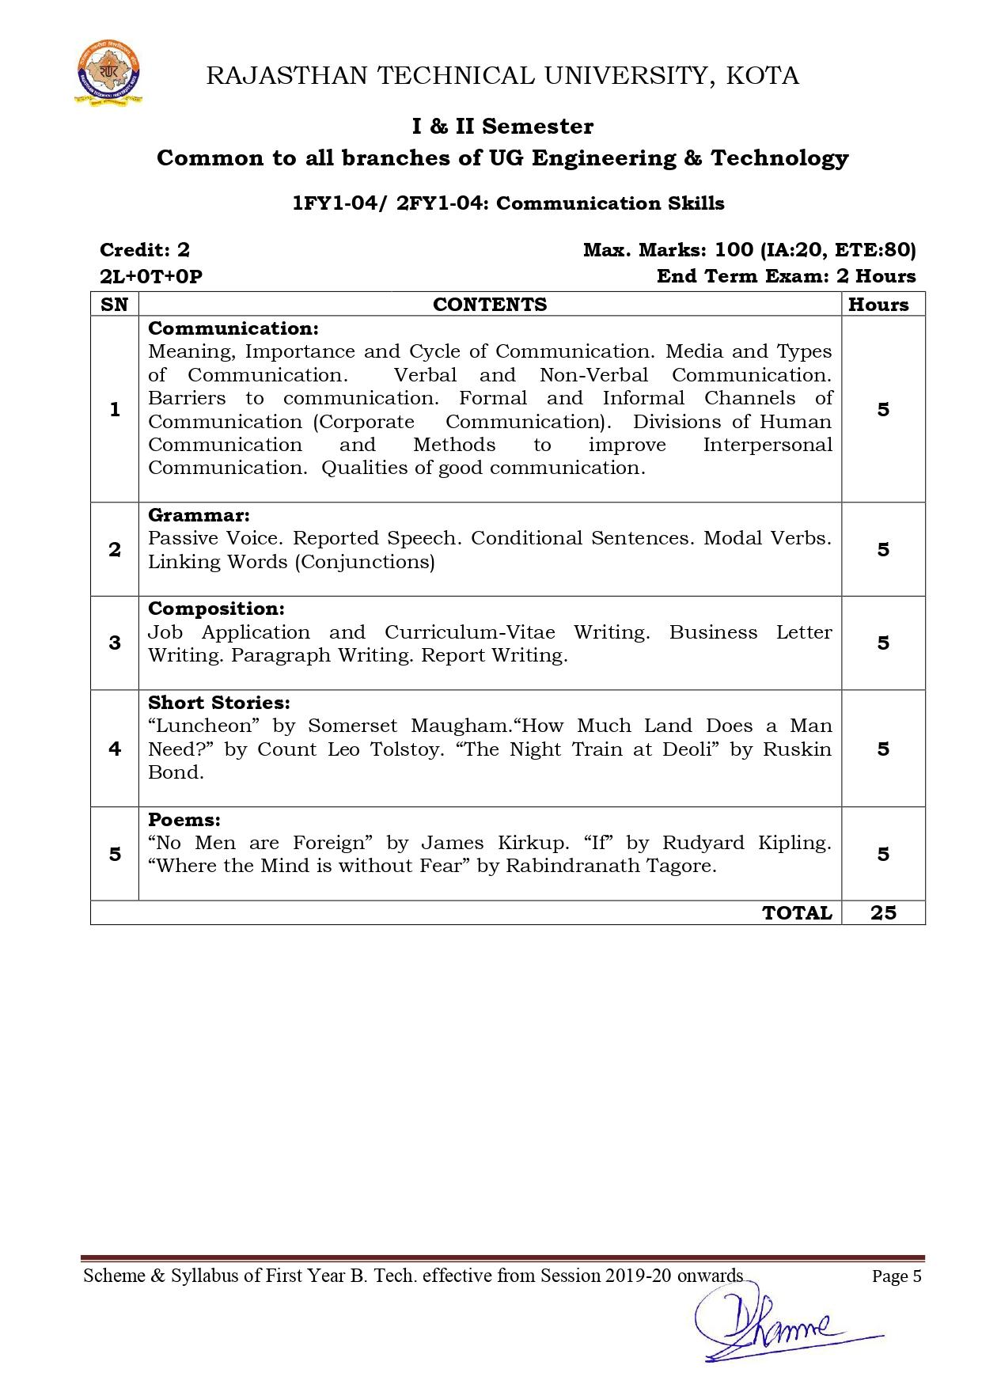

**Course Overview –**

Students will be able to learn various barriers related to communication and learn the basics of grammar. As most students do not belong to an English medium background, this course teaches them the basics of grammar and communication so as to improve their communication skills in future.

Students will be able to understand and develop communication skills and techniques which will felicitate their ability to work collaboratively with others.

Students will be able to use English grammar accurately that will increase their confidence in English writing and speaking.

Students will be able to invent, draft, organize, abstract, elaborate and synthesize their own and other's ideas in formatted way.

Students will be able to understand literary devices after reading poems and stories and also escalate art in all forms.

**Course Outcomes –**

1. Students will be able to understand and develop communication skills and techniques which will felicitate their ability to work collaboratively with others.
2. Students will be able to use English grammar accurately, which will increase their confidence in English writing and speaking.
3. Students will be able to invent, draft, organize, abstract, elaborate and synthesize their own and other's ideas in a formatted way.
4. Students will be able to understand literary devices and also appreciate art in all forms.
5. Students will be able to write, think, understand the value and importance of poems and stories.

**Course Outcome Mapping with Program Outcome –**

PO1 PO2 PO3 PO4 PO5 PO6 PO7 PO8 PO9 PO10 PO11 PO12

0 1 1 0 1 2 2 1 2 3 1 3

0 0 0 0 0 0 0 0 1 2 0 2

0 0 0 0 0 0 0 1 1 2 0 2

0 1 1 0 1 1 1 1 2 3 1 2

1 – Slight (low)

2 – Moderate (medium)

3 – Substantial (high)

**Course Module Lecture-wise –**

| Lecture No. | Unit | Topic |
| --- | --- | --- |
| 1 | 1 | Meaning and Importance of Communication. |
| 2 | 1 | Cycle of comm. Various types of communication. |
| 3 | 1 | Medium of communication. |
| 4 | 1 | Verbal and non-verbal comm. |
| 5 | 1 | Barriers to comm. |
| 6 | 1 | Channels of comm. |
| 7 | 1 | Corporate communication. |
| 8 | 1 | Divisions of Human communication – A. |
| 9 | 1 | Divisions of Human communication – B. |
| 10 | 1 | Interpersonal Communication. |
| 11 | 1 | Methods of Interpersonal communication. |
| 12 | 1 | Qualities of good communication. |
| 13 | 2 | Passive Voice. |
| 14 | 2 | Reported Speech. |
| 15 | 2 | Conditional Sentences. |
| 16 | 2 | Linking Verbs. |
| 17 | 2 | Modal Verbs (Conjunctions). |
| 18 | 3 | Job Application. |
| 19 | 3 | CV-Resume-Biodata writing. |
| 20 | 3 | Business Proposal/letter writing. |
| 21 | 3 | Paragraph writing. |
| 22 | 3 | Report writing. |
| 23 | 4 | Short story – Luncheon – A. |
| 24 | 4 | Short story – Luncheon – B. |
| 25 | 4 | How much Land does a man need? (A) |
| 26 | 4 | How much land does a man need? (B) |
| 27 | 4 | The night train at Deoli – A. |
| 28 | 4 | The night train at Deoli – B. |
| 29 | 5 | No men are foreign – A |
| 30 | 5 | No men are foreign – B. |
| 31 | 5 | If – A |
| 32 | 5 | If – B |
| 33 | 5 | Where the mind is without fear – A |
| 34 | 5 | Where the mind is without fear – B. |

**Text/Reference Books –**

1. Communication Skills, Pushplata & Sanjay Kumar, Oxford University Press, India.

2. The Written Word, Vandana Singh, Oxford University Press, India.

3. Current English Grammar and Usage with Composition, R. P. Sinha, Oxford University Press, India.

4. Rodriques M. V., ‘Effective Business Communication’, Concept Publishing Company, New Delhi, 1992 reprint (2000).

5. Bansal, R K and Harrison J B, ‘Spoken English’ Orient Longman, Hyderabad.

6. Binod Mishra & Sangeeta Sharma, ‘Communication Skills for Engineers and Scientists, PHI Learning Private Ltd, New Delhi, 2011.

7. Gartside L. ‘Modern Business Correspondence, Pitman Publishing, London.

**Assessment Methodology –**

1. Online quiz through Google forms after every chapter.
2. Practical exam in lab where they have to write various formal documents at a very basic level like formal letter, business proposal, resume-CV etc. once a week.
3. Assignments – 1 from each unit.
4. Midterm subjective paper where they have to write sample e-mails, formal letter, paragraph, critical appreciations of various texts each in poetry and short stories, meanings of difficult words and terms.
5. Final paper at the end of the semester subjective.

**Teaching and Learning Resources unit-wise –**

**Unit – 1**

Online reading: <https://www.zippia.com/advice/communication-skills/>

<https://www.thebalancecareers.com/communication-skills-list-2063779>

<https://www.skillsyouneed.com/ips/communication-skills.html>

Video Tutorials: <https://www.youtube.com/watch?v=o3s0HhAqJEo>

<https://www.youtube.com/watch?v=RPUPSWCIO9Y>

<https://www.youtube.com/watch?v=doAVuehH-L4>

<https://www.youtube.com/watch?v=-8cMOh5roUs>

Sample Quiz: <https://www.highspeedtraining.co.uk/hub/communication-skills-quiz/>

<https://www.vskills.in/practice/communication-skills-test>

**Unit – 2**

Online Reading: <https://www.towson.edu/ows/activepass.htm>

<https://www.ego4u.com/en/cram-up/grammar/conditional-sentences>

<https://dictionary.cambridge.org/grammar/british-grammar/reported-speech_2>

Video Tutorials: <https://www.youtube.com/watch?v=VxHCs9W7tW4>

<https://www.youtube.com/watch?v=W1_IRU6zx9g>

<https://www.youtube.com/watch?v=jcMjKxZzJl0>

Sample Quiz: <https://www.perfect-english-grammar.com/reported-speech-exercises.html>

<https://www.wallstreetenglish.com/exercises/direct-and-indirect-speech-exercises>

<https://classroom.google.com/c/MjQyNjA0MjUzODA1/a/MjQyNjA0OTA4Mzcw/details>

**Unit – 3**

Online Reading: <https://www.lkouniv.ac.in/site/writereaddata/siteContent/202004291614538778Savya-Sachi-Difference-between-Resume-CV-and-Biodata.pdf>

<https://www.thebalancecareers.com/how-to-format-a-business-letter-2062540>

<https://wts.indiana.edu/writing-guides/paragraphs-and-topic-sentences.html>

Video Tutorials: <https://www.youtube.com/watch?v=L1J9ZPVydrc>

<https://www.youtube.com/watch?v=_fP43gcBywU>

<https://www.youtube.com/watch?v=7xUTguLaaXI>

Sample Quiz: <https://quizizz.com/admin/quiz/56fbc81fbb00b31b0a1b9bfd>

<https://www.englishclub.com/business-english/resumes-cv-quiz.php>

<https://www.testprepreview.com/modules/reading1.htm>

**Unit – 4**

Online Reading: <https://www.jaroska.cz/elearning/anglictina/library%20luncheon.html>

<https://www.uvic.ca/research/centres/cisur/assets/docs/iminds/gam-how-much-land-a-man-needs.pdf>

<https://www.waterstones.com/book/night-train-at-deoli-and-other-stories/ruskin-bond/9780143432043>

Video Tutorials: <https://www.youtube.com/watch?v=430VOBMC4tg>

<https://www.youtube.com/watch?v=FD724EB3YV4>

<https://www.youtube.com/watch?v=4eWa3285leU>

Sample Quiz: <https://www.goconqr.com/en/quiz/3200025/-the-luncheon-william-somerset-maugham>

<https://classroom.google.com/c/MjQyNjA0MjUzODA1/a/MjQ5NzAyOTc5MDg5/details>

<https://quizizz.com/admin/quiz/57d61b40b70143a147c62831/how-much-land-does-a-man-need>

<https://wordwall.net/embed/edddef745b9c45a584ab6699ae02c41d?themeId=4&templateId=5>

**Unit – 5**

Online Reading: <https://www.successcds.net/learn-english/class-9/no-men-are-foreign-class-9-english-poem.html>

<https://nios.ac.in/media/documents/srsec302new/302EL10.pdf>

<https://www.poetryfoundation.org/poems/46473/if--->

Video tutorials: <https://www.youtube.com/watch?v=NvBm6Kq0fgI>

<https://www.youtube.com/watch?v=H_Kvbe1rwu4>

<https://www.youtube.com/watch?v=5Goe8K1QApA>

<https://www.youtube.com/watch?v=430VOBMC4tg>

<https://www.youtube.com/watch?v=mbthTKMCdp8>

<https://www.youtube.com/watch?v=DC8zC-WM9gQ>

Sample Quiz: <https://www.enotes.com/topics/if-kipling/quizzes>

<https://quizizz.com/admin/quiz/5f02f814cdce1b001bb7b7b0/where-the-mind-is-without-fear>

<https://www.learninsta.com/no-men-are-foreign-class-9-mcq-questions/>

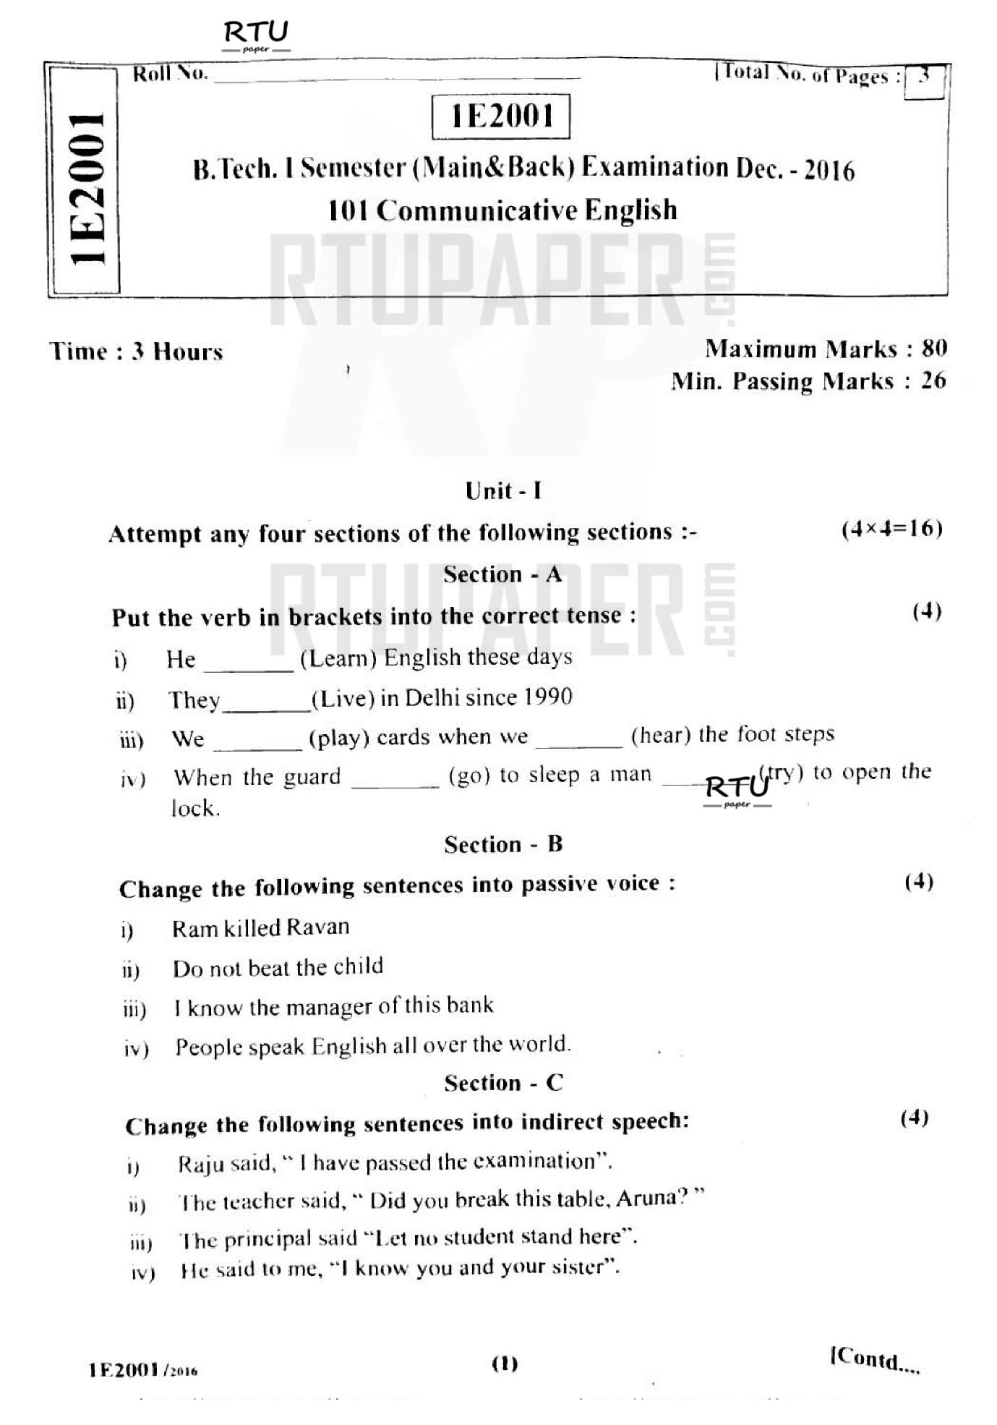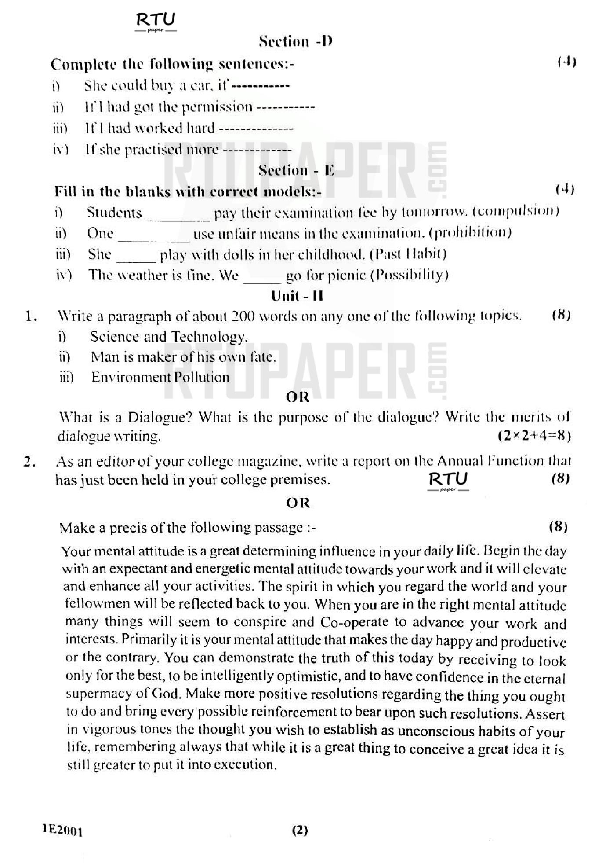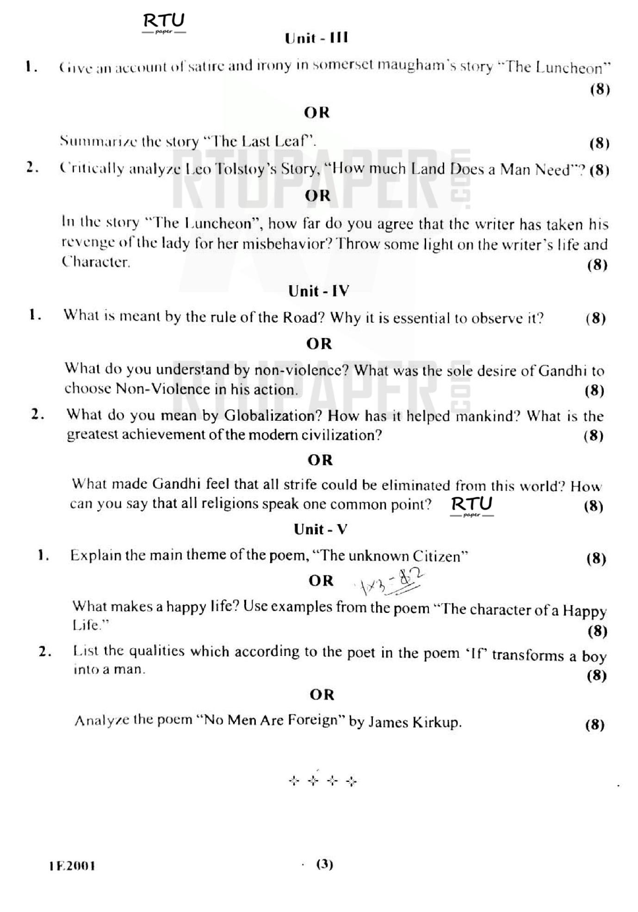

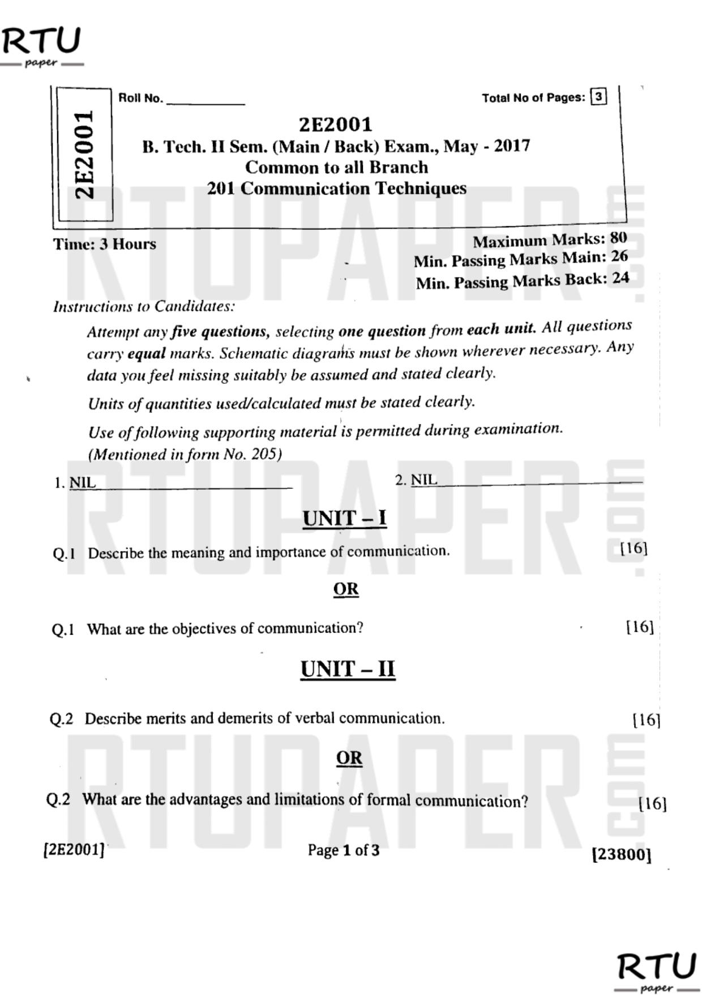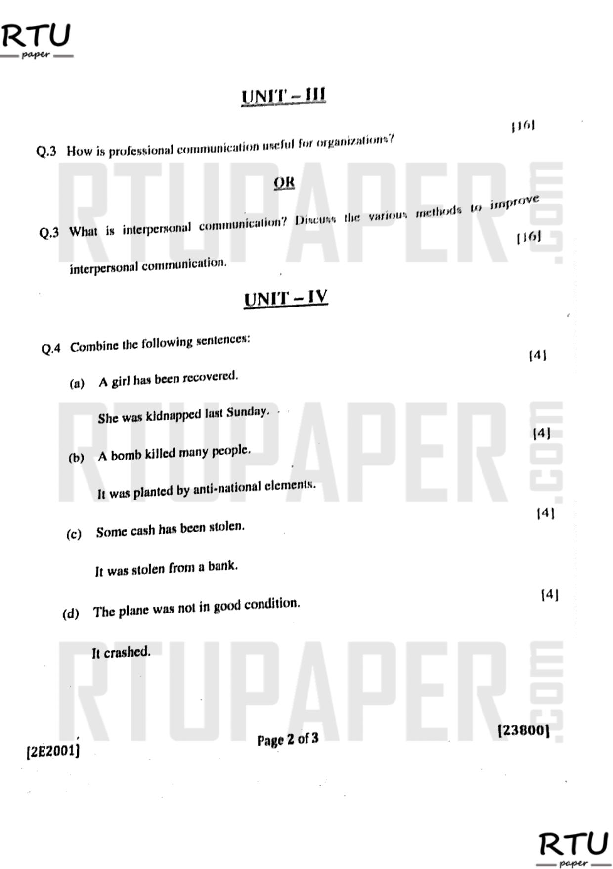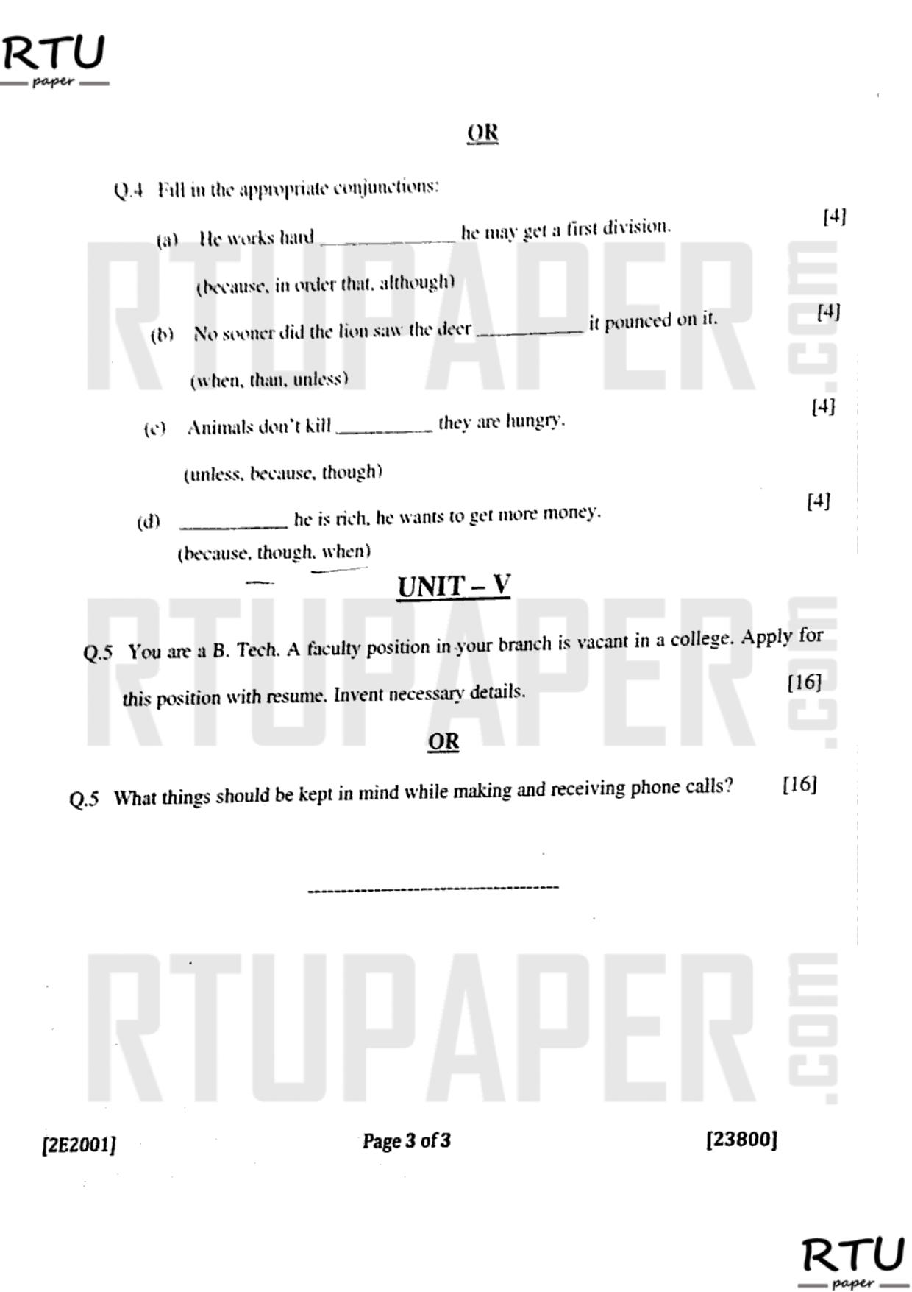

**TECHNO INDIA NJR INSTITUTEOFTECHNOLOGY, UDAIPUR**

**B. TECH I – YEAR (I SEM.) Common for all branches**

**SUBJECT–Communication Skills.**

**I–Mid-term Examination**

Maximum Marks -70

Attempt any five question

Q1. Write the advantages of lateral (horizontal) communication and diagonal (crosswise) communication.

Q2. What kind of ambience does the poet want for his country in the poem “Where the mind is without fear”

Q3. Differentiate between discriminative, selective and emphatic listening.

Q4. Fill with appropriate conjunctions

a) Animals don’t kill they are hungry. (unless/because/although)

b) He works hard he may get a first division. (best/because/so)

c) He took his wife to that doctor she might become healthy again. (because/therefore/so that)

d) He is neither a gambler a thief. (or/nor/and)

Q5. Describe the element of humor in the story “The Luncheon”.

Q6. You are a B.Tech. A faculty position in your branch is vacant in a college. Apply for this position inventing necessary details. Attach a CV.

Q7. What do you understand by ‘channel of communication’?