Techno India NJR Institute of Technology



Course File Hydraulics Engineering (4CE4-06)


Jitendra Choubisa (Assistant Professor) Department of CE


RAJASTHAN TECHNICAL UNIVERSITY, KOTA
SYLLABUS
II Year-IV Semester: B.Tech. (Civil Engineering)

4CE4-06: HYDRAULICS ENGINEERING
Credit: 3 Max. Marks: 150 (IA:30, ETE:120)
3L+0T+0P End Term Exam: 3 Hours

SN | CONTENTS | Hrs.
1 | Introduction: to scope, objective and outcome of subject | 1
2 | Dimensional Analysis & Models: Dynamical Similarity and Dimensional Homogeneity Model experiment, geometric, Kinematic and Dynamic  Distorted river models and undistorted models, proper choice of scale ratios. Scale effect. Principle of dimensional analysis Rayleigh method, Buckingham theorem. | 4
3 | Turbulent flow  Equations of velocity distribution and friction coefficient  Boundary Layer Theory: Concept of boundary layer, laminar and turbulent boundary layers, boundary layer thickness, von Karman integral equation, laminar sub-layer, hydro-dynamically smooth and rough boundaries, separation of flow and its control, cavitation. | 6
4 | Open channel Flow Uniform, Non-Uniform and variable flow. Resistance equations of Chezy and Manning. Section factor for uniform flow. Most Efficient rectangular, triangular and trapezoidal sections. Velocity distribution in open channels. | 5
5 | Gradually varied flow in Prismatic channels. Specific energy of flow. Critical depth in prismatic channels. Alternate depths. Rapid, critical and sub critical Flow Mild, steep and Critical Slopes. Classification of surface curves in prismatic channels and elementary computation | 4
6 | Rapidly varied flow: Hydraulic jump or standing wave in rectangular channels. Conjugate or sequent depths Losses in jump, location of jump. velocity distribution in open channels. Energy correction factor. Moment correction factor | 4
7 | Impact of free Jets: Impact of a jet on a flat or a curved vane, moving and stationary vane.  Introduction of Hydraulic machine Type of pumps and turbine and its brief description. Draft tube and its principle | 3

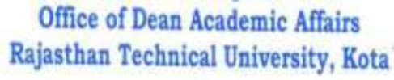

Syllabus of 2nd Year B. Tech. (AG) for students admitted in Session 2017-18 onwards. Page 7

RAJASTHAN TECHNICAL UNIVERSITY, KOTA
SYLLABUS
II Year-IV Semester: B.Tech. (Civil Engineering)

8 | Hydrology: Definition, Hydrologic cycle, Application to Engineering problems, measurement ofrainfall, rain gauge, peak flow, flood frequency method, catchment area formulae, Floodhydrograph, Rainfall analysis, Infiltration, Run off, Unit hydrograph and its determination,Estimation of run off. | 8
9 | Ground Water: Aquifers and its types, Confined and unconfined aquifer, | 3
10 | Canal Hydraulics: Types of canals, parts of canal irrigation system, channel alignment,assessment of water requirements, estimation of channel losses, design of channels, regime andsemi theoretical  siltcontrol in canals. | 4
 | TOTAL | 42

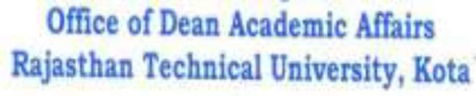

Syllabus of 2nd Year B. Tech. (AG) for students admitted in Session 2017-18 onwards. Page 8

Course Overview:
Hydraulic engineering, as a sub-discipline of civil engineering, is concerned with the flow and conveyance of fluids. This course consists of the topic like viscous fluid flow, laminar and turbulent flow, boundary layer analysis, dimensional analysis, open channel flows, flow through pipes, and computational fluid dynamics. The objective of this course is to introduce various hydraulic engineering problems like open channel flows and hydraulic machines.
Hydraulic engineering is a sub-discipline of Civil Engineering. It deals with the flow of fluid, typically water and sewage conduits and uses the force of gravity for the movement of the same. It is used extensively in the construction of dams, bridges, canal, sewers etc. Hydraulic engineering uses fluid mechanics as its foundation, to deal with problems of collection, storage, segregation, measurement, transport, control and use of water.

Course Outcomes:

CO. NO. | Cognitive Level | Course Outcome
1 | Comprehension | Students will be able to analyze the process of deriving equation by using dimensional methods.
2 | Analysis | Students will analyze the problems related to flow of fluids in channel.
3 | Synthesis | Students will be able to explain and remember the different types of turbines & pumps used.
4 | Synthesis | Student will be able to create economic sections for fluid channels.
5 | Synthesis | Students will be able to remember the concepts of Hydrology.

Prerequisites:
- Student must have a knowledge of basics of Fluid Mechanics.
- Students with basic knowledge of mathematical geometry can understand the topics clearly.
- Students with understanding of basic physics principle can grasp the topics of this course.
- Students with a basic calculation methodologies can perform surveying calculations.

Course Outcome Mapping with Program Outcome:
Course Outcome | PO1 | PO2 | PO3 | PO4 | PO5 | PO6 | PO7 | PO8 | PO9 | PO10 | PO11 | PO12 | PSO1 | PSO2 | PSO3
CO245.1 | 3 | 3 | 3 | 2 | 1 | 2 | 1 | 1 | 1 | 1 | 1 | 1 | 1 | 2 | 1
CO245.2 | 3 | 2 | 3 | 1 | 1 | 2 | 1 | 1 | 1 | 1 | 1 | 1 | 1 | 2 | 1
CO245.3 | 3 | 2 | 3 | 2 | 1 | 1 | 1 | 1 | 1 | 1 | 1 | 1 | 1 | 2 | 1
CO245.4 | 3 | 3 | 3 | 3 | 2 | 1 | 1 | 1 | 2 | 1 | 1 | 3 | 2 | 2 | 1
CO245.5 | 3 | 3 | 2 | 3 | 2 | 1 | 2 | 1 | 2 | 1 | 1 | 3 | 1 | 2 | 1
CO245 (AVG) | 3 | 2.6 | 2.8 | 2.2 | 1.4 | 1.4 | 1.2 | 1 | 1.4 | 1 | 1 | 1.8 | 1.2 | 2 | 1

Course Coverage Module Wise:

Lecture  No. | Unit | Topic
1 | 1 | INTRODUCTION: Objective, scope and outcome of the course.
2 | 2 | DIMENSIONAL ANALYSIS & MODELS: Dynamical similarity and dimensional homogeneity model experiment. Geometric, kinematic and dynamic similarity.
3 | 2 | Reynold’s, Froude’s, Weber’s, Euler and Mach numbers. Distorted river models and
4 | 2 | Scale effect. Principle of dimensional analysis Rayleigh method.
5 | 2 | Buckingham theorem
6 | 3 | TURBULENT FLOW: Reynolds equations, Prandtl’s mixing length theory
7 | 3 | Equations of velocity distribution and friction coefficient.
8 | 3 | Boundary Layer Theory: Concept of boundary layer, laminar and
9 | 3 | Boundary layer thickness, Von Karman integral equation, laminar sub-layer.
10 | 3 | Hydro-dynamically smooth and rough boundaries
11 | 3 | Separation of flow and its control, cavitation.
12 | 4 | OPEN CHANNEL FLOW: Uniform, Non-Uniform and variable flow, Resistance
13 | 4 | Section factor for uniform flow. Most Efficient rectangular section
14 | 4 | Most Efficient trapezoidal section and its numerical.
15 | 4 | Most Efficient triangular section and its numerical.
16 | 4 | Velocity distribution in open channels.

17 | 5 | GRADUALLY VARIED FLOW: Specific energy of flow. Critical depth in prismatic
18 | 5 | Numerical based on specific energy of flow
19 | 5 | Rapid, critical and sub critical Flow Mild, steep and Critical Slopes.
20 | 5 | Classification of surface curves in prismatic channels and elementary computation
21 | 6 | RAPIDLY VARIED FLOW: Hydraulic jump or standing wave in rectangular  Channels.
22 | 6 | Conjugate or sequent depths, Losses in jump, location of jump.
23 | 6 | Numerical based on above topics. Velocity distribution in open channels.
24 | 6 | Energy correction factor. Moment correction factor
25 | 7 | IMPACT OF FREE JETS: Impact of a jet on a flat or a curved vane, Moving and
26 | 7 | Introduction of Hydraulic machine: Type of pumps and its brief description.
27 | 7 | Type of turbine and its brief description. Draft tube and its principle
28 | 8 | HYDROLOGY: Definition, Hydrologic cycle, Application to Engineering problems
29 | 8 | Measurement of rainfall, rain gauge.
30 | 8 | Peak flow, flood frequency method.
31 | 8 | Catchment area formulae, Flood hydrograph.
32 | 8 | Rainfall analysis, Infiltration, Run off.
33 | 8 | Numerical based on above topics.
34 | 8 | Unit hydrograph and its determination
35 | 8 | Estimation of run off.
36 | 9 | GROUND WATER: Aquifers and its types, Confined and unconfined aquifer
37 | 9 | Darcy’s Law, hydraulic conductivity
38 | 9 | Transmissivity, well hydraulics and numerical.
39 | 1  0 | CANAL HYDRAULICS: Types of canals, parts of canal irrigation system, Channel
40 | 1  0 | Assessment of water requirements. Estimation of channel losses and Numerical.
41 | 1  0 | Design of channels, regime and semi theoretical approaches (Kennedy’s Theory)
42 | 1  0 | Design of channels, regime and semi theoretical approaches (Lacey’s Theory), Cross

TEXT/REFERENCE BOOKS
- Fluid Mechanics & Hydraulics by Dr. K.R, Arora, Standard Publishers & Distributers, Delhi.
- Fluid Mechanics & Hydraulics by Dr. R.K. Bansal, Laxmi Publications (P) Ltd.
- Fluid Mechanics & Hydraulics by Modi & Seth, Standard Publishers & Distributers, Delhi.
- Fluid Mechanics & Machinery by C.S.P.Ojha, R.Berndtsson and
P.N. Chandramauli, Oxford Publishers, Delhi.

Course Level Problems (Test Items):

CO.NO. | Problem description
1 | - Explain the types of flows in open channel.  - Discuss the concept of alternate depths and critical depths.  - Explain the concept of most economic section for open channel flow.
2 | - Write and explain working of turbines.  - Explain the concept of specific speed of pumps and turbines.  - Discuss the types of turbines used with their application areas.
3 | - Explain the types of dimensional methods.  - State what is Buckingham’s Pi Theorem.

Assessment Methodology:
  - Practical exam in lab where they have to analyze the problem statement. (Once in a week)
  - Assignments one from each unit.
  - Midterm subjective paper based on topics as mentioned in the modules. (Twice during the semester)
  - Final paper at the end of the semester subjective.

TEACHING AND LEARNING RESOURCES UNIT-WISE
- NPTEL Hydraulics Engineering Lecture Link: https://nptel.ac.in/courses/105/105/105105203/
- Buckingham’s Pi-Theorem: https://en.wikipedia.org/wiki/Buckingham_%CF%80_theorem
- Rayleigh’s Theorem:

https://en.wikipedia.org/wiki/Rayleigh%27s_method_of_dimensional_analysis#:~:text=Rayleigh 's%20method%20of%20dimensional%20analysis%20is%20a%20conceptual%20tool%20used,w as%20named%20after%20Lord%20Rayleigh.
- Most Economical Section:

https://unacademy.com/lesson/most-efficient-triangular-and-circular-channel-sections- hydraulics-engineering-in-hindi/RKEGX1TS


SUBJECT: HYDRAULICS ENGINEERING

Faculty Name: Jitendra Choubisa

TUTORIAL SHEET – 01
MARKS-30 DUE DATE: 01/June/2021

Each question carries equal marks

Q1. Explain Buckingham Pi theorem with example.
Q2. What do you understand by Dimensional Homogeneity? Explain with example. Q3. State what Dimensionless number are and explain each of them.

Note: Attempt all of the above questions and make a clear pdf and upload on google classroom’s specific assignment before the due date.

SUBJECT: HYDRAULICS ENGINEERING

Faculty Name: Jitendra Choubisa

TUTORIAL SHEET – 02
MARKS-30 DUE DATE: 05/June/2021

Each question carries equal marks

Q1
.

Q2. Explain what the types of similarities considered in Model analysis are?

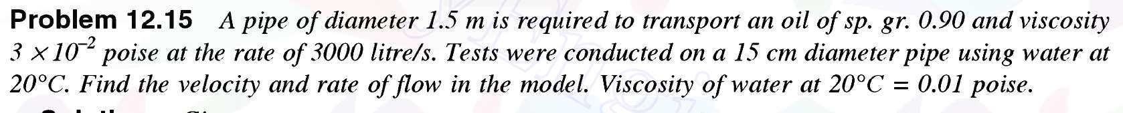
Q3.

Note: Attempt all of the above questions and make a clear pdf and upload on google classroom’s specific assignment before the due date.

SUBJECT: HYDRAULICS ENGINEERING

Faculty Name: Jitendra Choubisa

TUTORIAL SHEET – 03
MARKS-30 DUE DATE: 10/June/2021

Each question carries equal marks

Q1. Explain Reynold’s experiment for turbulent flow.

Q2. Derive the formulae for loss of head due to friction in pipes.

Q3. Write about Shear Stress in turbulent flow.

Note: Attempt all of the above questions and make a clear pdf and upload on google classroom’s specific assignment before the due date.

TECHNO INDIA NJR INSTITUTE OF TECHNOLOGY UDAIPUR
I MID TERM ONLINE EXAMINATION – June - 2021 II YEAR IV SEM
MAX MARKS: 80 HYDRAULICS ENGINEERING TIME: 2 Hr.
Instruction for candidates: PART-A Attempt all Questions PART-B Attempt any 5 Questions PART-C Attempt any 2 Questions

Answer the following terms:
PART-A

    - Fundamental Dimensions (b) Modal Analysis
(c) Dynamic Similarity (d) Dimensionless Number
(e) Weber Number (f) Reynolds Number
(g) Distorted Models (h) Shear Stress
(i) Kinematic Similarity (j) Velocity distribution in Pipe
(2 x 10 = 20 Marks)

PART-B
The efficiency η of a fan depends upon density ρ, dynamic viscosity µ, angular velocity ω, diameter
D of the rotor and discharge Q. Express η in terms of dimensional parameters. (Take D, ω, ρ as
repeating variable). (8 MARKS)
What do you mean by Dimensionless numbers? Write any 4 dimensionless number with their
respective formulas and their applications. (8 MARKS)
The pressure drop in an airplane model of size 1/10 of its prototype is 80 N/cm2. The model is
tested in water. Find the corresponding pressure drop in the prototype. Take density of air =
1.24 kg/m3. The viscosity of water is 0.01 poise while the viscosity of air is 0.00018 poise.

(8 MARKS)
Determine the dimensions of the quantities given below: Angular velocity, angular acceleration, Discharge, Kinematic Viscosity, Force, Specific weight and Dynamic Viscosity. (8 MARKS)
Describe what is dimensional Homogeneity with example. (8 MARKS)
Explain the types forces acting in moving fluid. (8 MARKS)

PART-C
Define what is Rayleigh’s method of dimensional analysis.
The time period (t) of a pendulum depends upon the length (L) of the pendulum and acceleration due to gravity (g). Derive the expression for the time period. (10 MARKS)

Write down the types of similarity in modal analysis.
Explain the types of forces present in a fluid flow with their respective formulas. (10 MARKS)
Explain what model laws are and how they are useful in modal analysis. (10 MARKS)


TECHNO INDIA NJR INSTITUTE OF TECHNOLOGY UDAIPUR
Civil Engineering Department

B. TECH II– YEAR (IV Sem.) II MID-TERM (2020-2021)
SUBJECT – HYDRAULICS ENGINEERING

Time: 1Hr 30 minutes + 15 Minutes for Submission Max. Marks: 40 Attempt any five questions. [5 * 8 =40]

- Explain Prandtl’s mixing length theory for turbulent flow. [CO1]

- Explain the concepts of boundary layer thickness and write what are hydro dynamically smooth and rough boundaries.

- Derive the condition for trapezoidal section to be most economical section. [CO1]

- A rectangular channel carries water at the rate of 400 litres/s when bed slope is 1 in 2000. Find the most economical dimensions of the channel if C = 50. [CO1]

- Explain Specific energy and derive the formula by showing Specific energy curve. [CO1]

- The discharge of water through a rectangular channel of width 8 m, is 15 m3/s when depth of flow of water is 1.2 m. Calculate: (i) Specific energy of the flowing water, (iii) Value of minimum specific energy. [CO1]

- State what is gradually varied Flow. Find the rate of change of depth of water in a rectangular channel of 10 m wide and 1.5 m deep, when the water is flowing with a velocity of 1 m/s. The flow of water through the channel of bed slope 1 in 4000, is regulated in such a way that energy line is having a slope of.00004. [CO1]

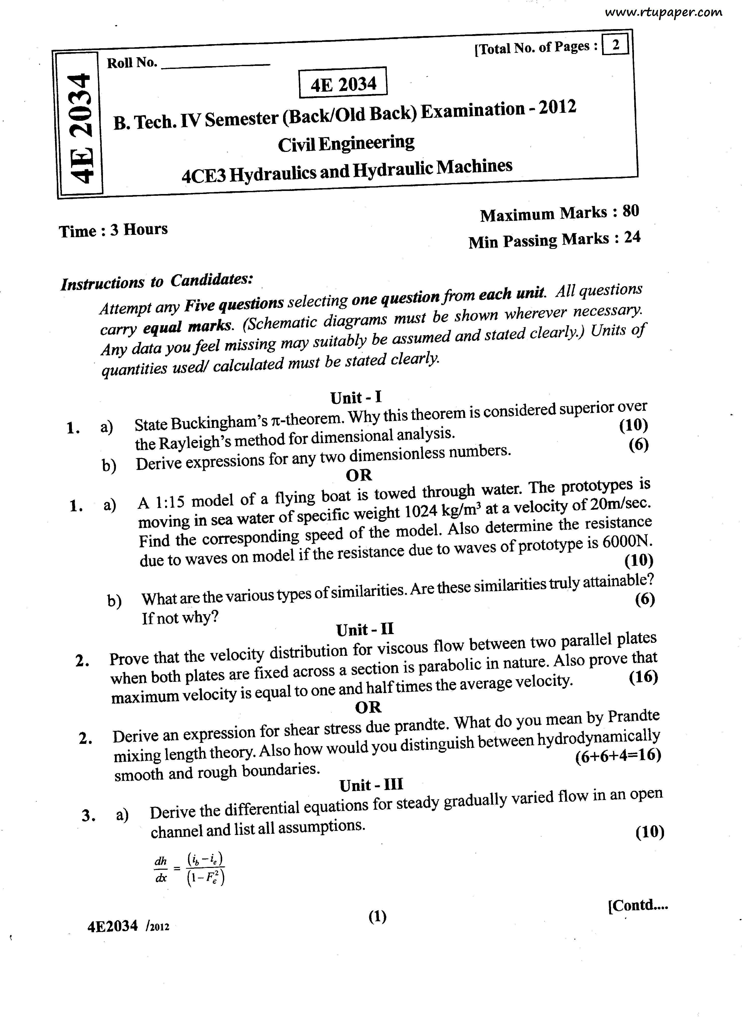

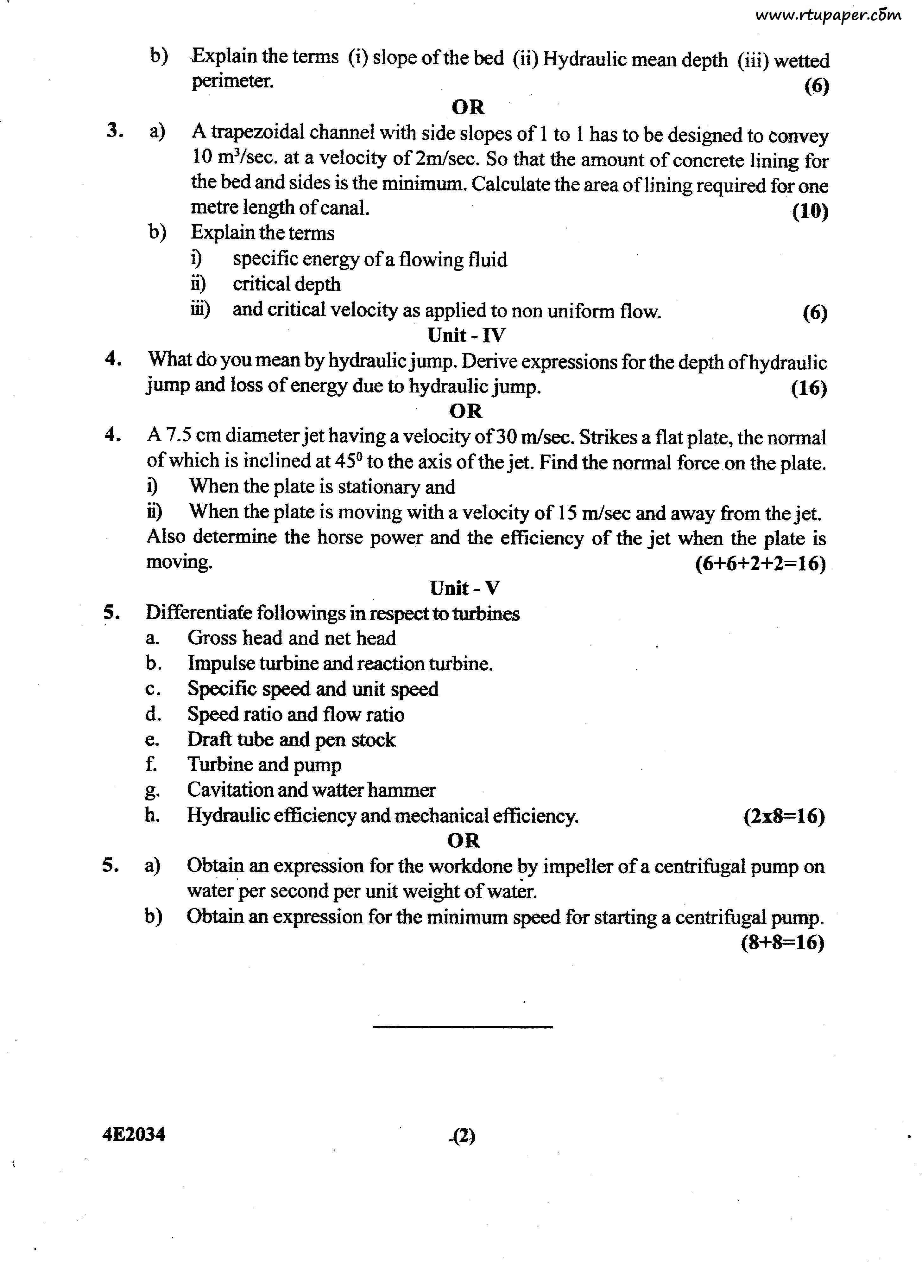

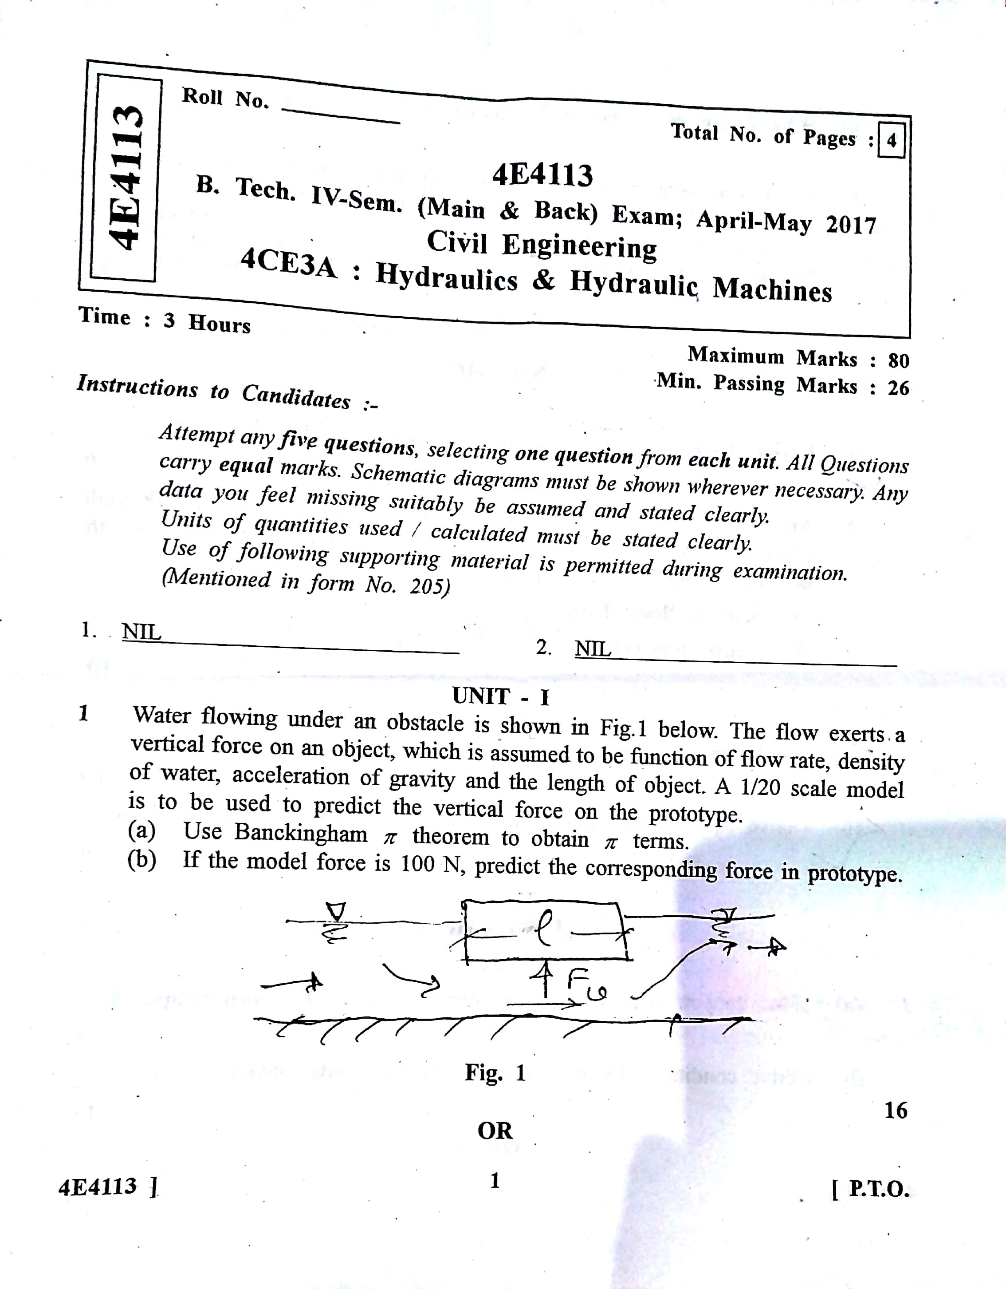

Scanned by CamScanner

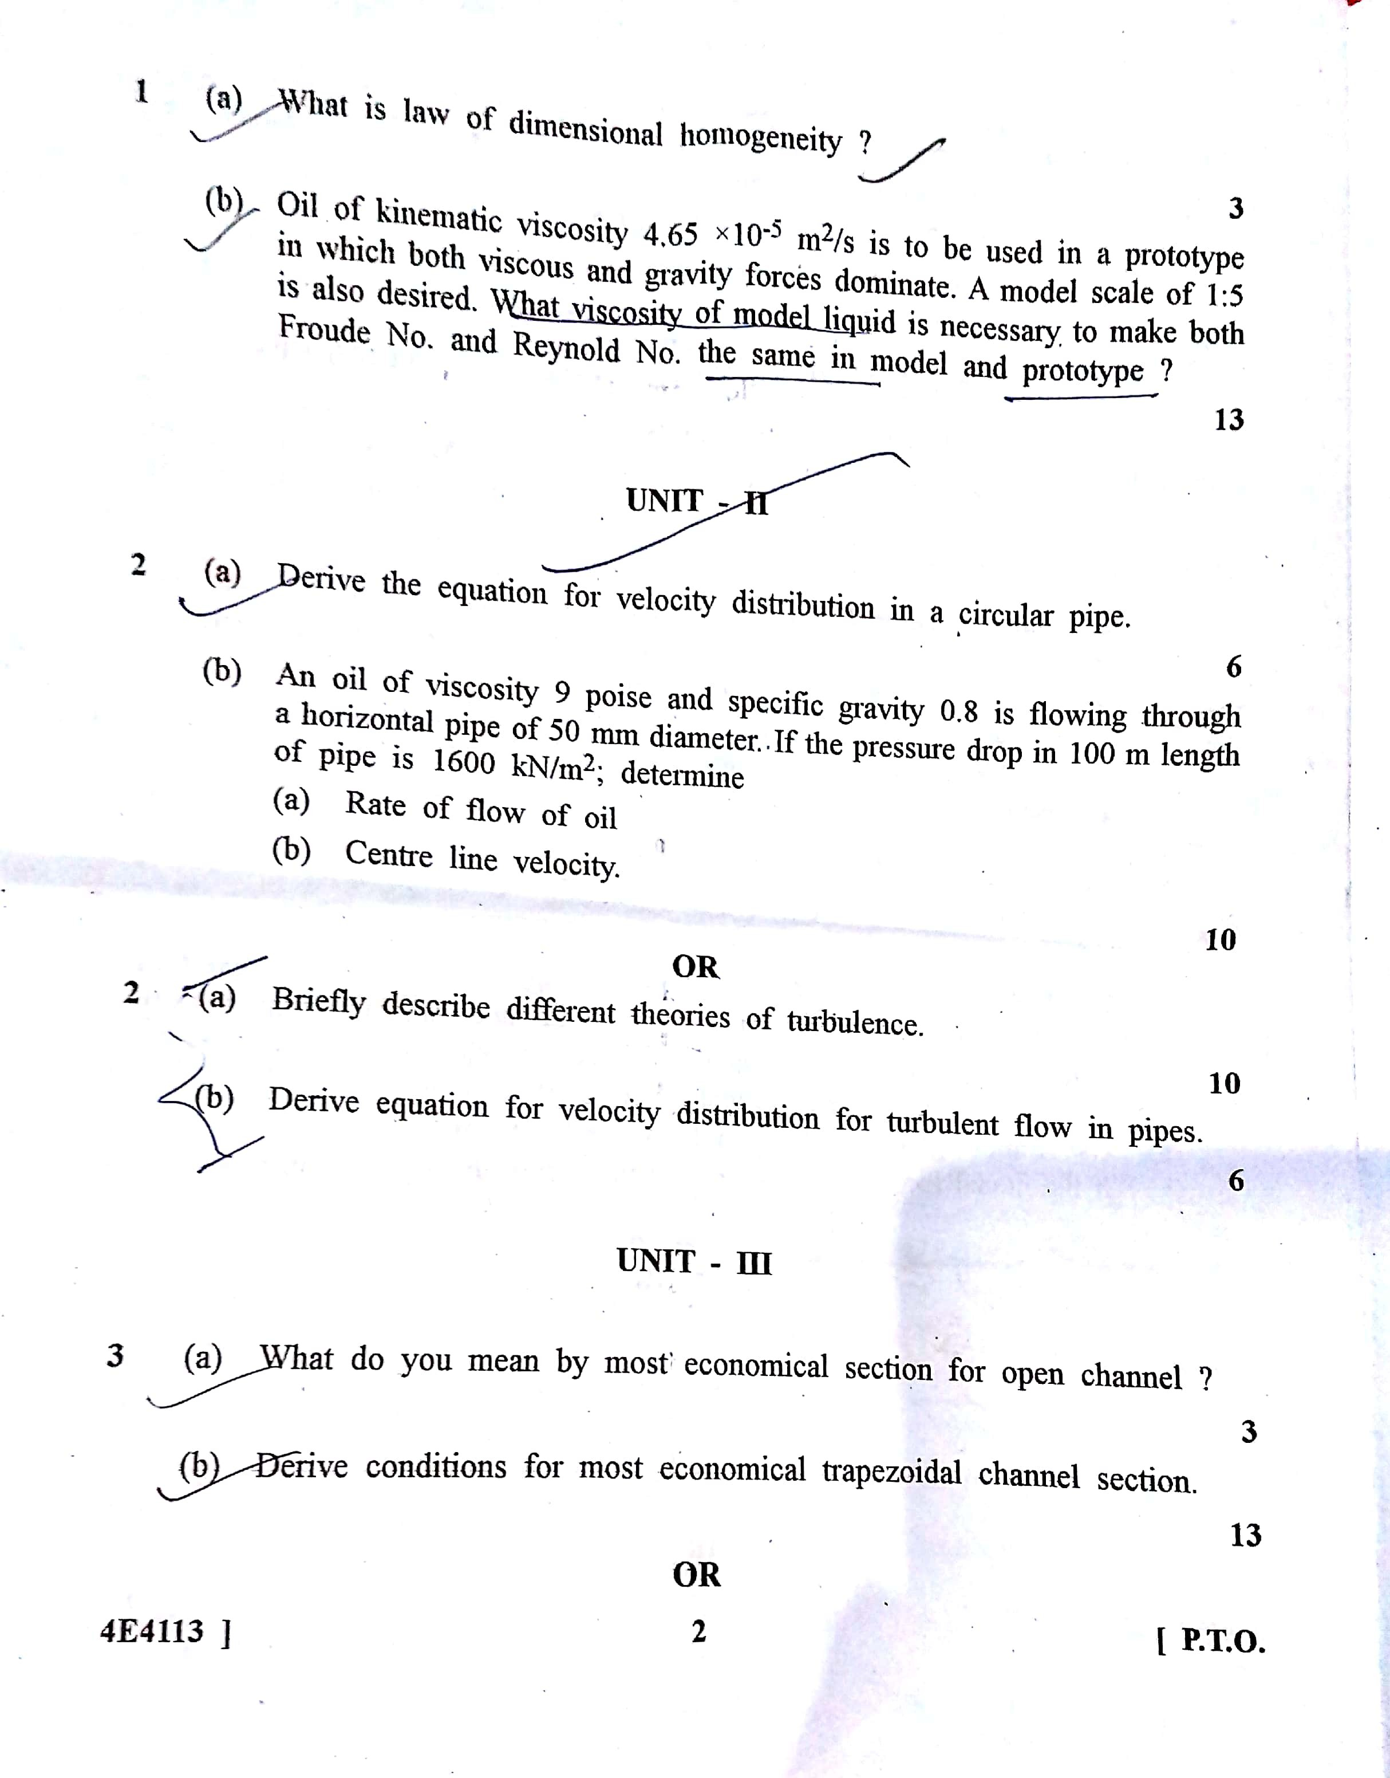

Scanned by CamScanner

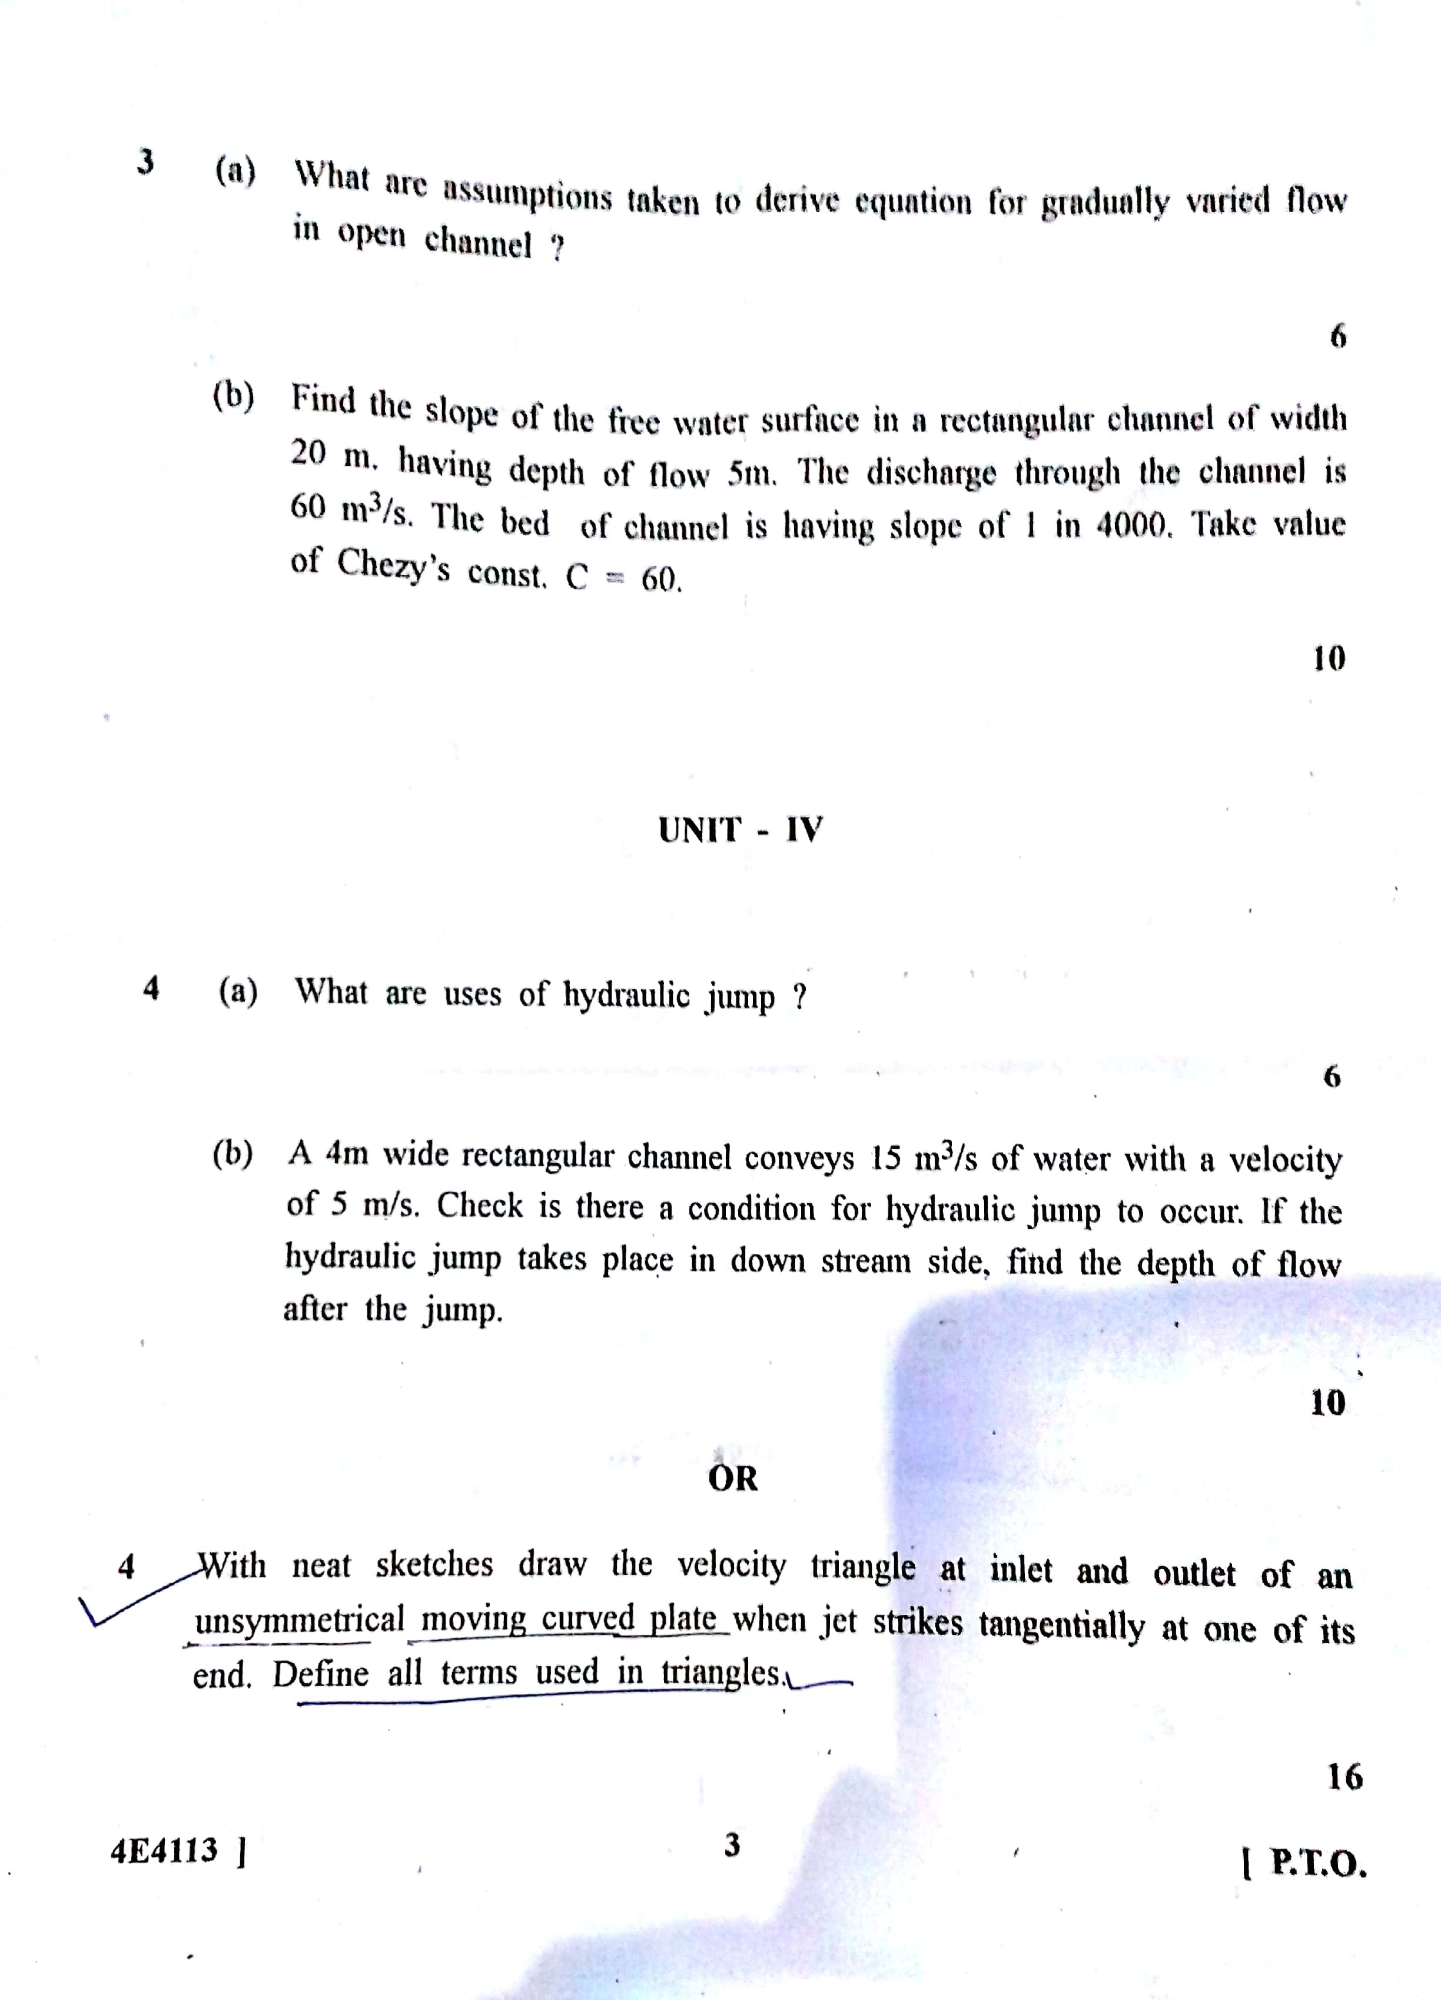

Scanned by CamScanner

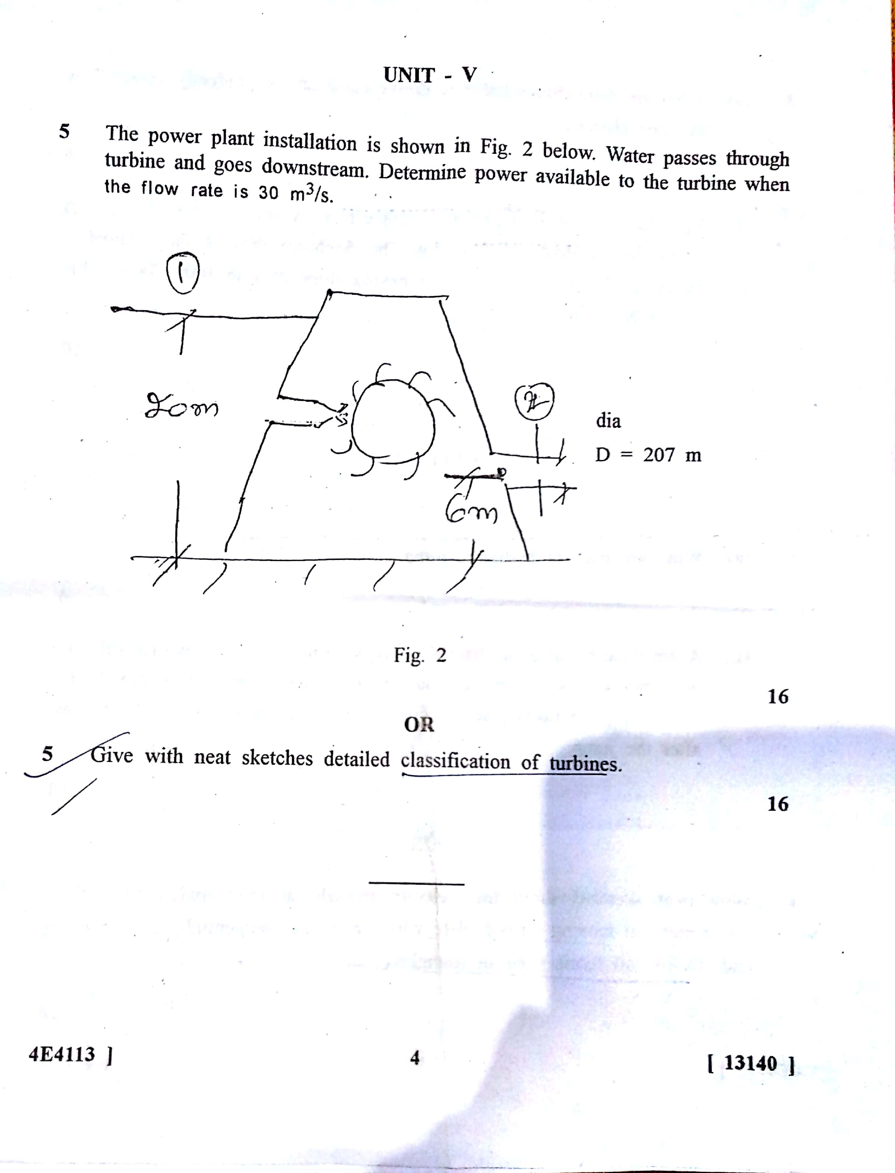

Scanned by CamScanner

