**Techno India NJR Institute of Technology**



**Course File**

**Session 2020-21**

**Basic Electronics for Civil Engineering Applications(4CE3-04)**

Yogendra Singh Solanki

(Assistant Professor)

**Department of ECE**

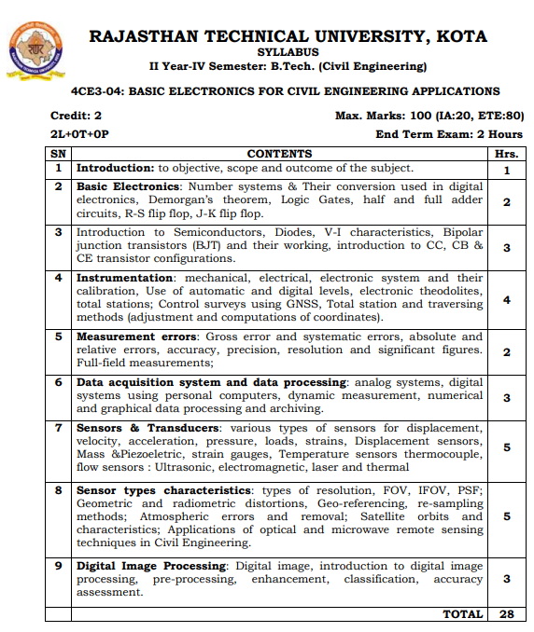

**Course Overview:**

The objective of this Course is to provide the students with an introductory and broad treatment of the field of Electronics Engineering to facilitate better understanding of the devices, instruments and sensors used in Civil Engineering applications.

**Course Outcomes:**

|  |  |  |
| --- | --- | --- |
| **CO NO** | **COGNITIVE LEVEL** | **COURSE OUTCOME** |
| 4CE3-04.1 | Synthesis | Learner can define introduction to Semiconductors, Diodes, V-I characteristics, Bipolar junction transistors uses. |
| 4CE3-04.2 | Synthesis | Learner can state data acquisition system and data processing. |
| 4CE3-04.3 | Synthesis | Students get to understand the basic of Sensors & Transducers used in various instruments. |
| 4CE3-04.4 | Synthesis | Understand the working of various instruments and measure the error. |
| 4CE3-04.5 | Synthesis | Understand the concept and processing of digital images. |

**Prerequisites:**

1. Fundamentals of semiconductor devices.

**Course Outcome Mapping with Program Outcome:**

|  |  |  |  |  |  |  |  |  |  |  |  |  |  |  |  |
| --- | --- | --- | --- | --- | --- | --- | --- | --- | --- | --- | --- | --- | --- | --- | --- |
| **Course Outcome** | **PO1** | **PO2** | **PO3** | **PO4** | **PO5** | **PO6** | **PO7** | **PO8** | **PO9** | **PO10** | **PO11** | **PO12** | **PSO1** | **PSO2** | **PSO3** |
| **CO243.1** | 2 | 2 | 2 | 2 | 1 | 1 | 1 | 1 | 1 | 1 | 1 | 2 | 1 | 1 | 0 |
| **CO243.2** | 2 | 2 | 2 | 2 | 3 | 1 | 1 | 2 | 1 | 1 | 1 | 1 | 1 | 1 | 0 |
| **CO243.3** | 2 | 1 | 3 | 2 | 2 | 2 | 2 | 1 | 1 | 1 | 1 | 1 | 1 | 1 | 0 |
| **CO243.4** | 2 | 1 | 2 | 1 | 1 | 2 | 1 | 2 | 1 | 2 | 1 | 2 | 1 | 1 | 0 |
| **CO243.5** | 2 | 2 | 2 | 2 | 1 | 1 | 1 | 1 | 1 | 1 | 1 | 2 | 1 | 1 | 0 |
| **CO243 (AVG)** | 2 | 1.6 | 2.2 | 1.8 | 1.6 | 1.4 | 1.2 | 1.4 | 1 | 1.2 | 1 | 1.6 | 1 | 1 | 0 |

**Course Coverage Module Wise:**

|  |  |  |
| --- | --- | --- |
| **LectureNo.** | **Unit** | **Topic** |
| 1 | **1** | **INTRODUCTION:** to objective, scope and outcome of the subject |
| 2 | **2** | **BASIC ELECTRONICS**: Number systems & Their conversion used in digital  Electronics, Demorgan’s theorem, Logic Gates |
| 3 | 1 | Half and full adder, R-S flip flop, J-K flip flop |
| 4 | **3** | **INTRODUCTION TO SEMICONDUCTORS**, Diodes, V-I characteristics |
| 5 | 2 | Bipolar junction transistors (BJT) and their working, introduction to CC |
| 6 | 2 | CB & CE transistor configurations |
| 7 | **4** | **INSTRUMENTATION**: mechanical, electrical, electronic system and their calibration |
| 8 | 3 | Use of automatic and digital levels, electronic theodolites |
| 9 | 3 | Total stations; Control surveys using GNSS |
| 10 | 3 | Total station and traversing methods (adjustment and computations of coordinates) |
| 11 | **5** | **MEASUREMENT ERRORS:** Gross error and systematic errors |
| 12 | 5 | Absolute and relative errors, accuracy, precision, resolution and significant figures |
| 13 | **6** | **DATA ACQUISITION SYSTEM** and data processing: analog systems |
| 14 | 6 | Digital systems using personal computers, dynamic measurement |
| 15 | 6 | Numerical and graphical data processing and archiving |
| 16 | **7** | **SENSORS & TRANSDUCERS:** various types of sensors for displacement |
| 17 | 7 | velocity, acceleration, pressure, loads, strains, Displacement sensors |
| 18 | 7 | Mass & Piezoelectric, strain gauges, Temperature sensors thermocouple |
| 19 | 7 | flow sensors: Ultrasonic, electromagnetic, laser and thermal |
| 20 | **8** | **SENSOR TYPES CHARACTERISTICS:** types of resolution, FOV, IFOV, PSF |
| 21 | 8 | Geometric and radiometric distortions, Geo-referencing, re-sampling |
| 22 | 8 | methods; Atmospheric errors and removal |
| 23 | 8 | Satellite orbits and characteristics; remote sensing |
| 24 | **8** | Applications of optical and microwave techniques in Civil Engineering |
| 25 | **9** | **DIGITAL IMAGE PROCESSING**: Digital Image |
| 26 | **9** | Introduction to Digital Image Processing, Pre-Processing, Enhancement, Classification, |
| 27 | **9** | Accuracy Assessment |
| 28 | **9** | Digital Image Processing: Digital Image, Introduction to Digital Image |

**TEXT/REFERENCE BOOKS**

1.Neil Storey, “Electronics A Systems Approach”, 4/e - Pearson Education Publishing Company Pvt Ltd, 2011.

2.Bhargava N. N., D C Kulshreshtha and S C Gupta, “Basic Electronics & Linear Circuits”, Tata McGraw Hill, 2/e, 2013.

**Teaching and Learning resources:**

* **Unit 2 & 3: -** Class Notes
* **Unit 4: -** https://circuitglobe.com/classification-of-measuring-instruments.html
* **Unit 5: -** https://www.tutorialspoint.com/electronic_measuring_instruments/electronic_measuring_instruments_errors.htm
* **Unit 6: -** https://www.tutorialspoint.com/electronic_measuring_instruments/electronic_measuring_instruments_data_acquisition_systems.htm
* **Unit 7: -** https://nptel.ac.in/courses/112/107/112107298/
* **Unit 8 : -** http://hillagric.ac.in:999/downloads/gis/notes/4-IntroductiontoRemoteSensing.pdf
* **Unit 9: -** https://nptel.ac.in/courses/105/103/105103193/

**Assessment Methodology:**

1. Two Midterm exams where student have to showcase subjective learning.
2. Final Exam (subjective paper) at the end of the semester.

