**Techno India NJR Institute of Technology**



**Course File**

**Strength of Material (4CE4- 05)**

Bharat Kr. Suthar (Assistant Professor) **Department of CE**

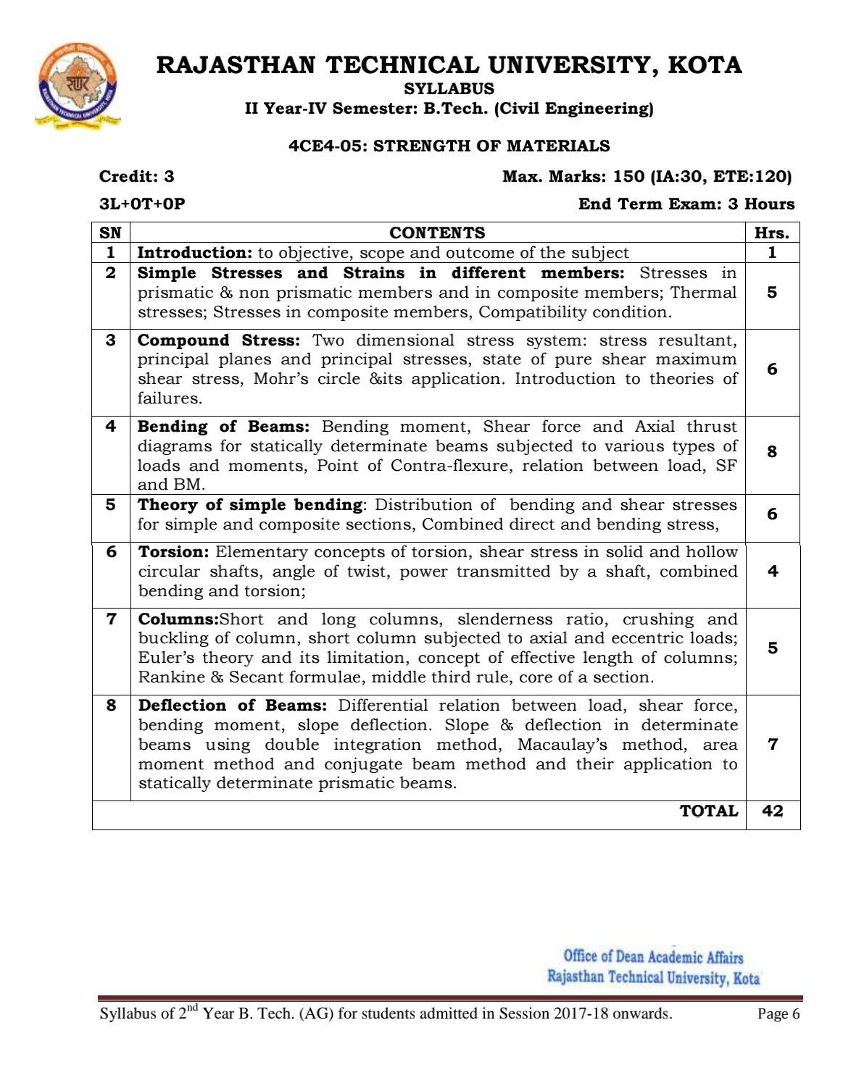

# Course Overview:

Strength of Materials (also known as *Mechanics of Materials*) is the study of the internal effect of external forces applied to structural member. Stress, strain, deformation deflection, torsion, flexure, shear diagram, and moment diagram are some of the topics covered by this subject. The knowledge of this subject is a must in Civil Engineering, Mechanical Engineering, The main part in this subject is

O Focuses on the strength of materials and structural components subjected to different types of force and thermal loadings.

O Investigates materials subjected to different types of force and thermal loadings

O Emphasizes actual operating conditions.

# Course Outcomes:

|  |  |  |
| --- | --- | --- |
| **CO. NO.** | **Cognitive Level** | **Course Outcome** |
| 1 | Design | Analyze and design structural members subjected to tension, compression, torsion, bending and combined stresses using the fundamental concepts of stress, strain and elastic behavior of materials. |
| 2 | Application | Execute the use of appropriate materials in design considering engineering properties, sustainability, cost and weight. |
| 3 | Application | Implement the skills for engineering work in accordance with ethical and economic constraints related to the design of structures. |
| 4 | Analysis | Understand the concept of torsion and columns. |
| 5 | Application | Determine deflection of beam by using various method |

**Prerequisites:**

1. Student will be able to Analyze and design structural members
2. Student will be able to Utilize appropriate materials in design.
3. Students will be able to Perform engineering work.
4. Students will be able to provide students with exposure to the systematic methods for solving engineering problems in solid mechanics.
5. Students will be able to build the necessary theoretical background for further structural analysis



# Course Outcome Mapping with Program Outcome:

|  |  |  |  |  |  |  |  |  |  |  |  |  |  |  |  |
| --- | --- | --- | --- | --- | --- | --- | --- | --- | --- | --- | --- | --- | --- | --- | --- |
| **Course Outcome** | **PO1** | **PO2** | **PO3** | **PO4** | **PO5** | **PO6** | **PO7** | **PO8** | **PO9** | **PO10** | **PO11** | **PO12** | **PSO1** | **PSO2** | **PSO3** |
| **CO244.1** | 2 | 2 | 2 | 2 | 0 | 1 | 1 | 0 | 0 | 0 | 0 | 1 | 1 | 1 | 1 |
| **CO244.2** | 2 | 2 | 2 | 2 | 1 | 1 | 0 | 0 | 0 | 1 | 0 | 0 | 1 | 1 | 1 |
| **CO244.3** | 2 | 2 | 2 | 1 | 2 | 2 | 2 | 2 | 1 | 1 | 2 | 1 | 1 | 1 | 1 |
| **CO244.4** | 3 | 3 | 3 | 3 | 2 | 1 | 2 | 1 | 1 | 1 | 1 | 2 | 2 | 2 | 1 |
| **CO244.5** | 3 | 2 | 3 | 2 | 2 | 1 | 2 | 2 | 1 | 2 | 1 | 2 | 2 | 2 | 1 |
| **CO244 (AVG)** | 2.4 | 2.2 | 2.4 | 2 | 1.4 | 1.2 | 1.4 | 1 | 0.6 | 1 | 0.8 | 1.2 | 1.4 | 1.4 | 1 |

**Course Coverage Module Wise:**

|  |  |  |
| --- | --- | --- |
| Lecture No. | Unit | Topic |
| 1 | **1** | **INTRODUCTION:** To Objective, Scope And Outcome Of The Subject |
| 2 | 2 | Student should be able to understand SIMPLE STRESSES AND STRAINS IN DIFFERENT MEMBERS: Stresses In Prismatic & Non Prismatic Members |
| 3 | 2 | Student should be able to understand (Contd.) Simple Stresses And Strains In Different Members |
| 4 | 2 | Student should be able to understand Simple Stresses And Strains In Different Members In Composite Members. |
| 5 | 2 | Student should be able to understand Thermal Stresses |
| 6 | 2 | Student should be able to understand Stresses In Composite Members, Compatibility Condition |
| 7 | 2 | Student should be able to understand Stresses In Composite Members, Compatibility Condition |
| 8 | **3** | Student should be able to understand COMPOUND STRESS**:** Two Dimensional Stress System |

|  |  |  |
| --- | --- | --- |
| 9 | 3 | Student should be able to understand Stress Resultant, Principal Planes And Principal Stresses |
| 10 | 3 | Student should be able to understand Stress Resultant, Principal Planes And Principal Stresses |
| 11 | 3 | Student should be able to understand State Of Pure Shear Maximum Shear Stress |



|  |  |  |
| --- | --- | --- |
| 12 | 3 | Student should be able to understand Mohr’s Circle &Its Application |
| 13 | 3 | Student should be able to Introduce To Theories Of Failures |
| 14 | **4** | Student should be able to understand BENDING OF BEAMS**:** Bending Moment |
| 15 | 4 | Student should be able to understand Shear Force And Axial Thrust Diagrams For Statically Determinate |
| 16 | 4 | Student should be able to understand Shear Force And Axial Thrust Diagrams For Statically Determinate |
| 17 | 4 | Student should be able to understand Point Of Contra-Flexure, Relation Between Load |
| 18 | 4 | Student should be able to solve problem based on SF And BM. |
| 19 | 4 | Student should be able to solve problem based on SF And BM. |
| 20 | 4 | Student should be able to solve problem based on SF And BM. |
| 21 | 4 | Student should be able to solve problem based on SF And BM. |
| 22 | 4 | Student should be able to solve problem based on SF And BM. |
| 23 | 5 | Student should be able to understand THEORY OF SIMPLE BENDING |
| 24 | 5 | Student should be able to understand Distribution Of Bending And Shear Stresses |
| 25 | 5 | Student should be able to understand (Contd.) Distribution Of Bending And Shear Stresses |
| 26 | 5 | Student should be able to understand Distribution Of Bending And Shear Stresses |
| 27 | 5 | Student should be able to understand Distribution Of Bending And Shear Stresses |
| 28 | 5 | Student should be able to understand Combined Direct And Bending Stress |
| 29 | 5 | Student should be able to understand Combined Direct And Bending Stress |
| 30 | 6 | Student should be able to understand TORSION: Elementary Concepts Of Torsion |
| 31 | 6 | Student should be able to understand Shear Stress In Solid And Hollow Circular Shafts |
| 32 | 6 | Student should be able to understand Angle Of Twist, Power Transmitted By A Shaft |
| 33 | 6 | Student should be able to understand Bending And Torsion |
| 34 | 7 | Student should be able to understand COLUMNS: Short And Long Columns |
| 35 | 7 | Student should be able to understand Slenderness Ratio, Crushing And Buckling Of Column |
| 36 | 7 | Student should be able to understand Short Column Subjected To Axial And Eccentric Loads |
| 37 | 7 | Student should be able to understand Euler’s Theory And Its Limitation, Concept Of Effective Length Of |
| 38 | 7 | Student should be able to understand Rankine & Secant Formulae, Middle Third Rule, Core Of A |



|  |  |  |
| --- | --- | --- |
| 39 | 8 | Student should be able to understand DEFLECTION OF BEAMS: Differential Relation Between Load |
| 40 | 8 | Student should be able to understand Shear Force, Bending Moment, Slope Deflection. |
| 41 | 8 | Student should be able to understand Slope & Deflection In Determinate |
| 42 | 8 | Student should be able to understand Double Integration Method |

**TEXT/REFERENCE BOOKS**

* 1. Mechanics of Structures Vol. I & II by S.B Junarkar, Charotar Publishing House, Anand.
  2. Strength of Materials & Mechanics of Structures: Vol. I, II by Dr. B.C. PunmiaLaxmi Publications (p) Ltd.
  3. Strength of Material by Singer and Pytel, Harper Collins Publishers.
  4. Elements of Strength of Materials by Timoshenko & Young, Mc Graw HillBook Co.

**Course Level Problems (Test Items):**

|  |  |
| --- | --- |
| **CO.NO.** | **Problem description** |
| **1** | 1. What is stress 2. Define Hooke’s law. 3. Define Modulus of Elasticity and Shear Modulus. |
| **2** | 1. Define Resilience, Proof Resilience & Modulus of Resilience. Give expression for Stress due to gradually applied load & suddenly applied load. 2. Explain the classification of Columns. c. 3. Derive the Torsion Equation 4. List the assumptions made in theory of simple bending |
| **3** | 1. What must be the length of a 5m diameter aluminum wire be so that it can be so twisted through one complete revolution without exceeding a shearing stress of 42 N/mm2 . Let G=2.7X104 N/mm2. 2. Define the following. a) Slenderness ratio b) Buckling. 3. Find the safe compressive load on a hollow C.I. column, one end rigidly fixed and other hinged, of 150mm external diameter and 100mm internal diameter and 10m in length. Use Euler’s formula with   F.O.S. of 5 and E= 95KN/mm2 |

|  |  |
| --- | --- |
| **4** | 1. A hollow shaft is to transmit is to 400 KW power at 90 r.p.m. If fs = 74 N/mm2 and internal diameter is 0.6 times the external diameter, then find both the diamers assuming the following relations Tmax= 1.35 Tmean. d. 2. A laminated spring 600mm long is made up of plates each being 60mm wide and 8mm thick. Fing the number of plates required to enable the spring to carry a central point load of 4000N if the permissible bending stress is 120N/mm2 . Also find deflection if E=200KN/mm2 . |
| **5** | 1. A closed coil helical spring is to carry a load of 500 N. The mean coil diameter is 10 times that of wire diameter. Calculate the diameters of spring and coil if the maximum shear stress in the material of the spring is 80 N/mm2 . 2. Define any five mechanical properties of a material. h. 3. Describe the functions of a spring. Write the formulas for calculating stiffness for springs connected in parallel and series.. |

# Assessment Methodology:

1. Practical exam in lab where they have to analyze problem statement. (Once in a week)
2. Assignments one from each unit.
3. Midterm subjective paper based on topics as mentioned in the modules. (Twice during the semester)
4. Final paper at the end of the semester subjective

# Teaching and Learning resources unit-wise:

Simple Stress and Strain.

Video Tutorials: https://youtu.be/YkdQB0JnJD4

Theory concepts: https://[www.jntua.ac.in/gate-online-](http://www.jntua.ac.in/gate-online-) classes/registration/downloads/material/a158938439610.pdf

Sample ppt: https:/[/www.careerride.co](http://www.careerride.com/mcq-tag-)m[/mcq-tag-](http://www.careerride.com/mcq-tag-) wise.aspx?Key=Simple%20Stresses%20and%20Strains&Id=16

1. Torsion

Video Tutorials: https://youtu.be/g5hZE2jMqmc

Theory concepts: https://en.wikipedia.org/wiki/Torsion_(mechanics)

Sample Quiz: https://quizlet.com/194524432/torsion-flash-cards/

1. Spring

Video Tutorials: https[://youtu.be/YAJIromkA2U](https://edurev.in/studytube/Chapter-9-Springs-Strength-of-Material--Mechanical/95956b26-9268-43d8-ba14-0710ccca152e_t)

T[heory concepts: https://edurev.in/studytube/Chapter-9-](https://edurev.in/studytube/Chapter-9-Springs-Strength-of-Material--Mechanical/95956b26-9268-43d8-ba14-0710ccca152e_t)Springs-Strength-of-Material-- Mechanical/9595[6b26-9268-43d8-ba14-0710ccca152e_t](https://www.javatpoint.com/spring-quiz)

Sample Quiz: https://[www.javatpoint.com/spring-quiz](http://www.javatpoint.com/spring-quiz)

1. Deflection.

Video Tutorials: https://youtu.be/4Xd18oVl80c

Theory concepts: [https://en.wikipedia.org/wiki/Deflection_(engineer](https://en.wikipedia.org/wiki/Deflection_(engineering))ing)#:~:text=In%20engineering%2C%20deflection%2 0is%20the,an%[20angle%20or%20a%20distance.](https://edurev.in/course/quiz/attempt/-1_Test-Deflection-Theories-of-Failure-2/63527653-48b9-4608-8fef-a4e99aae92d2)

[Sample Quiz: https://edurev.in/course/quiz/a](https://edurev.in/course/quiz/attempt/-1_Test-Deflection-Theories-of-Failure-2/63527653-48b9-4608-8fef-a4e99aae92d2)ttempt/-1_Test-Deflection-Theories-of-Failure- 2/63527653-48b9-4608-8fef-a4e99aae92d2

1. Column

Video Tutorials: https://youtu.be/XxFn138C1H0

T[heory concepts:](https://www.rajagiritech.ac.in/Home/mech/Course_Content/Semester%20III/ME%20201%20Mechanics%20of%20Solids/Module%206.pdf)

[https://www.rajagiritech.ac.in/Home/](https://www.rajagiritech.ac.in/Home/mech/Course_Content/Semester%20III/ME%20201%20Mechanics%20of%20Solids/Module%206.pdf)mech/Course_Content/Semester%20III/ME%20201%20Mechanics

%20of%20Solids/Module%206.pdf

[Sample Quiz: http://www.texalab.com/prepare.php](http://www.texalab.com/prepare.php?dept=104-Mechanical_Engineering&sub=204-SOM&page=4)?dept=104- Mechanical_Engineering&sub=204-SOM&page=4



Previous Year Question Papers:

