Techno India NJR Institute of Technology



Course File
Concrete Technology (4CE4- 08)


Bharat Kr. Suthar (Assistant Professor) Department of CE

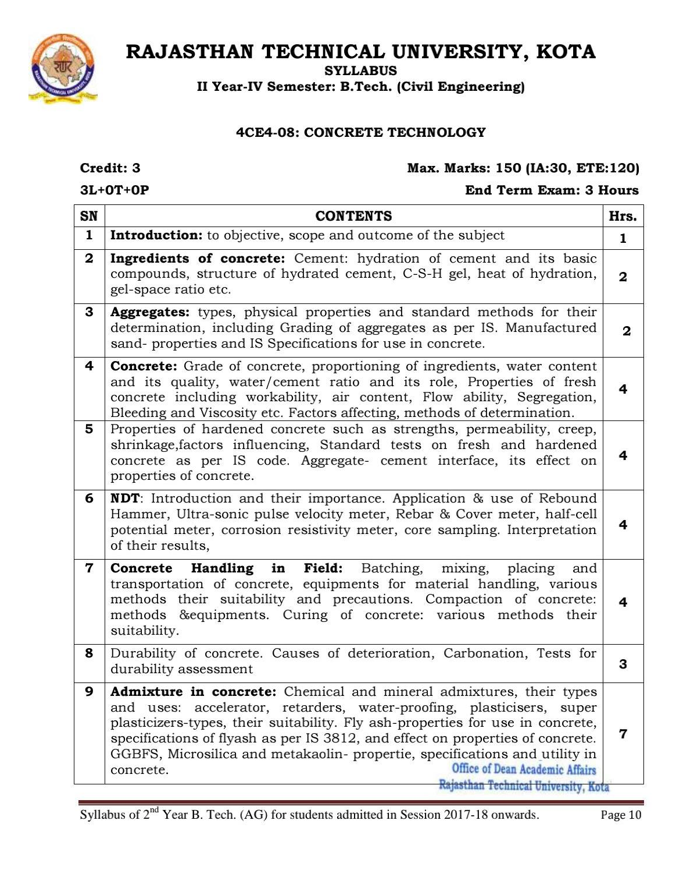

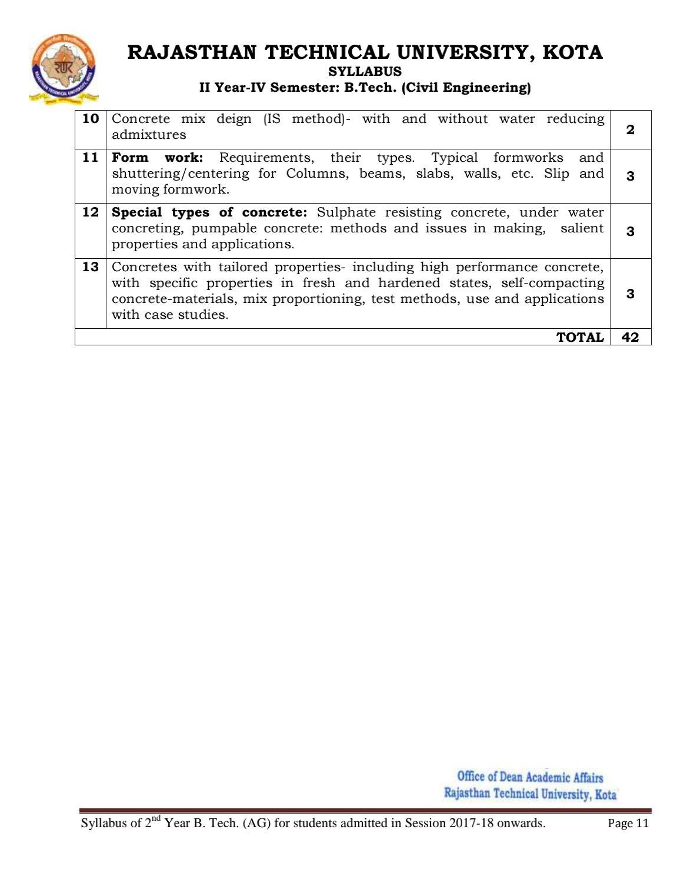

Course Overview:
The course on “Concrete Technology” focuses on concrete making materials including supplementary cementations materials. Concrete production process also forms a part of the discussion. Going through the course one would develop first-hand knowledge on concrete production process and properties and uses of concrete as a modern material of construction. The courses will enable one to make appropriate decision regarding ingredient selection and use of concrete. This course broadly encompasses the study of properties of ingredients of concrete, design of concrete mix, production of concrete and various concreting operations. Cementing material is the vital component of the concrete, hence study of process of manufacturing of cement, types of cement and their properties are covered in this course. Study of properties of aggregates and water also finds their due coverage in the course. Process of concrete production and concreting operations also forms an essential component of the course. In addition to the study of special purpose concretes, the course also provides the due coverage of admixtures which are added to modify the properties of concrete. Properties of concrete in plastic as well as in hardened stage find its due coverage in this course. The course aims at imparting knowledge and skill to supervise concreting operations involving proportioning, mixing, transporting, placing, compacting, finishing and curing of concrete. Hence this course has its stand alone value also.

Course Outcomes:

CO. NO. | Cognitive Level | Course Outcome
1 | Application | Understand chemistry, properties, and classification of cement, fly ash, aggregates and admixtures, and hydration of cement in concrete.
2 | Application | Execute the test for fresh concrete.
3 | Analysis | Execute the test for hardened concrete with destructive and non-destructive testing instruments.
4 | Design | Implement India standard codes procedure for design concrete mix of desired grade.
5 | Application | Learner can state the concrete handling equipments and different special concrete types.

Prerequisites:
- Student will be able to Understand chemistry, properties, and classification of cement, fly ash, aggregates and admixtures, and hydration of cement in concrete.
- Student will be able to Prepare and test the fresh concrete.
- Students will be able to Test hardened concrete with destructive and non-destructive testing instruments.
- Students will be able to Design concrete mix of desired grade.
- Students will be able to Get acquainted to concrete handling equipments and different special concrete

types.

Course Outcome Mapping with Program Outcome:

Course Outcome | PO1 | PO2 | PO3 | PO4 | PO5 | PO6 | PO7 | PO8 | PO9 | PO10 | PO11 | PO12 | PSO1 | PSO2 | PSO3
CO247.1 | 3 | 1 | 2 | 1 | 1 | 2 | 2 | 1 | 1 | 1 | 1 | 1 | 2 | 1 | 1
CO247.2 | 3 | 2 | 2 | 1 | 1 | 1 | 1 | 1 | 1 | 1 | 1 | 2 | 2 | 1 | 1
CO247.3 | 3 | 1 | 2 | 1 | 1 | 2 | 2 | 1 | 1 | 1 | 1 | 1 | 2 | 1 | 1
CO247.4 | 3 | 3 | 3 | 3 | 2 | 2 | 2 | 1 | 1 | 1 | 1 | 2 | 2 | 1 | 1
CO247.5 | 3 | 1 | 2 | 1 | 1 | 2 | 1 | 1 | 1 | 1 | 1 | 1 | 2 | 1 | 1
CO247 (AVG) | 3 | 1.6 | 2.2 | 1.4 | 1.2 | 1.8 | 1.6 | 1 | 1 | 1 | 1 | 1.4 | 2 | 1 | 1

Course Coverage Module Wise:

Lecture No. | Unit | Topic
1 | 1 | INTRODUCTION: Objective, scope and outcome of the course.
2 | 2 | Student should be able to understand hydration of cement and its Basic compounds
3 | 2 | Student should be able to understand Structure of hydrated cement, C-S-H gel
4 | 2 | Student should be able to understand Heat of hydration, gel-space ratio etc
5 | 3 | Student should be able to understand Types, physical properties of aggregate.
6 | 3 | Student should be able to understand Standard methods for their determination, including Grading of Aggregates as per IS
7 | 3 | Student should be able to understand Manufactured sand- properties and IS Specifications for use in Concrete.
8 | 4 | Student should be able to understand Grade of concrete, proportioning of ingredients, water Content and its quality
9 | 4 | Student should be able to understand Water/cement ratio and its role, Properties of fresh concrete Including workability
10 | 4 | Student should be able to understand Air content, Flow ability, Segregation, Bleeding and Viscosity etc
11 | 4 | Student should be able to understand Factors affecting, methods of determination
12 | 5 | Student should be able to understand PROPERTIES OF HARDENED CONCRETE: Strengths and permeability
13 | 5 | Student should be able to understand Creep, shrinkage, factors influencing

14 | 5 | Student should be able to understand Standard tests on fresh and hardened concrete as per IS code
15 | 5 | Student should be able to understand Aggregate- cement interface, its effect on properties of concrete
16 | 6 | Student should be able to understand Application of NDT& use of Rebound Hammer
17 | 6 | Student should be able to understand Ultra-sonic pulse velocity meter, Rebar & Cover meter
18 | 6 | Student should be able to understand Half-cell potential meter, corrosion resistivity meter
19 | 6 | Student should be able to understand Core sampling. Interpretation of their results
20 | 7 | Student should be able to understand CONCRETE HANDLING IN FIELD: Batching, mixing
21 | 7 | Student should be able to understand Placing and transportation of concrete
22 | 7 | Student should be able to understand Equipment’s for material handling, various methods their suitability And precautions
23 | 7 | Student should be able to understand Compaction of concrete: methods & equipment’s
24 | 7 | Student should be able to understand Curing of concrete: various methods their suitability
25 | 8 | Student should be able to understand DURABILITY OF CONCRETE: Causes of deterioration
26 | 8 | Student should be able to understand Carbonation process.
27 | 8 | Student should be able to understand Tests for durability assessment.
28 | 9 | Student should be able to understand about Chemical and mineral admixtures, their Types and uses
29 | 9 | Student should be able to understand about Accelerator, retarders
30 | 9 | Student should be able to understand about Water-proofing, plasticizers
31 | 9 | Student should be able to understand about Super plasticizers-types, their suitability
32 | 9 | Student should be able to understand about Fly ash-properties for use in concrete
33 | 9 | Student should be able to understand Specifications of fly ash as per IS 3812, and effect on properties of Concrete
34 | 9 | Student should be able to understand about GGBFS: properties, specifications and utility in concrete
35 | 9 | Student should be able to understand about Micro silica: properties, specifications and utility in concrete

36 | 9 | Student should be able to understand about Metakaolin: properties, specifications and utility in concrete
37 | 10 | Student should be able to understand CONCRETE MIX DEIGN (IS METHOD): with water reducing admixtures
38 | 10 | Student should be able to understand Concrete mix deign (IS method): without water reducing Admixtures
39 | 10 | Student should be able to understand about Form work: Requirements, their types
40 | 10 | Student should be able to understand about Typical formworks and shuttering/centering for Columns, beams
41 | 11 | Student should be able to understand about TYPICAL FORMWORKS AND SHUTTERING/centering for slabs, walls, etc
42 | 11 | Student should be able to understand about Slip and moving formwork

TEXT/REFERENCE BOOKS
  - Concrete Technology by M. S. Shetty, S. Chand & Co.
  - Concrete Technology by Neville & Brooks, Pearson Education.
  - Concrete: Microstructure, Properties & Materials by Mehta P. K, Tata McGraw Hill.

Course Level Problems (Test Items):

CO.NO. | Problem description
1 | - Explain flakiness index and elongation index  - Describe field testing of cement.  - Distinguish between setting and hardening of cement.
2 | - State factors affecting durability of concrete and state prevention for any one.  - State factors affecting durability of concrete and state prevention for any one  - State methods of application of repair materials for cracked concrete and explain any one method .
3 | - Explain procedure to determine soundness test of cement.  - Explain procedure to determine aggregate crushing value test.  - Explain procedure to determine aggregate impact value test.
4 | - State methods of mixing of concrete and explain any one.  - State different methods of transportation of concrete .  - State different methods of compaction of concrete.
5 | - Explain procedure to determine compressive strength test of cement.  - Explain procedure to determine soundness test of cement.  - Explain procedure to determine aggregate crushing value test.

Assessment Methodology:
- Practical exam in lab where they have to analyze problem statement. (Once in a week)
- Assignments one from each unit.
- Midterm subjective paper based on topics as mentioned in the modules. (Twice during the semester)
- Final paper at the end of the semester subjective.

Teaching and Learning resources unit-wise:

INTRODUCTION: Objective, scope and outcome of the course. Video Tutorials: https://youtu.be/cx5gPKp9QEc
Theory concepts: https://www.cement.org/learn/concrete- technology#:~:text=In%20its%20simplest%20form%2C%20concrete,and%20coarse%20(larger)%20aggre gates.

Concrete.

Video Tutorials: https://youtu.be/UU6PccuoleE

Theory concepts: https://en.wikipedia.org/wiki/Concrete

- flakiness and elongation test

Video Tutorials: https://youtu.be/pZOBN-hIgiE

Theory concepts: https://helptheengineer.com/determination-of-indices-flakiness-and- elongation/#:~:text=The%20Flakiness%20Index%20of%20aggregates,1.8%20times%20their%20mean%2 0dimension.

- concrete preparation

Video Tutorials: https://youtu.be/3UyqRqcdWLw

Theory concepts: http://www.madehow.com/Volume- 1/Concrete.html#:~:text=First%2C%20the%20cement%20(usually%20Portland,placed%2C%20compacte d%2C%20and%20cured.

- concrete crack

Video Tutorials: https://youtu.be/lwKFJTYgMJk

Theory concepts: https://concretesupplyco.com/6-concrete- cracks/#:~:text=When%20the%20top%20of%20a,or%20pattern%20to%20concrete%20surfaces.

- admixtures

Video Tutorials: https://youtu.be/bl4g38BuvlA

Theory concepts: https://www.cement.org/learn/concrete- technology#:~:text=In%20its%20simplest%20form%2C%20concrete,and%20coarse%20(larger)%20aggre gates.

Previous Year Question Papers:
