**Techno India NJR Institute of Technology**



**Course File**

**Solid And Hazardous Waste Management**

**(Subject Code: 6CE5-12)**

Bhupendra Purohit

(Assistant Professor)

**Department of CE**

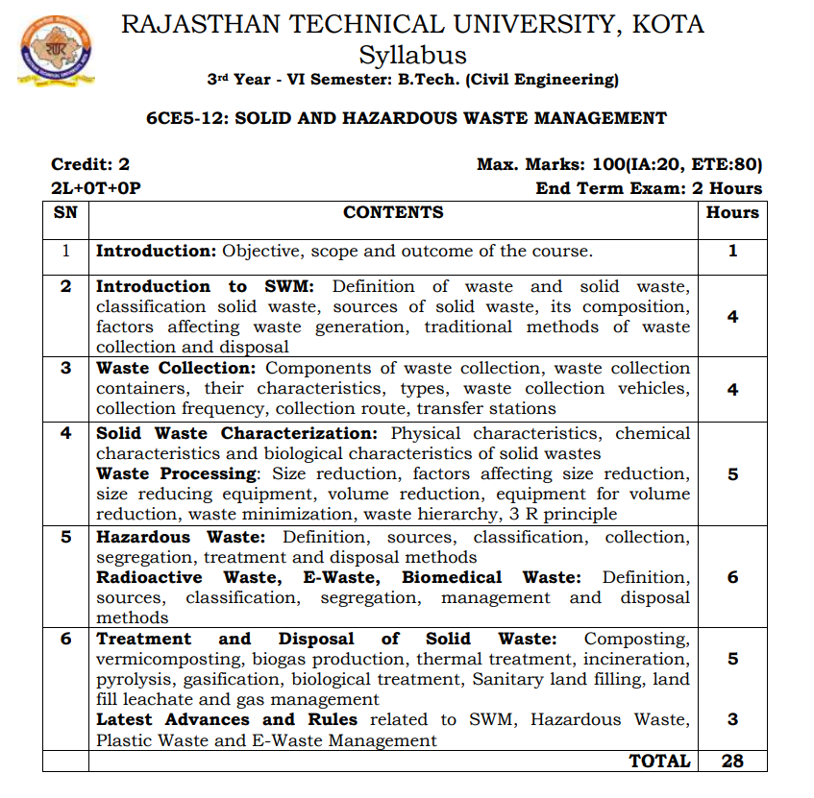

**Course Overview:**

1. Student will learn basics of SWM from this 30 hours course. They will be able to reducing and eliminating adverse impacts of waste materials on human health and the environment to support economic development and superior quality of life. Municipal solid waste generation in large quantities on daily basis constitutes serious environmental problems. ... The need to encourage the increasing recycling of municipal solid waste to facilitate a global sustainable environment as well as boosting the circular economy and green cities is recommended.

This is to be done in the most efficient manner possible, to keep costs low and prevent waste build-up. Proper solid-waste collection is important for the protection of public health, safety, and environmental quality. It is a labour-intensive activity, accounting for approximately three-quarters of the total cost of solid-waste management

**Course Outcomes:**

|  |  |  |
| --- | --- | --- |
| **CO. NO.** | **Cognitive Level** | **Course Outcome** |
| 1 | Application | To list the solid waste management and disposal techniques. |
| 2 | Synthesis | To define the waste management rules to generators of solid waste and its generation rate. |
| 3 | Application | To state what biomedical waste management and hazardous solid waste management are. |
| 4 | Synthesis | To understand the environment and health impacts of solid waste mismanagement. |
| 5 | Application | Understand the engineering, financial and technical options for waste management. |

**Prerequisites:**

1 To know about the solid waste management and disposal techniques.

2: To know the waste management rules to generators of solid waste and its generation rate.

3: To know about the biomedical waste management and hazardous solid waste.

4.Outline the design, operation, and maintenance of different methods of treatment

5.Explain the operation, and maintenance of sanitary landfill

**Course Outcome Mapping with Program Outcome:**

|  |  |  |  |  |  |  |  |  |  |  |  |  |  |  |  |
| --- | --- | --- | --- | --- | --- | --- | --- | --- | --- | --- | --- | --- | --- | --- | --- |
| **Course Outcome** | **PO1** | **PO2** | **PO3** | **PO4** | **PO5** | **PO6** | **PO7** | **PO8** | **PO9** | **PO10** | **PO11** | **PO12** | **PSO1** | **PSO2** | **PSO3** |
| **CO366.1** | 3 | 1 | 2 | 1 | 1 | 2 | 2 | 1 | 1 | 1 | 1 | 1 | 1 | 2 | 3 |
| **CO366.2** | 3 | 2 | 2 | 1 | 1 | 1 | 1 | 1 | 1 | 1 | 1 | 2 | 1 | 2 | 2 |
| **CO366.3** | 3 | 1 | 2 | 1 | 1 | 2 | 2 | 1 | 1 | 1 | 1 | 1 | 1 | 2 | 3 |
| **CO366.4** | 1 | 2 | 2 | 1 | 1 | 2 | 2 | 1 | 2 | 2 | 2 | 2 | 2 | 2 | 1 |
| **CO366.5** | 1 | 1 | 2 | 2 | 1 | 2 | 1 | 1 | 2 | 2 | 2 | 2 | 2 | 2 | 1 |
| **CO366 (AVG)** | 2.2 | 1.4 | 2 | 1.2 | 1 | 1.8 | 1.6 | 1 | 1.4 | 1.4 | 1.4 | 1.6 | 1.4 | 2 | 2 |

**Course Coverage Module Wise:**

|  |  |  |
| --- | --- | --- |
| Lecture No. | Unit | Topic |
|  | **1** | **INTRODUCTION:** Objective, scope and outcome of the course |
| 2 | **2** | **INTRODUCTION TO SWM**: Definition of waste and solid waste, classification solid waste. |
| 3 | 2 | Sources of solid waste, its composition. |
| 4 | 2 | Factors affecting waste generation |
| 5 | 2 | Traditional methods of waste collection and disposal |
| 6 | **3** | **WASTE COLLECTION:** Components of waste collection. |
| 7 | 3 | Waste collection containers, their characteristics, types. |
| 8 | 3 | Waste collection vehicles, collection frequency, collection route, transfer stations |
| 9 | 3 | Waste collection vehicles, collection frequency, collection route, transfer stations |
| 10 | 4 | **SOLID WASTE CHARACTERIZATION**: Physical characteristics. |
| 11 | 4 | Solid Waste Characterization: Chemical characteristics. |
| 12 | 4 | Solid Waste Characterization: Biological characteristics. |
| 13 | 4 | Waste Processing: Size reduction, factors affecting size reduction |
| 14 | 4 | Size reducing equipment, volume reduction, equipment for volume reduction, waste minimization, waste hierarchy, 3 R principle |
| 15 | 5 | **HAZARDOUS WASTE**: Definition, sources, classification, collection, segregation, treatment and disposal methods |
| 16 | 5 | Classification, collection, Segregation, treatment and disposal methods |
| 17 | 5 | Segregation, treatment and disposal methods |
| 18 | 5 | Radioactive Waste, E-Waste, Biomedical Waste: Definition, sources |
| 19 | 5 | Classification, segregation |
| 20 | 5 | Management and disposal Methods |
| 21 | 6 | **TREATMENT AND DISPOSAL OF SOLID WASTE**: Composting,  vermicomposting. |
| 22 | 6 | Composting, vermicomposting. |
| 23 | 6 | Biogas production, thermal treatment, incineration, pyrolysis, gasification. |
| 24 | 6 | Biological treatment, Sanitary land filling |
| 25 | 6 | Land fill leachate and gas management |
| 26 | 6 | Latest Advances and Rules related to SWM, Hazardous Waste, Plastic Waste and E- Waste Management |
| 27 | 6 | (Contd.) Latest Advances and Rules related to SWM |
| 28 | 6 | (Contd.) Latest Advances and Rules related to SWM |
| 29 |  | Revision of course work |
| 30 |  | Revision of course work |

**TEXT/REFERENCE BOOKS**

1. Tchobanoglous G, Theisen H and Vigil SA ‘Integrated Solid Waste Management, Engineering Principles and Management Issues’ McGraw- Hill, 1993.
2. Vesilind PA, Worrell W and Reinhart D, ‘Solid Waste Engineering’ Brooks/Cole Thomson Learning Inc., 2002.
3. Peavy, H.S, Rowe, D.R., and G. Tchobanoglous, ‘Environmental Engineering’.

**Course Level Problems (Test Items):**

|  |  |
| --- | --- |
| **CO.NO.** | **Problem description** |
| **1** | Write about Solid waste Management   1. Write about Classification of Solid waste 2. Write about Composition of Solid Waste 3. Write a short note on Factor Affecting of Solid waste Generation 4. Write about different types of Traditional method of Collection and Disposal of Solid Waste |
| **2** | Write a note on Components of Waste Collection   1. Explain in detail about Waste Collection Centenars 2. Write a note on Waste Collection Vehicle 3. Explain in detail Process of Waste collection 4. Explain in detail about Collection Routs |
| **3** | Explain in detail about Physical Characteristics of solid waste   1. Write a note on Chemical and biological Characteristics of solid waste 2. How can we Size Reduce of Solid waste 3. Explain in detail about Volume Reduction Equipment 4. Write a note on Waste minimization |
| **4** | What is E waste and Biomedical waste?  Explain in Detail Sanitary land Filling   1. Explain in detail about Vermicomposting   Write about Biogas production   1. Write a note on Radioactive Waste in detail |

**Assessment Methodology**

1. Assignments one from each unit.
2. Midterm subjective paper where they have to write on the subject (Twice during the semester)
3. Final paper at the end of the semester subjective.

**Teaching and Learning resources unit-wise:**

**Unit-1**

**Introduction to SWM**

Video Tutorials: <https://www.youtube.com/watch?v=k0ktJRoRcOA>

Theory concepts: <http://www.uap-bd.edu/ce/nehreen/Lecture%201_431.pdf>

Sample Quiz: <https://quizizz.com/admin/quiz/5c4f0285accae2001aed8bbf/solid-waste>

**Unit-2**

**Waste Collection**

Video Tutorials: <https://www.youtube.com/watch?v=CME8ym5WbcY>

Theory concepts: <http://homepages.hs-bremen.de/~office-ikrw/invent/e-learning_Dateien/Handbook_chapters/chapter_4.pdf>

Sample Quiz: <https://quizizz.com/admin/quiz/5c9d1f18d9c4cc001b6cf1bc/waste-management>

**Unit-3**

**Solid Waste Characterization**

Video Tutorials: <https://www.youtube.com/watch?v=at5NuSbIiW8>

Theory concepts: <https://www.jica.go.jp/jica-ri/IFIC_and_JBICI-Studies/english/publications/reports/study/topical/waste/pdf/waste_02.pdf>

Sample Quiz: <https://quizizz.com/admin/quiz/5c9d1f18d9c4cc001b6cf1bc/waste-management>

**Unit4**

**Hazardous waste**

Video Tutorials: <https://www.youtube.com/watch?v=e2NCMulhMN0>

Theory concepts: <https://www.bbau.ac.in/Docs/FoundationCourse/TM/Lecture%209%20Hazardous%20waste.pdf>

Sample Quiz: <https://study.com/academy/exam/topic/solid-and-hazardous-waste.html>

**Unit-5**

**Treatment and Disposal**

Video Tutorials: <https://www.youtube.com/watch?v=cNiy1kR-W74>

Theory concepts: <https://www.researchgate.net/publication/344519543_Solid_Waste_Treatment_Technologies_and_Environmental_Sustainability>

Sample Quiz: <https://testbook.com/objective-questions/mcq-on-solid-waste-management--5eea6a0839140f30f369d6e9>

