**Techno India NJR Institute of Technology**



**Course File**

**COMPUTER AIDED CIVIL ENGINEERING DRAWING (3CE4-23)**

Jitendra Choubisa

(Assistant Professor) **Department of CE**

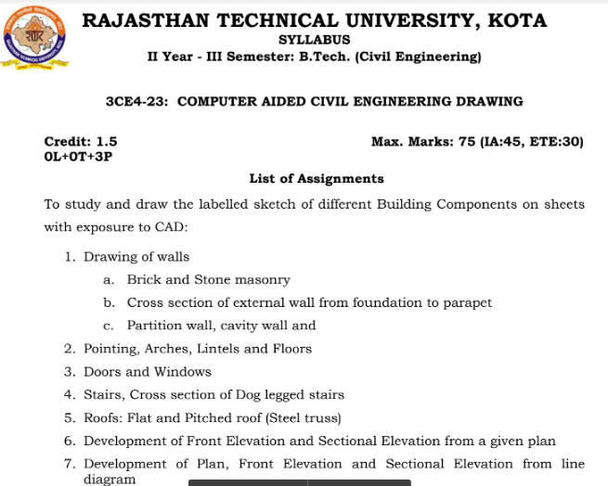

**Course Overview:**

Computer-aided Design (CAD) Course is the process of creation, modification, analysis and optimization of designs with the help of a computer or workstation is termed computer-aided design (CAD). There are many software solutions that are used for this purpose; they are called CAD software. The productivity of a designer has been enhanced manifold by the use of this Computer-aided Design (CAD) software. They are also used for improving the quality of design and communication. The database for manufacturing is created using CAD software.

**Course Outcomes:**

|  |  |  |
| --- | --- | --- |
| **CO.NO.** | **Cognitive Level** | **Course Outcome** |
| 1 | **Comprehension** | To understand the basic command, principles and features behind AutoCAD. |
| 2 | **Application** | Execute skills to draft the plan, elevation and sectional views of buildings. |
| 3 | **Analysis** | Students can Sketch or draft 2D and 3D views of buildings |
| 4 | **Synthesis** | Understand development of front elevation and sectional elevation from a given plan |
| 5 | **Evaluation** | Understand development of plan, front elevation and sectional elevation from line diagram. |

**Prerequisites:**

1. Fundamentals knowledge of Computer.
2. Fundamentals knowledge of Drawing fundamentals.
3. Fundamentals knowledge of planning.

**Course Coverage Module Wise:**

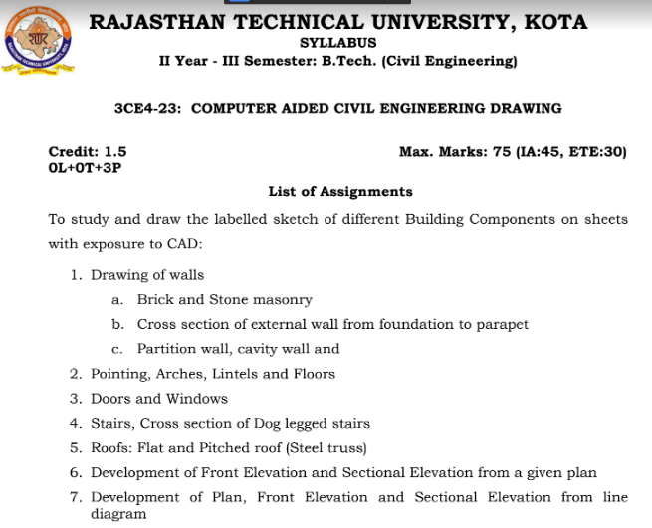



**Faculty Lab Manual Link:**

<https://drive.google.com/drive/folders/14E9Z6UjJxNu_mZ-5USoU6QdMEl5vFq_M>

**Viva QUIZ Link**

1. <https://www.thesourcecad.com/autocad-quiz-with-answers/>
2. <https://www.mycadsite.com/quizzes.html>
3. <https://www.proprofs.com/quiz-school/topic/autocad>
4. <https://quizizz.com/admin/quiz/5cee714ad4d101001cdaab04/auto-cad-quiz>
5. <https://quizlet.com/102925191/autocad-quiz-questions-flash-cards/>

**Assessment Methodology:**

1. Practical exam using AutoCAD software.
2. Internal exams and Viva Conduct.
3. ****Final Exam (practical paper) at the end of the semester.