**Techno India NJR Institute of Technology**



**Course File**

**CIVIL ENGINEERING MATERIALS LAB (3CE4-24)**

Rakesh Yadav

(Assistant Professor) **Department of CE**

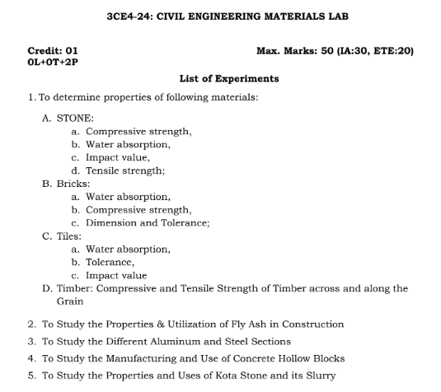

**Course Overview:**

Study the nature and performance of civil engineering materials and evaluation of their physical and mechanical properties. This course focuses on materials used in construction and maintenance of building and infrastructure such as ferrous and nonferrous metals, aggregates, Portland cement, concrete, masonry, asphalt and asphalt mixtures, wood and composites. Emphasis will be placed on selection criteria, design, applications and proper use of these materials. The objective of this course is to understand the nature, characteristics, performance, and behavior of civil engineering materials used in buildings and infrastructure and to evaluate their physical and mechanical properties. Students will learn how to select materials based on their properties and their proper use for a particular facility under prevailing environmental conditions.

**Course Outcomes:**

|  |  |  |
| --- | --- | --- |
| **CO.NO.** | **Cognitive Level** | **Course Outcome** |
| 1 | **Comprehension** | Explain about fly ash, different stones, different glasses, aluminum and steel sections. |
| 2 | **Application** | To memorize the various properties of cement. |
| 3 | **Analysis** | Student can distinguish the various building materials by visual inspection. |
| 4 | **Synthesis** | Identify the properties and utilization of fly ash, glass, timber, kota stone, aluminum and steel sections. |
| 5 | **Evaluation** | Understand the manufacturing and use of concrete hollow block |

**Prerequisites:**

1. Fundamentals knowledge of chemistry.
2. Fundamentals knowledge of science.
3. Fundamentals knowledge of civil engineering.

**Course Coverage Module Wise:**

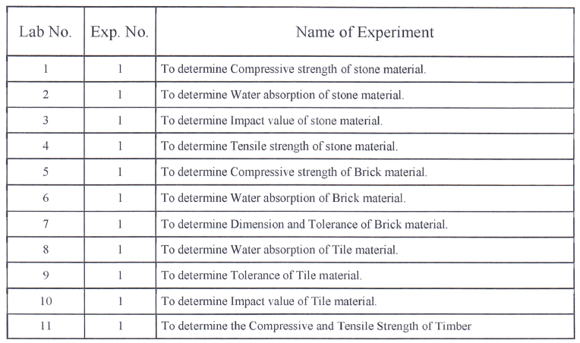



**Faculty Lab Manual Link:**

<https://drive.google.com/file/d/19_r2yi18wx--9spIYiDXTTYkAUqbDgVS/view?usp=share_link>

**Viva QUIZ Link**

1. <https://www.indiabix.com/civil-engineering/building-materials/>
2. <https://quizizz.com/admin/quiz/5fcd823d41c265001b3d3de7/civil-engineering-material>
3. <https://www.objectivebooks.com/2016/04/building-materials-and-construction.html>
4. <https://www.examveda.com/civil-engineering/practice-mcq-question-on-building-materials/>

**Assessment Methodology:**

1. Practical exam.
2. Internal exams and Viva Conduct.
3. ****Final Exam (practical paper) at the end of the semester.