**Techno India NJR Institute of Technology**



**Course File**

**Fluid Mechanics (3CE4-06)**

Jitendra Choubisa (Assistant Professor) **Department of CE**



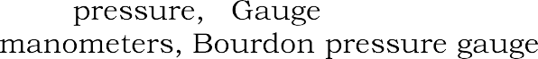





|  |  |  |
| --- | --- | --- |
|  |  |  |
|  |  |  |
|  |  |  |
|  |  |  |
|  |  |  |
|  |  |  |
|  |  |  |
|  |  |  |
|  |  |  |
|  | |  |









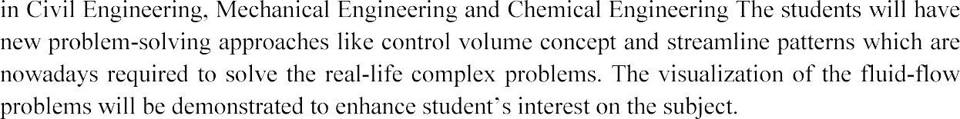









|  |  |
| --- | --- |
| **3CE4-06** | **FLUID MECHANICS** |
| 3CE5A.1 | Students will be able to remember the basic properties of fluid flow. |
| 3CE5A.2 | Students will learn to analyze the pressure, buoyancy and types of flow and its characteristics. |
| 3CE5A.3 | Students be able to solve problems related to Fluid Kinematics. |
| 3CE5A.4 | Students will be able to apply concepts on flow parameters such as discharge, velocity, acceleration etc. on the basis of flow problems (Dynamics). |
| 3CE5A.5 | Students be able to analyze the flow through pipes. |





|  |  |  |  |  |  |  |  |  |  |  |  |  |  |  |  |
| --- | --- | --- | --- | --- | --- | --- | --- | --- | --- | --- | --- | --- | --- | --- | --- |
| **Course Outcome** | **PO1** | **PO2** | **PO3** | **PO4** | **PO5** | **PO6** | **PO7** | **PO8** | **PO9** | **PO10** | **PO11** | **PO12** | **PSO1** | **PSO2** | **PSO3** |
| **CO236.1** | 3 | 3 | 3 | 2 | 1 | 2 | 1 | 1 | 1 | 1 | 1 | 1 | 1 | 1 | 1 |
| **CO236.2** | 3 | 2 | 3 | 1 | 1 | 2 | 1 | 1 | 1 | 1 | 1 | 1 | 1 | 1 | 1 |
| **CO236.3** | 3 | 2 | 3 | 2 | 1 | 1 | 1 | 1 | 1 | 1 | 1 | 1 | 1 | 1 | 1 |
| **CO236.4** | 3 | 3 | 3 | 2 | 1 | 2 | 1 | 1 | 1 | 1 | 1 | 1 | 1 | 1 | 1 |
| **CO236.5** | 3 | 2 | 3 | 1 | 1 | 2 | 1 | 1 | 1 | 1 | 1 | 1 | 1 | 1 | 1 |
| **CO236 (AVG)** | 3 | 2.4 | 3 | 1.6 | 1 | 1.8 | 1 | 1 | 1 | 1 | 1 | 1 | 1 | 1 | 1 |



|  |  |  |
| --- | --- | --- |
|  |  |  |
|  |  |  |
|  |  |  |
|  |  |  |
|  |  |  |
|  |  |  |
|  |  |  |
|  |  |  |
|  |  |  |
|  |  |  |
|  |  |  |
|  |  |  |
|  |  |  |
|  |  |  |
|  |  |  |
|  |  |  |
|  |  |  |
|  |  |  |
|  |  |  |
|  |  |  |
|  |  |  |
|  |  |  |

|  |  |  |
| --- | --- | --- |
|  |  |  |
|  |  |  |
|  |  |  |
|  |  |  |
|  |  |  |
|  |  |  |

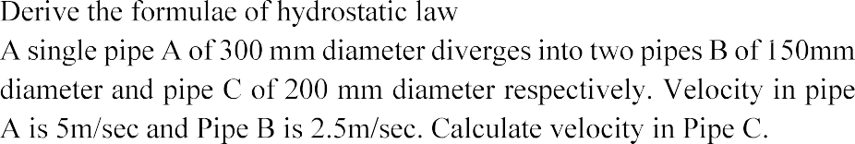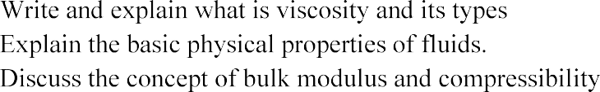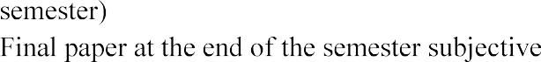





|  |  |
| --- | --- |
|  |  |
|  |  |
|  |  |
|  |  |







Techno India NJR Institute of Technology Academic Administration of Techno NJR Institute Syllabus Deployment

Total No. of Lectures Planned: 28

|  |  |  |
| --- | --- | --- |
| Name of Faculty | : Mr. Jitendra Choubisa | Subject Code: 3CE4-06 |
| Subject  Department | : Fluid Mechanics  : Civil Engineering | Sem: III |

COURSE OUTCOMES HERE (3 OUTCOMES)

At the end of this course students will be able to: CO1: Solve the Hydrostatic problems.

CO2: Describe the physical properties of fluid.

CO3: Calculated the pressure distribution of incompressible fluid.

|  |  |  |
| --- | --- | --- |
| Lecture No. | Unit | Topic |
| 1 | **1** | **INTRODUCTION TO OBJECTIVE, SCOPE AND OUTCOME OF THE COURSE.** |
| 2 | **2** | **FLUIDS**: Definition, Type of fluids, Ideal fluids, real fluids, Newtonian and  Non-Newtonian fluids |
| 3 | **3** | **PROPERTIES OF FLUIDS:** Units of measurement, Mass density, Specific weight, Specific volume, Specific Gravity |
| 4 | 3 | Viscosity, Surface tension and Capillarity, Compressibility and Elasticity |
| 5 | **4** | **PRINCIPLES OF FLUID STATICS**: Basic equations, Pascal Law |
| 6 | 4 | Type of pressure:-atmospheric pressure, Gauge pressure, vacuum pressure,  absolute pressure |
| 7 | 4 | Manometers, Bourdon pressure gauge |

|  |  |  |
| --- | --- | --- |
| 8 | 4 | Manometers, Bourdon pressure gauge |
| 9 | **5** | **BUOYANCY**; Forces acting on immersed plane surface |
| 10 | 5 | Centre of pressure, forces on curved surfaces |
| 11 | 5 | Conditions of equilibrium for floating bodies |
| 12 | 5 | Meta-centre |
| 13 | 5 | Analytical determination of meta centric height |
| 14 | **6** | **KINEMATICS OF FLOW**: Visualisation of flow, Types of flow: Steady and  unsteady, uniform and non-uniform, rotational and ir-rotaional flow, Laminar and turbulent flow |
| 15 | 6 | Streamline, path line, streak line, principle of conservation of mass, equation of continuity |
| 16 | 6 | Acceleration of fluid particles local and convective, velocity, acceleration |
| 17 | 6 | Velocity potential and stream function, elementary treatment of flow net |
| 18 | 6 | Fluid mass subject to horizontal and vertical acceleration and uniform rotation |
| 19 | **7** | **FLUID DYNAMICS**: Control volume approach |
| 20 | 7 | Euler’s equation, Bernoulli’s equation and its applications, venture-meter, orifice meter, orifices & mouthpieces |
| 21 | 7 | Pressure on flat plates and nozzles. Time of emptying of tanks by orifices |
| 22 | 7 | Momentum and angular momentum equations and their applications |
| 23 | **8** | **LAMINAR FLOW THROUGH PIPES**: Laminar flow through pipes |
| 25 | 8 | Relation between shear & pressure gradient. Flow between plates & pipes |
| 26 | 8 | Hagen- Poiseuille equation, Equations for velocity distribution |
| 27 | 8 | Pressure difference velocity distribution over a flat plate and in a pipe section |
| 28 | 8 | Darcy-Welsbach equation, friction factor , minor losses, pipe networks |

**TEXT/REFERENCE BOOKS**

1. Fluid Mechanics by Modi & Seth, Standard Publishers, Delhi.
2. Fluid Mechanics by Dr. R.K. Bansal, Laxmi Publication (P) Ltd.
3. Fluid Mechanics by Dr. K.R. Arora, Standard Publishers and Distributers, Delhi.
4. Fluid Mechanics & Machinery by C.S.P.Ojha, R.Berndtsson and P.N.Chandramauli, Oxford Publishers, Delhi



TECHNO INDIA NJR INSTITUTE OF TECHNOLOGY, UDAIPUR DEPARTMENT OF CIVIL ENGINEERING

SUBJECT: **FLUID MECHANICS**

MAX MARKS: **80** TIME: **3 Hrs.**

2 Hrs

#### Instruction for candidates:

PART-A Attempt all Questions, Each question carries 2 Marks. PART-B Attempt any 4 Questions, Each question carries 10 Marks. PART-C Attempt any 2 Questions, Each question carries 15 Marks.

#### PART-A

**Q.1:** Answer the following terms in 30 words:

1. Specific Gravity
2. Kinematic Viscosity
3. Metacenter
4. Center of pressure
5. Manometers. (5 x 2 = 10 Marks)

#### PART-B

**Q.2:** Write down any three basic properties of fluid with their respective formulae’s and their Units. Calculate the specific weight & density of one litre of a liquid which weighs 7 N. (10 Marks)

**Q.3:** Define what viscosity is?

A plate 0.025mm distant from a fixed plate, moves at 60 cm/s and require a force of 2 N per unit area i.e., 2 N/m2 to maintain the speed. Determine the fluid viscosity between the plates. (10 Marks)

**Q.4:** Define what surface tension is and explain capillarity.

Calculate the capillary rise in a glass tube of 2.5 mm diameter when immersed vertically in (a) water and (b) mercury. Take surface tension σ = 0.0725 N/m for water and σ = 0.52 N/m for mercury in contact with air. The specific gravity for mercury is given as 13.6 and angle of contact = 130° (10 Marks)

**Q.5:** Explain in detail what Vapor pressure & Cavitation is.

State what is newton’s law of viscosity? (10 Marks)

**Q.6:** Define what Pascal Law & Hydrostatic law is. A hydraulic press has a ram of diameter 30 cm and a plunger of dia 4.5 cm. Find the weight lifted by press when the force at the plunger is 500 N. (10 Marks)

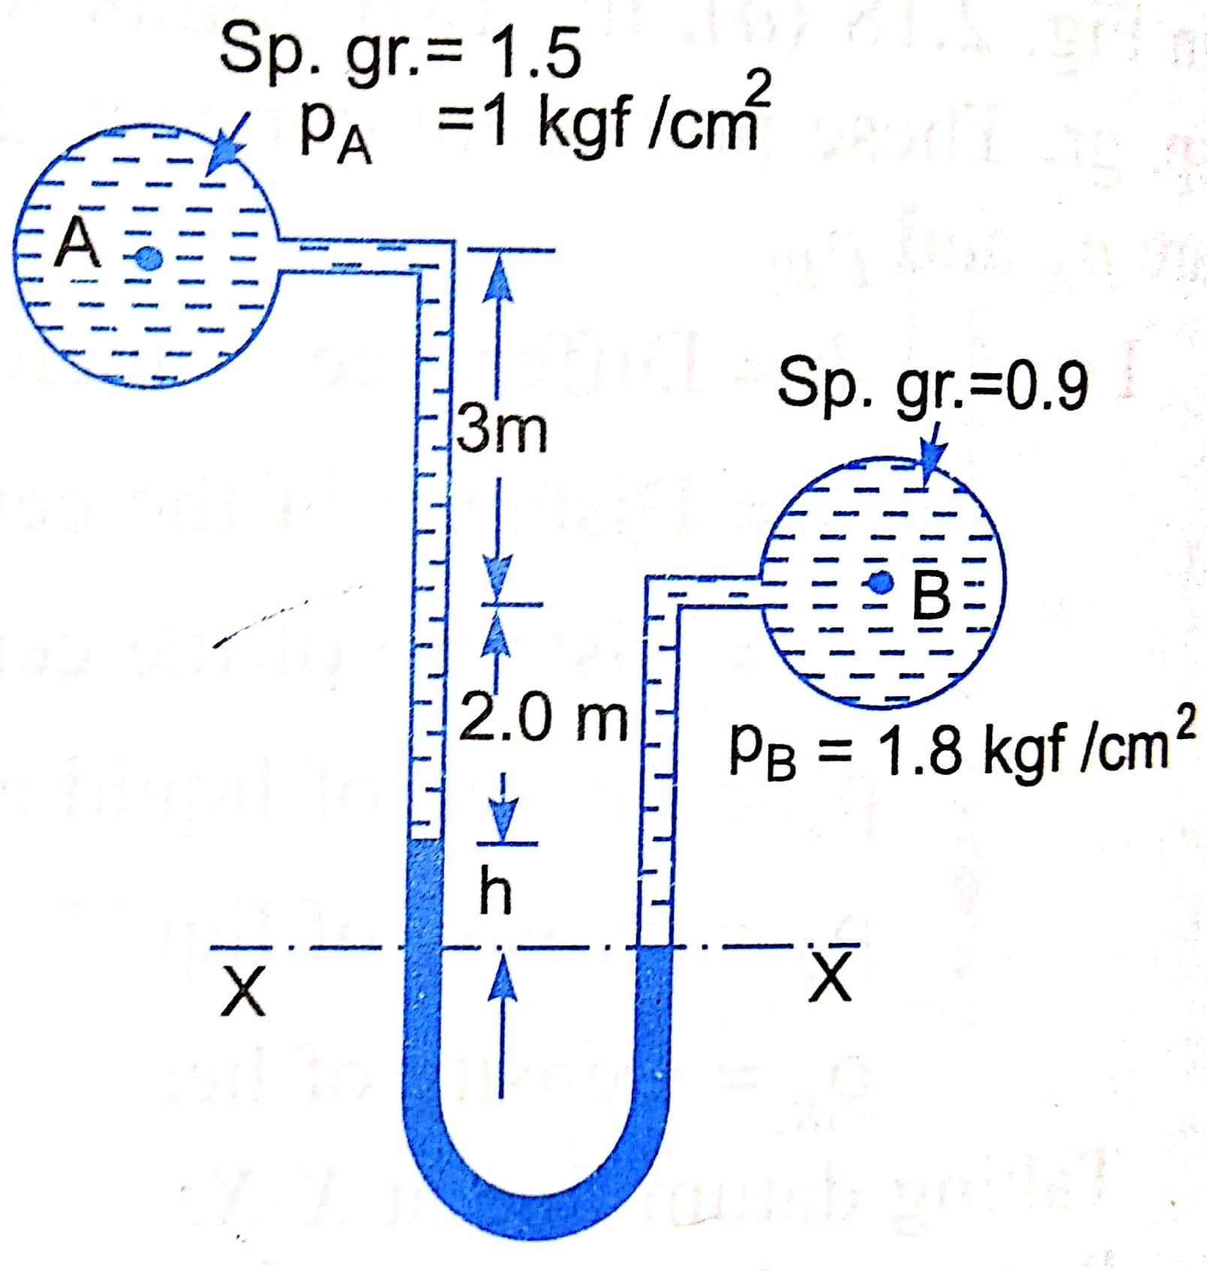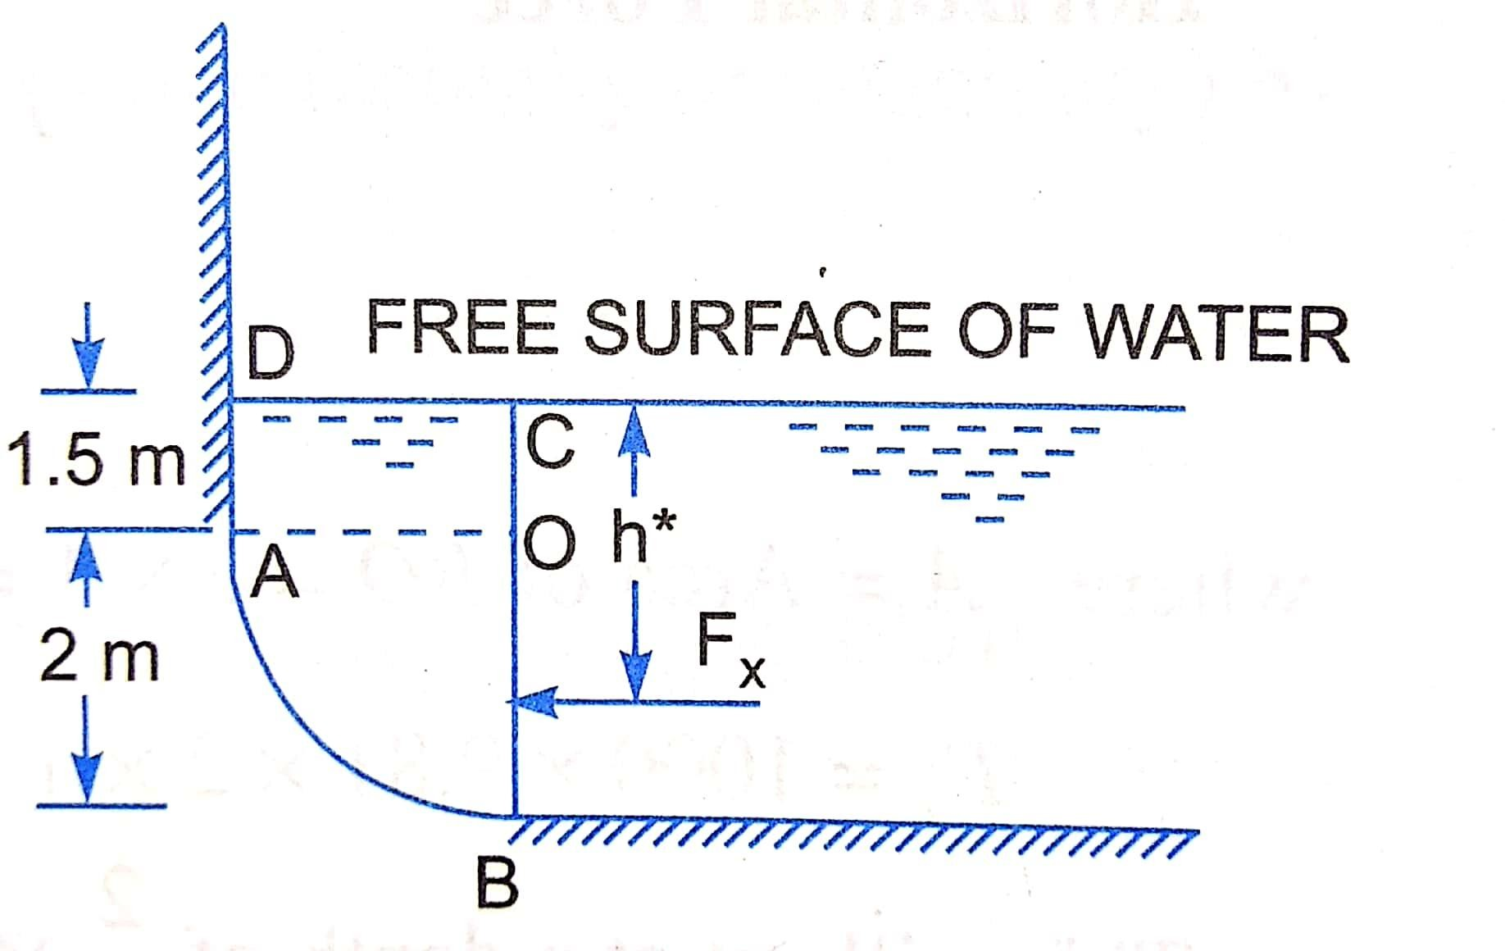

**Q.7:** Write down the conditions of equilibrium for floating and submerged bodies both. Explain with neat diagram and forces causing the phenomena. (10 Marks)

#### PART-C

**Q.8:** Define what total pressure is and center of pressure, derive the expressions for center of pressure.

A rectangular plane surface is 2m wide and 3m deep. It lies in vertical plane in water. Determine the total pressure and position of center of pressure on the plane surface when its upper edge is horizontal and (a) coincides with water surface, (b) 2.5m below the free water surface. (15 Marks)

**Q.9:** Compute the horizontal and vertical components of the total force acting on a curved surface AB, which is in the form of a quadrant of a circle of radius 2 m as shown below. Take the width of gate as unity. (15 Marks)

**Q.10:** A differential manometer is connected at the points A & B of two pipes as shown below. The pipe A Contains a liquid of sp. gr. = 1.5 while pipe B contains a liquid of sp. gr. = 0.9. The pressure at A and B are 1 kgf/cm2 and 1.80 kgf/cm2 respectively.

Find the difference of pressure in mercury level in the differential manometer.

(15 Marks)





QUIZ ON FLUID MECHANICS

Total Questions 10

Total Marks 10

[**choubisa.jitendra7@gmail.com**](mailto:choubisa.jitendra7@gmail.com) (not shared) Switch account

* Required



Name Of student *

Your answer



Mass per unit volume of a fluid is known as? *

1 point

Mass Density Weight Density Specific Gravity

Relative Density



Weight per unit volume of a fluid is known as? *

1 point

Mass Density

Weight Density or Unit Weight Specific Gravity

Viscosity



The property by which fluid layers resist the flow? *

1 point

Viscosity Density Pressure

Velocity



Kinematic Viscosity has a formula of: *

1 point

Density / Dynamic Viscosity Dynamic Viscosity / Density Density / Specific Gravity

Specific Gravity / Density



Continuity equation for a compressible fluid flow is given by?

1 point

AV=Q

A1V1 = A2V2

(rho)1 A1 V1 = (rho)2 A2 V2

None of the above



What is the use of Pitot Tube? *

1 point

It calculates Discharge It Calculates Velocity It Calculates Pressure

None



Sum of all the energies are same throughout the sections of flow, this

statement corresponds to: *

1 point

Continiuity Equation Bernoulii's Theorem Darcy Weisbach Equation

Chezy's Theorem



The study of fluid in motion without considering the forces causing that

motion: *

1 point

Dynamics Statics Kinematics

Mechanics



What contributes to the major loss of energy in pipes? *

1 point

Contraction Friction Expansion

Bend in pipe





In pipes Velocity is maximum at: *

1 point

Inlet Outlet At walls

At Center

Submit Clear form

Never submit passwords through Google Forms.

This content is neither created nor endorsed by Google. R eport Abuse - [T erms of Service](https://policies.google.com/terms) - [P rivacy Policy](https://policies.google.com/privacy)

[Forms](https://www.google.com/forms/about/?utm_source=product&utm_medium=forms_logo&utm_campaign=forms)



**TECHNO INDIA NJR INSTITUTE OF TECHNOLOGY UDAIPUR**

**DEPARTMENT OF CIVIL ENGINEERING**

**SUBJECT NAME : FLUID MECHANICS SUBJECT CODE : 3CE4-06**

**Video Tutorial Links for all the Lectures of Fluid Mechanics**

### Till Metacentric Height

[https://www.youtube.com/playlist?list=PL-Yu0VXx3q-cOM7TNn9INXT](https://www.youtube.com/playlist?list=PL-Yu0VXx3q-cOM7TNn9INXT_-oFN2gAA8)

### [_-oFN2gAA8](https://www.youtube.com/playlist?list=PL-Yu0VXx3q-cOM7TNn9INXT_-oFN2gAA8)

1. After That all the topics videos can be accessed from below link:

[https://drive.google.com/drive/folders/1TILTARmJ6LPPVCPvrbf6qBM](https://drive.google.com/drive/folders/1TILTARmJ6LPPVCPvrbf6qBMmgFdv8zOh?usp=sharing) [mgFdv8zOh?usp=sharing](https://drive.google.com/drive/folders/1TILTARmJ6LPPVCPvrbf6qBMmgFdv8zOh?usp=sharing)

FACULTY NAME : JITENDRA CHOUBISA



# TECHNO INDIA NJR INSTITUTE OF TECHNOLOGY, UDAIPUR

DEPARTMENT OF CIVIL ENGINEERING

# ASSIGNMENT NO. 01

SUBJECT NAME: FLUID MECHANICS SUBJECT CODE: 3CE4-06

FACULTY NAME: JITENDRA CHOUBISA

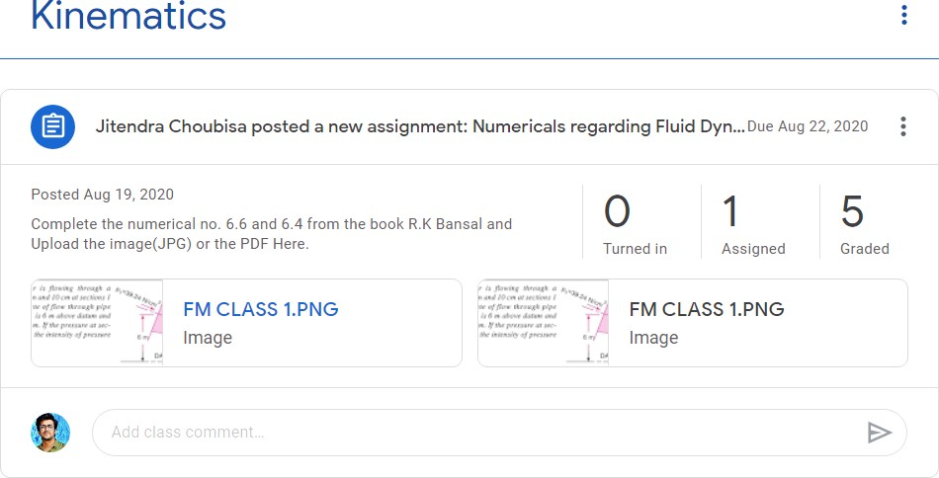

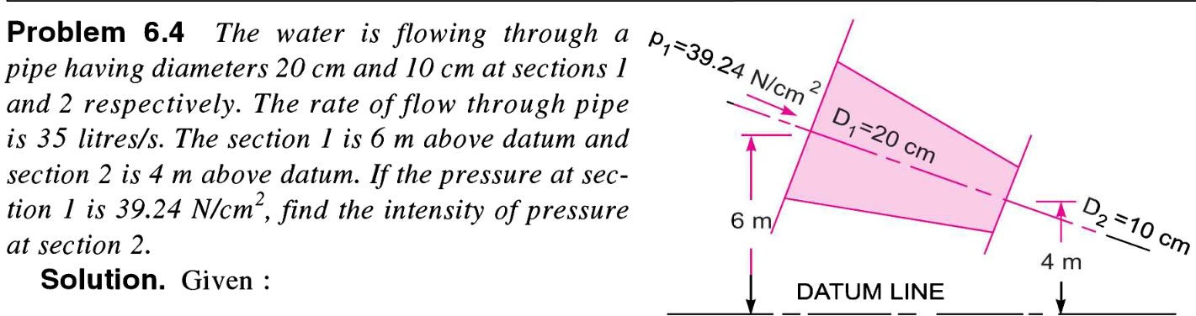

# TECHNO INDIA NJR INSTITUTE OF TECHNOLOGY, UDAIPUR

DEPARTMENT OF CIVIL ENGINEERING

# ASSIGNMENT NO. 02

SUBJECT NAME: FLUID MECHANICS SUBJECT CODE: 3CE4-06

FACULTY NAME: JITENDRA CHOUBISA

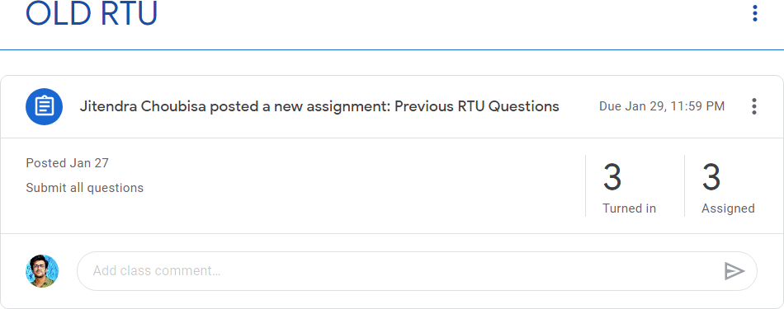

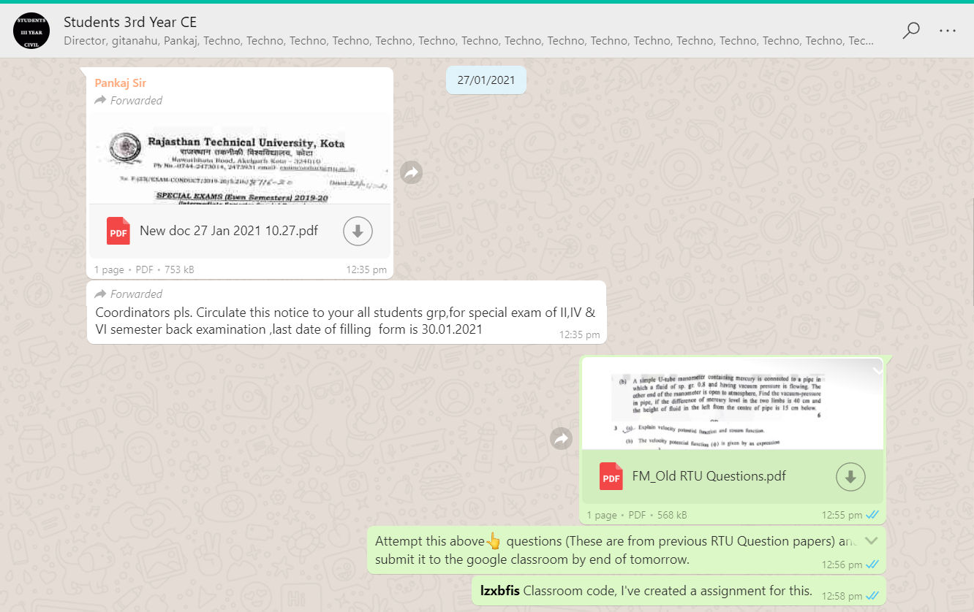

# TECHNO INDIA NJR INSTITUTE OF TECHNOLOGY, UDAIPUR

DEPARTMENT OF CIVIL ENGINEERING

# ASSIGNMENT NO. 03

SUBJECT NAME: FLUID MECHANICS SUBJECT CODE: 3CE4-06

FACULTY NAME: JITENDRA CHOUBISA

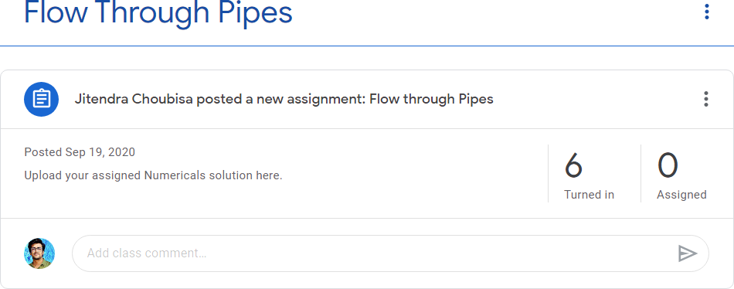



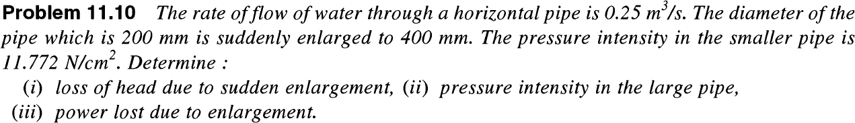



## TECHNO INDIA NJR INSTITUTE OF TECHNOLOGY, UDAIPUR

DEPARTMENT OF CIVIL ENGINEERING

## ASSIGNMENT NO. 01

SUBJECT NAME: FLUID MECHANICS SUBJECT CODE: 3CE4-06

FACULTY NAME: JITENDRA CHOUBISA

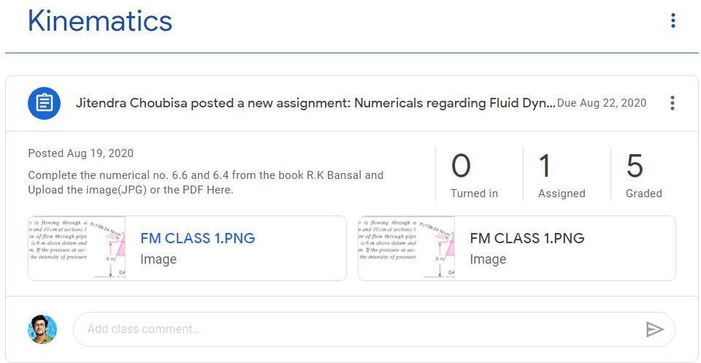

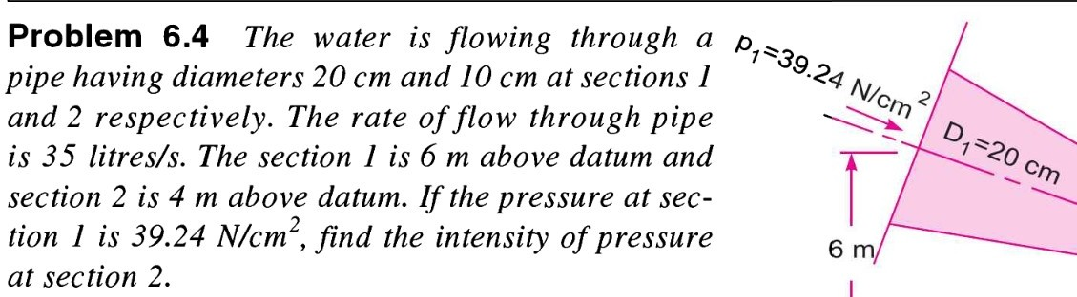

## TECHNO INDIA NJR INSTITUTE OF TECHNOLOGY, UDAIPUR

DEPARTMENT OF CIVIL ENGINEERING

## ASSIGNMENT NO. 02

SUBJECT NAME: FLUID MECHANICS SUBJECT CODE: 3CE4-06

FACULTY NAME: JITENDRA CHOUBISA

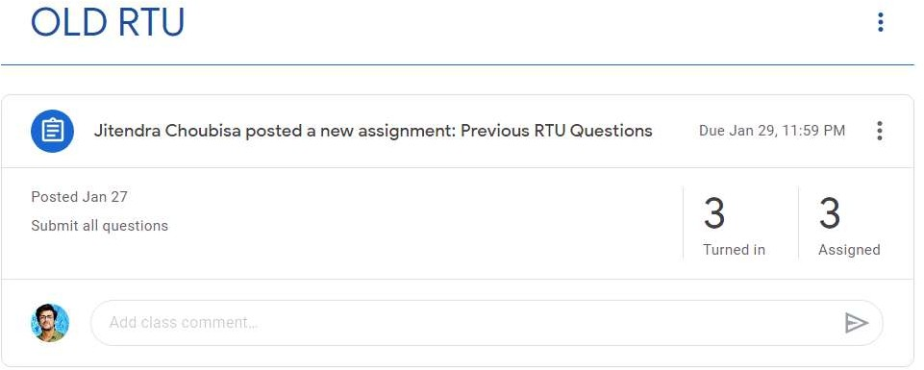

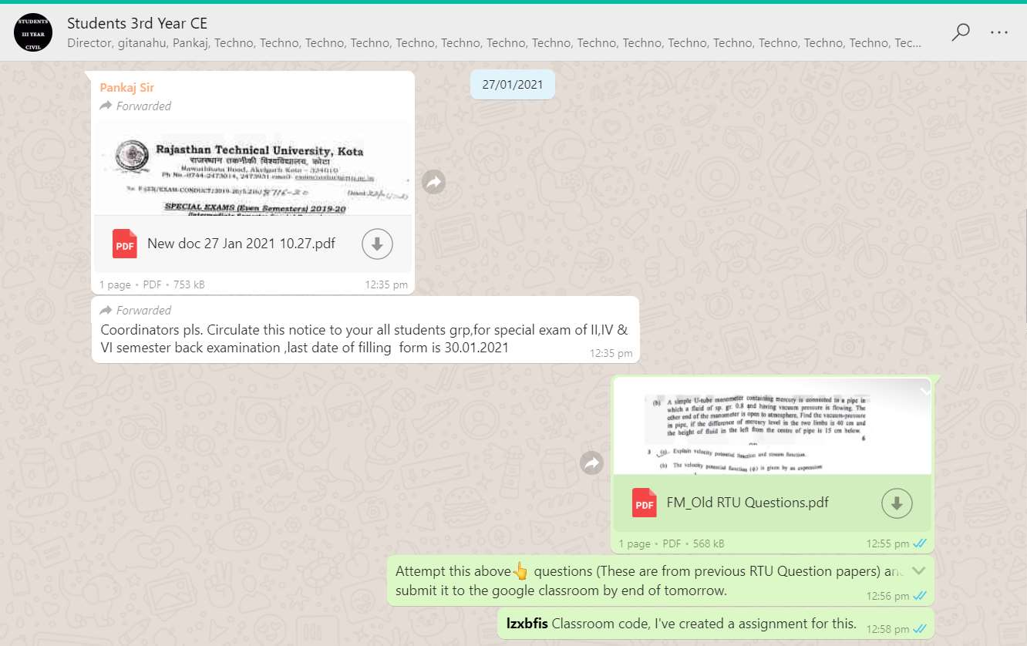

## TECHNO INDIA NJR INSTITUTE OF TECHNOLOGY, UDAIPUR

DEPARTMENT OF CIVIL ENGINEERING

## ASSIGNMENT NO. 03

SUBJECT NAME: FLUID MECHANICS SUBJECT CODE: 3CE4-06

FACULTY NAME: JITENDRA CHOUBISA

