**Techno India NJR Institute of Technology**



**Course File**

**Building Material and Construction**

**(3CE4-07)**

Rakesh Yadav

(Assistant Professor)

**Department of CE**

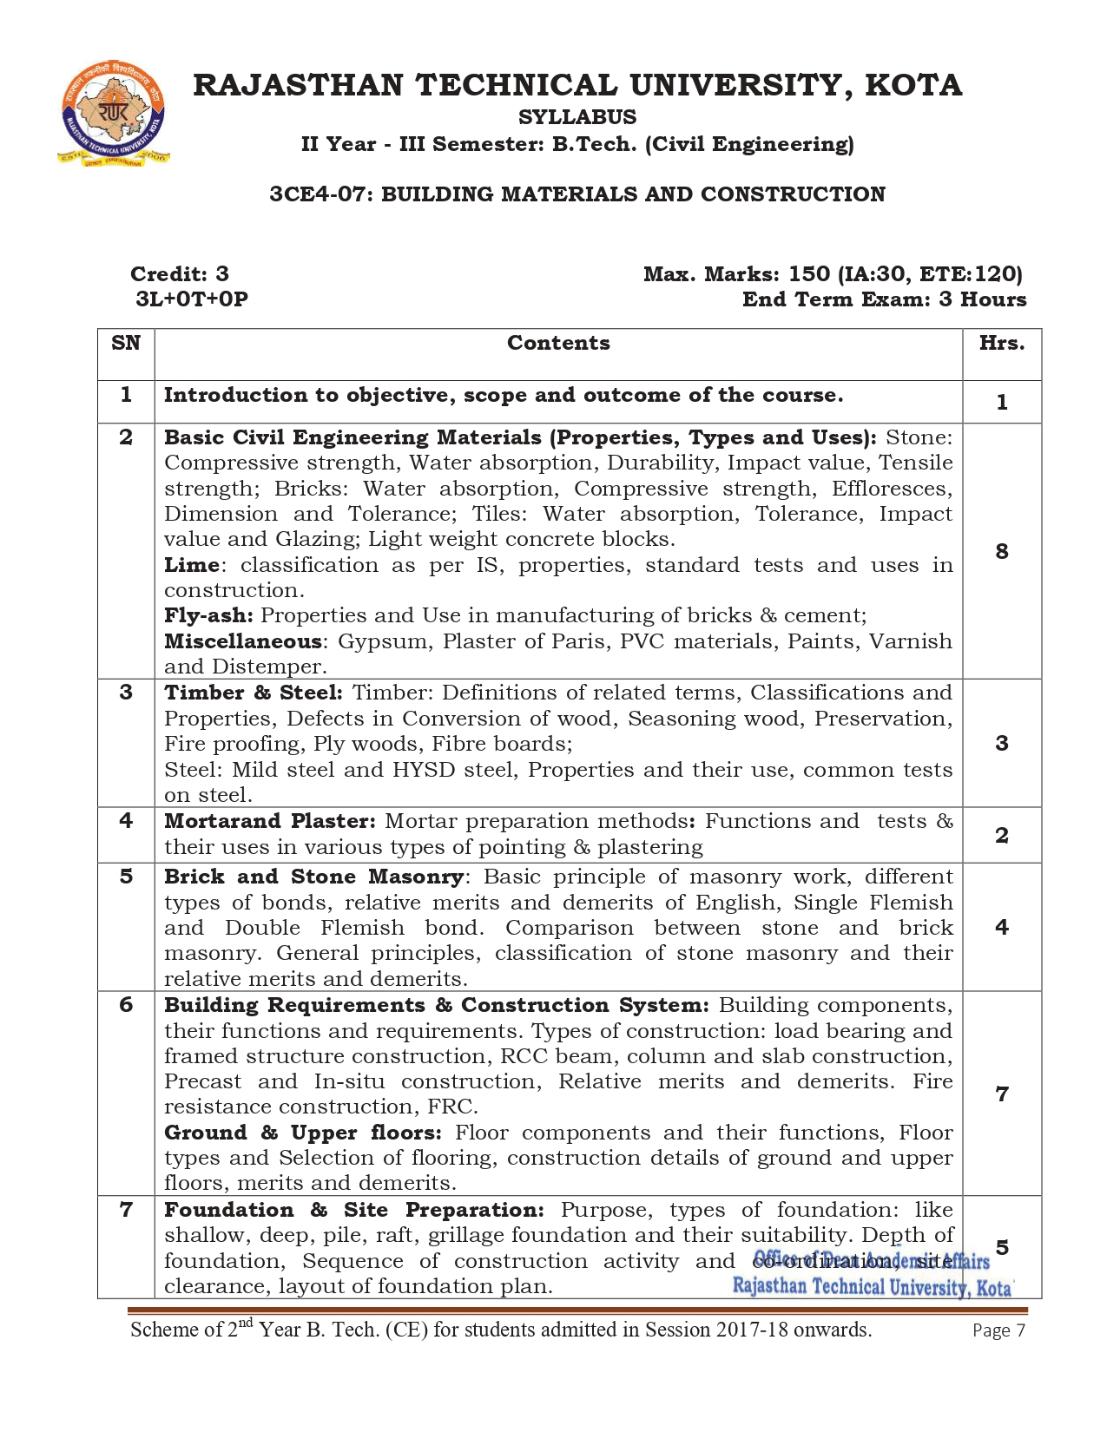

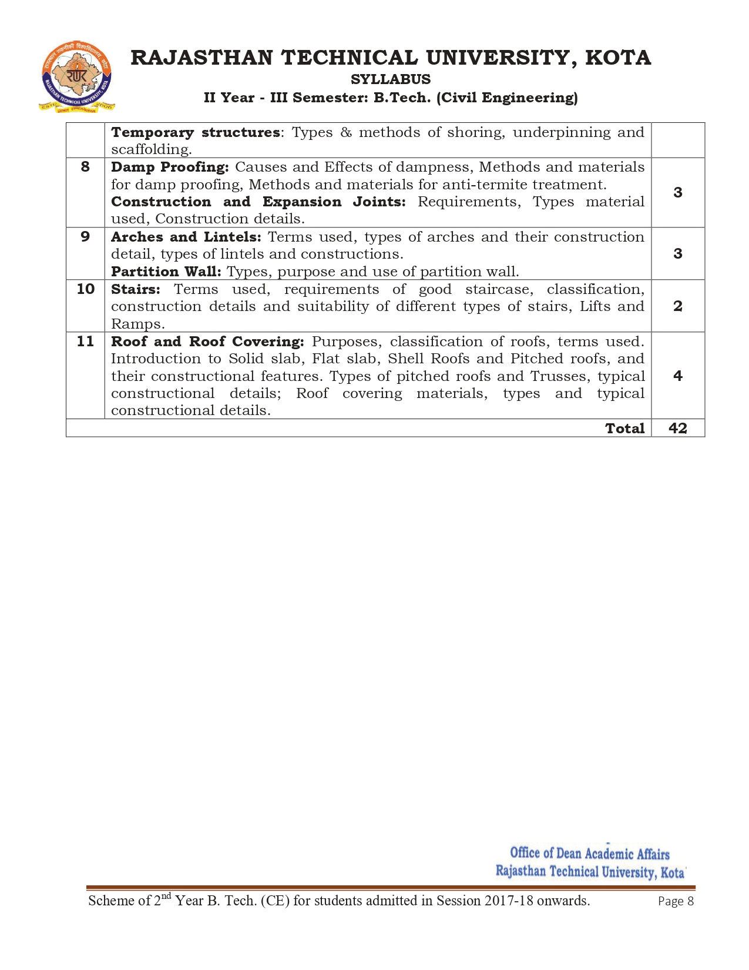

**Course Overview:**

Student will learn basics of “Building Material and Construction” from these 42 hours course. Building Material and Construction covers information of important civil engineering materials, importance and information of Indian standard codes applicable to civil engineering material also cover the concrete production, mix design, and properties of concrete.

**BMC**plays a significant role in ensuring that all Company’s projects are aligned with strategic vision and objectives, and meet operational. Student should learn of identifying abilities of different material and construction activities in for multipurpose construction projects to get a good job in top civil engineering company India or abroad.

**Course Outcomes:**

|  |  |  |
| --- | --- | --- |
| **CO. NO.** | **Cognitive Level** | **Course Outcome** |
| 1 | Comprehension | Define different materials especially eco-friendly materials and safety measures to be adopted at any construction site. |
| 2 | Synthesis | Describe the various types of building materials and its engineering application. |
| 3 | Comprehension | Memorize the knowledge of modern equipment’s and the recent techniques to be used. |
| 4 | knowledge | Understanding the use of non-conventional Civil Engineering materials |
| 5 | Analysis | Understand use of arches, lintels and partition wall. And learn about stairs and damp-proof course and joints in construction. |

**Prerequisites:**

* Students will able to extend the knowledge about the characteristics, sources and defects in various materials
* Students will able to Understand the manufacturing process of bricks and cement
* Students will able to design and test the materials in laboratory and field as per IS standards.
* Students will be able to understand the types and functions of main building services to be provided and the defects in the buildings along with the remedial measures for proper maintenance of the buildings.

**Course Outcome Mapping with Program Outcome:**

|  |  |  |  |  |  |  |  |  |  |  |  |  |  |  |  |
| --- | --- | --- | --- | --- | --- | --- | --- | --- | --- | --- | --- | --- | --- | --- | --- |
| **Course Outcome** | **PO1** | **PO2** | **PO3** | **PO4** | **PO5** | **PO6** | **PO7** | **PO8** | **PO9** | **PO10** | **PO11** | **PO12** | **PSO1** | **PSO2** | **PSO3** |
| **CO236.1** | 3 | 1 | 1 | 2 | 2 | 1 | 3 | 3 | 2 | 2 | 2 | 1 | 2 | 1 | 1 |
| **CO236.2** | 3 | 1 | 2 | 2 | 1 | 2 | 3 | 1 | 1 | 1 | 1 | 1 | 2 | 1 | 1 |
| **CO236.3** | 3 | 2 | 2 | 2 | 3 | 1 | 1 | 2 | 1 | 1 | 1 | 1 | 2 | 1 | 1 |
| **CO236.4** | 2 | 1 | 3 | 2 | 2 | 2 | 2 | 1 | 1 | 1 | 1 | 1 | 2 | 1 | 1 |
| **CO236.5** | 2 | 1 | 1 | 2 | 2 | 1 | 2 | 1 | 1 | 1 | 1 | 2 | 2 | 1 | 0 |
| **CO236(AVG)** | 2.6 | 1.2 | 1.8 | 2 | 2 | 1.4 | 2.2 | 1.6 | 1.2 | 1.2 | 1.2 | 1.2 | 2 | 1 | 0.8 |

|  |  |  |
| --- | --- | --- |
| **Lecture No.** | **Unit** | **Topic** |
| 1 | **1** | **INTRODUCTION:** Objective, scope and outcome of the course |
| 2 | **2** | **BASIC CIVIL ENGINEERING MATERIALS (PROPERTIES, TYPES AND USES):**  **Stone**: Students should be able to understand Compressive strength, Water absorption, Durability, students will able to compute Impact value, Tensile strength |
| 3 | 2 | **Bricks**: Students will able to compute Water absorption, compressive strength of bricks |
| 4 | 2 | Students should be able to compute Compressive strength, Effloresces, Dimension and Tolerance |
| 5 | 2 | **Tiles:** Students will able to compute Impact value, Tensile strength  compute Compressive strength Water absorption, Tolerance, Impact value  Students should be able to identify Light weight concrete blocks |
| 6 | 2 | **Lime**: Students should be able to understand of classification as per IS, properties, standard tests and uses in construction |
| 7 | 2 | Fly-ash: Students should be able to understand Properties and Use in manufacturing of bricks & cement |
| 8 | 2 | Miscellaneous: Students should be able to identify Gypsum, Plaster of Paris |
| 9 | 2 | Students should be able to understand PVC materials, Paints, Varnish and Distemper |
| 10 | **3** | **TIMBER & STEEL:** Timber: Students should be able to understand definitions of related terms, Classifications and Properties, defects in Conversion of wood |
| 11 | 3 | Students should be able to understand Seasoning wood, Preservation, Fire proofing, Ply woods, Fiber boards |
| 12 | 3 | Steel: Students should be able to identify Mild steel and HYSD steel, relate Properties and their use, Students should be able to perform common tests on steel |
| 13 | **4** | **MORTAR AND PLASTER**: Students should able to attain knowledge of Mortar preparation methods |
| 14 | 4 | Students should be able to identify Functions and their uses in various types of pointing & plastering, also able to perform tests |
| 15 | **5** | **BRICK AND STONE MASONRY**: Students should be able to understand Basic principle of masonry work and different types of bonds |
| 16 | 5 | Students should be able to compare merits and demerits of English, Single Flemish and Double Flemish bond |
| 17 | 5 | Students should be able to select stone and brick masonry for construction project |
| 18 | 5 | Students should be able to classify of stone masonry and relate their merits and demerits |
| 19 | **6** | **BUILDING REQUIREMENTS & CONSTRUCTION SYSTEM:**  Students should be able to understand Building components, their functions and requirements |
| 20 | 6 | Types of construction: Students should be able to understand load bearing and framed structure construction |
| 21 | 6 | Students should be able to identify RCC beam, column and slab construction |
| 22 | 6 | Precast and In-situ construction, Relative merits and demerits. Fire resistance construction, FRC |
| 23 | 6 | **GROUND & UPPER FLOORS:**  Students should be able to understand Floor components and their functions |
| 24 | 6 | Students should be able to understand floor types and Selection of flooring |
| 25 | 6 | Construction details of ground and upper floors, merits and demerits |
| 26 | **7** | **FOUNDATION & SITE PREPARATION:**  Students should be able to understand Purpose, types of foundation: like shallow, deep |
| 27 | 7 | Students should be able to identify Pile, raft, grillage foundation and their suitability |
| 28 | 7 | Students should be able to compute depth of foundation, sequence of construction activity and co-ordination, and prepare layout of foundation plan |
| 29 | 7 | **TEMPORARY STRUCTURES**:  Students should be able to classify methods of shoring |
| 30 | 7 | Students should be able to attain knowledge of Underpinning and scaffolding |
| 31 | **8** | **DAMP PROOFING:** Students should be able to identify Causes and Effects of dampness, and should able to classify Methods and materials for damp proofing |
| 32 | 8 | Methods and materials for anti-termite treatment |
| 33 | 8 | **CONSTRUCTION AND EXPANSION JOINTS:**  Students should be able to select Type’s material used and Construction details |
| 34 | **9** | **ARCHES AND LINTELS:**  Students should be able to understand terms used for arche construction |
| 35 | 9 | Students should be able to identify Arch construction detail, |
| 36 | 9 | Students should be able to classify types of lintels and constructions. |
| 37 | **10** | **STAIRS:**  Students should be able to understand terms used, requirements of good staircase |
| 38 | 10 | Students should be able to prepare construction details and suitability of different types of stairs |
| 39 | **11** | **ROOF AND ROOF COVERING:**  Students should be able to understand Purposes, of covered roofs and related terms |
| 40 | 11 | Students should be able to understand of Solid slab, Flat slab, Shell Roofs and Pitched roofs |
| 41 | 11 | Students should be able to compare in pitched roofs and Trusses, |
| 42 | 11 | Students should be able to identify Roof covering materials, and typical constructional details |

**TEXT/REFERENCE BOOKS**

1. Building Material and Construction, Saurabh kumar soni, S.K. Kataria & Sons.
2. Building Materials: Products, Properties and Systems by ML Ghambir, Tata Mc Graw Hill
3. Engineering Materials by S. C. Rangwala, Charotar Publishing House Pvt. Limited

**Course Level Problems (Test Items):**

|  |  |
| --- | --- |
| **CO.NO.** | **Problem description** |
| **1** | 1. Write General Principles of good bond in brick masonry. 2. Classify the types of stone masonry? Explain Rubble and ashlar masonry. 3. Describe the various methods of damp proofing. |
| **2** | 1. Classify various types of lintels and discuss their relative use. 2. Explain the types of joints in construction with their neat sketch. 3. Write about various the components of building and their functions. |
| **3** | 1. Classification of partition wall, Enumerate purpose of partition wall. 2. Explain in brief the following: (Any two) 3. RCC Lintel b) Brick Lintel c**)** Steel Lintel. 4. Describe the term scaffolding? Explain timber and steel scaffolding. |
| **4** | 1. Classify pitched type roof, Explain any two.   B. Explain the following:  a) Lean to roof b) Mansard roof truss,  c) AC Sheet roofing d) Mud pukka roofing. |
| **5** | 1. What do you understand by shoring? Describe in brief various types of shores. 2. Write about the grillage foundation and its suitability in construction. |

**Assessment Methodology:**

1. Assignments one from each unit.
2. Online Quiz at Google classroom.
3. Midterm subjective paper based on topics as mentioned in the modules (Twice during the semester).
4. Final paper at the end of the semester subjective.

**TEACHING AND LEARNING RESOURCES UNIT-WISE**

1. **BASIC CIVIL ENGINEERING MATERIALS (PROPERTIES, TYPES AND USES**

**Video Tutorials:**

<https://www.youtube.com/watch?v=ULt4aEst4mM&t=1288s>

<https://www.youtube.com/watch?v=SLPPFykORjA&t=1133s>

<https://www.youtube.com/watch?v=NVibXq8hGnU>

<https://www.youtube.com/watch?v=w3CXwcBlHX4&list=RDCMUC__JX7j7HYXROO6jCAUmHIw&index=2>

**Theory concepts:**

<https://drive.google.com/drive/folders/13Q3VmuLAlGkQKxA3_K8hxvXwNleqiF-B>

<https://drive.google.com/drive/folders/1hfe7KiBFOCxYxU_ZW77o-GRqw5cjlwef>

**Sample Quiz:**

<https://engineeringinterviewquestions.com/building-materials-and-construction-interview-questions-civil-engineering-objective-type-questions-and-answers/>

<https://www.civilsutras.com/civil-quiz-construction-materials-1/>

1. **CONSTRUCTION MATERIAL TIMBER, STEEL, BRICK AND STONE MASONRY**

**Video Tutorials:**

<https://www.youtube.com/watch?v=hJkuBhCr0Us>

<https://www.youtube.com/watch?v=8cw96_WLqCo>

<https://www.youtube.com/watch?v=g4jGOPSphW8&list=PLmRuqPJhrsb43g9Rr2d0bT1emrKyAkx4M&index=10>

<https://www.youtube.com/watch?v=T3v71a00Xjg&list=PLmRuqPJhrsb43g9Rr2d0bT1emrKyAkx4M&index=11>

<http://www.nptelvideos.com/lecture.php?id=3722>

<http://www.nptelvideos.com/lecture.php?id=3717>

**Theory concepts:**

<https://drive.google.com/drive/folders/13Q3VmuLAlGkQKxA3_K8hxvXwNleqiF-B>

<https://drive.google.com/drive/folders/1hfe7KiBFOCxYxU_ZW77o-GRqw5cjlwef>

**Sample Quiz:**

<https://edurev.in/course/quiz/attempt/-1_Test-Bricks-Brick-Masonry-1/655c1a5e-698d-4792-9362-6263803adc5d>

<https://edurev.in/course/quiz/attempt/-1_Test-Bricks-Brick-Masonry-2/f0f1a944-76d0-415d-a8be-8744262c8b76>

<https://www.examveda.com/civil-engineering/practice-mcq-question-on-design-of-masonry-structures/>

1. **BUILDING COMPONENTS AND DAMP PROOFING**

**Video Tutorials:**

<https://www.youtube.com/watch?v=DPMZ9e8j8qQ&t=370s>

<https://www.youtube.com/watch?v=5d10jRejNYI>

<https://www.youtube.com/watch?v=IY7IA7PRclQ>

**Theory concepts:**

<https://drive.google.com/drive/folders/13Q3VmuLAlGkQKxA3_K8hxvXwNleqiF-B>

<https://drive.google.com/drive/folders/1hfe7KiBFOCxYxU_ZW77o-GRqw5cjlwef>

**Sample Quiz:**

<https://amigoz.app/mcq/s/building-maintenance-mcq-questions/5fbf5735de490d50fa738e3c/?page=4>

1. **CONSTRUCTION AND EXPANSION JOINTS**

**Video Tutorials:**

<https://www.youtube.com/watch?v=1MZc3EBLDcI>

<https://www.youtube.com/watch?v=X8xqs7q43jk>

**Theory concepts:**

<https://www.yourownarchitect.com/building-joints/>

<https://www.civilconcept.com/construction-joints/>

<https://drive.google.com/drive/folders/13Q3VmuLAlGkQKxA3_K8hxvXwNleqiF-B>

<https://drive.google.com/drive/folders/1hfe7KiBFOCxYxU_ZW77o-GRqw5cjlwef>

**Sample Quiz:**

<https://edurev.in/course/quiz/attempt/-1_Test-Bricks-Brick-Masonry-1/655c1a5e-698d-4792-9362-6263803adc5d>

1. **ROOF AND ROOF COVERING**

**Video Tutorials:**

<http://www.nptelvideos.com/lecture.php?id=3723>

**Theory concepts:**

<https://sjce.ac.in/wp-content/uploads/2018/01/Roofs.pdf>

**Sample Quiz:**

<https://www.proprofs.com/quiz-school/story.php?title=roofing-system>

<https://edurev.in/course/quiz/attempt/-1_Test-Industrial-Roofs-2/894b8fad-eb50-42b7-b2c0-f44f0bd9fdb4>

**PREVIOUS YEAR QUESTION PAPERS**

