**Techno India NJR Institute of Technology**



**Professional Practices & Field Engineering Lab (7CE4-22)**

Bhupendra Purohit

(Associate Professor)

**Department of CE**

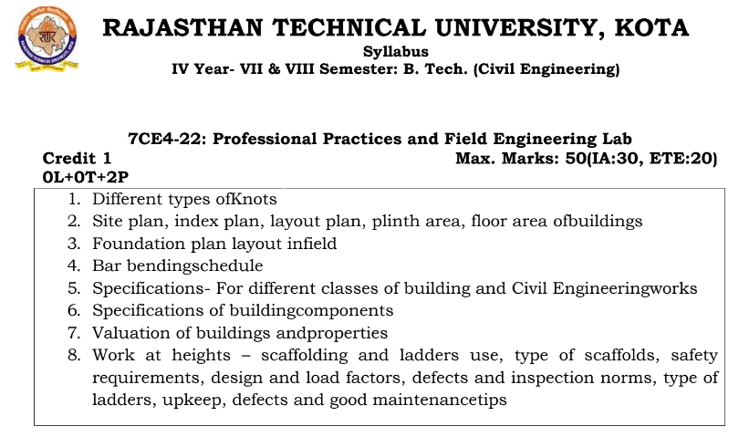

**Course Overview:**

Field Engineering Lab course is designed to provide Civil Engineers with hands-on experience in field testing and measurement techniques. The course covers the following topics:

1. Soil mechanics laboratory testing: Students will learn how to conduct various laboratory tests on soil samples to determine their physical and engineering properties, such as compaction, permeability, and shear strength.
2. Concrete laboratory testing: Students will learn how to test the strength and durability of concrete by conducting compressive strength, flexural strength, and slump tests.
3. Asphalt laboratory testing: Students will learn how to test the properties of asphalt, such as viscosity, flow, and Marshall stability.
4. Surveying and leveling: Students will learn how to use surveying equipment to measure and record elevation, angles, and distances.
5. Material testing: Students will learn how to test the properties of various construction materials, including steel, wood, and masonry.
6. Field inspection and documentation: Students will learn how to inspect and document construction sites, and how to detect and report potential issues.

The course includes a mix of classroom lectures and laboratory practicals to provide students with a comprehensive understanding of field engineering techniques. The course is designed to be hands-on and interactive, with an emphasis on real-world applications of the material covered.

**Course Outcomes:**

|  |  |  |
| --- | --- | --- |
| **CO.NO.** | **Cognitive Level** | **Course Outcome** |
| 1 | **Analysis** | Understand the Different types of Knots Site plan, index plan, layout plan, plinth area, floor area of buildings |
| 2 | **Evaluation** | Understand the Foundation plan layout infield |
| 3 | **Synthesis** | Analysis of Bar bending schedule |
| 4 | **Synthesis** | Understand the Specifications- For different classes of building and Civil Engineering works |
| 5 | **Application** | Understand the Valuation of buildings and properties |

**Prerequisites:**

1. Basic understanding of designs and drawing
2. Understanding of civil engineering materials

**Course Outcome Mapping with Program Outcome:**

|  |  |  |  |  |  |  |  |  |  |  |  |  |  |  |  |
| --- | --- | --- | --- | --- | --- | --- | --- | --- | --- | --- | --- | --- | --- | --- | --- |
| **Course Outcome** | **PO1** | **PO2** | **PO3** | **PO4** | **PO5** | **PO6** | **PO7** | **PO8** | **PO9** | **PO10** | **PO11** | **PO12** | **PSO1** | **PSO2** | **PSO3** |
| 3 | 2 | 2 | 2 | 2 | 1 | 1 | 1 | 2 | 1 | 1 | 2 | 2 | 2 | 2 |
| 2 | 2 | 1 | 1 | 1 | 2 | 1 | 1 | 2 | 2 | 2 | 1 | 1 | 2 | 2 |
| 3 | 2 | 2 | 2 | 2 | 1 | 1 | 1 | 2 | 1 | 1 | 2 | 2 | 2 | 2 |
| 3 | 3 | 3 | 2 | 2 | 1 | 2 | 1 | 2 | 1 | 1 | 1 | 2 | 2 | 1 |
| 3 | 3 | 3 | 2 | 2 | 1 | 2 | 1 | 2 | 1 | 1 | 1 | 2 | 2 | 1 |
| **CO471 (AVG)** | 2.8 | 2.4 | 2.2 | 1.8 | 1.8 | 1.2 | 1.4 | 1 | 2 | 1.2 | 1.2 | 1.4 | 1.8 | 2 | 1.6 |

**Course Coverage Module Wise:**

|  |
| --- |
| **Faculty Lab Manual Link**  <https://drive.google.com/file/d/1cyNIDpgd-uhb5jFUcSxFw5ZLGCvGZOig/view?usp=share_link> |

**Assessment Methodology:**

1. Practical exam.
2. Internal exams and Viva Conduct.
3. Final Exam (practical paper) at the end of the semester.