**Techno India NJR Institute of Technology**



**Road Material Testing Lab (7CE4-21)**

Bharat Suthar

(Assistant Professor)

**Department of CE**

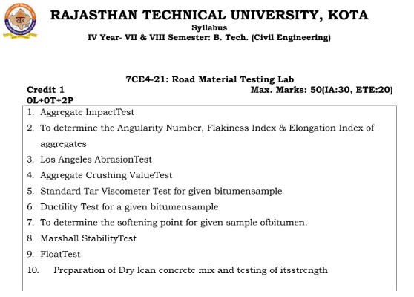

**Course Overview:**

Road material testing is the process of evaluating the physical and mechanical properties of materials used in road construction and maintenance. This may include testing for characteristics such as strength, durability, and elasticity. Common tests include compressive strength testing, flexural strength testing, and abrasion resistance testing. The course overview would likely cover the various types of tests used, the equipment and procedures involved in performing the tests, and the interpretation of test results. It may also cover topics such as quality control and standard specifications for road materials.

**Course Outcomes:**

|  |  |  |
| --- | --- | --- |
| **CO.NO.** | **Cognitive Level** | **Course Outcome** |
| 1 | **Analysis** | Understand the importance and determination of physical properties of aggregates. |
| 2 | **Evaluation** | Understand the importance and determination of physical properties of bitumen. |
| 3 | **Synthesis** | Evaluate and analyze the suitability of materials from data collected by physical tests done on aggregates and bitumen. |
| 4 | **Synthesis** | Design of different bituminous layers of flexible pavement and compare their results with IRC/MoRTH recommendations. |
| 5 | **Application** | Prepare a formal report describing complex design procedures and results. |

**Prerequisites:**

1. Basic understanding of civil engg. Material.
2. Understanding of transportation engg.
3. Basic understanding of Indian road codes.

**Course Outcome Mapping with Program Outcome:**

|  |  |  |  |  |  |  |  |  |  |  |  |  |  |  |  |
| --- | --- | --- | --- | --- | --- | --- | --- | --- | --- | --- | --- | --- | --- | --- | --- |
| **Course Outcome** | **PO1** | **PO2** | **PO3** | **PO4** | **PO5** | **PO6** | **PO7** | **PO8** | **PO9** | **PO10** | **PO11** | **PO12** | **PSO1** | **PSO2** | **PSO3** |
| 3 | 2 | 2 | 2 | 2 | 1 | 1 | 1 | 2 | 1 | 1 | 2 | 2 | 2 | 2 |
| 2 | 2 | 1 | 1 | 1 | 2 | 1 | 1 | 2 | 2 | 2 | 1 | 1 | 2 | 2 |
| 3 | 2 | 2 | 2 | 2 | 1 | 1 | 1 | 2 | 1 | 1 | 2 | 2 | 2 | 2 |
| 3 | 3 | 3 | 2 | 2 | 1 | 2 | 1 | 2 | 1 | 1 | 1 | 2 | 2 | 1 |
| 3 | 3 | 3 | 2 | 2 | 1 | 2 | 1 | 2 | 1 | 1 | 1 | 2 | 2 | 1 |
| **CO471 (AVG)** | 2.8 | 2.4 | 2.2 | 1.8 | 1.8 | 1.2 | 1.4 | 1 | 2 | 1.2 | 1.2 | 1.4 | 1.8 | 2 | 1.6 |

**Course Coverage Module Wise:**

|  |  |  |
| --- | --- | --- |
| Lab No. | Exp.  No. | Topic |
| 1 | 1 | Aggregate Impact Test. |
| 2 | 2 | To determine the Angularity Number, Flakiness Index & Elongation Index of aggregates. |
| 3 | 3 | Los Angeles Abrasion Test. |
| 4 | 4 | Aggregate Crushing Value Test. |
| 5 | 5 | Standard Tar Viscometer Test for given bitumen sample. |
| 6 | 6 | Ductility Test for a given bitumen sample. |
| 7 | 7 | To determine the softening point for given sample of bitumen. |
| 8 | 8 | Marshall Stability Test. |
| 9 | 9 | Float Test. |
| 10 | 10 | Preparation of Dry lean concrete mix and testing of its strength. |

|  |
| --- |
| **Faculty Lab Manual Link**  <https://drive.google.com/file/d/12H_9odeY1SSXebi4FIOcsI31kBaatijg/view?usp=share_link> |

**Assessment Methodology:**

1. Practical exam.
2. Internal exams and Viva Conduct.
3. Final Exam (practical paper) at the end of the semester.