**Techno India NJR Institute of Technology**



**Soft Skills Lab**

**(7CE4-23)**

Rakesh Yadav

(Associate Professor)

**Department of CE**

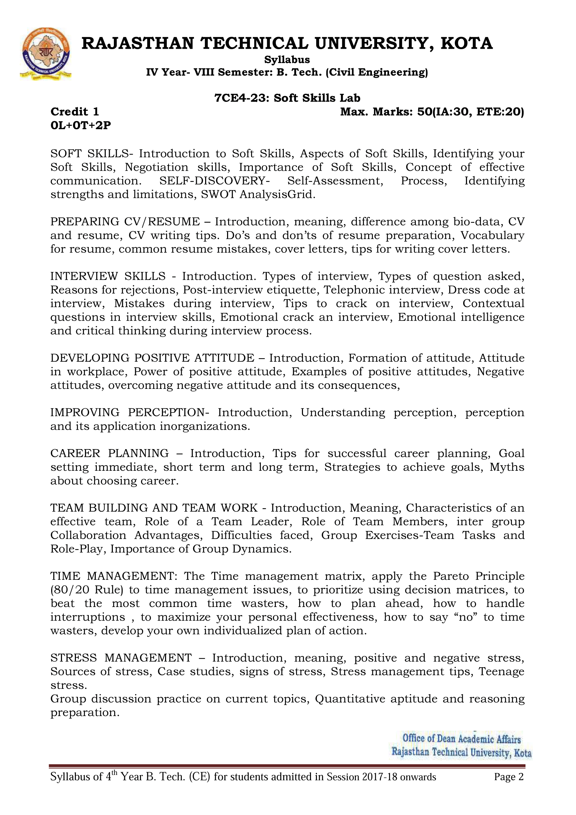**Course Overview:**

A soft skills course would typically cover a wide range of interpersonal and professional skills that are essential for success in the workplace. These skills include:

1. Communication: Understanding how to effectively convey ideas and information, both verbally and in writing.
2. Teamwork: Learning how to collaborate and work effectively with others in a team environment.
3. Leadership: Developing the skills needed to lead and manage others, including decision making, problem solving and conflict resolution.
4. Time management: Learning how to prioritize tasks and manage one's time effectively.
5. Interpersonal skills: Understanding how to build and maintain positive relationships with colleagues, customers and clients.
6. Problem solving: Developing the ability to identify and solve problems in a logical and efficient manner.
7. Adaptability: Being able to adjust to new or changing situations and environments.\
8. Emotional Intelligence: Being able to understand and manage one's own emotions and the emotions of others.
9. Professionalism: Understanding the importance of ethics, integrity and professionalism in the workplace.
10. Presentation skills: Developing the ability to present information in a clear and organized manner.

The course may also include interactive activities, group discussions and role-playing exercises to help students practice and apply the skills they are learning.

**Course Outcomes:**

|  |  |  |
| --- | --- | --- |
| **CO.NO.** | **Cognitive Level** | **Course Outcome** |
| 1 | **Analysis** | To encourage the all-round development of students by focusing on soft skills. |
| 2 | **Evaluation** | To make the engineering students aware of the importance, the role and the content of soft skills through instruction, knowledge acquisition, demonstration and practice |
| 3 | **Synthesis** | To test the practices about Time management |
| 4 | **Synthesis** | To develop and nurture the soft skills of the students through individual and group activities. |
| 5 | **Application** | To expose students to right attitudinal and behavioral aspects and to build the same through activities |

**Prerequisites:**

1. Knowledge of basic ethics and English grammar.

**Course Outcome Mapping with Program Outcome:**

|  |  |  |  |  |  |  |  |  |  |  |  |  |  |  |  |
| --- | --- | --- | --- | --- | --- | --- | --- | --- | --- | --- | --- | --- | --- | --- | --- |
| **Course Outcome** | **PO1** | **PO2** | **PO3** | **PO4** | **PO5** | **PO6** | **PO7** | **PO8** | **PO9** | **PO10** | **PO11** | **PO12** | **PSO1** | **PSO2** | **PSO3** |
| 3 | 3 | 3 | 3 | 2 | 2 | 2 | 1 | 1 | 1 | 2 | 3 | 2 | 1 | 1 |
| 3 | 2 | 2 | 3 | 2 | 1 | 2 | 1 | 1 | 1 | 1 | 1 | 2 | 1 | 1 |
| 2 | 2 | 2 | 1 | 2 | 2 | 2 | 2 | 1 | 1 | 2 | 1 | 1 | 1 | 1 |
| 3 | 2 | 2 | 3 | 2 | 1 | 2 | 1 | 1 | 1 | 1 | 1 | 2 | 1 | 1 |
| 2 | 2 | 2 | 1 | 2 | 2 | 2 | 2 | 1 | 1 | 2 | 1 | 1 | 1 | 1 |
| CO475 (AVG) | 2.6 | 2.2 | 2.2 | 2.2 | 2 | 1.6 | 2 | 1.4 | 1 | 1 | 1.6 | 1.4 | 1.6 | 1 | 1 |

**Course Coverage Module Wise:**

|  |  |  |
| --- | --- | --- |
| Lab No. | Exp.  No. | Topic |
| 1 | 1 | SOFT SKILLS- Introduction to Soft Skills, Aspects of Soft Skills, Identifying your Soft Skills |
| 2 | 2 | Negotiation skills, Importance of Soft Skills, Concept of effective communication |
| 3 | 3 | SELF-DISCOVERY- Self-Assessment, Process, Identifying strengths and limitations, SWOT analysis grid |
| 4 | 4 | PREPARING CV/RESUME – Introduction, meaning, difference among bio-data, CV and resume, CV writing tips |
| 5 | 5 | Do’s and don’ts of resume preparation, Vocabulary for resume, common resume mistakes, cover letters, tips for writing cover letters |
| 6 | 6 | INTERVIEW SKILLS - Introduction. Types of interview, Types of question asked, Reasons for rejections, Post-interview etiquette |
| 7 | 7 | Telephonic interview, Dress code at interview, Mistakes during interview, Tips to crack on interview |
| 8 | 8 | Contextual questions in interview skills, Emotional crack an interview, Emotional intelligence and critical thinking during interview process |
| 9 | 9 | DEVELOPING POSITIVE ATTITUDE – Introduction, Formation of attitude, Attitude in workplace, Power of positive attitude, Examples of positive attitudes, Negative attitudes |
| 10 | 10 | Overcoming negative attitude and its consequences, |
| 11 | 11 | IMPROVING PERCEPTION- Introduction, Understanding perception, perception and its application in organizations |
| 12 | 12 | CAREER PLANNING – Introduction, Tips for successful career planning, Goal setting immediate, short term and long term, Strategies to achieve goals, Myths about choosing career |
| 13 | 13 | TEAM BUILDING AND TEAM WORK - Introduction, Meaning, Characteristics of an effective team, Role of a Team Leader |
| 14 | 14 | Role of Team Members, inter group Collaboration Advantages, Difficulties faced, Group Exercises-Team Tasks and Role-Play, Importance of Group Dynamics |
| 15 | 15 | TIME MANAGEMENT: The Time management matrix, apply the Pareto Principle (80/20 Rule) to time management issues, to prioritize using decision matrices, to beat the most common time wasters, how to plan ahead, how to handle interruptions , to maximize your personal effectiveness, how to say “no” to time wasters, develop your own individualized plan of action |
| 16 | 16 | STRESS MANAGEMENT – Introduction, meaning, positive and negative stress, Sources of stress, Case studies, signs of stress, Stress management tips, Teenage stress. |
| 17 | 17 | Group discussion practice on current topics, Quantitative aptitude and reasoning preparation |

|  |
| --- |
| **Faculty Lab Manual Link**  <https://drive.google.com/file/d/1CoPUT2MAcwf5TbHPV46rZ6Wo6vXQqix8/view?usp=share_link> |

**Assessment Methodology:**

1. Practical exam Of Environmental lab Experiment
2. Internal exams and Viva Conduct.
3. Final Exam (practical paper) at the end of the semester.