**Techno India NJR Institute of Technology**



Transportation Engineering

**(Subject Code: 7CE4-01)**

Bharat K Suthar

(Assistant Professor)

**Department of CE**

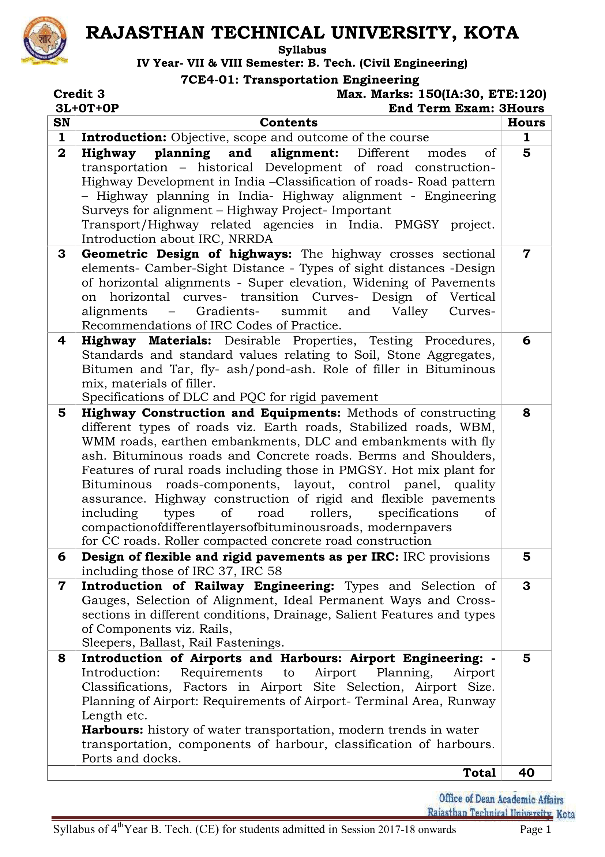

**Course Overview:**

This course is designed for engineering students who would like to understand the role of railway engineering in transportation system. The course is suitable for civil, engineering students. The information provided in this course falls into three categories:

1) Railway engineering and its comparison with Highways,

2) Introduction to Bridge Engineering, and

3) Introduction to airport engineering

**Course Outcomes:**

|  |  |  |
| --- | --- | --- |
| **CO. NO.** | **Cognitive Level** | **Course Outcome** |
| 1 | Analysis | To understand the principles of Highway geometrics design as per IRC standards. Perform geometric design for the Highway & Basic concept of Pavement design. |
| 2 | Application | To understand Types of pavements & Materials required for highway construction. Construction procedures for different types of pavements. Maintenance procedures for different types of pavements. |
| 3 | Design | To understand the Traffic engineering & different types of traffic control device. |
| 4 | Design | Analysing the strength required for pavement and designing flexible and rigid pavement by different methods. |
| 5 | Synthesis | Describe and understand the various components of railway track. |

**Prerequisites:**

1. Basic knowledge of Indian Road Codes
2. Basic knowledge of planning
3. Knowledge of Surveying subject.
4. Knowledge of Horizontal and vertical curves.

**Course Outcome Mapping with Program Outcome:**

|  |  |  |  |  |  |  |  |  |  |  |  |  |  |  |  |
| --- | --- | --- | --- | --- | --- | --- | --- | --- | --- | --- | --- | --- | --- | --- | --- |
| **Transportation Engineering** | | | | | | | | | | | | | | | |
| **Course Outcome** | **PO1** | **PO2** | **PO3** | **PO4** | **PO5** | **PO6** | **PO7** | **PO8** | **PO9** | **PO10** | **PO11** | **PO12** | **PSO1** | **PSO2** | **PSO3** |
| **CO471.1** | 3 | 2 | 2 | 2 | 2 | 1 | 1 | 1 | 2 | 1 | 1 | 2 | 2 | 2 | 2 |
| **CO471.2** | 2 | 2 | 1 | 1 | 1 | 2 | 1 | 1 | 2 | 2 | 2 | 1 | 1 | 2 | 2 |
| **CO471.3** | 3 | 2 | 2 | 2 | 2 | 1 | 1 | 1 | 2 | 1 | 1 | 2 | 2 | 2 | 2 |
| **CO471.4** | 3 | 3 | 3 | 2 | 2 | 1 | 2 | 1 | 2 | 1 | 1 | 1 | 2 | 2 | 1 |
| **CO471.5** | 3 | 3 | 3 | 2 | 2 | 1 | 2 | 1 | 2 | 1 | 1 | 1 | 2 | 2 | 1 |
| **CO471 (AVG)** | 2.8 | 2.4 | 2.2 | 1.8 | 1.8 | 1.2 | 1.4 | 1 | 2 | 1.2 | 1.2 | 1.4 | 1.8 | 2 | 1.6 |

**Course Coverage Module Wise:**

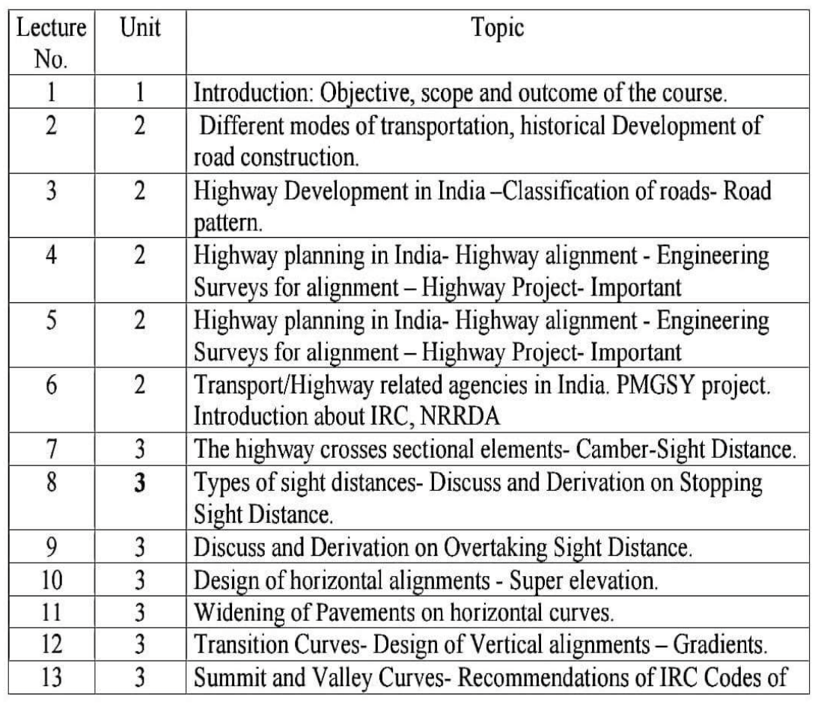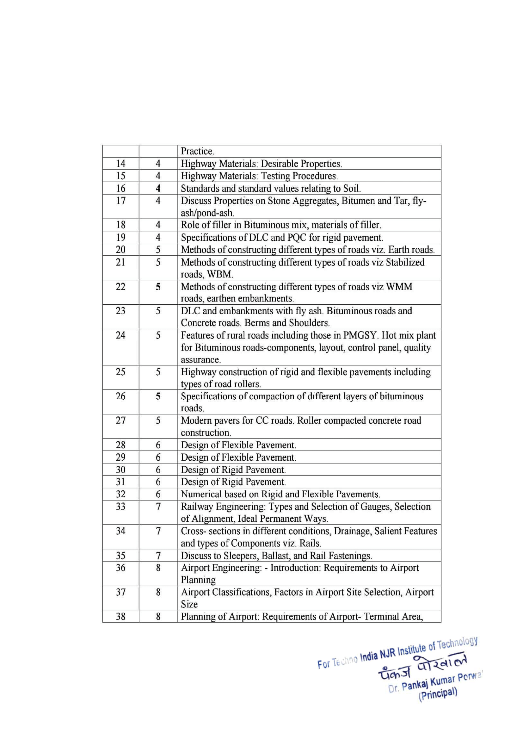

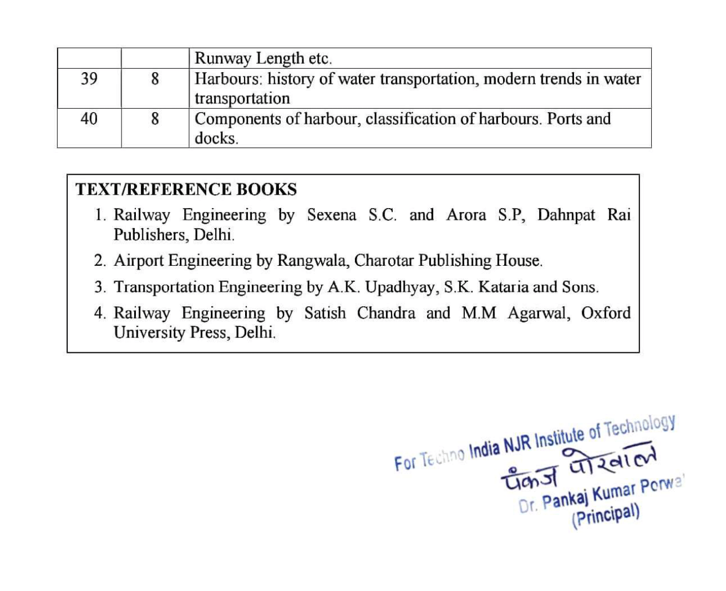

**Assessment Methodology:**

1. Practical exam in lab where they have to write Tests Related to the Quality of road material and construction. (Once in a week)
2. Assignments one from each unit.
3. Midterm subjective paper where they have to write about concepts related to road materials.
4. Final paper at the end of the semester subjective.

**Teaching and Learning resources unit-wise:**

**Theory concepts**

**https://nptel.ac.in/courses/105101087**

<https://www.iare.ac.in/sites/default/files/lecture_notes/IARE_TEI_Lecture_Notes.pdf>

<https://vssut.ac.in/doc/Transportation-1_Lecture-Note.pdf>