**Techno India NJR Institute of Technology**



**Lab Manual**

**Mobile Application Development Lab (6CS4-24)**

**Gaurav Kumawat**

**Department of CSE**

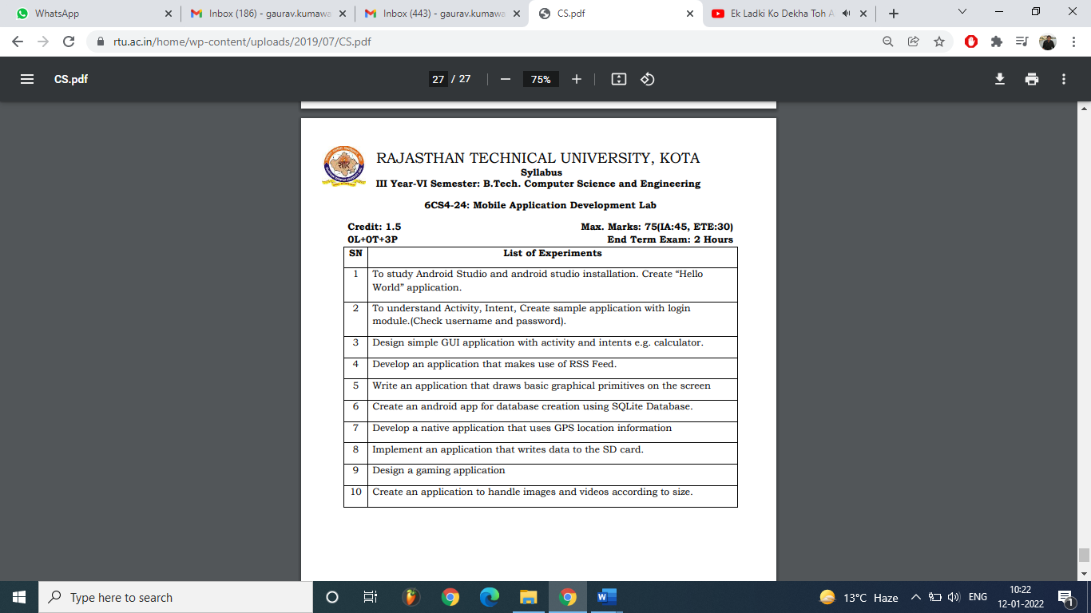

**Experiment 1**

## To study android studio and its installation. Create “Hello World” application.

#### Simple application to change font size and color of text view

1. Open eclipse or android studio and select new androidproject

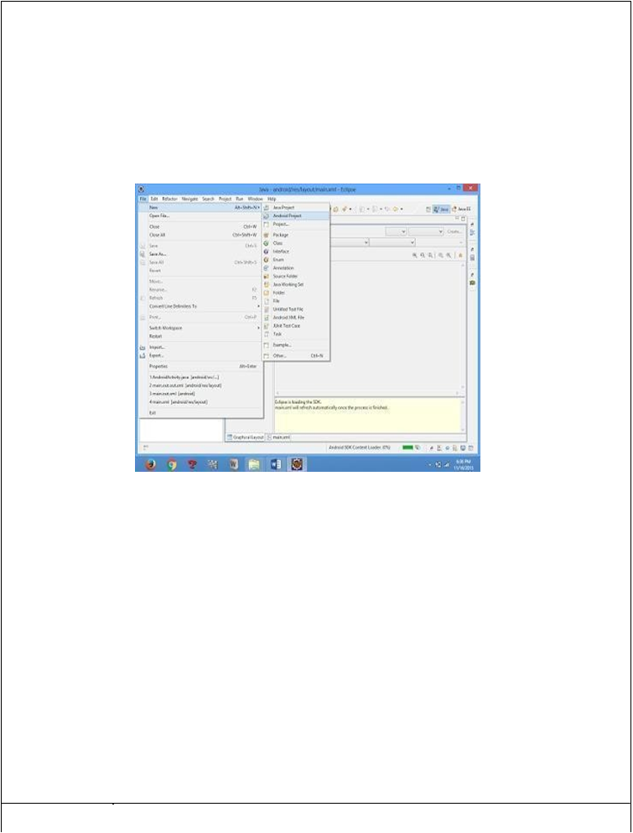

1. Give project name and select next
2. Choose the android version. Choose the lowest android version (Android 2.2) and selectnext
3. Enter the package name. Package name must be two word separated by comma and clickfinish
4. Go to package explorer in the left hand side. Select ourproject.
5. Go to res folder and select layout. Double click the main.xmlfile
6. Now you can see the Graphics layoutwindow.

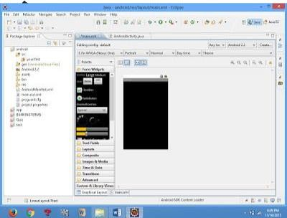

1. Click the main.xml file and type the codebelow

Code:

<?xml version="1.0" encoding="utf-8"?>

<LinearLayoutxmlns:android=["http://schemas.android.com/apk/res/android"](http://schemas.android.com/apk/res/android)android:layout_width="fill_parent" android:layout_height="fill_parent" android:orientation="vertical" >

<TextViewandroid:id="@+id/textView1" android:layout_width="match_parent" android:layout_height="wrap_content" android:layout_margin="20sp" android:gravity="center" android:text="HELLO WORLD" android:textSize="20sp" android:textStyle="bold" />

<Button

android:id="@+id/button1" android:layout_width="match_parent" android:layout_height="wrap_content"

android:gravity="center" android:text="Change font size" android:textSize="20sp"/>

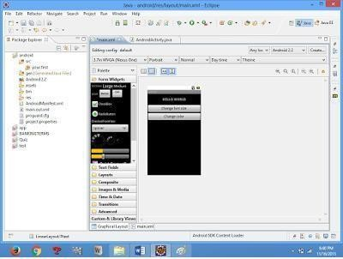

<Button android:id="@+id/button2"

android:layout_width="match_parent"

android:layout_height="wrap_content" android:gravity="center" android:text="Change color" android:textSize="20sp"/>

<Button

android:id="@+id/button3" android:layout_width="match_parent" android:layout_height="wrap_content" android:gravity="center" android:text="Change font" android:textSize="20sp" />

</LinearLayout>

1. ***Again click the graphics layout tab and screen layout is look likebelow***
2. Go to project explorer and select *src*folder.Now select mainactivity.java file and type the followingcode.

PROGRAM

#### import android.R; import android.app.Activity; import android.graphics.Color; import android.graphics.Typeface; import android.os.Bundle; import android.view.View; import android.widget.Button; import android.widget.TextView;

public class AndroidActivity extends Activity

{ floatfont =24; int i=1;

#### @Override public void onCreate(Bundle savedInstanceState){ super.onCreate(savedInstanceState); setContentView(R.layout.main);

final TextView t1=(TextView) findViewById(R.id.textView1); Button b1 = (Button)findViewById(R.id.button1);

b1.setOnClickListener(new View.OnClickListener() {

public void onClick(View view) { t1.setTextSize(font);

font=font+4; if(font==40) font=20;

}

});

Button b2 = (Button) findViewById(R.id.button2); b2.setOnClickListener(new View.OnClickListener() {

public void onClick(View view) {

switch(i)

{ case1:

t1.setTextColor(Color.parseColor("#0000FF ")); break; case2:

t1.setTextColor(Color.parseColor("#00FF00 ")); break; case3:

t1.setTextColor(Color.parseColor("#FF0000")); break; case 4: t1.setTextColor(Color.parseColor("#800000")); break;

} i++;

if(i==5) i=1;

}

});

} }

1. Now go to main.xml and right click .select run as option and select runconfiguration

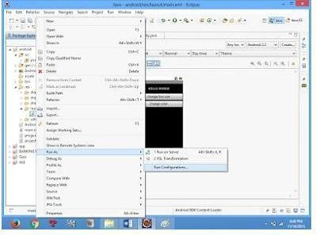

1. Android output is present in the android emulator as shown inbelow.

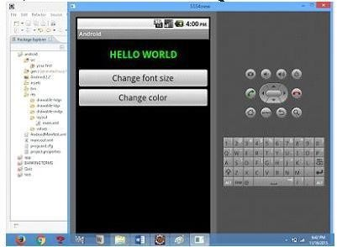

Experiment 2

## To understand activity, Intent, Create sample application with login module.

1. Open eclipse or android studio and select new androidproject
2. Give project name and selectnext
3. Choose the android version. Choose the lowest android version (Android 2.2) and selectnext
4. Enter the package name. Package name must be two word separated by comma and clickfinish
5. Go to package explorer in the left hand side. select ourproject.
6. Go to res folder and select layout. Double click the main.xml file. Add the codebelow

<RelativeLayoutxmlns:android=["http://schemas.android.com/apk/res/android"](http://schemas.android.com/apk/res/android)android:id="@+id/relativeLayout1" android:layout_width="fill_parent" android:layout_height="fill_parent">

<LinearLayout

android:id="@+id/linearLayout1" android:layout_width="wrap_content" android:layout_height="wrap_content" android:layout_alignParentLeft="true" android:layout_alignParentRight="true" android:layout_alignParentTop="true" >

<TextViewandroid:layout_width="wrap_content" android:layout_height="wrap_content" android:layout_gravity="center" android:text="ADDITION" android:textSize="20dp"

/TextView>

</LinearLayout><LinearLayoutandroid:id="@+id/linearLayout2" android:layout_width="wrap_content" android:layout_height="wrap_content" android:layout_alignParentLeft="true" android:layout_alignParentRight="true" android:layout_below="@+id/linearLayout1" >

<TextViewandroid:layout_width="wrap_content" android:layout_height="wrap_content" android:text="ENTER NO 1">

</TextView><EditTextandroid:layout_width="wrap_content" android:layout_height="wrap_content" android:layout_weight="0.20" android:id="@+id/edittext1" android:inputType="number">

</EditText>

</LinearLayout><LinearLayoutandroid:id="@+id/linearLayout3" android:layout_width="wrap_content" android:layout_height="wrap_content" android:layout_alignParentLeft="true" android:layout_alignParentRight="true" android:layout_below="@+id/linearLayout2" >

<TextViewandroid:layout_width="wrap_content" android:layout_height="wrap_content" android:text="ENTER NO 2" >

</TextView><EditTextandroid:layout_width="wrap_content"

android:layout_height="wrap_content" android:layout_weight="0.20" android:id="@+id/edittext2" android:inputType="number">

</EditText>

</LinearLayout><LinearLayoutandroid:id="@+id/linearLayout4" android:layout_width="wrap_content" android:layout_height="wrap_content" android:layout_alignParentLeft="true" android:layout_alignParentRight="true"

android:layout_below="@+id/linearLayout3" >

<Button android:layout_width="wrap_content" android:id="@+id/button1" android:layout_height="wrap_content" android:text="Addition" android:layout_weight="0.50"/>

<Button android:layout_width="wrap_content" android:id="@+id/button3" android:layout_height="wrap_content" android:text="subtraction" android:layout_weight="0.50"/>

<Button android:layout_width="wrap_content" android:id="@+id/button2" android:layout_height="wrap_content" android:text="CLEAR" android:layout_weight="0.50" />

</LinearLayout>

<View android:layout_height="2px" android:layout_width="fill_parent"

android:layout_below="@+id/linearLayout4" android:background="#DDFFDD"/>

</RelativeLayout>

1. Now select mainactivity.java file and type the followingcode.

package layout.ne;

import android.app.Activity; import android.os.Bundle; import android.view.View; import

android.view.View.OnClickListener; import android.widget.Button; import android.widget.EditText; import android.widget.Toast;

public class LAYOUTActivity extends Activity {

/** Called when the activity is first created. */ EditText txtData1,txtData2; float num1,num2,result1,result2;

@Override

public void onCreate(Bundle savedInstanceState) { super.onCreate(savedInstanceSt ate);

setContentView(R.layout.main);

Button add = (Button) findViewById(R.id.button1); add.setOnClickListener(new

OnClickListener(){ public

void onClick(View v) { try

{

txtData1 = (EditText)

findViewById(R.id.edittext1); txtData2 = (EditText) findViewById(R.id.edittext2); num1 = Float.parseFloat(txtData1.getTe xt().toString()); num2

=

Float.parseFloat(txtData2.getTe xt().toString()); result1=num1+num2;

Toast.makeText(getBaseContext(),"ANSWER:"+result1,Toast.LENGTH_SHORT).show();

}

catch(Exception e)

{

Toast.makeText(getBaseContext(), e.getMessage(), Toast.LENGTH_SHORT).show();

}

}

});

Button sub = (Button) findViewById(R.id.button3); sub.setOnClickListener(new OnClickListener() {

try

public void onClick(View v) {

{

txtData1 = (EditText) findViewById(R.id.edittext1);

txtData2 =(EditText)findViewById(R.id.edittext2); num1 = Float.parseFloat(txtData1.getText().toString()); num2 = Float.parseFloat(txtData2.getText().toString());

result2=num1-num2;

Toast.makeText(getBaseContext(),"ANSWER:"+result2,Toast.LENGTH_SHORT).show();

}

catch(Exception e)

{

Toast.makeText(getBaseContext(), e.getMessage(), Toast.LENGTH_SHORT).show();

}

}

});

Button clear = (Button) findViewById(R.id.button2); clear.setOnClickListener(new OnClickListener() {

try

public void onClick(View v) {

{

txtData1.setText("");

txtData2.setText("");

}

catch(Exception e)

{

}

}

});

} }

Toast.makeText(getBaseContext(), e.getMessage(), Toast.LENGTH_SHORT).show();

1. ow go to main.xml and right click .select run as option and select runconfiguration
2. Android output is present in the android emulator as shown inbelow.

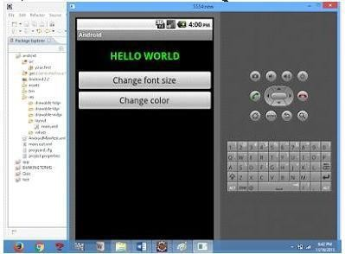

Experiment 3

## Design simple GUI application with activity and Intents e. g. calculator.

* 1. Open eclipse or android studio and select new androidproject
  2. Give project name and selectnext
  3. Choose the android version. Choose the lowest android version(Android 2.2) and selectnext
  4. Enter the package name. package name must be two word separated by comma and clickfinish
  5. Go to package explorer in the left hand side. select ourproject.
  6. Go to res folder and select layout. Double click the main.xml file. Add the codebelow

#### Main.xml coding

<?xml version="1.0" encoding="utf-8"?>

<LinearLayoutxmlns:android=["http://schemas.android.com/apk/res/android"](http://schemas.android.com/apk/res/android)android:orientation="vertical" android:layout_width="fill_parent" android:layout_height="fill_parent">

<LinearLayoutandroid:layout_width="match_parent" android:layout_height="wrap_content" android:id="@+id/linearLayout1" android:layout_marginLeft="10pt" android:layout_marginRight="10pt" android:layout_marginTop="3pt">

<EditTextandroid:layout_weight="1" android:layout_height="wrap_content" android:layout_marginRight="5pt" android:id="@+id/etNum1" android:layout_width="match_parent" android:inputType="numberDecimal">

</EditText><EditTextandroid:layout_height="wrap_content" android:layout_weight="1" android:layout_marginLeft="5pt" android:id="@+id/etNum2" android:layout_width="match_parent" android:inputType="numberDecimal">

</EditText>

</LinearLayout><LinearLayoutandroid:layout_width="match_parent" android:layout_height="wrap_content" android:id="@+id/linearLayout2" android:layout_marginTop="3pt" android:layout_marginLeft="5pt" android:layout_marginRight="5pt">

<Button android:layout_height="wrap_content" android:layout_width="match_parent" android:layout_weight="1" android:text="+"

android:textSize="15pt" android:id="@+id/btnAdd">

</Button><Button android:layout_height="wrap_content" android:layout_width="match_parent" android:layout_weight="1" android:text="-" android:textSize="15pt" android:id="@+id/btnSub">

</Button><Button android:layout_height="wrap_content" android:layout_width="match_parent" android:layout_weight="1" android:text="*" android:textSize="15pt" android:id="@+id/btnMult">

</Button><Button android:layout_height="wrap_content" android:layout_width="match_parent"

android:layout_weight="1" android:text="/" android:textSize="15pt" android:id="@+id/btnDiv"></Button>

</LinearLayout><TextViewandroid:layout_height="wrap_content" android:layout_width="match_parent" android:layout_marginLeft="5pt" android:layout_marginRight="5pt" android:textSize="12pt" android:layout_marginTop="3pt" android:id="@+id/tvResult" android:gravity="center_horizontal">

</TextView>

</LinearLayout>

* 1. Now select mainactivity.java file and type the following code.package

MainActivity.java coding package CALCU.CALU; import android.app.Activity;

import android.os.Bundle; import android.text.TextUtils; import android.view.View; import

android.view.View.OnClickListener; import android.widget.Button; import android.widget.EditText; import android.widget.TextView;

public class CALCULATORActivity extends Activity implements OnClickListener

{ EditText input1;

EditText input2;

Button addition; Button subtraction;

Button multiplication; Button division;

TextViewtvResult; String oper = "";

@Override

public void onCreate(Bundle savedInstanceState) { super.onCreate(savedInstanceState); setContentView(R.layout.main); input1 = (EditText)findViewById(R.id.etNum1); input2

= (EditText) findViewById(R.id.etNum2);

addition = (Button) findViewById(R.id.btnAdd); subtraction = (Button) findViewById(R.id.btnSub); multiplication = (Button) findViewById(R.id.btnMult); division = (Button) findViewById(R.id.btnDiv); tvResult = (TextView) findViewById(R.id.tvResult);

// set a listener addition.setOnClickListener(this); subtraction.setOnClickListener(this); multiplication.setOnClickListener(this); division.setOnClickListener(this);

}

@Override

public void onClick(Viewv){ // TODO Auto-generated methodstub

float num1= 0; float num2 =0;

float result = 0;

// check if the fieldsareempty if (TextUtils.isEmpty(input1.getText().toString())

|| TextUtils.isEmpty(input2.getText().toString())){ return; }

// read EditText and fill variables with numbers num1 = Float.parseFloat(input1.getText().toString()); num2 = Float.parseFloat(input2.getText().toString());

// defines the button that has been clicked and performs the corresponding operation

// write operation into oper, we will use it later for output switch(v.getId()){ case R.id.btnAdd: oper= "+"; result

= num1 + num2; break; case R.id.btnSub:

oper= "-"; result

= num1 - num2; break;caseR.id.btnMult:

oper= "*"; result

= num1 * num2; break;caseR.id.btnDiv:

oper = "/"; result

= num1 / num2; break; default: break;

}

/ form the output line

tvResult.setText(num1 + " " + oper + " " + num2 + " = " + result);

}

}

* 1. Android output is present in the android emulator as Shown inbelow

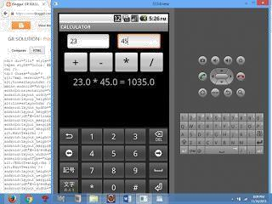

# Experiment 5

## Write An Application That Draws Basic Graphical Primitives on The Screen In Android

1. Open eclipse or android studio and select new androidproject
2. Give project name and selectnext
3. Choose the android version. Choose the lowest android version(Android 2.2) and selectnext
4. Enter the package name. package name must be two word separated by comma andclick finish
5. Go to package explorer in the left hand side. select ourproject.
6. Go to res folder and select layout. Double click the main.xml file. Don’tchange anything in layout. Leave as default.
7. Now select mainactivity.java file and type the followingcode.

package Basic.primitive; import android.app.Activity; import android.content.Context; import android.graphics.Canvas

; import android.graphics.Color; import android.graphics.Paint; import android.os.Bundle; import android.view.View;

public class BasicprimitiveActivity extends Activity {

/** Called when the activity is first created. */ @Override

public void onCreate(Bundle savedInstanceState) { super.onCreate(savedInstanceState); setContentView(new myview(this));

}

private class myview extends View

{

public myview(Context context)

{

super(context);

}

@Override

protected void onDraw(Canvas canvas)

|  |  |  |
| --- | --- | --- |
| ***{*** |  |  |
| ***super.onDraw(canvas);*** | ***Paint*** | |
| ***paint=new Paint();*** |  |  |
| ***paint.setTextSize(40);*** |  |  |
| ***paint.setColor(Color.GREEN);*** | | |
| ***canvas.drawText("Circle", 55, 30,*** | | |
| ***paint);*** |  |  |
| ***paint.setColor(Color.RED);*** | | |
| ***canvas.drawCircle(100, 150,100, paint);*** | | |
| ***paint.setColor(Color.GREEN);*** | | |
| ***canvas.drawText("Rectangle", 255, 30, paint);*** | | |
| ***paint.setColor(Color.YELLOW);*** | | ***canvas.drawRect(250,*** |
| ***50,400,350, paint);*** | ***paint.setColor(Color.GREEN);*** | |
| ***canvas.drawText("SQUARE", 55, 430, paint);*** | | |
| ***paint.setColor(Color.BLUE);*** | | ***canvas.drawRect(50,*** |
| ***450,150,550, paint);*** | ***paint.setColor(Color.GREEN);*** | |

canvas.drawText("LINE", 255, 430, paint); paint.setColor(Color.CYAN);

canvas.drawLine(250, 500, 350, 500, paint);

}

}

}

1. Now go to main.xml and right click .select run as option and select runconfiguration
2. Android output is present in the android emulator as shown inbelow.

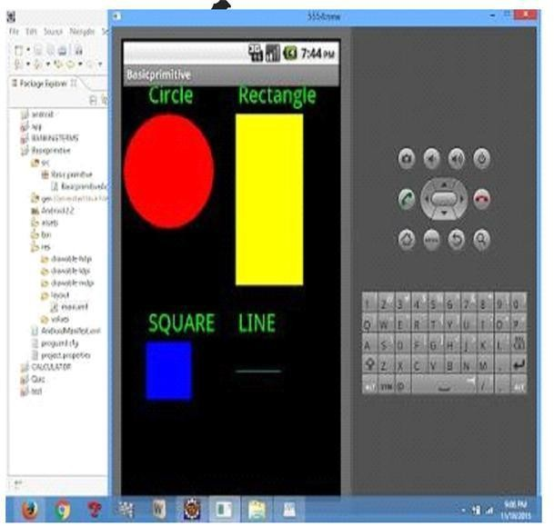

# Experiment 5

## Create an android app for database creation using SQLite database.

1. Open eclipse or android studio and select new androidproject
2. Give project name and selectnext
3. Choose the android version. Choose the lowest android version (Android 2.2) and selectnext
4. Enter the package name. package name must be two word separated by comma and clickfinish
5. Go to package explorer in the left hand side. select ourproject.
6. Go to res folder and select layout. Double click the main.xml file. Add the codebelow

<?xml version="1.0" encoding="utf-8"?>

<AbsoluteLayoutxmlns:android=["http://schemas.android.com/apk/res/android"](http://schemas.android.com/apk/res/android)android:id="@+id/myLayout" android:stretchColumns="0" android:layout_width="fill_parent" android:layout_height="fill_parent"><TextViewandroid:text="@string/title" android:layout_x="110dp" android:layout_y="10dp"

android:layout_width="wrap_content" android:layout_height="wrap_content"/><TextViewandroid:text="@string/empid" android:layout_x="30dp"

android:layout_y="50dp" android:layout_width="wrap_content" android:layout_height="wrap_content"/><EditTextandroid:id="@+id/editEmpid" android:inputType="number" android:layout_x="150dp" android:layout_y="50dp"

android:layout_width="150dp" android:layout_height="40dp"/><TextViewandroid:text="@string/name" android:layout_x="30dp" android:layout_y="100dp" android:layout_width="wrap_content" android:layout_height="wrap_content"/><EditTextandroid:id="@+id/editName" android:inputType="text" android:layout_x="150dp" android:layout_y="100dp" android:layout_width="150dp" android:layout_height="40dp"/><TextViewandroid:text="@string/salary"

android:layout_x="30dp" android:layout_y="150dp" android:layout_width="wrap_content" android:layout_height="wrap_content"/><EditTextandroid:id="@+id/editsalary" android:inputType="number" android:layout_x="150dp" android:layout_y="150dp" android:layout_width="150dp" android:layout_height="40dp"/><Button android:id="@+id/btnAdd" android:text="@string/add" android:layout_x="30dp" android:layout_y="200dp" android:layout_width="130dp" android:layout_height="40dp"/><Button android:id="@+id/btnDelete" android:text="@string/delete"

android:layout_x="160dp" android:layout_y="200dp" android:layout_width="130dp" android:layout_height="40dp"/>n <Button android:id="@+id/btnModify" android:text="@string/modify" android:layout_x="30dp" android:layout_y="250dp" android:layout_width="130dp" android:layout_height="40dp"/><Button android:id="@+id/btnView" android:text="@string/view" android:layout_x="160dp" android:layout_y="250dp" android:layout_width="130dp" android:layout_height="40dp"/><Button android:id="@+id/btnViewAll" android:text="@string/view_all" android:layout_x="85dp" android:layout_y="300dp" android:layout_width="150dp"

android:layout_height="40dp"/>

</AbsoluteLayout>

1. Go to values folder and select string.xml file. Replace the codebelow

<?xml version="1.0" encoding="utf-8"?>

<resources>

<string name="app_name">Employee detail1</string>

<string name="hello">Hello World, Employee detail Activity!</string><string name="title">Employee Details</string>

<string name="empid">Enter Employee ID: </string>

<string name="name">Enter Name: </string>

<string name="salary">Enter salary: </string>

<string name="add">Add Employee</string>

<string name="delete">Delete Employee</string>

<string name="modify">Modify Employee</string>

<string name="view">View Employee</string>

<string name="view_all">View All Employee</string>

</resources>

1. Now select mainactivity.java file and type the following code.In mycoding maniactivity name isEmployeedetailActivity.

package employee.detail;

//import android.R; import android.app.Activity; import android.app.AlertDialog.Builder; import android.content.Context; import android.database.Cursor; import android.database.sqlite.SQLiteDatabase;

import android.os.Bundle; import android.view.View;

import android.view.View.OnClickListener; import android.widget.Button; import android.widget.EditText;

public class EmployeedetailActivity extends Activity implements OnClickListener

{ EditTexteditEmpid,editName,editsalary;

Button btnAdd,btnDelete,btnModify,btnView,btnViewAll; SQLiteDatabasedb;

/** Called when the activity is first created. */ @Override

public void onCreate(Bundle savedInstanceState)

{

super.onCreate(savedInstanceState); setContentView(R.layout.main); editEmpid=(EditText)findViewById(R.id.editEmpid); editName=(EditText)findViewById(R.id.editName); editsalary=(EditText)findViewById(R.id.editsalary); btnAdd=(Button)findViewById(R.id.btnAdd); btnDelete=(Button)findViewById(R.id.btnDelete); btnModify=(Button)findViewById(R.id.btnModify); btnView=(Button)findViewById(R.id.btnView); btnViewAll=(Button)findViewById(R.id.btnViewAll); btnAdd.setOnClickListener(this); btnDelete.setOnClickListener(this); btnModify.setOnClickListener(this); btnView.setOnClickListener(this); btnViewAll.setOnClickListener(this);

db=openOrCreateDatabase("EmployeeDB", Context.MODE_PRIVATE, null); db.execSQL("CREATE TABLE IF NOT EXISTS employee(empid VARCHAR,nameVARCHAR,salary VARCHAR);");

}

public void onClick(View view)

{

if(view==btnAdd)

{

if(editEmpid.getText().toString().trim().length()==0|| editName.getText().toString().trim().length()==0|| editsalary.getText().toString().trim().length()==0)

{

showMessage("Error", "Please enter all values"); return;

}

db.execSQL("INSERT INTO employee VALUES('"+editEmpid.getText()+"','"+editName.getText()+

"','"+editsalary.getText()+"');");

showMessage("Success", "Record added"); clearText();

}

if(view==btnDelete)

{

if(editEmpid.getText().toString().trim().length()==0)

{

showMessage("Error", "Please enter Employee id"); return; }

Cursor c=db.rawQuery("SELECT * FROM employee WHERE empid='"+editEmpid.getText()+"'", null);

if(c.moveToFirst())

{

db.execSQL("DELETE FROM employee WHERE empid='"+editEmpid.getText()+"'"); showMessage("Success", "Record Deleted");

}else

{

showMessage("Error", "Invalid Employee id");

}

clearText();

}

if(view==btnModify)

{

if(editEmpid.getText().toString().trim().length()==0)

{

showMessage("Error", "Please enter Employee id"); return;

}

Cursor c=db.rawQuery("SELECT * FROM employee WHERE

empid='"+editEmpid.getText()+"'", null); if(c.moveToFirst())

{

db.execSQL("UPDATE employee SET name='"+editName.getText()+"',salary='"+editsalary.getText()+ "'WHERE

empid='"+editEmpid.getText()+"'");

showMessage("Success", "Record Modified");

}

else

{

showMessage("Error", "Invalid Rollno");

}

clearText();

}

if(view==btnView)

{

if(editEmpid.getText().toString().trim().length()==0)

{

showMessage("Error", "Please enter Employee id"); return;

}

Cursor c=db.rawQuery("SELECT * FROM employee WHERE empid='"+editEmpid.getText()+"'", null); if(c.moveToFirst())

{

editName.setText(c.getString(1)); editsalary.setText(c.getString(2));

}

else

{

showMessage("Error", "Invalid Employee id"); clearText();

}

}

if(view==btnViewAll)

{

Cursor c=db.rawQuery("SELECT * FROM employee", null); if(c.getCount()==0)

|  |  |
| --- | --- |
| ***{*** |  |
| ***showMessage("Error", "No records found");*** | ***return;*** |
| ***}*** |  |
| ***StringBuffer buffer=new StringBuffer();*** | ***while(c.moveToNext())*** |
| ***{*** |  |

buffer.append("Employee id: "+c.getString(0)+"\n"); buffer.append("Name: "+c.getString(1)+"\n"); buffer.append("salary: "+c.getString(2)+"\n\n");

}

showMessage("Employee details Details", buffer.toString());

}

}

public void showMessage(String title,String message)

{

Builder builder=new Builder(this); builder.setCancelable(true); builder.setTitle(title); builder.setMessage(message);

builder.show();

}

public voidclearText()

{

editEmpid.setText(""); editName.setText(""); editsalary.setText("");

editEmpid.requestFocus();

}

}

* 1. Now go to main.xml and right click .select run as option and select runconfiguration
  2. Android output is present in the android emulator as shown in below.

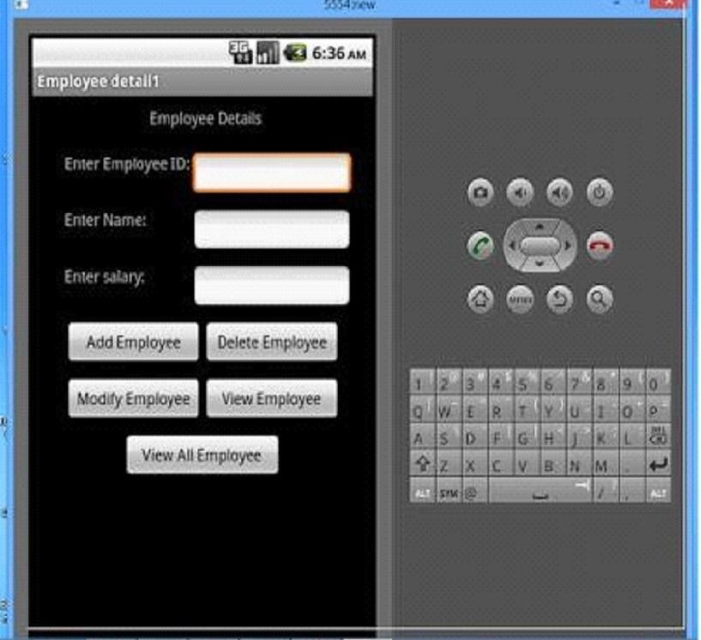

# Experiment 6

## Develop An Application that Makes Use of Rss Feed

1. Open eclipse or android studio and select new androidproject
2. Give project name and selectnext
3. Choose the android version. Choose the lowest android version (Android 2.2) and selectnext
4. Enter the package name. Package name must be two word separated by comma and clickfinish
5. Go to package explorer in the left hand side. Select ourproject.
6. Go to res folder and select layout. Double click the main.xmlfile
7. Now you can see the Graphics layoutwindow.

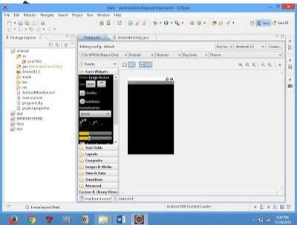

1. Click the main.xml file and type the codebelow

Code:

<?xml version="1.0" encoding="utf-8"?>

<LinearLayoutxmlns:android=["http://schemas.android.com/apk/res/android"](http://schemas.android.com/apk/res/android)

android:layout_width="fill_parent" android:layout_height="fill_parent" android:orientation="vertical" >

<TextViewandroid:id="@+id/textView1" android:layout_width="match_parent" android:layout_height="wrap_content"

android:layout_margin="20sp" android:gravity="center" android:text="HELLO WORLD" android:textSize="20sp" android:textStyle="bold" />

<Button

android:id="@+id/button1" android:layout_width="match_parent" android:layout_height="wrap_content" android:gravity="center" android:text="Change font size" android:textSize="20sp"/>

<Button

android:id="@+id/button2" android:layout_width="match_parent" android:layout_height="wrap_content" android:gravity="center" android:text="Change color" android:textSize="20sp"/>

<Button

android:id="@+id/button3" android:layout_width="match_parent" android:layout_height="wrap_content" android:gravity="center" android:text="Change font" android:textSize="20sp" />

</LinearLayout>

1. Again click the graphics layout tab and screen layout is look likebelow

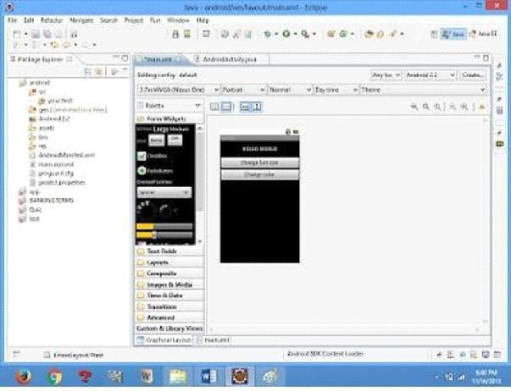

1. Go to project explorer and select *src*folder.Now select mainactivity.java file and type the followingcode.

|  |  |  |  |
| --- | --- | --- | --- |
| **PROGRAM** |  |  |  |
| **import android.R; import** | | | |
| **android.app.Activity; import** | | | |
| **android.graphics.Color; import** | | | |
| **android.graphics.Typeface; import** | | | |
| **android.os.Bundle; import** | | | |
| **android.view.View; import** | | | |
| **android.widget.Button; import** | | | |
| **android.widget.TextView;** | | | |
| **public class AndroidActivity extends Activity {** | | | **Float** |
| **font =24;** | **int i=1;** |  |  |
| **@Override public void onCreate(Bundle** | | | |
| **savedInstanceState) {** | | | |
| **super.onCreate(savedInstanceState);** | | **setContentView(R.layout.main);** | |

#### final TextViewt1=(TextView)findViewById(R.id.textView1); Button b1

= (Button) findViewById(R.id.button1); b1.setOnClickListener(new View.OnClickListener() {

public void onClick(View view) { t1.setTextSize(font);

font=font+4; if(font==40) font=20;

}

});

Button b2 = (Button) findViewById(R.id.button2); b2.setOnClickListener(new View.OnClickListener() {

public void onClick(View view) { switch(i)

{ case1:

t1.setTextColor(Color.parseColor("#0000FF")); break; case2:

t1.setTextColor(Color.parseColor("#00FF00")); break; case3:

t1.setTextColor(Color.parseColor("#FF0000")); break; case 4: t1.setTextColor(Color.parseColor("#800000"));

break;

} i++;

if(i==5) i=1;

}

});

} }

8) Now go to main.xml and right click .select run as option and select run configuration

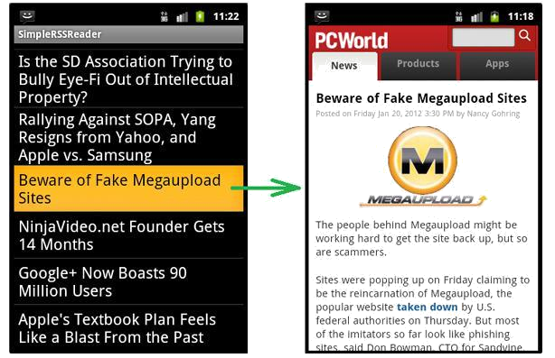

# Experiment 7

## Develop A Native Application That Uses Gps Location Information

1. Open eclipse or android studio and select new androidproject
2. Give project name and selectnext
3. Choose the android version. Choose the lowest android version (Android 2.2) andselect next
4. Enter the package name. package name must be two word separated by commaand clickfinish
5. Go to package explorer in the left hand side. select ourproject.
6. Go to res folder and select layout. Double click the main.xml file. Add the codebelow

<?xml version="1.0"encoding="utf-8"?>

<RelativeLayoutxmlns:android=["http://schemas.android.com/apk/res/android"](http://schemas.android.com/apk/res/android)android:id="@+id/relativeLayout1" android:layout_width="match_parent" android:layout_height="match_parent">

<Button android:id="@+id/show_Location "

android:layout_width="wrap_content" android:layout_height="wrap_contentandroid:text="Show_Location" android:layout_centerVertical="tr ue"

android:layout_centerHorizontal="true"

/>

</RelativeLayout>

1. Now select mainactivity.java file and type the following code. In my coding manactivity name is GPSlocation Activity. Packagegps.location;

//import android.R; import android.app.Activity; import android.os.Bundle; import android.view.View; import android.widget.Butto n; import android.widget.Toast

;

public class GPSlocationActivity extends Activity {

/** Called when the activity is first created. */ Button btnShowLocation;

GPStracegps; @Override

public void onCreate(Bundle savedInstanceState) { super.onCreate(savedInstanceState); setContentView(R.layout.main); btnShowLocation=(Button)findViewById(R.id.show_Location); btnShowLocation.setOnClickListener(new View.OnClickListener(){ @Override

public void onClick(View v) {

// TODO Auto-generated method stub gps=new GPStrace(GPSlocationActivity.this); if(gps.canGetLocation()){

double latitude=gps.getLatitude(); double longitude=gps.getLongtiude(); Toast.makeText(getApplicationContext(),"Your Location is

\nLat:"+latitude+"\nLong:"+longitude, Toast.LENGTH_LONG).show();

}

else

{

gps.showSettingAlert();

}

}

});

}

}

1. Go to src folder and Right Click on your package folder and choose new class and give the class names as GPStrace

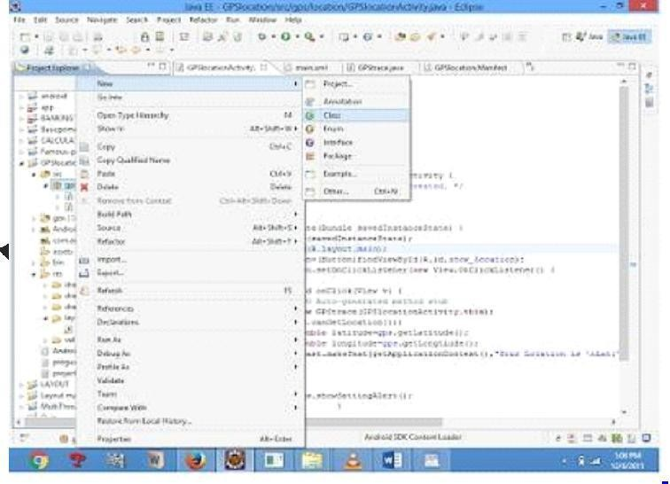

1. Select the GPStrace.java file and paste the followingcode.

Package gps.location;

import android.app.AlertDialog; import android.app.Service; import android.content.Context; import android.content.DialogInterface; import android.content.Intent; import android.location.Location; import android.location.LocationListener

; import android.location.LocationManage r; import android.os.Bundle; import android.os.IBinder; import android.provider.Settings;

public class GPStrace extends Service implements LocationListener{ private final Context context; booleanisGPSEnabled=false; booleancanGetLocation=false; booleanisNetworkEnabled=false;

Location location; double latitude; double longtitude;

private static final long MIN_DISTANCE_CHANGE_FOR_UPDATES=10; private static final long MIN_TIME_BW_UPDATES=1000*60*1; protectedLocationManagerlocationManager; public GPStrace(Contextcontext)

{

this.context=conte xt;

getLocation();

}

public Location getLocation()

{

try{

locationManager=(LocationManager) context.getSystemService(LOCATION_SERVICE); isGPSEnabled=locationManager.isProviderEnabled(LocationManager.GPS_PROVIDER);

isNetworkEnabled=locationManager.isProviderEnabled(LocationManager.NETWORK_PR OVI DER);

if(!isGPSEnabled&& !isNetworkEnabled){

}else{ this.canGetLocation=true; if(isNetworkEnabled){

locationManager.requestLocationUpdates( LocationManager.NETWORK_PROVIDER, MIN_TIME_BW_UPDATES, MIN_DISTANCE_CHANGE_FOR_UPDATES,this);

}

if(locationManager!=null){

location=locationManager.getLastKnownLocation(LocationManager.NETWORK_PROVI DER)

;

if(location !=null){ latitude=location.getLatitude(); longtitude=location.getLongitude();

}

}

}

if(isGPSEnabled){ if(location==null){

locationManager.requestLocationUpdates(LocationManager.GPS_PROVIDER,MIN_TIM E_BW_UPDATES, MIN_DISTANCE_CHANGE_FOR_UPDATES, this);

if(locationManager!=null){

location=locationManager.getLastKnownLocation(LocationManager.GPS_PROV IDER); if(location!=null){

latitude=location.getLatitude(); longtitude=location.getLongitude();

}

}

}

}

}

catch(Exception e)

{

e.printStackTrace();

}

return location;

}

public void stopUsingGPS(){ if(locationManager!=null){ locationManager.removeUpdates(GPStrace.this);

} } public double getLatitude(){ if(location!=null){ latitude=location.getLatitude();

}

return latitude;

}

public double getLongtiude(){ if(location!=null){ longtitude=location.getLatitude();

}

return longtitude;

}

public booleancanGetLocation(){

return this.canGetLocation;

}

public void showSettingAlert(){

AlertDialog.BuilderalertDialog=new AlertDialog.Builder(context); alertDialog.setTitle("GPS is settings"); alertDialog.setMessage("GPS is not enabled.Do you want to go to setting menu?"); alertDialog.setPositiveButton("settings", new DialogInterface.OnClickListener()

{ @Override

public void onClick(DialogInterfacedialog,int which){

Intent intent=new Intent(Settings.ACTION_LOCATION_SOURCE_SETTINGS); context.startActivity(intent);

}

});

alertDialog.setNegativeButton("cancel", new DialogInterface.OnClickListener() {

@Override

public void onClick(DialogInterface dialog, int which) {

// TODO Auto-generated method stub dialog.cancel();

}

});

alertDialog.show();

}

@Override

public void onLocationChanged(Location location) {

// TODO Auto-generated method stub

}

@Override

public void onProviderDisabled(String provider) {

// TODO Auto-generated method stub

}

@Override

public void onProviderEnabled(String provider) {

// TODO Auto-generated method stub

}

@Override

public void onStatusChanged(String provider, int status, Bundle extras)

{ // TODO Auto-generated method stub

}

@Override

public IBinderonBind(Intent intent) { // TODO Auto-generated methodstub return null;

}

}

1. ***Go to manifest.xml file and add the codebelow***

<uses-permission android:name="android.permission.ACCESS_FINE_LOCATION"/>

<uses-permission android:name="android.permission.INTERNET"/>

1. Now go to main.xml and right click .select run as option andselect runconfiguration
2. Android output is present in the android emulator as shown inbelow.

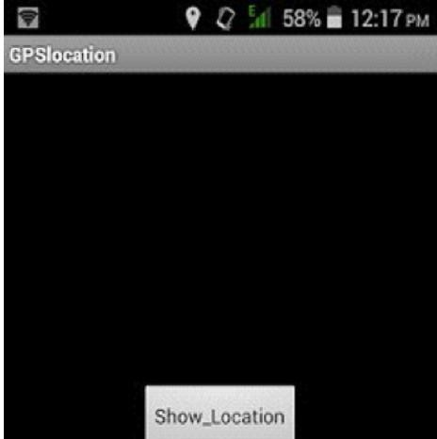

# Experiment 8

## Implement An Application That Writes Data to The

SD CARD

1. Open eclipse or android studio and select new androidproject
2. Give project name and selectnext
3. Choose the android version. Choose the lowest android version (Android 2.2) and selectnext
4. Enter the package name. Package name must be two word separated by commaand clickfinish
5. Go to package explorer in the left hand side. Select ourproject.
6. Go to res folder and select layout. Double click the main.xml file. Add the codebelow

<?xml version="1.0" encoding="utf-8"?><LinearLayoutxmlns:android=["http://schemas.android.com/apk/res/android"](http://schemas.android.com/apk/res/android)android:layout_width="fill_parent" android:layout_height="fill_parent" android:background="#ff0000ff" android:orientation="vertical" >

<EditText

android:id="@+id/editText1" android:layout_width="match_parent" android:layout_height="wrap_content"

><requestFocus />

</EditText>

<Button

android:id="@+id/button1" android:layout_width="match_parent" android:layout_height="wrap_content" android:text="SAVE DATA" /><Button

android:id="@+id/button2" android:layout_width="match_parent" android:layout_height="wrap_content" android:text="SHOW DATA" />

<TextViewandroid:id="@+id/textView1" android:layout_width="wrap_content" android:layout_height="wrap_content"

/>

</LinearLayout>

1. ***Now select mainactivity.java file and type thefollowing code. packagesave.sd;***

import java.io.File; import java.io.FileInputStream; import java.io.FileNotFoundException; import java.io.FileOutputStream; import java.io.IOException; import java.io.InputStreamReader; import java.io.OutputStreamWriter; import android.app.Activity; import android.os.Bundle; import android.os.Environment; import android.view.View; import android.widget.Button; import android.widget.EditText; import android.widget.TextView; import android.widget.Toast;

public class SavedatasdcardActivity extends Activity

{ /** Called when the activity is first created. */ Button save,load;

EditText message; TextView t1;

String Message1; @Override

public void onCreate(Bundle savedInstanceState) { super.onCreate(savedInstanceState); setContentView(R.layout.main); save=(Button) findViewById(R.id.button1); load=(Button) findViewById(R.id.button2); message=(EditText) findViewById(R.id.editText1); t1=(TextView) findViewById(R.id.textView1); save.setOnClickListener(newView.OnClickListener(){ public void onClick(Viewv){

//Get message from user store in message1 variable Message1=message.getText().toString(); try{

//Create a new folder called MyDirectory in SDCard

File sdcard=Environment.getExternalStorageDirectory();

File directory=new File(sdcard.getAbsolutePath()+"/MyDirectory"); directory.mkdirs();

//Create a new file name textfile.txt inside MyDirectory File file=new File(directory,"textfile.txt"); //Create File Outputstream to read the file FileOutputStreamfou=new FileOutputStream(file); OutputStreamWriterosw=new OutputStreamWriter(fou); try{

//write a user data to file osw.append(Message1); osw.flush();

osw.close(); Toast.makeText(getBaseContext(),"Data Saved",Toast.LENGTH_LONG).show();

}catch(IOException e){ e.printStackTrace();

}

}catch (FileNotFoundException e){ e.printStackTrace();

}

}

});

load.setOnClickListener(new View.OnClickListener(){ public void onClick(View v){

try{

File sdcard=Environment.getExternalStorageDirectory();

File directory=new File(sdcard.getAbsolutePath()+"/MyDirectory"); File file=new File(directory,"textfile.txt");

FileInputStreamfis=new FileInputStream(file); InputStreamReaderisr=new InputStreamReader(fis); char[] data=new char[100];

String final_data=""; int size;

try{ while((size=isr.read(data))>0)

{

//read a data from file

String read_data=String.copyValueOf(data,0,size); final_data+=read_data;

data=new char[100];

}

//display the data in output

Toast.makeText(getBaseContext(),"Message:"+final_data,Toast.LENGTH_LONG).show()

;

}catch(IOException e){ e.printStackTrace();

}

}catch (FileNotFoundException e){ e.printStackTrace();

}

}

});

}

}

1. Next step is to set permission to write data in sd card. So go to AndroidManifest.xmlfile. Copy and paste the following coding. The code should come before <application>tab.

<uses-permission android:name="android.permission.WRITE_EXTERNAL_STORAGE"></uses-permission>

1. Now go to main.xml and right click .select run as option and select runconfiguration
2. Android output is present in the android emulator as shown inbelow.

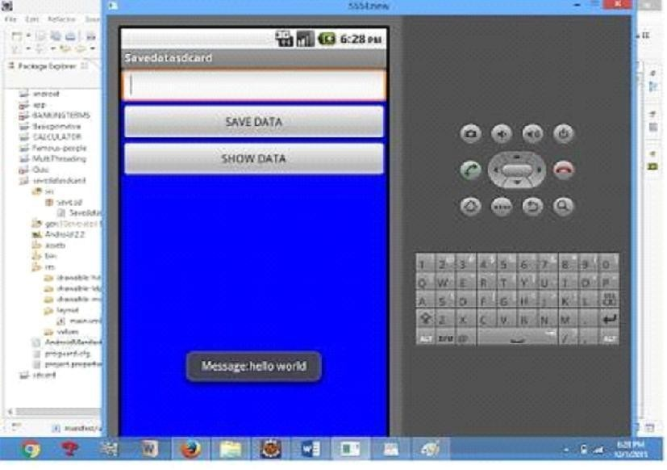

# Experiment 9

## Design A Gaming Application

1. Open eclipse or android studio and select new androidproject
2. Give project name and selectnext
3. Choose the android version. Choose the lowest android version(Android 2.2) and selectnext
4. Enter the package name. package name must be two word separated by commaand clickfinish
5. Go to package explorer in the left hand side. select ourproject.
6. Go to res folder and select layout. Double click the main.xml file. Add the codebelow

<ScrollViewxmlns:android=["http://schemas.android.com/apk/res/android"](http://schemas.android.com/apk/res/android)android:layout_width="fill_parent" android:layout_height="wrap_content" android:scrollbars="vertical" >

<TableLayoutandroid:layout_width="match_parent" android:layout_height="wrap_content" android:shrinkColumns="*" android:stretchColumns="*" android:background="#000000">

<TableRowandroid:layout_height="wrap_content" android:layout_width="match_parent" android:gravity="center_horizontal">

<TextView

android:id="@+id/Title" android:layout_width="fill_parent" android:layout_height="wrap_content"

android:layout_margin="5px" android:focusable="false" android:focusableInTouchMode="false" android:gravity="center_vertical|center_horizontal" android:text="QUIZ" android:textSize="25sp" android:textStyle="bold"/>

<View android:layout_height="2px" android:layout_marginTop="5dip"

android:layout_marginBottom="5dip" android:background="#DDFFDD"/>

</TableRow>

<TableRowandroid:layout_height="wrap_content" android:layout_width="match_parent" android:gravity="center_horizontal">

<TextViewandroid:layout_width="match_parent" android:layout_height="wrap_content" android:textSize="18sp" android:text="1.CAPTIAL OF INDIA" android:layout_span="4" android:padding="18dip" android:textColor="#ffffff"/>

</TableRow><TableRowandroid:id="@+id/tableRow1" android:layout_height="wrap_content" android:layout_width="match_parent">

<RadioGroupandroid:id="@+id/answer1" android:layout_width="match_parent"

android:layout_height="wrap_content" android:layout_weight="0.4" >

<RadioButtonandroid:id="@+id/answer1A" android:layout_width="match_parent" android:layout_height="wrap_content" android:textColor="#ffffff" android:text="CHENNAI" />

<RadioButtonandroid:id="@+id/answer1B" android:layout_width="match_parent" android:layout_height="wrap_content" android:textColor="#ffffff" android:text="NEW DELHI" />

<RadioButtonandroid:id="@+id/answer1C" android:layout_width="match_parent" android:layout_height="wrap_content" android:textColor="#ffffff" android:text="MUMBAI" />

<RadioButtonandroid:id="@+id/answer1D" android:layout_width="match_parent" android:layout_height="wrap_content" android:textColor="#ffffff" android:text="HYDERBAD" />

</RadioGroup>

</TableRow><TableRowandroid:layout_height="wrap_content" android:layout_width="match_parent" android:gravity="center_horizontal">

<TextView

android:layout_width="match_parent" android:layout_height="wrap_content" android:textSize="18sp" android:text="2. CAPTIAL OF RUSSIA?" android:layout_span="4"

android:padding="18dip" android:textColor="#ffffff"/>

</TableRow>

<TableRowandroid:id="@+id/tableRow2" android:layout_height="wrap_content" android:layout_width="match_parent">

<RadioGroup

android:id="@+id/answer2" android:layout_width="match_parent" android:layout_height="wrap_content" android:layout_weight="0.4">

<RadioButtonandroid:id="@+id/answer2A" android:layout_width="match_parent" android:layout_height="wrap_content" android:textColor="#ffffff" android:text="WARSAW " />

<RadioButtonandroid:id="@+id/answer2B" android:layout_width="match_parent" android:layout_height="wrap_content" android:textColor="#ffffff" android:text="BERLIN" />

<RadioButton

android:id="@+id/answer2C" android:layout_width="match_parent" android:layout_height="wrap_content" android:textColor="#ffffff" android:text="MASCOW " />

<RadioButtonandroid:id="@+id/answer2D" android:layout_width="match_parent" android:layout_height="wrap_content" android:textColor="#ffffff" android:text="CANEBRA " />

</RadioGroup>

</TableRow><TableRowandroid:layout_height="wrap_content" android:layout_width="match_parent" android:gravity="center_horizontal">

<Button android:id="@+id/submit"

android:layout_width="wrap_content" android:layout_height="wrap_content" android:gravity="center" android:text="Submit" />

</TableRow>

</TableLayout></ScrollView>

1. Now select mainactivity.java file and type the following code. In my coding man activityname isAlert1Activity.
2. Now go to main.xml and right click .select run as option and select runconfiguration
3. Android output is present in the android emulator as shown inbelow.

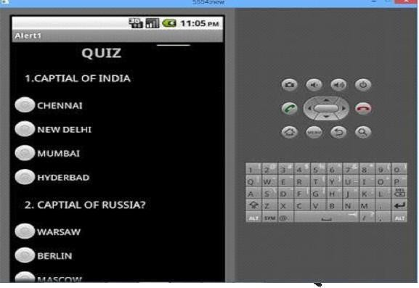

# Experiment 10

## Write A Mobile Application That Creates Alarm

CLOCK

1. **AndroidManifest**

AndroidManifest.xml

We need to give uses-permission for WAKE_LOCK, other than that the AndroidManifest.xml is pretty standard one. Just need to include the service and receiver.

<?xml version="1.0" encoding="utf-8"?>

<manifest xmlns:android="<http://schemas.android.com/apk/res/android>" package="com.javapapers.androidalarmclock"><uses-permission android:name="android.permission.WAKE_LOCK" /><application

android:allowBackup="true" android:icon="@drawable/ic_launcher" android:label="@string/app_name"android:theme="@style/AppTheme">

<activity

android:name=".AlarmActivity" android:label="@string/app_name">

<intent-filter>

<action android:name="android.intent.action.MAIN" />

<category android:name="android.intent.category.LAUNCHER" />

</intent-filter>

</activity><service

android:name=".AlarmService" android:enabled="true" />

<receiver android:name=".AlarmReceiver" /></application>

</manifest>

## AndroidActivity

### activity_my.xml

The Android Activity is designed to be simple. We have a Time Picker component followed by a Toggle Button. That’s it. Choose the time to set the alarm and toggle the switch to on. The alarm will work.

<RelativeLayoutxmlns:android="[http://schemas.android.com/apk/res/android"](http://schemas.android.com/apk/res/android)xmlns:tools="<http://schemas.android.com/tools>" android:layout_width="match_parent" android:layout_height="match_parent" android:paddingLeft="@dimen/activity_horizontal_margin" android:paddingRight="@dimen/activity_horizontal_margin" android:paddingTop="@dimen/activity_vertical_margin" android:paddingBottom="@dimen/activity_vertical_margin" tools:context=".MyActivity">

<TimePicker

android:layout_width="wrap_content" android:layout_height="wrap_content" android:id="@+id/alarmTimePicker" android:layout_alignParentTop="true" android:layout_centerHorizontal="true" />

<ToggleButtonandroid:layout_width="wrap_content"

android:layout_height="wrap_content" android:text="Alarm On/Off" android:id="@+id/alarmToggle" android:layout_centerHorizontal="true" android:layout_below="@+id/alarmTimePicker" android:onClick="onToggleClicked"/>

<TextView

android:layout_width="wrap_content" android:layout_height="wrap_content"

android:textAppearance="?android:attr/textAppearanceLarge" android:text="" android:id="@+id/alarmText" android:layout_alignParentBottom="true" android:layout_centerHorizontal="true" android:layout_marginTop="20dp" android:layout_below="@+id/alarmToggle"/>

</RelativeLayout>

### AlarmActivity.java

Alarm Activity uses the Alarm Manager to set the alarm and send notification on alarm trigger.

package com.javapapers.androidalarmclock; import android.app.Activity; import android.app.AlarmManager; import android.app.PendingIntent; import android.content.Intent; import android.os.Bundle; import

android.util.Log; import android.view.View; import android.widget.TextView; import android.widget.TimePicker; import android.widget.ToggleButton; import java.util.Calendar; public class AlarmActivity extends Activity

{

AlarmManageralarmManager; private PendingIntentpendingIntent; private TimePickeralarmTimePicker; private staticAlarmActivityinst; private TextViewalarmTextView;

public static AlarmActivity instance(){ returninst; }

@Override

public void onStart() { super.onStart(); inst= this; }

@Override

protected void onCreate(Bundle savedInstanceState) { super.onCreate(savedInstanceState); setContentView(R.layout.activity_my);

alarmTimePicker =(TimePicker)findViewById(R.id.alarmTimePicker); alarmTextView

= (TextView) findViewById(R.id.alarmText);

ToggleButtonalarmToggle = (ToggleButton) findViewById(R.id.alarmToggle); alarmManager = (AlarmManager) getSystemService(ALARM_SERVICE);

}

public void onToggleClicked(Viewview){ if (((ToggleButton) view).isChecked()) { Log.d("MyActivity", "AlarmOn");

Calendar calendar = Calendar.getInstance(); calendar.set(Calendar.HOUR_OF_DAY, alarmTimePicker.getCurrentHour());

calendar.set(Calendar.MINUTE, alarmTimePicker.getCurrentMinute()); Intent myIntent = new Intent(AlarmActivity.this, AlarmReceiver.class);

pendingIntent = PendingIntent.getBroadcast(AlarmActivity.this, 0, myIntent, 0); alarmManager.set(AlarmManager.RTC, calendar.getTimeInMillis(), pendingIntent);

} else {

alarmManager.cancel(pendingIntent); setAlarmText(""); Log.d("MyActivity", "Alarm Off");

} }

public void setAlarmText(StringalarmText){ alarmTextView.setText(alarmText);

}

}

## AlarmReceiver

### AlarmReceiver.java

this is the one that receives the alarm trigger on set time. From here we initiate different actions to notify the user as per our choice. I have given three type of notifications, first show a message to user in the activity UI, second play the alarm ringtone and third send an Android notification message. So this is the place to add enhancement for different types of user notifications.

package com.javapapers.androidalarmclock;

import android.app.Activity; import android.content.ComponentName; import android.content.Context; import android.content.Intent; import android.media.Ringtone; import android.media.RingtoneManager; import android.net.Uri;

import android.support.v4.content.WakefulBroadcastReceiver; public class AlarmReceiver extends WakefulBroadcastReceiver { @Override

public void onReceive(final Context context, Intent intent) {

//this will update the UIwith message AlarmActivityinst = AlarmActivity.instance(); inst.setAlarmText("Alarm! Wake up! Wakeup!");

//this will sound the alarm tone

//this will sound the alarm once, if you wish to

//raise alarm in loop continuously then use MediaPlayer and setLooping(true) Uri alarmUri = RingtoneManager.getDefaultUri(RingtoneManager.TYPE_ALARM

); if (alarmUri == null) { alarmUri = RingtoneManager.getDefaultUri(RingtoneManager.TYPE_NOTIFICATION); }

Ringtone ringtone =RingtoneManager.getRingtone(context,alarmUri); ringtone.play();

//this will send a notification message

ComponentName comp = new ComponentName(context.getPackageName(), AlarmService.class.getName());

startWakefulService(context, (intent.setComponent(comp))); setResultCode(Activity.RESULT_OK); }

}

## Alarm NotificationMessage

### AlarmService.java

The receiver will start the following Intent Service to send a standard notification to the user.

package com.javapapers.androidalarmclock; import android.app.IntentService; import android.app.NotificationManager; import android.app.PendingIntent; import android.content.Context; import android.content.Intent;

import android.support.v4.app.NotificationCompat; import android.util.Log;

public class AlarmService extends IntentService { private NotificationManageralarmNotificationManager;

public AlarmService() { super("AlarmService"); }

@Override

public void onHandleIntent(Intentintent){ sendNotification("Wake Up!Wake

Up!");

}

private void sendNotification(String msg) {

Log.d("AlarmService", "Preparing to send notification...: " + msg); alarmNotificationManager = (NotificationManager) this

.getSystemService(Context.NOTIFICATION_SERVICE);

PendingIntentcontentIntent =PendingIntent.getActivity(this,0, newIntent(this,

AlarmActivity.class), 0);

NotificationCompat.BuilderalamNotificationBuilder = new NotificationCompat.Builder(

this).setContentTitle("Alarm").setSmallIcon(R.drawable.ic_launcher)

.setStyle(new NotificationCompat.BigTextStyle().bigText(msg))

.setContentText(msg);

alamNotificationBuilder.setContentIntent(contentIntent); alarmNotificationManager.notify(1, alamNotificationBuilder.build()); Log.d("AlarmService", "Notification sent."); } }

