**Techno India NJR Institute of Technology**



**Course File**

**Digital Image Processing (6CS3-01)**

Vivek Jain

(Associate Professor)

**Department of ECE**

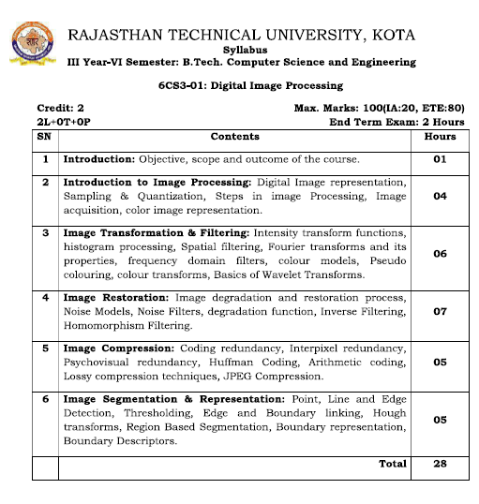

**Course Overview:**

For the last few decades, image processing has emerged as an important technology to extract useful information for scene understanding. To develop next-generation image processing systems, it is essential to equip our students with a deep understanding of the challenges in image understanding, and with advanced skills to develop image processing techniques by integrating approaches from information processing and pattern recognition. This course will provide both basic and in-depth coverage of image processing techniques for students to develop information processing systems. In particular, this course will help students understand many image processing approaches for scene analysis and understanding; to acquire working knowledge of many image processing systems; to have a hands-on experience on analyzing a variety of images for image understanding.

**Course Outcomes:**

|  |  |  |
| --- | --- | --- |
| **CO.NO.** | **Cognitive Level** | **Course Outcome** |
| 1 | **Comprehension** | Able to generate different Continuous and Discrete time signals. |
| 2 | **Application** | Develop image enhancement , compression and edge detection using MATLAB . |
| 3 | **Analysis** | Design and Develop IIR & FIR Filter using different approximation methods using MATLAB . |
| 4 | **Synthesis** | Implement algorithms for image processing on DSP Processor. |
| 5 | **Evaluation** | Evaluate the signal to noise ration of the image. |

**Prerequisites:**

1. Fundamentals knowledge of Fourier transform .
2. Fundamentals knowledge of LTI system.
3. Fundamentals knowledge of Z transform and Basic signals.

**Course Outcome Mapping with Program Outcome:**

|  |  |  |  |  |  |  |  |  |  |  |  |  |
| --- | --- | --- | --- | --- | --- | --- | --- | --- | --- | --- | --- | --- |
| **Course Outcome** | **Program Outcomes (PO’s)** | | | | | | | | | | | |
| **CO. NO.** | **Domain Specific** | | | | | **Domain Independent** | | | | | | |
|  | **PO1** | **PO2** | **PO3** | **PO4** | **PO5** | **PO6** | **PO7** | **PO8** | **PO9** | **PO10** | **PO11** | **PO12** |
| CO1 | 3 | 2 | 1 | 1 | 0 | 0 | 1 | 0 | 0 | 0 | 0 | 1 |
| CO2 | 3 | 2 | 3 | 2 | 3 | 0 | 0 | 0 | 0 | 0 | 0 | 0 |
| CO3 | 3 | 2 | 3 | 2 | 3 | 0 | 0 | 0 | 0 | 0 | 0 | 0 |
| CO4 | 0 | 1 | 1 | 0 | 2 | 0 | 0 | 2 | 0 | 0 | 0 | 1 |
| CO5 | 1 | 1 | 2 | 1 | 3 | 0 | 0 | 0 | 0 | 0 | 0 | 1 |
| 1: Slight (Low) , 2: Moderate (Medium), 3: Substantial (High) | | | | | | | | | | | | |

**Course Coverage Module Wise:**

|  |  |  |
| --- | --- | --- |
| **Lecture No.** | **Unit** | **Topic** |
| 1 | **1** | **DIGITAL IMAGE FUNDAMENTALS**: Image Sensing and acquisition,Image sampling and quantization |
| 2 | 1 | Representing digital image |
| 3 | 1 | Spatial and gray-level resolution |
| 4 | 1 | Spatial operations, Vector & matrix operations |
| 5 | 1 | Zooming and Shrinking of digital images |
| 6 | 1 | RGB and HSI Color models |
| 7 | **2** | **BASIC IMAGE OPERATIONS:** Intensity Transformation functions |
| 8 | 2 | Histogram equalization |
| 9 | 2 | Spatial filtering for image smoothing |
| 10 | 2 | Image sharpening by first and second order derivatives |
| 11 | 2 | Image smoothing filters |
| 12 | 2 | Image sharpening filters |
| 13 | 2 | Frequency domain filters |
| 14 | 2 | Frequency domain filters |
| 15 | **3** | **IMAGE RESTORATION:**Image restoration model |
| 16 | 3 | Noise Models, Spatial and frequency properties of noise |
| 17 | 3 | Noise probability density functions |
| 18 | 3 | Spatial filter: Mean filter, Mode Filter, Median Filter |
| 19 | 3 | Spatial filter: Mean filter, Mode Filter, Median Filter |
| 20 | 3 | Adaptive filters |
| 21 | 3 | Concepts of inverse filter |
| 22 | 3 | Concepts of Wiener filtering |
| 23 | **4** | **MORPHOLOGICAL IMAGE PROCESSING:** Erosion and Dilation |
| 24 | 4 | Opening |
| 25 | 4 | Closing |
| 26 | 4 | Morphological algorithms for Boundary extraction |
| 27 | 4 | Thinning |
| 28 | 4 | Pruning |
| 29 | 4 | Smoothing |
| 30 | 4 | Thickening |
| 31 | **5** | **IMAGE SEGMENTATION AND COMPRESSION:** Edge based segmentation |
| 32 | 5 | Edge detection masks |
| 33 | 5 | Gradient operators |
| 34 | 5 | Thresholding |
| 35 | 5 | Region growing |
| 36 | 5 | Watershed transform |
| 37 | 5 | Fundamentals of image compression |
| 38 | 5 | Loss-less compression techniques |
| 39 | 5 | Lossy compression techniques |
| 40 | 5 | Compression standards |

|  |
| --- |
| **NPTEL COUSES LINK**   1. https://nptel.ac.in/courses/106/105/106105032/ |

|  |
| --- |
| **Faculty Notes Link**   1. <https://drive.google.com/drive/folders/1FNMji5fGuR0ESCxfrYe4AWswxdG2Kk_?usp=sharing> |

|  |
| --- |
| **QUIZ Link**   1. <https://www.onlineinterviewquestions.com/digital-image-processing-mcq/> 2. <https://www.sanfoundry.com/digital-image-processing-mcqs-image-sampling-quantization/> 3. <https://compsciedu.com/Category/Digital-Image-Processing-(DIP)> 4. <https://mcqslearn.com/cs/dip/digital-image-processing-mcqs-questions-and-answers.php> |

**Assessment Methodology:**

1. Practical exam using MATALB software.
2. Two Midterm exams where student have to showcase subjective learning.
3. Final Exam (subjective paper) at the end of the semester.

