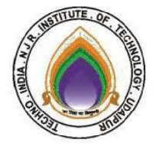**Techno India NJR Institute of Technology**

**Course File**

**Computer Graphics & Multimedia (5CS4- 04)**

**Akhilesh Arya Assistant professor Department of CSE**

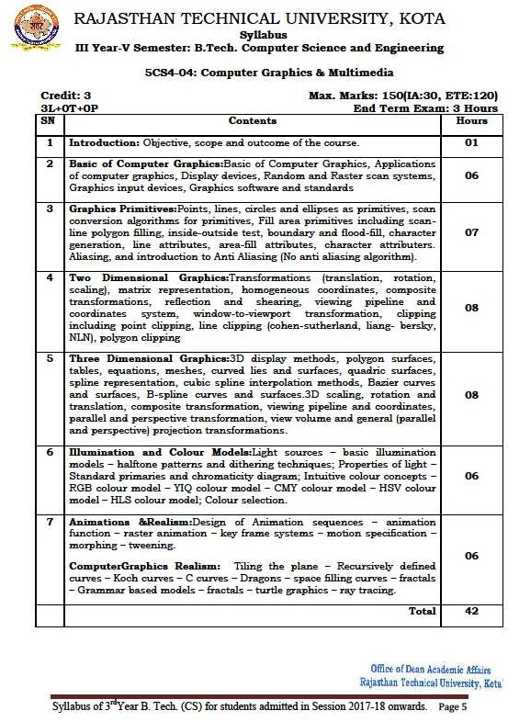

# Course Overview:

Students will learn basics of computer graphics with this 42 hours course. They will be able to draw objects such as line and circle using various line and circle drawing algorithms. They will also learn the various color filling algorithms. Students will learn the tools and techniques used to build animation in the real world. This course will also teach the students about 2D. 3D designs, web designs, animation design, image processing etc. The concept of Physics, Optics, and Geometry are largely used in computer graphics.

Computer Graphics is an art of creating pictures and films using specially developed hardware and software graphics. This course is extremely useful for the student looking for jobs in entertainment, gaming and, animation industry

# Course Outcome:

|  |  |  |
| --- | --- | --- |
| **5CS404** | **Cognitive Level** | **Computer Graphics & uMltimedia Year of study: 2019-20** |
| 1 | Knowledge | Students will be able to define the basics of computer graphics, different graphics systems, application of computer graphics and rasterisation of line, circle and ellipse. |
| 2 | Application | Students will be able to apply geometric transformations on graphics objects, their application in composite form, different color filling algorithm and clipping algorithm. |
| 3 | Comprehension | Students will be able to identify visible surface detection techniques & curves. |
| 4 | Synthesis | Students will be able to render projected objects to naturalize the scene in 2D view and use of illumination models & color models. |
| 5 | Knowledge | Students will be able to identify multimedia components and animation techniques. |

**Prerequisites:**

1. Basic mathematics including round off, floor and ceiling functions.
2. Basics of linear algebra.
3. Intermediate programming skills.
4. Understanding of basic geometric shapes.

# aMpping of Cos with Pos and PSOs:

|  |  |  |  |  |  |  |  |  |  |  |  |  |  |  |  |
| --- | --- | --- | --- | --- | --- | --- | --- | --- | --- | --- | --- | --- | --- | --- | --- |
| **Computer Graphics & uMltimedia Year of study: 2019-20** | | | | | | | | | | | | | | | |
| **Course Outcome** | **PO1** | **PO2** | **PO3** | **PO4** | **PO5** | **PO6** | **PO7** | **PO8** | **PO9** | **PO10** | **PO11** | **PO12** | **PSO1** | **PSO2** | **PSO3** |
| **CO35404.1** | 2 | 3 | 3 | 1 | 2 | 0 | 0 | 0 | 1 | 0 | 0 | 1 | 2 | 1 | 1 |
| **CO35404.2** | 2 | 3 | 3 | 3 | 2 | 0 | 0 | 0 | 0 | 0 | 1 | 2 | 2 | 1 | 1 |
| **CO35404.3** | 2 | 3 | 3 | 3 | 3 | 0 | 0 | 0 | 0 | 0 | 1 | 2 | 2 | 1 | 1 |
| **CO35404.4** | 3 | 3 | 3 | 3 | 3 | 1 | 1 | 0 | 0 | 0 | 1 | 2 | 2 | 1 | 1 |
| **CO35404.5** | 2 | 1 | 1 | 2 | 2 | 1 | 1 | 0 | 0 | 0 | 1 | 1 | 2 | 1 | 1 |
| **C35404 (AVG)** | 2.20 | 2.60 | 2.60 | 2.40 | 2.40 | 0.40 | 0.40 | 0.00 | 0.20 | 0.00 | 0.80 | 1.60 | 2.00 | 1.00 | 1.00 |

**Course Coverage oMdule Wise:**

|  |  |  |
| --- | --- | --- |
| **Lecture No.** | **Unit** | **Topic** |
| 1 | **1** | **Introduction:** Objective, scope and outcome of the course |
| 2 | **2** | **Basic of Computer Graphics** |
| 3 | 2 | Student will be able to learn the basic of Computer Graphics |
| 4 | 2 | Student will be able to list the applications of computer graphics in various  fields |
| 5 | 2 | Students will be able to explain the working of display devices such as CRT  tubes. |
| 6 | 2 | Students can list the difference between Random and Raster scan systems |
| 7 | 2 | Student will be able to list the different Graphics software and standards used  in designing the graphics |
| 8 | **3** | **Graphics Primitives** |
| 9 | 3 | Students will be able to draw lines using DDA and Bresenham’s algorithms. |
| 10 | 3 | Students will be able to draw Circle using mid-point circle algorithm. |
| 11 | 3 | Students will be able to draw ellipse using mid-point ellipse drawing  algorithm. |
| 12 | 3 | Students will be able to implement Boundary and flood-fill algorithms and  drive the coordinates of the pixels. |
| 13 | 3 | Students will be able to list the difference between a 4-connected and 8-  connected approach of filling algorithms |
| 14 | 3 | Students will be able to understand the and explain what is Aliasing |
| 15 | 3 | Introduction to Anti Aliasing |
| 16 | **4** | **Two Dimensional Graphics** |
| 17 | 4 | Students should be able to perform Transformations (translation, rotation,  scaling) on 2 dimensional graphic objects. |

|  |  |  |
| --- | --- | --- |
| 18 | 4 | Students should be able to perform multiple transformation using  homogeneous coordinates |
| 19 | 4 | Students will be able to perform Composite transformations, reflection and  shearing on 2-D graphics objects |
| 20 | 4 | Student should be able to calculate coordinates of clipped line using Cohen  Sutherland line clipping algorithm |
| 21 | 4 | Student should be able to calculate coordinates of clipped line using Nicholl-  le-Nicholl line clipping algorithm |
| 22 | **5** | **Three Dimensional Graphics** |
| 23 | 5 | Students should be able to identify 1-point, 2-point and, 3-point display  methods for 3D Graphics |
| 24 | 5 | Students should be able to represent 3D graphics using meshes, curved lies  and surfaces |
| 25 | 5 | Quadric surfaces, Spline representation |
| 26 | 5 | Cubic spline interpolation methods, Bazier curves and surfaces |
| 27 | 5 | B-spline curves and surfaces.3D scaling |
| 28 | 5 | Rotation and translation, composite transformation |
| 29 | 5 | Viewing pipeline and coordinates |
| 30 | 5 | Parallel and perspective transformation |
| 31 | 5 | View volume and general (parallel and perspective) projection transformations |
| 32 | **6** | **Illumination and Colour Models** |
| 33 | 6 | Light sources – basic illumination models – halftone patterns and dithering  techniques |
| 34 | 6 | Properties of light – Standard primaries and chromaticity diagram |
| 35 | 6 | Intuitive colour concepts – RGB colour model |
| 36 | 6 | YIQ colour model – CMY colour model |
| 37 | 6 | HSV colour model – HLS colour model; Colour selection |
| 38 | **7** | **Animations &Realism** |
| 39 | 7 | Design of Animation sequences – animation function |
| 40 | **7** | Raster animation – key frame systems |
| 41 | **7** | Motion specification –morphing – tweening |
| 42 | **7** | Tiling the plane – Recursively defined curves |
| 43 | **7** | Koch curves – C curves – Dragons – space filling curves – fractals |
| 44 | **7** | Grammar based models – fractals – turtle graphics – ray tracing |

# TEXT/REFERENCE BOOKS

* 1. J. Foley, A. Van Dam, S. Feiner, J. Hughes: Computer Graphics- Principles and Practice, Pearson
  2. Hearn and Baker: Computer Graphics, PHI
  3. Multimedia Systems Design, Prabhat Andleigh and Thakkar, PHI.
  4. Multimedia Information Networking, N.K.Sharda, PHI.

# Course Level Problems (Test Items):

**Objective: Quiz**

1. THE INSIDE OF THE CATHODE RAY TUBE IS COATED WITH WHAT MATERIAL?
   1. Fluorescent powder
   2. No coating
   3. Phosphorus
   4. None of the above ANSWER: C
2. Beam penetration method is usually used in ...............................
   1. LCD
   2. Raster Scan display
   3. Random scan display
   4. DVST ANSWER: C
3. Shadow mask method
4. Raster Scan Display
5. Random Scan Display
6. DVST ANSWER: B
7. Identify the colors produced in beam penetration method.
   1. Red, Green, Blue, White
   2. Red, Orange, Yellow, Green
   3. Red, Green, Blue
   4. Green, Red, White, Orange ANSWER: B
8. In raster scan display, the frame buffer holds ......................
   1. Line drawing commands
   2. Scanning instructions
   3. Image Resolution
   4. Intensity information ANSWER: D
9. In random scan display, the frame buffer holds ......................
   1. Line drawing commands
   2. Scanning instructions
   3. Image Resolution
   4. Intensity information ANSWER: A
10. THE QUANTITY OF AN IMAGE DEPEND ON
    1. No of Pixel used by image
    2. No of lines used by image
    3. No of resolution used by image
    4. None ANSWER: A
11. WHICH AMONG THE FOLLOWING IS NOT MERIT (ADVANTAGE) OF THE CATHODE RAY TUBE?
    1. It runs at highest pixel ratio
    2. It is less expensive than any other display technology
    3. It is very large, heavy and bulgy
    4. None of the above ANSWER: C
12. WHICH AMONG THE FOLLOWING IS A PART OF THE CATHODE RAY TUBE?
    1. Control Electrode
    2. Electron Gun
    3. Focusing System
    4. All ANSWER: D
13. Electron gun section
    1. Provides sharp beam
    2. Provides poorly focussed beam
    3. Doesn’t provide any beam
    4. Provides electrons only ANSWER: A
14. Control grid is given
    1. Positive voltage
    2. Negative voltage
    3. Neutral voltage
    4. Zero voltage ANSWER: B
15. What determines light intensity in a CRT?
    1. Voltage
    2. Current
    3. Momentum of electrons
    4. Fluorescent screen ANSWER: C
16. Effect of negative voltage to the grid is
    1. No force
    2. A gravitational force
    3. An attractive force
    4. A repulsive force ANSWER: D
17. How many guns are available for color monitor in shadow mask method?
    1. 1
    2. 2
    3. 3
    4. 4 ANSWER: C
18. How many colors can be generated using beam penetration method?
    1. 3
    2. 4

C) 254

D) 24 ANSWER: B

# Subjective:

|  |  |
| --- | --- |
| **CO. No.** | **Problem Description** |
| 1 | 1. Explain the functionality of CRT with the diagram. 2. List any 3 differences of raster and random scan. |
| 2 | 1. Derive DDA line drawing algorithm to find the coordinates of line. 2. What is 8-way symmetric algorithm of circle drawing derive the equation to generate the first octant of a circle. |
| 3 | 1. Explain line clipping algorithm with suitable example. 2. Perform multiple transformation on a 2D object using homogeneous coordinates |
| 4 | 1. Explain B-spline curves and application of it. 2. Perform Translation and rotations in 3D graphic objects. |
| 5 | 1. Explain the use of halftone and dithering methods in graphic printing,.. 2. What is RGB and CMY color models. |
| 6 | 1. What are morphing and tweening techniques in motion pictures? 2. Explain any 2 space filling techniques. |

**Assessment Methodology:**

1. Online quiz on kahoot/ Moodle after every module completion.
2. Practical exam in lab where they have to write code on C compiler for various drawing algorithms explained in the modules above. (Once in a week)
3. Assignments one from each unit.
4. Midterm subjective paper where they have to write algorithms to perform different operations on different data structures as mentioned in the modules. (Twice during the semester)
5. Final paper at the end of the semester subjective.

# Unit-I/ II

1. https://[www.javatpoint.com/computer-graphics-tutorial](http://www.javatpoint.com/computer-graphics-tutorial)
2. https://[www.javatpoint.com/application-of-computer-graphics](http://www.javatpoint.com/application-of-computer-graphics)
3. https://[www.javatpoint.com/computer-graphics-display-processor](http://www.javatpoint.com/computer-graphics-display-processor)
4. https://[www.javatpoint.com/computer-graphics-cathode-ray-tube](http://www.javatpoint.com/computer-graphics-cathode-ray-tube)
5. https://[www.javatpoint.com/difference-between-random-scan-and-raster-scan-display](http://www.javatpoint.com/difference-between-random-scan-and-raster-scan-display)
6. https://[www.javatpoint.com/computer-graphics-color-crt-monitors](http://www.javatpoint.com/computer-graphics-color-crt-monitors)

Video Lecture: https://[www.youtube.com/watch?v=nAlwNXSaAR8](http://www.youtube.com/watch?v=nAlwNXSaAR8) NPTEL:

https://[www.youtube.com/watch?v=0ZuSu44-WeE&t=20s](http://www.youtube.com/watch?v=0ZuSu44-WeE&t=20s)

# Unit-III

* 1. https://[www.javatpoint.com/computer-graphics-scan-conversion-definition](http://www.javatpoint.com/computer-graphics-scan-conversion-definition)
  2. https://[www.javatpoint.com/computer-graphics-scan-converting-a-point](http://www.javatpoint.com/computer-graphics-scan-converting-a-point)
  3. https://[www.javatpoint.com/computer-graphics-scan-converting-a-straight-line](http://www.javatpoint.com/computer-graphics-scan-converting-a-straight-line)
  4. https://[www.javatpoint.com/computer-graphics-dda-algorithm](http://www.javatpoint.com/computer-graphics-dda-algorithm)
  5. https://[www.javatpoint.com/computer-graphics-bresenhams-line-algorithm](http://www.javatpoint.com/computer-graphics-bresenhams-line-algorithm)
  6. https://[www.javatpoint.com/computer-graphics-defining-a-circle](http://www.javatpoint.com/computer-graphics-defining-a-circle)
  7. https://[www.javatpoint.com/defining-a-circle-using-polynomial-method](http://www.javatpoint.com/defining-a-circle-using-polynomial-method)
  8. https://[www.javatpoint.com/computer-graphics-midpoint-circle-algorithm](http://www.javatpoint.com/computer-graphics-midpoint-circle-algorithm)
  9. https://[www.javatpoint.com/computer-graphics-midpoint-ellipse-algorithm](http://www.javatpoint.com/computer-graphics-midpoint-ellipse-algorithm) Video Lecture:

https://[www.youtube.com/watch?v=0HeTPi82gZQ&list=PL338D19C40D6D1732&inde](http://www.youtube.com/watch?v=0HeTPi82gZQ&list=PL338D19C40D6D1732&inde) x=13

# Unit IV

1. https://[www.javatpoint.com/computer-graphics-boundary-filled-algorithm](http://www.javatpoint.com/computer-graphics-boundary-filled-algorithm)
2. https://[www.javatpoint.com/computer-graphics-flood-fill-algorithm](http://www.javatpoint.com/computer-graphics-flood-fill-algorithm)
3. https://[www.javatpoint.com/computer-graphics-introduction-of-transformations](http://www.javatpoint.com/computer-graphics-introduction-of-transformations)
4. https://[www.javatpoint.com/computer-graphics-translation](http://www.javatpoint.com/computer-graphics-translation)
5. https://[www.javatpoint.com/computer-graphics-scaling](http://www.javatpoint.com/computer-graphics-scaling)
6. https://[www.javatpoint.com/computer-graphics-rotation](http://www.javatpoint.com/computer-graphics-rotation)
7. https://[www.javatpoint.com/computer-graphics-reflection](http://www.javatpoint.com/computer-graphics-reflection)
8. https://[www.javatpoint.com/computer-graphics-shearing](http://www.javatpoint.com/computer-graphics-shearing)
9. https://[www.javatpoint.com/computer-graphics-homogeneous-coordinates](http://www.javatpoint.com/computer-graphics-homogeneous-coordinates)
10. https://[www.javatpoint.com/computer-graphics-composite-transformation](http://www.javatpoint.com/computer-graphics-composite-transformation)
11. https://[www.javatpoint.com/sutherland-hodgeman-polygon-clipping](http://www.javatpoint.com/sutherland-hodgeman-polygon-clipping)

Video Lecture:

https://[www.youtube.com/watch?v=DPcVMEBDpAY&list=PL338D19C40D6D1732&index](http://www.youtube.com/watch?v=DPcVMEBDpAY&list=PL338D19C40D6D1732&index)

=6

# Unit-V

1. https://[www.javatpoint.com/computer-graphics-3d-graphics](http://www.javatpoint.com/computer-graphics-3d-graphics)
2. https://[www.javatpoint.com/computer-graphics-3d-transformations](http://www.javatpoint.com/computer-graphics-3d-transformations)
3. https://[www.javatpoint.com/computer-graphics-3d-scaling](http://www.javatpoint.com/computer-graphics-3d-scaling)
4. https://[www.javatpoint.com/computer-graphics-3d-rotation](http://www.javatpoint.com/computer-graphics-3d-rotation)
5. https://[www.javatpoint.com/computer-graphics-3d-rotation-about-arbitrary-axis](http://www.javatpoint.com/computer-graphics-3d-rotation-about-arbitrary-axis)
6. https://[www.javatpoint.com/computer-graphics-3d-inverse-transformations](http://www.javatpoint.com/computer-graphics-3d-inverse-transformations)
7. https://[www.javatpoint.com/computer-graphics-3d-reflection](http://www.javatpoint.com/computer-graphics-3d-reflection)
8. https://[www.javatpoint.com/computer-graphics-3d-shearing](http://www.javatpoint.com/computer-graphics-3d-shearing) Video Lecture:

https://[www.youtube.com/watch?v=_eVRNdGsLWc&list=PL338D19C40D6D1732&index=](http://www.youtube.com/watch?v=_eVRNdGsLWc&list=PL338D19C40D6D1732&index)  8

# Unit-VI

1. https://[www.javatpoint.com/introduction-to-color-spaces](http://www.javatpoint.com/introduction-to-color-spaces)
2. https://[www.javatpoint.com/dip-dithering-concept](http://www.javatpoint.com/dip-dithering-concept)
3. https://[www.mat.univie.ac.at/~kriegl/Skripten/CG/node6.html](http://www.mat.univie.ac.at/~kriegl/Skripten/CG/node6.html) Video Lecture:

https://[www.youtube.com/watch?v=8I5rpAhYk4Y&list=PL338D19C40D6D1732&index=3](http://www.youtube.com/watch?v=8I5rpAhYk4Y&list=PL338D19C40D6D1732&index=3) 3

# Unit- VII

1. https://[www.javatpoint.com/computer-graphics-animation](http://www.javatpoint.com/computer-graphics-animation)
2. https://[www.javatpoint.com/computer-graphics-application-areas-of-animation](http://www.javatpoint.com/computer-graphics-application-areas-of-animation)
3. https://[www.javatpoint.com/computer-graphics-animation-functions](http://www.javatpoint.com/computer-graphics-animation-functions) Video Lecture:

https://[www.youtube.com/watch?v=RU0wScIj36o](http://www.youtube.com/watch?v=RU0wScIj36o) https://[www.youtube.com/watch?v=lKPz6t-gw3M](http://www.youtube.com/watch?v=lKPz6t-gw3M)

# Sample mid-term question paper:

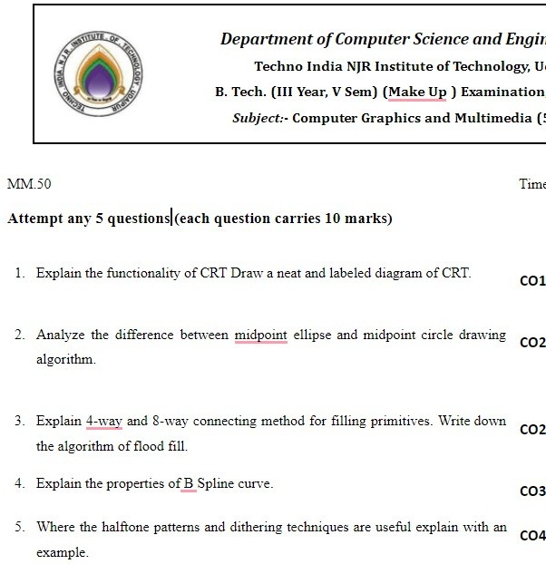

**Previous Year Question Papers:**

