https://www.technonjr.org/

2021

Academic Session

Course File

Human Computer Interaction

Dr Paras Kothari

Techno India NJR Institute of Technology – Udaipur 

# Course Scheme: Human Computer Interaction

## Theory Session

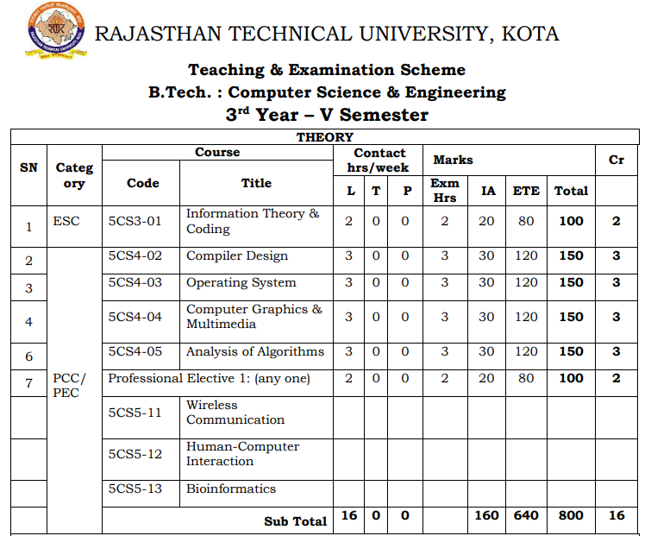

**Note: L: Lecture; T: Tutorial; Cr: Credits; ETE: End Term Exam; IA: Internal Assessment**

# Course Overview

In this course, students are introduced to the fundamental theories and concepts of human computer interaction (HCI). HCI is an interdisciplinary field that integrates theories and methodologies across many domains including cognitive psychology, neurocognitive engineering, computer science, human factors, and engineering design. Students will gain theoretical knowledge of and practical experience in the fundamental aspects of human perception, cognition, and learning as relates to the design, implementation, and evaluation of interfaces.

Topics covered include: interface design, usability evaluation, universal design, different modes of interfaces (touch, vision, natural language and 3-D audio), virtual reality, and spatial displays.

In addition to lectures, students will work on individual and team assignments to design, implement, and evaluate various interactive systems and user interfaces based on knowledge picked from class material and additional research.

## Objectives

* To learn the basic physiological, perceptual, and cognitive components of human learning and memory.
* To gain theoretical knowledge of and practical experience in the fundamental aspects of designing and implementing user interfaces.
* To analyze interaction problems from a technical, cognitive, and functional perspective.
* To develop an awareness of the range of general human-computer interaction issues that must be considered when designing information systems.
* To learn about multimodal displays for conveying and presenting information.

## Consequences (Outcomes)

Upon completion of the course, students would be able to:

* Explain the capabilities of both humans and computers from the viewpoint of human information processing.
* Describe typical human–computer interaction (HCI) models and styles, as well as various historic HCI paradigms.
* Apply an interactive design process and universal design principles to designing HCI systems.
* Describe and use HCI design principles, standards and guidelines.
* Analyze and identify user models, user support, socio-organizational issues, and stakeholder requirements of HCI systems.
* Discuss tasks and dialogs of relevant HCI systems based on task analysis and dialog design.
* Analyze and discuss HCI issues in groupware, ubiquitous computing, virtual reality, multimedia, and Word Wide Web-related environments.

## Course Outcomes:

|  |  |  |
| --- | --- | --- |
| **5CS512** | **Cognitive Level** | **Human-Computer Interaction Year of study: 2020** |
| CO3512.1 | Comprehension | Student will be able to list the capabilities of both humans and computers from the viewpoint of human information processing. |
| C03512.2 | Comprehension | Student will be able to describe typical human–computer interaction (HCI) models and styles, as well as various historic HCI paradigms. |
| CO3512.2 | Application | Students will be able to apply an interactive design process and universal design principles to designing HCI systems. |
| C03512.3 | Analysis | Students will analyze and identify user models& support, socio-organizational issues, and stakeholder requirements of HCIs. |
| CO3512.3 | Comprehension | Students will be able to discuss tasks and dialogs of relevant HCI systems based on task analysis and dialog design. |

|  |  |  |  |  |  |  |  |  |  |  |  |  |  |  |  |
| --- | --- | --- | --- | --- | --- | --- | --- | --- | --- | --- | --- | --- | --- | --- | --- |
| **Human- Computer Interaction Year of study: 2020-21** | | | | | | | | | | | | | | | |
| **Course Outcome** | **PO1** | **PO2** | **PO3** | **PO4** | **PO5** | **PO6** | **PO7** | **PO8** | **PO9** | **PO10** | **PO11** | **PO12** | **PSO1** | **PSO2** | **PSO3** |
| **CO35511.1** | 3 | 1 | 0 | 1 | 0 | 0 | 0 | 0 | 0 | 0 | 0 | 1 | 2 | 1 | 1 |
| **CO35511.2** | 2 | 2 | 0 | 1 | 0 | 0 | 0 | 0 | 0 | 0 | 0 | 1 | 2 | 1 | 1 |
| **CO35511.3** | 3 | 2 | 3 | 1 | 0 | 0 | 0 | 1 | 1 | 0 | 1 | 1 | 2 | 1 | 1 |
| **CO35511.4** | 2 | 2 | 1 | 3 | 1 | 0 | 0 | 0 | 1 | 2 | 2 | 1 | 2 | 1 | 1 |
| **CO35511.5** | 1 | 3 | 3 | 2 | 1 | 0 | 0 | 0 | 0 | 0 | 2 | 1 | 2 | 1 | 1 |
| **C35511 (AVG)** | 2.20 | 2.00 | 1.40 | 1.60 | 0.40 | 0.00 | 0.00 | 0.20 | 0.40 | 0.40 | 1.00 | 1.00 | 2.00 | 1.00 | 1.00 |

**Note**: Relationship Matrix between Objectives and Outcome need to be furnished during course implementation period.

## Prerequisites

* Significant experience using computers and GUI-based applications, and ability to create simple web pages.
* Demonstrable programming skill in at least one high-level language.
* Aware with design engineering concepts and implementation
* Thoughtfulness of problem solving techniques in OO environment

# Course Syllabus: Human Computer Interaction

## Theory Classes



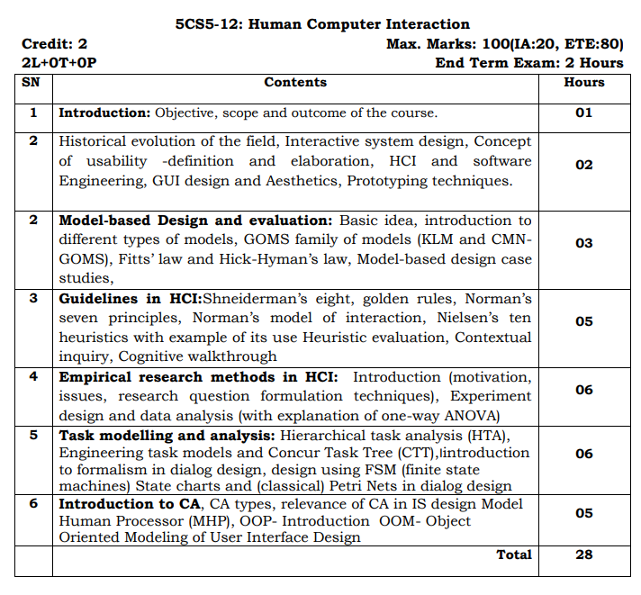

## Lecture Plan: (42 Hours)

|  |  |  |  |  |
| --- | --- | --- | --- | --- |
| **Date** | | **Hrs (T)** | **Unit** | **Lecture Title** |
| **From** | **To** |
|  |  | 1 | **1** | **Subject Introduction** |
|  |  | 1 | Objective, scope and outcome of the course. |
|  |  | 1 | Historical evolution of the field, Interactive system |
|  |  | 1 | Concept of usability -definition and elaboration |
|  |  | 1 | HCI and software Engineering |
|  |  | 1 | GUI design and Aesthetics, Prototyping techniques |
|  |  | 1 | **2** | **Model-based Design and evaluation** |
|  |  | 2 | Basic idea and introduction to different types of models |
|  |  | 2 | GOMS family of models (KLM and CMNGOMS) |
|  |  | 1 | Fitts’ law and Hick-Hyman’s law |
|  |  | 2 | Model-based design case studies |
|  |  | **1** | **3** | **Guidelines in HCI** |
|  |  | 1 | Shneiderman’s eight, golden rules |
|  |  | 1 | Norman’s seven principles |
|  |  | 1 | Norman’s model of interaction |
|  |  | 2 | Nielsen’s ten heuristics with example of its use Heuristic evaluation |
|  |  | 1 | Contextual inquiry, Cognitive walkthrough |
|  |  | **1** | **4** | **Empirical research methods in HCI** |
|  |  | 1 | Introduction( motivation, issues) |
|  |  | 1 | Research question formulation techniques |
|  |  | 2 | Experiment design and data analysis |
|  |  | **1** | one-way ANOVA |
|  |  | 2 | **5** | **Task modeling and analysis** |
|  |  | 2 | Hierarchical task analysis (HTA) |
|  |  | **1** | Engineering task models and Concur Task Tree (CTT) |
|  |  | **1** | Introduction to formalism in dialog design |
|  |  | **1** | Design using FSM (finite state machines) State charts |
|  |  | **1** | Petri Nets in dialog design |
|  |  | **2** | **6** | **Introduction to CA** CA types, relevance of CA in IS design Model |
|  |  | **1** | Human Processor (MHP), |
|  |  | **1** | OOP- Introduction OOM |
|  |  | **1** | Object Oriented Modeling of User Interface Design |
|  |  | **2** | **ALL** |  |

# Learning Resources

## Text Books/Reference Books

* Alan Dix, Janet Finlay, Gregory Abowd, Russell Beale, ―Human Computer Interaction, 3rd Edition, Pearson Education. ISBN: 9780130461094
* Andrew Sears – Human Computer Interaction , CRC Press ISBN: 1410615863
* Preece J., Rogers Y., Sharp H., Baniyon D., Holland S. and Carey T. Human Computer Interaction, Addison-Wesley, 1994. ISBN:  0201627698
* Cooper, Reimann, Cronin, & Noessel., About Face: The Essentials of Interaction Design, Wiley. ISBN: 1118766571

## Online References

* ***Notes*** by [**www.tutorialspoint.com**](http://www.tutorialspoint.com)   
  <https://www.tutorialspoint.com/human_computer_interface/index.htm>
* ***Article*** on [www.geeksforgeeks.com](http://www.geeksforgeeks.com)   
  <https://www.geeksforgeeks.org/human-computer-interaction-through-the-ages/>
* NPTEL ***Videos***   
  <https://nptel.ac.in/courses/106/103/106103115/>

## Teaching Resources

* Presentations, during classroom discussion, will be available on Google in PDF format
* Various online and offline resources will be shared during course compilation

# Assessment

## Internal

* Online Quiz during course compilation with tools like Kahoot, Google forms etc.
* Assignment Submission through Google Classroom after every Unit of Syllabus.
* Case studies and Problem Scenario discussion after every topic
* Presentation and Report on Final Assignment

## External

* As per Rajasthan Technical University – Kota’s guidelines
* Previous Years Question Papers are available on [www.rtu.ac.in](http://www.rtu.ac.in) or Examination Cell of [www.technonjr.org](http://www.technonjr.org)