**Techno India NJR Institute of Technology**



**Course File**

**Session 2021-22**

**Internet of Things (7CS4-01)**

Yogendra Singh Solanki

(Assistant Professor)

**Department of ECE**

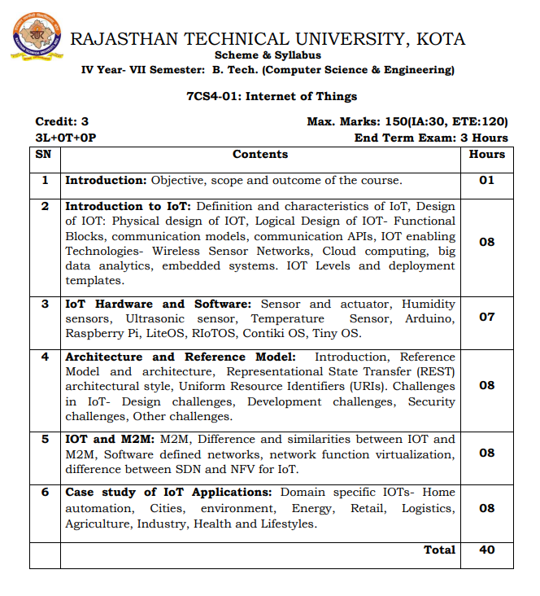

**Course Overview:**

The explosive growth of the “Internet of Things” is changing our world and the rapid drop in price for typical IoT components is allowing people to innovate new designs and products at home. In this subject, student will learn the importance of IoT in society, the current components of typical IoT devices and trends for the future. IoT design considerations, constraints and interfacing between the physical world and your device will also be covered. You will also learn how to make design trade-offs between hardware and software. We'll also cover key components of networking to ensure that students understand how to connect their device to the Internet.

**Course Outcomes:**

|  |  |  |
| --- | --- | --- |
| **CO. NO.** | **Cognitive Level** | **Course Outcome** |
| 1 | Comprehension | Describe the definition and usage of the term “Internet of Things” in different contexts understand the key components that make up an IoT system |
| 2 | Comprehension | Differentiate between the levels of the IoT stack and be familiar with the key technologies and protocols employed at each layer of the stack |
| 3 | Knowledge | Understand famous IoT relevant Operating systems and hardware. |
| 4 | Analysis | Appreciate the role of big data, cloud computing and data analytics in a typical IoT system |
| 5 | Synthesis | Design and Develop IOT based applications such as Lake Monitoring System, Air Quality System and Smart Energy Meter. |

**Prerequisites:**

1. Fundamentals of Networking, Operating Systems.
2. Fundamentals of Communication protocols
3. Must have completed the course on basic C programming.

**Course Outcome Mapping with Program Outcome:**

|  |  |  |  |  |  |  |  |  |  |  |  |  |
| --- | --- | --- | --- | --- | --- | --- | --- | --- | --- | --- | --- | --- |
| **Course Outcome** | **Program Outcomes (PO’s)** | | | | | | | | | | | |
| **CO. NO.** | **Domain Specific** | | | | | **Domain Independent** | | | | | | |
|  | **PO1** | **PO2** | **PO3** | **PO4** | **PO5** | **PO6** | **PO7** | **PO8** | **PO9** | **PO10** | **PO11** | **PO12** |
| CO1 | 3 | 2 | 2 | 0 | 0 | 0 | 0 | 0 | 0 | 0 | 0 | 3 |
| CO2 | 3 | 2 | 1 | 0 | 0 | 0 | 0 | 0 | 0 | 0 | 0 | 2 |
| CO3 | 3 | 2 | 2 | 0 | 0 | 0 | 0 | 0 | 0 | 0 | 0 | 2 |
| CO4 | 3 | 2 | 1 | 0 | 0 | 0 | 0 | 0 | 0 | 0 | 0 | 2 |
| CO5 | 3 | 2 | 1 | 0 | 0 | 0 | 0 | 0 | 0 | 0 | 0 | 2 |
| 1: Slight (Low) , 2: Moderate (Medium), 3: Substantial (High) | | | | | | | | | | | | |

**Course Coverage Module Wise:**

|  |  |  |
| --- | --- | --- |
| **Lecture No.** | **Unit** | **Topic** |
| 1 | **1** | **Introduction: Objective, scope and outcome of the course** |
| 2 | **2** | **Introduction to IoT** |
| 3 | 2 | Definition and characteristics of IoT |
| 4 | 2 | Design of IOT, Physical design of IOT and Logical Design of IOT- Functional Blocks |
| 5 | 2 | Communication models, communication APIs |
| 6 | 2 | IOT enabling Technologies- Wireless Sensor Networks, Cloud computing |
| 7 | 2 | Big data analytics, IOT Levels and deployment templates |
| 8 | 2 | Introduction of Embedded systems |
| 9 | 2 | IOT Levels and deployment templates |
| 10 | **3** | **IoT Hardware and Software** |
| 11 | 3 | Basic Introduction of Sensor and actuator |
| 12 | 3 | Humidity sensors, Ultrasonic sensor, Temperature Sensor |
| 13 | 3 | Humidity sensors, Ultrasonic sensor, Temperature Sensor |
| 14 | 3 | Basic Introduction of Arduino and Programming |
| 15 | 3 | Basic Introduction of Raspberry Pi and Programming |
| 16 | 3 | Basic Introduction of LiteOS, RIoTOS, Contiki OS, Tiny OS |
| 17 | **4** | **Architecture and Reference Model** |
| 18 | 4 | Introduction, Reference Model and architecture |
| 19 | 4 | Representational State Transfer (REST) architectural style |
| 20 | 4 | Uniform Resource Identifiers (URIs) |
| 21 | 4 | Uniform Resource Identifiers (URIs) |
| 22 | 4 | Challenges in IoT- Design challenges |
| 23 | 4 | Development challenges |
| 24 | 4 | Security challenges and other challenges |
| 25 | **5** | **IOT and M2M** |
| 26 | 5 | M2M, Difference and similarities between IOT and M2M |
| 27 | 5 | M2M, Difference and similarities between IOT andM2M |
| 28 | 5 | Software defined networks |
| 29 | 5 | Software defined networks |
| 30 | 5 | Network function virtualization |
| 31 | 5 | Network function virtualization |
| 32 | 5 | Difference between SDN and NFV for IoT |
| 33 | **6** | **Case study of IoT Applications** |
| 34 | 6 | Domain specific IOTs- Home automation |
| 35 | 6 | Domain specific IOTs- Cities |
| 36 | 6 | Domain specific IOTs- Environment, Energy |
| 37 | 6 | Domain specific IOTs- Retail, Logistics |
| 38 | 6 | Domain specific IOTs- Agriculture |
| 39 | 6 | Domain specific IOTs- Industry |
| 40 | 6 | Domain specific IOTs- Health and Lifestyles |

**TEXT/REFERENCE BOOKS**

1. Internet of Things, “A Hands on Approach”, Vijay Madisetti, Arshdeep Bahga, University Press.
2. Introduction to Internet of Things: A practical Approach, Dr. SRN Reddy, Rachit Thukral and Manasi Mishra, ETI Labs.
3. The Internet of Things: Enabling Technologies, Platforms, and Use Cases, Pethuru Raj and Anupama C. Raman, CRC Press.
4. Internet of Things, Jeeva Jose,Khanna Publishing House, Delhi.

**Teaching and Learning resources:**

* **MOOC (NPTEL): -** https://nptel.ac.in/courses/106/105/106105166/
* **Unit Wise Internet Resourses**

**Unit 2**

1.<https://iotbyhvm.ooo/physical-and-logical-design-of-iot/#:~:text=Physical%20Design%20of%20IoT%20refers,based%20server%20over%20the%20Internet>.

2. <https://iotbyhvm.ooo/iot-enabling-technologies/#:~:text=IoT%20is%20enabled%20by%20several,Internet%2C%20and%20Semantic%20Search%20engines>.

**Unit -3**

1. <https://iotbyhvm.ooo/iot-sensors-actuators/>

**Unit 4**  
  
1. <https://iotnotesbyparita.wordpress.com/architecture-reference-model/>  
  
2. <https://www.finoit.com/blog/enterprise-challenges-in-iot/>  
  
3. <https://www.iotevolutionworld.com/iot/articles/445866-top-five-challenges-iot.htm>  
  
**Unit 5**  
  
1. <https://www.peerbits.com/blog/difference-between-m2m-and-iot.html>  
  
2. <https://ardas-it.com/what-is-the-difference-between-m2m-and-iot>  
  
3. <https://www.sdxcentral.com/networking/sdn/definitions/what-the-definition-of-software-defined-networking-sdn/>  
  
4. <https://www.sdxcentral.com/networking/nfv/definitions/whats-network-functions-virtualization-nfv/>

**Assessment Methodology:**

1. Two Midterm exams where student have to showcase subjective learning.
2. Final Exam (subjective paper) at the end of the semester.