**Techno India NJR Institute of Technology**



**Course File**

**Advanced Engineering Mathematics**

**(3EE201)**

Dr. Kalpana Fatawat

(Associate Professor)

**Department of Basic Science**

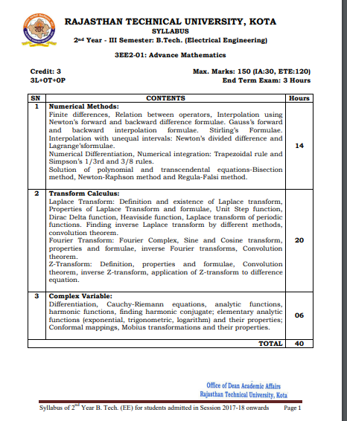

**Course Overview:**

In this course, students will learn the concepts of transformation and numerical methods to solve the problems and will apply in the field of communication.

**Course Outcomes:**

| **CO. NO.** | **Cognitive Level** | **Course Outcome** |
| --- | --- | --- |
| 1 | Knowledge | To learn the concepts of various methods to solve the numerical problems. |
| 2 | Application | Students apply the knowledge of Fourier Transformation, z-transform and calculus in study of Signal Processing, Control Theory etc. |
| 3 | Analysis | Employ appropriate numerical methods to solve algebraic and transcendental equations and analysis the circuit problem. |
| 4 | Application | Students apply the knowledge of complex variable. |
| 5 | Synthesis | Student able to apply the concept of complex theory in designing the circuit. |

**Prerequisites:**

* Understanding of basic Algebra
* Understanding of basic high-school mathematics.
* Aware of function theory.

|  |  |  |  |  |  |  |  |  |  |  |  |  |  |  |  |
| --- | --- | --- | --- | --- | --- | --- | --- | --- | --- | --- | --- | --- | --- | --- | --- |
| Advanced Engineering Mathematics year of study 2020-21 | | | | | | | | | | | | |  |  |  |
| Course Outcome | PO1 | PO2 | PO3 | PO4 | PO5 | PO6 | PO7 | PO8 | PO9 | PO10 | PO11 | PO12 | PSO1 | PSO2 | PSO3 |
| COEE201.1 | 3 | 1 | 0 | 2 | 0 | 0 | 0 | 0 | 0 | 0 | 0 | 0 | 0 | 0 | 0 |
| COEE201.2 | 3 | 2 | 1 | 2 | 1 | 0 | 0 | 0 | 0 | 0 | 0 | 0 | 0 | 0 | 0 |
| COEE201.3 | 1 | 2 | 2 | 2 | 2 | 1 | 0 | 0 | 0 | 0 | 0 | 0 | 0 | 0 | 0 |
| COEE201.4 | 2 | 1 | 2 | 1 | 2 | 0 | 0 | 0 | 0 | 0 | 0 | 0 | 0 | 0 | 0 |
| COEE201.5 | 2 | 1 | 1 | 1 | 2 | 1 | 0 | 0 | 0 | 0 | 0 | 0 | 0 | 0 | 0 |
| COEE201(AVG) | 2.20 | 1.40 | 1.20 | 1.60 | 1.40 | 0.40 | 0.00 | 0.00 | 0.00 | 0.00 | 0.00 | 0.00 | 0.00 | 0.00 | 0.00 |

**Course Coverage Module Wise:**

**Lecture plan based on Unit 1**

| Lecture Sl. No. | Topic |
| --- | --- |
| 1 | Student is able to grasp interpolation methods. |
| 2 | Student becomes familiar with different transcendental functions and their solutions. |
| 3 | Student is able to grasp the concept of numerical integration. |

**Lecture plan based on Unit 2**

| Lecture Sl. No. | Topic |
| --- | --- |
| 4 | Laplace transformation. |
| 5 | Various properties of Laplace transformation. |
| 6 | Student is able to grasp concept of various functions like Unit step function, Dirac delta functions etc. |
| 7 | Student becomes familiar with the concepts Laplace inverse transformation |
| 8 | Convolution theorems |
| 9 | Fourier sine and cosine series |
| 10 | Student becomes familiar with the concepts fourier inverse transformation |
| 11 | Convolution theorems |
| 12 | Student is able to compare the Fourier series and transformation. |
| 13 | Student becomes familiar with uniform and exponential distributions. |
| 14 | Student is able to grasp concept of correlation coefficient. |
| 15 | Student becomes familiar with the concepts Z-transform. |
| 16 | Convolution theorems |
| 17 | Student is able to understand inverse Z-transform. |
| 18 | Student is able to grapes the properties of Z-transform. |
| 19 | Student is able to use Z-transform in difference equations. |

**Lecture plan based on Unit 3**

| Lecture Sl. No. | Topic |
| --- | --- |
| 20 | Student is able to grasp the concept of complex variable. |
| 21 | Student becomes familiar with the use of differential in complex theory. |
| 22 | Cachy-Riemann equations |
| 23 | Student is able to understand the harmonic functions and conjugate functions. |
| 24 | Concept of analytic functions and study of some elementary analytic functions like log, exponent etc. |
| 25 | Conformal mapping |
| 26 | Mobius transformation and their properties |

**TEXT/REFERENCE BOOKS**

* Advanced Engineering Mathematics –III (RTU), K.C. Sarangi, Amber Srivastava, Monika Malhotra, Rohit Mukharjee, Vivek Kr Sharma, Genius Publications.
* Introduction to the Theory of functions of a complex variable, E.T. Copson, Oxford.
* M. Ray, J. C. Chaturvedi & H.C. Sharma, Differential Equations, Students friends & company
* Chandrika Prasad, Mathematics for Engineers, Prasad Mudralaya

**Teaching and Learning resources:**

**Unit 1**

<https://www.youtube.com/watch?v=5WuwBpMJXKQ>

<https://www.youtube.com/watch?v=r6MTvrI8SQ4>

<https://www.youtube.com/watch?v=AeSnsuZ7srI>

**Unit 2**

[**https://www.youtube.com/watch?v=c9NibpoQjDk**](https://www.youtube.com/watch?v=c9NibpoQjDk)

[**https://www.youtube.com/watch?v=KvS5qHW8S4U**](https://www.youtube.com/watch?v=KvS5qHW8S4U)

[**https://www.youtube.com/watch?v=n9XP6pljtw8&list=PLbRMhDVUMngfsMNuiGSQQuNwPevZukOY_**](https://www.youtube.com/watch?v=n9XP6pljtw8&list=PLbRMhDVUMngfsMNuiGSQQuNwPevZukOY_)

[**https://www.youtube.com/watch?v=zmxWaXvKfdc&list=PLs7oDAL8_ouKSagWiC_IwrEsRwvD2WJ73**](https://www.youtube.com/watch?v=zmxWaXvKfdc&list=PLs7oDAL8_ouKSagWiC_IwrEsRwvD2WJ73)

**Unit 3**

[**https://www.youtube.com/watch?v=HswQxH4G63c**](https://www.youtube.com/watch?v=HswQxH4G63c)

[**https://www.youtube.com/watch?v=QIqHxGVLPOA**](https://www.youtube.com/watch?v=QIqHxGVLPOA)

[**https://www.youtube.com/watch?v=znvskofPNXc**](https://www.youtube.com/watch?v=znvskofPNXc)

[**https://www.youtube.com/watch?v=2I4jKIGy238**](https://www.youtube.com/watch?v=2I4jKIGy238)

**Assessment Methodology:**

1. Assignments one from each unit and oral questioning.
2. Midterm subjective paper. (Twice during the semester)
3. Final paper at the end of the semester subjective.

**ADVANCED ENGINEERING MATHEMATICS QUESTION BANK**

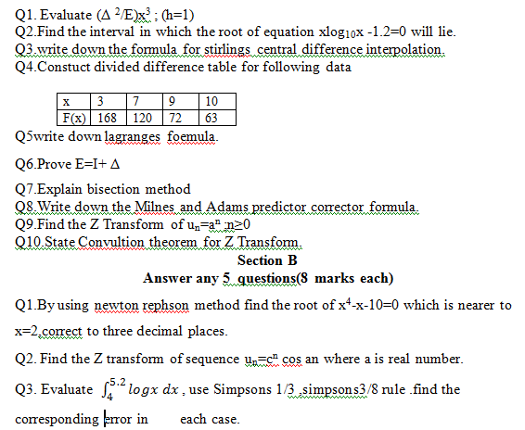

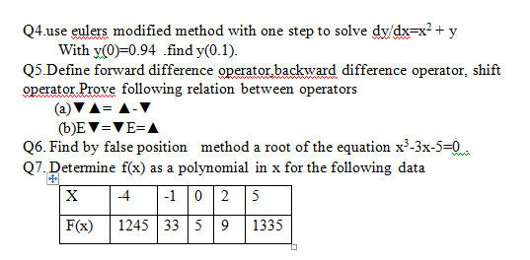

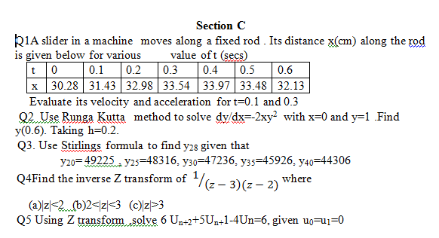

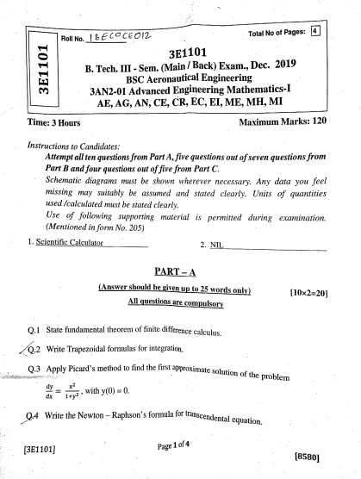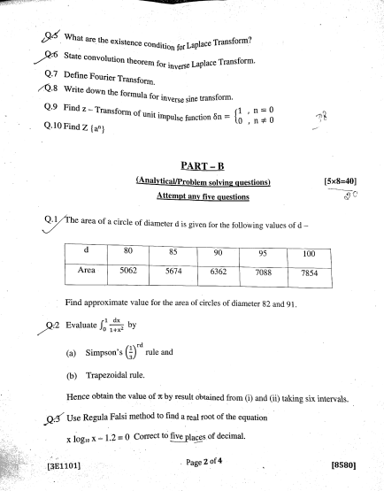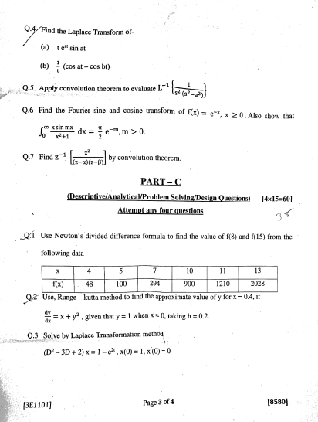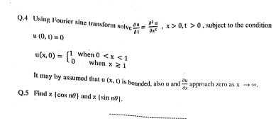

**TECHNO INDIA NJR INSTITUTE OF TECHNOLOGY, UDAIPUR**

**B. TECH 2nd – YEAR (III SEM.) – MT-III**

Advance Mathematics (**3EE2-01**)

**Time:** 3 Hr **Max. Marks:** 70

**Note:**

1. The paper is divided into 2 parts: Part-A and, Part-B.
2. Part-A contains 10 questions and carries 2 mark each.
3. Part-B contains 5 questions. Each question is having two options and carries 10 marks each.

Part- A (20 Marks)

|  |  |  |
| --- | --- | --- |
|  | Evaluate (Δ 2/E)x3 ; (h=1) | CO1 |
|  | Write down the formula for Stirlings central difference interpolation. | CO1 |
|  | Prove that $(∆-∇)≅∆∇$ and Trapezoidal rule of numerical integration. | CO1 |
|  | Write Gauss forward central interpolation formula and write Newton’s Raphson formula. | CO1 |
|  | Find the roots of $f\left(x\right)=x^{2}+2x+1$ by bisection method. | CO1 |
|  | Define transdental equations. | CO1 |
|  | Write the Newton’s divided difference formula. | CO1 |
|  | Find the Laplace transform of $te^{at}sinbt$ | CO2 |
|  | Explain the Laplace transformation. | CO2 |
|  | Explain the first shifting property for Laplace transformation. Give an example. | CO2 |

Part- B (100 Marks)

|  |  |
| --- | --- |
| 1.A. Use Stirlings formula to find y28 given that  y20= 49225 , y25=48316, y30=47236, y35=45926, y40=44306  B. By using Newton-Raphson method find the root of x4-x-10=0 which is nearer to x=2, correct to three decimal places. | CO1 |
| OR | |
| 1. A. (i) show that . Find  , where h is the interval differencing.   B. (i) Use Regular-Falsi method to solve correct upto four places of decimal.  (ii) Find f(x) as the polynomial in x for the following data:   |  |  |  |  |  |  | | --- | --- | --- | --- | --- | --- | | X | -4 | -1 | 0 | 2 | 5 | | F(x) | 1245 | 33 | 5 | 9 | 1335 | | CO1 |

|  |  |  |  |  |  |  |  |  |  |  |  |  |  |  |  |  |  |
| --- | --- | --- | --- | --- | --- | --- | --- | --- | --- | --- | --- | --- | --- | --- | --- | --- | --- |
| 2. From the following table find f’(1.2)   |  |  |  |  |  |  |  |  | | --- | --- | --- | --- | --- | --- | --- | --- | | X | 1 | 1.2 | 1.4 | 1.6 | 1.8 | 2.0 | 2.2 | | f(x) | 2.72 | 3.32 | 4.06 | 4.96 | 6.o5 | 7.39 | 9.02 | | CO2 |
| OR | |
| 2. Find the smallest positive root of the equation $x^{3}- 3x^{2}+x+1=0$ by secant method. | CO2 |

|  |  |
| --- | --- |
| 3. Evaluate $\int_{0}^{6}{\frac{dx}{{1+x}^{2}}}$ by using (1) Simpson 1/3 method (2) Simpson 3/8 method (3) Trapzoidal rule and compare the results with its actual value. | CO3 |
| OR | |
| 3. Find the root of the equation  using Newton’s Raphson method correct to three decimal places. | CO3 |

|  |  |
| --- | --- |
| 1. A State and prove convolution theorem for Laplace transform.   B. Deduce that: | CO2 |
| OR | |
| 1. A Use Z-transform to solve the following equation:  Given   B. Find Z-transform of . | CO2 |

|  |  |
| --- | --- |
| 5 Prove that Hence deduce that | CO2 |
| OR | |
| 5 Prove that L $\left(\frac{sint}{t}\right)$ = $\tan^{-1}\left(\frac{1}{s}\right)$ and hence find L $\left(\frac{\sin{a}t}{t}\right)$ | CO2 |

----------­­­­­-----------

**TECHNO INDIA NJR INSTITUTE OF TECHNOLOGY, UDAIPUR**

**B. TECH 2nd – YEAR (III SEM.) – MT-II**

Advance Mathematics (**3EE2-01**)

**Time:** 3 Hr **Max. Marks:** 70

**Note:**

1. The paper is divided into 2 parts: Part-A and, Part-B.
2. Part-A contains 10 questions and carries 2 mark each.
3. Part-B contains 5 questions. Each question is having two options and carries 10 marks each.

Part- A (20 Marks)

|  |  |  |
| --- | --- | --- |
|  | Evaluate (Δ 2/E)x3 ; (h=1) | CO1 |
|  | Write down the formula for Stirlings central difference interpolation. | CO1 |
|  | Write the Heaviside’s Unit step function and the Error function. | CO2 |
|  | Write the Shifting Property for Laplace transformation. | CO2 |
|  | Explain the Fourier transformation. | CO3 |
|  | Find the Fourier cosine transform of the function. | CO3 |
|  | Find the Z Transform of un=an ;n≥0 | CO4 |
|  | Solve  if | CO4 |
|  | Prove that does not exist. | CO5 |
|  | Explain Magnification and Contraction | CO5 |

Part- B (100 Marks)

|  |  |
| --- | --- |
| 1.A. Use Stirlings formula to find y28 given that  y20= 49225 , y25=48316, y30=47236, y35=45926, y40=44306  B. By using Newton-Raphson method find the root of x4-x-10=0 which is nearer to x=2, correct to three decimal places. | CO1 |
| OR | |
| 1. A. (i) show that . Find  , where h is the interval differencing.   B. (i) Use Regular-Falsi method to solve correct upto four places of decimal.  (ii) Find f(x) as the polynomial in x for the following data:   |  |  |  |  |  |  | | --- | --- | --- | --- | --- | --- | | X | -4 | -1 | 0 | 2 | 5 | | F(x) | 1245 | 33 | 5 | 9 | 1335 | | CO1 |

|  |  |
| --- | --- |
| 1. A. Prove that Hence deduce that   B. Find (a) (c) | CO2 |
| OR | |
| 1. A. Find the inverse Laplace transform of   B. State and prove convolution theorem. | CO2 |

|  |  |
| --- | --- |
| 1. A. Find f(x) if its Fourier **sine** transform is   B. Find f(x) if its Fourier **cosine** transform is | CO3 |
| OR | |
| 1. A. Solve the integral equation:  Hence deduce that:   B. Find Fourier sine transform of | CO3 |

|  |  |
| --- | --- |
| 1. A. Find the inverse Z-transform of   B. Establish the following Z-transform of . | CO4 |
| OR | |
| 1. A Use Z-transform to solve the following equation:  Given   B. Find Z-transform of . | CO4 |

|  |  |
| --- | --- |
| 1. A. state the CR-equations. Examine the nature of the function   B. If ;find the analytic function | CO5 |
| OR | |
| 1. A. Find the bilinear transformation which maps the points respectively onto the points . For this transformation, find the image of (i)  (ii) concentric circles   B. Show that the transformation maps the circle  onto the straight line , and explain why the curve obtained is not a circle. | CO5 |

----------­­­­­-----------