**Techno India NJR Institute of Technology**



**Course File**

**Session 2021-22**

**Electromagnetic Fields (3EE4-08)**

Payal Paliwal

(Assistant Professor)

**Department of ECE**

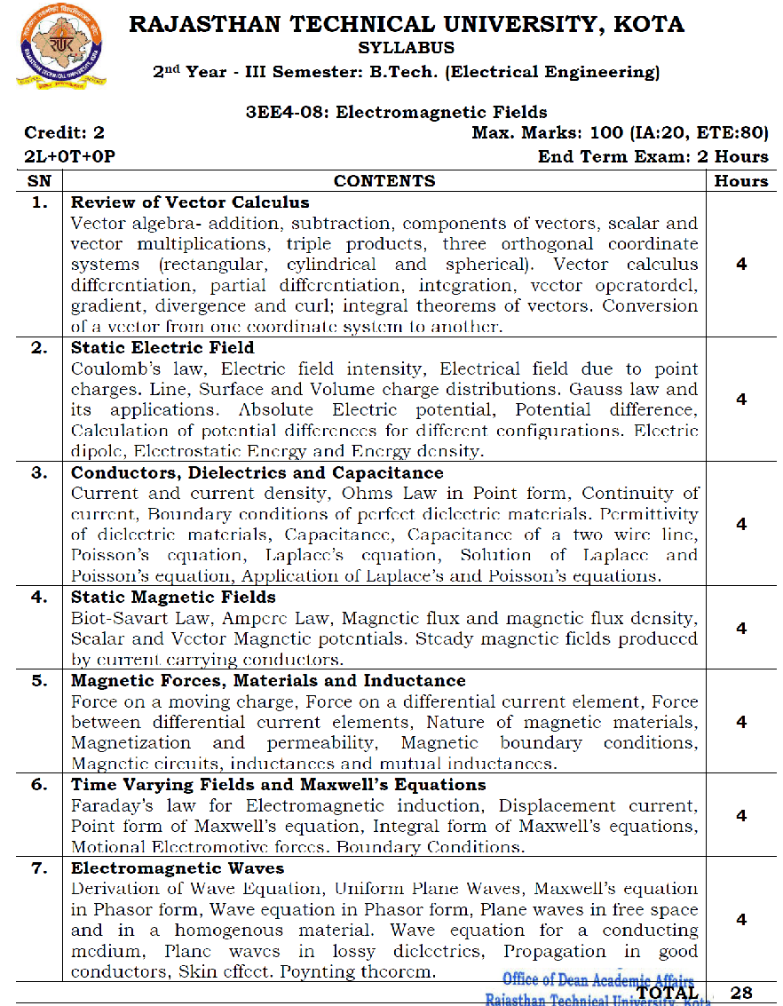

**Course Overview:**

Student will learn fundamentals of Electromagnetic waves from this 28-hour course. In this course, student will study the fundamental concepts and application of electromagnetic radiations. Also, they will study vector calculus, coordinate systems, maxwell’s equation and fundamentals of waveguide and antennas.

**Course Outcomes:**

| **CO. NO.** | **Cognitive Level** | **Course Outcome** |
| --- | --- | --- |
| CO1 | Knowledge | Define and recognize different co‐ordinate systems to describe the spatial variations of the    physical quantities. |
| CO2 | Analysis | Analyze fundamental laws governing electromagnetic fields and evaluate the physical quantities of electromagnetic fields. |
| CO3 | Application | Student learn to Maxwell’s equations apply electromagnetic theory to solve problems primarily in physics and electrical engineering. |
| CO4 | Synthesis | To synthesis time varying fields, propagation of electromagnetic waves in different media, pyonting theorem, their sources & effects and to apply the theory of electromagnetic waves in practical problems. |
| CO5 | Evaluation | To evaluate electric field and magnetic filed in space using gaussian theorem , amperes laws, maxwells equation . |

**Prerequisites:**

1. Fundamentals of various orthogonal coordinate systems.
2. Must have completed the course on electrostatics and magnetostatics.
3. Student should be able to solve the problems of vector calculus.

**Course Outcome Mapping with Program Outcome:**

| **Course Outcome** | **Program Outcomes (PO’s)** | | | | | | | | | | | |
| --- | --- | --- | --- | --- | --- | --- | --- | --- | --- | --- | --- | --- |
| **CO. NO.** | **Domain Specific** | | | | | **Domain Independent** | | | | | | |
|  | **PO1** | **PO2** | **PO3** | **PO4** | **PO5** | **PO6** | **PO7** | **PO8** | **PO9** | **PO10** | **PO11** | **PO12** |
| **CO1** | 1 | 2 | 1 | 2 | 1 | 0 | 0 | 0 | 0 | 0 | 0 | 0 |
| **CO2** | 2 | 1 | 2 | 2 | 1 | 0 | 0 | 0 | 0 | 0 | 0 | 0 |
| **CO3** | 2 | 2 | 2 | 1 | 2 | 0 | 0 | 0 | 0 | 0 | 0 | 0 |
| **CO4** | 2 | 1 | 1 | 1 | 2 | 1 | 1 | 0 | 0 | 0 | 0 | 0 |
| **CO5** | 1 | 2 | 1 | 1 | 1 | 1 | 1 | 0 | 0 | 0 | 0 | 0 |
| 1: Slight (Low) , 2: Moderate (Medium), 3: Substantial (High) | | | | | | | | | | | | |

**Course Coverage Module Wise:**

| **Lecture No.** | **Unit** | **Topic** |
| --- | --- | --- |
|  | **1** | **Review of Vector Calculus** |
|  | 1 | Vector algebra- addition, subtraction, components of vectors, scalar and vector multiplications, triple products |
|  | 1 | Three orthogonal coordinate systems (rectangular, cylindrical and spherical). Vector calculus, differentiation, partial differentiation, integration |
|  | 1 | Vector operator del, gradient, divergence and curl; integral theorems of vectors. Conversion of a vector from one coordinate system to another |
|  | **2** | **Static Electric Field:**  Coulomb’s law, Electric field intensity |
|  | 2 | Electrical field due to point charges. Line, Surface and Volume charge distributions, Gauss law and its applications |
|  | 2 | Absolute Electric potential, Potential difference, Calculation of potential differences for different configurations |
|  | 2 | Electric dipole, Electrostatic Energy and Energy density |
|  | **3** | **Conductors, Dielectrics and Capacitance:**  Current and current density, Ohms Law in Point form |
|  | 3 | Continuity of current, Boundary conditions of perfect dielectric materials |
|  | 3 | Permittivity of dielectric materials, Capacitance, Capacitance of a two wire line |
|  | 3 | Poisson’s equation, Laplace’s equation, Solution of Laplace and Poisson’s equation, Application of Laplace’s and Poisson’s equations |
|  | **4** | **Static Magnetic Fields:**  Biot-Savart Law, Ampere Law |
|  | 4 | Magnetic flux and magnetic flux density |
|  | 4 | Scalar and Vector Magnetic potentials |
|  | 4 | Steady magnetic fields produced by current carrying conductors |
|  | **5** | **Magnetic Forces, Materials and Inductance:**  Force on a moving charge, Force on a differential current element, Force  between differential current elements |
|  | 5 | Nature of magnetic materials, Magnetization and permeability |
|  | 5 | Magnetic boundary conditions |
|  | 5 | Magnetic circuits, inductances and mutual inductances |
|  | **6** | **Time Varying Fields and Maxwell’s Equations** |
|  | 6 | Faraday’s law for Electromagnetic induction, Displacement current |
|  | 6 | Point form of Maxwell’s equation, Integral form of Maxwell’s equations |
|  | 6 | Motional Electromotive forces. Boundary Conditions. |
|  | **7** | **Electromagnetic Waves:**  Derivation of Wave Equation, Uniform Plane Waves |
|  | 7 | Maxwell’s equation in Phasor form, Wave equation in Phasor form, Plane waves in free space and in a homogenous material. |
|  | 7 | Wave equation for a conducting medium, Plane waves in lossy dielectrics |
|  | 7 | Propagation in good conductors, Skin effect, Poynting theorem |

**TEXT/REFERENCE BOOKS**

1.Electromagnetic Field Theory, Sadiku, Oxford.

2. Principles of Electromagnetics, Mahapatra, TMH.

3. Electromagnetic Field Theory and Transmission Lines, Rao, Wiley

**Teaching and Learning resources:**

* **MOOC (NPTEL): -** https://nptel.ac.in/courses/117/101/117101056/

**Assessment Methodology:**

1. Practical exam using lab instruments.
2. Two Midterm exams where student have to showcase subjective learning.
3. Final Exam (subjective paper) at the end of the semester.

