**Techno India NJR Institute of Technology**



**Course File**

**Session 2021-22**

**MOS (3ME-07)**

Abhishek Sharma

(Assistant Professor)

**Department of ME**

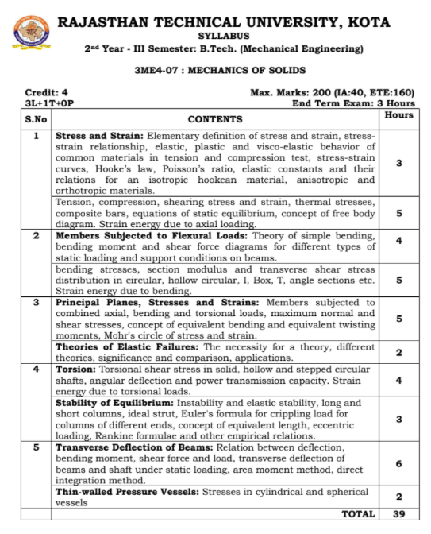

**Course Overview:**

Strength of materials is **the discipline related to calculation of stresses and strains in structures and mechanical components**. ... In order to do so, we define the term stress as a measure for internal force per area acting inside a structure.

**Course Outcomes:**

|  |  |  |
| --- | --- | --- |
| **CO. NO.** | **Cognitive Level** | **Course Outcome** |
| 1 | Analysis | To understand the basics of material properties, stress and strain |
| 2 | Synthesis | To apply knowledge of mathematics, science, for engineering applications |
| 3 | Synthesis | Ability to identify, formulate, and solve engineering & real life problems |
| 4 | Synthesis | Ability to design and conduct experiments, as well as to analyze and interpret data |
| 5 | Analysis | To Design Pressure Vessels and Find Stress Concentration Factor. |

**Prerequisites:**

1. Basic Knowledge about Free Body Diagram
2. Must have completed the course on Engineering Mechanics.

**Course Scheme -**

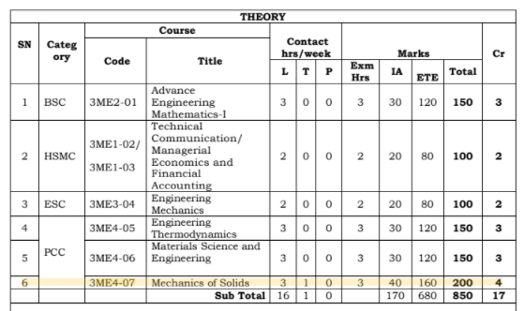

**Course Outcome Mapping with Program Outcome:**

|  |  |  |  |  |  |  |  |  |  |  |  |  |  |  |  |
| --- | --- | --- | --- | --- | --- | --- | --- | --- | --- | --- | --- | --- | --- | --- | --- |
| **Mechanics of Solids Year of study: 2021-22** | | | | | | | | | | | | | | | |
| **Course Outcome** | **PO1** | **PO2** | **PO3** | **PO4** | **PO5** | **PO6** | **PO7** | **PO8** | **PO9** | **PO10** | **PO11** | **PO12** | **PSO1** | **PSO2** | **PSO3** |
| CO1 | 2 | 2 | 2 | 2 | 0 | 2 | 1 | 1 | 1 | 2 | 0 | 1 | 1 | 1 | 1 |
| CO2 | 2 | 2 | 2 | 1 | 1 | 2 | 1 | 0 | 1 | 2 | 0 | 1 | 1 | 0 | 1 |
| CO3 | 2 | 2 | 2 | 2 | 1 | 1 | 1 | 1 | 1 | 2 | 0 | 1 | 1 | 0 | 1 |
| C04 | 2 | 2 | 1 | 1 | 1 | 1 | 1 | 0 | 1 | 1 | 0 | 1 | 1 | 1 | 1 |
| C05 | 2 | 2 | 1 | 1 | 1 | 1 | 1 | 0 | 1 | 1 | 0 | 1 | 1 | 1 | 1 |
| **Average** | 2.00 | 2.00 | 1.60 | 1.40 | 0.80 | 1.40 | 1.00 | 0.40 | 1.00 | 1.60 | 0.00 | 1.00 | 1.00 | 0.60 | 1.00 |

**Course Coverage Module Wise:**

|  |  |  |
| --- | --- | --- |
| Lecture  No. | Unit | Topic |
| 1 | 1 | ELEMENTARY DEFINITION OF STRESS AND STRAIN: stress  strain relationship, elastic, plastic and visco-elastic behavior of common  materials in tension and compression test, stress-strain curves |
| 2 | 1 | Hooke’s law, Poisson’s ratio, elastic constants and their relations for an  isotropic hookean material |
| 3 | 1 | Anisotropic and orthotropic materials. |
| 4 | 1 | Tension, compression, shearing stress |
| 5 | 1 | strain, thermal stresses, composite bars |
| 6 | 1 | equations of static equilibrium, |
| 7 | 1 | concept of free body diagram. |
| 8 | 1 | Strain energy due to axial loading |
| 9 | 2 | THEORY OF SIMPLE BENDING |
| 10 | 2 | bending moment and shear force diagrams for different types of static  loading and support conditions on beams.(Point load problem) |

|  |  |  |
| --- | --- | --- |
| 11 | 2 | bending moment and shear force diagrams for different types of static  loading and support conditions on beams.(UDL Problem) |
| 12 | 2 | bending moment and shear force diagrams for different types of static  loading and support conditions on beams.(UVL Problem) |
| 13 | 2 | bending stresses |
| 14 | 2 | section modulus and transverse shear stress distribution in circular |
| 15 | 2 | section modulus and transverse shear stress distribution in hollow circular, I  section. |
| 16 | 2 | section modulus and transverse shear stress distribution in T section and  angle sections. |
| 17 | 2 | Strain energy due to bending |
| 18 | 3 | EQUIVALENT BENDING & TWISTING |
| 19 | 3 | Members subjected to combined axial bending and torsional loads, |
| 20 | 3 | concept of equivalent bending and equivalent twisting moments |
| 21 | 3 | maximum normal and shear stresses |
| 22 | 3 | Mohr's circle of stress and strain. |
| 23 | 3 | The necessity for a theory, different theories |
| 24 | 3 | Significance and comparison, applications. |
| 25 | 4 | TORSION: Torsional shear stress in solid, hollow |
| 26 | 4 | Torsional shear stress in Angular stepped shaft. |
| 27 | 4 | angular deflection and power transmission capacity |
| 28 | 4 | Strain energy due to torsional loads. |
| 29 | 4 | Instability and elastic stability, long and short columns, ideal strut |
| 30 | 4 | Euler's formula for crippling load for columns of different ends, concept of  equivalent length |
| 31 | 4 | Eccentric loading, Rankine formulae and other empirical relations. |
| 32 | 5 | BENDING MOMENT |
| 33 | 5 | Relation between deflection bending moment, shear force and load |
| 34 | 5 | transverse deflection of beams and shaft under static loading |
| 35 | 5 | transverse deflection of beams and shaft under static loading(Numerical  Problem) |
| 36 | 5 | Area moment method,. |
| 37 | 5 | direct integration method |
| 38 | 5 | Stresses in cylindrical |
| 39 | 5 | Stresses in Spherical Vessels |

**TEXT/REFERENCE BOOKS**

1. BANSAL, R. K., “A TEXTBOOK OF STRENGTH OF MATERIALS LAXMI PUBLICATIONS.

2. PUNMIA, JAIN AND JAIN, “MECHANICS OF MATERIALS”,   LAXMI PUBLICATION.

**Teaching and Learning resources:**

* **MOOC (NPTEL): -**

<https://drive.google.com/drive/u/1/folders/1gimy5aZo207_Oja05Hw6JE2qNjyotPOz>.

YouTube Videos Link –

<https://www.youtube.com/c/TECHNICALCLASSES_TC>

* **Assessment Methodology:**

1. Two Midterm exams where student have to showcase subjective learning.
2. Final Exam (subjective paper) at the end of the semester.
3. Surprise Test

**Last Year Paper.**



