**NEWSPRISM**

**(ONLINE NEWS PORTAL)**

***A***

***Major Project Report***

***Submitted***

***In partial fulfilment***

***For the award of the Degree of***

**BACHELOR OF TECHNOLOGY**

***In Department of Computer science and Engineering***

**Submitted By: Guided By: Submitted To:**

Naresh Mali Mr. Aaditya Maheshwari HOD CS Department

Ashish Jain (Project In charge)

Tarun Tailor

Krishna Goswami



**Department of Computer Science and Engineering**

**TECHNO INDIA NJR INSTITUTE OF TECHNOLOGY**

**RAJASTHAN TECHNICAL UNIVERSITY**

**May 2022**

**TECHNO INDIA NJR INSTITUTE OF TECHNOLOGY**



**CERTIFICATE**

This is to certify that this project report **“Online News Portal”** is the confide work of **“Naresh Mali, Ashish Jain, Tarun Tailor, Krishna Goswami”** who have carried out the project work under my supervision. I approve this project for submission of the Bachelor of Technology in the **Department of Computer Science and Engineering, Techno India NJR Institute of Technology**, affiliated to Rajasthan Technical University, Kota.

**Aaditya Maheshwari**

**Assistant Professor, Project In charge**  Department of Computer Science

**ABSTRACT**

1. **Purpose**
   1. **Introduction**

The purpose of Online News Portal is to automate the existing manual system by the help of computerized equipment’s and full-fledged computer software, fulfilling their requirements, so that their valuable data/information can be stored for a longer period with easy accessing and manipulation of the same. The required software and hardware are easily available and easy to work with.

* 1. **Scope**

The online news portal system may serve a variety of purposes

Few of them are: -

* This portal is open to public and end user or customer can come here and browse the desired news.
* You don't have to wait for newspaper in morning.
* Any time any news related to different fields will be available.

1. **Document Overview**

The remainder of this document is 8 chapters, the first providing introduction of the project. It lists all the functions performed by the system. The second chapter consists of software requirements specification. The third chapter provides details about system analysis and design. The fourth chapter gives data dictionary information. The fifth chapter consists of snapshots of the complete project. The sixth chapter gives testing for the project. The seventh chapter talks about the conclusion and future enhancements of the project. The final chapter concerns with the bibliography.

**ACKNOWLEDGEMENT**

It gives me immense pleasure to express my deepest sense of gratitude and sincere thanks to my highly respected and esteemed guide **Mr. Aaditya Maheshwari (Assistant Professor, Project In charge), TINJRIT** for their valuable guidance, encouragement and help for completing this work. Their useful suggestions for this whole work and co-operative behaviour are sincerely acknowledged.

I would like to express my sincere thanks to **Dr. Prasun Chakrabarti, Head of Department, Dept. of CSE TINJRIT** for giving me this opportunity to undertake this project.

I also wish to express my indebtedness to my parents as well as my family member whose blessings and support always helped me to face the challenges ahead.

At the end I would like to express my sincere thanks to all my friends and others who helped me directly or indirectly during this project work.

|  |  |  |  |  |  |
| --- | --- | --- | --- | --- | --- |
| **Place: Udaipur**  **Date:** |  |  |  |  | **Naresh Mali**  **Ashish Jain**  **Tarun Tailor**  **Krishna Goswami** |

**TABLE OF CONTENT**

Abstract.…….…...……………………………………………………………………..........………...iii

Acknowledgement………........……….………....…………………………………….………..….... iv

Table Of Content ……………………………………..………………………………………..………v

List Of Tables...………………..………...……………………………………….…………...………vii

List Of Figures….…………………………………………………………………............................viii

List Of Symbols …...…………..……………………………………...………………...……………..ix

**CHAPTER – 1 Introduction**…………..……………………………………...……………1-4

* 1. Introduction of Newsprism………..….………………………………………..…………………..2
  2. Functionalities……………………..…………………………………………..…………………..2
  3. Why we need to make this website..….…...…………………………………...………………...…3
  4. Purpose……………….………………..………………………………………..……………..…..3
  5. Merit and Demerits…..………………………………………………………………………….....3
  6. Reports of Online News Portal…………………………………………………………………......4
  7. Modules of Online News Portal …………………….……………………………………………..4

**CHAPTER – 2 Software Requirement Specification**……………...….……………………5-10

2.1. Node.js……………………………………..……………………………………...………………6

2.2. Angular……………………………………………………………………….……………………7

2.3. Express.js…………………………………………………………………………….……………8

2.4. MongoDB……………………………………………………………………………………….…8

2.5. System Requirements…………………………………………………………………………...…9

2.6. Full Stack Developer Responsibilities……………………………………………………………..9

2.7. Full Stack Developer Requirements……….…………………………………………………..…10

**CHAPTER – 3 System Analysis And Design**.…….…..………………………………………….11-16

3.1. Use Case Diagram…………………………………………..……………………………………12

3.2. Context Diagram…………………………………………………………………………………14

3.3. Activity Flow Diagram……………………………………………………………………...……15

3.4. Data Flow Diagram (DFD) ………………………………………………………………………16

**CHAPTER – 4 Data Dictionary**.…………….…………..………………………………………….17-19

4.1. Table Details……………………...………………………………………………………………18

4.2. ER Diagram……………………..….…………………….………………………………………19

**CHAPTER – 5 Project Profile**………………………………..…………………………20-30

5.1. Login Page......................................................................................................................................21

5.2. Index Page......................................................................................................................................22

5.3. User Specification..........................................................................................................................23

5.4. Contact Us……………………………………………………………………………………..…29

5.5. Header……………………………………………………………………………………………29

5.6. Footer………………….…………………………………………………………………………30

5.7. About Us…………………….……………………………………………………………………30

**CHAPTER – 6 Testing**………………………...……………………...……………………………….31-36

**CHAPTER – 7 Conclusion And Future Enhancements**………………………………………37-38

7.1. Conclusion……………………………………………..…………………………………………38

7.2. Future Scope……………………………………………….……………………………………………38

**CHAPTER - 8 Bibliography**………………………………...….……………………………………39-40

**LIST OF TABLES**

|  |  |  |
| --- | --- | --- |
| **Table No.** | **Table Name** | **Page No.** |
| Table 4.1 | Table Details | 18 |
| Table 6.1 | Test Report with test data | 35 |

**LIST OF FIGURES**

|  |  |  |
| --- | --- | --- |
| **Figure No.** | **Figure Name** | **Page No.** |
| Figure 2.1 | Concepts of Node.js | 16 |
| Figure 3.1 | Use Case for Portal | 21 |
| Figure 3.2 | Use Case for Admin Panel | 22 |
| Figure 3.3 | Use Case for User Panel | 22 |
| Figure 3.4 | Context Diagram | 23 |
| Figure 3.5 | Activity Diagram | 24 |
| Figure 3.6 | DFD Level 0 | 25 |
| Figure 3.7 | DFD Level 1 | 25 |
| Figure 4.1 | ER Diagram | 28 |
| Figure 5.1 | Login Page | 30 |
| Figure 5.2 | Index Page | 31 |
| Figure 5.3 | Business News Page | 32 |
| Figure 5.4 | Entertainment News Page | 33 |
| Figure 5.5 | Health News Page | 34 |
| Figure 5.6 | Science News Page | 35 |
| Figure 5.7 | Sports News Page | 36 |
| Figure 5.8 | Tech News Page | 37 |
| Figure 5.9 | Contact Us Page | 38 |
| Figure 5.10 | Header | 38 |
| Figure 5.11 | Footer | 39 |
| Figure 5.12 | About Us | 39 |

**LIST OF SYMBOLS**

|  |  |
| --- | --- |
| **Term** | **Definition** |
| Admin | The only user who has the permission to insert or update category etc. in the database. |
| HTML | Hypertext markup language |
| QA | Quality assurance |
| SCMP | Software Configuration Management Plan |
| SDD | Software Design Document |
| SQAP | Software Quality Assurance Plan |
| SRS | Software Requirements Specification |
| Web Site | A place on the world wide web |
| HTTP | Hyper Text Transfer Protocol |
| SMTP | Simple Mail Transfer protocol |
| PDF | Personal document Format |
| OS | Operating System |
| ER | Entity Relationship |
| CSS | Cascading Style Sheet |
| AJAX | Asynchronous Java Script and XML |

**CHAPTER – I**

**INTRODUCTION**

**INTRODUCTION**

#### **1.1. Introduction of Newsprism**

* The project Online News Portal aims at establishing a complete portal for providing news. This portal can provide up-to-date news information on the Internet. The portal will reside of sections addressing different information needs. It informs, provides extensive resources and services online for the general public. It provides a vast range of new opportunities for feedback, customization of content instant publishing, linking, articles etc. It is concerned with the development of a system.
* This project admin post latest news. User can view latest news category wise like Bollywood, Movies, Business, National, International, Entertainment, Sports news etc. The online news portal system may serve a variety of purposes. This system provides many newspapers: headlines and links to important national — and maybe local — news, weather forecasts, the day’s prime time television listing, stock market reports, and sports headlines. In this system we can provide a special feature such as COVID-19 tracker.
* This system can save times for users. It can also give the information about entertainment news, health news, dating and romance tips, a horoscope, trending topics, hyperlinks to related sites, a search engine, and sometimes free, web-based email. This Online News Portal System provides users read latest news online.
* The main aim of this project is to develop a newspaper where everyone of a society can read recent news, events, educational things, sports etc. This system is providing up-to date news information of our city. Editor and journalist identity is scrutinized and then the news is uploaded.
* Without any payment or login, he/she can also contact us to give suggestions and can also give us feedback related to our site.
* New news can be added or post by the admin and only admin have the authorized to update or delete any news.
* Admin have to right to give authority to other for insert, update and delete the news.

**1.2. Functionalities provided by Online News Portal are as follows:**

* Provides the searching facilities based on various factors. Such as News, Latest News, Weather News, Bollywood News
* Online News Portal also manage the News Report details online for Weather News details, Bollywood News details, News.
* It tracks all the information of Category, News Report, Weather News etc
* Shows the information and description of the News, Latest News
* To increase efficiency of managing the News, Category
* It deals with monitoring the information and transactions of Weather News.
* Manage the information of News
* Manage the information of Weather News

**1.3. Why we need to make this website?**

* The main objective of this website is that to provide the all type of instant and important news related to Magazine, Business, Sports, Art, Politics, Travel, breaking news, etc.
* Manage the information of Magazine, Business, Sports, Art, Politics, Travel, Breaking news.
* Integration of all records of news.
* Those people who don’t have time to read the newspaper and always linked with internet can get more informative.
* Publish news about local region, town and city, national and international. End user can upload news from anywhere at any time through web, mobile, tables, etc. with registered their login id and password.

**1.4. Purpose**

* This portal is open to public and end user or customer can come here and browse the desired news.
* You don't have to wait for newspaper in morning.
* Any time any news related to different fields will be available.

**1.5. Merit and Demerits of the project**

**Merits:**

* Extremely fast news.
* Flexible to access.
* Completely free.
* No personal information required.
* Interactive news.
* Environmentally friendly.
* Quick and easy way to get the news.
* Provides details efficiently.
* User friendly interface.
* Availability of multiple categorized News at one place at same time.
* Any time any news related to different fields will be available.

**Demerits:**

* Not accessible in some part of the world.
* Difficult to navigate the internet.
* Only those persons can use this website who know the basic computer knowledge.

**1.6. Reports of Online News Portal**

* It generates the report on News, Category, News Report
* Provide filter reports on Latest News, Weather News, Bollywood News
* You can easily export PDF for the News, News Report, Weather News
* Application also provides excel export for Category, Latest News, Bollywood News
* You can also export the report into csv format for News, Category, Bollywood News

**1.7. Modules of Online News Portal:**

* News Management Module: Used for managing the News details.
* Bollywood News Module: Used for managing the details of Bollywood News
* News Report Module: Used for managing the details of News Report
* Category Management Module: Used for managing the information and details of the Category.
* Latest News Module: Used for managing the Latest News details
* Weather News Module: Used for managing the Weather News information
* Login Module: Used for managing the login details
* Users Module: Used for managing the users of the system.

**CHAPTER – II**

**SOFTWARE REQUIREMENT SPECIFICATION**

**SOFTWARE REQUIREMENT SPECIFICATION**

Now we will be describing all the languages, platforms tools and technologies are used in order to complete this project.

#### **2.1. Node.js**

Node.js is a server-side platform built on Google Chrome's JavaScript Engine (V8 Engine). Node.js was developed by Ryan Dahl in 2009 and its latest version is v0.10.36 Node.js is an open source, cross-platform runtime environment for developing server-side and networking applications. Node.js applications are written in JavaScript, and can be run within the Node.js runtime on OS X, Microsoft Windows, and Linux. Node.js also provides a rich library of various JavaScript modules which simplifies the development of web applications using Node.js to a great extent.

Node.js = Runtime Environment + JavaScript Library 12

**Features of Node.js:**

Following are some of the important features that make Node.js the first choice of software architects.

1. Asynchronous and Event Driven- All APIs of Node.js library are asynchronous, that is, nonblocking. It essentially means a Node.js based server never waits for an API to return data. The server moves to the next API after calling it and a notification mechanism of Events of Node.js helps the server to get a response from the previous API call.
2. Very Fast- Being built on Google Chrome's V8 JavaScript Engine; Node.js library is very fast in code execution.
3. Single Threaded but Highly Scalable- Node.js uses a single threaded model with event looping. Event mechanism helps the server to respond in a non- blocking way and makes the server highly scalable as opposed to traditional servers which create limited threads to handle requests. Node.js uses a single threaded program and the same program can provide service to a much larger number of requests than traditional servers like Apache HTTP Server.
4. No Buffering − Node.js applications never buffer any data. These applications simply output the data in chunks.
5. License − Node.js is released under the MIT license

**Who uses Node.js?**

Node.js is used by eBay, General Electric, Go Daddy, Microsoft, PayPal, Uber, Wiki pins, Yahoo!, and Yammer to name a few. Projects, Applications, and Companies Using Node.

**Concepts**:

The following diagram depicts some important parts of Node.js which we will discuss in detail in the subsequent.

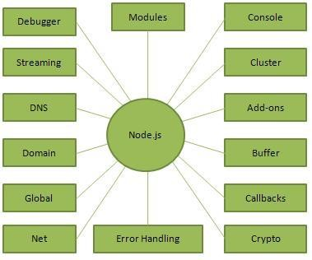

**Fig 2.1 – Concepts of Node.js**

**Where do we use Node.js?**

Following are the areas where Node.js is proving itself as a perfect technology partner.

* 1. I/O bound Applications.
  2. Data Streaming Applications.
  3. Data Intensive Real-time Applications (DIRT).
  4. JSON APIs based Applications.
  5. Single Page Applications.
  6. It is not advisable to use Node.js for CPU intensive applications.

#### **2.2. Angular**

Angular is an application design framework and development platform for creating efficient and sophisticated single-page apps.

Angular is a development platform, built on TypeScript. As a platform, Angular includes:

* A component-based framework for building scalable web applications
* A collection of well-integrated libraries that cover a wide variety of features, including routing, forms management, client-server communication, and more
* A suite of developer tools to help you develop, build, test, and update your code

**Installation** **command** - $ npm install -g @angular/cli

**Applications of Angular:**

The general features of Angular are as follows:

## **Easy to Learn**

## **It has a Two-Way Binding Feature**

## **Supports SPA features**

## **Has a Declarative UI**

## **Supported by Google**

## **Allows for Optimal Web Application Management**

## **It is a Powerful Framework**

## **Real-Time Testing**

#### **2.3. Express.js**

Express is a minimal and flexible Node.js web application framework that provides a robust set of features to develop web and mobile applications. It facilitates the rapid development of Node based Web applications. Following are some of the core features of Express framework.

* Allows setting up middleware’s to respond to HTTP Requests.
* Defines a routing table which is used to perform different actions based on HTTP Method and URL.
* Allows to dynamically rendering HTML Pages based on passing arguments to templates.

**Installation command** - $ npm install express --save

The above command saves the installation locally in the node modules directory and creates a directory express inside node modules. You should install the following important modules along with express −

**Body-parser −** This is a Node.js middleware for handling JSON, Raw, Text and URL encoded form data.

**Cookie-parser −** Parse Cookie header and populate req.cookies with an object keyed by the cookie names.

**Mulder −** This is a Node.js middleware for handling multipart/form-data.

#### **2.4. MongoDB**

MongoDB is an open-source document database and leading No SQL database. MongoDB is written in C++. This tutorial will give you great understanding on MongoDB concepts needed to create and deploy a highly scalable and performance-oriented database.

**Audience**:

This tutorial is designed for Software Professionals who are willing to learn MongoDB Database in simple and easy steps. It will throw light on MongoDB concepts and after completing this tutorial you will be at an intermediate level of expertise, from where you can take yourself at higher level of expertise.

**Prerequisites**:

Before proceeding with this tutorial, you should have a basic understanding of database, text editor and execution of programs, etc. Because we are going to develop high performance database, so it will be good if you have an understanding on the basic concepts of Database (RDBMS).

#### **2.5. System Requirements**

## **Supported Operating Systems**

* Windows 7 and above
* Windows Server 2008 R2+

## **Development Environments**

By using the following IDEs, you can develop the Bold Reports Angular:

* [Microsoft Visual Studio Code](https://code.visualstudio.com/)
* Internet Information Services (IIS) 7.0+
* [Node JS](https://nodejs.org/en/) (version 8.x or 10.x)
* [NPM](https://docs.npmjs.com/getting-started/installing-node#install-npm--manage-npm-versions) (v3.x.x or higher)
* Angular 4+

## **Browser Compatibility**

* IE 9+
* Microsoft Edge
* Mozilla Firefox 22+
* Chrome 17+
* Opera 12+
* Safari 5+

**2.6. Full Stack Developer Responsibilities:**

* Developing front end website architecture.
* Designing user interactions on web pages.
* Developing back-end website applications.
* Creating servers and databases for functionality.
* Ensuring cross-platform optimization for mobile phones.
* Ensuring responsiveness of applications.
* Working alongside graphic designers for web design features.
* Seeing through a project from conception to finished product.
* Designing and developing APIs.
* Meeting both technical and consumer needs.
* Staying abreast of developments in web applications and programming languages.

**2.7. Full Stack Developer Requirements:**

* Degree in Computer Science.
* Strong organizational and project management skills.
* Proficiency with fundamental front end languages such as HTML, CSS and JavaScript.
* Familiarity with JavaScript frameworks such as Angular JS, React and Amber.
* Proficiency with server-side languages such as Python, Ruby, Java, PHP and .Net.
* Familiarity with database technology such as MySQL, Oracle and MongoDB.
* Excellent verbal communication skills.
* Good problem-solving skills.

**CHAPTER – III**

**SYSTEM ANALYSIS AND DESIGN**

**SYSTEM ANALYSIS AND DESIGN**

#### **3.1. Use Case Diagram:**

Use-case diagrams illustrate and define the context and requirements of either an entire system or the important parts of the system. You can model a complex system with a single use-case diagram, or create many use-case diagrams to model the components of the system. You would typically develop use-case diagrams in the early phases of a project and refer to them throughout the development process.

Use-case diagrams are helpful in the following situations:

* Before starting a project, you can create use-case diagrams to model a business so that all participants in the project share an understanding of the workers, customers, and activities of the business.
* While gathering requirements, you can create use-case diagrams to capture the system requirements and to present to others what the system should do.
* During the analysis and design phases, you can use the use cases and actors from your use-case diagrams to identify the classes that the system requires.
* During the testing phase, you can use use-case diagrams to identify tests for the system.

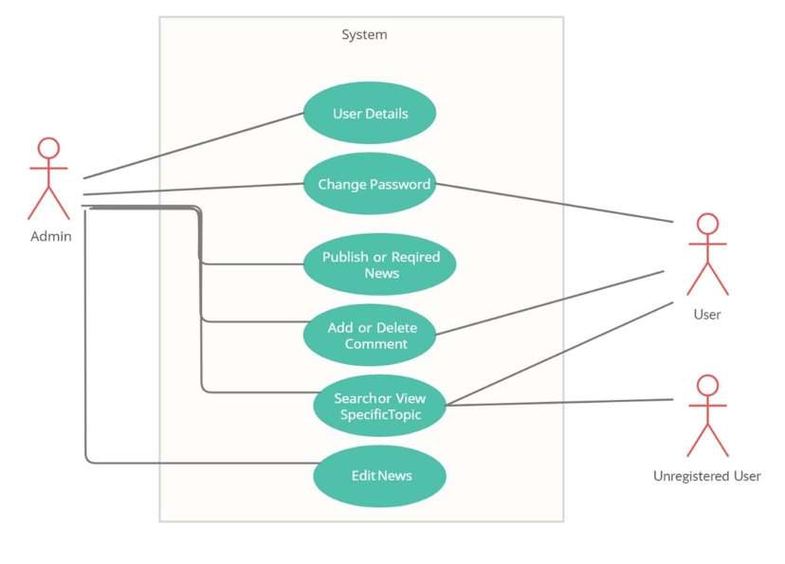

##### **Fig 3.1. – Use case Diagram of Portal**

**3.1.1 Use Case Diagram for Admin:**



**Login**

**Access**



**Upload**

**Function**



**Perform**

**Queries**

**Fig 3.2 – For Admin Panel**

1. The admin just needs to have login access.
2. Upload functions (with textbox and button).
3. Upload news, along with an image. Update news, images, Delete news and images.
4. Upload photos for gallery by dates with a hyperlink to enlarge and Delete button.
5. Upload videos (with textbox and button) and if can download you see.
6. Delete members the news we will upload it, just give us the layout and functionalities.
7. Approve or Disapprove User Details
8. Change Password
9. Publish Required news
10. Edit News
    * 1. **Use Case Diagram for User:**



**Open**

**Website**



**Read**



**Contact**

##### **Fig 3.3 – For User Panel**

1. Login as user and see the news.
2. Read the news category wise
3. Contact to admin if any requirement
4. Search or View Specific Topic
5. Change Password

**3.2. Context Diagram:**

A context diagram, sometimes called a level 0 data-flow diagram, is drawn in order to define and clarify the boundaries of the software system. It identifies the flows of information between the system and external entities. The entire software system is shown as a single process.

##### 

##### **Fig 3.4 – Context Diagram**

#### **3.3. Activity Flow Diagram:**

An activity diagram used to model a large activity’s sequential work flow by focusing on action sequences and respective action conditions. An activity diagram is represented by shapes that are connected by arrows. Arrows run from activity start to complete and represent the sequential order of performance activity. In this rectangle represents performances action, and described by text inside each rectangle. In this circle represents an initial workflow state or an end state. In this diamond shape is used shape is used to represents a decision, which is key activity diagram concept.

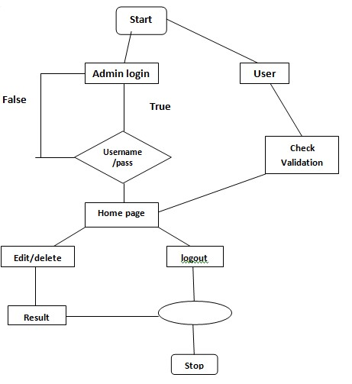

**Fig 3.5 – Activity Diagram**

#### **3.4. Data Flow Diagram (DFD):**

A DFD is a graphical representation of the “flow” of data through an information system, modelling its process aspects. A DFD is often used as a preliminary step to create an overview of the system without going into great detail, which can later be elaborated DFDs can also be used for the visualization of data processing (structured design).



**User**



**Website**



**Server**



**View Website**



**Request**



**Response**

##### **Fig 3.6 – DFD Level 0**

This is a 0 Level Data Flow Diagram of the online news portal. In this DFD, user can see the news and website will send request to server and server gives respond of that request. In this diagram the portal accommodates three entities that are as follows:

* User
* News Website
* Server response

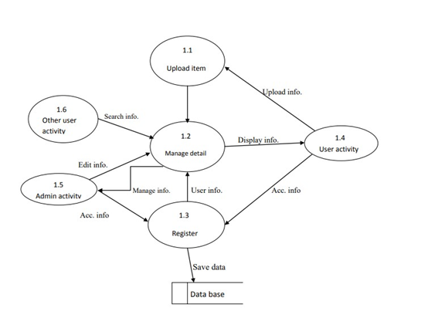

**Fig 3.7 – DFD Level 1**

As described previously, context diagrams (level 0 DFDs) are diagrams where the whole system is represented as a single process. A level 1 DFD notates each of the main sub-processes that together form the complete system. We can think of a level 1 DFD as an “exploded view” of the context diagram.

**CHAPTER – IV**

**DATA DICTIONARY**

**DATA DICTIONARY**

A data dictionary is a catalogue-a-repository of the elements in a system. As the name suggests, their elements centre on data and the way they are structured to meet user requirements and organization needs. In a data dictionary you will find a list of all the elements composing the data flowing through a system. The major elements are data flows, data stores and processes. The data dictionary stores details and descriptions of these elements.

If analysis want to know characters are in a data item by what other names it is referenced in the system, or where it is referenced in the system, or where it is issued in the system, they should be able to find the answers in issued in the system, they should be able to find the answer in properly developed data dictionary.

The Dictionary contains two types of description for the data following through the system.

**1. Data Elements:**

The most fundamental data is the elements. They are building blocks for all other data in the system. Data elements are also alternatively known as fields, data item or elementary item.

**2. Data Structure:**

A data structure is a set if items that are related to one another and described a components in the system.

**4.1. Table Details**

News Details: {Sports News + Education News + Business news…}

User Details: {User Id + Email Id + Password}

Content Details: {Email Id + Message}

Account Details: {User+ Old Password + New Password}

Feedback: {Name+ Email+ Message}

View Detail: {Headlines + Previous News}

Search Detail: {Topic + News}

**4.1.1 Admin Login:**

|  |  |  |  |
| --- | --- | --- | --- |
| **Field Name** | **Description** | **Size** | **Data Type** |
| Username | Unique username of the user | 50 | varchar |
| Password | User password | 50 | varchar |

**4.2. ER Diagram**

An Entity Relationship (ER) Diagram is **a type of flowchart that illustrates how “entities” such as people, objects or concepts relate to each other within a system**.

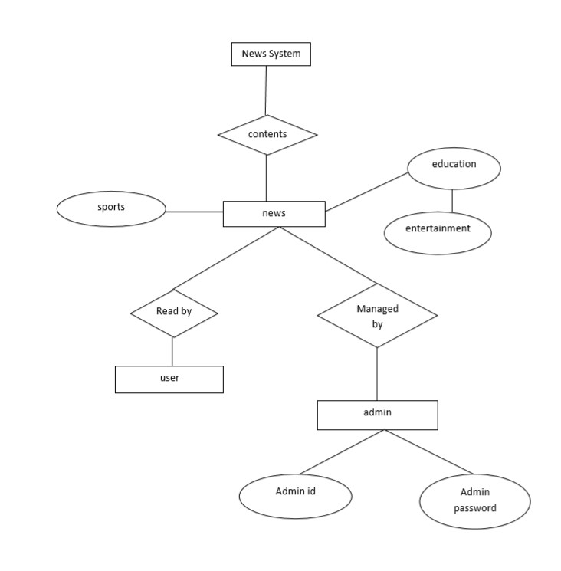

##### **Fig. 4.1 – ER Diagram**

**CHAPTER – V**

**PROJECT PROFILE**

# **PROJECT PROFILE**

## **5.1. Login Page**

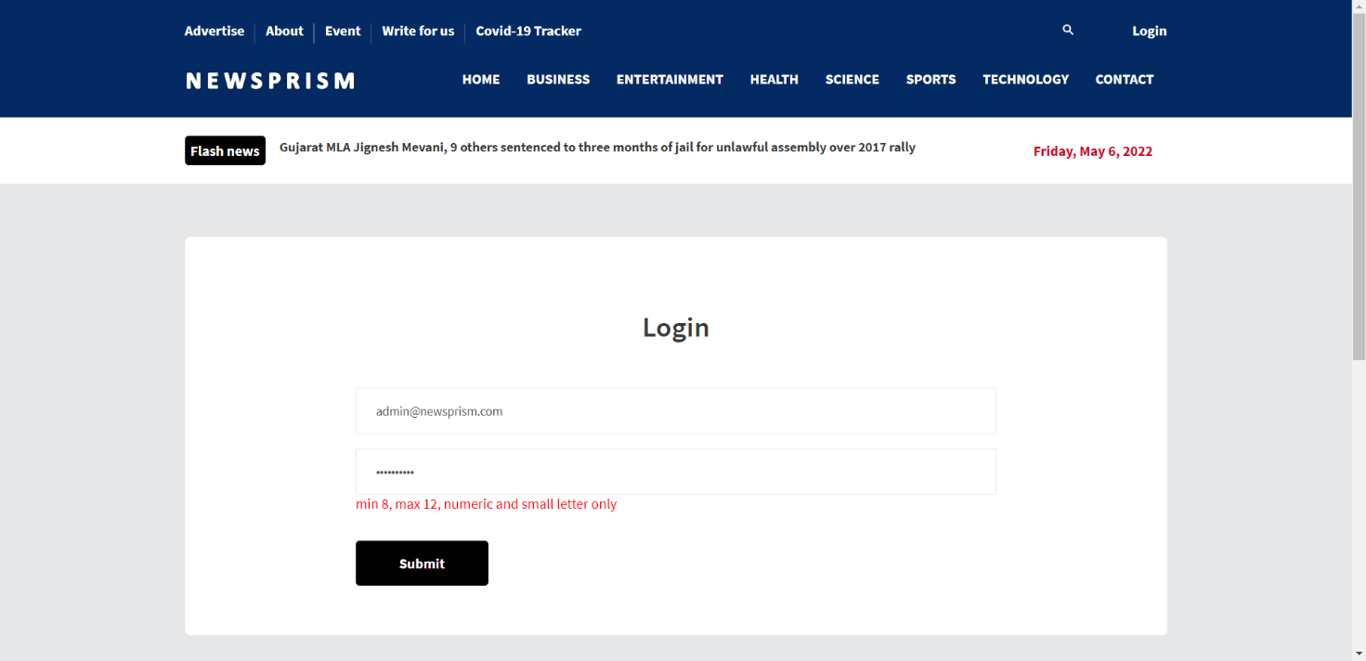

### **Fig 5.1 – Login Page**

The login page allows a admin to gain access to an application by entering their username and password.

## **5.2. Index Page**

## 

### **Fig 5.2 – Index Page**

* The home page is the name of the main page of a website where visitors can find hyperlinks and functionality to find other pages.
* Visitor navigating to a website from a search engine will see.
* It may also serve as a landing page to attract visitors.

## **5.3. User Specification**

**5.3.1 Business News**

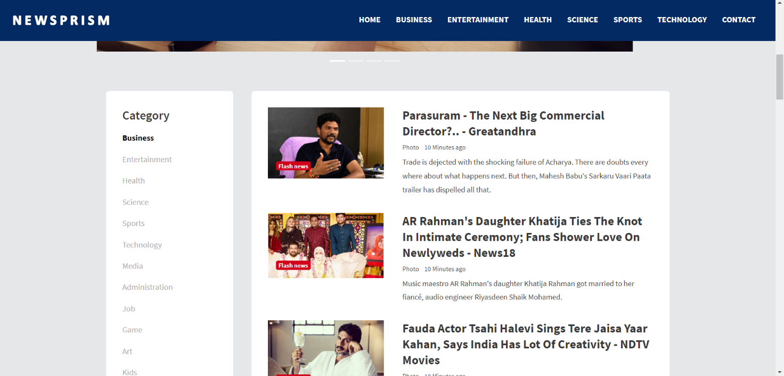

### **Fig 5.3 – Business News Page**

Business journalism is the part of journalism that tracks, records, analyses and interprets the business, economic and financial activities and changes that take place in societies. This area of journalism provides news and feature articles about people, places and issues related to the business sector.

**5.3.2 Entertainment News**

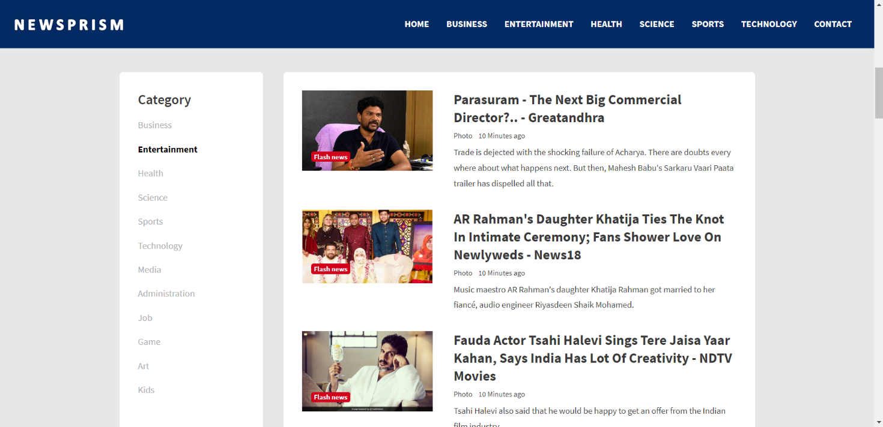

### **Fig 5.4 – Entertainment News Page**

Entertainment News is a flagship television news Entertainment program formatting infotainment which contains interesting news from the world of entertainment at home and abroad based on facts and information that broadcasts on the Indonesian TV station NET. This program also discusses news from the world of music, film, fashion, art, biography and event organizers.

**5.3.3 Health News**

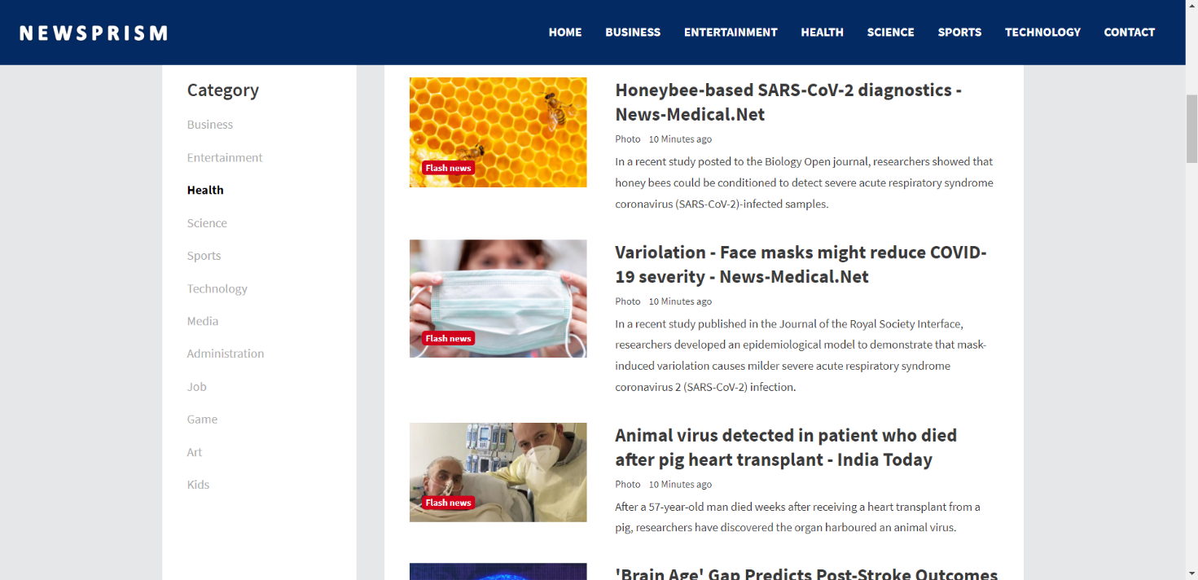

### **Fig 5.5 – Health News Page**

The latest health and wellness news, including case studies, research breakthroughs, celebrity health updates, and internet trends. After all, staying in the know is part of a balanced lifestyle.

**5.3.4 Science News**

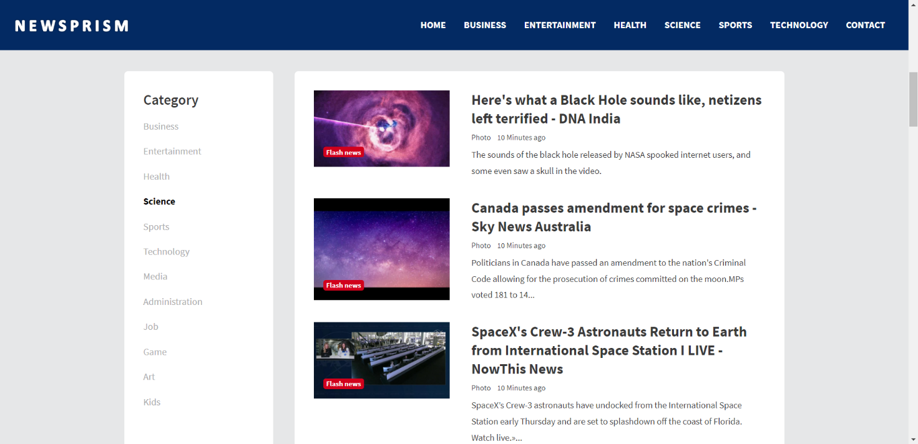

#### **Fig 5.6 – Science News Page**

Daily updates of the latest science news, new scientific research, technology breakthroughs, and how the science headlines affect you.

**5.3.5 Sports News**

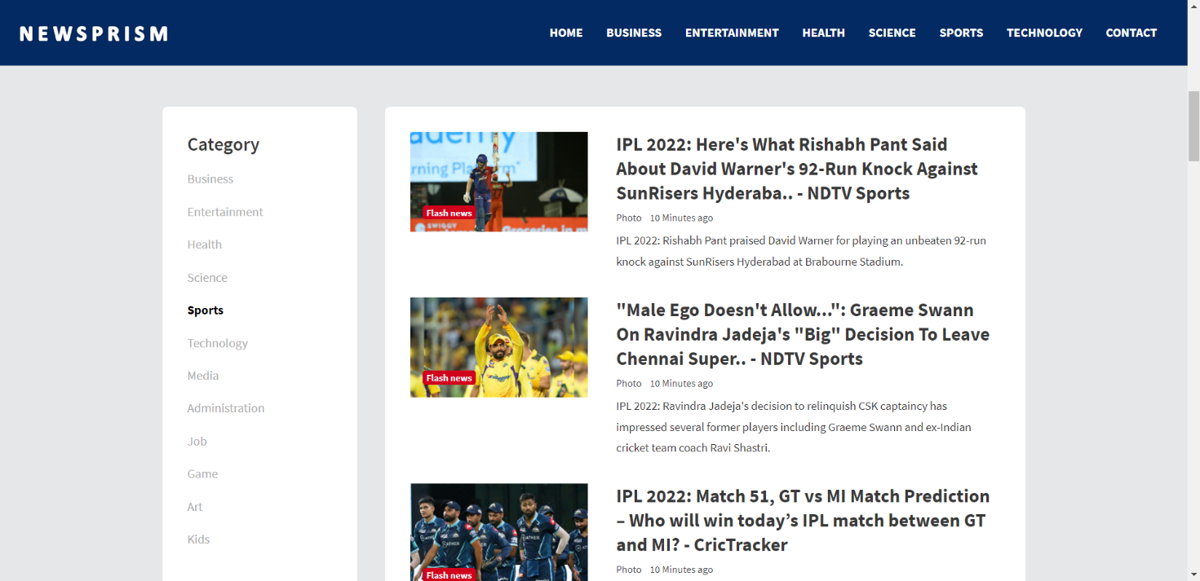

#### **Fig 5.7 – Sports News Page**

Sports journalism is a form of writing that reports on matters pertaining to sporting topics and competitions. Sports Journalism started in the early 1800s when it was targeted to the social elite and has transitioned into an integral part of the news business with newspapers having dedicated sports sections.

**5.3.6 Tech News**

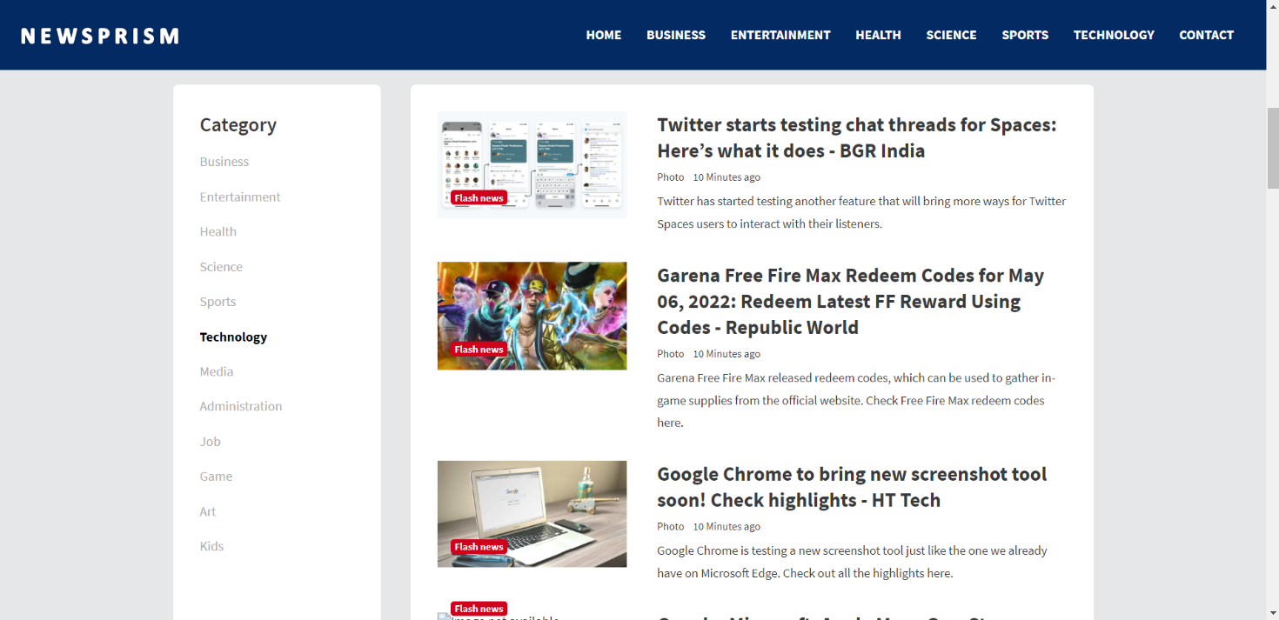

#### **ig 5.8 – Tech News Page**

The latest tech news about the world's best (and sometimes worst) hardware, apps, and much more. From top companies like Google and Apple to tiny start-ups vying for your attention, the latest in what matters in technology daily.

**5.4. Contact Us**

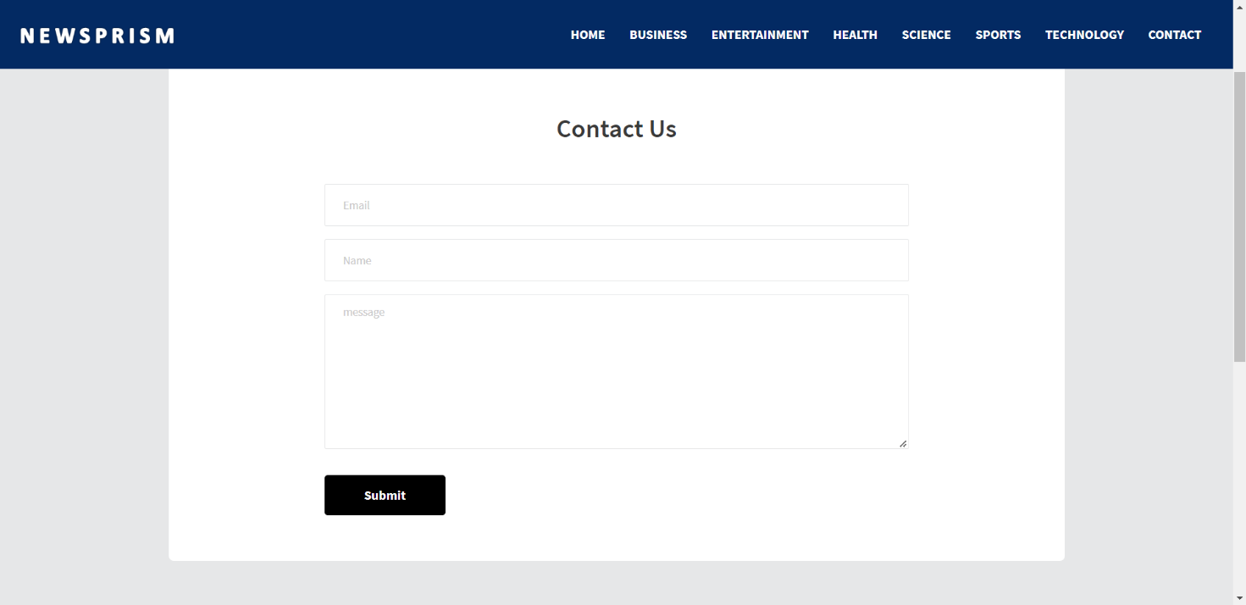

#### **Fig 5.9 – Contact Us Page**

It could be beneficial to let your visitor decide what’s useful for them. It’s also helping the visitor to contact the website owner.

**5.5. Header**



#### **Fig 5.10 - Header**

Header is the top section of the web page. Headers are often the first thing site visitors see so having the logo is important.

**5.6. Footer**

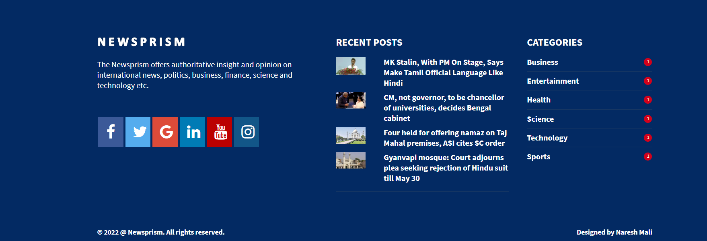

#### **Fig 5.11 - Footer**

The footer appears at the bottom of site page. It usually contains small-print items like copyright Information and footer design is about choosing what to include, with the intention to helping Visitors and meeting business goals.

**5.7. About Us**

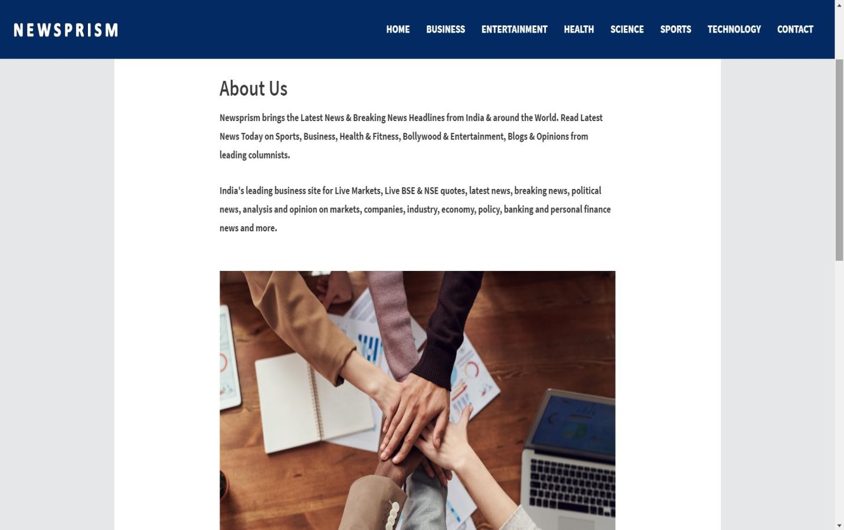

**Fig 4.12 - About Us Page**

**CHAPTER – VI**

**TESTING**

**TESTING**

**Testing Methodology**

Companies rely on software more than ever to provide and manage information with strategic and operational importance and to provide key decision support. Rising customer expectations for fault-free, requirements-exact software have increased awareness of the importance of software testing as a critical activity.

We begin the testing process by developing a comprehensive plan to test the general functionality and special features on a variety of platform combinations. Strict quality control procedures are used. The process verify that the application meets the requirements specified in the system requirements document and is bug free. At the end of each testing day, we prepare a summary of completed and failed tests. Applications are not allowed to launch until all identified problems are fixed. A report is prepared at the end of testing to show exactly what was tested and to list the final outcomes.

Our software testing methodology is applied in three distinct phases: Unit testing, System testing, and Acceptance were testing.

**Unit Testing:**

The programmers conduct unit testing during the development phase. Programmers can test their specific functionality individually or with other units. However, unit testing is designed to test small pieces of functionality rather than the system as a whole. This allows the programmers to conduct the first round of testing to eliminate bugs before they reach the testing staff. In unit testing the analyst tests the programs making up a system.

For this reason, unit testing is sometimes called program testing. Unit testing gives stress on the modules independently of one another, to find errors. This helps the tester in detecting errors in coding and logic that are contained within that module alone. The errors resulting from the interaction between modules are initially avoided.

For example, a hotel information system consists of modules to handle reservations; guest checking and checkout; restaurant, room service and miscellaneous charges; convention activities; and accounts receivable billing. For each, it provides the ability to enter, modify or retrieve data and respond to different types of inquiries or print reports. The test cases needed for unit testing should exercise each condition and option.

Unit testing can be performed from the bottom up, starting with smallest and lowest-level modules and proceeding one at a time. For each module in bottom-up testing a short program is used to execute the module and provides the needed data, so that the module is asked to perform the way it will when embedded within the larger system.

**System Testing:**

The objective of system testing is to ensure that all individual programs are working as expected, that the programs link together to meet the requirements specified and to ensure that the computer system and the associated clerical and other procedures work together.

The initial phase of system testing is the responsibility of the analyst who determines what conditions are to be tested, generates test data, produced a schedule of expected results, runs the tests and compares the computer produced results with the expected results with the expected results.

The analyst may also be involved in procedures testing. When the analyst is satisfied that the system is working properly, he hands it over to the users for testing. The importance of system testing by the user must be stressed. Ultimately it is the user must verify the system and give the go-ahead.

During testing, the system is used experimentally to ensure that the software does not fail, i.e., that it will run according to its specifications and in the way users expect it to. Special test data is input for processing (test plan) and the results are examined to locate unexpected results.

A limited number of users may also be allowed to use the system so analysts can see whether they try to use it in unexpected ways. It is preferably to find these surprises before the organization implements the system and depends on it. In many organizations, testing is performed by persons other than those who write the original programs. Using persons who do not know how certain parts were designed or programmed ensures more complete and unbiased testing and more reliable software.

The system is tested as a complete, integrated system. System testing first occurs in the development environment but eventually is conducted in the production environment. Functionality and performance testing are designed to catch bugs in the system, unexpected results, or other ways in which the system does not meet the stated requirements.

The testers create detailed scenarios to test the strength and limits of the system, trying to break it if possible. Editorial reviews not only correct typographical and grammatical errors, but also improve the system’s overall usability by ensuring that on-screen language is clear and helpful to users. Accessibility reviews ensure that the system is accessible to users with disabilities.

System testing consists of the following five steps:

1. Program testing
2. String testing
3. System testing
4. System documentation
5. User acceptance testing

**Program Testing:**

A program represents the logical elements of a system. For a program to run satisfactorily, it must compile and test data correctly and tie in properly with other programs. It is the responsibility of a programmer to have an error free program. At

The time of testing the system, there exists two types of errors that should be checked. These errors are syntax and logic.

A syntax error is a program statement that violates one or more rules of the language in which it is written. An improperly defined field dimension or omitted key words are common syntax errors. These errors are shown through error messages generated by the computer. A logic error, on the other hand, deals with incorrect data fields out of range items, and invalid combinations.

Since the logical errors are not detected by compiler, the programmer must examine the output carefully to detect them. When a program is tested, the actual output is compared with the expected output. When there is a discrepancy, the sequence of the instructions, must be traced to determine the problem. The process is facilitated by breaking the program down into self-contained portions, each of which can be checked at certain key points.

**String Testing:**

Programs are invariably related to one another and interact in a total system. Each program is tested to see whether it conforms to related programs in the system. Each part of the system is tested against the entire module with both test and live data before the whole system is ready to be tested.

**System Testing:**

System testing is designed to uncover weaknesses that were not found in earlier tests. This includes forced system failure and validation of total system as it will be implemented by its user in the operational environment. Under this testing, generally we

Take low volumes of transactions based on live data. This volume is increased until the maximum level for each transaction type is reached.

The total system is also tested for recovery and fallback after various major failures to ensure that no data are lost during the emergency.

All this is done with the old system still in operation. When we see that the proposed system is successful in the test, the old system is discontinued.

**System Documentation:**

All design and test documentation should be well prepared and kept in the library for future reference. The library is the central location for maintenance of the new system.

**User Acceptance Testing:**

An acceptance test has the objective of selling the user on the validity and reliability of the system. It verifies that the system's procedures operate to system specifications and that the integrity of important data is maintained. Performance of an acceptance test is actually the user's show. User motivation is very important for the successful performance of the system. After that a comprehensive test report is prepared. This report shows the system's tolerance, performance range, error rate and accuracy.

**Table 6.1 Test Report with test data**

|  |  |  |
| --- | --- | --- |
| **TEST REPORT WITH TEST DATA**  **(To be filled by System Analyst/Programmer)** | | |
| **Project Name: Online News Portal** | | |
| **S No.** | **Testing Parameter** | **Observations** |
| A. | INTERFACE TESTING   1. User-friendliness 2. Consistent menus | OK  NA |
| B. | CONTROL FLOW TESTING   1. IF-THEN-ELSE 2. DO WHILE 3. CASE-SWITCH | OK  OK  OK |
| C. | VALIDATION TESTING   1. Check for improper or inconsistent typing 2. Check for erroneous initialization or default values 3. Check for incorrect variable names 4. Check for inconsistent Data Types 5. Check for relational/arithmetic operators | OK  OK  OK  OK  OK |
| D. | DATA INTEGRITY/SECURITY TESTING   1. Data Insertion/ Deletion/ Updating 2. Boundary condition (Underflow, Overflow Exception) 3. Check for unauthorized access of data 4. Check for data availability | OK  OK  OK  OK |
| E. | EFFICIENCY TESTING   1. Throughput of the system 2. Response time of the system 3. Online disk storage required by the system 4. Primary memory required by the system | OK  OK  OK  OK |
| F. | ERROR HANDLING ROUTINES   1. Error description are intelligent/ understandable 2. Error recovery is smooth 3. All error handling routines are tested and executed at least once | OK  OK  OK |

**CHAPTER – VII**

**CONCLUSION AND FUTURE ENHANCEMENTS**

## **CONCLUSION AND FUTURE ENHANCEMENTS**

### 7.1. **Conclusion**

* To get information about current world ages anytime, anywhere, anyone can access by internet at low cost.
* Coverage of distribution and faster dissemination of information in a more timely manner.
* To provides a wonderful user interface that attracts more and more user.
* All new updated information that is more effective and useful for people.
* In our project work, an attempt has been made to develop a News or information based website. We develop this project that helps the people and make them aware so that they can know any news. To establish this website, we use various methodologies. To develop this project, we have faced many problems but we hardly tried to develop this project. Our training faculty helps us by giving his valuable opinion, decision and time.

### **7.2. Future Scope**

In this we can make many further advancements and improvements to make it better. The more we attractive the website the more it will become better. And we can also integrate any kind of news according to our need. We will like for support systems, news systems, software’s, etc. In future we will do following work:

* We can add more security features in it.
* We can make any kind of user interface according to our need.
* We can add many kinds of APIs like Google, discovery APIs.
* We will develop this website for large volume.
* We update our database.
* We can make searching system more flexible.

**CHAPTER – VIII**

**BIBLIOGRAPHY**

**BIBLIOGRAPHY**

We are using various type of books and websites from which we get the Knowledge about

MEAN Stack which are following: -

1. Fundamentals of Software Engineering. New Delhi: Prentice-Hall India.
2. Software Engineering, Girdhari Singh, ShaliniPuri.
3. Fundamental of Software Engineering Rajib mall, Phi.
4. Full-Stack JavaScript Development with MEAN
5. https://angular.io
6. WWW.Google.com
7. [WWW.W3schools.com](http://WWW.W3schools.com)
8. Photoshop
9. https://nodejs.org

10. [www.tutorialspoint.com](http://www.tutorialspoint.com/)

11. [www.wikipedia.org](http://www.wikipedia.org)