## FURNITURE SHOPPING SYSTEM ECOMMERCE

A

Major Project Report Submitted

In partial fulfillment

For the award of the Degree of

## BACHELOR OF TECHNOLOGY

In Department of Computer science and Engineering

Submitted By: Guided By: Submitted To:

ADNAN PIPAWALA 18ETCS004 DARSHAN JAIN 18ETCCS027 APOORV PANWAR 18ETCCS010 BHUMIKA SALVI 18ETCCS020

Mr.GAURAV KUMAWAT Mr.ADITYA MAHESHWARI



Department of Computer Science and Engineering TECHNO INDIA NJR INSTITUTE OF TECHNOLOGY

i

RAJASTHAN TECHNICAL UNIVERSITY

MAY 2022

TECHNO INDIA NJR INSTITUTE OF TECHNOLOGY



CERTIFICATE

This is to certify that this project report “Furniture Shopping System” is the confide work of “Adnan Pipawala, Darshan Jain, Apoorv Panwar, Bhumika Salvi” who have carried out the project work under my supervision. I approve this project for submission of the Bachelor of Technology in the Department of Computer Science and Engineering, Techno India NJR Institute of Technology, affiliated to Rajasthan Technical University, Kota.

Mr.Aditya Maheshwari Project Incharge

Department Of Computer Sciene

## ABSTRACT

* 1. Introduction

This Software Requirements Specification provides a complete description of all the functions and specifications of the website Furniture Shopping System.

The main objective of shopping system is to do shopping efficiently thoroughly through a fully automated system that not only saves lot of time but also gives fast results.

* 1. Scope

Scope of this project is very broad in terms of o. Few of them are:-

* + - This can be used in online shopping.
    - Can be used anywhere any time as it is a web based application.
    - No more cash , online payment option available.

1. Document overview

The remainder of this document is 8 chapters, the first providing introduction of the project. It lists all the functions performed by the system. The second chapter consists of software requirements specification. The third chapter provides details about system analysis and design. The fourth chapter gives data dictionary information. The fifth chapter consists of snapshots of the complete project. The sixth chapter gives testing for the project. The seventh chapter tells about the conclusion and future enhancements of the project. The final chapter concerns with the bibliography.

## ACKNOWLEDGEMENT

It gives me immense pleasure to express my deepest sense of gratitude and sincere thanks to my highly respected and esteemed guide Mr. Aditya Maheshwari (Assistant Professor, Project In charge), TINJRIT for their valuable guidance, encouragement and help for completing this work. Their useful suggestions for this whole work and co-operative behavior are sincerely acknowledged.

I would like to express my sincere thanks to facculty.of CSE TINJRIT for giving me this opportunity to undertake this project.

I also wish to express my indebtedness to my parents as well as my family member whose blessings and support always helped me to face the challenges ahead.

At the end I would like to express my sincere thanks to all my friends and others who helped me directly or indirectly during this project work.

Place: Udaipur Date: 25-04-2022

## TABLE OF CONTENTS

Table of Contents

Abstract iv

Acknowledgement v

Table of Contents vi

List of Tables & Figures viii

List of Symbols ix

CHAPTER -1 Introduction ..............................................................................................................

1Introduction .............................................................................................................................................

1.1. Goal.............................................................................................................................................

1.2. Need of the application...........................................................................................................................

1.3. Scope…………………………………………………………………………………………………...

CHAPTER - 2 Software Requirement Specification ..............................................................................

CHAPTER-3 System Requirement Analysis ...........................................................................

3.1Information Gathering .......................................................................................................

3.2System Feasibility.....................................................................................................

3.2.1 Economic Feasibility .........................................................................................

3.2.2 Technical Feasibility..........................................................................................

3.2.3 Behavioral Feasibility ........................................................................................

CHAPTER-4 System Analysis........................................................

4.1 ER Diagram ..............................................................................................................

4.2 Data Flow Diagram...................................................................................................

4.3 Use case Diagram ...................................................................................................

4.4 Class Diagram.........................................................................................................

CHAPTER-5 Design ......................................................................................................

5.1 Design Goals..................................................................................................

5.2Architectural Design ................................................................................................

5.2.1.Architectural Context Diagram..........................................................

5.2.2.Description of Architectural Design .........................................................

5.3Procedural/Modular Approach................................................................................

5.3.1.Shop Products Module.....................................................................................

5.3.2.Product Description Module............................................................................

5.3.3.Cart Details Module.................................................................................

CHAPTER-6 Implementation ............................................................................................

6.1.Database Design and Implementation ....................................................................

6.2.User Interface Design and Implementation ...........................................

6.3.Technical Discussions....................................................................................

CHAPTER-7 Testing.............................................................................................................

7.1Unit Testing ......................................................................................................

7.2Integration Testing...............................................................................................

7.3Validation Testing...................................................................................................

7.4White Box Testing ............................................................................

7.5Performance Testing ...............................................................................................

CHAPTER-8 Results & Challenges..............................................................

8.1 Challenges.....................................................................................

CHAPTER-9 Conclusions......................................................................

9.1Limitations ..............................................................................................................

9.2Scope for Future Work............................................................................................

CHAPTER-10 References…………………………………………………………

### List of Tables & Figures

|  |  |  |
| --- | --- | --- |
| Figure No. | Figure Name |  |
|  | Use Cases |  |
| Figure | Access Home page |  |
| Figure | User login or signup |  |
| Figure | Admin selects, create a new category/subcategory/subject/topic/question |  |
| Figure | Choose Product Page |  |
|  | Data Flow Diagrams |  |
| Figure | DFD Level 0 |  |
| Figure | Registrations(DFD Level 1) |  |
| Figure | Question Insert(DFD Level 1) |  |
| Figure | Examination(DFD Level 1) |  |
| Figure | Registrations(DFD Level 2) |  |
| Figure | Question Insert(DFD Level 2) |  |
| Figure | Examination(DFD Level 2) |  |
| Figure | User Authentication(DFD Level 3) |  |
| Figure | User Authentication(DFD Level 4) |  |
|  | UML Modelling |  |
|  | Activity Diagrams |  |
| Figure | For Student |  |
| Figure | For Admin |  |
| Figure | Class Diagram |  |
| Figure | Context Diagram |  |
|  | Sequence Diagram |  |
| Figure | Login |  |
| Figure |  |  |
| Figure | Manage Test |  |
| Figure | Appear for test |  |
| Figure | E-R Diagram |  |

### List of Symbols

|  |  |
| --- | --- |
| Term | Definition |
| Admin | The only user who has the permission to insert or update category etc. in the database. |
| Entry | Admin stored in the Database |
| Html | Hyper text markup language |
| AJAX | Asynchronous JavaScript And XML |
| QA | Quality assurance |
| SCMP | Software Configuration Management Plan |
| SDD | Software Design Document |
| SQAP | Software Quality Assurance Plan |
| SRS | Software Requirements Specification |
| Web Site | A place on the world wide web |



# CHAPTER – I INTRODUCTION

1.1.1Introduction

* 1. Goal

Shopping has long been considered a recreational activity by many. Shopping online is no exception. The goal of this application is to develop a web based interface for online retailers. The system would be easy to use and hence make the shopping experience pleasant for the users. The goal of this application is

* + To develop an easy to use web based interface where users can search for products, view a complete description of the products and order the products.
  + A search engine that provides an easy and convenient way to search for products specific to their needs. The search engine would list a set of products based on the search term and the user can further filter the list based on various parameters.
  + An AJAX enabled website with the latest AJAX controls giving attractive and interactive look to the web pages and prevents the annoying post backs.
  + Drag and Drop feature which would allow the users to add a product to or remove a product from the shopping cart by dragging the product in to the shopping cart or out of the shopping cart.
  + A user can view the complete specification of the product along with various images and also view the customer reviews of the product. They can also write their own reviews.



* 1. Need of the application

There are large numbers of commercial Online Shopping websites offering large number of products tailored to meet the shopping interests of large number of customers. These online marketplaces have thousands of products listed under various categories. Problem:

* The basic problems with the existing systems are the non-interactive environment they provide to the users.
  + The use of traditional user interfaces which make continuous post backs to the server; each post back makes a call to the server, gets the response and then refreshes the entire web form to display the result. This scenario adds an extra trade off causing a delay in displaying the results • A search engine that would display the results without allowing the users to further filter the results based on various parameters.
  + Use of traditional and non user friendly interfaces that are hard to use 2 Solution:
  + The motive of this Online Shopping Web Application is to allow the user to play with the search tool and create different combinatorial search criterion to perform exhaustive search.
  + Making the application AJAX enabled gets rid of these unnecessary delays letting the user to perform exhaustive search. The users of this application can easily feel the difference between the Ajax empowered user interfaces vs. traditional user interfaces.
  + Provide Interactive interface through which a user can interact with different areas of application easily.
  + A search engine that provides an easy and convenient way to search for products specific to their needs. The search engine would list a set of products



based on the search term and the user can further filter the list based on various parameters.

* + Provide Drag and Drop feature thereby allowing the user to add products to or remove products from the shopping cart by dragging the products in to or out of the shopping cart.
  1. Scope
  + The current system can be extended to allow the users to create accounts and save products in to wish list.
  + The users could subscribe for price alerts which would enable them to receive messages when price for products fall below a particular level.
  + The current system is confined only to the shopping cart process. It can be extended to have a easy to use check out process.
  + Users can have multiple shipping and billing information saved. During checkout they can use the drag and drop feature to select shipping and billing information.

# CHAPTER – II

SOFTWARE REQUIREMENT SPECIFICATION

Software Requirement Specification Web Server Meaning

* It refers to a common computer, which provides information to other computers on the internet.



* It is either the hardware (the computer) or the software (the computer programs) that stores the digital information (web content) and delivers it through Internet whenever required. The three components to a web server
* The Hardware
* Operating system software
* web server software Website & Internet Utility Programs Meaning of Website
* A Website is a collection of related web pages on a web server maintained by any individual or organization.
  + A website is hosted on web server, accessible via internet or private LAN through an internet address called URL (Uniform Resource Locator). All publicly accessible websites collectively constitute the WWW (world wide web) Meaning of Utility Programs These are software tools to help users in developing, writing and documenting programs (a sequence of instructions to a computer) There are 2 types of utility programs

1. File Management Utilities – it helps in creating, copying, printing, erasing and renaming the files.
2. Program Development Utilities – it is useful in assembler, compiler, linker, locator etc, Website & utility programs include: Electronic Mail – sending & receiving messages globally via internet. Use Net News – it’s a software that enables a group of internet users to exchange their view, ideas, information on some common topic of interest with all members belonging to the group.

Ex:-politics, social issues, sports etc. Real Time Chatting – It is an internet program available to users across the net to talk to each other, text messages, video chat and video conference via internet. Finger and Ping Finger – it is the utility program used to find some information about the users that are on the network.

Ex: - last time a user logged on to the network Ping (Packet Internet Groper) – it is a program used to test the connectivity between two computers connected to the internet. Connection with the internet to ensure proper network Tracer (Route Tracing Program) – it is a program that sends data packets to every computer on the path between one computer to another computer in the network and records the time it takes to reach the destination computer from the originating computer. Telnet and FTP Telnet – it is a software that allows one computer user to access files and run programs on another computer that is connected to the internet. FTP -



(FILE TRANSFER PROTOCOL) it is a service used on internet to exchange files between computer. Indexing & Searching Utility programs it helps the search engine to search the specific website (Search for Information) Data Analysis Program – it is software used to obtain the visitor information. i.e., website visitor is accessing, time lag the website viewed, the date and time of each visit, pages viewed etc., Line checking utility program – it examines each page on the website and reports any URLs broken or someway incorrect. Besides checking links, link checker programs sometimes check spelling and other structural components of web pages. Remote Server Administration Program – this software allows the web administrator to manage and monitor a website from any Internet connected computer. Web Hosting It means to store website contents on a web server. It is a type of service, provided by Internet. Service Providers that allow individuals and organizations to make their website accessible when people browse via the [www.](http://www/) Thus, web hosts are companies that provide space on a server owned or leased for use by clients. There are two choices to host the website: -

On own web server platform (in house) ii) On the platform of someone else (i.e., ISP's) TYPES OF WEB HOSTING - Choice of web hosting

* Home Server – it is a single machine placed in a private residence used to host one or few websites from a broadband connection.
* Free Web Hosting service – it is the type of service provided by web hosting companies free of cost with limited services. The hosting companies offer free space on their web server with a condition that some advertisements are allowed on the web pages. Later the business can change the package by paying.
  + Shared Website Hosting - it refers to hosting of multiple websites simultaneously on the same web server. The web host also maintains the server and provides technical support on it.
* Virtual Dedicated Hosting – In this type the client or user will have a dedicated web server with separate bandwidth and RAM. The user will be given ID and password to maintain the web server – the user can install or remove any software.
* Dedicated Hosting – the service provider makes a web server available to the client and has control over it. The service provider owns server hardware and software but leases it to the client.
* Managed Hosting – in this type ,the client user gets his own web server but is not allowed full control on it.(no install or remove software)



* Collocation Hosting – in this type the service provider rents a physical space to the client to install his/her server hardware. In other words, co-location allows a client to put his machine in a service provider's premises to avail all the available facilities. The client installs his own software and maintains the server. The service provider is responsible only for providing a reliable power supply, internet connection and other networking hardware.
  + Cloud hosting – it is a new type of hosting platform that allows clients a decentralized, powerful, scalable (i.e., can be upgraded or a new server added as necessary) and reliable hosting, based on clustered load-balanced servers and utility billing. A cloud hosted website may be more reliable than other choices since other computers in the cloud can compensate when a single piece of hardware goes down.
* Clustered Hosting -Multiple servers hosting the same content for better resources is called Clustered Hosting.
* Grid Hosting – it is a form of distributed hosting where a server clusters acts like a grid and is composed of multiple clients. E-commerce Requirement Telecommunication Infrastructure Requirements – it is entailed with bandwidth and security. Bandwidth varies from one e-commerce to another. Two main components of security requirements for e-commerce are type of firewall and encryption/algorithm mechanism. Security requirements area crucial part of e- commerce. Hardware Requirement for E-commerce - Pentium II/III based Intel server running Linux can serve hundreds of unique customers each day. Low traffic sites can be easily served from a single machine depending on the needs of the business. High traffic sites require a backup of servers which automatically takes over operations in case of failure of primary ones. Software Requirements for E-commerce – Several software are available free on the internet that can be used to build e-commerce exchanges.

Ex:- Linux OS, myMONGO DB database ,Apache web server etc., Technical Skill

-A systems administrator must have a good knowledge of computer hardware, must be able to maintain and upgrade hardware including hard drive, processor and motherboard. He/she must also have the skill to install and compile Apache, MyMONGO DB and Java servlet engine.

Financial Infrastructure - i) Dependable telecommunication network

1. Use of integrated banking software for ack office and front office data processing



1. Use of WAN and internet for banking operations
2. Availability of legal infrastructure supporting online payment mechanism.

V) Availability of EFT Legal and Policy framework – policies that ensure legal certainty, security and consumer protection for online transactions and interactions should be enacted. These include the resolution of issues such as transactional security, electronic contract enforceability and authentication of individuals and documentation. E-commerce software Catalogue display A catalogue is an organized list of goods & services being sold. An e-catalogue is a simple list of goods and services in HTML form that appears on a webpage on the website of an ecommerce company.

Two types (i)static catalogue -providing simple list of goods and services on offer.

(ii) dynamic catalogue -providing a detailed feature about items on sale in a database, detailed descriptions, shipment time etc., Shopping Cart It is an electronic basket provided by E-commerce service providers to be used by net users to keep track of the products selected in the basket, compare and review them, modify it by adding new ones or removing unwanted goods before finally deciding to purchase. After the shopping is completed the customer will make the payment through online. Features or Procedures for Shopping cart

* Compare and select the goods before purchasing.
* Select the goods easily -by clicking.
* Customize the product based on the size, quantity, colour etc., before proceeding to order.
* Getting information about the offers, discounts & price.
* Specify the payment mode like credit card, debit card, cheque, online payment, payment at the time of delivery etc.,
* Mention the venue for delivery of selected goods.
* Compute shipping charges and obtain information about taxes to incur. • Get information about delivery time.
* Have transaction confirmation message and transaction report through an email or SMS.
* Transact securely with the web seller.



* Transaction Processing It is the software that prompts processing the transaction when an online customer orders for a purchase. Transaction processing software calculates volume discounts to be allowed, sales tax or VAT to be charged; shipment cost etc., and arranges to receive payment as agreed. It also maintains the sales and inventory management modules in accounting software. Additional component of e-commerce software includes: -

1. Middleware – it is the software that establishes the connection between e- commerce software, accounting and inventory management databases or application.
2. Enterprise Application Integration- it performs a specific function such as creating invoices, calculating payrolls, processing payments, etc., logically integrates them.
3. Enterprise Resource Planning (ERP)- It is a software package that integrates all facets of business, including accounting, logistics, manufacturing, marketing, planning, and finance function. Example: -SAP
4. Customer Relationship Management (CRM) – It is a software that conducts activities like sales automation, customer centre operations and marketing campaigns. It gathers information about customer activities on the company's website and meets they need.
5. Supply chain Management – it is a software which helps the companies to integrate planning and coordinates activities of supply chain partners with the aim of efficiently reaching customers.
6. Web service – it is a set of software’s and technologies that allow computers to use the web to interact with each other directly, without human operators directing the specific interactions.
7. Content Management Software – it helps companies control the large amount of text, graphics, drawings, photographs and media files that have become important in doing ecommerce business. this software easily allows the company to perform regular maintenance activities like adding, creating or deleting categories on the web page.
8. Knowledge Management Software – it is used by companies to collect and organize information, share information among users, enhance the ability of users to collaborate. It includes tools that read electronic document, scanned paper documented-mail messages, web pages etc., to help users in decision making



# CHAPTER III

System Requirement Analysis

3.1 Information Gathering

As the goal of the application is ease of use and to provide an interactive interface, extensive research has been done to gain an insight into the needs and behaviors of various users. The working of the application is made convenient and easy to use for the end user. Dr Andresen, Associate Professor, CIS provided regular feedback on the project. Users can be classified into two types based on their knowledge of the products that suit their needs.

They can be classified as users who know about the product that would satisfy their needs and users who have to figure out the product that would satisfy their needs. Users who know about the product should be able to find the product easily with the click of a button. Such users can search for the product by using the product name as the search term.

Users who have to figure out the product that would satisfy their needs could use a search term to find a list of products and then should be able to filter the results based on various parameters like product type, manufacturer, price range, platform supported etc. The users should be able to view the complete specification of the product and various images at different Zoom levels. The user should be able to read the customer reviews for the product and the ratings provided. They should be able to write their own reviews.

They should be able to print out the specifications for a product or email the product page to a friends etc.

To increase the ease of use the user should be able to add a product to the shopping cart by dragging a product and dropping it in the shopping cart. A user should able to edit the contents of a shopping cart.

They should be able to update the quantities of the products added to the cart and remove the products from the cart. The user should be able to remove the product from the shopping cart by dragging the product and dropping it outside the cart. The application can be made interactive by pop up messages when a product has been dropped in to the shopping cart or out of the shopping cart.

The user can be notified 4 if the cursor enters a drop area and the object that could be dropped.



Also users are impatient making it important to load pages soon. Other than this, I did a lot of research on various other methods of building this application which and was able to incorporate a few stronger features into the application. The tools and controls used in the application are recommended ASPREACT controls and AJAX Toolkit controls which improves the navigation and usability and interactivity.

* 1. System Feasibility

The system feasibility can be divided into the following sections:

* + 1. Economic Feasibility

The project is economically feasible as the only cost involved is having a computer with the minimum requirements mentioned earlier. For the users to access the application, the only cost involved will be in getting access to the Internet.

* + 1. Technical Feasibility

To deploy the application, the only technical aspects needed are mentioned below: Operating Environment Win 2000/XP Platform

REACT Components& IIS MONGO DB

For Users: Internet Browser Internet Connection

* + 1. Behavioral Feasibility

The application requires no special technical guidance and all the views available in the application are self explanatory. The users are well guided with warning and failure messages for all the actions taken.

5 3. System Analysis After carefully analyzing the requirements and functionality of the web application, I had two important diagrams by the end of the analysis phase. They are the ER diagram and data flow diagram which were the basis for finding out entities and relationships between them, the flow of information.

# CHAPTER IV SYSTEM ANALYSIS

After carefully analyzing the requirements and functionality of the web application, I had two important diagrams by the end of the analysis phase. They



are the ER diagram and data flow diagram which were the basis for finding out entities and relationships between them, the flow of information.

* 1. ER Diagram

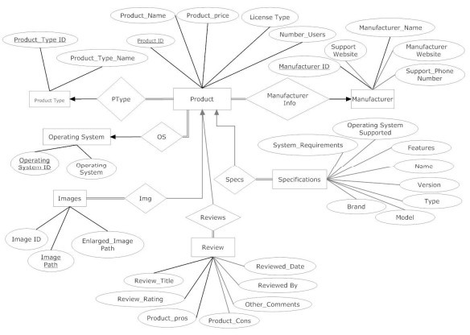

* 1. Data Flow Diagram

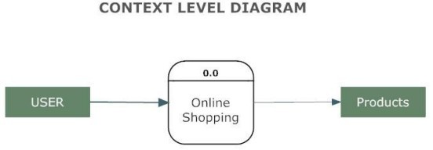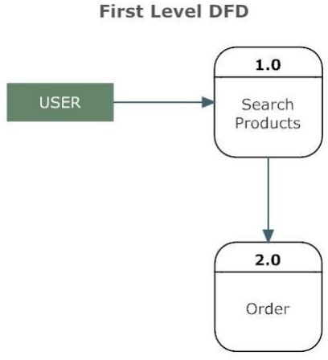



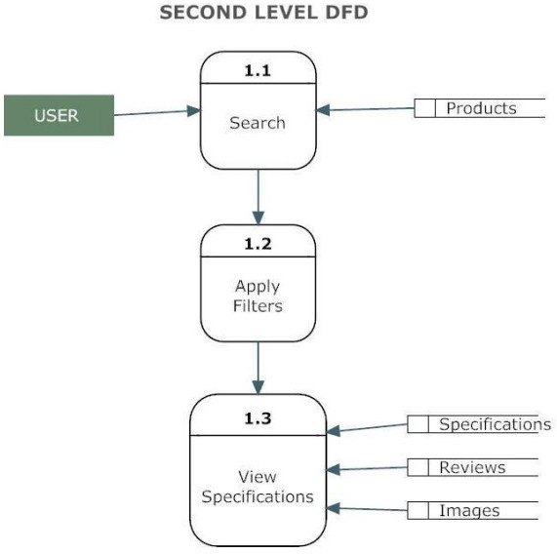



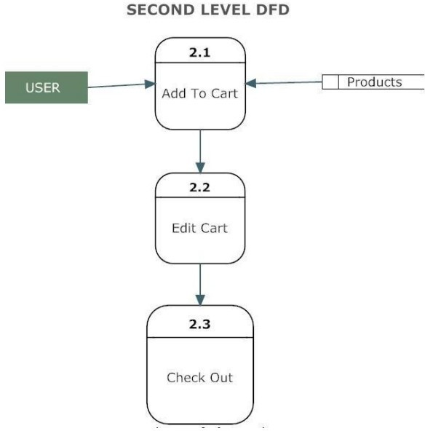

* 1. Use Case Diagram



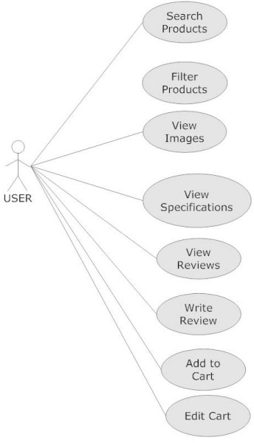

* 1. Class Diagram

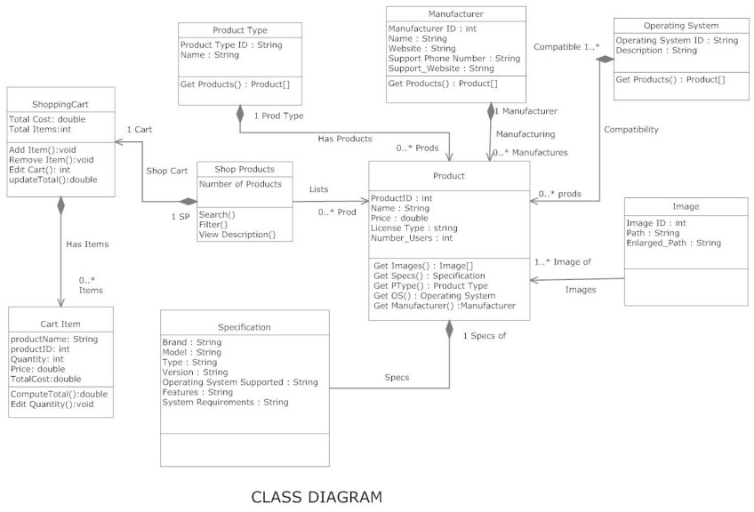



# CHAPTER V DESIGN

* 1. Design Goals
* The design of the web application involves the design of the forms for listing the products, search for products, display the complete specification for the product, and design a shopping cart that is easy to use.
* Design of an interactive application that enables the user to filter the products based on different parameters.
* Design of an application that has features like drag and drop etc.
  + Design of application that decreases data transfers between the client and the server.
  1. Architectural Design 5.2.1Architectural Context Diagram

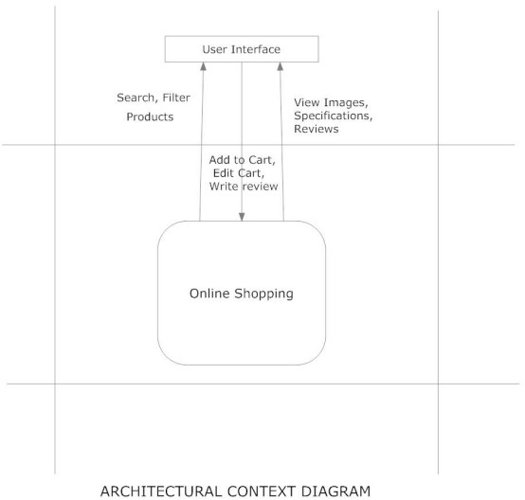



5.2.2 Description of Architectural Design

In this context diagram, the information provided to and received from the ‘Online Shopping’ is identified. The arrows represent the information received or generated by the application. The closed boxes represent the set of sources and sinks of information.

* + 1. Shop Products Module

This module starts when the user visits the home page or when a user searches for a product by entering a search term. This part of the application includes displaying all the products that are available or the products that match the search term entered by the user. The user can then filter these products based on various parameters like manufacturer, product type, operating system supported or a price range. The user browse through the products and each product would be displayed with an image and its features like operating system supported, number of user licenses and if it is a full version or an upgrade version. A user can add a product to the cart either by dragging the product and dropping it in the cart or by clicking a button. The user would be able to see the shopping cart summary.

* + 1. Product Description Module

This module starts when a user visits the product description page. A user can view various images of the product of different sizes. The use can see an enlarged image in a popup window. The user can view the complete specification of the product like its features, operating system supported, system requirements etc. A user can also view the manufacturer information and also information about rebates, exchange policies etc. A user can also view the reviews of the product. A user can also write a review for the product.

* + 1. Shopping Cart Module

This module starts when the user views the shopping cart. All the products that have been added to the shopping cart by the user are listed along with their price and the quantity. The total price of all the products added to cart is displayed. A user can edit the quantity of each product or remove the product from the shopping cart. A user can remove the product from the cart by clicking a button or by dragging the product and dropping it outside the cart. The total price changes accordingly when a user edits the quantity of a product or when a product is removed from the cart.



# CHAPTER VI IMPLEMENTATION

6.1 Database Design and Implementation

The design of the database was similar to the analysis phase. The database has been developed using MONGO DB Server 2005.

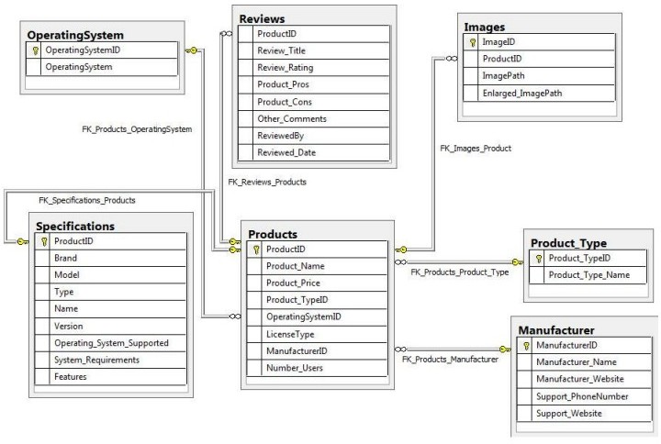

These are the main tables in the application and others are lookup and query tables. The tables were derived from the ER-Diagram.

5.2 User Interface Design and Implementation



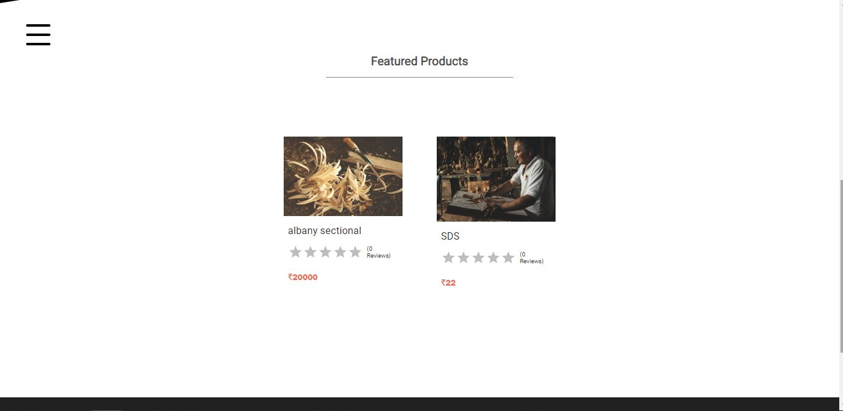The user interface of the application has been designed using Microsoft Visual Studio 2008. The main controls used in the design are Repeaters, Ajax Update panels, Ajax toolkit controls like modal popup, textbox watermark and Auto complete controls.

# Shop Product Page

The user can see the list of products that are available. The user can search for products by entering the search term into the search textbox provided on the top. This text box is watermarked with the words “Search Terms” to let the user know that this is the place to enter the search terms. The user can filter the products by using the dropdown lists.

A user can view the complete description of the product by clicking on the product link. The user can move the cursor on to the small images to view the same image in the enlarged position. The user can click on the enlarged picture to see a still bigger image in a pop up window as shown.



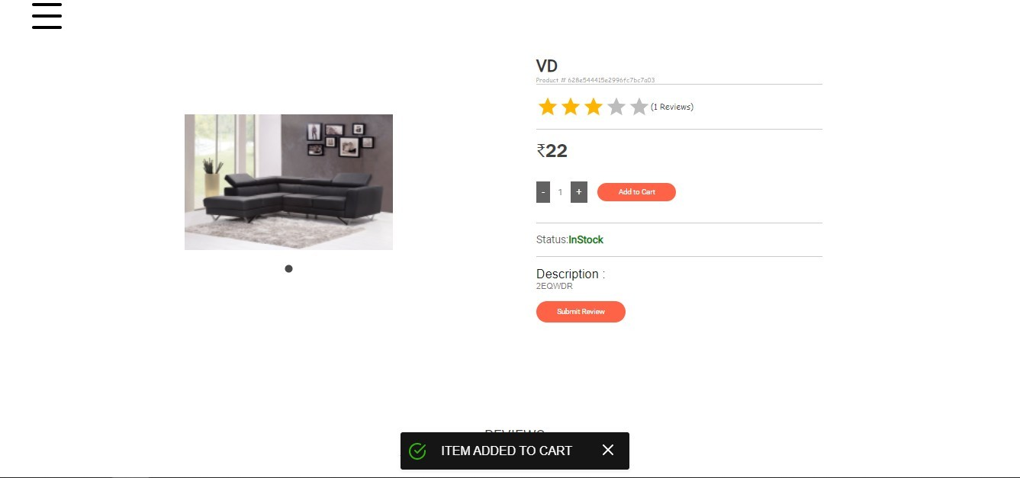

# Item Added to Cart



Review Panel



A user can also write a review by clicking on the write review tab panel as shown . Similarly a user can click on the tab panel customer reviews, specifications, manufacturer Info etc to see the respective information.

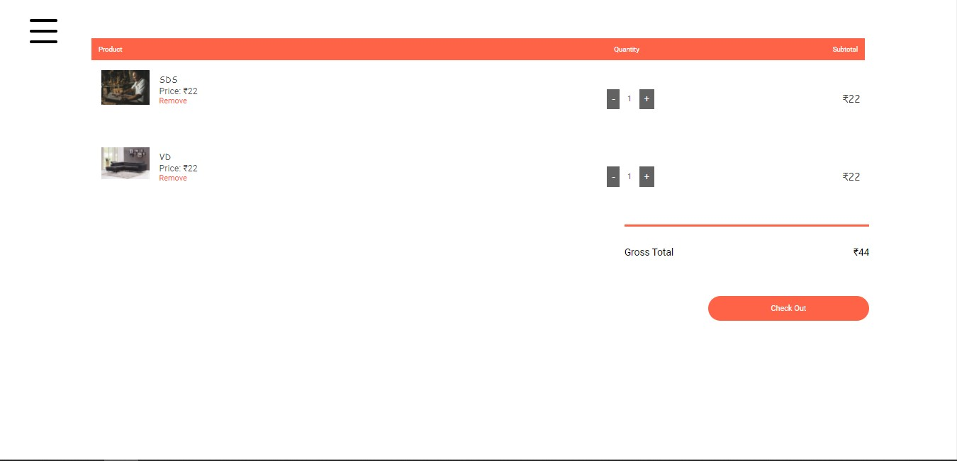

# Checkout Page

The user can click on the Go to cart button to see the Items in the cart as shown. The Summary is at the bottom of the page.

6.3 Technical Discussions

The products can be filtered based on various parameters like Manufacturer, Product Type, Operating System supported etc. Initially it was decided to have the various list items predefined. But with time new manufacturers and product types could be added. So the values for the list of manufacturers and product types are loaded dynamically by retrieving from the database. Also it was decided initially to have a drop down list for price range and the user could select a price range from the ranges available. But this would limit the user’s ability to filter the products based on different price ranges. Instead providing two text fields so that the user can enter their price range would give them more flexibility.

A product could be added to a shopping cart by dragging it and dropping it in the cart area. Items in the cart could be removed by clicking a button. To maintain



symmetry and ease of use products could be removed from the cart by dragging the product out of the cart.

A product can be added to the cart by dragging it and dropping it in the cart. Initially it was decided that when a product is dropped in the cart the cart summary label could be updated on the client side without any call to the server and later the session variables (Shopping cart) could be updated. This would result in loss of information when the user loses internet connection. So when a product is dropped in the cart area a web service is called and this service updates the session variables for the shopping cart and the cart summary is recalculated and sent back to the client. This would improve the reliability of the application.

# CHAPTER VII TESTING

Software testing is a process of running with intent of finding errors in software. Software testing assures the quality of software and represents final review of other phases of software like specification, design, code generation etc.

* 1. Unit Testing

Unit testing emphasizes the verification effort on the smallest unit of software design i.e.; a software component or module. Unit testing is a dynamic method for verification, where program is actually compiled and executed. Unit testing is performed in parallel with the coding phase. Unit testing tests units or modules not the whole software.

I have tested each view/module of the application individually. As the modules were built up testing was carried out simultaneously, tracking out each and every kind of input and checking the corresponding output until module is working correctly.

The functionality of the modules was also tested as separate units. Each of the three modules was tested as separate units. In each module all the functionalities were tested in isolation.

In the Shop Products Module when a product has been added to cart it has been made sure that if the item already exists in the shopping cart then the quantity is increased by one else a new item is created in the shopping cart. Also the state of the system after a product has been dragged in to the shopping cart is same as the state of the system if it was added by clicking the add to cart button. Also it has been ensured that all the images of the products displayed in the shop products



page are drag gable and have the product property so that they can be dropped in the cart area. In the Product Description Module it has been tested that all the images are displayed properly. Users can add review and the as soon as a user adds a review it is updated in the view customer review tab. It has been checked to see if the whole page refreshes or a partial page update happens when a user writes a review.

In the Cart Details it has been tested that when a user edits a quantity or removes a product from the cart, the total price is updated accordingly. It has been checked to see if the whole page refreshes or a partial page update happens when a user edits the cart. Visual Studio 2008 has in built support for testing the application. The unit testing can be done using visual studio 2008 without the need of any external application. Various methods have been created for the purpose of unit testing. Test cases are automatically generated for these methods. The tests run under the ASPREACT context which means settings from Web.config file are automatically picked up once the test case starts running.

Methods were written to retrieve all the manufacturers from the database, strings that match a certain search term, products that match certain filter criteria, all images that belong to a particular product etc. Unit test cases were automatically generated for these methods and it can be seen that the tests have passed.

* 1. Integration Testing

In integration testing a system consisting of different modules is tested for problems arising from component interaction. Integration testing should be developed from the system specification. Firstly, a minimum configuration must be integrated and tested.

In my project I have done integration testing in a bottom up fashion i.e. in this project I have started construction and testing with atomic modules. After unit testing the modules are integrated one by one and then tested the system for problems arising from component interaction.

* 1. Validation Testing

It provides final assurances that software meets all functional, behavioral & performance requirement. Black box testing techniques are used. There are three main components

* Validation test criteria (no. in place of no. & char in place of char)
* Configuration review (to ensure the completeness of s/w configuration.)



* Alpha & Beta testing-Alpha testing is done at developer’s site i.e. at home & Beta testing once it is deployed. Since I have not deployed my application, I could not do the Beta testing.

Test Cases- I have used a number of test cases for testing the product. There were different cases for which different inputs were used to check whether desired output is produced or not.

* + 1. Addition of a new product to the cart should create a new row in the shopping cart.
    2. Addition of an existing product to the cart has to update the quantity of the product.
    3. Any changes to items in the cart have to update the summary correctly.
    4. Because same page is inserting data into more than one table in the database atomicity of the transaction is tested.
    5. The state of the system after a product has been dragged in to the cart should be same as the state of the system if the same product is added to the cart by clicking a button.
  1. White Box Testing

In white box testing knowing the internal working of the product, tests can be conducted to ensure that internal operations are performed according to specification and all internal components have been adequately exercised. In white box testing logical path through the software are tested by providing test cases that exercise specific sets of conditions and loops. Using white-box testing software developer can derive test case that

* Guarantee that all independent paths within a module have been exercised at least once. • Exercise all logical decisions on their true and false side.
* Exercise all loops at their boundaries and within their operational bound.
* Exercise internal data structure to ensure their validity. At every stage of project development I have tested the logics of the program by supplying the invalid inputs and generating the respective error messages. All the loops and conditional statements are tested to the boundary conditions and validated properly.
  1. Performance Testing Jakarta JMeter, a tool for testing applications was used to simulate the virtual users (clients) and test the performance of the system. It can be used to test performance both on static and dynamic resources (files, Servlets, Perl scripts, Java Objects, Data Bases and Queries, FTP Servers and more). It can be used to simulate a heavy load on a server, network or object to test its strength or to analyze overall performance under different load types.



It can be used to make a graphical analysis of performance and test the server/script/object behavior under heavy concurrent load. I have done performance testing to achieve an estimate of the peak and sustained load the application. This has done with few pages like the Shop Products (extensive Database access, business logic Intensive and more Images) and the Cart Details (simple page). A few sample Screenshots of test results are shown below. The tests have been conducted by running the application (server) and JMeter on same machine. These test results do not include factors like network bandwidth etc as the server is running on the same machine along with JMeter.

# CHAPTER VIII

Results & Challenges

The application can be used for any Ecommerce application. It is easy to use, since it uses the GUI provided in the user dialog. User friendly screens are provided. The application is easy to use and interactive making online shopping a recreational activity for users. It has been thoroughly tested and implemented.

8.1 Challenges

* Compatibility with browsers like Mozilla Firefox, Internet explorer etc
* Using a layered approach in developing the application which would make the application maintainable.
* Learning new technologies like using JavaScript for drag and drop behavior and Ajax toolkit controls with little guidance. The overall idea of doing this project is to get a real time experience. Learn new technologies.

# CHAPTER IX CONCLUSONS

The ‘Online Shopping’ is designed to provide a web based application that would make searching, viewing and selection of a product easier. The search engine provides an easy and convenient way to search for products where a user can Search for a product interactively and the search engine would refine the products available based on the user’s input. The user can then view the complete specification of each product. They can also view the product reviews and also write their own reviews. Use of Ajax components would make the application interactive and prevents annoying post backs. Its drag and drop feature would make it easy to use.



* 1. Limitations

This application does not have a built in check out process. An external checkout package has to be integrated in to this application. Also users cannot save the shopping carts so that they can access later i.e. they cannot create wish lists which they can access later. This application does not have features by which user can set price ranges for products and receive alerts once the price reaches the particular range.

* 1. Scope for Future Work

The following things can be done in future.

* The current system can be extended to allow the users to create accounts and save products in to wish list.
* The users could subscribe for price alerts which would enable them to receive messages when price for products fall below a particular level.
* The current system is confined only to the shopping cart process. It can be extended to have an easy to use check out process.
  + Users can have multiple shipping and billing information saved. During checkout they can use the drag and drop feature to select shipping and billing information.

# CHAPTER X REFERENCES

* All about Microsoft controls in C# <http://www.msdn.microsoft.com/>
* Wikipedia for various diagrams & testing methods <http://www.wikipedia.org/>
* Cool text for Images and Buttons <http://cooltext.com/>
* K-State Research Exchange for samples in report writing <http://krex.k-state.edu/dspace/handle/2097/959>
* Smart Draw for drawing all the Diagrams used in this report. <http://www.smartdraw.com/>
* Sample Ecommerce Application [http://www.NewEgg.com](http://www.NewEgg.com/)