**TOGETHER**

A

Major Project Report

Submitted

In partial fulfilment

For the award of the Degree of

## BACHELOR OF TECHNOLOGY

In Department of Computer science and Engineering

|  |  |  |
| --- | --- | --- |
| Submitted By: |  | Submitted To: |
| Aayush Dadhich (18etccs001)  Dhairya Kanthalia (18etccs028)  Tanmay Prajapat (18etccs088)  Kratik Jain (18etccs054) | Mr. Aaditya Maheshwari  (Dept. Of Computer science and engineering) |



Department of Computer Science and Engineering

TECHNO INDIA NJR INSTITUTE OF TECHNOLOGY

RAJASTHAN TECHNICAL UNIVERSITY

TECHNO INDIA NJR INSTITUTE OF TECHNOLOGY



### CERTIFICATE

This is to certify that this project report “Together” is the confide work of “Aayush Dadhich, Dhairya Kanthalia, Tanmay Prajapat, Kratik Jain” who have carried out the project work under my supervision. I approve this project for submission of the Bachelor of Technology in the Department of Computer Science and Engineering, Techno India NJR Institute of Technology, affiliated to Rajasthan Technical University, Kota.

Mr. Aaditya Maheshwari

Project InCharge

Department of Computer Science and Engineering

# ABSTRACT

1. Purpose
   1. Introduction

Together is an online social network service by which user can establish a network among the people residing in all over the world. All the information can be easily accessed and shared among the people. This system provides users to register, send messages, upload photos, texts, and many more.

* 1. Scope

Together can be used as a social media site where users can connect with their friends or connect professionally. Users can share their content, ideas, facts, news, etc. It would provide a secure networking and chatting platform. It would also act as an entertainment source for users as they will be consuming various kinds of contents.

2. Document overview

The remainder of this document is 8 chapters, the first providing introduction of the project. It lists all the functions performed by the system. The second chapter consists of software requirements specification. The third chapter provides details about system analysis and design. The fourth chapter gives data dictionary information. The fifth chapter consists of snapshots of the complete project. The sixth chapter gives testing for the project. The seventh chapter talks about the conclusion and future enhancements of the project. The final chapter concerns with the bibliography.

# ACKNOWLEDGEMENT

It gives me immense pleasure to express my deepest sense of gratitude and sincere thanks to my highly respected and esteemed guide Mr. Aaditya Maheshwari (Project In-charge), TINJRIT for their valuable guidance, encouragement, and help in completing this work. Their useful suggestions for this whole work and co-operative behaviour are sincerely acknowledged.

I would like to express my sincere thanks to Faculties, Head of Department, Dept. of CSE TINJRIT for giving me this opportunity to undertake this project.

I also wish to express my indebtedness to my parents as well as my family member whose blessings and support always helped me to face the challenges ahead.

At the end I would like to express my sincere thanks to all my friends and others who helped me directly or indirectly during this project work.

|  |  |  |  |  |  |
| --- | --- | --- | --- | --- | --- |
| Place: Udaipur  Date: |  |  |  |  | Aayush Dadhich (18ETCCS001)  Dhairya Kanthalia (18ETCCS028)  Tanmay Prajapat (18ETCCS088)  Kratik Jain (18ETCCS054) |

# TABLE OF CONTENTS

Table of Contents

ABSTRACT 3

ACKNOWLEDGEMENT 4

CHAPTER – 1 Introduction .............................................................................................................. 8-10

Introduction ............................................................................................................................................. 8

1.1. Purpose ............................................................................................................................................. 9

1.2. Overall Description ........................................................................................................................... 10

CHAPTER – 2 Software Requirement Specification ...................................................................... 11-17

2.1. Purpose............................................................................................................................................. 11

2.2. Overall Description ........................................................................................................................... 13

2.2.1. Functional Requirements definitions .............................................................................................. 13

2.2.2. Use Cases ...................................................................................................................................... 14

2.2.3. Non – Functional Requirements ................................................................................................... 15

2.3. Requirement Specification .............................................................................................................. 16

2.3.1. External interface specifications ................................................................................................... 16

2.3.2. Functional Requirements ............................................................................................................. 17

2.4. Hardware Specification ................................................................................................................... 17

2.5. Software Specification .................................................................................................................... 17

2.6. Hardware and Software Requirements in detail ............................................................................... 17

CHAPTER – 3 System Analysis and Design .................................................................................. 18-20

3.1. Features of new System .................................................................................................................. 19

3.2. Data flow diagram .......................................................................................................................... 20

CHAPTER – 4 Data Dictionary ..................................................................................................... 21-25

4.1. Table Details .................................................................................................................................. 23

CHAPTER - 5 Screen Shots .......................................................................................................... 26-32

CHAPTER – 6 Testing ................................................................................................................... 33-39

CHAPTER – 7 Bibliography .............................................................................................................. 40

CHAPTER – I

INTRODUCTION

Introduction

1.1. Purpose

### 1.1.1. Introduction

Together is an online social network service by which user can

establish a network among the people residing in all over the

world. All the information can be easily accessed and shared among the people.

This system provides users to register, send messages, upload photos, texts, and many more.

### 1.1.2. Scope

Together can be used as a social media site where users can connect with their friends or connect professionally. Users can share their content, ideas, facts, news, etc. It would provide a secure networking and chatting platform. It would also act as an entertainment source for users as they will be consuming various kinds of contents.

### 1.1.3. Document overview

The remainder of this document is 8 chapters, the first providing introduction to the project. It lists all the functions performed by the system. The second chapter consists of software requirements specifications. The third chapter provides details about system analysis and design. The fourth chapter gives data dictionary information. The fifth chapter consists of snapshots of the complete project. The sixth chapter gives testing for the project. The seventh chapter talks about the conclusion and future enhancements of the project. The final chapter concerns the bibliography.

This document is meant for describing all the features and procedures that were followed while developing the system.

This document specially mentions the details of the project how it was developed, the primary requirement, as well as various features and functionalities of the project, and the procedures followed in achieving these objectives.

1.2. Overall description

Together is a social media web application where user can connect and chat with friends. Users can share photos, and text status on their feed. They can like each other’s posts. They can see their online friends list.

### 1.2.1. Functional requirements definitions

Functional Requirements are those that refer to the functionality of the system, i.e., what services it will provide to the user. Non- Functional (supplementary) requirements pertain to other information needed to produce the correct system and are detailed separately.

### 1.2.2. Use cases

### This system will be used in one user mode. Users can do the following functions in the different modules.

### User Onboarding:

1. Login
2. Signup
3. Logout
   * Feed
4. Share Posts:
5. Text
6. Photos
7. Like Posts
8. Online Friends List
   * User Profile
9. Own Posts
10. User Details

CHAPTER – II

## SOFTWARE REQUIREMENT SPECIFICATION

Software Requirement Specification

2.1. Purpose

### 2.1.1. Introduction

### Together is an online social network service by which user can

### establish a network among the people residing in all over the

### world. All the information can be easily accessed and shared among the

### people.

### This system provides users to register their various types of profile

### like social, personal, general, professional. Send messages, upload the

### photos so that user can maintain own album &amp; many more.

### 2.1.2. Scope

### Together can be used as a social media site where users can connect

### with their friends or connect professionally. Users can share their

### content, ideas, facts, news, etc. It would provide a secure networking

### and chatting platform. It would also act as an entertainment source for

### users as they will be consuming various kinds of contents.

### 2.1.3. Glossary

Table 2.1

|  |  |
| --- | --- |
| Term | Definition |
| User | The person who can manage and see profile details and posts, etc. |
| Feed | Page where all the posts will be displayed. |
| Post | Text/Photo shared by users. |
| Database | Storage of data. |

### 2.1.5. Document overview

The remainder of this document is two chapters, the first providing a full description of the project for the owners of the Online Examination System. It lists all the functions performed by the system. The final chapter concerns details of each of the system functions and actions in full for the software developers’ assistance. These two sections are cross-referenced by topic; to increase understanding by both groups involved.

2.2. Overall description

Together is a social media web application where user can connect and chat with friends. Users can share photos, and text status on their feed. They can like each other’s posts. They can see their online friends list.

This application uses database to save records such as:

* User Details
* Post Details
* Chat Records

### 2.2.1. Functional requirements definitions

Functional Requirements are those that refer to the functionality of the system, i.e., what services it will provide to the user. Non-functional (supplementary) requirements pertain to other information needed to produce the correct system and are detailed separately.

### 2.2.2. Use cases

This system will be used in one user mode. Users can do the following functions in the different modules.

1. User Onboarding:
   1. Login
   2. Signup
   3. Logout
2. Feed
   1. Share Posts:
   2. Text
   3. Photos
   4. Like Posts
   5. Online Friends List
3. User Profile
   1. Own Posts
   2. User Details

2.2.2a. Use Case: User Login or Signup

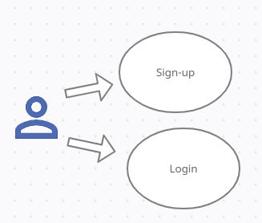

Fig. 2.1 Login/Sign-up for User

Brief Description:

Either the user can Login or Sign-up.

Initial step-by-step description:

For this use case to be initiated the user must be on the Login Page.

1. For user to login.
2. Enter Username
3. Enter Password
4. Username and Password matches from database
5. Login Success

.

2.2.2b. Use Case: AFTER USER LOGINS SUCCESSFULLY.

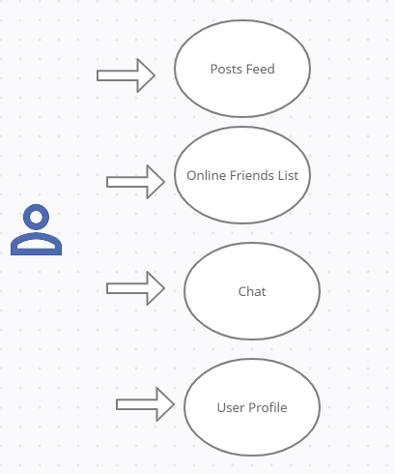

Fig. 2.2 User Homepage

Initial step-by-step description:

1. For this use case to be initiated, the user must login successful.
2. The user can see his posts feed, where he can see all the posts shared by his friends.
3. The user can see the list of all online friends.
4. Users can go to his profile page where they can view their posts and profile details.
5. Users can have a text chat with their online friends.

### 2.2.3. Non-functional requirements

There are requirements that are not functional in nature. Specifically, these are the constraints the system must work within.

2.3. Requirement specifications

2.3.1. External interface specifications

None

### 2.3.2. Functional Requirements

Table 2.1 Access Home Page:

|  |  |
| --- | --- |
| Use Case Name: | Access Home Page |
| Priority | Essential |
| Trigger | Successful Login |
| Precondition | User is on the home page. |
| Basic Path | User must Login. |
| Alternate Path | N/A |
| Postcondition | The User is on the Home Page |
| Other |  |

Table 2.3 User Login:

|  |  |
| --- | --- |
| Use Case Name: | User Login |
| Priority | Essential |
| Trigger | Login/Signup |
| Precondition | The User is on the Home Page |
| Basic Path | User enter username and password and clicks on Login button. |
| Postcondition | The user is on the home page. |
| Other |  |

2.4. Hardware Specification

Client Side:

* RAM :4GB
* Hard Disk: 256GB

2.5. Software Specification

Client Side:

* Windows 7/Windows 10/Windows 11
* Web Browser

Data Base Server:

* MongoDB

CHAPTER – III

## SYSTEM ANALYSIS AND DESIGN

System Analysis and Design

3.1. Features of Together.

The new system has been designed as per the user requirements so as to fulfil almost all them.

* + Post Sharing

Users can share posts with text and pictures.

* + Likes

Users can like the post of their friends.

* + Follow / Unfollow

Users can follow or unfollow according to their wish.

* + Friends list

Users can see their friend list.

* + Chatting

Users can chat with their friends.

3.5. Data Flow Diagram (DFD)

The DFD (also known as bubble chart) is a simple graphical formalism that can be used to represent a system in terms of the input data into the system, various processes carried on these data, and the output data generated by the system.

The main reason why the DFD technique is so popular is because the fact that the DFD is a very simple formalism – it is simple to understand and use. A DFD model uses a very limited number of primitive symbols to represent the functions performed by a system and the data flow among the functions. Starting with a set of high-level functions that a system performs, a DFD model hierarchy represents various sub-functions.

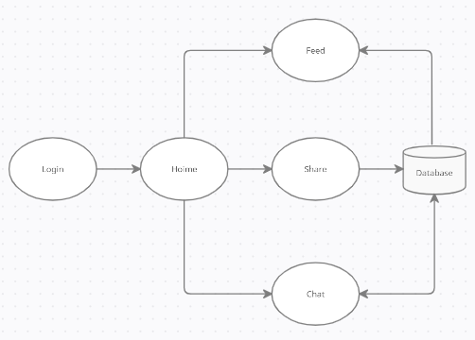

CHAPTER – IV

DATA DICTIONARY

Data Dictionary

A data dictionary is a catalog-a-repository of the elements in a system. As the name suggests, their elements centre on data and the way they are structured to meet user requirements and organization needs. In a data dictionary you will find a list of all the elements composing the data flowing through a system. The major elements are data flows, data stores and processes. The data dictionary stores details and descriptions of these elements.

If analysis want to know characters are in a data item by what other names it is referenced in the system, or where it is referenced in the system, or where it is issued in the system, they should be able to find the answers in issued in the system, they should be able to find the answer in properly developed data dictionary.

The Dictionary contains two types of description for the data following through the system.

1. Data Elements

The most fundamental data is the elements. They are building blocks for all other data in the system. Data elements are also alternatively known as fields, data item or elementary item.

1. Data Structure

A data structure is a set if items that are related to one another and described a component in the system.

4.1. Table Details

Table 4.1. USERS

|  |  |  |
| --- | --- | --- |
| Field Name | Description | Data Type |
| username | Unique username of the user | string |
| password | User password | string |
| email | User Email | string |
| followers | User Followers | array |
| following | User following | array |
| coverPicture | User Cover Picture | string |
| isAdmin | Is user admin or not | boolean |
| profilePicture | User Profile Picture | string |
| createdAt | Creation Time | Date |

Table 4.2. POST

|  |  |  |
| --- | --- | --- |
| Field Name | Description | Data Type |
| userId | User id | string |
| likes | No of Users likes this post | array |
| desc | Description of Post | string |
| createdAt | Creation Time | Date |

Table 4.3. Messages

|  |  |  |
| --- | --- | --- |
| Field Name | Description | Data Type |
| conversationId | Conversation ID | string |
| sender | ID of sender | string |
| text | Description | string |
| createdAt | Creation Time | Date |

Table 4.4. Conversation

|  |  |  |
| --- | --- | --- |
| Field Name | Description | Data Type |
| members | IDs of members | array |
| createdAt | Creation time | string |

CHAPTER – V SCREEN SHOTS

Profile Page

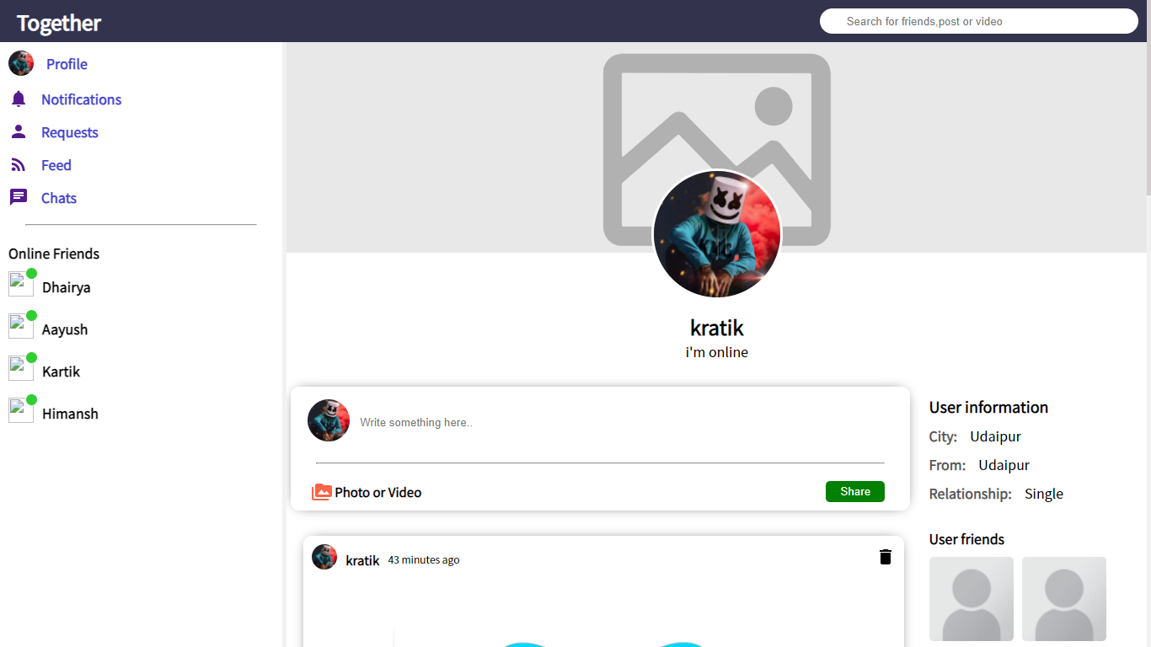

Home / Feed Page

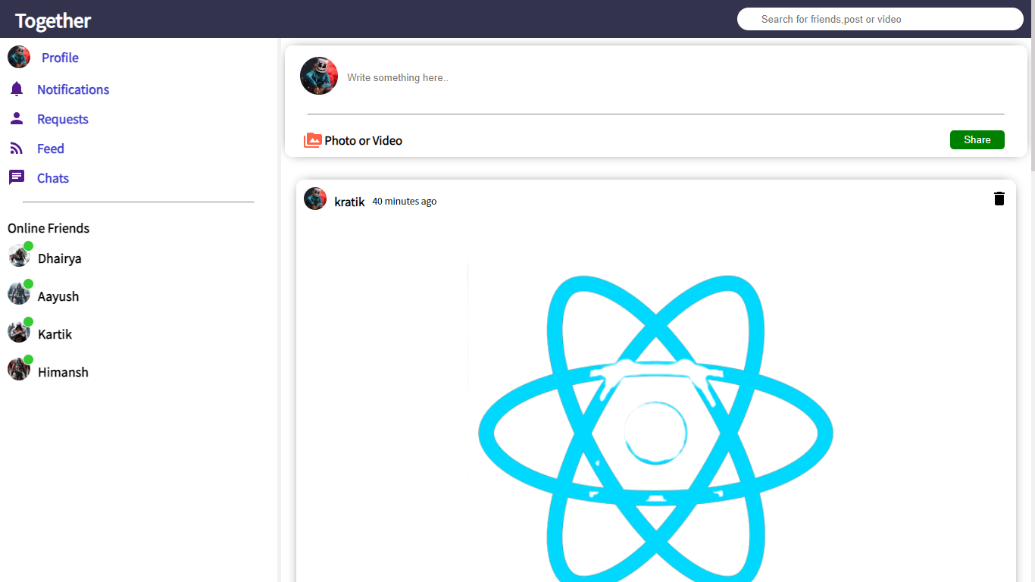

Create Post

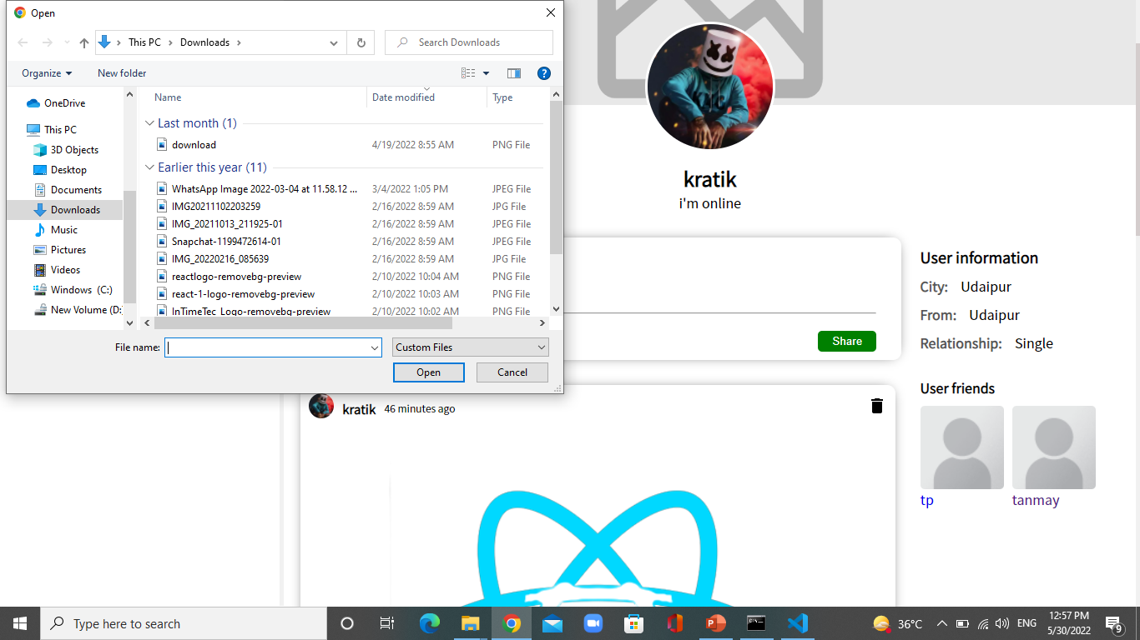

Chat

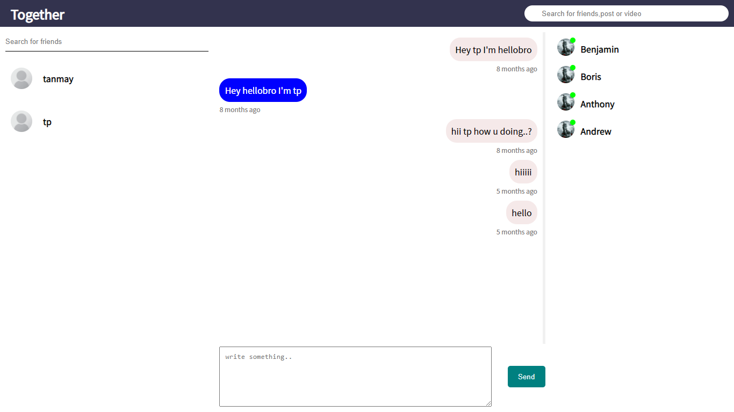

Others

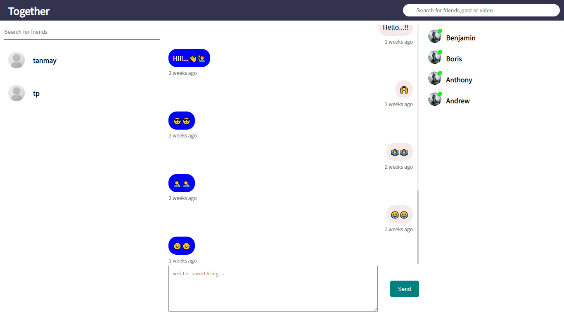

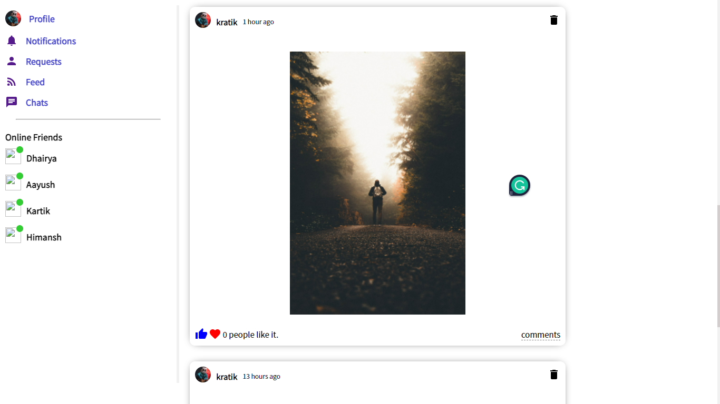

CHAPTER – VI

## TESTING

Testing

Testing Methodology

Companies rely on software more than ever to provide and manage information with strategic and operational importance and to provide key decision support. Rising customer expectations for fault-free, requirements-exact software have increased awareness of the importance of software testing as a critical activity.

We begin the testing process by developing a comprehensive plan to test the general functionality and special features on a variety of platform combinations. Strict quality control procedures are used. The process very fies that the application meets the requirements specified in the system requirements document and is bug free. At the end of each testing day, we prepare a summary of completed and failed tests. Applications are not allowed to launch until all identified problems are fixed. A report is prepared at the end of testing to show exactly what was tested and to list the final outcomes.

Our software testing methodology is applied in three distinct phases: unit testing, system testing, and acceptance were testing.

Unit Testing: The programmers conduct unit testing during the development phase. Programmers can test their specific functionality individually or with other units. However, unit testing is designed to test small pieces of functionality rather than the system as a whole. This allows the programmers to conduct the first round of testing to eliminate bugs before they reach the testing staff. In unit testing the analyst tests the programs making up a system.

For this reason, unit testing is sometimes called program testing. Unit testing gives stress on the modules independently of one another, to find errors. This helps the tester in detecting errors in coding and logic that are contained within that module alone. The errors resulting from the interaction between modules are initially avoided.

For example, a hotel information system consists of modules to handle reservations; guest checking and checkout; restaurant, room service and miscellaneous charges; convention activities; and accounts receivable billing. For each, it provides the ability to enter, modify or retrieve data and respond to different types of inquiries or print reports. The test cases needed for unit testing should exercise each condition and option.

Unit testing can be performed from the bottom up, starting with smallest and lowest-level modules and proceeding one at a time. For each module in bottom-up testing a short program is used to execute the module and provides the needed data, so that the module is asked to perform the way it will when embedded within the larger system.

System Testing: The objective of system testing is to ensure that all individual programs are working as expected, that the programs link together to meet the requirements specified and to ensure that the computer system and the associated clerical and other procedures work together.

The initial phase of system testing is the responsibility of the analyst who determines what conditions are to be tested, generates test data, produced a schedule of expected results, runs the tests and compares the computer produced results with the expected results with the expected results.

The analyst may also be involved in procedures testing. When the analyst is satisfied that the system is working properly, he hands it over to the users for testing. The importance of system testing by the user must be stressed. Ultimately it is the user must verify the system and give the go-ahead.

During testing, the system is used experimentally to ensure that the software does not fail, i.e., that it will run according to its specifications and in the way users expect it to. Special test data is input for processing (test plan) and the results are examined to locate unexpected results.

A limited number of users may also be allowed to use the system so analysts can see whether they try to use it in unexpected ways. It is preferably to find these surprises before the organization implements the system and depends on it. In many organizations, testing is performed by persons other than those who write the original programs. Using persons who do not know how certain parts were designed or programmed ensures more complete and unbiased testing and more reliable software.

The system is tested as a complete, integrated system. System testing first occurs in the development environment but eventually is conducted in the production environment. Functionality and performance testing are designed to catch bugs in the system, unexpected results, or other ways in which the system does not meet the stated requirements.

The testers create detailed scenarios to test the strength and limits of the system, trying to break it if possible. Editorial reviews not only correct typographical and grammatical errors, but also improve the system’s overall usability by ensuring that on-screen language is clear and helpful to users. Accessibility reviews ensure that the system is accessible to users with disabilities.

System testing consists of the following five steps:

1. Program testing
2. String testing
3. System testing
4. System documentation
5. User acceptance testing

* Program Testing

A program represents the logical elements of a system. For a program to run satisfactorily, it must compile and test data correctly and tie in properly with other programs. It is the responsibility of a programmer to have an error free program. At

The time of testing the system, there exists two types of errors that should be checked. These errors are syntax and logic.

A syntax error is a program statement that violates one or more rules of the language in which it is written. An improperly defined field dimension or omitted key words are common syntax errors. These errors are shown through error messages generated by the computer. A logic error, on the other hand, deals with incorrect data fields out of range items, and invalid combinations.

Since the logical errors are not detected by compiler, the programmer must examine the output carefully to detect them. When a program is tested, the actual output is compared with the expected output. When there is a discrepancy, the sequence of the instructions, must be traced to determine the problem. The process is facilitated by breaking the program down into selfcontained portions, each of which can be checked at certain key points.

String Testing

Programs are invariably related to one another and interact in a total system. Each program is tested to see whether it conforms to related programs in the system. Each part of the system is tested against the entire module with both test and live data before the whole system is ready to be tested.

* System Testing

System testing is designed to uncover weaknesses that were not found in earlier tests. This includes forced system failure and validation of total system as it will be implemented by its user in the operational environment. Under this testing, generally we

Take low volumes of transactions based on live data. This volume is increased until the maximum level for each transaction type is reached.

The total system is also tested for recovery and fallback after various major failures to ensure that no data are lost during the emergency.

All this is done with the old system still in operation. When we see that the proposed system is successful in the test, the old system is discontinued.

System Documentation

All design and test documentation should be well prepared and kept in the library for future reference. The library is the central location for maintenance of the new system.

User Acceptance Testing

An acceptance test has the objective of selling the user on the validity and reliability of the system. It verifies that the system's procedures operate to system specifications and that the integrity of important data is maintained. Performance of an acceptance test is actually the user's show. User motivation is very important for the successful performance of the system. After that a comprehensive test report is prepared. This report shows the system's tolerance, performance range, error rate and accuracy.

Table 6.1 Test Report with test data

|  |  |  |
| --- | --- | --- |
| TEST REPORT WITH TEST DATA  (To be filled by System Analyst/Programmer) | | |
| Project Name : Online Examination System | | |
| S No. | Testing Parameter | Observations |
| A. | INTERFACE TESTING   1. User-friendliness 2. Consistent menus | OK  NA |
| B. | CONTROL FLOW TESTING   1. IF-THEN-ELSE 2. DO WHILE 3. CASE-SWITCH | OK  OK  OK |
| C. | VALIDATION TESTING   1. Check for improper or inconsistent typing 2. Check for erroneous initialization or default values 3. Check for incorrect variable names 4. Check for inconsistent Data Types 5. Check for relational/arithmetic operators | OK  OK  OK  OK  OK |
| D. | DATA INTEGRITY/SECURITY TESTING   1. Data Insertion/ Deletion/ Updating 2. Boundary condition (Underflow, Overflow   Exception)   1. Check for unauthorized access of data 2. Check for data availability | OK  OK  OK  OK |
| E. | EFFICIENCY TESTING   1. Throughput of the system 2. Response time of the system 3. Online disk storage required by the system 4. Primary memory required by the system | OK  OK  OK  OK |
| F. | ERROR HANDLING ROUTINES   1. Error description are intelligent/ understandable 2. Error recovery is smooth 3. All error handling routines are tested and executed at least once | OK  OK  OK |

CHAPTER – VII

BIBLIOGRAPHY

Bibliography

➢ List of useful Websites

**React.js:** [***https://reactjs.org/***](https://reactjs.org/)

**MongoDB:** [***https://docs.mongodb.com/***](https://docs.mongodb.com/)

**Node.js:** [***https://nodejs.org/en/docs/***](https://nodejs.org/en/docs/)

**Express: *https://expressjs.com/***