*A*

*MAJOR PROJECT REPORT*

*On*

POSSIBLE USE OF RECYCLED DISPOSABLE FACE MASK IN CONCRETE

**(**Preliminary results of concrete with shredded disposable face masks**)** *Submitted in partial fulfillment of the requirements of the degree of*

BACHELOR OF TECHNOLOGY



Submitted to:

Mr. Rakesh Yadav Mr. Jitendra Choubisa TINJRIT, Udaipur

Submitted by Priyal Kothari (18ETCCE020) JayeshNagda (18ETCCE012) HardikGoswami (18ETCCE009) Ishika Sharma (18ETCCE011)

**DEPARTMENT OF CIVIL ENGINEERING**

**TECHNO INDIA NJR INSTITUTE OF TECHNOLOGY, UDAIPUR 2018-2022**

A

A

MAJOR PROJECT REPORT

On

POSSIBLE USE OF RECYCLED DISPOSABLE FACE MASK IN CONCRETE

(Preliminary results of concrete with shredded disposable face masks) *Submitted in partial fulfilment of the requirements of the degree of* BACHELOR OF TECHNOLOGY



**Under Guidance of:** Mr. Rakesh Yadav Mr. Jitendra Choubisa TINJRIT, Udaipur

**Submitted by:**

Priyal Kothari (18ETCCE020) Jayesh Nagda (18ETCCE012) Hardik Goswami (18ETCCE009) Ishika Sharma (18ETCCE011)

## DEPARTMENT OF CIVIL ENGINEERING

**TECHNO INDIA NJR INSTITUTE OF TECHNOLOGY, UDAIPUR 2018-2022**

24

# ACKNOWLEDGMENT

I express my sincere gratitude to TINJR, Udaipur, India, for his stimulating guidance, continuous encouragement and supervision throughout the course of present work. I would like to place on record my deep sense of gratitude to Mr. Rakesh Yadav, Head of the Department of Civil Engineering, TINJR, and Udaipur, India for her generous guidance, help and useful suggestions. I also wish to extend my thanks to Jitendra Choubisa Sir and other faculties for attending my seminars and for their insightful comments constructive suggestions to improve the quality of his project work. I am extremely thankful to R.S Vyas Sir, Director, TINJR, Udaipur, for providing me infrastructural facilities to work in, without which this work would not have been possible

Signatures of Students





DEPARTMENT OF CIVIL ENGINEERING

TECHNO INDIA NJR INSTITUTE OF TECHNOLOGY, UDAIPUR

# DECLARATION

I hereby certify that the work which is being presented in the B.Tech. Major Project Report entitled “**POSSIBLE USE OF RECYCLED DISPOSABLE FACE MASK IN**

**CONCRETE(**Preliminary results of concrete with shredded disposable face masks**)**”, in partial fulfilment for the award of the Bachelor of Technology in Civil Engineering and submitted to the Department of Civil Engineering of Techno India NJR Institute of Technology, Udaipur, Rajasthan is an authentic record of our own carried out during a period from MARCH-2022 to JUNE-2022 (8th Semester) under the supervision of Rakesh Yadav, Civil Engineering Department. The matter presented in this Report has not been submitted by me /us for the award of any other degree elsewhere.

Signature of students

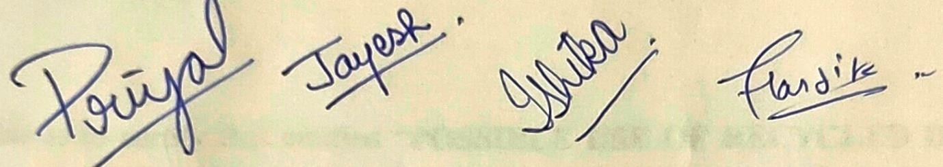

This is certifying that the above statement made by the students is correct to the best of my knowledge.



Signature of Supervisors

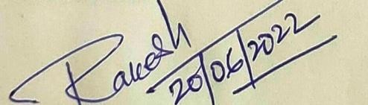Date: 18/06/2022

Head Civil Engineering Department

# CERTIFICATE



Department of Civil Engineering

Techno India NJR Institute of Technology, Udaipur

This is to certify that entitled “**POSSIBLE USE OF RECYCLED DISPOSABLE FACE MASK IN CONCRETE (**Preliminary results of concrete with shredded disposable face masks)”, is submitted by PRIYAL KOTHARI, JAYESH NAGDA, HARDIK GOSWAMI,

ISHIKA SHARMA in partial fulfilment of the requirements for the award of the Bachelor of Technology in Civil Engineering during a period from MARCH-2022 to JUNE-2022(8th Semester) from Techno India NJR Institute of Technology affiliated to RTU Kota is approved for award of the degree.

Principal/ Director Techno India NJR Institute of Technology Udaipur, Rajasthan

**PREFACE**

* Concrete can be manipulated in many different aspects. Admixtures and material replacements are very commonly used.
* Many have experimented with introducing recycled materials into concrete batches, such as shredded rubber tires, crushed glass, or fly ash. There are numerous one-use products polluting the Earth, harming wildlife, and endangering fragile environments.
* These could be reduced, reused, and recycled in various construction materials. Disposable face masks are one of many single use products that are detrimental to the environment.
* The construction industry has been introducing new ways to incorporate recycled products into their materials. This paper addresses one possible way to use more environmentally friendly materials in the construction industry.
* The bulk of the discarded face masks are send to the landfill along with Municipality Solid Waste (MSW). Based on the estimation that each face mask weights two to three grams, the face masks disposed of at landfills every day weight at least 10 to 15 tones. But a significant number end up polluting the environment.
* In this paper we describe a method to sanitize the facemasks and also recycle them into useful concrete products. The paper describes the preliminary experiments that establish the feasibility of the approach as concrete mixes with a range of compressive strengths are produced.
* It is possible to sanitize the used face masks alongside mixed plastics to recycle them into useful concrete products. It involves the collection of used face masks, sanitizing the same using air tight container for 72 hours, disinfect them, shredding them, and mix them in suitably designed cement-bases composite mixes to make products like bricks, tiles, slab, etc. Such as approach can help ease the burden of safe and sustainable disposal of waste plastic including PPEs.

# TABLE OFCONTENTS

1. ABSTRACT
2. CHAPTER : 1
   1. INTRODUCTION 1
   2. PROJECT STATEMENT 2
3. CHAPTER : 2
   1. OBJECTIVES 3
   2. LITERATURE REVIEW 4
   3. PURPOSE OF THIS PROJECT 6
4. CHAPTER : 3
   1. MANUFACTURING OF CONCRETE 8
   2. TYPES OF FIBER USED IN CONCRETE 12
   3. M25 GRADE CONCRETE RATIO IN CONCRETE MIX DESIGN 15
   4. APPLICATION AND PRODUCTION OF CONCRETE 18
5. CHAPTER : 4
   1. PROPOSED MATERIALS TO BE USED… 23
   2. PROPOSED METHODOLOGY… 33
6. CHAPTER : 5
   1. RESULT AND DISCUSSION 38
   2. RECOMMENDATION
      1. USE OF CONCRETE CONTAINING FACE MASK 39
      2. RECOMMENDATION OF FUTURE WORK 41
7. REFERENCE

# TABLE OFFIGURES

* 1. FIGURE: 1 WEIGHT BATCHING 9
  2. FIGURE: 2 HAND MIXING 10
  3. FIGURE: 3 PLACING OF CONCRETE 11
  4. FIGURE: 4 HAND COMPACTION OF CONCRETE 12
  5. FIGURE: 5 CURING OF CONCRETE CUBES 13
  6. FIGURE: 6 CEMENT 24
  7. FIGURE: 7 FINE AGGREGATES 26
  8. FIGURE:8 COARSE AGGREGATES 28
  9. FIGUE:9 FACE MASK 30
  10. FIGURE:10 WATER 32
  11. FIGURE:11 CTM MACHINE 36
  12. FIGURE:12 CONCRETE BLOCKS AFTER TESTING 37

# ABSTRACT

With the ongoing global pandemic due to Corona virus (COVID-19), the use of personal protective equipment (PPE), specifically single-use surgical masks, have been on a sharp incline. Currently, many countries are experiencing second and third waves of COVID-19 and as such have resorted to making face masks a mandatory requirement. The repercussions of this have resulted in millions of single-use face masks being discharged into the environment, washing up on beaches, floating beneath oceans and ending up in vulnerable places. The global pandemic has not only affected the economy and health of the world’s population but now is seriously threatening the natural environment. The main plastic in single-use face masks is polypropylene which in landfill can take more than 25 years to break down. This paper explores an innovative way to use pandemic waste in concrete construction with the main focus on single-use face masks. Single-use masks have been cut-up by first removing the ear loops and inner nose wire to size and spread throughout different mix designs to explore the possible benefits and uses within concrete. The masks were introduced by volume at 0% and 0.10%with testing focusing on compressive strength of the concrete. The introduction of the single-use face masks led to an increase in the strength properties of the concrete samples, as well as an increase in the overall quality of the concrete.

# CHAPTER: 1

# INTRODUCTION

Concrete can be manipulated in many different aspects. Admixtures and material replacements are very commonly used. Many have experimented with introducing recycled materials into concrete batches, such as shredded rubber tires, crushed glass, or fly ash. There are numerous one-use products polluting the Earth, harming wildlife, and endangering fragile environments. These could be reduced, reused, and recycled in various construction materials. Covid-19 Impact. The Covid-19 pandemic has increased the production and use of disposable or single-use face masks. Face masks are one of the preventative measures that is being used to slow the spread of infection. Fadare and Okoffo explain, “Disposable face masks (single use face masks) are produced from polymers such as polypropylene, polyurethane, polyacrylonitrile, polystyrene, polycarbonate, polyethylene, or polyester” (Fadare & Okoffo, 2020). These types of polymers are detrimental to the environment. Measures should be taken to keep these harmful pollutants out of the ocean. Fadare and Okoffo continue, “…disposable face masks (single use) that get in to the environment (disposal in landfill, dumpsites, freshwater, oceans or littering at public spaces) could be an emerging new source of micro plastic fibres, as they can degrade/fragment or break down into smaller size/pieces of particles under 5 mm known as micro plastics under environmental conditions” (Fadare & Okoffo, 2020). As production and consumption of face masks increases, so does the environmental danger. Use of Waste Materials in Concrete Today, waste materials are being used more and more in concrete to reduce the environmental impact. Fly ash, glass, and tires are a few examples of waste products that have been used in concrete. These materials pose a serious threat to the environment, so it is better that they be reused instead of trashed. There has been a lot of success with fly ash use in concrete. Fly ash is a by-product of burning coal for the generation of electricity. Studies find that “…it is possible to produce concretes with low Portland cement content, i.e. with improved environmental performance, achieving satisfactory expected compressive strength, thus being a promising alternative instead to plain cement concretes”. More waste products could be used in concrete as long as they do not sacrifice the structural integrity.

# PROJECT STATEMENT

The goal of this experiment is to test the possibility of recycling a waste product in concrete. Research will show whether the waste material helps or hinders the concrete’s compressible strength. The waste material, disposable shredded face masks, could be beneficial to the concrete mix and performance. The fibres, plastics, and wires in the face masks could be useful in holding the concrete together, therefore making it stronger.

# CHAPTER: 2

* 1. **OBJECTIVE**
* Concrete can be manipulated in many different aspects. Admixtures and material replacements are very commonly used.
* Many have experimented with introducing recycled materials into concrete batches, such as shredded rubber tires, crushed glass, or fly ash. There are numerous one-use products polluting the Earth, harming wildlife, and endangering fragile environments.
* These could be reduced, reused, and recycled in various construction materials. Disposable face masks are one of many single use products that are detrimental to the environment.
* The construction industry has been introducing new ways to incorporate recycled products into their materials. This paper addresses one possible way to use more environmentally friendly materials in the construction industry.
* The bulk of the discarded face masks are send to the landfill along with Municipality Solid Waste (MSW). Based on the estimation that each face mask weights two to three grams, the face masks disposed of at landfills every day weight at least 10 to 15 tonnes. But a significant number end up polluting the environment.
* In this paper we describe a method to sanitize the facemasks and also recycle them into useful concrete products. The paper describes the preliminary experiments that establish the feasibility of the approach as concrete mixes with a range of compressive strengths are produced.
* It is possible to sanitize the used face masks alongside mixed plastics to recycle them into useful concrete products. It involves the collection of used face masks, sanitizing the same using air tight container for 72 hours, disinfect them, shredding them, and mix them in suitably designed cement-bases composite mixes to make products like bricks, tiles, slab, etc. Such as approach can help ease the burden of safe and sustainable disposal of waste plastic including PPEs

# LITERATURE REVIEW

## Zoran J. Grdic et al. (2012):

The authors concluded that: Abrasive resistance of concrete is reduced with the increase of water/cement ratio from 0.5 to 0.7 which is reflected in the increase the addition of fibers increases tensile strength across the whole range of W/C factors from 0.5 to 0.7 in respect to the benchmark concrete. The concretes with extreme compressive and tensile strength (at bending) have higher abrasive resistance, so these limits may serve as indicators of the abrasive–erosive resistance of concrete. The polypropylene fibrillated fibers verified better in respect to the monofilament fibers in terms of abrasive– erosive resistance of concrete.

## S.Sharmila et al. (2013):

The authors indicated that: The effect of adding hybrid fibers influence the behavior of beams by increasing the ductility characteristics by 80% and energy absorption characteristics by more than 160%. Instead of adding single fiber, the combination of different types of fibers (Hybrid fibers) increases the energy absorption capacity substantially.

## Gurunathan k et al. (2014):

The authors conversed that the tallying of polypropylene fibers, reckons fibers, fly ash and silica fume in different concrete mixes marginally improve the compressive strength at 28 days. The least percentage of fly ash and silica fume were added in concrete so that the presentation of the concrete increases. There is an increase from 3% to 9% in split tensile strength for all fiber mixes when equated with that of control mix. Then from the test results the authors determined that the volume fraction of hybrid fiber concrete.

## Chaitanya Kumar (2016):

Study where carried out using an M20 grade of concrete and glass fiber is added as 0.5%, 1%, 2%, and 3%. And the specimens are cast for a compressive and tensile test of the concrete. In this experiment, concrete achieves strength when 2% of the fiber is added to the concrete and when 3% fiber is added to the concrete the strength of concrete declines. When the fiber is added 2% the strength of the concrete attains 26.98 Mpa of compressive strength,

2.94 Mpa of Flexural Strength and 3.57 Mpa of the Tensile strength of the concrete after 28

days of curing. In this experiment, the author mentioned that the work ability of the concrete is increased and thus the glass fiber reduces the crack under different loading.

## Majid Ali:

He studied the mechanical and dynamic properties of coconut fiber reinforced concrete (CFRC). He investigated then the mix proportions of 2%, 3% and 5% fiber contents by mass of cement and fiber lengths of 2.5, 5 and 7.5 cm is investigated. Noor Md. Sadiqul Hasan, etc. They have investigated the physical and mechanical characteristics of concrete after adding coconut fiber on a volume basis. Mahyuddin Ramli: Studied the strength and durability of coconut fiber reinforced concrete in aggressive environments. The aim was to reduce the enlargement of cracks in structures by introducing coconut fibers.

## Domke P. V:

had investigated the use of natural and agricultural waste products like coconut fibers and rice husk ash to enhance the properties of concrete and their studies describes the strength of the concrete. Foti (2013): Investigate use of different forms of reinforcements with pet bottle viz circular fibers, half bottles and rectangular strips. The tests resulted in high concrete PET adherence. Further, more ductile behavior was observed when subjected to bending load.

## Ramadevi and Manju (2012):

Examined the impact of 0.5%, 1%, 2%, 4% and 6% replacement of fine aggregates with ground pet fibers. Pet bottles were first shredded into flakes and subsequently ground. Optimal compressive strength, split tensile strength and flexural strength was recorded on 2% replacement. Safinia and Alkalbani (2016): Compared the compressive strength of concrete blocks with empty 500ml PET bottles placed in between to that of hollow concrete blocks procured from a local market. Concrete specimen with bottles resulted in an increase of 57% as compared to hollow concrete block from market.

## Asha and Resmi (2015):

Checked strength of concrete by replacing cement in dry mix by 0.5%, 1% and 1.5% plastic fibers. Straight and crimped fibers were used in different specimens. Both types of fibers gave optimal results at 1% fiber. For straight fibers compressive and tensile strength increased by 16% and 37% respectively on the other hand, for crimped fibers there was increase of 18% and 42% in compressive and split tensile strength.

# 2.3 PURPOSE OF THIS PROJECT

After more than two years wearing surgical masks due to the COVID-19 pandemic, used masks have become a significant risk for ecosystems, as they are producing wastes in huge amounts. They are a potential source of disturbance by themselves and as micro plastic contamination in the water system. As 5500 tons of face masks are estimated to be used each year, there is an urgent need to manage them according to the circular economy principles and avoid their inadequate disposal. In this paper, surgical wear masks (WM), without any further pre-treatment, have been introduced as addition to mortars up to 5% in the weight of cement. Mechanical and microstructural characterization has been carried out. The results indicate that adding MW to the cement supposes a decrease in the properties of the material, concerning both strength and durability behaviour. However, even adding a 5% of WM in weight of cement, the aspect of the mortars is quite good, the flexural strength is not significantly affected, and the strength and durability parameters are maintained at levels that—even lower than the reference—are quite reasonable for use. Provided that the worldwide production of cement is around 4.1 Bt/year, the introduction of a 5% of WM in less than 1% of the cement produced, would make it possible to get rid of the mask waste being produced.

Due to the COVID-19 pandemic, people have started wearing surgical masks in order to take precautionary measures, which has dramatically increased the amount of waste created, one surgical mask per person, per day for a year in the UK would create over 124,000 tons of plastic waste. WHO estimated that nearly 89 million masks were needed to control COVID- 19 each month. Face masks are a source of micro plastic contaminants in water ecosystems and in indoor and outdoor air, as polypropylene and other plastics—polystyrene, polycarbonate, polyethylene, or polyester, among others—are used in making face masks. This constitutes a big problem related to health for different living beings, including humans and the environment as a whole. Thus, some voices are claiming that the circular economy principle should guide policy making for the management of medical waste and, specifically, single-use face masks. A life cycle analysis of single-use and reusable face masks can be found in.

Since the beginning of the pandemic, several researchers have made a characterization of face masks using several techniques. Mainly, the studies have been focused on disinfection and

reuse of the masks, among other solutions. The mask were characterized by thermal, morphological, and chemical analyses, proposing a recycling of the resulting material after thermal treatment. The pore structure of the surgical mask was investigated after treatment with ethyl alcohol, UV light, steam, or a washing machine. Peinador used capillary flow and liquid extrusion porometry to characterize pore size distributions. Scarce studies have arisen concerning recycling used masks. Crespo el al.demonstrated the possibility of recycling face masks using the same protocols that are used in mechanical recycling of thermoplastics. In, the masks were transformed into S-doped porous carbon as the cathode electrode for supercapacitors. In, researchers demonstrated that, depending on the type of mask, the sound pressure level transmitted is different; additionally, presented the results of an experimental study on the recycled material obtained from masks, including characterization as bulk density, fibre diameter, porosity, flow resistivity, and tortuosity, as well as acoustic efficiency. The polypropylene fibres from the masks were blended with acrylonitrile butadiene rubber. Researchers presented a theoretical strategy of disposing the masks by their conversion to alternative fuel. Shredded face masks were added to recycled concrete aggregate (RCA) for road base and subbase applications.

The use of polypropylene fibres has been previously described and extensively used in the concrete sector, mainly due to their high tensile strength and Young’s modulus, but also due to improvement of some properties, such as shrinkage and high alkaline resistance; that is why face mask wastes are good candidates to be reused in cement-based materials. Rehman el al. Added shredded face masks and silica fume to cement to stabilize fat clay soils. The only paper found using face masks as an addition to produce cementitious materials is , where the masks were introduced by volume of concrete up to 0.25%. According to the mixes given in, the 0.25% in volume of concrete corresponds to 0.37% and 2.2% in weight of concrete and cement, respectively. These percentages seem to be quite low for dealing with the huge environmental problem of mask waste. In addition, the focus of the paper was put on the mechanical properties of the resulting mixes, not paying attention to aspects of durability.

In this paper, surgical wear masks without any pre-treatment were introduced as addition to mortars up to 5% in the weight of the cement. Mechanical and microstructural characterization was carried out.

# CHAPTER: 3

# MANUFACTURING OF CONCRETE

The manufacturing of concrete is broadly carried in six steps, which when sequentially followed, will produce a properly proportioned and complete mixed concrete. Each step has its own significance on the contribution of different properties, in the finished product.

Different types of the quality control mechanism and testing are involved in each phase, to make sure that that the concrete produced is of the appropriate quality and which will satisfy all the requirements of being used as a structure.

The name of the methods and detailed explanation of each method has been mentioned in the following:

1. [Batching](https://civilwale.com/manufacturing-of-concrete/#Batching)
2. [Mixing](https://civilwale.com/manufacturing-of-concrete/#Mixing)
3. [Transporting](https://civilwale.com/manufacturing-of-concrete/#Transporting)
4. [Placing](https://civilwale.com/manufacturing-of-concrete/#Placing)
5. [Compacting](https://civilwale.com/manufacturing-of-concrete/#Compacting)
6. [Curing](https://civilwale.com/manufacturing-of-concrete/#Curing)

## Batching

It is the first and foremost method of preparation of concrete, which involves the measurements of the materials for making concrete. Before starting any concrete operation, the volume of the concrete required, to do that work, will always be mentioned or should be worked out from the drawings provided for that structure.

Depending upon the volume of the work, and grade of concrete mentioned in the design documents, the volume of the Cement, sand and Course aggregates are determined respectively, through adopting Mix Design methodology. After the volume has been accurately determined, then the process involves accurately measuring the volume of each material on-site, to be used for making concrete. The batching method usually deals with this accurate measurement of materials.

**Weigh Batching**: This is the most common and accurate method of Batching which involves measuring the materials depending upon their weight. Generally, the materials of concrete can be measured using the tools below:

Cement: the weight of one bag cement is generally taken as 50 kg, irrespective of different wastes. When taken for a small amount, it is generally measured in the weighing machine.

Aggregates: Aggregates are measured using Gauge boxes which also sometimes called Farmas.

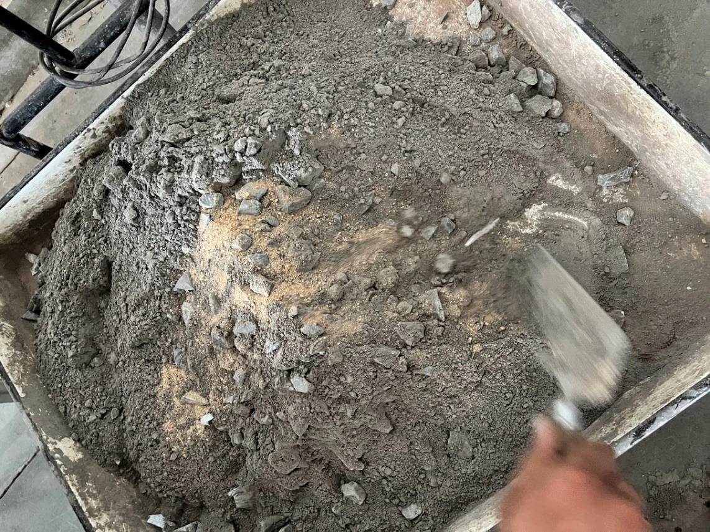

FIGURE: 1 WEIGHT BATCHING

Water: Water is measured in the usual procedure

## Mixing

After Batching, the mixing phase takes place which is the actual production of the material Concrete. In this phase, the necessity of different construction equipment is immense, which will as well determine the quality of concrete produced.

The mixing phase can be defined as the phase involving, actual physical mixing of different raw material in the provided proportion along with the controlled operation, which produces

the material concrete. In various modern construction, the mixing procedures greatly differ, depending upon the type of concrete to be produced, but in simple, it Is as following:

At first, take a small amount of water and put it into a mixture machine to prevent the sticking of any materials in the body of the machine. Then half the amount of course aggregate is placed in it, over which half the amount of sand is placed. Then the full quantity of cement is placed, and over which the previous sequence is adopted. This is done to prevent any wastage of cement, which is of course very costly material. The amount and number of water are equally distributed throughout the mixing phase.

**Hand Mixing:** Though the name indicates hand Mixing, it is not actually Mixed through the hand. It is generally done using a mixer that is manually operated. It is not very popular because of the great amount of effort to be used for the mixing and the mixing speed varies greatly if it is done using human operation. It is generally adopted for petty concreting works.

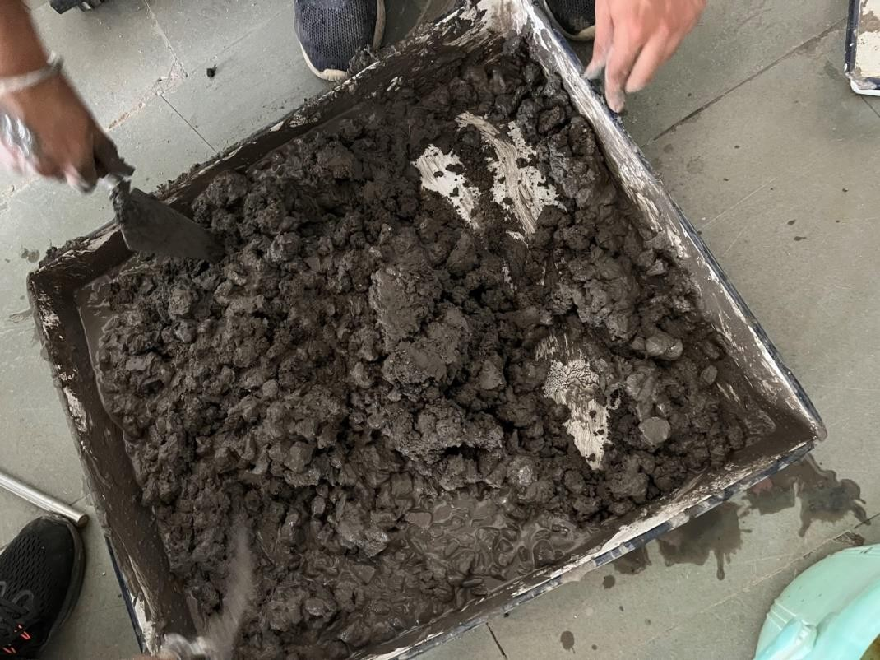

FIGURE: 2 HAND MIXING

## Placing

It is the process of placing of produced concrete, on the required place, according to the position of the structural member in the Drawing. The placing can be of different types, depending upon the methods used, such as placing of concrete for foundation and walls, placing of concrete for Underwater works, etc.

The placing operation largely involves the Formwork fixing operation. Before placing concrete to the required place, the Formworks, planks that can be manufactured of different materials, such as Timber and steel and whose depth and thickness depending upon the depth of the structural member and a number of other factors, are fixed on the four sides. This Formwork act as a medium in order to obtain the desired shape of the concrete, by suitably designing the forms, one can attain any Architectural or geometrical shape of the concrete. The removal of the Formworks also depends upon the type of components and various site conditions.

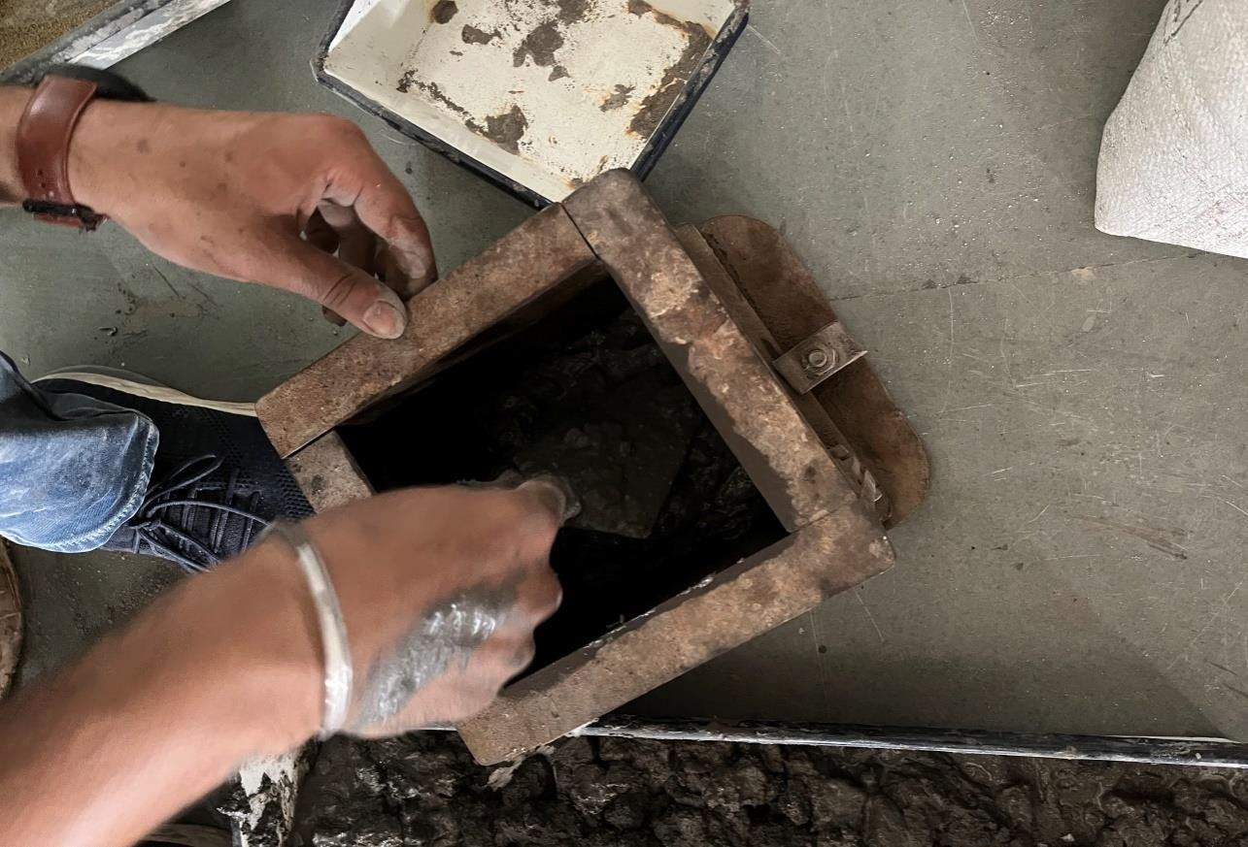

FIGURE: 3 PLACING OF CONCRETE

## Compacting

It is a method of eliminating air voids on the surface of the concrete. Whenever concrete is placed, many times, different sizes of air voids already exist in the concrete. If the concrete is not subjected to the Compacting efforts, this air voids remain, which on a later stage results in the reduction of the strength of concrete as well as other different faults. So in order to attain full strength so that it can perform safely as per it’s predecided lifespan, Compacting is necessary.

Compacting may be broadly classified into two types,

o **Hand Compaction:** Hand Compaction is done by a steel tamping rod. By equally distributing the strokes as per the number specified in the design documents(generally 25 times for a layer of 10 cm), the concrete is Compacted. This method is used for petty and small concreting works

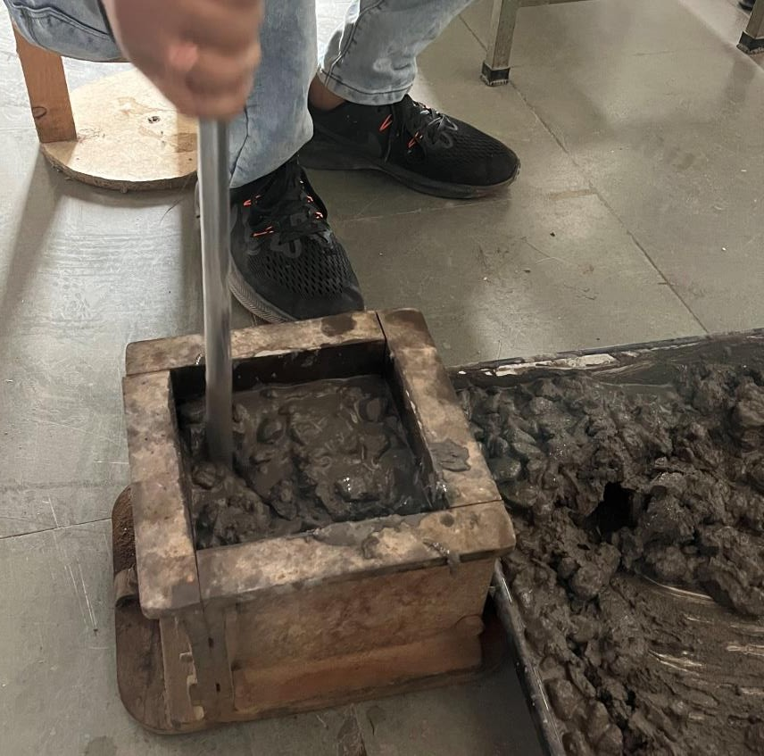

FIGURE: 4 HAND COMPACTION OF CONCRETE

## Curing

As we all know, the reaction between cement and water is exothermic, which evolves a considerable amount of heat. Due to the hydration of Cement, a large amount of heat develops on the concrete surface as well the water quantity gets reduced. Both occurrences pose a great danger to the structural member from the stability point of view. So in order to maintain sufficient temperature, as well as providing adequate moisture to the concrete, Curing is necessary. So, in other words, curing is the process of making the concrete warm and moist enough so that hydration of cement can continue.

There are different types of curing, but the most common of them all is Water Curing.

o **Water Curing**: it is the application of water on the surface of the concrete. Again, these may be of several types such as immersion, ponding, spraying, and fogging. The types of water curing may be different based on the types of elements, as well method of construction (i.e precast or cast in place. The time of curing generally depends upon the site and weather conditions. But in Normal condition, a Curing of 7 days may be assumed necessary.

So these are the major methods of Preparation of concrete. There is another method, which is Finishing. It is practically giving a suitable finish to the surface of the member, for Architectural and aesthetic consideration. After going through all the methods, the concreting Operation is said to have been finished, and which is completely ready to get loaded.

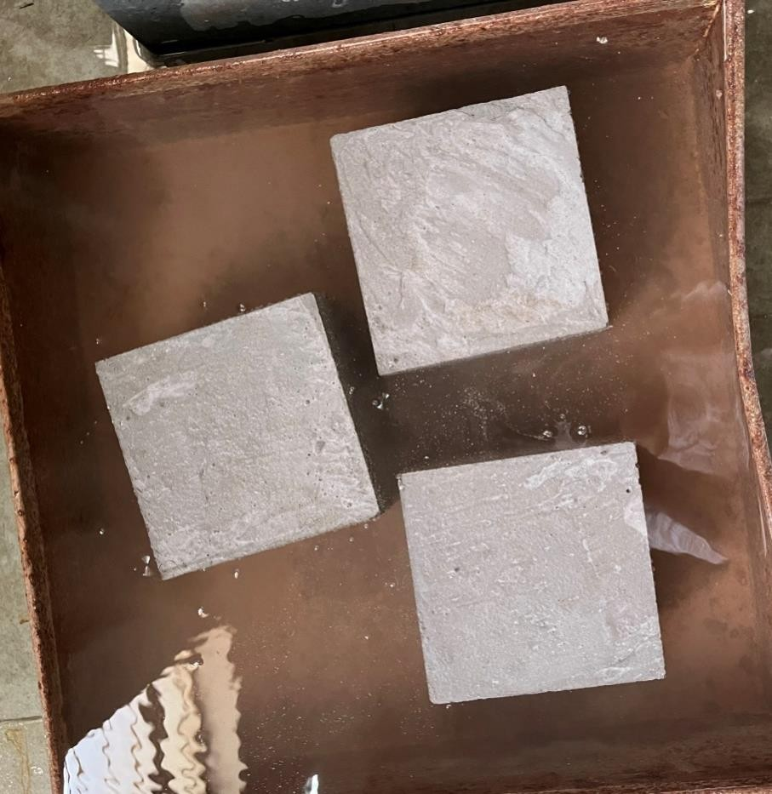

FIGURE: 5 CURING OF CONCRETE CUBES

# TYPES OF FIBERS USED IN CONCRETE

Fibre concrete, or ‘fibre’ in U.S. English, which people also call fibre-reinforced concrete, is a type of construction material that contains various types of small fibres. Putting fibres in concrete adds structural integrity for a project as it helps reduce the possibility of any cracking or water permeating the concrete.

There are many different types of fibre that you can add to concrete, with the main advantage of making it more secure. Types of fibre concrete include glass fibre reinforced concrete (GFRC), plastic-based polypropylene fibre concrete, carbon fibre concrete, steel fibre concrete and blends of fibres in some cases.

## Glass fibre reinforced concrete (GFRC) for a light weight and strength

GFRC uses small glass fibres and has many applications in the construction industry. GFRC has a lot of useful properties and you make it by mixing cement, water, sand and glass fibre. The type of glass fibre that you use will be alkali-resistant. Alkali resistant glass fibres help prevent absorption.

The advantages of GFRC is that it is lightweight, but still has a high degree of strength. These properties make it suitable for wall panels, countertops and the area surrounding fireplaces. The glass fibre gives GFRC extra strength, so you can use thinner pieces of concrete without reducing the weight it can take.

The disadvantages of using GFRC are that it can be costly to use. It is always more expensive than using regular concrete. You also have to pre-fabricate GFRC, so a lot of planning is necessary. There is also a chance that GFRC will lose some strength over time, which may make it a poor choice in some settings.

## Plastic fibre concrete for flexibility and freeze-resistance

Similarly to GFRC, plastic fibre concrete is very lightweight – so has some of the same applications. The properties of plastic fibre lend itself well to the construction industry, most notably because of the fact that plastic has a good level of flexibility – which will help reduce or prevent any cracking.

The kind of plastic that you will typically use in this type of fibre concrete is nylon or polypropylene. Polypropylene is a polymer that has other uses in everything from clothing to

medical supplies. Plastic fibre concrete has the advantage of better resistance to very cold temperatures and resisting wear.

The main disadvantages of plastic fibre concrete include the strength of the material. Plastic has properties that are quite soft, so it does not have the same level of strength as other types of fibre concrete. It will also have a low melting point, and so is unsuitable for furnaces or certain other industrial settings.

## Carbon fibre concrete for high strength and chemical resistance

Carbon fibre concrete uses small pieces of carbon fibre to fill the concrete. You manufacture carbon fibre by bonding carbon atoms together. The properties this type of concrete fibre has include being low-weight, high-strength and having a solid level of chemical resistance.

Using carbon fibre concrete gives you a lower chance of concrete fatigue over time, and it is an extremely long-lasting choice. The durability and lack of corrosion make it useful for industrial settings, including ones where there is high acidity. Carbon fibre concrete resists salt so will prevent seawater damage.

The primary disadvantage of carbon fibre concrete is that it is a very expensive option. You are probably worrying about the costs of your project, so carbon fibre concrete is not the best choice if you are on a budget. Handling carbon fibre can also be an issue during construction as it conducts electricity.

## Steel fibre concrete for durability and crack-resistance

Steel is a reliable and sturdy material that makes it a good choice for many projects that will be using fibre concrete. The properties of steel fibre concrete are that it is highly durable and provides significant structural integrity. If cracking occurs, steel fibre concrete will limit the impact of the cracks.

Using steel fibre concrete is beneficial because it resists freezing temperatures, which means it can have applications in cold conditions. It also has a high melting point, so it has the ability to keep the integrity of its structure at very high temperatures – which makes it useful in industrial settings.

Disadvantages of steel include the weight of the material. When using steel fibre concrete it is difficult to get an even distribution of fibres, which may affect the strength. Steel fibre concrete can also be a pricier option in many cases and may develop corrosion if it has heavy exposure to weather or chemicals.

## Blends of fibre concrete for a mixture of attributes

It is possible to blend certain types of fibre to achieve the most suitable type of fibre concrete. The light weight of glass may be desirable, but certain projects may also require a high degree of strength. In this instance, using a combination of glass and steel fibre may be appropriate.

It is essential to remember that blends of fibre concrete do not necessarily give you the same advantages of each type, there will be a reduction in their properties as there will be less of each material present. It is also important to remember that you will also have the disadvantages of each type of fibre.

# M25 GRADE CONCRETE RATIO IN CONCRETE MIX DESIGN

M25 means grade of concrete in which M stands for mix of concrete and numerical figure 25 stands for compressive strength of concrete cube such as 25 MPa (N/mm2) after 28 days of curing. M25 concrete comes under nominal concrete which can be easily designed by the help of IS 10, 262:2009.Concrete mainly composed of cement, sand & aggregate in which aggregate mainly responsible for strength whereas cement & sand responsible for binding of total volume. Concrete is a composite mixture consisting of cement, sand ( fine aggregates) and coarse aggregate. design of the concrete grade mix is a procedure to find the correct quantities of cement sand and aggregate materials to achieve the desired compressive strength. Precise design of the concrete grade mix makes concrete construction more economical. Large commercial and industrial building Super structure and other structure such as bridges and dams, require an enormous amount of concrete for casting and the right amount of constituents like cement sand and aggregate (concrete)makes the structure economical.

What is M25 concrete grade ratio in concrete mix design

To calculate or find the right M25 grade concrete ratio you need to know various types of load acting on a structure member like column, beam and slab and their shearing and bending moment

CONCRETE MIX DESIGN

Concrete is a composite mixture which consists of Cement, Sand (fine aggregate) and coarse aggregate. Concrete mix design is the procedure for finding the right quantities of these materials to achieve the desired compressive strength. Accurate concrete mix design makes concrete construction more economical. Large constructions of structure such as Bridges, dams and multi storage building factories requires huge amount of concrete, using the right quantity of constituents make the structure economical. In order to calculate or find the right amount of cement, sand and aggregate required in m25 grade concrete; you need to know about concrete mix design. As per IS code 456:2000, Different grades of concrete are classified into M5, M7.5, M10, M15 etc., whereas M stands for Mix and the numerical figure behind M stands for Characteristic Compressive strength (fck) of the concrete in N/mm^2 in curing of 28 days when checked with 15cm×15cm×15cm cube compressive test. There is two types of concrete grade mix nominal mix and design mix, nominal mix is used for lower

grade of concrete like M5, M 10, M15, M20 and M 25 grade concrete but higher grade concrete have M25, M30 and so more, M 25 grade concrete is prepared by both type of mix design, nominal mix and design mix. But in this topic we discuss about nominal and design mix of M25 grade concrete in which M25 grade concrete ratio is 1:1:2 (one part cement one part sand and two part is aggregate) used. M25 grade concrete mix design is based on various types of load acting on compressive and tensile structure of building sharing and bending moment, and M25 grade concrete ratio is decided by calculating and considering all factors.

What is M25 grade concrete?

The concrete grades are defined by the compressive strength and composition of cement, sand and aggregate in the concrete and the minimum strength that the concrete must have gain after 28 days of the curing period of initial construction. The degree of concrete is understood in the measurements of compressive strength in MPa, where M is stand for mix, and MPa indicates the characteristics of compressive strength. Compressive strength of M25 grade of concrete is 25 N/mm^2 gain after 28 days of curing. According to compressive strength concrete grades are lower strength concrete and higher strength concrete, lower strength concrete is M5, M7.5,M10,M15 and higher strength concrete is M20, M25, M30 and so many more. But in this topic we have to discuss about m25 grade concrete ratio.

Meaning of M25 grade concrete-

M25 grade concrete is type of grade of concrete that would achieve a compressive strength of 25 N/mm^2 after 28 days of curing period of initial construction. M is stand for mix and numerical figure 25 is characteristics of compressive strength.

M25 grade concrete ratio

M25 grade concrete is made by mixing cement, sand and coarse aggregates in a 1: 1: 2 ratio (1 part is cement,1 part is sand and 2 part is cement) in which keeping the water-cement ratio between 0.4 and 0.6. M25 grade concrete ratio is 1:1:2 mixture of cement, fine aggregates and course aggregate in which one part is cement, one part is sand and two parts is aggregate.

The degree of preparation of the concrete is selected based on the m25 grade concrete mix design. There are two types of m25 concrete ratio concrete mixes, nominal mix and design mix.

M25 concrete grade nominal mix ratio

Nominal mix of m25 concrete grade is that generally used for small-scale construction and small residential buildings where the consumption of concrete (cement sand and aggregate) is not high. Nominal mix ratio of m25 grade of concrete is 1:1:2, mixture of cement, sand, aggregate and water in which one part is cement, one part is sand and two part is aggregate and water cement ratio is 0.4 to 0.6.The nominal mix takes care of the safety factor against several quality control problems that usually occur during the preparation of the concrete.

M25 grade concrete design mix ratio

Design mixing of M25 grade concrete is one for which mixing rates of cement sand and aggregate are obtained in various laboratory tests considering various types of load acting on structure member of building, other types of a structure like Bridge, dams and multi- storage building, use of shotcrete requires good quality control during the selection, mixing, transportation, and placement of the concrete.

# APPLIATIONS AND PRODUCTION OF CONCRETE

Concrete is a fixture in urban infrastructure, from interstate highways to towering city skyscrapers. Concrete can be spotted anywhere to no surprise as it is the most commonly used manmade material in the world. In the United States alone, approximately [10 billion](http://concretehelper.com/concrete-facts/) [tons of concrete are produced annually.](http://concretehelper.com/concrete-facts/)

Concrete is an exceptionally versatile building material with malleable or solid properties, depending on its stage of curing. It consists of aggregates and rocks mixed with fluid cement. After a certain amount of time, concrete hardens into a rock-like mass due to a chemical reaction known as hydration. Once hardened, it becomes exceptionally strong and durable at strength of 3000–20,000 psi—enough to hold up bridges, skyscrapers, and dams.

## Concrete production

Concrete is produced at a plant or on a job site. Equipment can vary from hand tools to large industrial machinery. Whatever the scale of production, concrete components must be thoroughly mixed, moulded, and shaped within specific time constraints. Any disruptions can affect the integrity and appearance of the final product.

## Large-scale concrete production

Large-scale concrete production takes place in two types of concrete plants: ready-mix plants and central mix plants. Ready-mix plants mix all concrete components except for water. Central mix plants mix all concrete components including water and are best for accurate control. Typically, concrete is a viscous fluid that is poured into molds to give a desired shape. However, concrete can also be in non-fluid form. This dryer version is preferred for manufacturing precast concrete products.

## Small-scale concrete production

Smaller amounts of concrete are made at a job site using a volumetric mixer or mobile batch mixer. These mixers serve as mini concrete plants, capable of producing various types of concrete. They are perfect for sites that only require minimal concrete for installing smaller applications. For example, an installer uses a volumetric mixer to make concrete for embedding [bike racks,](https://www.reliance-foundry.com/bike-parking/bike-racks) or for installing [bollards](https://www.reliance-foundry.com/bollard/decorative-architectural) and [steel pipes](https://www.reliance-foundry.com/bollard/steel-pipe) as traffic safety devices.

## Types of concrete

There are dozens of concrete types available on the market for construction and building needs. Listed below are a few common types of concrete used in modern infrastructure.

## Ordinary concrete

Ordinary concrete is one of the most popular forms of concrete. A typical mix includes cement, sand, and coarse aggregates mixed with specific quantities of water. It has a setting time of approximately 30–90 minutes with strength values of 1450–5800 psi. At 28 days of curing, 75–80% of total strength is achieved, and after 90 days, 95% is achieved.

## High-performance concrete

High-performance concrete has higher strength, workability, and durability compared to ordinary concrete. It has long-term mechanical properties and early age strength. It can withstand harsh environments and is resistant to creep and shrinkage which minimizes cracking. Strength ranges from 10000–15000 psi.

## Reinforced concrete

Reinforced concrete uses various forms of steel as reinforcement. The combination of concrete (with its high compressive strength) and steel (with its high tensile strength) gives reinforced concrete its unique strength properties. Reinforced concrete has the capacity to endure many forms of stress in any type of construction.

## Precast concrete

Precast concrete casts concrete into moulds in a controlled environment. Once completely set and hardened, they are transported to the construction site. The curing stage happens under controlled conditions where temperature and humidity are monitored. Steam curing is sometimes used to produce precast products with high strength with less curing time.

## Lightweight concrete

Lightweight concrete is any concrete with a density less than 240 kg/m³. It includes lightweight aggregate concrete, foamed concrete, and autoclaved aerated concrete. Lightweight concrete typically improves thermal abilities and fire resistance. However, it is more susceptible to creep and shrinkage.

## Pervious concrete

Pervious concrete allows air or water to circulate through a series of holes or voids created within the concrete. Water can drain naturally, allowing for the drainage of surface water and replenishment of groundwater. It is a low-impact development material that protects water quality and used in sustainable construction.

## Concrete applications

Before starting on any concrete application, the appropriate concrete type must first be determined. For example, reinforced concrete is suitable for building materials requiring high tensile strength, such as columns and beams. Lightweight concrete is best for building light concrete blocks for home construction.

Concrete is a versatile material and its applications are plentiful. Concrete’s malleable, yet tough characteristics make it ideal base materials for constructing buildings, urban infrastructure, and various precast products.

# CHAPTER4

* 1. **PROPOSED MATERIAL TO BE USED**

## CEMENT-

Cement, in general, [adhesive](https://www.britannica.com/technology/adhesive) substances of all kinds, but, in a narrower sense, the binding materials used in [building](https://www.britannica.com/technology/construction) and [civil engineering](https://www.britannica.com/technology/civil-engineering) construction. Cements of this kind are finely ground powders that, when mixed with [water](https://www.britannica.com/science/water), set to a hard mass. Setting and hardening result from hydration, which is a chemical combination of the cement [compounds](https://www.merriam-webster.com/dictionary/compounds) with water that yields sub microscopic crystals or a gel-like material with a high surface area. Because of their hydrating properties, constructional cements, which will even set and harden under water, are often called hydraulic cements. The most important of these is [portland cement](https://www.britannica.com/technology/portland-cement).

This article surveys the historical development of cement, its manufacture from raw materials, its [composition](https://www.merriam-webster.com/dictionary/composition) and properties, and the testing of those properties. The focus is on portland cement, but attention also is given to other types, such as slag-containing cement and high-alumina cement. Construction cements share certain chemical [constituents](https://www.merriam-webster.com/dictionary/constituents) and processing techniques with ceramic products such as [brick and tile,](https://www.britannica.com/technology/brick-building-material) [abrasives,](https://www.britannica.com/technology/abrasive) and [refractories.](https://www.britannica.com/technology/refractory) For detailed description of one of the principal applications of cement, see the article [building construction.](https://www.britannica.com/technology/construction)

Applications of cement –

Cements may be used alone (i.e., “neat,” as grouting materials), but the normal use is in [mortar](https://www.britannica.com/technology/mortar-building-material) and [concrete](https://www.britannica.com/technology/concrete-building-material) in which the cement is mixed with inert material known as [aggregate](https://www.britannica.com/technology/aggregate). Mortar is cement mixed with [sand](https://www.britannica.com/science/sand) or crushed stone that must be less than approximately 5 mm (0.2 inch) in size. Concrete is a mixture of cement, sand or other fine [aggregate](https://www.merriam-webster.com/dictionary/aggregate), and a coarse aggregate that for most purposes is up to 19 to 25 mm (0.75 to 1 inch) in size, but the coarse aggregate may also be as large as 150 mm (6 inches) when concrete is placed in large masses such as [dams.](https://www.britannica.com/technology/dam-engineering) Mortars are used for binding bricks, blocks, and stone in walls or as surface renderings. Concrete is used for a large variety of constructional purposes. Mixtures of soil and portland cement are used as a base for roads. Portland cement also is used in the

manufacture of bricks, tiles, shingles, pipes, [beams](https://www.britannica.com/dictionary/beams), railroad ties, and various extruded products. The products are prefabricated in factories and supplied ready for installation.

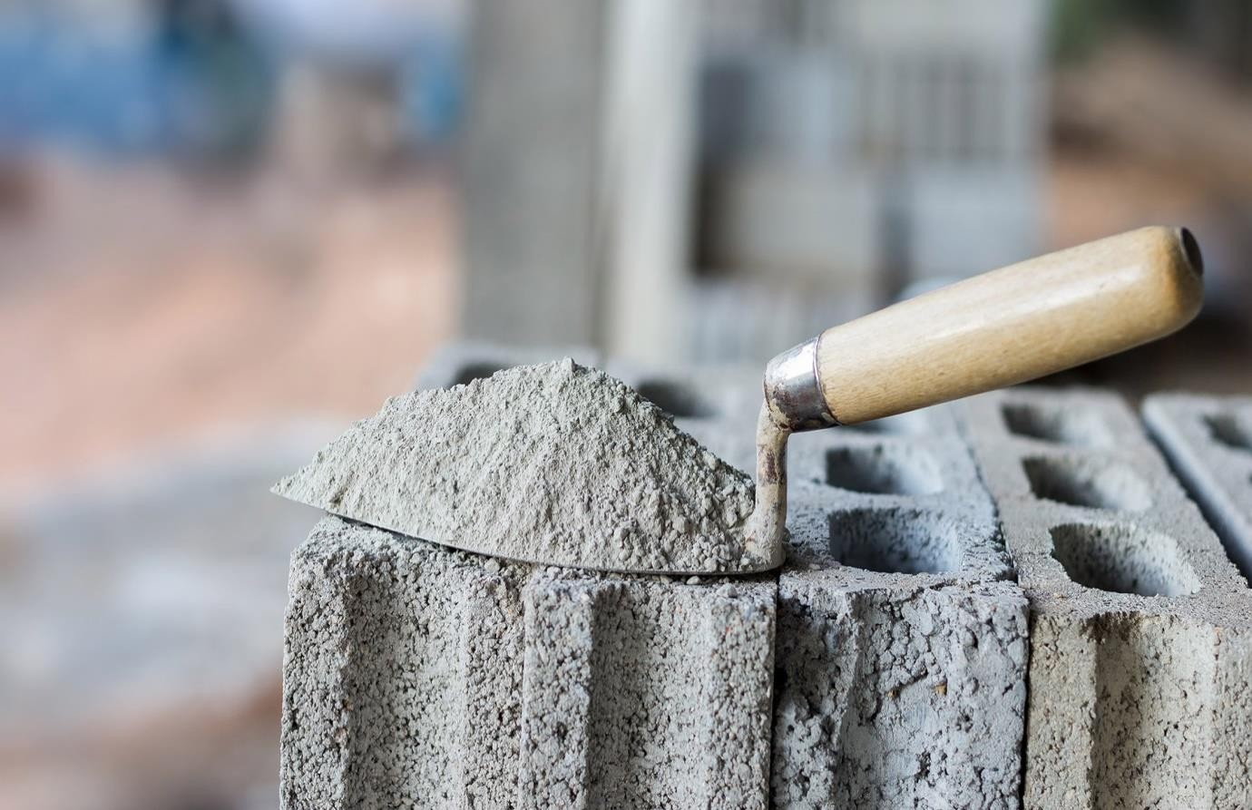

FIGURE: 6 CEMENT

## FINE AGGREGATES-

Fine aggregates are the structural filler that occupies most of the volume of the concrete mix formulas. Depending on composition, shape, size and other properties of fine aggregate you can have a significant impact on the output. The role of fine aggregate can be described in few points:

* + - * Fine aggregates provide dimensional stability to the mixture
      * The elastic modulus and abrasion resistance of the concrete can be influenced with fine aggregate
      * Fine aggregates quality also influence the mixture proportions and hardening properties
      * The properties of fine aggregates also have a significant impact on the shrinkage of the concrete.

Properties of Fine Aggregates

While making the selection for appropriate aggregate to be used in particular concrete mix, few properties needs to be considered, such as:

* + - * Void content: How much amount of cement paste will be required for the mix eventually depends on the empty spaces between the aggregate particles. Always keep in mind that angular aggregates increase the void content, whereas well- graded aggregate and improved grading decreases the void content.
      * Shape and texture: Size and shape greatly influence the quality of the concrete mix. For the preparation of economical concrete mix, you should know that rough- textured, angular, and elongated particles require more water for the formula. However, you will need less water to produce workable concrete when the aggregates are smooth, rounded compact aggregate.
      * Absorption and surface moisture: The fine aggregate density depends on the inside solid material and void content, thus you need to measure the absorption rate prior to ensure how much water will be required in the concrete mixture.
      * Abrasion and skid resistance: In order to minimize the wear in high traffic areas, such as heavy duty floors and pavements you can consider the relative measure when the fine aggregate is rotated in a cylinder along with some abrasive charge.

Grading Zone of Fine Aggregate

A good concrete mix must include aggregates that are clean, hard, strong and free of absorbed chemicals or coatings of clay and other fine materials. Ignorance of these characteristics can cause the deterioration of concrete, thus regulatory authorities have decided grading zone of fine aggregate, where each zone defines the percentage of fine aggregate passed from the 600 microns sieve size:

1. Zone I: 15% to 34%
2. Zone II: 34% to 59%
3. Zone III: 60% to 79%
4. Zone IV: 80% to 100%

You can assess the quality of fine aggregate with help of the grading zones. However, for precise assessment, you can seek help from experts who are well versed in performing tests for bulk density, bulkage, and specific gravity to find the best in class material.



## FIG: 7 FINE AGGREGATES

* + 1. **COARSE AGGREGATES-**

Aggregates are inert granular materials such as sand, gravel, or crushed stone that, along with water and Portland cement, are an essential ingredient in concrete.

For a good concrete mix, aggregates need to be clean, hard, strong particles free of absorbed chemicals or coatings of clay and other fine materials that could cause the deterioration of concrete. Aggregates, which account for 60 to 75 percent of the total volume of concrete, are divided into two distinct categories--fine and coarse. Fine aggregates generally consist of natural sand or crushed stone with most particles passing through a 3/8-inch sieve. Coarse aggregates are any particles greater than 0.19 inch, but generally range between 3/8 and 1.5

inches in diameter. Gravels constitute the majority of coarse aggregate used in concrete with crushed stone making up most of the remainder.

Natural gravel and sand are usually dug or dredged from a pit, river, lake, or seabed. Crushed aggregate is produced by crushing quarry rock, boulders, cobbles, or large-size gravel. Recycled concrete is a viable source of aggregate and has been satisfactorily used in granular subbases, soil-cement, and in new concrete.

After harvesting, aggregate is processed: crushed, screened, and washed to obtain proper cleanliness and gradation. If necessary, a benefaction process such as jigging or heavy media separation can be used to upgrade the quality. Once processed, the aggregates are handled and stored to minimize segregation and degradation and prevent contamination.

Aggregates strongly influence concrete's freshly mixed and hardened properties, mixture proportions, and economy. Consequently, selection of aggregates is an important process. Although some variation in aggregate properties is expected, characteristics that are considered include:

* grading
* durability
* particle shape and surface texture
* abrasion and skid resistance
* unit weights and voids
* absorption and surface moisture

Grading refers to the determination of the particle-size distribution for aggregate. Grading limits and maximum aggregate size are specified because these properties affect the amount of aggregate used as well as cement and water requirements, workability, pumpability, and durability of concrete. In general, if the water-cement ratio is chosen correctly, a wide range in grading can be used without a major effect on strength. When gap-graded aggregate are specified, certain particle sizes of aggregate are omitted from the size continuum. Gap-graded aggregate are used to obtain uniform textures in exposed aggregate concrete. Close control of mix proportions is necessary to avoid segregation.

Shape and Size Matter

Particle shape and surface texture influence the properties of freshly mixed concrete more than the properties of hardened concrete. Rough-textured, angular, and elongated particles require more water to produce workable concrete than smooth, rounded compact aggregate. Consequently, the cement content must also be increased to maintain the water-cement ratio. Generally, flat and elongated particles are avoided or are limited to about 15 percent by weight of the total aggregate. Unit-weight measures the volume that graded aggregate and the voids between them will occupy in concrete.

The void content between particles affects the amount of cement paste required for the mix. Angular aggregates increase the void content. Larger sizes of well-graded aggregate and improved grading decrease the void content. Absorption and surface moisture of aggregate are measured when selecting aggregate because the internal structure of aggregate is made up of solid material and voids that may or may not contain water. The amount of water in the concrete mixture must be adjusted to include the moisture conditions of the aggregate.

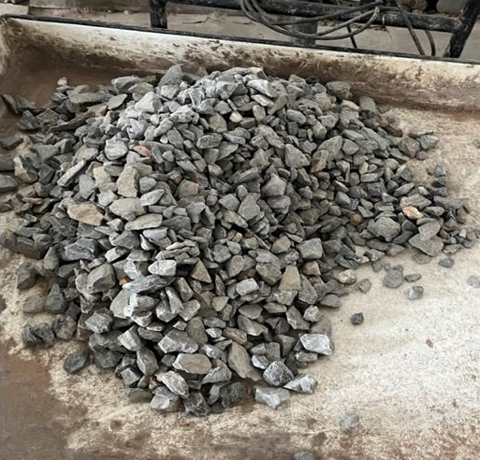Abrasion and skid resistance of an aggregate are essential when the aggregate is to be used in concrete constantly subject to abrasion as in heavy-duty floors or pavements. Different minerals in the aggregate wear and polish at different rates. Harder aggregate can be selected in highly abrasive conditions to minimize wear.

**FIGURE: 8 COARSE AGGREGATES**

## FACE MASKS-

During the [COVID-19 pandemic,](https://en.wikipedia.org/wiki/COVID-19_pandemic) face masks, such as [surgical masks](https://en.wikipedia.org/wiki/Surgical_mask) and [cloth masks,](https://en.wikipedia.org/wiki/Cloth_mask) are employed as a public and personal health control measures against the spread of [SARS-CoV-](https://en.wikipedia.org/wiki/SARS-CoV-2)

[2](https://en.wikipedia.org/wiki/SARS-CoV-2). In community and healthcare settings, their use is intended as [source control](https://en.wikipedia.org/wiki/Source_control_(respiratory_disease)) to limit [transmission](https://en.wikipedia.org/wiki/Transmission_of_COVID-19) of the virus and also for personal protection to prevent infection.[[1]](https://en.wikipedia.org/wiki/Face_masks_during_the_COVID-19_pandemic#cite_note-AR2021-1) Properly worn masks both limit the [respiratory droplets](https://en.wikipedia.org/wiki/Respiratory_droplet) and [aerosols](https://en.wikipedia.org/wiki/Airborne_transmission) spread by infected individuals and help protect healthy individuals from infection.

Masking has proven effective in reducing the transmission of COVID-19. Masks vary in how well they work, with [N95](https://en.wikipedia.org/wiki/N95_respirator) and surgical masks outperforming cloth masks, which are more common due to supply shortages, but even cloth masks, with their variability in fabric type and mask fit, provide wearers with substantial protection from particles carrying COVID-

19. Among readily available fabrics, double-layered cotton, hybrid masks, and cotton flannel perform bestand filtration effectiveness generally improves with thread count. Healthcare workers, given their exposure, are recommended against using cloth masks.

A surgical mask is a loose-fitting, [disposable](https://en.wikipedia.org/wiki/Disposable_product) mask that creates a physical barrier separating the mouth and nose of the wearer from potential [contaminants](https://en.wikipedia.org/wiki/Contamination) in the immediate environment. If worn properly, a surgical mask is meant to help block large-particle [droplets](https://en.wikipedia.org/wiki/Respiratory_droplets), splashes, [sprays,](https://en.wikipedia.org/wiki/Spray_(liquid_drop)) or splatter that may contain viruses and bacteria, keeping them from reaching the wearer's mouth and nose. Surgical masks may also help reduce exposure of others to the wearer's [saliva](https://en.wikipedia.org/wiki/Saliva) and respiratory secretions.

Certified medical masks are made of non-woven material, and they are mostly multi-layer. Filters may be made of [microfibers](https://en.wikipedia.org/wiki/Microfibers) with an electrostatic charge; that is, the fibers are [electrets](https://en.wikipedia.org/wiki/Electret). An electret filter increases the chances that smaller particles will veer and hit a fiber, rather than going straight through (electrostatic capture). While there is some development work on making electret filtering materials that can be washed and reused, current commercially produced electret filters are ruined by many forms of disinfection, including washing with soap and water or alcohol, which destroys the electric charge. During the COVID-19 pandemic, public health authorities issued guidelines on [how](https://en.wikipedia.org/wiki/Mechanical_filter_respirator#Disinfection_and_reuse) [to save, disinfect and reuse electret-filter masks](https://en.wikipedia.org/wiki/Mechanical_filter_respirator#Disinfection_and_reuse) without damaging the filtration efficiency. Standard disposable surgical masks are not designed to be washed. Surgical masks may be labeled as surgical, isolation, dental, or medical procedure masks. The material surgical masks are made from is much poorer at filtering very small particles (in range a tenth

of a micrometer to a micrometre across) than that of filtering respirators (for example N95, FFP2) and the fit is much poorer. Surgical masks are made of a non-woven fabric created using a [melt blowing](https://en.wikipedia.org/wiki/Melt_blowing) process. Random control studies of respiratory infections like [influenza](https://en.wikipedia.org/wiki/Influenza) find little difference in protection between surgical masks and respirators (such as N95 or FFP masks). However, the filtering performance of correctly worn N95/FFP2 type filtering respirators is clearly superior to surgical and to cloth masks and for influenza, work by the UK Health and Safety executive found that live virus penetrated all surgical masks tested but properly fitted respirators reduced the viral dose by a factor of at least a hundred.

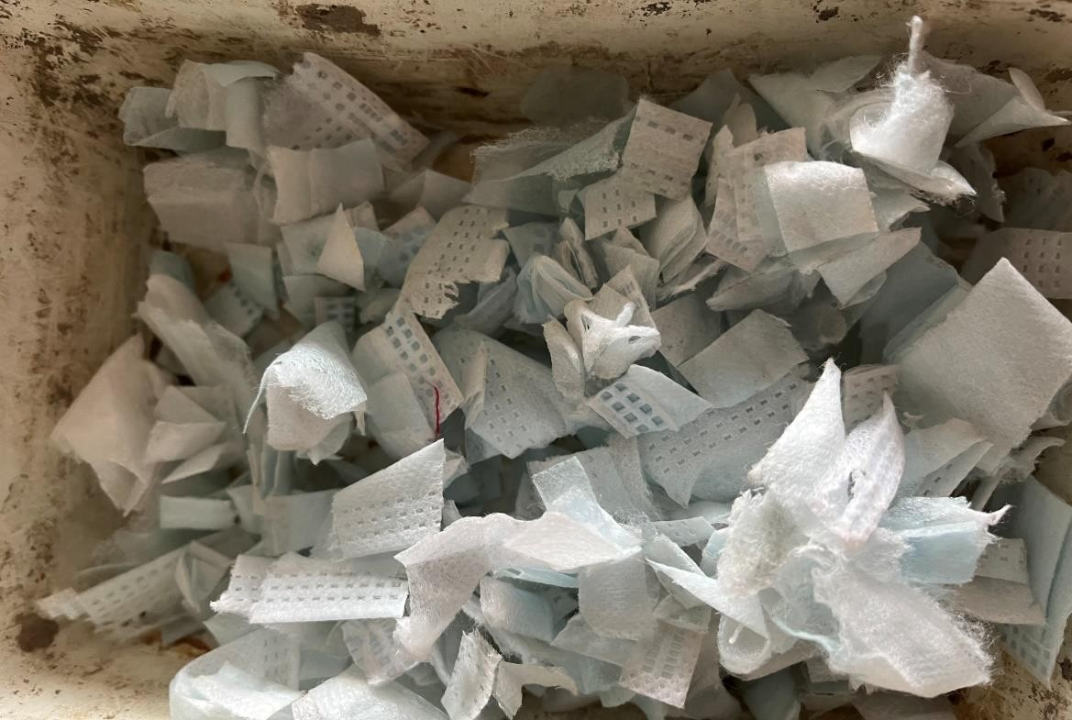Surgical masks made to different standards in different parts of the world have different ranges of particles which they filter. For example, the People's Republic of China regulates two types of such masks: single-use medical masks (Chinese standard YY/T 0969) and surgical masks (YY 0469). The latter ones are required to filter bacteria-sized particles ([BFE](https://en.wikipedia.org/wiki/Bacterial_filtration_efficiency) ≥ 95%) and some virus-sized particles (PFE ≥ 30%), while the former ones are required to only filter bacteria-sized particles.

FIGURE: 9 FACE MASK

## WATER-

Role of Water in Concrete-

Water is the most important & least expensive ingredient of concrete. It plays an important role in mixing, laying, compaction, setting & hardening of concrete.

The strength of concrete depends on the quality & quantity of water used in the mix. The functions of water in the concrete mix are given below:

1. It acts as a lubricant for the fine and coarse aggregate & makes the mixture workable.
2. It acts chemically with cement to form the binding paste.
3. It is employed to damp the aggregate surface in order to prevent them from absorbing water vitally necessary for chemical action.
4. It facilitates the spreading of aggregate.
5. It helps to flux the cementing material over the surface of the aggregate.
6. It enables the concrete mix to flow into moulds.

Quality Of Mixing Water In Concrete

The water to be used for preparing the concrete should fulfil the following requirement.

1. It should be fresh & clean.
2. It should be free from organic impurities injurious amounts of acids or alkalis, hygroscopic, greasy & oily substance.
3. It should be free from iron, vegetable matter, or any other substance which is likely to have an adverse effect on concrete or reinforcement.
4. It should be fit for drinking purpose.
5. The PH value shall generally be between 6 and 8.



FIGURE: 10 WATER

# PROPOSED METHODOLOGY

3x3x3 specimens were chosen for this experiment. A total of 18 cubes were cast 150mm x 150mm x 150mm each. Each batch of concrete will be tested for its COMPRESSIVE STRENGTH. Compressive strength of concrete depends on many factors such as water- cement ratio, cement strength, quality of concrete material, quality control during the production of concrete, etc.

Mix design for the first batch (Batch-A) consisting of cement, fine aggregates, coarse aggregates and water. 9 cubes will be cast for this batch to test compressive strength for 7 days, 14 days and 28 days. An average compressive strength of 3 cubes will take simultaneously on each mentioned day by the following procedure

* 1. Remove the specimen from the water after specified curing time and wipe out excess water from the surface.
  2. Take the dimension of the specimen to the nearest 0.2m
  3. Clean the bearing surface of the testing machine
  4. Place the specimen in the machine in such a manner that the load shall be applied to the opposite sides of the cube cast.
  5. Align the specimen centrally on the base plate of the machine.
  6. Rotate the movable portion gently by hand so that it touches the top surface of the specimen.
  7. Apply the load gradually without shock and continuously at the rate of 140 kg/cm2/minute till the specimen fails
  8. Record the maximum load and note any unusual features in the type of failure.

Similarly, we’ll prepare mix design for the second batch (Batch-B) considering cement, fine aggregates, coarse aggregates, water and shredded disposable face masks in different amount in two different batches. And calculate compressive strength of the following batches.

COMPRESSIVE TEST MACHINE (CTM)-

A [compression testing machine](https://www.safeloadtesting.com/project/compression-tester/) is a testing machine specifically designed to evaluate the resistance of materials and products to compression forces.

Safe Load Testing Technologies has developed the inn Press family, composed of several [Compression Tester](https://www.safeloadtesting.com/project/compression-tester/) models used to perform compression tests, as well as creep performance tests on shipping containers, pallets and load units.

This system allows for the performance of proprietary tests and for compliance with the ASTM, ISTA and ISO 8611 international standards, since the accessories that are required to perform those tests can be included.

In order to perform the tests, the sample is placed on the base of the compress meter and the compression plate moves until it touches the sample, applying the compression forces specified by the technician. Meanwhile, the machine measures the displacement of the compression platen by means of a linear encoder with micrometric precision, and the force with a load cell.

Safe Load TT machines feature intuitive controls which, through the use of a touchscreen, allow for simple test performance and control of all variables.

compressive strength is one of the most important engineering properties of [concrete](https://en.wikipedia.org/wiki/Concrete). It is standard industrial practice that the compressive strength of a given concrete mix is classified by grade. Cubic or cylindrical samples of concrete are tested under a compression testing machine to measure this value. Test requirements vary by country based on their differing design codes. Use of a [Compress meter](https://en.wikipedia.org/wiki/Compressometer) is common. As per Indian codes, compressive strength of concrete is defined as:

The compressive strength of concrete is given in terms of the characteristic compressive strength of 150 mm size cubes tested after 28 days (fck). In field, compressive strength tests are also conducted at interim duration i.e. after 7 days to verify the anticipated compressive strength expected after 28 days. The same is done to be forewarned of an event of failure and take necessary precautions. The characteristic strength is defined as the strength of the concrete below which not more than 5% of the test results are expected to fall.[[11]](https://en.wikipedia.org/wiki/Compressive_strength#cite_note-11)

For design purposes, this compressive strength value is restricted by dividing with a factor of safety, whose value depends on the design philosophy used.

The construction industry is often involved in a wide array of testing. In addition to simple compression testing, testing standards such as ASTM C39, ASTM C109, ASTM C469, ASTM C1609 are among the test methods that can be followed to measure the mechanical properties of concrete. When measuring the compressive strength and other material properties of concrete, testing equipment that can be manually controlled or servo-controlled may be selected depending on the procedure followed. Certain test methods specify or limit the loading rate to a certain value or a range, whereas other methods request data based on test procedures run at very low rates.

A compression testing machine can be used to access essential information to determine whether a product package system is ready for release to the real-world distribution cycle.

Compressive testing is typically applied to materials such as plastics, metals, ceramics, or corrugated cardboard since their ability to withstand these forces will be essential during shipping, handling and storage.

In the case of packaging, it is tested against the typical compression forces of the distribution cycle. One example is the implementation of these testing methods to corrugated boxes that will be stacked during storage or transportation.

Compression testing can be implemented to obtain two types of results:

* To obtain the maximum resistance to compression:

This involves using a compression testing machine to obtain the value at which the system starts to fail. In the case of the more fragile materials, this happens when the product breaks. On the other hand, in products with high ductility, the result of the test is a deformation percentage based on the dimensions of the material.

* To comply with [international standards](https://www.safeloadtesting.com/shipping-test-standards/):

Certain standards by organizations such as ASTM, ISTA and ISO include a compression test among their testing protocols. In this case, each standard will outline the desired end result and the manner in which the simulation is to be performed.

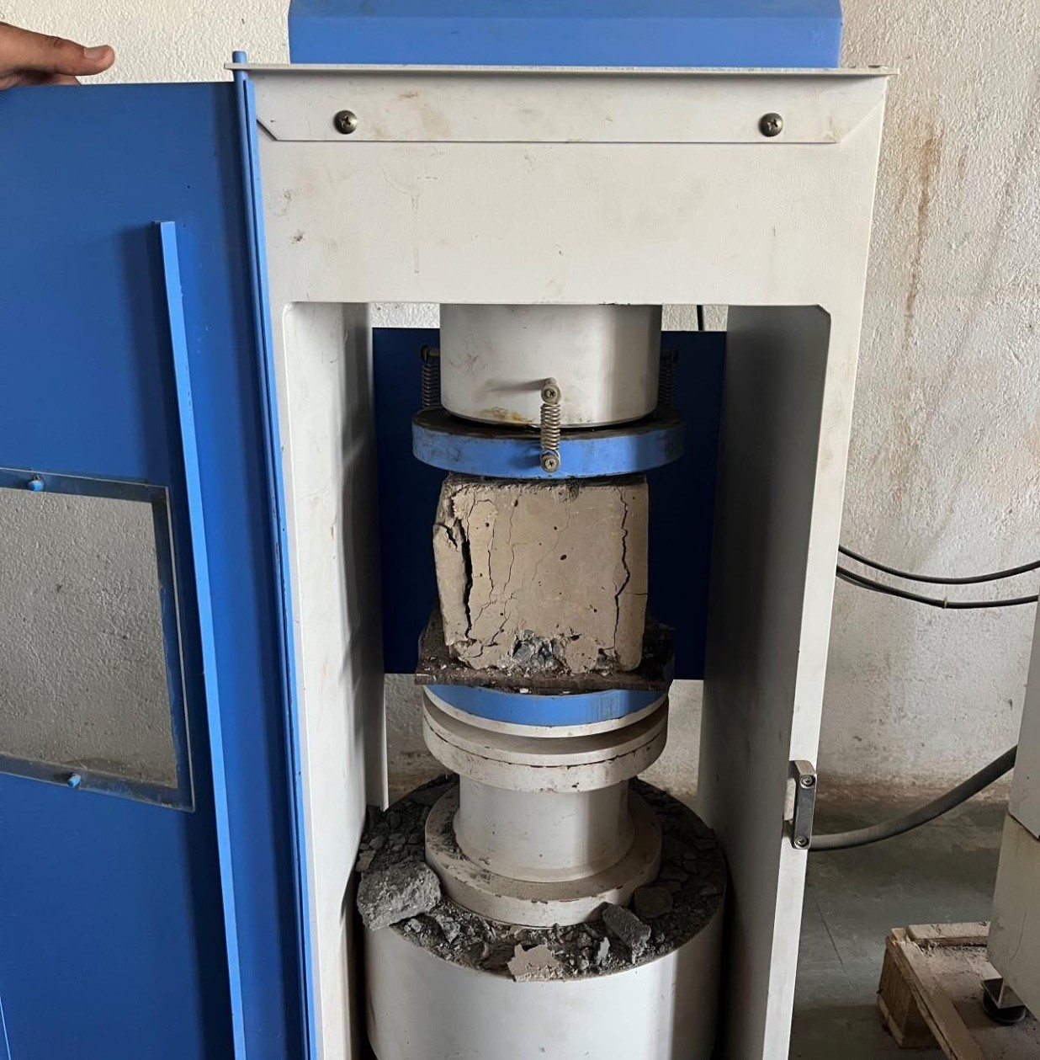

FIGURE:11 CTM MACHINE

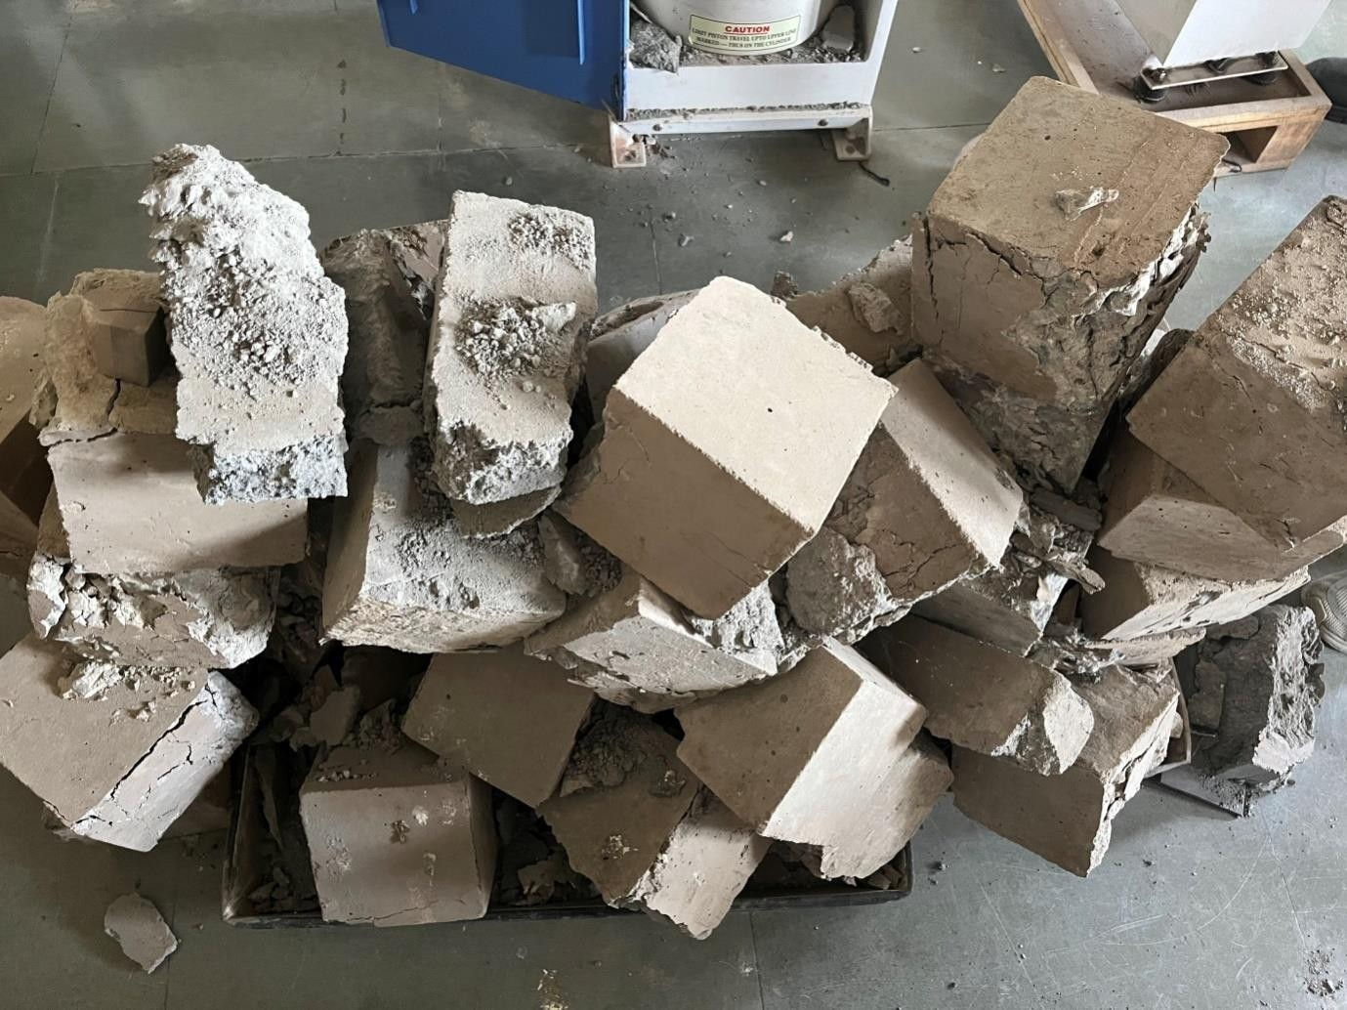

FIG: 12 CONCRETE BLOCKS AFTER TESTING

# CHAPTER: 5

# RESULT AND DISCUSSION

COMPRESSIVE STRENGTH OF M25 CONCRETE AFTER 7 DAYS:

The compression strength at 7 days of curing for constructed concrete cube is obtained as 16.25N/mm^2.

The compression strength at 7 days of curing for constructed concrete cube containing fibre is obtained as 20.54N/mm^2.

COMPRESSIVE STRENGTH OF M25 CONCRETE AFTER 14 DAYS:

The compression strength at 14 days of curing for constructed concrete cube is obtained as 22.5N/mm^2.

The compression strength at 14 days of curing for constructed concrete cube containing fibre is obtained as 24.27 N/mm^2.

COMPRESSIVE STRENGTH OF M25 CONCRETE AFTER 28 DAYS:

The compression strength at 28 days of curing for constructed concrete cube is obtained as 27.8N/mm^2.

The compression strength at 28 days of curing for constructed concrete cube containing fibre is obtained as 30.56 N/mm^2.

# RECOMMENDATION

* + 1. **USE OF CONCRETE CONTAINING FACE MASKS**

1. It’s an important building product. Concrete is chosen over wood as a construction material.
2. It is a durable and cost-effective material which is a necessity for underground use.
3. Concrete is a sustainable choice for residential and commercial projects.
4. The strength of concrete increases over time.
5. Concrete can hold up against weather condition and is easy to maintain.
6. It is budget friendly to use everywhere. It is easy to repair & energy efficient.
7. Concrete is safe for building occupants.
8. Concrete is an inert material which doesn’t burn, mildew or feed rot.
9. Its superior structural integrity provides added degree of protection from the severe weather as well as an earthquake.
10. Concrete walls and floors make a home quite place of rest, relaxation and rejuvenation.
11. Concrete is produced from locally available materials and leaves a small environmental footprint while still providing high-level durability.
12. It is used as [aggregate](https://civiltoday.com/civil-engineering-materials/aggregate) in roadbeds or as granular materials while making new concrete.
13. Concrete is fire resistant. It can resist extreme level of flames and heat which is a good choice of the ceiling in a storage room.
14. Concrete can be shaped in various forms when freshly mixed.
15. Concrete isn’t sensitive to moisture.
16. It doesn’t release any volatile organic compounds into the air which is environment- friendly.
17. Concrete gives a longer service life.
18. It keeps home safe from insects. It doesn’t attract insect pest and rodents. That’s why small animals cannot burrow through the concrete to make a home.
19. Concrete has multiple design possibilities.
20. Concrete can be used to achieve optimum environmental performance.
21. As it is recyclable, it is possible to use it for addition.
22. High-performance concrete is used to build bridges.
23. Concrete is able to accommodate [steel](https://civiltoday.com/civil-engineering-materials/steel) reinforcements in gates, tunnel lines, electrical controls.
24. A concrete floor can be stamped to create an attractive surface. It can admit natural light during the day and transmit artificial light after work.
25. Concrete is used in driveways and patios.

# RECOMMENDATION OF FUTURE WORK

The following are recommendation for the future work:

1. Better study with the composition of mask % used in concrete
2. Evaluation of other methods and addition of other fibres and admixture to increase the strength of concrete.
3. To study the use of face mask in different construction materials.

# References

Torkashvand, J.; Jafari, A.J.; Godini, K.; Kazemi, Z.; Kazemi, Z.; Farzadkia, M. Municipal solid waste management during COVID-19 pandemic: A comparison between the current activities and guidelines. J. Environ. Health Sci. Eng. 2021, 19, 173–179.

Hantoko, D.; Li, X.; Pariatamby, A.; Yoshikawa, K.; Horttanainen, M.; Yan, M. Challenges and practices on waste management and disposal during COVID-19 pandemic. J. Environ. Manag. 2021, 286, 112140

Allison, A.L.; Ambrose-Dempster, E.; Bawn, M.; Casas Arredondo, M.; Chau, C.; Chandler, K.; Dobrijevic, D.; DomenechAparisi, T.; Hailes, H.C.; Lettieri, P.; et al. The impact and effectiveness of the general public wearing masks to reduce the spread of pandemics in the UK: A multidisciplinary comparison of single-use masks versus reusable face masks. UCL Open Environ. 2020WHO. Shortage of Personal Protective Equipment Endangering Health Workers Worldwide.2020; News Release. Available online: [https://www.who.int/news/item/03-03-2020-shortage-of-personal-protective-](https://www.who.int/news/item/03-03-2020-shortage-of-personal-protective-equipment-endangering-health-workers-worldwide) [equipment-endangering-health-workers-worldwide](https://www.who.int/news/item/03-03-2020-shortage-of-personal-protective-equipment-endangering-health-workers-worldwide) (accessed on 20 January 2022).

Aragaw, T.A. Surgical face masks as a potential source for microplastic pollution in the COVID-19 scenario. Mar. Pollut. Bull. 2020, 159, 111517. [Google Scholar] [[CrossRef](https://doi.org/10.1016/j.marpolbul.2020.111517)] Roberts, K.P.; Bowyer, C.; Kolstoe, S.; Fletcher, S. Coronavirus Face Masks: An Environmental Disaster that Might Last Generations. The Conversation. 2020. Available online: [https://theconversation.com/coronavirus-face-masks-an-environmental-disaster-](https://theconversation.com/coronavirus-face-masks-an-environmental-disaster-that-might-last-generations-144328) [that-might-last-generations-144328](https://theconversation.com/coronavirus-face-masks-an-environmental-disaster-that-might-last-generations-144328) (accessed on 17 November 2020).

Fadare, O.O.; Okoffo, E.D. COVID-19 face masks: A potential source of microplasticfibers in the environment. Sci. Total Environ. 2020

Chowdhury, H.; Chowdhury, T.; Sait, S.M. Estimating marine plastic pollution from COVID-19 face masks in coastal regions. Mar. Pollut. Bull. 2021

Neto, H.G.; Bantel, C.G.; Browning, J.; Della Fina, N.; Ballabio, T.A.; de Santana, F.T.; Britto, M.d.K.e.; Barbosa, C.B. Mortality of a juvenile Magellanic penguin (Spheniscusmagellanicus, Spheniscidae) associated with the ingestion of a PFF-2 protective mask during the COVID-19 pandemic. Mar. Pollut. Bull. 2021

Torres-Agullo, A.; Karanasiou, A.; Moreno, T.; Lacorte, S. Overview on the occurrence of microplastics in air and implications from the use of face masks during the COVID-19 pandemic. Sci. Total Environ. 2021,

Liao, Z.; Ji, X.; Ma, Y.; Lv, B.; Huang, W.; Zhu, X.; Fang, M.; Wang, Q.; Wang, X.; Dahlgren, R.; et al. Airborne microplastics in indoor and outdoor environments of a coastal city in Eastern China. J. Hazard. Mater. 2021

Ma, J.; Chen, F.; Xu, H.; Jiang, H.; Liu, J.; Li, P.; Chen, C.C.; Pan, K. Face masks as a source of nanoplastics and microplastics in the environment: Quantification, characterization, and potential for bioaccumulation. Environ. Pollut. 2021, 288, 117748.

Singh, N.; Tang, Y.; Ogunseitan, O.A. Environmentally Sustainable Management of Used Personal Protective Equipment. Environ. Sci. Technol. 2020

Haque, M.S.; Uddin, S.; Sayem, S.M.; Mohib, K.M. Coronavirus disease 2019 (COVID- 19) induced waste scenario: A short overview. J. Environ. Chem. Eng. 2020, 9, 104660.

Sangkham, S. Face mask and medical waste disposal during the novel COVID-19 pandemic in Asia. Case Stud. Chem. Environ. Eng. 2020

Torres, F.G.; De-la-Torre, G.E. Face mask waste generation and management during the COVID-19 pandemic: An overview and the Peruvian case. Sci. Total Environ. 2021.