
AN INDUSTRIAL TRAINING REPORT
ON
“NEW BUILDING CONSTRUCTION AT TECHNO NJR”
SUBMITTED IN PARTIAL FULFIMENT OF THE REQUIREMENT FOR THE AWARD OF THE BECHLOR DEGREE
BECHLOR OF TECHNOLOGY
IN
CIVIL ENGINEERING

SUBMITTED TO:
MR. RAKESH YADAV (CO-ORDINATOR)
(DEPARTMENT OF CIVIL ENGINEERING)

TECHNO INDIA NJR INSTITUTE OF TECHNOLOGY
PLOT SPL-T, RIICO INDUSTRIAL AREA, KALADWAS, UDAIPUR 313004
RAJASTHAN TECHNICAL UNIVERSITY, KOTA

ABSTRACT
The internship report is broad spectrum contains six chapter in which I try to explain my days experience at Techno India NJR construction site. The content of all chapters is broadly explained and constructed from the practical basis of the site work enrolled all days.

In the opening chapter, I gives details about the construction site including its mission, vision and the activities those runs throughout the construction. In this chapter, I put all record, history, and facility of the constructing building with its official address. Therefore, it gives the whole introduction of the construction site.

The second chapter is about the design of the building. In which we provide the all details about the design perspective like the architectural plan, structural plan, 3D elevation, location of the site etc.,

After all next chapter are about the component, which are constructed on the site. As per IS codal provisions, we have accounted all-important features of the buildings. We also mention the all laboratory test as per the IS code.

The final chapter explains the conclusion of the internship training done.

ACKNOWLEDGEMENT
Success is epitome of hard work, cogency for fulfilling the mission, indefatigable perseverance and most of all encouraging guidance and steering.
We express our sincere thanks to, Mr. RS Vyas, director of techno India NJR, for the support and motivation provided to us. It gives us an immense pleasure to express our gratitude to Mr. Rakesh Yadav, Head of Department of Civil Engineering and Associate Prof.
Mr. Bhupendra Purohit, for their esteemed guidance and able supervision during this project. Their constant encouragement and co-operation made this project a success. This training would not have been successfully completed without the guidance and support of Mr. Rakesh Yadav sir and the entire Associates Team. We are deeply indebted to the project team members who were always ready to help us during project time.

UJJWAL JAIN
STUDENT, III YEAR CIVIL ENGINEERING

CONTENTS
- Introduction
- Project overview
- Features of the project
- Location of project
- Designs Of Building
- Architectural plan
- Structural design
- 3D Elevation
- Building Components
- Introduction
- Foundation
- Column
- Stone masonry
- Soiling And PCC
- Plinth beam
- Beams
- Slab
- Pool design
- Plan and Pool wall design
- Levels
- Laboratory Test
- Silt content test
- Gradation test
- Flakiness index test
- Slump test
- Compression strength test
- Impact test
- Quantity survey
- BOQ
- Conclusion

CHAPTER -1
INTRODUCTION
- Project Overview
- Name Of Project : New Building Construction At Techno NJR
- Location Of Site : RIICO Industrial Area, Kaladwas, Udaipur(Rajasthan)
- Project Start : 26 May 2021
- Area : 4900 SQFT Exclude Pool
- Estimate cost : Approx. 75 lacs
- Features Of The Project
We choose the l shaped design of the building. In which a wonderful pool is also provided. The building has also an open wide space. In this design we have unlimited possibilities for development and customization.
- Location Of The Site

Figure: 1 Location of the site
CHAPTER – 2
DESIGN OF BUILDING
- Architectural Plan

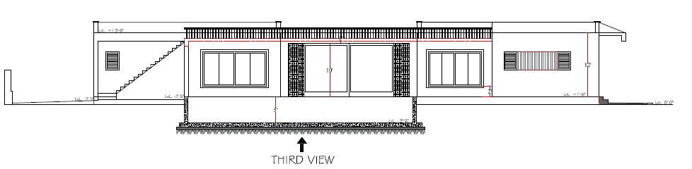
Figure: 2 Plans and Elevation of Building
- Structural Design
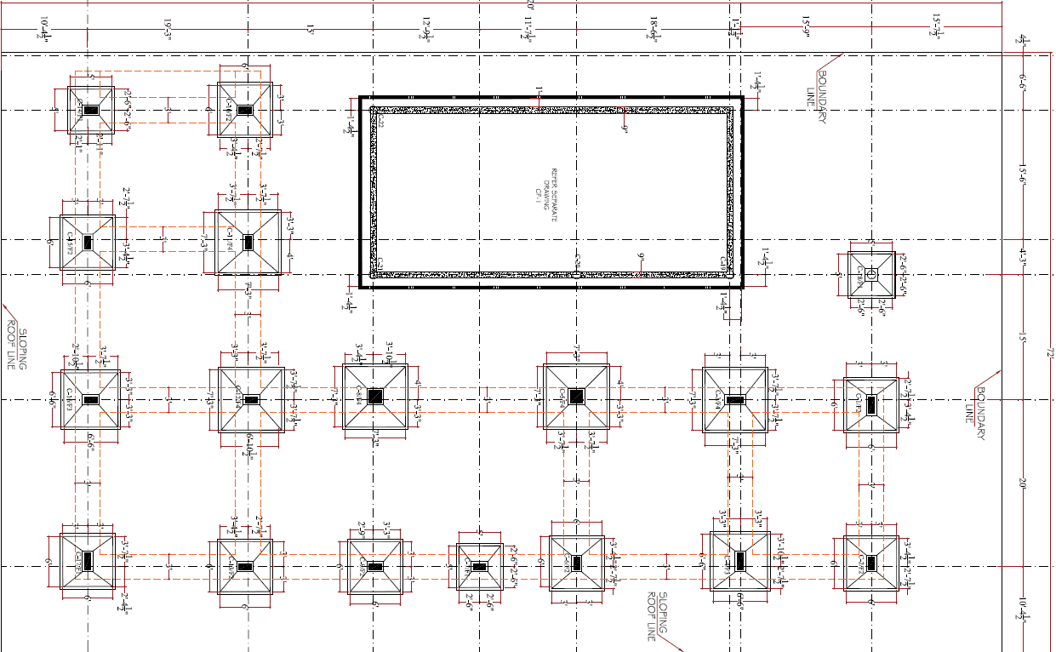
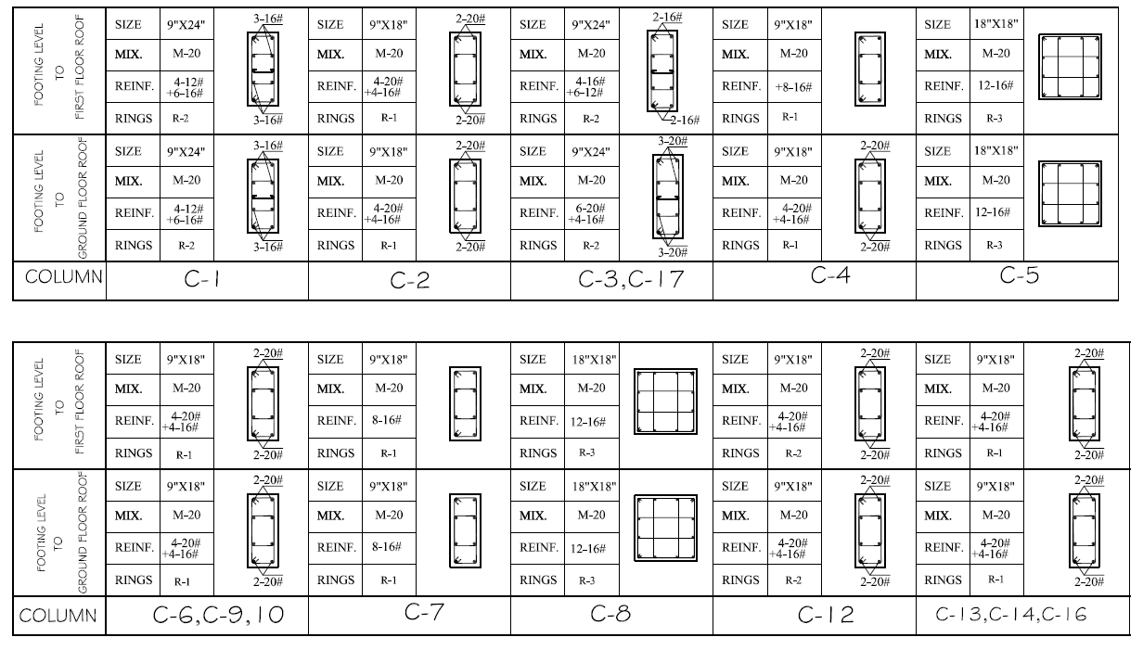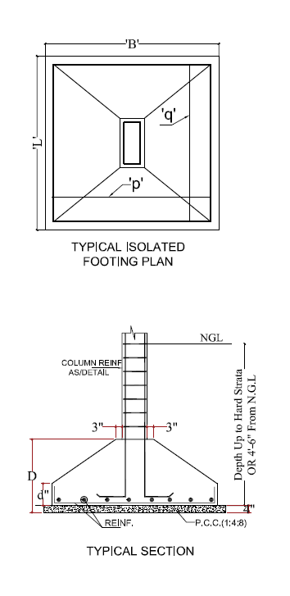
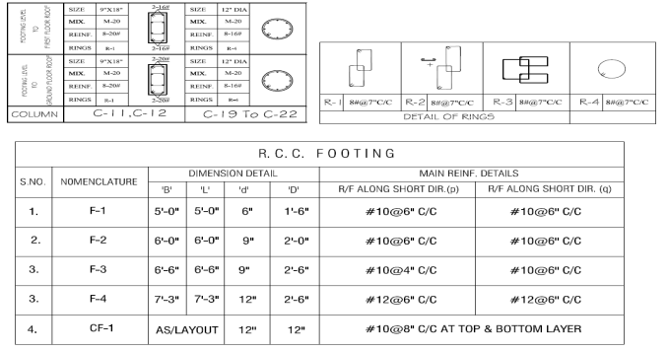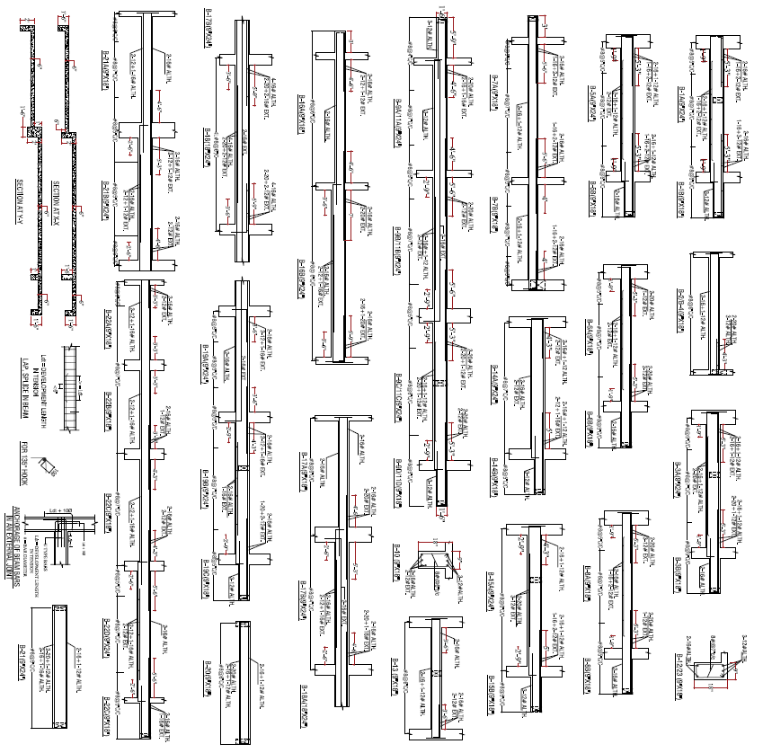

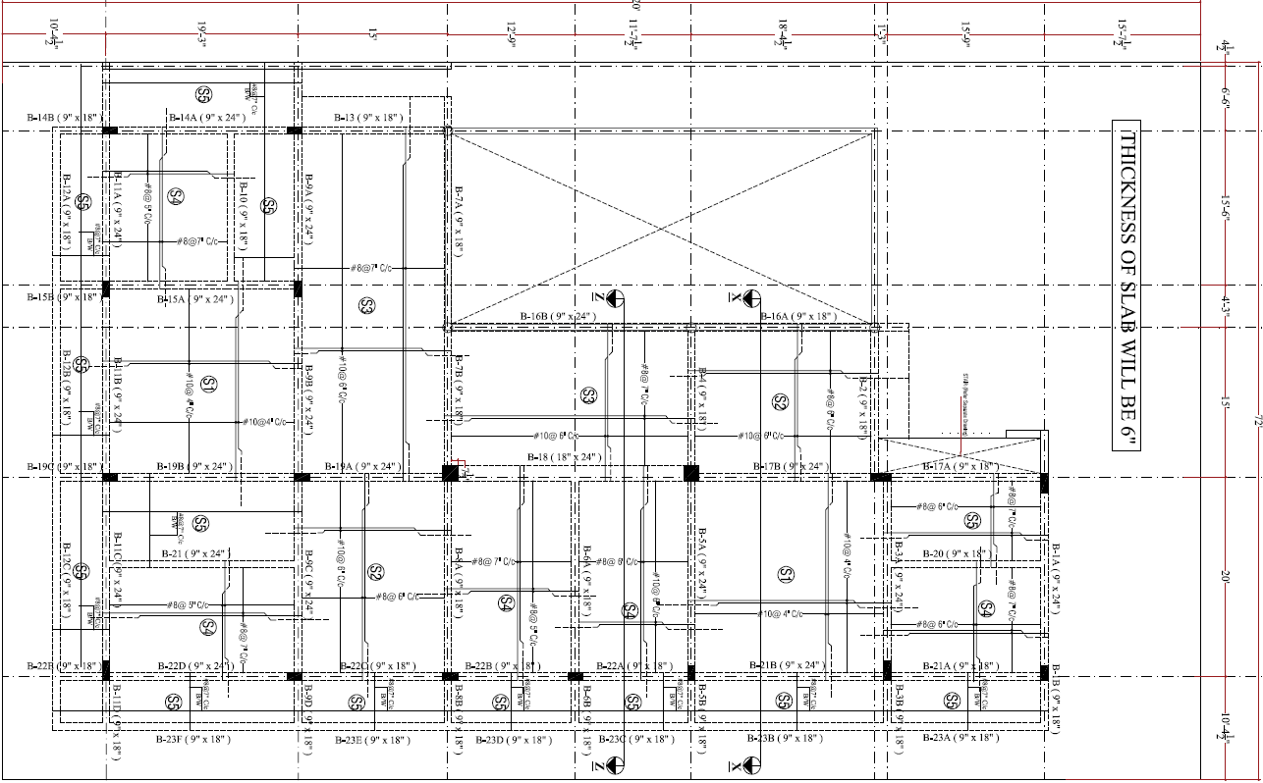
Figure: 3 Structural Details of Rc building

Figure: 4 Three Dimensional View of building
CHAPTER – 3
BUILDING COMPONENTS
- Foundation
Introduction
Foundation is an important part of the structure, which transfers the load of the structure to the foundation soil. The foundation distributes the load over a large area. Therefore, that pressure on the soil does not exceed its allowable bearing capacity and restricts the settlement of the structure within the permissible limits. Foundation increases the stability of the structure. The settlement of the structure should be as uniform as possible and it should be within the tolerable limits.
Main Functions of foundations
      - Distribution of loads
      - Stability against sliding & overturning
      - Minimize differential settlement
      - Safe against undermining
      - Provide level surface
      - Minimize distress against soil movement
Different types of Foundations
Foundations are mainly classified into two types:
            - Shallow Foundations
            - Deep foundations
Shallow Foundation
Shallow foundations are further classified into the following types:
1. Spread footing / isolated footing
2. Combined footing
3. Strap footing
4. Grillage foundations
5. Raft foundations
Deep Foundation
Deep foundation is further classified into following types:
- Basements
- Buoyancy rafts (hollow box foundations)
- Caissons
- Cylinders
- Shaft foundations
- Pile foundations
Isolated Footing
An isolated footing is one of the most used types of foundation to support single-columns when they are arranged at a long distance.
An isolated footing must be designed to avoid exceeding its bearing capacity and provide safety against overturning or sliding while preventing the ground from settling. Isolated footing must be applied when the mechanical properties of the ground do not drastically change in the foundation area. It consists the financially most beneficial kind of foundation.
The categories of isolated foundation footings are the following:
1. Pad Footing
A pad or flat isolated footing is constructed by plain or reinforced concrete. Its thickness is constant and its shape can be circular, rectangular or square. It is economic and requires less excavation but its size is highly depended on the load and it is less resistant in lateral forces.
2. Sloped Footing
Sloped isolated footing requires less concrete and reinforcements bars than pad footing. It is constructed cautiously in order to maintain a 45-degree inclination from all sides. The concrete mix used must be stiff in order to avoid sustaining viscous deformation.
3. Stepped Footing
This type of footing includes the construction of a footing step by step until it reaches the desired width. This technique is mostly used in residential buildings but its utilization has been decayed over the last decades.
In our project we have used isolated trapezoidal footing. We construct following sizes of footing:
      - F1 = 5’ X 5’
      - F2 = 6’ X 6’
      - F3 = 6.5’ X 6.5’
      - F4 = 7.25’ X 7.25’
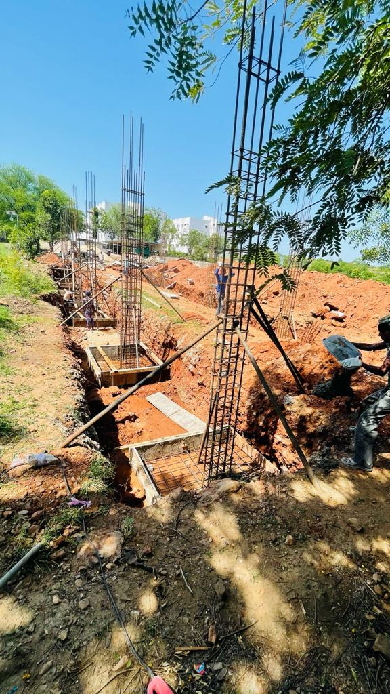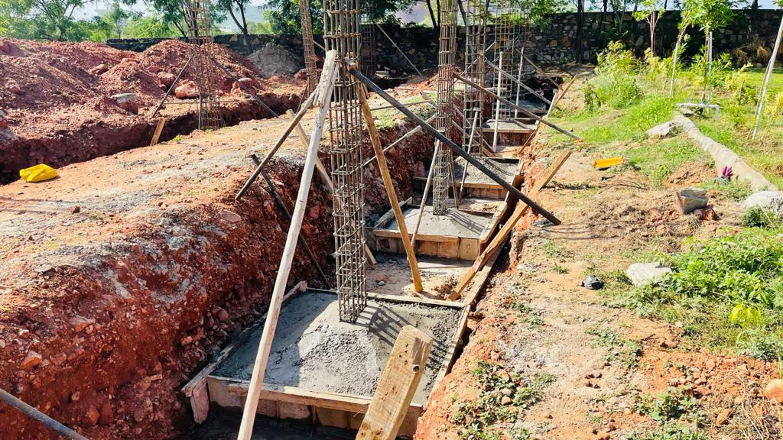
Figure: 5 Isolated Footing casting
- Column
Columns are defined as vertical load-bearing members supporting axial compressive loads chiefly. This structural member is used to transmit the load of the structure to the foundation. In reinforced concrete buildings beams, floors, and columns are cast monolithically. The bending action in the column may produce tensile forces over a part of cross-section. Still, columns are called compression members because compressive forces dominate their behavior.
Sizes used for column in our project:
1. C-1(18” X 18”)
2. C-2 (9” X 18”)
3. C-3 (9” X 24”)

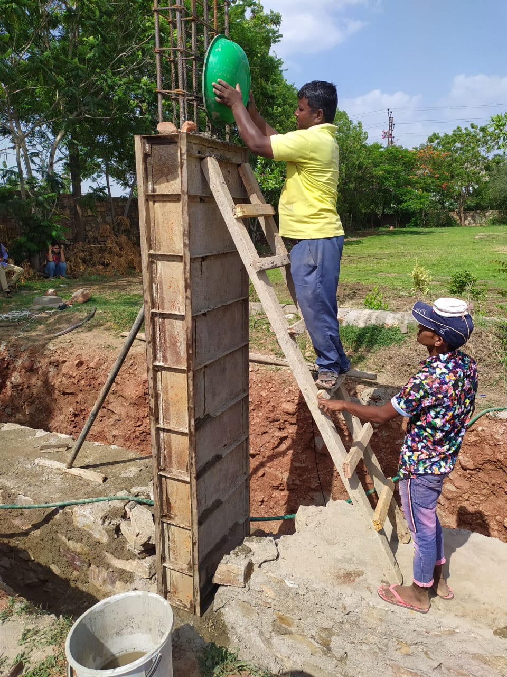
Figure: 6 RC Column casting at Site
- Stone Masonry
Stone masonry is a type of building masonry construction that uses stones and mortar. This construction technique is used for building foundations, floors, retaining walls, arches, walls and columns. The stones used for masonry construction are natural rocks. These natural rocks are cut and dressed into proper shape in order to use it in masonry construction. Stones are one of the most durable and strong building materials.
The materials used for stone masonry are:
1. Stones
2. Mortar
1. Stones
The stones used for masonry construction must be hard, tough and free from cracks, sand holes, and cavities. The selection of stone for particular work is dependent on the availability of the stone and the importance of the structure. The common stones used for masonry construction are limestone, sandstone, granite, marble, laterite, etc.

2. Mortar
The binding material used for masonry construction is the mortar. Cement or lime with sand and water from the mix for masonry mortar. The mix formed is uniform in nature. The two main factors affecting the selection of mortar for masonry are:
- Strength required
- Color of the stone
- The loads coming on the structure

Classification of Stone Masonry
- Rubble Masonry
- Ashlars Masonry

Rubble Masonry
This is the stone masonry type where stones employed are either undressed or roughly dressed. These masonry constructions do not have a uniform thickness. The strength of the rubble masonry is dependent on the:
- Quality of Mortar Used
- Use of Long through stones
- Proper filling of mortar between the stone spaces and joints
In our construction we used rubble masonry for the foundation wall work. We used sedimentary rock as stone.
The wall was constructed in three beds with different width. The width was arranged higher width to lower width by bottom to top.
The dimension of the walls in our project was following:
Width of Bed 1 = 3 feet
Width of Bed 2 = 2 feet
Width of Bed 3 = 1.5 feet

;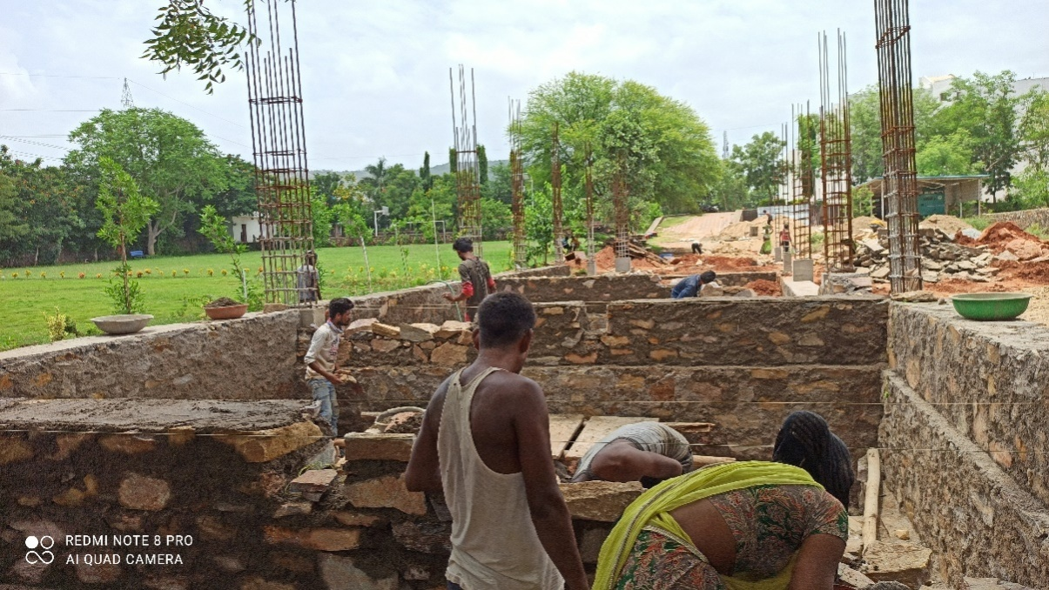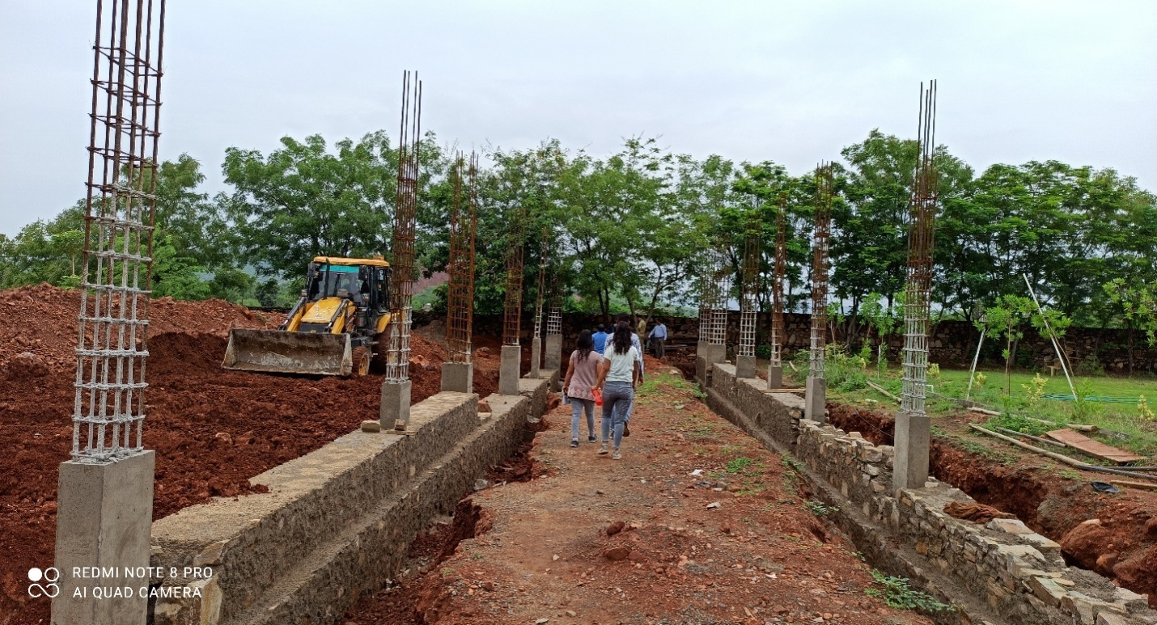
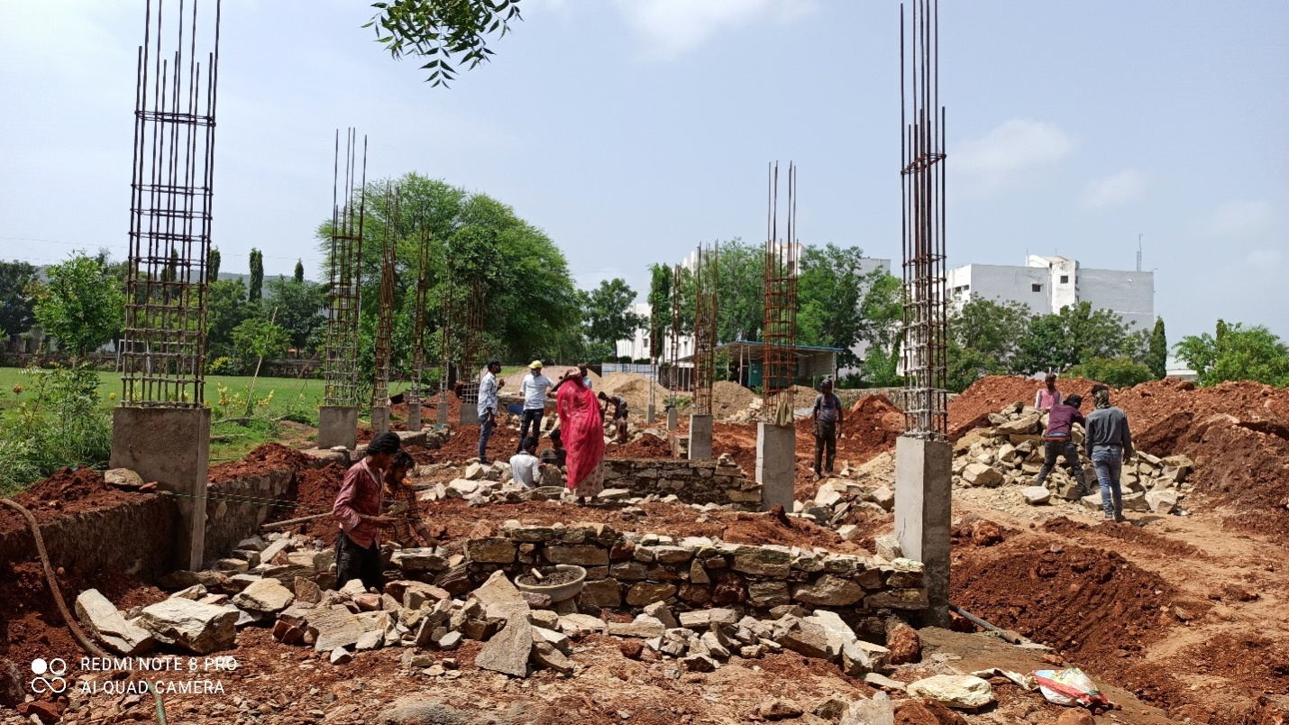
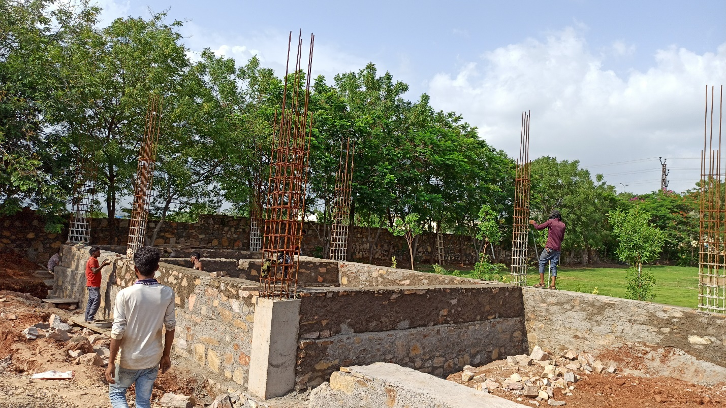
Figure: 7 Stone masonry work at site
- Soling And PCC
Soling:
Soling is the process of hand packing rubble stones one adjacent to another, to provide a stable base to the foundation and footing, before concreting work. Rubble or boulder soling is done to enhance the bearing capacity of the soil, where hard strata are not available.
PCC:
The term PCC refers to Plain Cement Concrete. PCC is the mixture of cement, fine aggregate (sand), and coarse aggregate without reinforcement. PCC Concrete is spread on the soil surface before concreting maid structure to avoid direct contact of reinforcement of concrete with soil and water.
In our project we provide 1feet depth of soling and provide 4” depth of the PCC.
The ratio used for PCC was 1:4:8, Here 1 is cement, 4 is sand and 8 is aggregate.
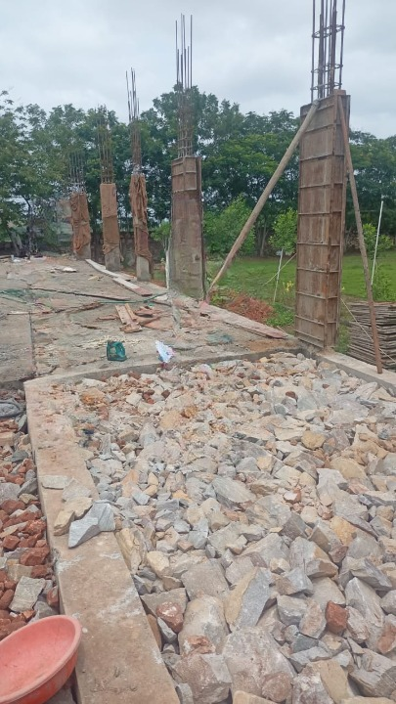
Figure: 8 Soling and Plain Cement Concrete at ground floor

- Plinth Beam
Plinth Beams are constructed between the foundation and walls and are reinforced concrete beams, these beams are provided when the foundation suffers from settlement to prevent the expansion or spread of cracks in the wall from the foundation and the foundation but these beams distribute the load of a wall.
In this project beam is provided in size of 9” X 12” inches

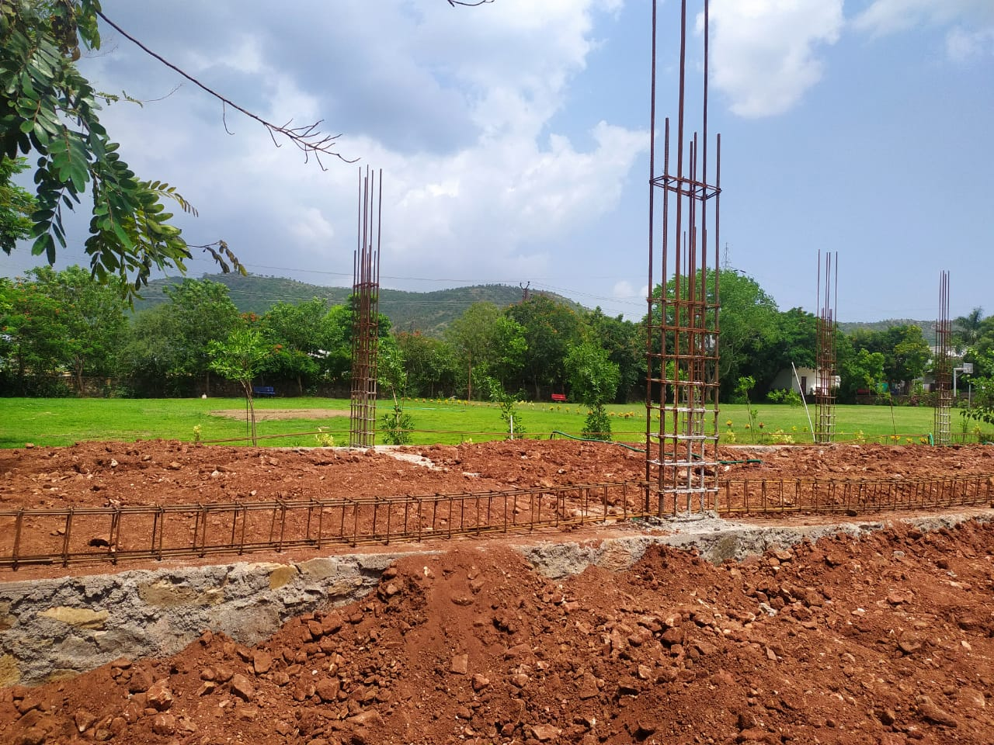
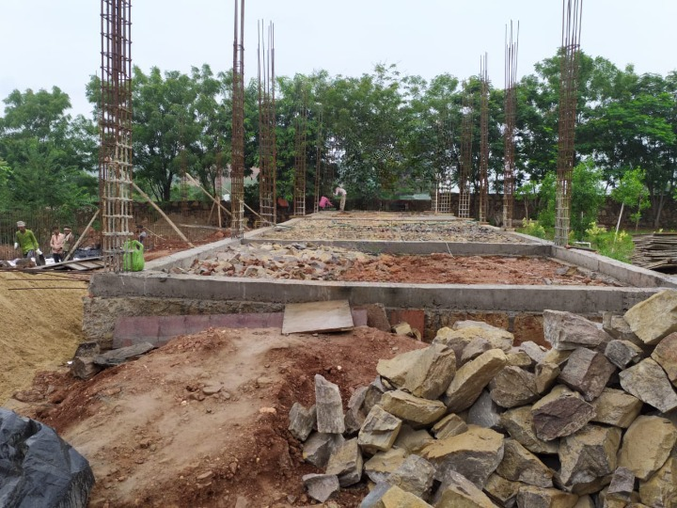
Figure: 9 Casting of Plinth Beam
- Slab And Beam
Slab:
Slab is an important structural element which is constructed to create flat and useful surfaces such as floors, roofs, and ceilings. It is a horizontal structural component, with top and bottom surfaces parallel or near so. Commonly, beams, columns (concrete or steel), walls, or the ground supports slabs. The depth of a concrete slab floor is very small compared to its span.

Types of Loads on a Slab
Types of loads acting on a slab include:
- Dead load of the slab
- Live load
- Floor finish load
- Snow load in the case of roof slab
- Earthquake loads

Load Transfer Mechanism in Slabs
The forces transfers from slab to beams occur either in one way or in two ways. The total system completely counts on the geometrical dimensions of the slab. Slabs may be supported by columns only, in this case two ways action will prevail. If the ratio Long side / short side < 2 it is considered as 2-way slab, and if Longer side to shorter side greater than 2 then it is considered as 1-way slab. The load transfer mechanism from floor slab to supporting elements for one way slab and two way slabs are shown in Fig. 2 and Fig. 3. Lastly, Fig. 4 illustrates the transfer of loads from slabs to different types of supporting elements.
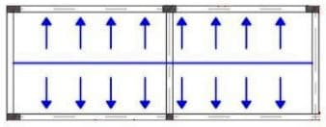
Figure 10: Load distribution mechanism from one way slab to supporting member

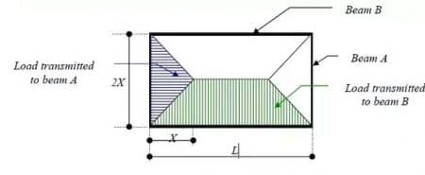
Figure 11: Load distribution mechanism from slab to beams or other supporting elements
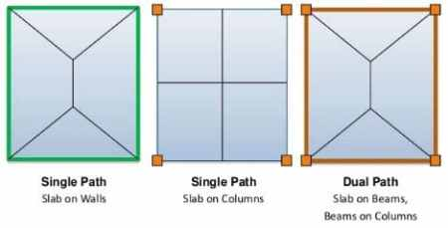
Figure 12: Transfer of loads from slab to different types of supporting members

Figure 13: Reinforcement work at ground floor
CHAPTER 4
POOL DESIGN
  - Plan And Wall Design
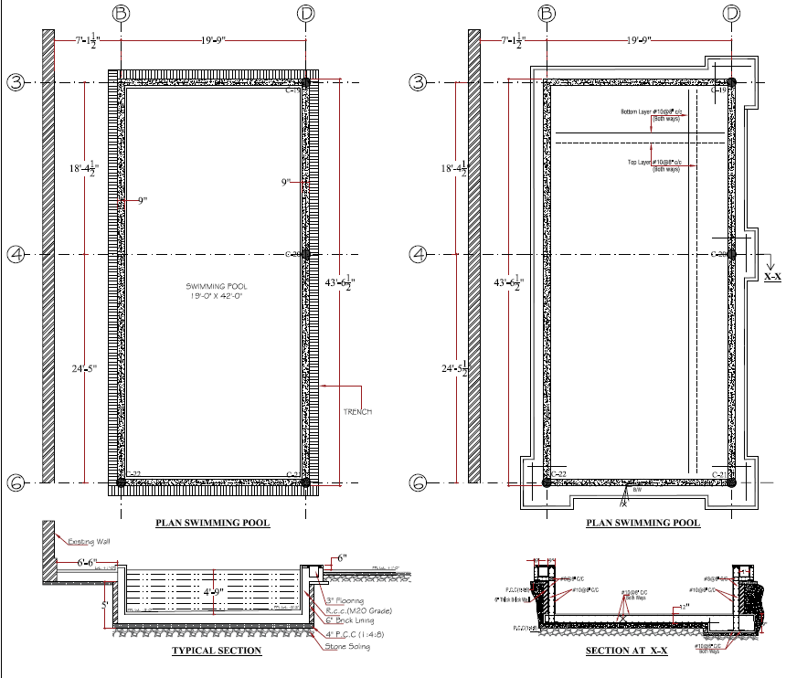

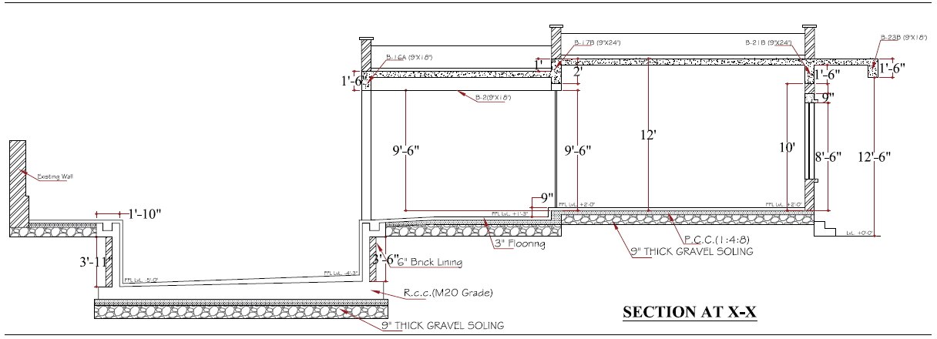

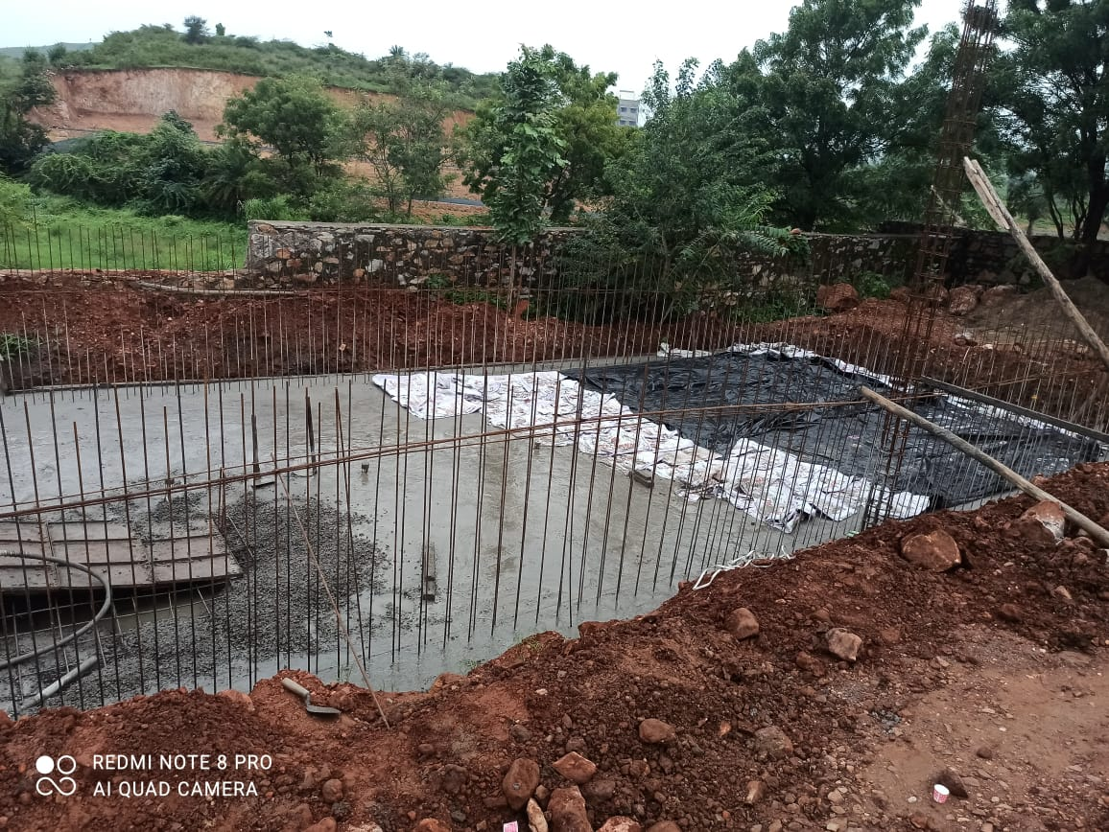
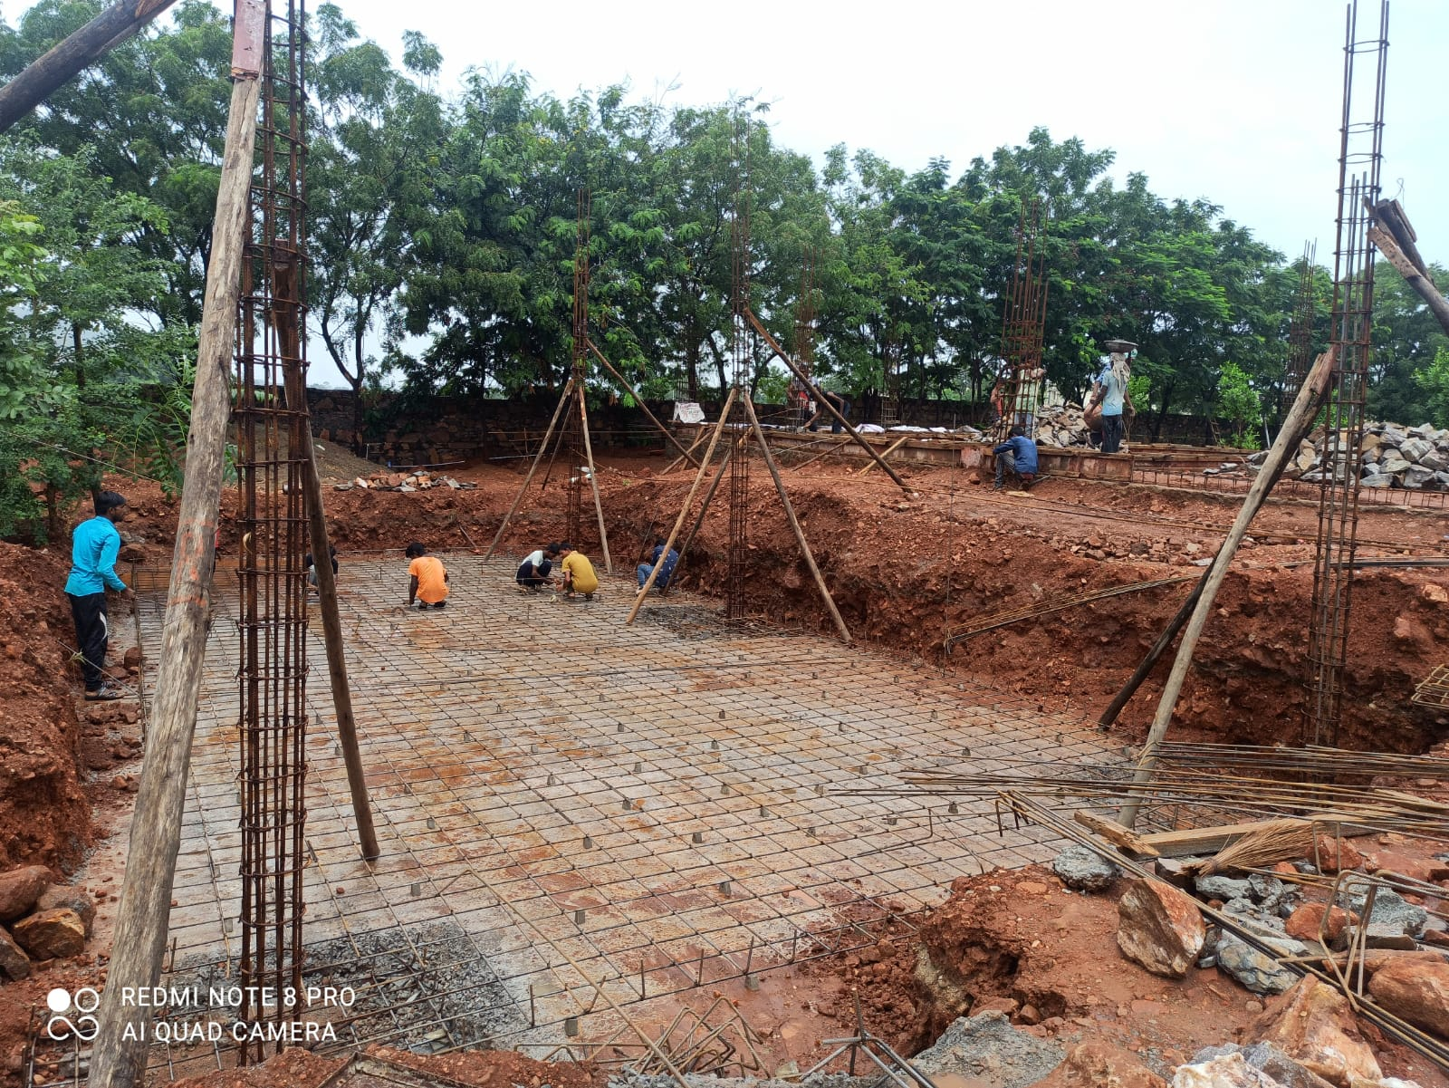
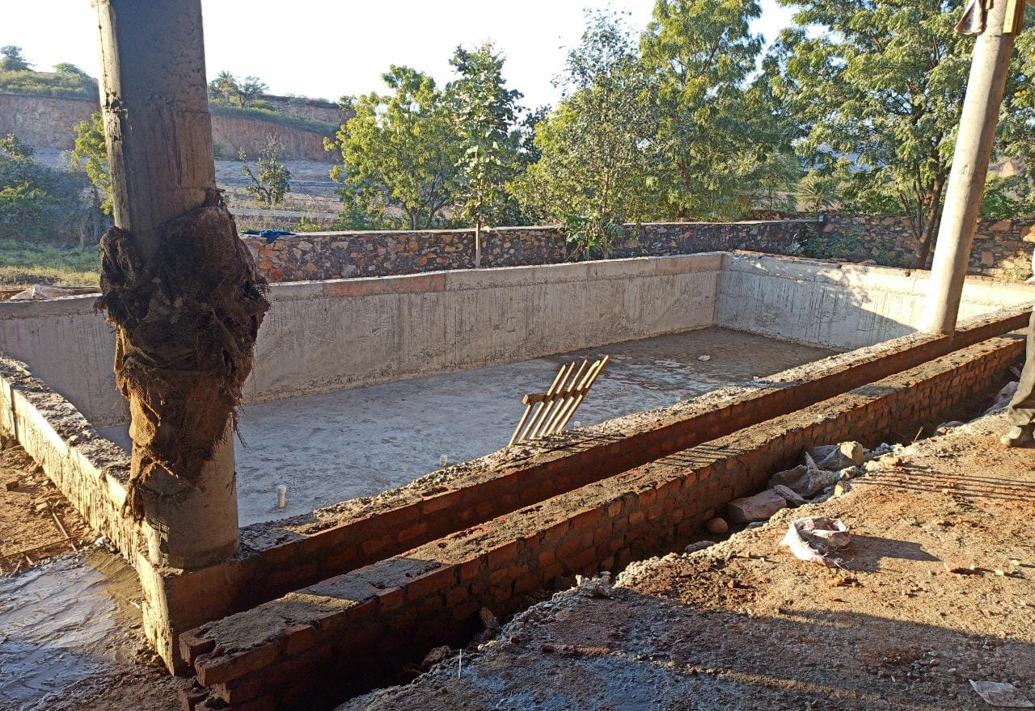
Figure 14: Details & Rc swimming pool (Size 20’x40’)
CHAPTER – 5
LABORATORY TEST
- Silt Content Test
Silt content is a fine material which is less than 150 micron. It is unstable in the presence of water.
It is unstable in the presence of water. If we use silty sand for bonding, it will reduce the strength and cause rework.
You may be experienced this while plastering for a roof where the mason tries to plaster the mortar where it gets continually peel off.
Excessive quantity of silt not only reduces the bonding of cement and fine aggregates but also affects the strength and durability of work. You can check out this article for silt and clay properties.
In the field, we have to conduct silt test for every 20 cum of sand. This may vary.



Figure 15: Apparatus of Silt Contest Test
OBJECTIVE
Find out silt content in sand (fine aggregate)

Apparatus required
- 250 ml measuring cylinder
- Water
- Sand & Tray

Test Procedure
- First, we have to fill the measuring cylinder with 1% solution of salt and water up to 50 ml.
- Add sand to it until the level reaches 100 ml. Then fill the solution up to 150 ml level.
- Cover the cylinder and shake it well (as shown in video)
- After 3 hours, the silt content settled down over the sand layer
- Now note down the silt layer alone volume as V1 ml (settled over the sand)
- Then note down the sand volume (below the silt) as V2 ml
- Repeat the procedure two more times to get the average
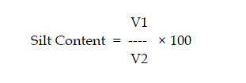
The permissible Silt content in sand percentage is only 6%.

Table: Silt Content test sand report

Determination of silt content

Observation Sheet
S.No. | Description | Sample No
 |  | Sample 1 | Sample 2 | Sample 3 | Avg.
1 | Volume of total sample (A) | 100 | 100 | 200 | 133.33
2 | Volume of sand (B) | 95 | 97 | 196 | 129.33
3 | Silt content = [(A-B)x100]/A | 5 | 3 | 2 | 3.33%
- Gradation Test
The gradation and size test is used to determine aggregate particle size distribution. Size distribution is perhaps the single most important aggregate quality associated with the control of HMA mixtures. Aggregate gradation and size affect HMA volumetric properties as well as mixture permeability and workability.


Figure 16: Arrangement of Gradation Test
Observation Table :
Sieve Size | Wt. Retaining | % of Wt. Retaining | Cu.% of Wt. | % Passing | Spec. Limits
40 | 0 | 0 | 0 | 100 | 100
20 | 1.07 | 21.4 | 21.4 | 78.6 | 85-100
10 | 3.66 | 73.2 | 94.6 | 5.4 | 0-20
4.75 | 0.23 | 4.6 | 99.2 | 0.8 | 0-5

RESULT: We achieve the average value of the aggregate size proportion by the IS 2386-1(1963) . That mean we are using best aggregates for our Project.
- Flakiness index test
Flakiness Index of aggregate is the percentage by weight of aggregate particles whose least dimension is less than 0.6 of their mean dimensions. This test is applicable to aggregates having size larger than 6.3mm.
It is not desirable to use flaky particles in construction of roads especially in surface course. This is because when the load acts along the thin axis (along the axis of minimum moment of inertia) of the flaky flat particles then they may get broken down easily. In order to avoid such condition, the particles have to be tested for their flakiness index values to check their suitability in using for construction of roads. This reason of the test being carried out.
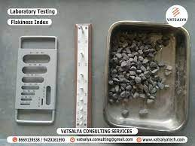
Figure 17: Apparatus of flakiness index Test
Observation Table :
Size (mm) | Total wt. | Flaky agg. wt. | % flaky agg. Wt. | Limits
20-16 | 500gm | 64gm | 12.8% | Less than 25%
16-12.5 | 231gm | 57.5gm | 24.89%
Result:
We got the value of flaky agg. Less than 25%, that mean our aggregates are of good quality. According to the IS 2386-1(1963).
- Slump Test
The concrete slump test measures the consistency of fresh concrete before it sets. It is performed to check the workability of freshly made concrete, and therefore the ease with which concrete flows. It can also be used as an indicator of an improperly mixed batch. The test is popular due to the simplicity of apparatus used and simple procedure. The slump test is used to ensure uniformity for different loads of concrete under field conditions
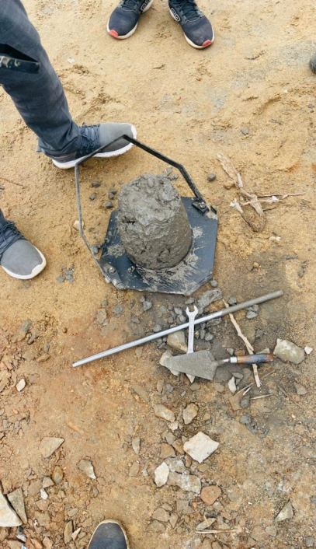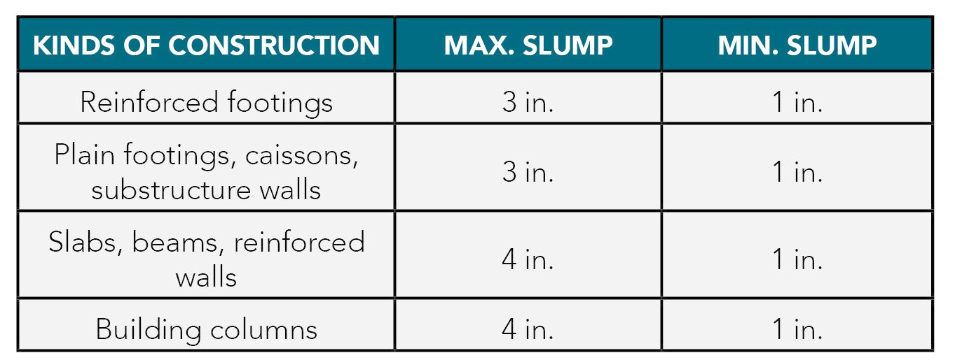
Figure 18: Apparatus of slump test and observation table
Result:
We have achieved 3.3 inch Slump value which is within permissible limit as per IS 456:2000

- Compression strength test
Compressive strength test, mechanical test measuring the maximum amount of compressive load a material can bear before fracturing. The test piece, usually in the form of a cube, prism, or cylinder, is compressed between the platens of a compression-testing machine by a gradually applied load.
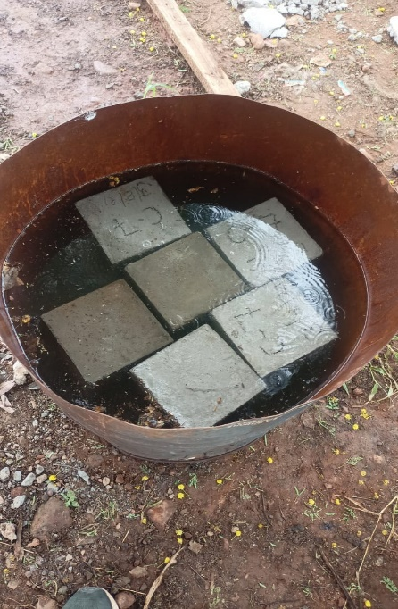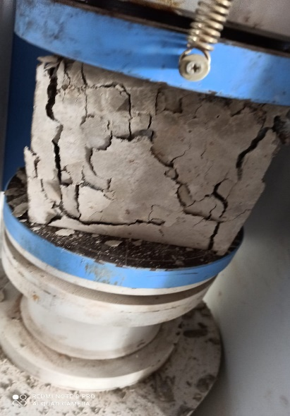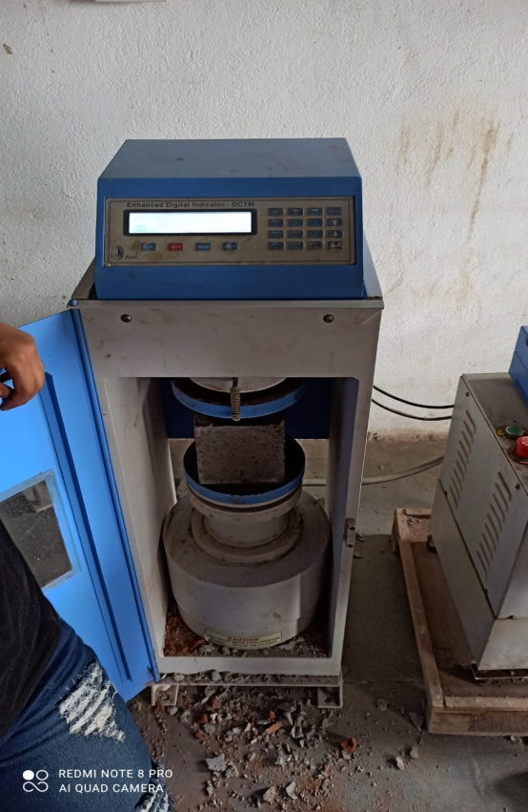
Figure 19: Compressive testing machine (CTM)

Result: We have obtained compressive strength 24 N/mm² for M20 grade of concrete cubes of 150mm X 150mm X 150mm as per IS 2386 part-4

