
AN INDUSTRIAL TRAINING REPORT
SUBMITTED IN PARTIAL FULFIMENT OF THE REQUIREMENT FOR THE AWARD OF THE BECHLOR DEGREE
BECHLOR OF TECHNOLOGY
IN
CIVIL ENGINEERING

SUBMITTED TO:
MR. RAKESH YADAV (CO-ORDINATOR)
(DEPARTMENT OF CIVIL ENGINEERING)

TECHNO INDIA NJR INSTITUTE OF TECHNOLOGY
PLOT SPL-T, RIICO INDUSTRIAL AREA, KALADWAS, UDAIPUR -313004
RAJASTHAN TECHNICAL UNIVERSITY, KOTA

ACKNOWLEDGEMENT

We wish to express our deep sense of gratitude to our training supervisor Er. Tejveer sir to guided me from the inception till the completion of the summer training. We sincerely acknowledge him/her for giving his/her valuable guidance, support for literature survey, critical reviews and comments for our training.

We also express sincere thanks and gratitude to Er Ashok Jain sir and AR Abhinav Mantri sir (B.L. Mantri and Association Pvt Ltd) for his kind cooperation and extendible support towards the completion of our project.

Words are inadequate in offering our thanks to Er. Rakesh Yadav Head of Civil Department, he has consistent for encouragement and support for shaping our project in the presentable form.

We also like to express our thanks to all supporting CE faculty members who have been a constant source of encouragement for successful completion of the project.

Also our warm thanks to Techno India NJR Institute of Technology, who provided us this opportunity to carryout, this prestigious Project and enhance our learning in various technical fields.

PRANJAL PALIWAL
II Year Student, Civil Engineering

DECLARATION

This is certifying that, Iam student of B.TECH(Civil)-7th Semesterhas undergone 45 days industrial training at“B.L. Mantri and Association PVT. LTD., ” as required for the award of Bachelor of Technology in Civil Engineering and submitted to the Department of Civil Engineering,Techno India NJR Institute of Technology, and had which is an authentic record of our work.
If any discrepancy is found regarding the originality of this report we may be held responsible. We have not copied from any report submitted earlier this or any other university. This is purely original and authentic work.

PRANJAL PALIWAL
II Year Student, Civil Engineering

ABSTRACT
Industrial training is a field based practical training experience that prepares trainees for tasks they are expected to perform on the completion of their training. Training is a prerequisite in order to equip students with skills for future demands.
This report is basically a presentation of what I did, observations made, skills and different aspects learnt and discovered in my industrial training
Chapter One basically covers the introduction, brief background about industrial training and its objectives.
Chapter Two covers the literature review about the work done such as scaffolding and formwork used on site, the different types of formwork, how it can be economized and its removal. Furthermore it highlights the concrete classes and their production, reinforcements.
Chapter Three is basically covers the training description such as site inspections, office work etc.
Chapter Four addresses the observations Made, achievements, challenges faced and the training conclusion.

TABLE OF CONTENT

CERTIFICATE…………………………………..
ACKNOWLEGEMENT...………………………
STUDENT’S DECLERATION…………..…….
ABSTRACT……...………………………………
TABLE OF CONTENTS……………………….
LIST OF FIGURES ……….……………………

CHAPTER 1- INTRODUCTION
  - BRIEF BACKGROUND ABOUT INDUSTRIAL TRAINING
  - OBJECTIVE OF INDUSTRIAL TRAINING
  - METHODS THAT WERE USED TO LEARN DURING TRAINING
CHAPTER 2 - LITERATURE REVIEW
  - INTRODUCTION ABOUT STRUCTURE
  - TYPES OF BUILDING
  - BRIEF DESCRIPTION ABOUT SOME SITE ELEMENT
  - CONCRETE
    - CLASSIFICATION OF CONCRETE
    - REINFORCED CONCRETE

  - . FORMWORK/SHUTTERING
2.5.1. TYPES OF FORMWORK FOR CONCRETE CONSTRUCTION
2.6 SCAFFOLDING
2.7 SITE PRECAUTIONS AND SAFETY

CHAPTER 3–TRAINING OUTLINE
3.1 SITE WORK
3.2 OFFICE WORK
CHAPTER 4 -OBSERVATION, ACHIEVEMENTS, CHALLENGES, CONCLUSIONS AND RECOMMENDATIONS
4.1OBSERVATION
4.2 ACHIEVEMENTS DURING TRAINING
4.3 CHALLENGES FACED DURING TRAINING
4.4CONCLUSION

^{CHAPTER ONE}

INDRODUCTION

BRIEF BACKGROUND ABOUT INDUSTRIAL TRAINING
Industrial training is basically a field-based practical training experience that students go through to prepare themselves for the tasks they are expected to perform on completion of their undergraduate studies.
This training is usually conducted at the end of the second year and the third year and goes for a period of at least eight (8) weeks per year. The students find out positions in various firms, companies, organizations and/or government departments where they get hands-on training on site or in office. Supervision is done by an on-site supervisor and a college supervisor who is a member of the faculty at their respective college/school.
  - OBJECTIVES OF INDUSTRIAL TRAINING
- To familiarize with proper planning, design and field operations.
- Plan should include construction methods to be adopted for different construction activities.
- To get exposure with the management and communication functions performed with in a construction project.
- Construction projects are executed based on the drawing and specifications. To enable the student to relate the theoretical knowledge acquired in class with the practical skills and actual work on site.
- To provide an opportunity to students to incorporate the principals and techniques theoretically learnt into real life problem solving situations.
- To identify and solve problems on site.
- To develop positive attitude towards work.
- To acquire good technical writing skills.
- To develop interpersonal and communication skills in associating With staff and people from different background.
- To expose students to Civil Engineering ethics and codes of practice.
- To enable us acquire supervision skills and control of projects to ensure that the work being done is of good quality.

METHODS THAT WERE USED TO LEARN DURINGTRAINING
In order to achieve the objectives of my training experience, a number of methods and avenues were employed. The major methods I used are briefly described below;
- Observation.
During our site works, we were able to observe and interpret how most of the activities were done. Through critical observations I was able to learn and grasp most of the techniques used
- Consultations.
This was mainly done through meetings with the Site Engineer, the consultants and other personnel from different trades on site who could give us detailed professional information concerning questions raised usually after rigorous sessions of site work.
- Participation in work.
My fellow trainees and I were able to work under various sections on site as away to participate and have a practical feel of all activities, which included; steelworks, Carpentry/formwork, concrete works, and work force management.
- Project documentations.
Most of the documents concerning the project like Structural drawings, Surveying drawings, electrical drawings, Material specifications, sites to remand work force management records and documentations, material procurement records, plant, machinery, equipment and tools management operational records among others which are necessary for proper interpretation and understanding of all work on site were available and accessible atheists offices. I was able to access them and draw out as much information and knowledge about the project.
- Internet and text based materials.
Through use of the internet, I was able to check out on various websites for information concerning different activities and why most of these site works were done. I also used some textbooks and printed material.

^{CHAPTER TWO}
LITERATURE REVIEW
2.1. INTRODUCTION ABOUT STRUCTURE
The structure of the building is divided into two parts. The sub-structure and the super-structure. The lower portion of the building which transmits the loads of the super structure to the foundation soil is called sub-structure and the portion of the building which is above the sub-structure is called super structure. The weight of super-structure is taken by the foundation hence the foundation must be strong enough to carry the whole load of the super structure.
2.2. TYPES OF BUILDING
Building are classified on the basis of character of occupancy and type of use as
- Residential building
- Educational building
- Institutional building
- Industrial building
2.2.1. Residential Building – Residential building means a building in which sleeping accommodation is provided for normal residential purposes, with or without cooking or dining facilities, and includes one or more family dwellings, lodging or boarding houses, hostels, dormitories, apartment houses, flats and private garages of such buildings.
2.2.2. Educational Building –Educational building means and shall include any building used for school, college or day care purpose involving assembly for instruction, education or recreation and shall also include crotchet.
2.2.3. Institutional Building – Institutional building simply refers to any structure that fulfils a role related to healthcare, education, recreation, or public works. For example - high-rise condos and office towers, stadiums, schools, hospitals, malls, libraries, art galleries and museums.
2.2.4.Industrial Building – Industrial building means a building or part thereof wherein products or material are fabricated, assembled or processed, such as assembly plants, laboratories, power plants, refineries, gas plants, mills, dairies and factories.

2.3. BRIEF DESCRIPTION ABOUT SOME SITE ELEMENTS
- Columns
This is a structural shaft of concrete which transfers applied vertical loads through its length and its base.
- Slabs.
This is a horizontal plate like structure usually of solid concrete or max spans (precast units) reinforced with steel bars to function as a floor or roof structure.
- Beams.
These are horizontal structural members that transfer loadings from above to its bearing points (to the supports and joints) which are always columns or load bearing walls.
- Staircase.
This refers to a series of steps leading from one floor to another. There are different types which include; half turn staircase/ switch back/ u-shaped, Quarter turn staircase, Straight staircase, Winder staircase, Curved staircase, Spiral staircases-shaped staircase, ladders

2.4. CONCRETE
Concrete a composite man-made material is the most widely used building material in the construction industry. It consists of a rationally chosen mixture of binding material such as lime or cement, well graded fine and coarse aggregates, water and admixtures (to produce concrete with special properties).
In a concrete mix, cement and water form a paste or matrix which in addition to filling the voids of the fine aggregate, coats the surface of fine and coarse aggregates and binds them together. The matrix is usually 22-34% of the total volume.

2.4.1. CLASSIFICATION OF CONCRETE
The concrete mix is always classified depending on the different categories such as;
- Based on cementing material.
Concretes are classified as lime concrete, gypsum concrete and cement concrete.
- Based on perspective specifications.
The cement concrete is specified by proportions of different ingredients, e.g., 1 (cement): 1.5 (fine aggregate): 3 (coarse aggregate).
- Based on performance oriented specifications.
When the concrete properties such as strength, water-cement ratio, compaction factor, slump, etc., are specified the concrete may be classified as designed-mix concrete. For a design mix concrete the mix is designed to produce the grade of concrete having the required workability and a characteristic strength not less than the appropriate values as specified.
- Based on grade of cement concrete.
Depending upon the strength (N/mm2) of concrete cubes (150 mm side) at 28 days, concrete is classified
- Based on bulk density.
On the basis of density, concrete is classified as super heavy (over 2500 kg/m3), dense (1800-2500 kg/m3), light weight (500–1800 kg/m3) and extra light weight concrete (below 500 kg/m3).
- Based on place of casting.
When concrete is made and placed in position at the site it is known as in-situ concrete and when used as a material for making prefabricated units in a factory is known as precast concrete.

2.4.2. REINFORCED CONCRETE
Reinforced concrete is a combination of traditional cement concrete with reinforcements (steel bar). This combination is made to utilize the compressive strength of concrete and tensile strength of steel simultaneously.
In reinforced concrete, the components work together to resist many types of loading. Concrete resists compression and steel reinforcement resists tension forces.
Reinforced concrete, as an economic building material, is very popular nowadays. It is widely used in many types building around the world. Along with many advantages, reinforced concrete also poses some disadvantages also.

2.5. FORMWORK/ SHUTTERING
Formwork in concrete construction is used as a mould for a structure in which fresh concrete is poured only to harden subsequently. Type of formwork for concrete construction depends on formwork material and type of structural element.
Formworks can also be named based on the type of structural member construction such as slab formwork for use in slab, beam formwork, column formwork for use in beams and columns respectively.
Timber is the most common material used for formwork.

TYPES OF FORMWORK FOR CONCRETE CONSTRUCTION

The type of formwork employed always depends on the structural design of the member and the weight of concrete to be casted. Different types include;
- Timber formwork.
- Steel formwork.
- Plywood formwork.

2.6. SCAFFOLDING
This is sometimes called staging or literally scaffold. It refers to the temporary structure used to support a work crew and materials to aid in the construction.
There are four main types of scaffolding used worldwide today. These are;
- Tube and Coupler (fitting) component
- Prefabricated modular system scaffold components.
- H-frame / facade modular system scaffolds.
- Timber scaffolds.
Each type is made from several components which often include:
- A base jack or plate which is a load bearing base for the scaffold.
- The standard which is the upright component with connector joins.
- The ledger (horizontal brace).
- The transom which is a horizontal cross section load bearing component which holds the batten, board or decking unit.
- Brace diagonal and/or cross section bracing component.
- Batten or board decking component used to make the working platform.
- Coupler a fitting used to join components together.
- Scaffold tie used to tie in the scaffold to structures.
- Brackets used to extend the width of working platforms.

SITE PRECAUTIONS AND SAFETY
- Always wear safety gloves, safety boots, reflector jacket and a helmet all time on site to safe from site injuries due to accidents.
- When climbing a ladder always ensure its steady and firm before climbing to protect yourself from falls
- When walking on top of the shutters always ensure they are well propped otherwise you might pass through and fall down.

Executive summary
This report is a report about the internship experience that we have under taken during the last months. In this
report we have tried to list the overall aspects of the internship experience. We have briefly summarized what is
expected in the next chapters in this report.
This report includes the overall of our internship program categorized into four main chapters. The first chapter
discuss the background of the hosting company including its brief history, its main products or services, its main
customers or end users, its overall organization and work flow as well as its vision, mission, core value, goals and
strategic direction.in the second chapter we have tried to give a brief review of structural elements of a building
and the steps we have followed to construct these structures, challenges we have faced while performing my tasks
and measures taken to overcome this challenges. The third chapter includes our project that we have done at
Commercial bank of Ethiopia Infrastructure Works project includes overall benefits we have gained in the
program followed by a chapter of conclusion and personal recommendation.

Executive summary
This report is a report about the internship experience that we have under taken during the last months. In this
report we have tried to list the overall aspects of the internship experience. We have briefly summarized what is
expected in the next chapters in this report.
This report includes the overall of our internship program categorized into four main chapters. The first chapter
discuss the background of the hosting company including its brief history, its main products or services, its main
customers or end users, its overall organization and work flow as well as its vision, mission, core value, goals and
strategic direction.in the second chapter we have tried to give a brief review of structural elements of a building
and the steps we have followed to construct these structures, challenges we have faced while performing my tasks
and measures taken to overcome this challenges. The third chapter includes our project that we have done at
Commercial bank of Ethiopia Infrastructure Works project includes overall benefits we have gained in the
program followed by a chapter of conclusion and personal recommendation.
Executive summary
This report is a report about the internship experience that we have under taken during the last months. In this
report we have tried to list the overall aspects of the internship experience. We have briefly summarized what is
expected in the next chapters in this report.
This report includes the overall of our internship program categorized into four main chapters. The first chapter
discuss the background of the hosting company including its brief history, its main products or services, its main
customers or end users, its overall organization and work flow as well as its vision, mission, core value, goals and
strategic direction.in the second chapter we have tried to give a brief review of structural elements of a building
and the steps we have followed to construct these structures, challenges we have faced while performing my tasks
and measures taken to overcome this challenges. The third chapter includes our project that we have done at
Commercial bank of Ethiopia Infrastructure Works project includes overall benefits we have gained in the
program followed by a chapter of conclusion and personal recommendation.
Executive summary
This report is a report about the internship experience that we have under taken during the last months. In this
report we have tried to list the overall aspects of the internship experience. We have briefly summarized what is
expected in the next chapters in this report.
This report includes the overall of our internship program categorized into four main chapters. The first chapter
discuss the background of the hosting company including its brief history, its main products or services, its main
customers or end users, its overall organization and work flow as well as its vision, mission, core value, goals and
strategic direction.in the second chapter we have tried to give a brief review of structural elements of a building
and the steps we have followed to construct these structures, challenges we have faced while performing my tasks
and measures taken to overcome this challenges. The third chapter includes our project that we have done at
Commercial bank of Ethiopia Infrastructure Works project includes overall benefits we have gained in the
program followed by a chapter of conclusion and personal recommendation.
Executive summary
This report is a report about the internship experience that we have under taken during the last months. In this
report we have tried to list the overall aspects of the internship experience. We have briefly summarized what is
expected in the next chapters in this report.
This report includes the overall of our internship program categorized into four main chapters. The first chapter
discuss the background of the hosting company including its brief history, its main products or services, its main
customers or end users, its overall organization and work flow as well as its vision, mission, core value, goals and
strategic direction.in the second chapter we have tried to give a brief review of structural elements of a building
and the steps we have followed to construct these structures, challenges we have faced while performing my tasks
and measures taken to overcome this challenges. The third chapter includes our project that we have done at
Commercial bank of Ethiopia Infrastructure Works project includes overall benefits we have gained in the
program followed by a chapter of conclusion and personal recommendation.
Executive summary
This report is a report about the internship experience that we have under taken during the last months. In this
report we have tried to list the overall aspects of the internship experience. We have briefly summarized what is
expected in the next chapters in this report.
This report includes the overall of our internship program categorized into four main chapters. The first chapter
discuss the background of the hosting company including its brief history, its main products or services, its main
customers or end users, its overall organization and work flow as well as its vision, mission, core value, goals and
strategic direction.in the second chapter we have tried to give a brief review of structural elements of a building
and the steps we have followed to construct these structures, challenges we have faced while performing my tasks
and measures taken to overcome this challenges. The third chapter includes our project that we have done at
Commercial bank of Ethiopia Infrastructure Works project includes overall benefits we have gained in the
program followed by a chapter of conclusion and personal recommendation.
Executive summary
This report is a report about the internship experience that we have under taken during the last months. In this
report we have tried to list the overall aspects of the internship experience. We have briefly summarized what is
expected in the next chapters in this report.
This report includes the overall of our internship program categorized into four main chapters. The first chapter
discuss the background of the hosting company including its brief history, its main products or services, its main
customers or end users, its overall organization and work flow as well as its vision, mission, core value, goals and
strategic direction.in the second chapter we have tried to give a brief review of structural elements of a building
and the steps we have followed to construct these structures, challenges we have faced while performing my tasks
and measures taken to overcome this challenges. The third chapter includes our project that we have done at
Commercial bank of Ethiopia Infrastructure Works project includes overall benefits we have gained in the
program followed by a chapter of conclusion and personal recommendation.

^{CHAPTER THREE}

TRAINING OUTLINE

3.1 SITE WORK
In this following section describe the duties and jobs in detail that done during the training:
3.1.1: SITE (1) LOCATION: Near Neelkanth Hospital, Bhuwana
DESCRIPTION:
This building was a multi-storey building. It is a commercial building. In which a huge basement was provide. The open hall was at ground floor. And the structure was constructing continuously.
When I joined that site, there was first floor shuttering and reinforcement work was running.
And When I leave that site at completion of my training period, then second floor casting process was started.
This project is handled by the Er Lalit Prajapat and B.L. Mantri and Asso. Pvt. Ltd.

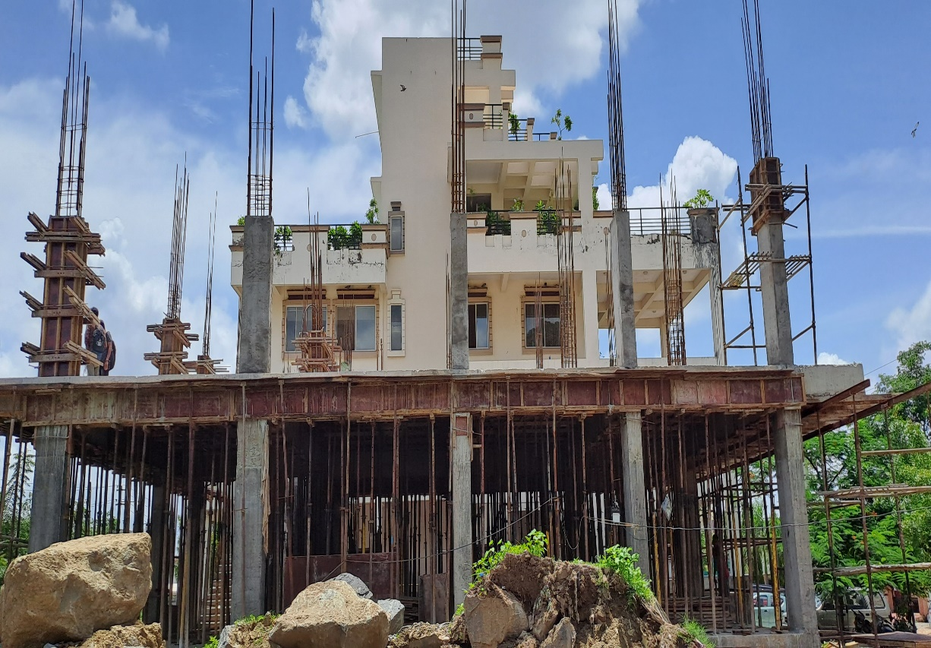
Site 2 Location: Near Tibi Hospital, Badi
DESCRIPTION: This site was situated in middle of nature. There were a lot of plants. In this site the engineer didn’t harm or cut any of the tree or plant. Even a big tree was situated mid of the building. In this site a lot of cantilever of big spans was constructed. Huge amount of heavy reinforced beam was used as per structural design. It was a big residential villa building.
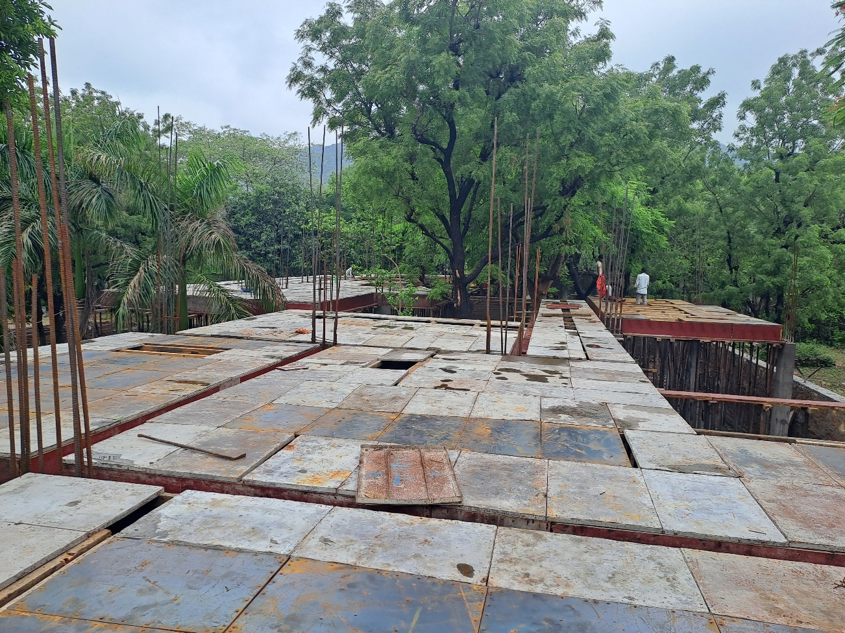
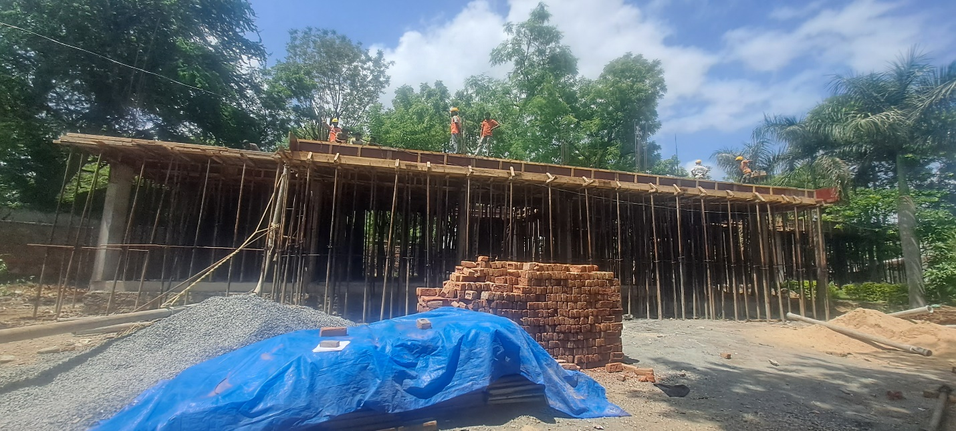
Site 3 Location: Near Pratap Gaurav Kendra, Tiger hills
DESCRIPTION:
This was a newly constructing site. When I joined this site, then there was only foundation work was preparing. And when I leave this site then the plinth beam and Pcc of ground floor was done.
This was also a huge site, where various numbers of columns of different sizes was constructed.
In this site various size and types of footing was also constructed. This was:
- Isolated footing
- Combined footing
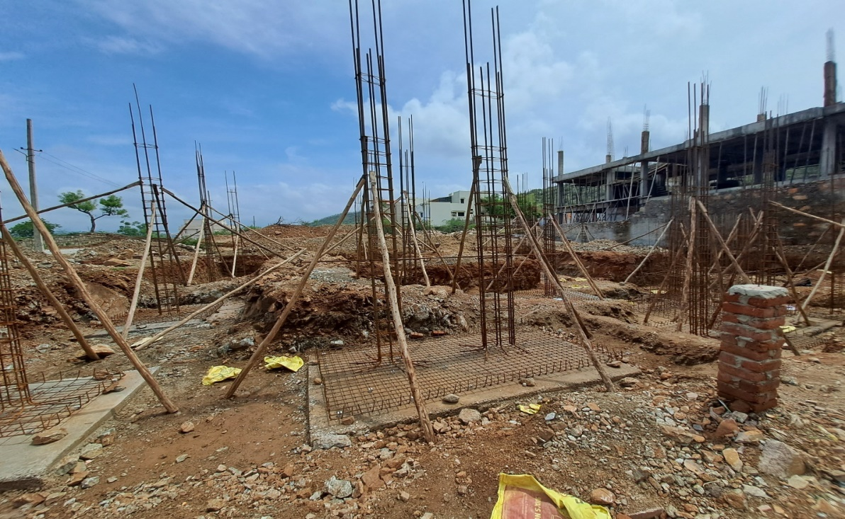
There was both type of isolated footing was used which was trapezoidal and flat isolated footing.

- DURINGTHETRAINING, WORKWASFINISHEDASFOLLOW:
In the construction of columns, the following steps were followed:
- COLUMN LAYOUT AND CENTRE:
The well-reputed architects always provide the separate drawing of column layout with their centre. This drawing shows the centre line or exact positions of each column at the site according to the reference dimensions. Practically, in field, ropes are our grid-line. So we place columns related to rope-line by measuring dimension shown in the drawing.
- COLUMN STARTER CONSTRUCTION:
Starters are needed to cast the column in proper alignment. Column starter marking is the process of casting the first 50 to 100 mm height of column for the alignment of rest of the column. To construct the column starter, shutters are made to the size of the column and the height of shutter should be normally 75 to 100 mm. The shutters are fixed at the bottom of the column according to the centre line. Check the shuttering and reinforcements of the starter for vertically. After the curing period is over, remove the formwork of the starter. The shuttering of the remaining column should be fixed by overlapping the shutter on casted starter.
- COLUMN REINFORCEMENT:
There are two types of reinforcements provided in a R.C.C. column.
- Longitudinal reinforcement.
- Transverse reinforcement.

Longitudinal Reinforcement
The longitudinal reinforcement consists of steel bars placed longitudinally in a column. It is also called as main steel.
- Transverse Reinforcement
The transverse reinforcement is provided along the lateral direction of the column in the form of ties spirals enclosing the main steel.

Column Reinforcement details
The reinforcement detail for RCC column according IS: 456 – 2000 is given below.
- Maximum reinforcement in any structure shall not exceed 6% of the gross area of concrete.
- In any structural part minimum reinforce should not be less than 0.8% of the gross sectional area of concrete.

- FOLLOWING CHECKS OF COLUMN REINFORCEMENT SHOULD BE CARRIED OUT:
- Check Reinforcement, placed according to drawing.
- Check the starter of column.
- Check the ring size.
- Check the master ring is tie or not.
- The diameter of the rings or ties shall be not less than one- fourth of the diameter of the largest longitudinal bar and in no case less than 6 mm. However, we recommended 8 mm diameter bars.
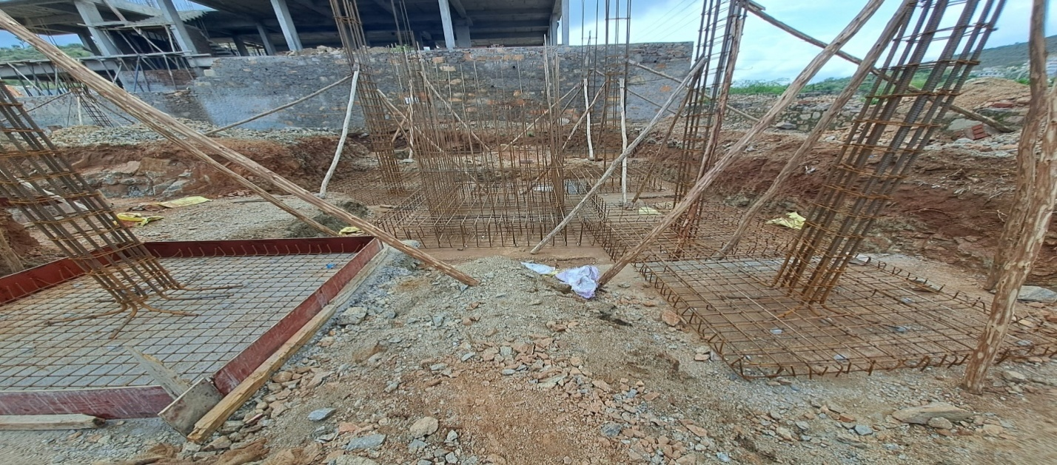
- Check the spacing.

- COLUMN SHUTTERING :
Column box or shuttering for columns is made of plywood sheets or steel sheets fabricated with adequate stiffeners. A Thin film of oil or grease should be applied to inner surface of the shuttering to enable easy removal of the column after the concrete hardness.
- FOLLOWING CHECKS OF COLUMN SHUTTERING SHOULD BE CARRIED OUT:

- Any two adjacent shutter sides should be checked for verticality by using the plumb bob.
- The minimum thickness of the plywood should be 12mm. for the residential columns. For the heavier structural columns, the plywood of thickness 18mm. or above should be used to avoid bulging.
- There are no gaps between the plates.
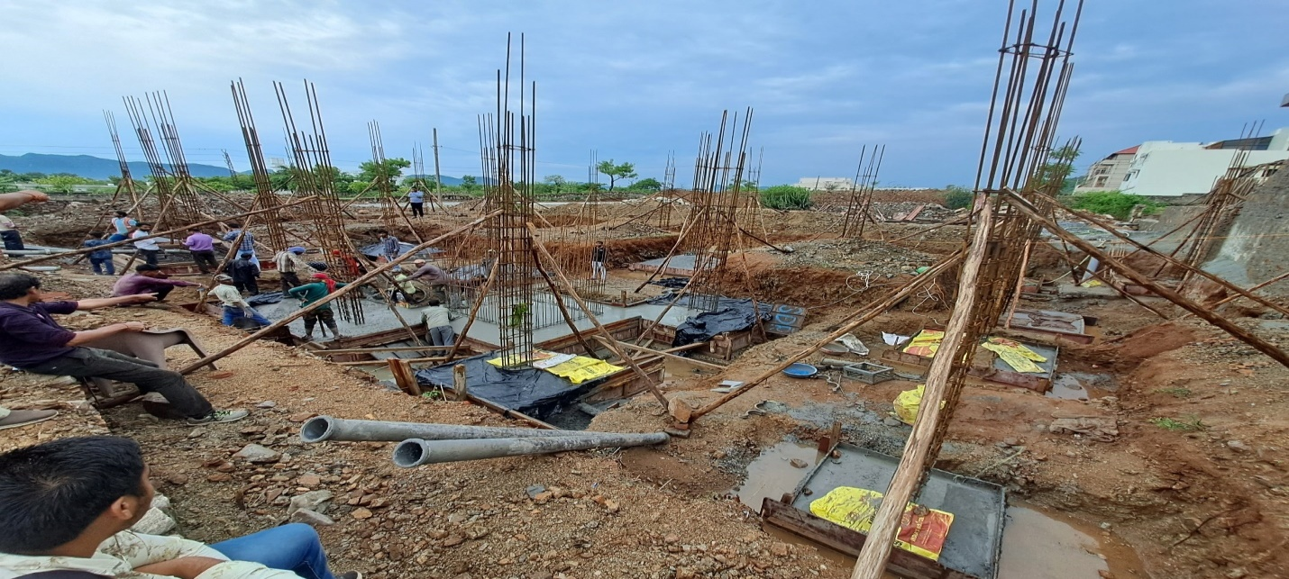
- All the column props should be nailed properly to the wooden planks or any such supports.
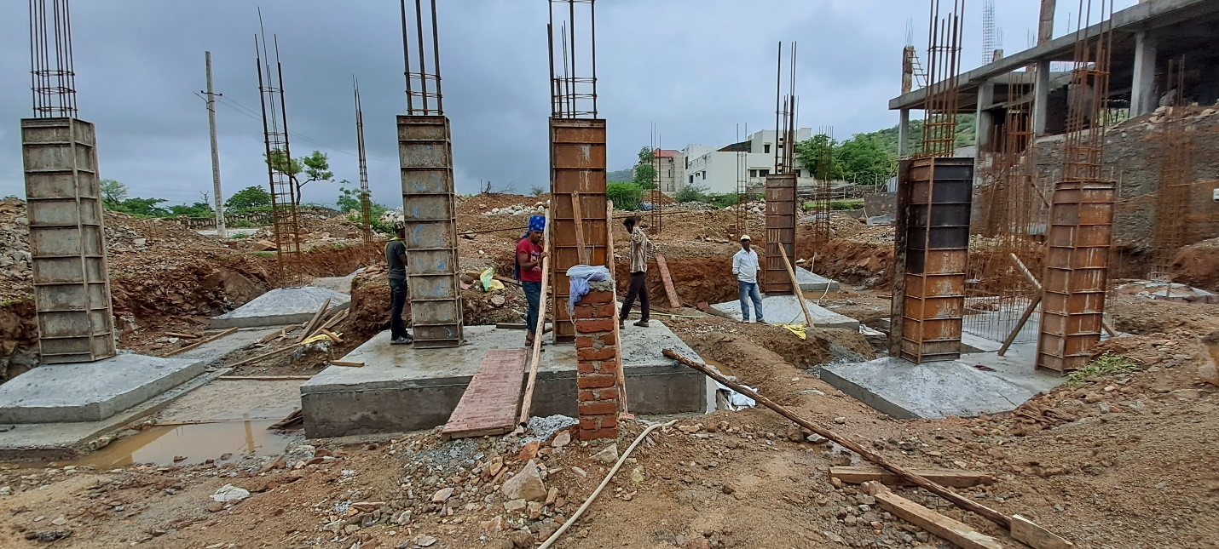
- COLUMN CASTING:
Casting column is easy. For small quantity of concrete volume we normally depend on machine-mix concrete and for large concrete quantity we order ready-mix concrete.
- FOLLOWING CHECKS OF COLUMN CASTING SHOULD BE CARRIED OUT:

- The gap between the joint of shutters should be sealed to prevent any leakage of cement slurry.
- Permissible concreting level should be marked by considering beam depth.
- Check cement, sand, & aggregate quality.
- It ensures that machine is use for concrete mix.
- Check concrete ratio it will be specified with site engineer.
- Proper vibrator is use.
- Finishing of honey combing, if any, with proper care.
- Covers should be given properly as per the structural drawing.
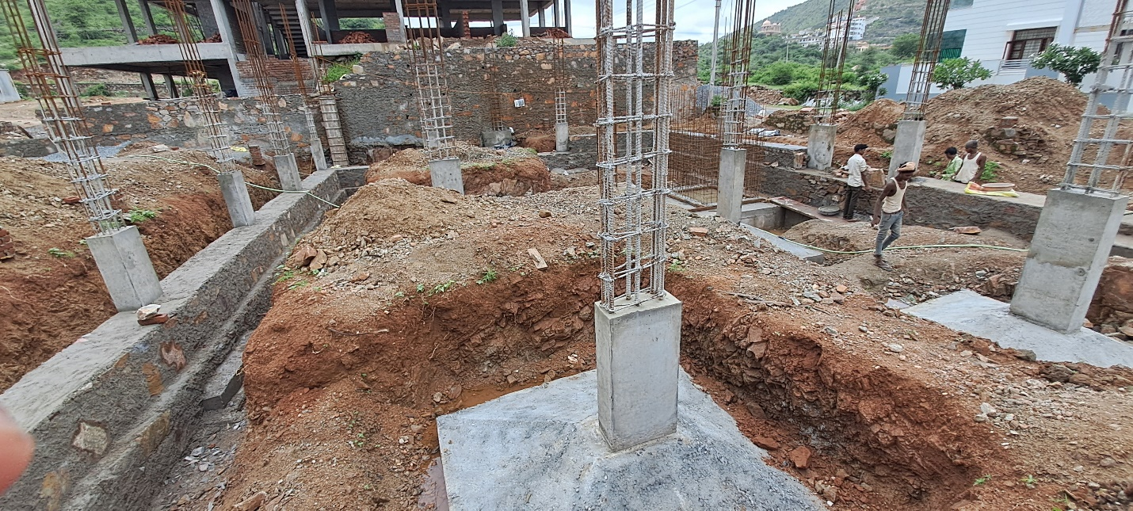
- CONSTRUCTION OF BEAM AND SLAB:

- SHUTTERING OF BEAM AND SLAB:

- FOLLOWING CHECKS OF BEAM & SLAB SHUTTERING WORK SHOULD BE CARRIED OUT:

  - Check Height of slab from plinth / slab level.
  - All vertical supports will be vertical face and no brick and stone use in base.
  - Check proper fixing of cap on column to take load of beam & slab shuttering.
  - Check Line & level of beam bottoms.
  - Check Depth of beam as per R.C.C. drawings.
  - Check proper fixing of beam in line, level & plumb.
  - Check Gaps in beam sides to be filled and also there are no gapes between plates.
  - Check Individual level of each bay of slab.
  - Check internal panel measurement, beam-to-beam & diagonal of panel.
  - Check Location & depth of sunken slab.
  - Check Outer line of beam sides and check outer face of beam, it will be in plumb & line.
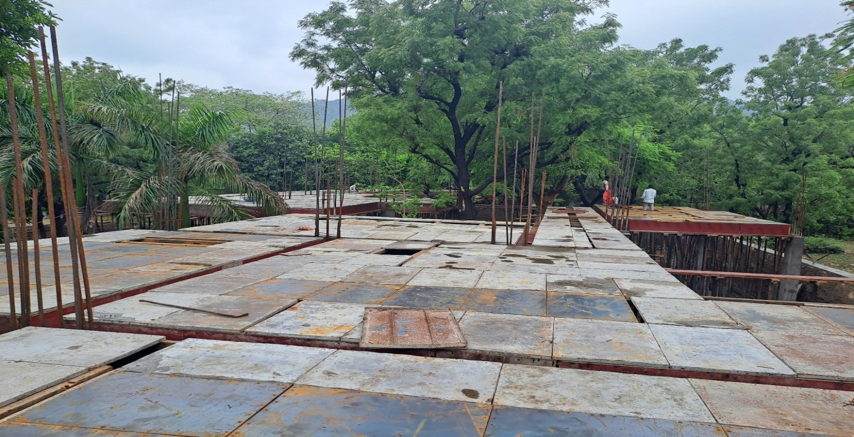
- REINFORCEMENT WORK:
- REINFORCEMENT OF BEAM:
Generally a beam consists of following steel reinforcements:
- Longitudinal reinforcement at tension and compression face.
- Shear reinforcements in the form of vertical stirrups and or bent up longitudinal bars.
- FOLLOWINGCHECKSOFBEAMREINFORCEMENTWORKSHOULDBECARRIEDOUT:
- Check ring size of beam.
- Check steel reinforcement with structural drawing.
- Check stirrups spacing.
- Check grade of steel bar.
- Check the extra bars at top and bottom as per drawing.
- Ensure the main reinforcement of the beam shall be passed through the column.
- REINFORCEMENT OF SLAB:
Generally slab consists of 2 types of reinforcement as per there type:
- Main bar: The reinforcement bars that are placed in the tension zone of the slab to resist the bending moment & to transfer the superimposed loads to the supports that are provided for the slab are called main bars.
The diameter of the main bar should not be less than 8mm for the HYSD bar and 10mm for plain bars.
- Distribution bar: The reinforcement bars that are placed above the main bar in a one-way slab, to distribute the superimposed load to the main bar are called distribution bars.

- FOLLOWING CHECKS OF SLAB REINFORCEMENT WORK SHOULD BE CARRIED OUT:

- Check slab reinforcement as per drawing.
- Check bent up bar position according to drawing.
- Chairs sufficient and strong to avoid bending of top reinforcement.
- Cover blocks are provided as per drawings and it should be sufficient.
- Cover blocks are placed 1m distance to each other.
- Checked lap length as per drawing.
- Check the electrical conduits work of slab as per electrical drawing.
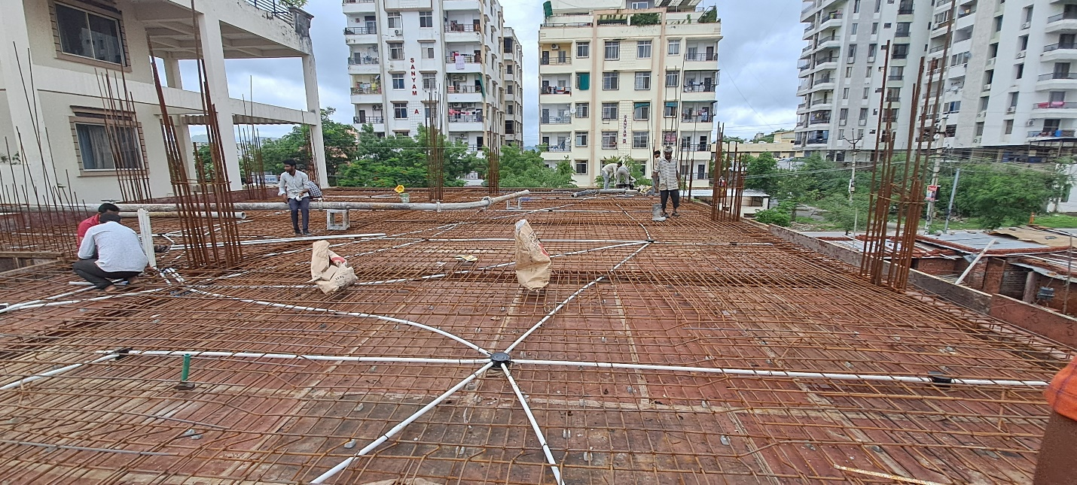

- CASTING OF BEAM AND SLAB:

- FOLLOWINGCHECKSOFSLAB&BEAMCASTINGSHOULDBECARRIEDOUT:

- Check cement, sand, & aggregate quality.
- It ensures that machine is use for concrete mix.
- Check concrete ratio it will be specified with site engineer.
- Proper vibrator is use.
- Concrete threw in maximum 3’ height.


- All bent up in top position while slab casting.

- BRICK MASONRY WORK:
The following checks are required for brick masonry work:
- Brick should be of proper size, shape.
- Check mortar ratio: (1: 6 in 9” thick wall) & (1: 4 in 4” thick wall).
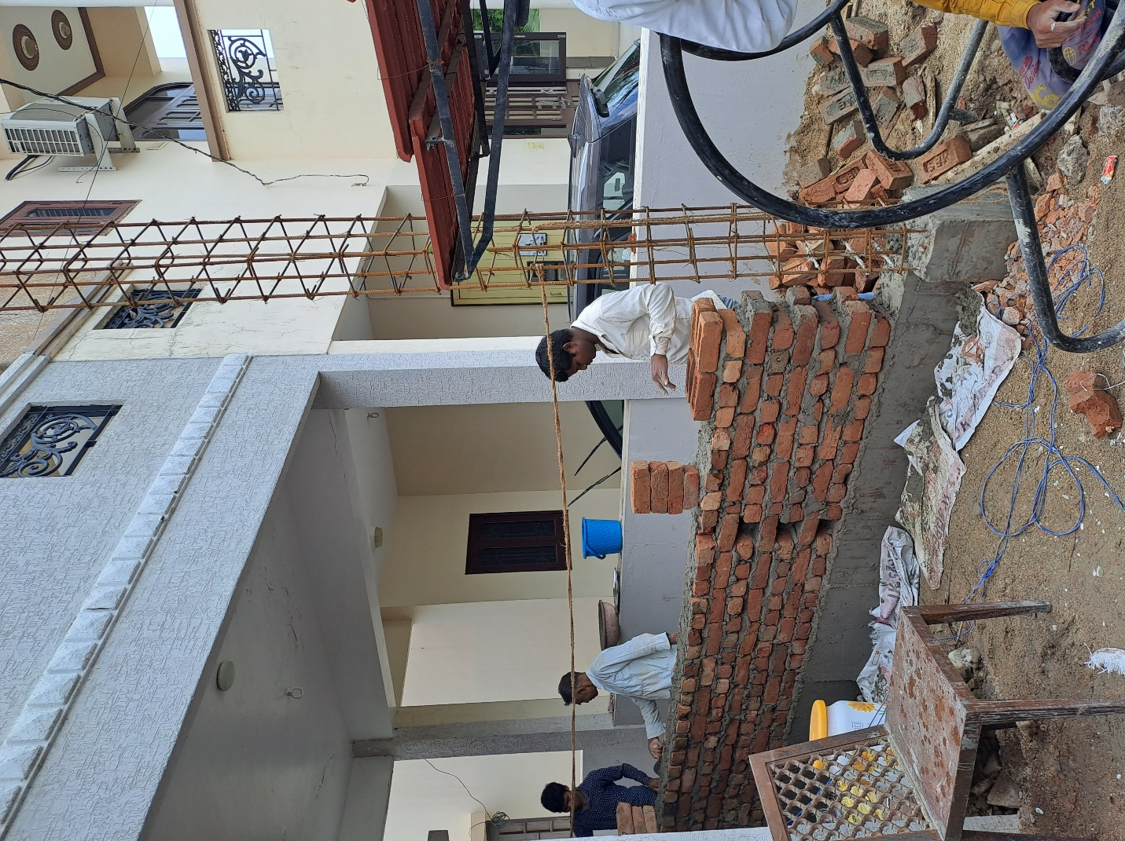
- All face of brick wall in plumb &line.
- Check opening for door& window.
- At first, wall should be constructed till 4’ height; further placement should be continued next day.

^{CHAPTERFOUR}

OBSERVATIONS, ACHIEVEMENTS, CHALLENGES, CONCLUSIONS
4.1 OBSERVATIONS
- We observed that the safety of workers at site was compromised as most would work without gumboots, gloves and helmets and this was to put them at risk to injuries.
- We also observed that if you do not take care of the work of the labours, then you can suffer a great loss.

4.2 ACHIEVEMENTS MADE DURING THE INDUSTRIAL TRAINING PERIOD
Despite the challenges that we faced in our quest for knowledge and gaining experience, The 7 weeks of our industrial training were a total success and it was quite a wonderful experience.
Besides the hands on experience we got from site, we also got to appreciate what it takes to be a civil engineer, a technician and a labour on site.
With this experience and exposure to various disciplines in the field, including site management and organization, we hope to be an effective, efficient and professional engineer in the near future.
We were also able to learn the following aspects;
- .positive response to criticism from client and site onlookers.
- Teamwork among the workers.
- Punctuality and time management at work.
- Discipline when conducting work which is a very vital aspect.
- Professionalism in handling clients and the public.

4.3 CHALLENGES FACED DURING INDUSTRIAL TRAINING
During my training we experienced a few challenges and they are as listed below;
- The time we had for our industrial training was short, yet multiple activities were taking place. This therefore meant that that some activities were foregone due to this limiting factor.

4.4 CONCLUSIONS.
Industrial training is very vital for every University student. Therefore every student should try as much as possible to ensure that they grasp the material and information given to them so that they can use it to expand on their career and level of experience. This can help them in future while applying for jobs.
Internship has boosted our career especially in structures department. It has also given us confidence to face future employment opportunities. With this experience and exposure to various disciplines in the field, including site management and organization, we hope to be an effective, efficient and professional engineer in the near future. All in all we are grateful to the Almighty God for having protected us throughout our training.

