**A Report**

**On**

**Survey Training – 2021**



**Submitted by: Submitted to:**

Kritika DodiaRakesh Yadav

B.Tech II yr (CE) Coordinator, Assistant Professor Roll No.: 20ETCCE011 Dept. of Civil Engineering

**Rajasthan Technical University**

**2021**

# ***Content***

1. Profile Levelling
2. Building Layout
3. Total Station
4. Radial Contouring
5. Grid Contouring
6. Plane Table

**1. Profile Levelling**

* Profile levelling is the process of levelling along a fixed line to determine the elevations of the ground surface along the line. Profile levelling is also known as longitudinal sectioning.
* **Instruments:**

Auto Level, Tripod, Cross Staff, Tape etc.

* **Theory:**

Profile levelling is a surveying method in which a straight line is drawn along the central axis of a track or road. This line represents the elevation of the ground at various points along the section. The gradient line is then drawn to show the amount of undulation of the ground surface. The formation levels at various points are determined and the amount of cutting and filling can be computed

* **Procedure:**

1. When carrying out profile levelling, the auto level does not necessarily need to be placed along the line of observation. It can be placed at a more convenient location, such as point

2.Position the instrument in a way that allows you to take a clear backsight on a bench mark.

3. observations are then taken at set intervals (1, 2, 3, 4) along the central line until a pre-selected turning point is reached (TP1).

4. The instrument is then moved to another location (for example, 2).

5. After the instrument set up the way you need it, you can start making observations starting from TP1. Make sure to take note at regular intervals (like every 5 or 6 minutes) and end at another turning point, which we'll call TP2.

6. Staff readings are essential in order to understand changes in slope, such as at X.

7. Lines' distances and directions are measured.

* **Formula:**

1. H.I. = R.L of B.M + B.S.
2. R.L. = H.I. – I.S./F.S.

|  |  |  |  |  |  |  |
| --- | --- | --- | --- | --- | --- | --- |
| ***Point*** | ***Staff Reading(m) h*** | | | ***H.I.***  ***(m)*** | ***R.L.***  ***(m)*** | ***Remarks*** |
|  |  | | |
|  | ***B.S.*** | ***I.S.*** | ***F.S.*** |
| *1* | *1.29* |  |  | *101.275* | *99.985* |  |
| *2* |  | *1.29* |  |  | *99.985* |  |
| *3* |  | *1.305* |  |  | *99.97* |  |
| *4* |  | *1.335* |  |  | *99.94* |  |
| *5* |  | *1.375* |  |  | *99.9* |  |
| *6* |  | *1.265* |  |  | *100.01* |  |
| *7* |  | *1.275* |  |  | *100* |  |
| *8* |  | *1.29* |  |  | *99.985* |  |
| *9* |  | *1.315* |  |  | *99.96* |  |
| *10* |  | *1.33* |  |  | *99.945* |  |
| *11* |  | *1.75* |  |  | *100.1* |  |
| *12* |  | *1.24* |  |  | *100.035* |  |
| *13* |  | *1.275* |  |  | *100* |  |
| *14* |  | *1.3* |  |  | *99.975* |  |
| *15* | *1.43* |  | *1.33* | *101.375* | *99.945* | *Instrument Change* |
| *16* |  | *2.05* |  |  | *99.325* |  |
| *17* |  | *1.36* |  |  | *100.015* |  |
| *18* |  | *1.415* |  |  | *99.96* |  |
| *19* |  | *1.45* |  |  | *99.925* |  |
| *20* |  | *1.335* |  |  | *100.04* |  |
| *21* |  | *1.365* |  |  | *100.01* |  |
| *22* |  | *1.425* |  |  | *99.95* |  |
| *23* |  | *1.49* |  |  | *99.885* |  |
| *24* |  | *1.525* |  |  | *99.85* |  |
| *25* |  | *1.345* |  |  | *100.03* |  |
| *26* |  | *1.385* |  |  | *99.99* |  |
| *27* |  | *1.46* |  |  | *99.915* |  |
| *28* |  | *1.44* |  |  | *99.935* |  |
| *29* |  | *1.* | *1.455* |  | *99.92* |  |

**Table 1:** Elevation of road measured by Auto Level

1. **Building Layout**

The first step in construction activity is site clearance. It was then marking foundation trenches which are going to be excavated. The excavation lines which are marked on site is known as building layout.

* **Equipment:**

Lime powder, Strings, Tape, Arrows etc.

* **Theory:**

When the time comes to start working, it's important to have a plan. This plan will be your foundation. To start any structure, you need to first excavate the trenches for the foundation. To do this, you need to outline the excavation on the ground. This process of outlining the excavation on the ground is known as setting out or lining out of works.

* **Procedure:**

1. The first step to surveying a building is to establish point A, and then set line AB in the desired direction.

2. Perpendiculars can be set using the 3-4-5 method.

3. Once all of the lines are drawn, check that they intersect at 90-degree angles.

4. To verify the work, measure the length of the diagonals on the ground. These values should match the calculated values.

5. If the measured and calculated values do not match, repeat steps.

6. Once all the pegs are in the ground, lime is spread between them to create lines.

7. The lime lines represent the walls and indicate where to excavate.

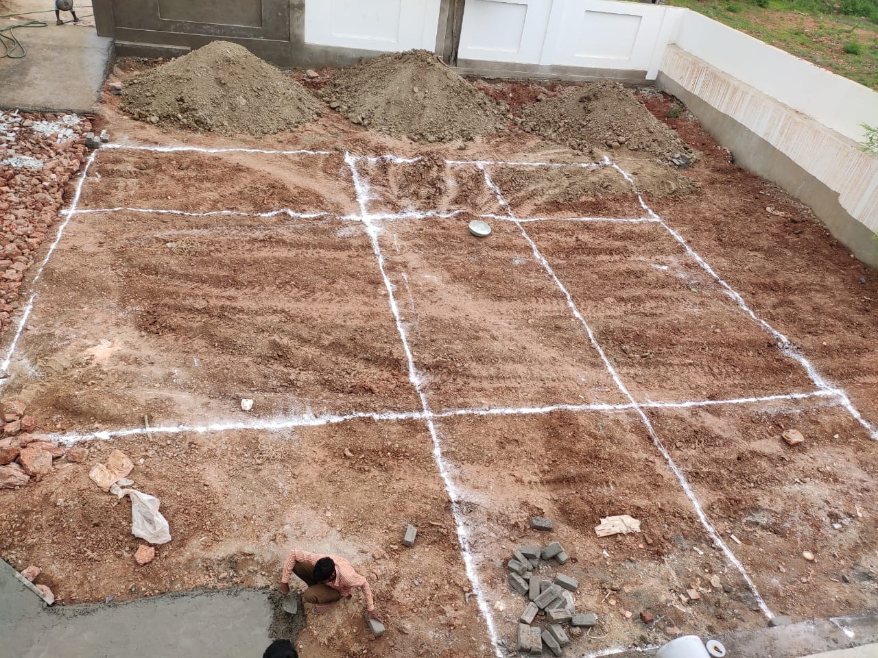

**Figure 1**: Layout of plan of a residential Building

1. **Total Station**

A total station is a surveying instrument that uses an electronic transit theodolite in conjunction with an electronic distance meter (EDM). It is also integrated with a microprocessor, electronic data collector and storage system.

The instrument is used to measure the sloping distance of an object, horizontal angles, and vertical angles. The microprocessor unit enables computation of collected data to further calculate the horizontal distance, coordinates of a point, and reduced level of the point.

Data collected from a total station can be transferred into a computer or laptop for further analysis. This allows for a more in-depth understanding of the information and can help make better decisions.

* **Principal:**

The principle behind a total station is that, if you know the velocity of light and the amount of time it takes to travel between two points, you can determine the distance between them. This is especially useful for surveying and construction work.

**Distance = Velocity X Time**

The total station is programmed with a relation and correction factors to determine the required horizontal distance. This information is displayed on the LCD screen of the instrument.

* **Advantages:**

1. Field work is carried out quickly and efficiently.

2. Measurements are accurate and reliable.

3. Manual errors are eliminated, making results more accurate.

4. Coordinates are calculated quickly and accurately. Temperature and pressure corrections are automatically made.

5. Computers can be used for map making, plotting contours, and cross-sections. Contour intervals and scales can be changed quickly and easily.

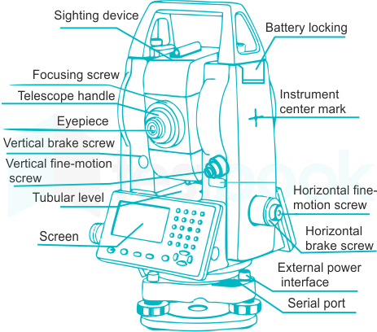

**Figure 2:** Elements of Total Station

1. **Radial Contouring**

Contour is defined as an imaginary line joining points of equal elevations.

* **Instruments:**

Theodolite, Cross Staff, Tape, Plumb Bob, Pegs, Notebook etc.

* **Theory:**

The process of tracing contour lines on the surface of the earth is called contouring. A contour map can provide insight into both the altitudes of surface features, as well as their relative positions. This can be especially useful for those trying to study a particular area, as it can serve as both a plan and a section.

1. If two contour lines cross or meet, it usually indicates an overhanging cliff.

2. The distance between contour lines can show how steep the slope is: Closely spaced contour lines indicate a steep slope, widely spaced contour lines indicate a gentle slope, and equally spaced contour lines indicate a uniform slope.

3. All contour lines should close within the map boundary or outside of it.

4. If a closed contour line has increasing elevation towards the centre, it indicates a hill.

5. If a closed contour line has decreasing elevation towards the centre, it indicates a depression.

* **Procedure:**

1. Find the centre point and measure out lines at equal angles.

2. Place arrows on the lines at 3m and 5m intervals.

3. Choose a location to set up your equipment that will cover the maximum number of points. 4. Hold the levelling staff in place of the arrows.

5. Take note of the readings and record them accurately.

6. Repeat these steps for the other radial lines.

* **Formula:**

1. H.I. = R.L. + B.M.
2. R.L. = H.I. – I.S./F.S.

**Table 2:** Points of Radial Counter by Theodolite

|  |  |  |  |  |  |  |
| --- | --- | --- | --- | --- | --- | --- |
| ***Point*** | ***Staff reading(m)*** | | | ***H.I.***  ***(m)*** | ***R.L.***  ***(m)*** | ***Remarks*** |
|  | ***B.S.*** | ***I.S.*** | ***F.S.*** |
|  | **1.36** |  |  | **101.275** | **99.915** |  |
|  |  | **1.34** |  |  | **99.935** |  |
|  |  | **1.155** |  |  | **100.12** |  |
|  |  | **1.105** |  |  | **100.17** |  |
|  |  | **0.965** |  |  | **100.31** |  |
|  |  | **1.395** |  |  | **99.88** |  |
|  |  | **1.29** |  |  | **99.985** |  |
|  |  | **1.185** |  |  | **100.09** |  |
|  |  | **1.11** |  |  | **100.165** |  |
|  |  | **1.03** |  |  | **100.245** |  |
|  |  | **1.415** |  |  | **99.86** |  |
|  |  | **1.435** |  |  | **99.84** |  |
|  |  | **1.4** |  |  | **99.875** |  |
|  |  | **1.37** |  |  | **99.905** |  |
|  |  | **1.285** |  |  | **99.99** |  |
|  |  | **1.185** |  |  | **100.09** |  |
|  |  | **1.535** |  |  | **99.74** |  |
|  |  | **1.67** |  |  | **99.605** |  |
|  |  | **1.655** |  |  | **99.62** |  |
|  |  | **1.71** |  |  | **99.565** |  |
|  |  | **1.73** |  |  | **99.545** |  |
|  |  | **1.6** |  |  | **99.675** |  |
|  |  | **1.85** |  |  | **99.425** |  |
|  |  | **2** |  |  | **99.275** |  |
|  |  | **2.21** |  |  | **99.155** |  |
|  |  | **2.31** |  |  | **99.055** |  |
|  |  | **1.615** |  |  | **99.66** |  |
|  |  | **1.875** |  |  | **99.4** |  |
|  |  | **2.085** |  |  | **99.19** |  |

|  |  |  |  |  |  |  |
| --- | --- | --- | --- | --- | --- | --- |
|  |  | ***2.26*** |  |  | ***99.015*** |  |
|  |  | ***2.475*** |  |  | ***99.8*** |  |
|  |  | ***2.65*** |  |  | ***99.625*** |  |
|  |  | ***1.64*** |  |  | ***99.635*** |  |
|  |  | ***1.82*** |  |  | ***99.455*** |  |
|  |  | ***1.955*** |  |  | ***99.32*** |  |
|  |  | ***2.06*** |  |  | ***99.215*** |  |
|  |  | ***2.145*** |  |  | ***99.13*** |  |
|  |  | ***1.57*** |  |  | ***99.705*** |  |
|  |  | ***1.695*** |  |  | ***99.58*** |  |
|  |  | ***1.82*** |  |  | ***99.455*** |  |
|  |  | ***1.79*** |  |  | ***99.485*** |  |
|  |  | ***1.81*** |  |  | ***99.465*** |  |
|  |  | ***1.8*** |  |  | ***99.475*** |  |
|  |  | ***1.485*** |  |  | ***99.79*** |  |
|  |  | ***1.56*** |  |  | ***99.715*** |  |
|  |  | ***1.59*** |  |  | ***99.685*** |  |
|  |  | ***1.625*** |  |  | ***99.65*** |  |
|  |  | ***1.635*** |  |  | ***99.64*** |  |
|  |  | ***1.38*** |  |  | ***99.895*** |  |
|  |  | ***1.345*** |  |  | ***99.93*** |  |
|  |  | ***1.4*** |  |  | ***99.875*** |  |
|  |  | ***1.33*** |  |  | ***99.945*** |  |
|  |  | ***1.275*** |  |  | ***100*** |  |
|  |  | ***1.36*** |  |  | ***99.915*** |  |
|  |  | ***1.295*** |  |  | ***99.98*** |  |
|  |  | ***1.305*** |  |  | ***99.97*** |  |
|  |  | ***1.24*** |  |  | ***100.035*** |  |
|  |  |  | ***1.155*** |  | ***100.12*** |  |

1. **Grid Contouring**

*Contour is defined as an imaginary line joining points of equal elevations.*

* **Instruments:**

Theodolite, Cross Staff, Tape, Plumb Bob, Pegs, Notebook etc.

* **Theory:**

The grid method is one way to survey an area. In this method, the area is divided into a grid or series of squares. The size of the grid may vary depending upon the terrain, the contour interval required, and the scale of the map desired.

To use this method, the grid corners are marked on the ground and spot levels of these corners are determined by levelling. The grid is plotted to the scale of the map and the spot levels of the grid corners are entered. The contours of desired values are then located by interpolation.

Special care should be taken to give the spot levels to the salient features of the ground such as hilltops, deepest points of the depressions, and their measurements from respective corners of the grids, for correct depiction of the features.

* **Procedure:**

There are a few steps that need to be taken in order to survey land successfully:

1. Mark square grids on the land - the size of the grid will depend on the size of the area being surveyed.

2.take levels at each corner of the square and at the intersection of the diagonals.

3.The levels taken at the intersection of the diagonals can be used to verify the accuracy of the interpolation.

4. plot a contour map in the office by interpolating points of equal elevation based on the levels taken at the corners of the square.

* **Formula:**
  + - 1. H.I. = R.L. + B.M.
      2. R.L. = H.I. – I.S./F.S.

**Table 3: Grid** Contour points by Theodolite

|  |  |  |  |  |  |  |
| --- | --- | --- | --- | --- | --- | --- |
| **Points** | **Staff Reading(m)** | | | **H.I.**  **(m)** | **R.L.**  **(m)** | **Remarks** |
| **B.S.** | **I.S.** | **F.S.** |
|  | **2.915** |  |  | **101.89** | **98.975** |  |
|  |  | **2.815** |  |  | **99.075** |  |
|  |  | **2.675** |  |  | **99.215** |  |
|  |  | **2.525** |  |  | **99.365** |  |
|  |  | **2.37** |  |  | **99.52** |  |
|  |  | **2.315** |  |  | **99.575** |  |
|  |  | **2.29** |  |  | **99.6** |  |
|  |  | **2.29** |  |  | **99.6** |  |
|  |  | **2.20** |  |  | **99.69** |  |
|  |  | **2.15** |  |  | **99.74** |  |
|  |  | **2.735** |  |  | **99.155** |  |
|  |  | **2.62** |  |  | **99.27** |  |
|  |  | **2.48** |  |  | **99.41** |  |
|  |  | **2.365** |  |  | **99.525** |  |
|  |  | **2.23** |  |  | **99.66** |  |
|  |  | **2.205** |  |  | **99.685** |  |
|  |  | **2.18** |  |  | **99.71** |  |
|  |  | **2.17** |  |  | **99.72** |  |
|  |  | **2.095** |  |  | **99.795** |  |
|  |  | **2.03** |  |  | **99.86** |  |
|  |  | **2.505** |  |  | **99.385** |  |
|  |  | **2.42** |  |  | **99.47** |  |
|  |  | **2.295** |  |  | **99.595** |  |
|  |  | **2.20** |  |  | **99.69** |  |
|  |  | **2.05** |  |  | **99.84** |  |
|  |  | **2.02** |  |  | **99.87** |  |
|  |  | **2.03** |  |  | **99.86** |  |
|  |  | **1.985** |  |  | **99.905** |  |
|  |  | **1.965** |  |  | **99.925** |  |
|  |  | **1.975** |  |  | **99.915** |  |
|  |  | **1.395** |  |  | **100.495** |  |
|  |  | **2.28** |  |  | **99.61** |  |
|  |  | **2.125** |  |  | **99.765** |  |
|  |  | **2.025** |  |  | **99.865** |  |
|  |  | **1.90** |  |  | **99.99** |  |
|  |  | **1.87** |  |  | **100.02** |  |
|  |  | **1.93** |  |  | **99.96** |  |
|  |  | **1.925** |  |  | **99.965** |  |
|  |  | **1.89** |  |  | **100** |  |
|  |  | **1.9** |  |  | **99.99** |  |
|  |  | **2.205** |  |  | **99.685** |  |
|  |  | **2.04** |  |  | **99.85** |  |
|  |  | **1.95** |  |  | **99.94** |  |
|  |  | **1.805** |  |  | **100.085** |  |
|  |  | **1.67** |  |  | **100.22** |  |
|  |  | **1.67** |  |  | **100.22** |  |
|  |  | **1.71** |  |  | **100.18** |  |
|  |  | **1.79** |  |  | **100.1** |  |
|  |  | **1.8** |  |  | **100.09** |  |
|  |  | **1.85** |  |  | **100.04** |  |
|  |  | **2.01** |  |  | **99.88** |  |
|  |  | **1.845** |  |  | **100.045** |  |
|  |  | **1.80** |  |  | **100.09** |  |
|  |  | **1.65** |  |  | **100.24** |  |
|  |  | **1.53** |  |  | **100.36** |  |
|  |  | **1.515** |  |  | **100.375** |  |
|  |  | **1.665** |  |  | **100.225** |  |
|  |  | **1.66** |  |  | **100.23** |  |
|  |  | **1.66** |  |  | **100.23** |  |
|  |  | **1.765** |  |  | **100.125** |  |
|  |  | **1.795** |  |  | **100.095** |  |
|  |  | **1.715** |  |  | **100.175** |  |
|  |  | **1.65** |  |  | **100.24** |  |
|  |  | **1.52** |  |  | **100.37** |  |
|  |  | **1.48** |  |  | **100.41** |  |
|  |  | **1.40** |  |  | **100.49** |  |
|  |  | **1.49** |  |  | **100.4** |  |
|  |  | **1.565** |  |  | **100.325** |  |
|  |  | **1.78** |  |  | **100.11** |  |
|  |  | **1.605** |  |  | **100.285** |  |
|  |  | **1.63** |  |  | **100.26** |  |
|  |  | **1.64** |  |  | **100.25** |  |
|  |  | **1.575** |  |  | **100.315** |  |
|  |  | **1.49** |  |  | **100.4** |  |
|  |  | **1.375** |  |  | **100.515** |  |
|  |  | **1.365** |  |  | **100.525** |  |
|  |  | **1.41** |  |  | **100.48** |  |
|  |  | **1.48** |  |  | **100.41** |  |
|  |  | **1.455** |  |  | **100.435** |  |
|  |  | **1.505** |  |  | **100.385** |  |
|  |  | **1.44** |  |  | **100.45** |  |
|  |  | **1.40** |  |  | **100.49** |  |
|  |  | **1.38** |  |  | **100.51** |  |
|  |  | **1.315** |  |  | **100.575** |  |
|  |  | **1.345** |  |  | **100.545** |  |
|  |  | **1.38** |  |  | **100.51** |  |
|  |  | **1.43** |  |  | **100.46** |  |
|  |  | **1.50** |  |  | **100.39** |  |
|  |  | **1.54** |  |  | **100.35** |  |
|  |  |  | **1.06** |  | **100.83** |  |

1. **Plane Table**

*(Radiation Method)*

* **Equipment:**

Plane table and its accessories (Tripod, Alidade, Trough Compass, Plumbing Fork, Spirit Level, Drawing Sheet, Cello Tape, Pencil, Eraser and dusting cloth), Chain, Tape, Ranging rods, Pegs, Hammer and Field Book.

* **Principle:**

The plane table is a surveying instrument that allows you to create a map or plane of an area without directly measuring any angles. One of the methods used in plane table surveying is radiation. This method is used to locate details.

In this method, you draw a ray from the instrument station to the point. Then, you measure the distance between the instrument station and the point. Finally, you plot the point by using the measured distance. This method is more suitable for small distances. With one instrument station, you can cover several points.

* **Procedure:**

1. Find a point on the ground from which all other points to be located are visible. This will be your vantage point, which we will call "T".

2. Set up a table at point "T" and make sure it is level.

3. Use a plumbing fork to transfer point "T" onto the drawing sheet, making sure it is exactly over station "T" on the ground. We will label this new point "t".

4. Use a trough compass to mark the direction of the magnetic meridian on the drawing sheet.

5. Using the alidade, find the midpoints of A, B, C, D, and E. Do this one after the other. Then, draw the rays along the fiducial edge.

6. Measure the distances from TA, TB, TC, etc. on the ground. Then, using a scale, plot these distances along the corresponding rays. This will show you the positions of points a, b, c, d, e on the drawing sheet.

7. Join points a, b, c, d on the drawing sheet.

* ***Result:***

The area of the plot is 1286.47m2.

