

**Department of Computer Science and Engineering**

**TECHNO INDIA NJR INSTITUTE OF TECHNOLOGY**

RAJASTHAN TECHNICAL UNIVERSITY ( RTU )

**May 2022**

**EMOTION BASED MUSIC PLAYER**

A

Major Project

submitted

in partial fulfillment

for the award of the degree of

**BACHELOR OF TECHNOLOGY**

**In Department Of Computer Science and Engineering**

**Submitted By:** **Submitted To:**

Krithik Jain (18ETCCS056) Mr. Aaditya Maheshwari

Ayush Gadiya (18ETCCS016) ( Project Incharge)

Muskan Panjwani (18ETCCS065)

Bhavika Bhatnagar (18ETCCS017)



**CERTIFICATE**

This is to certify that this project report “**EmMusic**” is the confide work of “**Krithik Jain, Ayush Gadiya, Muskan Panjwani, Bhavika Bhatnagar**” who have carried out the project work under my supervision. I approve this project for submission of the Bachelor of Technology in the **Department of Computer Science and Engineering, Techno India NJR Institute of Technology**, affiliated to Rajasthan Technical University, Kota.

Mr. Aaditya Maheshwari

( Project Incharge)

**ABSTRACT**

**1. Purpose**

***1.1 Introduction***

This Software Requirements Specification provides a complete description of

all the functions and specifications of EmMusic application( Emotion based music player)

The main objective of emotion based music player is to help the user automatically play songs according to their emotions. It reduces user load to face the task of manually browsing the playlist of songs and choosing songs that support their current mood and behavior.

***1.2 Scope***

Scope of this project includes:

* is a useful application for anyone who loves listening music
* be used anywhere any time as it is a mobile application.
* user does not need to manually select song.

**2. Document overview**

The remainder of this document is 8 chapters, the first providing introduction of the project. It lists all the functions performed by the system. The second chapter consists of software requirements specification. The third chapter provides details about system analysis and design. The fourth chapter gives data dictionary information. The fifth chapter consists of snapshots of the complete project. The sixth chapter gives testing for the project. The seventh chapter tells about the conclusion and future enhancements of the project. The final chapter concerns with the bibliography.

**ACKNOWLEDGEMENT**

It gives us immense pleasure to express our deepest sense of gratitude and sincere thanks to our highly respected and esteemed guide Mr**. Aaditya Maheshwari**, TINJRIT for their valuable guidance, encouragement and help for completing this work. Their useful suggestions for this whole work and co-operative behavior are sincerely acknowledged.

We would like to express our sincere thanks to the **faculty, Department of Computer Science and Engineering** TINJRIT for giving us this opportunity to undertake this project.

We also wish to express my indebtedness to our parents as well as our family member whose blessings and support always helped us to face the challenges ahead.

At the end we would like to express our sincere thanks to all our friends and others who helped us directly or indirectly during this project work.

**Krithik Jain ( 18ETCCS056) Place: Udaipur**

**Ayush Gadiya (18ETCCS016)**

**Muskan Panjwani (18ETCCS065)**

**Bhavika Bhatnagar (18ETCCS017)**

**TABLE OF CONTENTS**

**Table of Contents**

Abstract ........................................................................................................... iii

Acknowledgement .......................................................................................... iv

Table of Contents ............................................................................................ v

List of Tables .................................................................................................. vii

List of Figures ................................................................................................ viii

List of Symbols ............................................................................................... ix

**CHAPTER – 1** Introduction .......................................................................... 1-5

1.1. Purpose .................................................................................................... 2

1.2. Overall Description ................................................................................... 4

**CHAPTER – 2** Software Requirement Specification ….............................. 6-12

2.1. Purpose..................................................................................................... 7

2.2. Overall Description ................................................................................... 8

2.2.1. Functional Requirements definitions ..................................................... 9

2.2.2. Use Cases ............................................................................................. 9

2.3. Requirement Specification ...................................................................... 9

2.3.1. External interface specifications .......................................................... 9

2.3.2. Functional Requirements .....................................................................10

2.4. Hardware Specification .......................................................................... 11

2.5. Software Specification ........................................................................... 11

2.6. Software Requirements in detail……………………..………................... 11

**CHAPTER – 3** System Analysis and Design ........................................... 13-19

3.1. Study & Weaknesses of current system………………………................. 14

3.2. Requirements of new system ................................................................. 15

3.3. Feasibility Study ..................................................................................... 15

3.4. Features of new System ........................................................................ 16

3.5. Data flow diagram .................................................................................. 16

3.6. Flow Chart ……………………………………………………………………17

3.7. UML Modeling......................................................................................... 19

3.7.1. Activity Diagram .................................................................................. 19

**CHAPTER – 4** Literature Review ............................................................. 20-22

4.1.Literature Review .................................................................................... 21

**CHAPTER - 5** Screen Shots ................................................................... 23-27

**CHAPTER – 6** Testing ............................................................................. 28-32

**CHAPTER – 7** Conclusion and Future Enhancements ............................ 33-35

7.1. Conclusion ............................................................................................. 34

7.2. Future Enhancements ........................................................................... 34

**CHAPTER – 8** Bibliography .......................................................................... 36

**List of Tables**

|  |  |  |
| --- | --- | --- |
| **Table no** | **Table name** | **Page no** |
| Table 2.1 | Glossary | 7 |
|  | **Use Case** |  |
| Table 2.2 | Access Home Page | 10 |
| Table 2.3 | Get song | 10 |
|  | **Testing** |  |
| Table 6.1 | System functional Testing result | 29 |
| Table 6.2 | Testing result for various image | 30 |

**List of Figures**

|  |  |  |
| --- | --- | --- |
| **Figure no** | **Figure Name** | **Page No.** |
| Figure 1.1 | Use case | 4 |
| Figure 2.1 | Use case | 9 |
|  | **Data flow Diagram** |  |
| Figure 3.1 | DFD | 17 |
|  | **Flow Chart** |  |
| Figure 3.2 | Client side flow chart | 17 |
| Figure 3.3 | Server side flow chart | 18 |
|  | **Unified Modeling Language** |  |
| Figure 3.4 | Activity diagram for user | 19 |

**List of Symbols**

|  |  |
| --- | --- |
| **Term** | **Definition** |
| Application | EmMusic mobile application |
| IEEE | Institute of Electrical and Electronic Engineers |
| QA | Quality Assurance |
| SCMP | Software Configuration Management Plan |
| SDD | Software Design Document |
| SQAP | Software Quality Assurance Plan |
| SRS | Software requirement specification |
| User | End-user of application |
| URL | Uniform Resource Locator |

***CHAPTER – I***

***INTRODUCTION***

**1.1 Purpose**

***1.1.1 Introduction***

This Software Requirements Specification provides a complete description of all the functions and specifications of EmMusic application (Emotion based music player)

The main objective of emotion based music player is to help the user automatically play songs according to their emotions. It reduces user load to face the task of manually browsing the playlist of songs and choosing songs that support their current mood and behavior.

***1.1.2 Scope***

Scope of this project includes:

* is a useful application for anyone who loves listening music
* be used anywhere any time as it is a mobile application.
* user does not need to manually select song.

***1.1.3 References***

[IEEE] The applicable IEEE standards are published in “IEEE Standards Collection,” 2001 edition.

[Bruade] The principal source of textbook material is “Software Engineering: An Object-

Oriented Perspective” by Eric J. Bruade (Wiley 2001).

***1.1.4 Document overview***

The remainder of this document is 8 chapters, the first providing introduction of the project. It lists all the functions performed by the system. The second chapter consists of software requirements specification. The third chapter provides details about system analysis and design. The fourth chapter gives literature review information. The fifth chapter consists of snapshots of the complete project. The sixth chapter gives testing for the project. The seventh chapter tells about the conclusion and future enhancements of the project. The final chapter concerns with the bibliography.

This document is meant for describing all the features and procedures that were followed while developing the system.

This document specially mentions the details of the project how it was developed, the primary requirement, as well as various features and functionalities of the project and the procedures followed in achieving these objectives.

Emotion based music player is proposed system based on real-time extraction of facial expressions from image captured into a specific emotion that will play song according to specified emotion such that the computation cost is relatively low.

With the effective use, any person can use the “Emotion based music player” for playing music according to their mood.

**1.2 Overall description**

This project EmMusic(an emotion based music player) is a novel approach that helps the user to automatically play songs based on the emotions of the user. It recognizes the facial emotions of the user and plays the songs according to their emotion. In existing system user has to manually select the songs, randomly played songs may not match to the mood of the user, user has to classify the songs into multiple emotions and then for playing the songs user has to manually select a particular emotion. According to the emotion, the music will be played from the predefined playlist.

***1.2.1 Functional requirements definitions***

Functional Requirements are those that refer to the functionality of the system, i.e., what services it will provide to the user. Nonfunctional (supplementary) requirements pertain to other information needed to produce the correct system and are detailed separately.

***1.2.2 Use cases***

The user of the application can perform following actions;

* capture image
* view detected emotion
* play suggested song

**Figure 1.1**

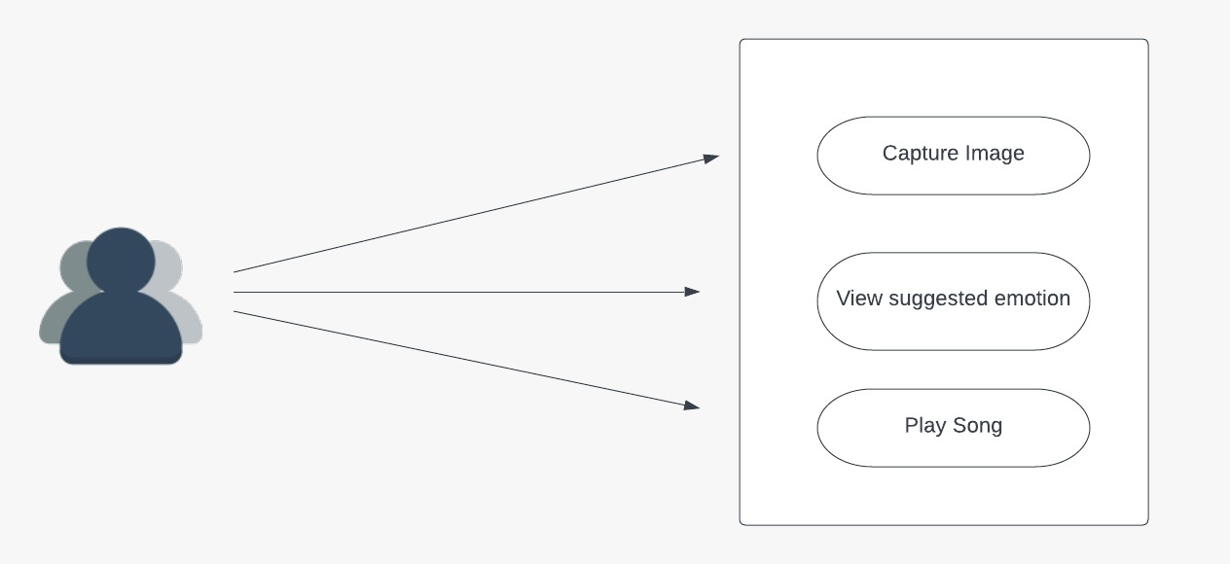

***1.2.3 User characteristics***

Users are typically listeners of music. The user should be familiar with the Music Player related terminology like Play/Pause etc. The user should be familiar with the Internet and Mobile Application.

***1.2.4 Constraints***

The proposed application has following constraints:

* Limited to HTTP/HTTPS.
* No multilingual support.

**CHAPTER – II**

**SOFTWARE REQUIREMENT SPECIFICATION**

**2.1 Purpose**

***2.1.1 Introduction***

This Software Requirements Specification provides a complete description of all the functions and specifications of EmMusic application( Emotion based music player)

The main objective of emotion based music player is to help the user automatically play songs according to their emotions. It reduces user load to face the task of manually browsing the playlist of songs and choosing songs that support their current mood and behavior.

***2.1.2 Scope***

Scope of this project includes:

* is a useful application for anyone who loves listening music
* be used anywhere any time as it is a mobile application.
* user does not need to manually select song.

***2.1.3 Glossary***

**Table 2.1**

|  |  |
| --- | --- |
| **Term** | **Definition** |
| Application | EmMusic mobile application |
| IEEE | Institute of Electrical and Electronic Engineers |
| QA | Quality Assurance |
| SCMP | Software Configuration Management Plan |
| SDD | Software Design Document |
| SQAP | Software Quality Assurance Plan |
| SRS | Software requirement specification |
| User | End-user of application |
| URL | Uniform Resource Locator |

***2.1.4. References***

[IEEE] The applicable IEEE standards are published in “IEEE Standards Collection,” 2001 edition.

[Bruade] The principal source of textbook material is “Software Engineering: An Object-

Oriented Perspective” by Eric J. Bruade (Wiley 2001).

***2.1.5. Document overview***

The remainder of this document is two chapters, the first providing a full description of the project for the owners of EmMusic. It lists all the functions performed by the system. The final chapter concerns details of each of the system functions and actions in full for the software developers’ assistance. These two sections are cross-referenced by topic; to increase understanding by both groups involved.

***2.2. Overall description***

This project EmMusic (an emotion based music player) is a novel approach that helps the user to automatically play songs based on the emotions of the user. It recognizes the facial emotions of the user and plays the songs according to their emotion. In existing system user has to manually select the songs, randomly played songs may not match to the mood of the user, user has to classify the songs into multiple emotions and then for playing the songs user has to manually select a particular emotion. According to the emotion, the music will be played from the predefined playlist.

***2.2.1. Functional requirements definitions***

Functional Requirements are those that refer to the functionality of the system, i.e., what services it will provide to the user. Nonfunctional (supplementary) requirements pertain to other information needed to produce the correct system and are detailed separately.

***2.2.2 Use cases***

The user of the application can perform following actions;

* + capture image
  + view detected emotion
  + play suggested song

**Figure 2.1**



**2.3. Requirement specifications**

***2.3.1. External interface specifications***

None

***2.3.2. Functional Requirements***

**Table 2.2**

|  |  |
| --- | --- |
| **Use case name** | **Access Home Page** |
| Priority | essential |
| trigger | open application |
| precondition | Application is installed |
| Basic path | 1. user launches the application |
| Alternate path | N/A |
| Postcondition | User is on home page |
| Exception path | N/A |

**Table 2.3**

|  |  |
| --- | --- |
| **Use case name** | **Get Song** |
| Priority | essential |
| trigger | Image capture |
| precondition | 1. user is on application home page  2. application has camera access |
| Basic path | User is on home page  1. user clicks “Take a Picture” button |
| Alternate path | N/A |
| Postcondition | User is suggested song. |
| Exception path | If the server is not running or server URL is not set, the application fails to suggest song. |

**2.4. Hardware Specification**

***Client Side:***

* Mobile Device : Android
* Android Version : 10 and Above
* RAM : 4 GB
* Camera : Required ( In-Built Front Camera )

***Server Side***:

* Processor : 2.00 GHz
* RAM : 8 GB
* Disk space : 20 GB

**2.5. Software Specification:**

***Client Side:***

* APK of EmMusic App

***Server Side:***

* Python
* Django
* Windows 10/11
* NGROK

**2.6 Software Requirements in Detail:**

***Microsoft Visual Studio 2010***

Microsoft Visual Studio is an integrated development environment (IDE) from Microsoft. It can be used to develop console and graphical user interface applications along with Windows Forms applications, web sites, web applications, and web services in both native code together with managed code for all platforms supported by Microsoft Windows, Windows Mobile.

***Required Libraries :***

openCV, Keras, TensorFlow, Pillow, Matplotlib, spotify,

***Android Studio***

Android Studio is the official integrated development environment (IDE) for Android application development. It is based on the IntelliJ IDEA, a Java integrated development environment for software, and incorporates its code editing and developer tools.

***Postman***

Postman is an application used for API testing.

**CHAPTER – III**

**SYSTEM ANALYSIS AND DESIGN**

**System Analysis and Design**

**3.1. Study & Weaknesses of Current System**

***Current System***

The Current system of listening music is highly complicated. In existing system user has to manually select the songs, randomly played songs may not match to the mood of the user.

***Weaknesses in Current System***

The current system is as mentioned earlier very complicated and as compared to the new system. It also wastes the precious time of the user which can then be used in focusing on different activities and helping them improvise our mood.

Music plays a very primary role in elevating an individual‘s life as it is an important medium of entertainment for music lovers and listeners. In today ‘s world, with the increasing advancements in the field of multimedia and technology, various music players have been developed with features like fast forward, reverse, variable playback speed, genre classification, streaming playback with multicast streams and including volume modulation, etc. These features might satisfy the user‘s basic requirements, but the user has got to face the task of manually browsing the playlist of songs and choose songs supported their current mood and behavior. It would mean extra time and extra work for the user.

Thus, the current system is in every way ineffective for listening music in these days when time is more costly than anything.

**3.2. Requirements of New System**

**3.2.1. User Requirements**

The User requirements for the new system are to make the system fast, flexible, less prone to errors and save time.

* Time can be saved in creating playlist according to emotion of the user.
* A system that can play music according to specified emotion.
* The system doesn’t need to have any records on hand which to use application.
* The New system should be more secure in managing user image data and reliable enough to be used in any condition.
* Finally, it should prove cost effective as compared to the current system.

**3.3. Feasibility Study**

A key part of the preliminary investigation that reviews anticipated costs and benefits and recommends a course of action based on operational, technical, economic, and time factors. The purpose of the study is to determine if the systems request should proceed further

***3.3.1. Does the New System Contribute to the Overall Objectives of the User?***

The new system would contribute to the overall objectives of the User. It would provide a quick, error free and effective solution to the current process. The focus of this project will be entirely on the detection of facial expression and integrates it to the play music. As a prototype, the proposed model will detect only the basic emotion such as happy, sad, neutral, angry, fear, and surprise etc. The new system is flexible and scalable it can also be upgraded and extended to meet other complex requirements which may be raised in the future. However it is up to the organization to upgrade or extend it.

***3.3.2. Can the New System be Implemented Using Current Technology?***

It would be very easy to set up the system in the current environment as the application is mobile based. The application is set up on the server and the Django installed on machine, the system can be started as quick as required by the management.

**3.4. Features of the New System**.

The features available in the existing Music players present in computer systems are as follows: Manual selection of Songs, Party Shuffle, Playlists, Music squares where user has to classify the songs manually according to particular emotions for only four basic emotions. In today‘s world, with ever increasing advancements in the field of multimedia and technology, various music players have been developed.

The new system has been designed as per the user requirements so as to fulfill almost all them.

* It recognizes emotions through facial expressions.
* Recommend songs based on specified emotion.
* Easy to use.
* save time and efforts.

**3.5. Data Flow Diagram (DFD)**

The DFD (also known as bubble chart) is a simple graphical formalism that can be used to represent a system in terms of the input data into the system, various processes carried on these data, and the output data generated by the system. The main reason why the DFD technique is so popular is because the fact that the DFD is a very simple formalism – it is simple to understand and use. A DFD model uses a very limited number of primitive symbols to represent the functions performed by a system and the data flow among the functions. Starting with a set of high-level functions that a system performs, a DFD model hierarchy represents various sub-functions

**Figure 3.1**

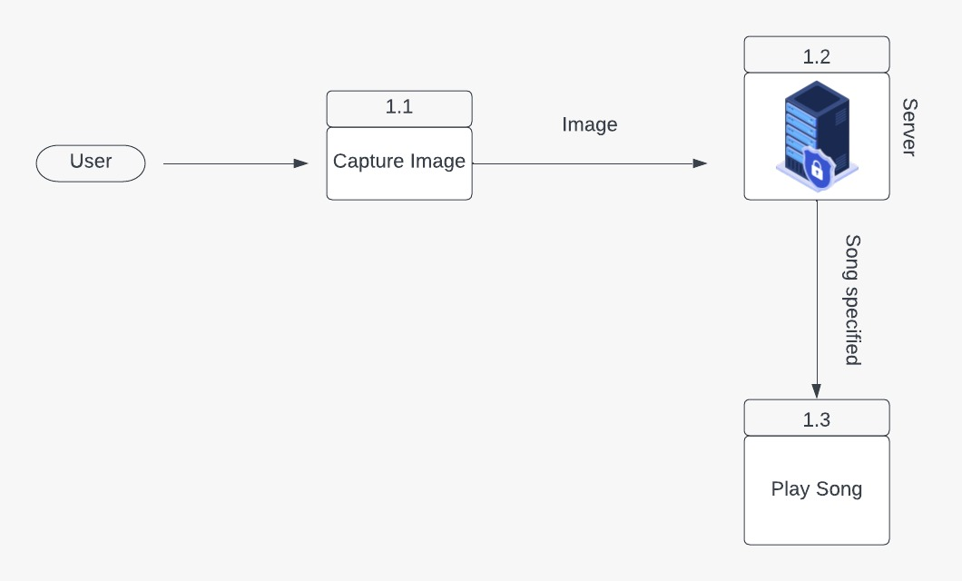

**3.6 Flow Chart**

A flowchart is a graphical representation of a process. It is a diagram that illustrates the workflow required to complete a task or a set of tasks with the help of symbols, lines and shapes. Flowcharts are used to study, improve and communicate processes in various fields.

***3.6.1 Client Side Flow Chart***

**Figure 3.2**

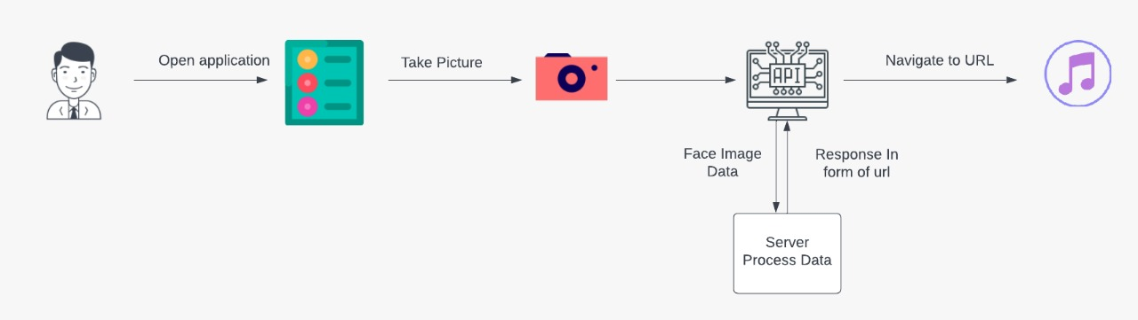

***3.6.2 Server Flow Chart***

**Figure 3.3**

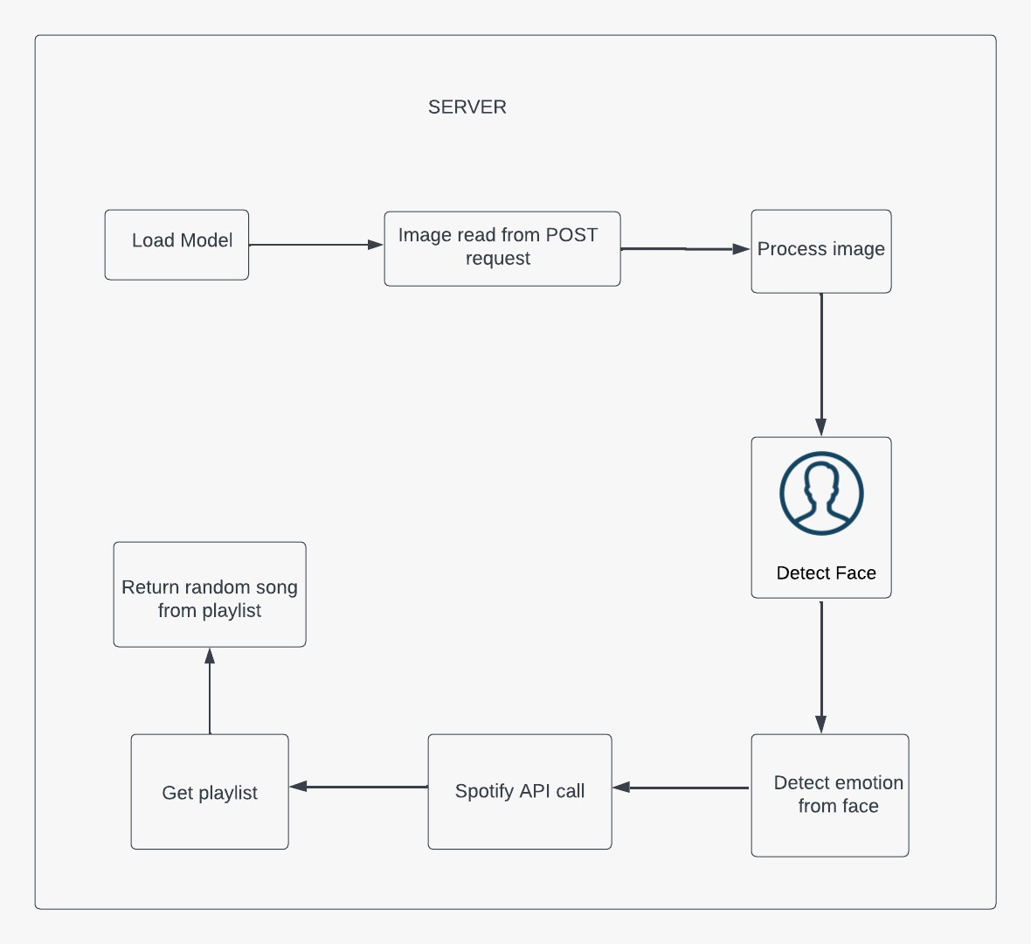

**3.7. UML Modelling**

***3.7.1 Activity Diagram***

**Figure 3.4:** **Activity Diagram for User**

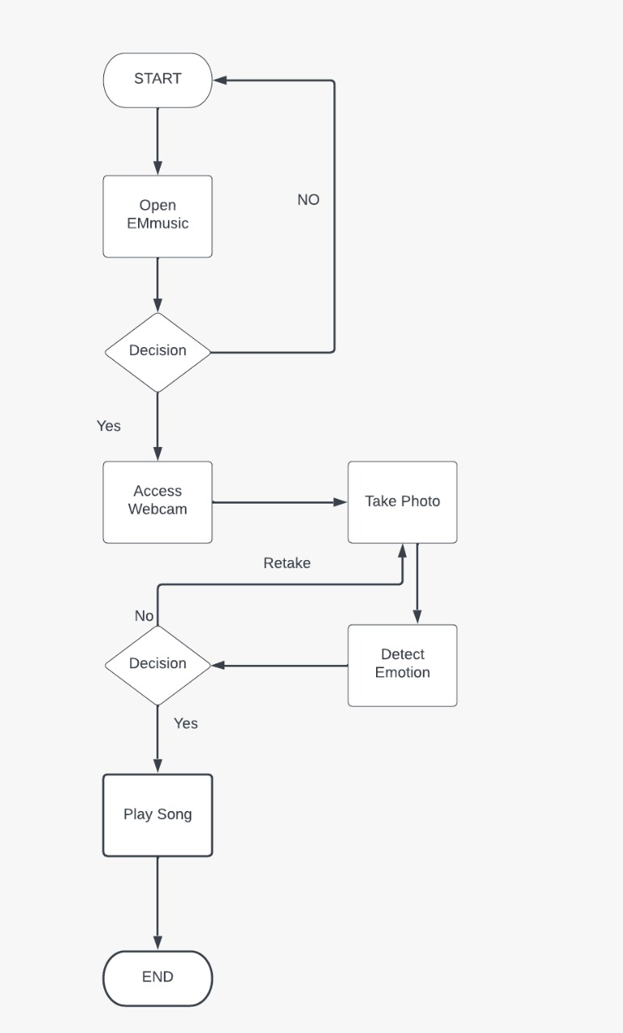

**CHAPTER IV**

**LITERATURE REVIEW**

**4.1 Literature Review**

There are several applications that provide facilities and services for music playlist generation or play a particular song and in this process, all manual work is involved. Now to provide there are various techniques and approaches have been proposed and developed to classify the human emotional state of behavior. The proposed approaches have only focused on only some of the basic emotions using complex technique

Mary Duenwald had published an article which summarizes that scientists had did several studies and researches and shown that facial expressions across the globe fall roughly into seven categories:

* **Sadness**: The eyelids droop while the inner corners of the brows rise. When in extreme sadness, the brows will all push nearer together. As for the lips, both of its corners pull down and the lower lip may push up in a mope.
* **Surprise**: Both the upper eyelids and brows rise, and the jaw drops open.
* **Anger:** Both the lower and upper eyelids squeeze in as the brows move down and draw together. The jaw pushes forward, the upper and lower lip press on each other when the lower lip pushes upper a bit.
* **Neutral:**
* **Disgust**: The individual’s nose wrinkles and the upper lip rise while the lower lip protrudes.
* **Fear:** The eyes widen and the upper lids rise. The brows draw together while the lips extend horizontally.
* **Happiness:** The corners of the lips lifted and shaped a smile, the eyelids tighten, the cheeks rise up and the outside corners of the brows pull down.

We primarily aim and focus on resolving the drawbacks involved in the existing system by designing an automated emotion based music player for the playing song based on user extracted facial features and thus avoiding the employment of any additional hardware

***CHAPTER – V***

***SCREEN SHOTS***

***Splash screen:***

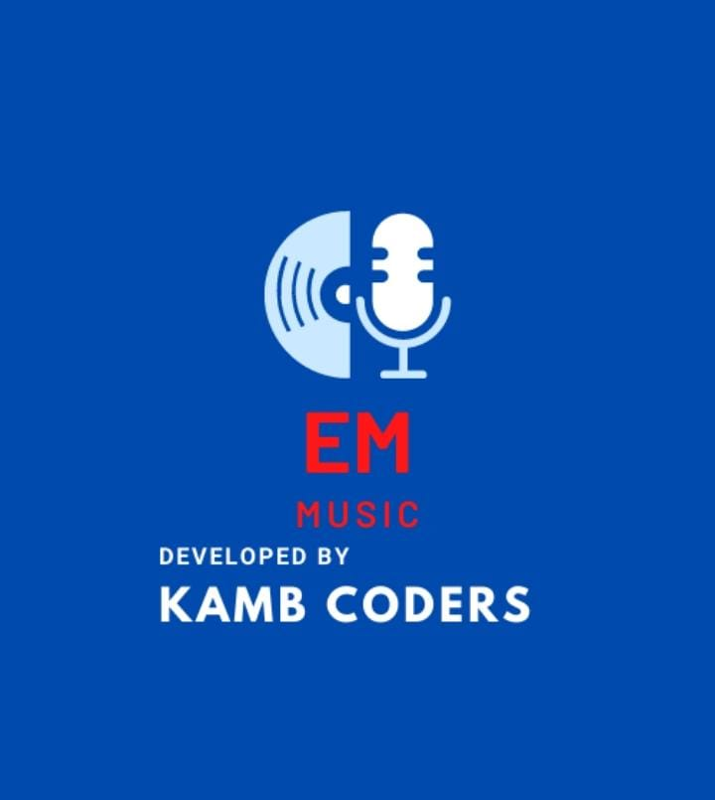

***Home-screen***

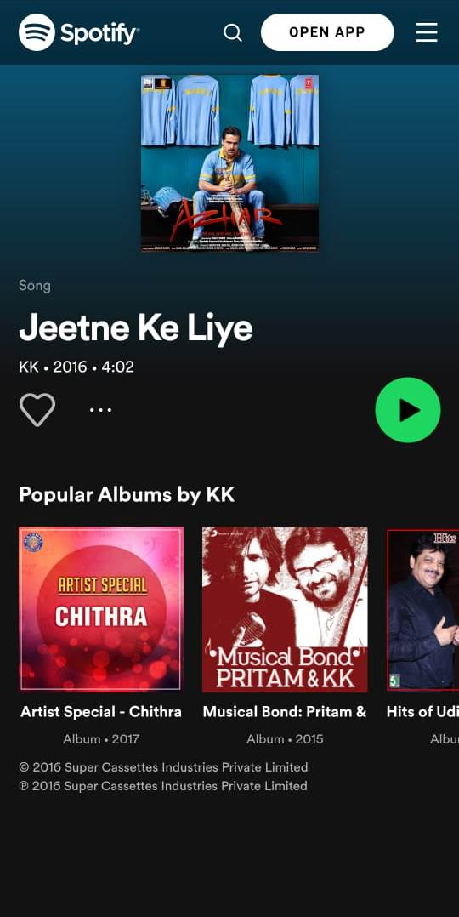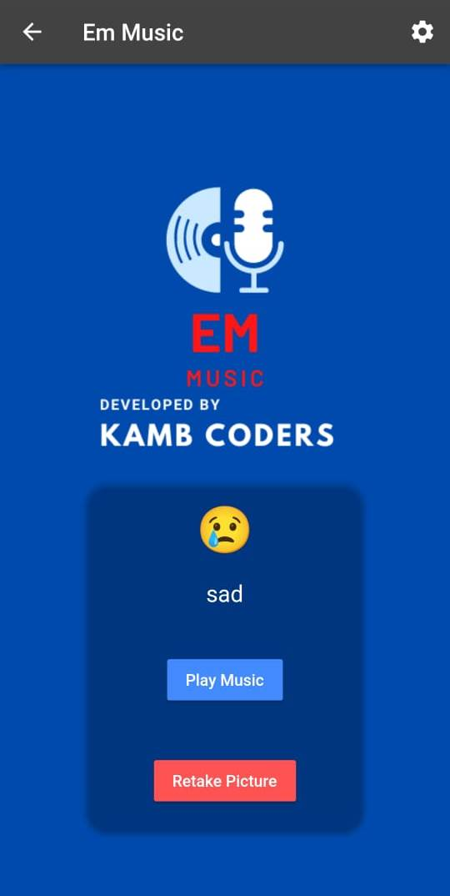**Result:**

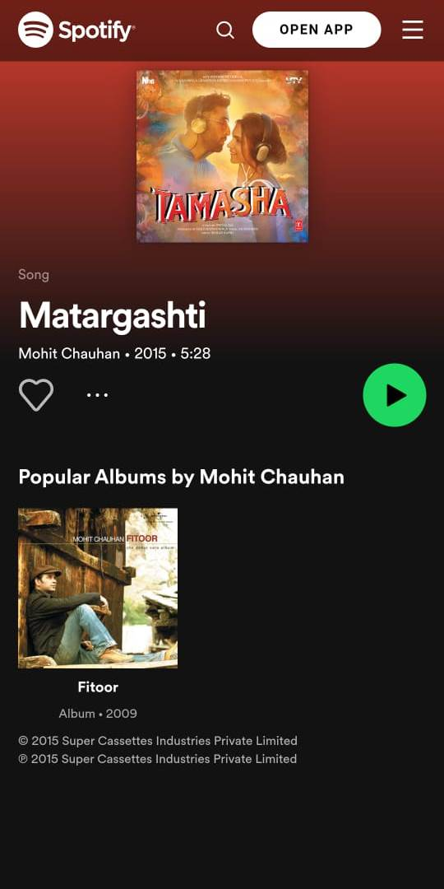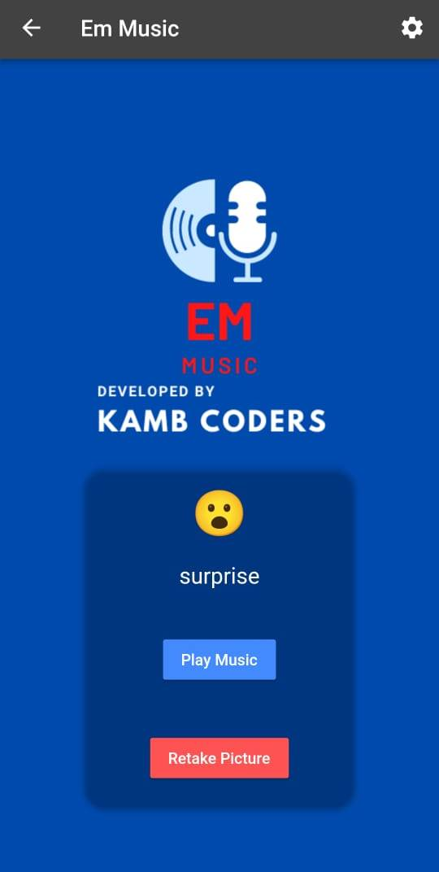

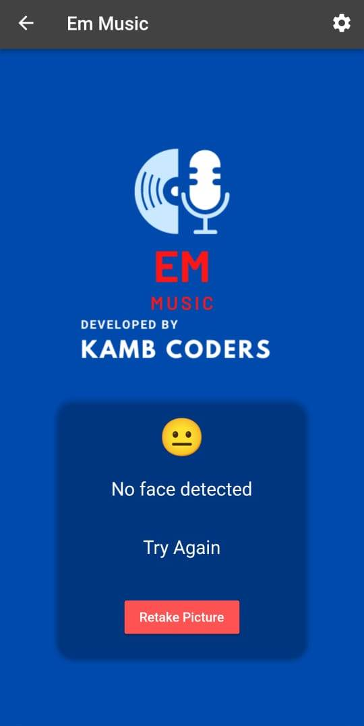

**CHAPTER – VI**

**TESTING**

**Testing**

**System Testing Results**

The user carried out system testing once the completion of the system development. The purpose of this testing is to check the functionalities system, whether if it is usable and well functioned. The results from the functional testing can be seen in the table below

**Table 6.1: System functional testing results**

|  |  |  |  |
| --- | --- | --- | --- |
| COMPONENT | EXPECTED FUNCTION | TESTING RESULT | |
| POSITIVE | NEGATIVE |
| “TAKE A PICTURE” Button | To capture image & fetch image analysis results. | ✓ |  |
| ‘’RETAKE PICTURE” Button | To navigate user back to previous screen to recapture image. | ✓ |  |
| “SETTING” Button | Enable user to set server URL | ✓ |  |
| “PLAY MUSIC” Button | To open window to play suggested music. | ✓ |  |
| “BACK ” Button | To take back to home screen. | ✓ |  |

**Emotion Accuracy Testing Results**

Set of images for the each emotions (normal, sad, surprise and happy) are saved in the proposed model for the comparison purposes. The newly load images will be compared with the saved dataset in order to detect the emotion of the users. Table below showed the set of images that saved in the proposed model.

**Table 6.2: Testing result for various images**

|  |  |  |  |
| --- | --- | --- | --- |
| Image | Expected Output | Detected Emotion | Test Status |
|  | Happy | Happy | Pass |
|  | Neutral | Neutral | Pass |
|  | Sad | Sad | Pass |
|  | Angry | Sad | Fail |
|  | No Face is Detected | No Face is Detected | Pass |
|  | Fear | Sad | Fail |
|  | Surprise | Surprise | Pass |
|  | Disgust | Sad | Fail |

**Recognition Rate:**

In order to find the RR (Recognition Rate), the following formula is applied to the results

Collected as follows:

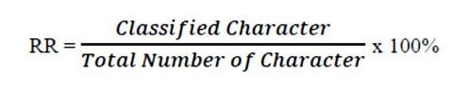

RR = 5/8* 100

RR = 62.5%

Based on the result above, it shows that the proposed model has the recognition rate (RR) of 62.5%

**CHAPTER – VII**

**CONCLUSION AND FUTURE ENHANCEMENTS**

**Conclusion:**

The significance of this project is the emotion detection of the images loaded into the proposed model. The main purpose is on its emotion detection functionality. Through the integration between emotion detection technology and music player, the proposed model is aimed to provide betterment in the individual’s entertainment. The proposed application is able to detect the emotions i.e. anger, fear, happy, surprised, neutral, sad and disgust. Once the proposed model detected the emotion, music player will play the song(s) accordingly. As for the usability and accuracy, both system testing and emotion accuracy testing has been done to the proposed model and return a satisfying result. The proposed model is an application which can works well in all mobile devices. Thus with this Emotion Based Music Player, users can have an alternative way of selecting songs, which is in a more interactive and simpler way. It can help the music lovers to search and play songs according to their emotions automatically

**Future Enhancements**

Enhancements are the perquisite for development of a system. Every existing system has proposed enhancements which make it better and easier to use and more secure. The enhancements that have been proposed for this system are listed here:

* the future scope of the system would be to design a mechanism that would be helpful in music therapy treatment and help the music therapist to treat the patients suffering from disorders like mental stress, depression, trauma, and anxiety.
* A more compact device can be designed
* A more accurate playlist can be generated
* Voice/Facial recognition can be made more efficient
* Humans tend to link the music they listen to; to the emotion, they are feeling. The song playlists though are, at times, too large to sort out automatically. It can be a great relief if the music player was “smart enough” to sort out the music based on the current state of emotion the person is feeling. The project sets out to use various techniques for an emotion recognition system, analyzing the impacts of different techniques used.
* We can develop parallel software that can be used anywhere with the help of providing the functionality of playing music according to the emotion detected. Developing a recommendation system could assist a user to decide which music one should listen to, helping the user to reduce his/her stress levels.
* Playing songs automatically, optimizing the EMO algorithm by including additional features which help the system to categorize users based on many other factors like location and suggesting the user travel to that location and play songs accordingly.
* There are a lot of limitations; creating a custom emotion recognition system that can be merged into the current application improves the functionality and performance of the system. Making the application run without needing an internet connection.

**CHAPTER – VIII**

**BIBLIOGRAPHY**

* **List of useful Websites**
* www.msdn.microsoft.com
* www.w3schools.com
* [www.webdevelopersnotes.com](http://www.webdevelopersnotes.com)
* <https://www.tutorialspoint.com/index.htm>
* <https://www.javatpoint.com/>
* <https://www.raspberrypi.org/educatio>
* <https://ijesc.org/upload/f84e4ed155562ccd70a125354f4d5ba9.Emotion%20Based%20Music%20Player.pdf>
* **List of useful Books**
* Hafeez Kabani, Sharik Khan, Omar Khan, Shabana Tadvi” Emotion Based Music Player” International Journal of Engineering Research and General Science Volume 3, Issue 1, January-February, 2015
* OReilly(E-Book) : Programming in Python