***Marketing Domain Automation***

*A*

***Major Project Report***

*Submitted*

*In partial fulfillment*

*For the award of the Degree of*

**BACHELOR OF TECHNOLOGY**

*In department of Computer Science and Engineering*

**Submitted By: Guided By: Submitted To:**

Mohit Sadhwani Mr. Aaditya Maheshwari Department of

*18ETCCS064 (Project In-charge,* Computer Science

Mehul Joshi *Department of Computer* and Engineering

*18ETCCS059 Science)*

Harshil Taunk

*18ETCCS038*



Department of Computer Science and Engineering

TECHNO INDIA NJR INSTITUTE OF TECHNOLOGY



CERTIFICATE

This is to certify that this project report “**Marketing Domain Automation**” is the confide work of **“Harshil Taunk - 18ETCCS038, Mehul Joshi - 18ETCCS059 & Mohit Sadhwani - 18ETCCS064**” who have carried out the project work under my supervision. I approve this project for submission of the Bachelor of Technology in the **Department of Computer Science and Engineering**, **Techno India NJR Institute of Technology**, affiliated to Rajasthan Technical University, Kota.

Mr. Aditya Maheshwari

Project In-charge,

Department of Computer Science

ABSTRACT

1. Purpose
   1. Introduction

This Software Requirement Specification provides a complete description of all the functions and specifications of the Marketing Domain Automation.

1. Document Overview

The remainder of this document 8 chapters, the first providing introduction of the project. It lists all the functions performed by the system. The second chapter consists of Software Requirements Specification. The third chapter provides details about system analysis and design. The fourth chapter gives data dictionary information. The fifth chapter consists of snapshots of the complete project. The sixth chapter gives the testing for the project. The seventh chapter tells about the conclusion and future enhancements of the project. The final eighth chapter concerns the bibliography.

## ACKNOWLEDGEMENT

It gives me immense pleasure to express my deepest sense of gratitude and sincere thanks to my highly respected and esteemed guide Mr. Aditya Maheshwari (Project In charge), TINJRIT for their valuable guidance, encouragement and help for completing this work. Their useful suggestions for this whole work and co-operative behaviour are sincerely acknowledged.

I would like to express my sincere thanks to Faculty of department of computer science & engineering, TINJRIT for giving me this opportunity to undertake this project.

I also wish to express my indebtedness to my parents as well as my family member whose blessings and support always helped me to face the challenges ahead.

At the end I would like to express my sincere thanks to all my friends and others who helped me directly or indirectly during this project work.

TABLE OF CONTENTS

Table of Contents

Abstract ..................................................................................................................................................... Acknowledgement ....................................................................................................................................

CHAPTER -1 Introduction ..........................................................................................................................

1.Introduction ...........................................................................................................................................

1.1. Goal.................................................................................................................................

1.2. Need of the application...................................................................................................

1.3. Scope………………………………………………………………………………………………………..…………………

CHAPTER - 2 Software Requirement Specification ...................................................................................

CHAPTER-3 System Requirement Analysis ................................................................................................

3.1. Information Gathering .....................................................................................................

CHAPTER-4 System Analysis.......................................................................................................................

CHAPTER-5 Design ..........................................................................................................................…………

5.1 Design Goals........................................................................................................................

5.2 Architectural Design ...........................................................................................................

CHAPTER-6 Implementation ......................................................................................................................

Screenshots of Implementation ...............................................................................................

CHAPTER-7 Results & Challenges...............................................................................................................

Challenges.................................................................................................................................

CHAPTER-8 Conclusions..............................................................................................................................

Limitations ...............................................................................................................................

Scope for Future Work...................................................................................................

CHAPTER-9 References………………………………………………………………………………………………………

CHAPTER – 1

INTRODUCTION

Introduction

* 1. Purpose
     1. Introduction
  2. Goal

Every business today needs marketing and one type of marketing is to improve to reach of your business or website to a greater target audience. For that, companies hire many employees to do their marketing on different social media platforms. So, the goal of this application is to automate these tedious and repetitive tasks and allow the bot or system to perform these tasks and allow the employees to use their skills to work on more creative and complex ones which require advance problem-solving.

* 1. Need of the application

Need of this application is equal to the need of social media marketing and social media marketing costs a lot of time and money if a company hires people to do this job. So once this bot is implemented in the system so there is no need for employees to work on tedious and repetitive tasks rather than they can work on tasks that require problem-solving skills. This promote more skilful work for humans and more tedious and repetitive work for machines.

CHAPTER – 2

SOFTWARE REQUIREMENT SPECIFICATION

Software Requirement Specification

**Automation**

Basic automation takes simple, rudimentary tasks and automates them. This level of automation is about digitizing work by using tools to streamline and centralize routine tasks, such as using a shared messaging system instead of having information in disconnected silos. [Business Process Management (BPM)](https://www.ibm.com/cloud/learn/business-process-management) and [Robotic Process Automation (RPA)](https://www.ibm.com/cloud/learn/rpa) are types of basic automation.

**Robotic Process Automation**

Robotic process automation (RPA) is a software technology that makes it easy to build, deploy, and manage software robots that emulate humans actions interacting with digital systems and software. Just like people, software robots can do things like understand what’s on a screen, complete the right keystrokes, navigate systems, identify and extract data, and perform a wide range of defined actions. But software robots can do it faster and more consistently than people, without the need to get up and stretch or take a coffee break.

**UiPath**

UiPath is a robotic process automation tool for large-scale end-to-end automation. For an accelerated business change, it provides solutions for businesses to automate routine office activities. It uses a variety of methods to transform tedious tasks into automated processes.

* **Save Time and Efforts**

UiPath streamlines processes, uncovers efficiencies and provides insights, making the path to digital transformation fast and cost-effective. It leverages existing systems to minimize disruption.

* **Elevate your employees’ experience**

By automating tasks, your teams are free to spend time on work with better returns. More than 200 ready-made components in our Marketplace give your employees more time—in less time.

* **Ensure Compliance**

UiPath robots improve compliance by following the exact process that meets your standards. Reporting tracks your robots, so documentation is always at your fingertips.

* **Improve Customer Experience**

With robots handling tasks, teams are free to deliver extra service to your highest-level customers. By standardizing processes, your outcomes are more efficient and effective.

**Microsoft Excel**

A software program created by Microsoft that uses spreadsheets to organize numbers and data with formulas and functions. Excel analysis is ubiquitous around the world and used by businesses of all sizes to perform [financial analysis](https://corporatefinanceinstitute.com/collections/finance).

**Chrome**

Chrome is a free Internet browser officially released by Google on December 11, 2008. Its features include synchronization with Google services and accounts, tabbed browsing, and automatic translation and spell check of web pages. It also features an integrated address bar/search bar, called the omnibox.

CHAPTER – 3

SYSTEM REQUIREMENT ANALYSIS

System Requirement Analysis

3.1. Information Gathering

Research is conducted on what other companies use for marketing on social media and the result was most companies hire other employees or ask their own employees for promotion of their company which requires extra time and money and the employees cannot focus on problem-solving tasks because of these repetitive and tedious tasks.

After this research, we thought of a solution to automate this process which saves time and money for the organization.

We have identified that UiPath will do this work for us. Therefore, the user just needs a good internet connection and the links to the blogs to post in Excel. In this project, we are using Microsoft Excel as a database. UiPath just works with one click and rest of the work will be done by the robot or machine.

CHAPTER – 4

SYSTEM ANALYSIS

System Analysis

After carefully analyzing the requirements and functionality of the automation project. We had two diagrams at the end of the analysis phase. They are the ER diagram and the Data Flow Diagram which were the basis for finding out entities and the relationship between them.

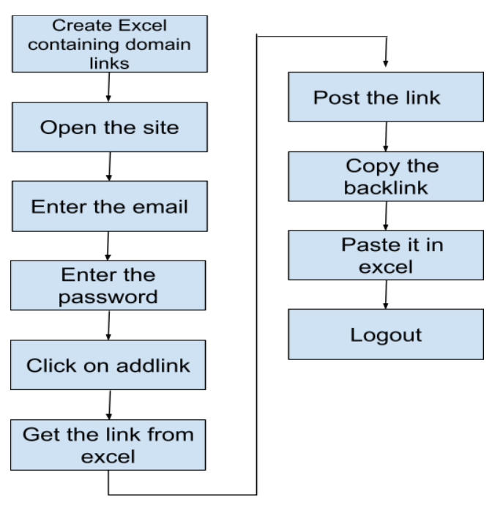

CHAPTER – 5

DESIGN

Design

The design of the project involves creating the UI flow in the UiPath Studio to perform the task. Designing in this scenario involves how the data should pass from excel to the provided websites and also how to authenticate credentials using UiPath automation.



CHAPTER – 6

IMPLEMENTATION

**Screenshots of working project:**

* *Excel (Database)*

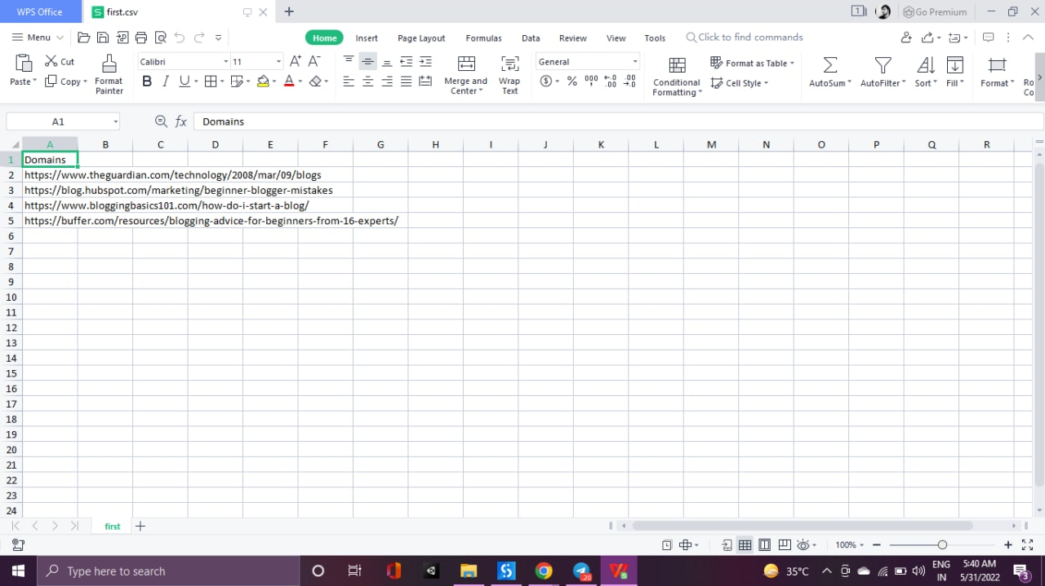

* *UiPath Flow*

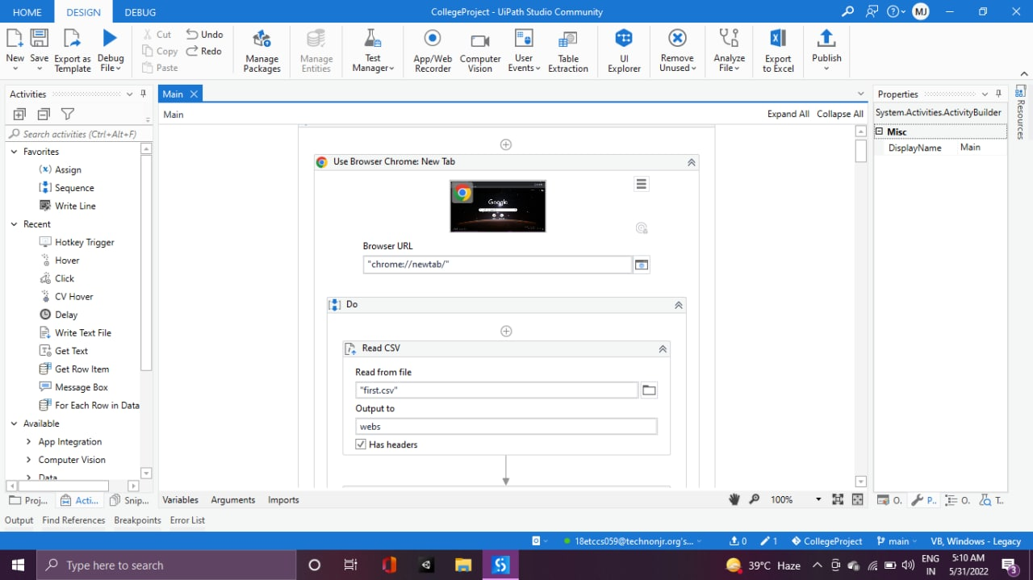

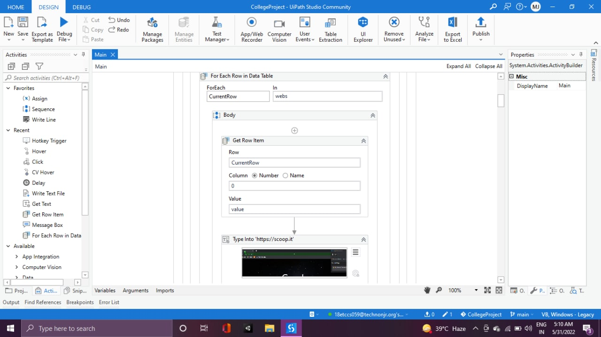

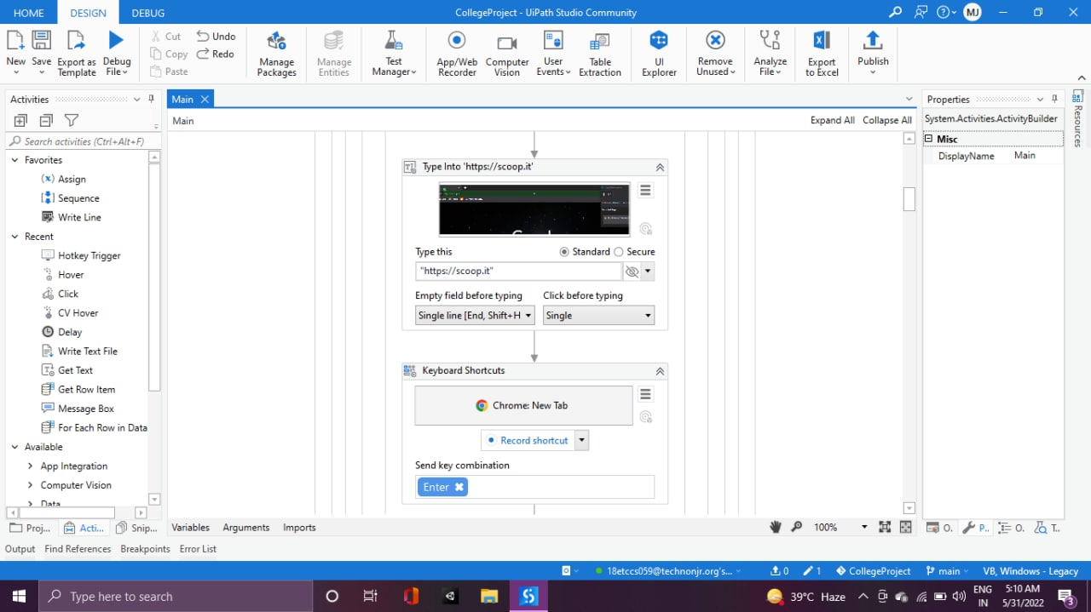

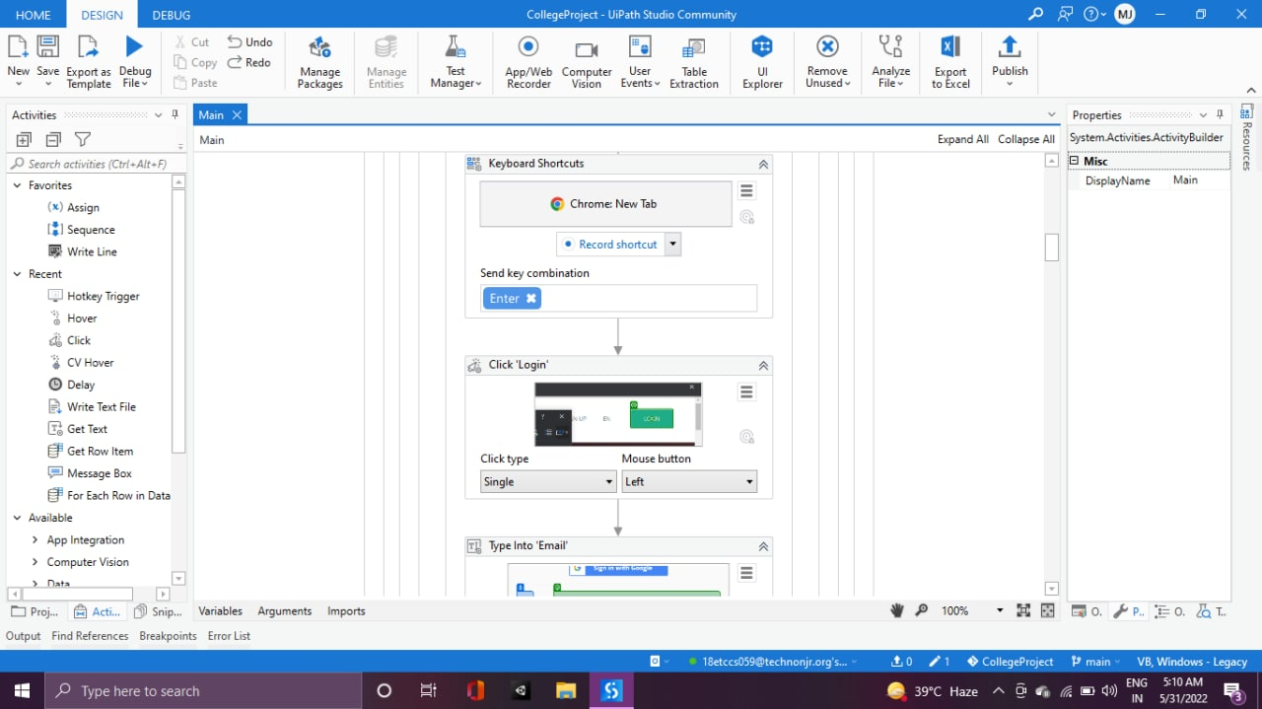

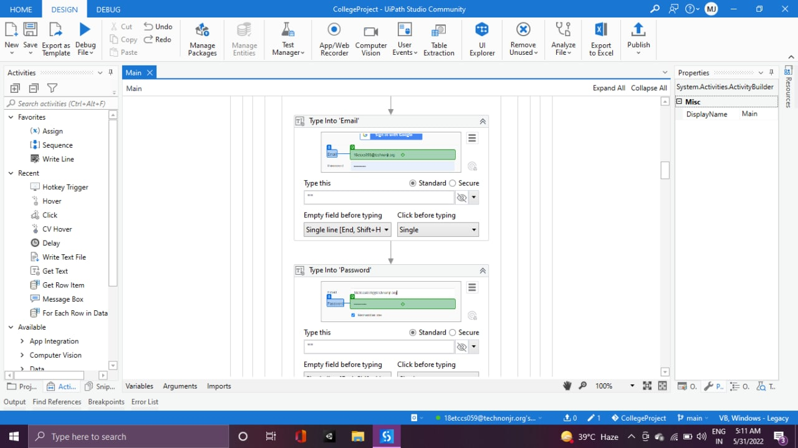

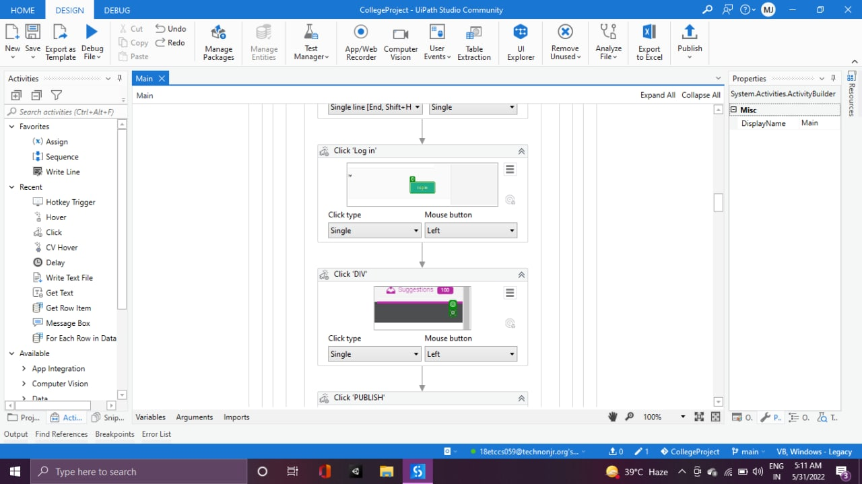

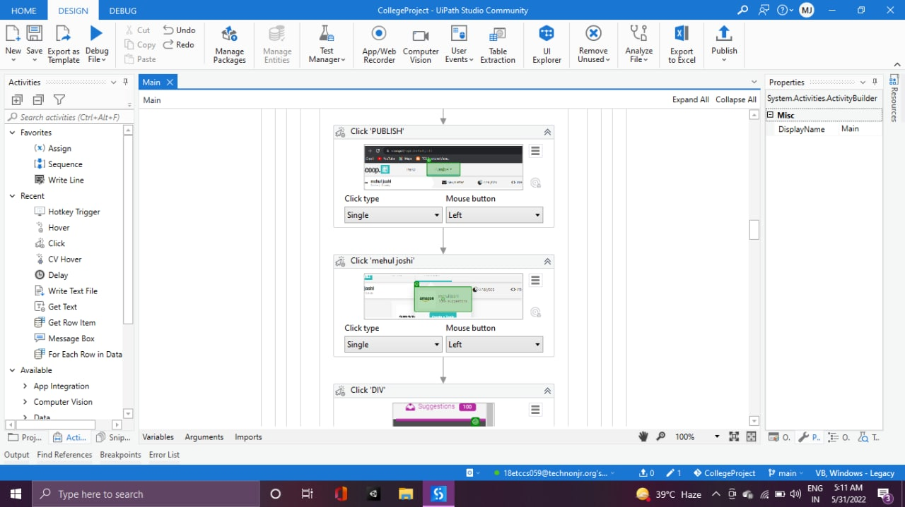

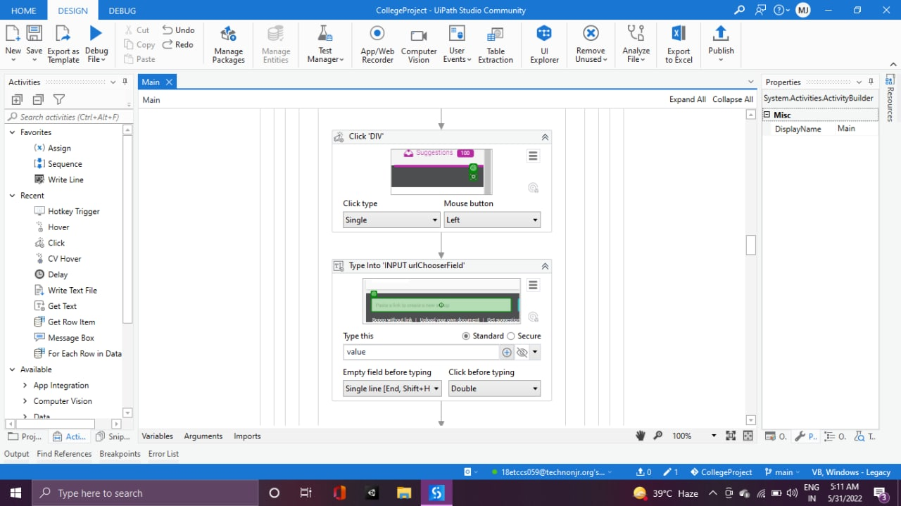

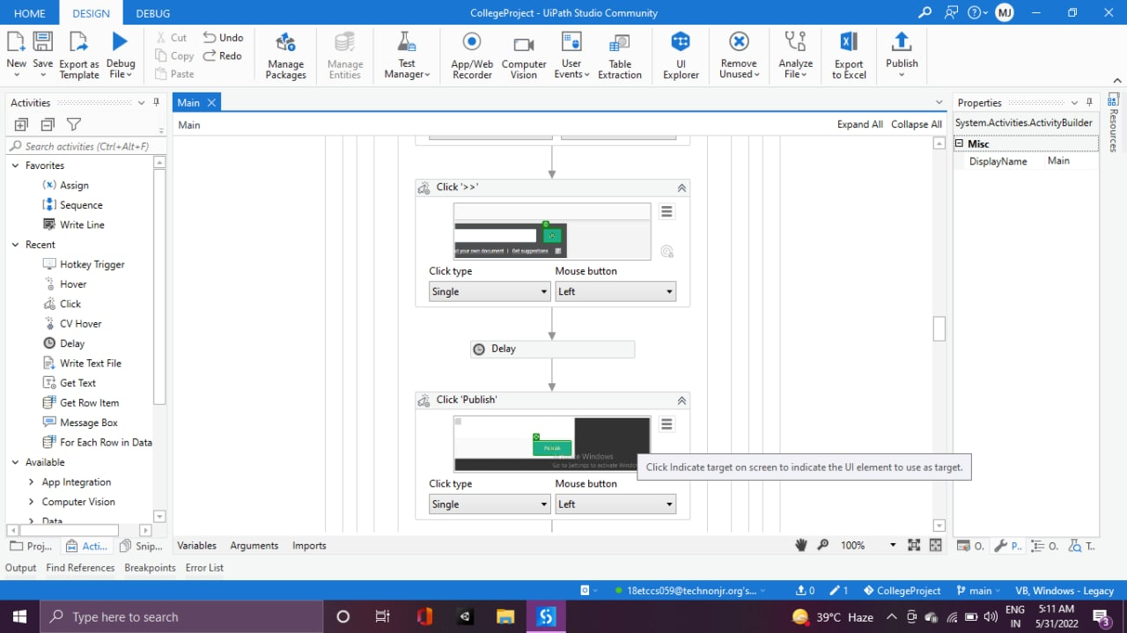

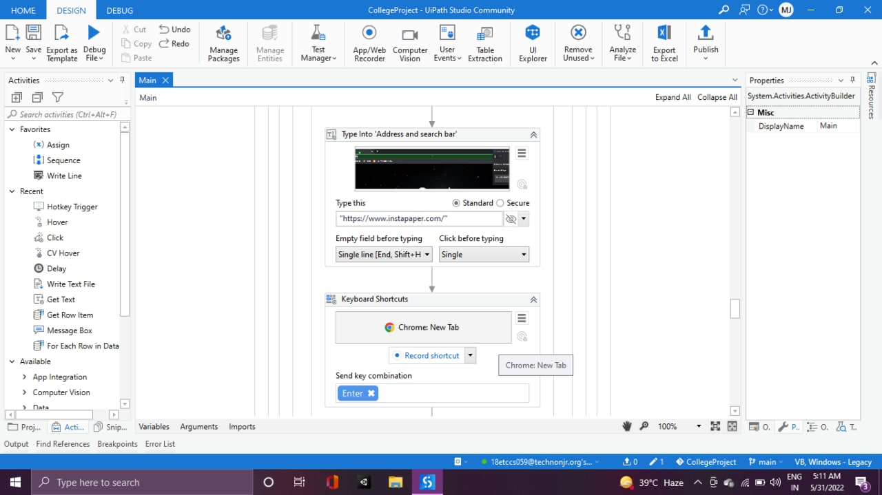

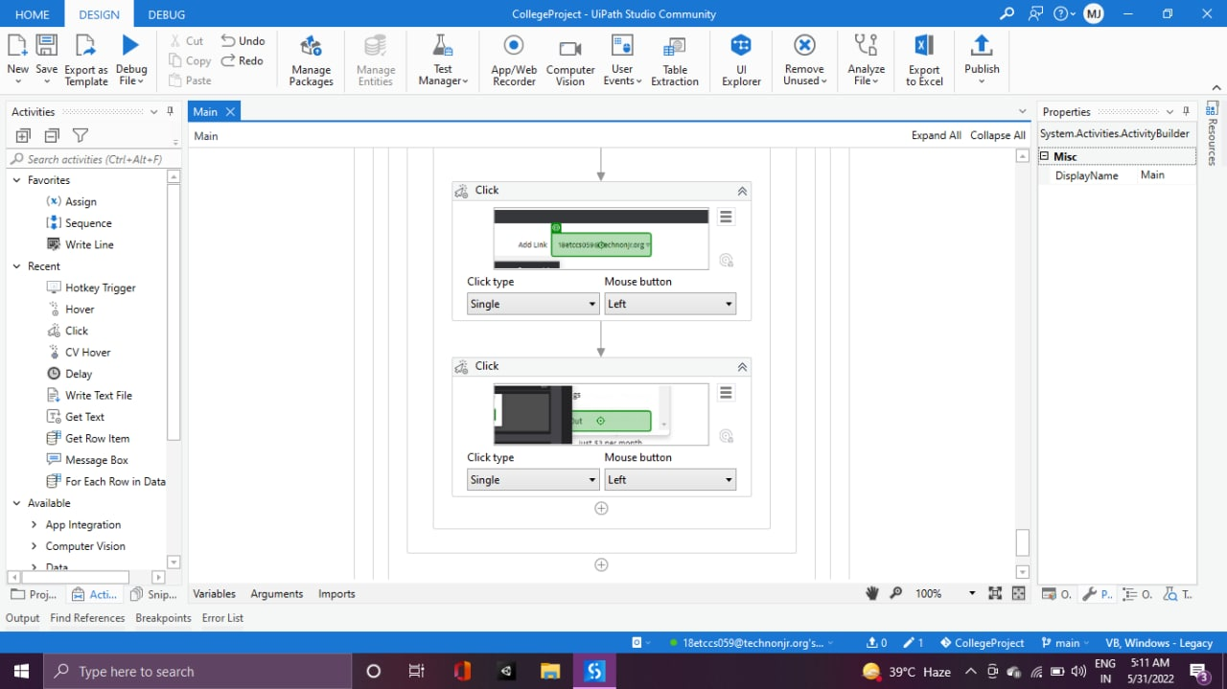

* *Sites which are automated*

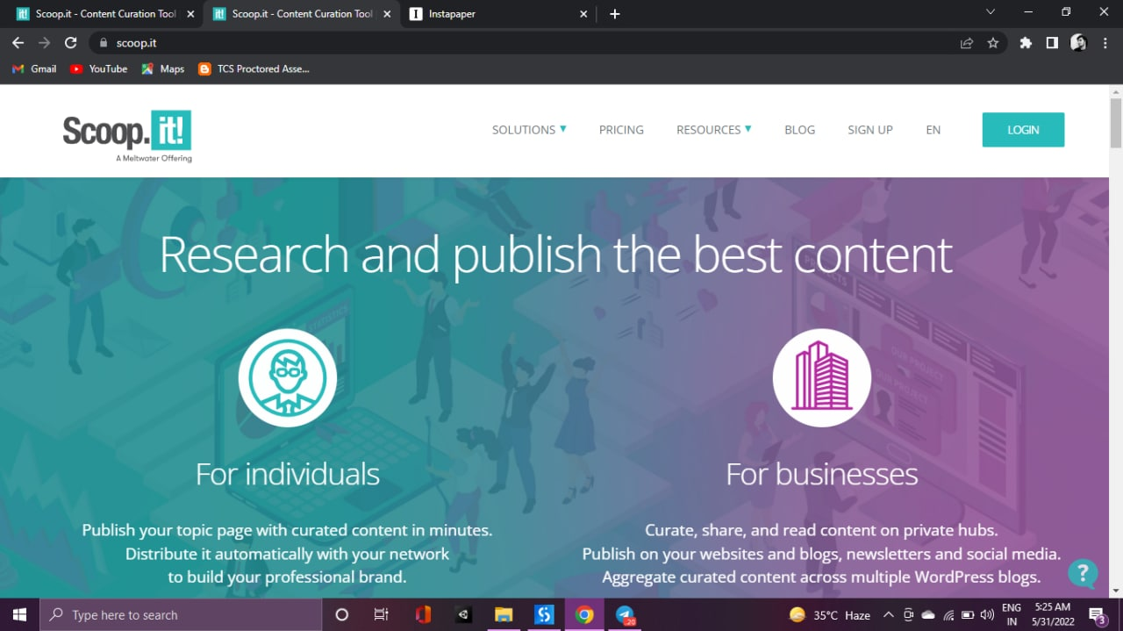

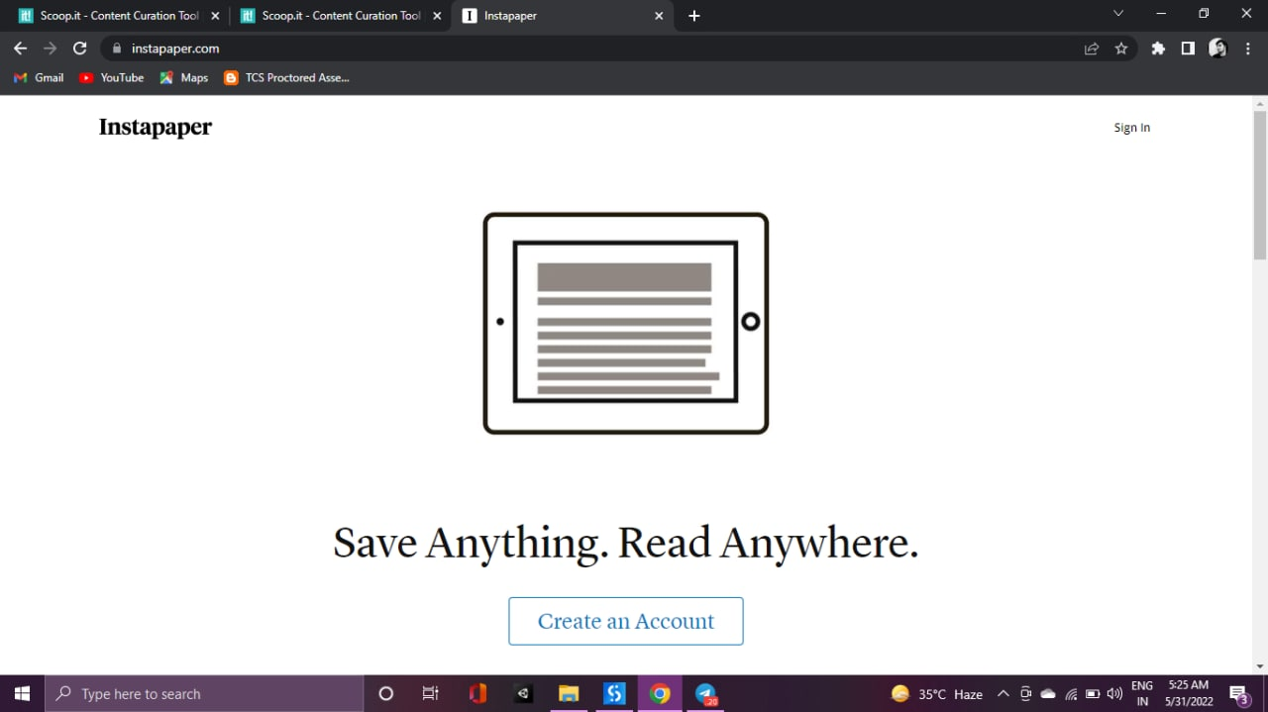

CHAPTER – 7

RESULTS AND CHALLENGES

Results And Challenges

* Results

This project is solving the problem in Performing Repetitive and Tedious tasks which require extra Work-Force, Time, and Money. The main task of this project is to do the marketing of the company, mainly startups by publishing the blogs of the company on the sites like SCOOP, INSTAPAPER, etc. The one should have the uipath software in order to run our project.

* Challenges

In order to build this automation project, we are using the UIPATH software for the automation and CSV files to store the data. We should have a good internet connection for a smooth experience. Limitation is that the desktop should have the uipath software in order to run this project. Desktop specification is like minimum 4gb ram but recommended is 8gb, minimum cpu core is [2 x 1.8 GHz 32-bit (x86)] but recommended one is [4 x 2.4 GHz 64-bit (x64)].

CHAPTER – 8

CONCLUSION

Conclusion

This project is solving the problem in Performing Repetitive and Tedious tasks which require extra Work-Force, Time, and Money. The main task of this project is to do the marketing of the company, mainly startups by publishing the blogs of the company on the sites like SCOOP, INSTAPAPER, etc. The one should have the uipath software in order to run our project.

Scope

The scope of this project is bright because nowadays companies hire number of employees to advertise the product on different social media platforms one by one, but now this project can automate these tasks which saves big amount of time, money and workload for the organization.

CHAPTER – 9

REFERENCES

References

For information and project research

* <https://www.ibm.com/topics/automation#:~:text=Automation%20is%20a%20term%20for,as%20home%20automation%20and%20more.>
* <https://www.uipath.com/rpa/robotic-process-automation>
* [https://www.simplilearn.com/tutorials/rpa-tutorial/ uipath](https://www.simplilearn.com/tutorials/rpa-tutorial/%20uipath)<https://corporatefinanceinstitute.com/resources/excel/study/>