

Department of Computer Science and Engineering

TECHNO INDIA NJR INSTITUTE OF TECHNOLOGY

RAJASTHAN TECHNICAL UNIVERSITY

May 2022

**ONLINE FOOD ORDERING SYSTEM**

*A*

*Major Project Report*

*Submitted*

*In partial fulfillment*

*For the award of* the Degree of

## BACHELOR OF TECHNOLOGY

*In Department of Computer science and Engineering*

| **Submitted By:** |  | **Submitted To:** |
| --- | --- | --- |
|  |  |  |
| Bhavya Lohar (18ETCCS019)  Gargi Sharma (18ETCCS032)  Heeya Joshi (18ETCCS043) |  | Mr. Aditya Maheshwari |

### ABSTRACT

***1. Purpose***

**1.1 . Introduction**

This Software Requirements Specification provides a complete description of all the functions and specifications of the website Online Food Ordering System.

The main objective of Online Food Ordering System is to manage the details of the item category, food delivery, add to cart, address. It manages all the information about the item category, customer, shopping cart.

This Case study looks at the problem of setting up a fast food restaurant.

In existing system there are few problems:

* For placing any orders customers have to visit hotels or restaurants to know about food items and then place order and pay. In this method time and manual work is required.
* While placing an order over the phone, the customer lacks the physical copy of the menu item, and lacks visual confirmation that the order was placed correctly.
* Every restaurant needs certain employees to take the order over phone or in-person, to offer a rich dining experience and process the payment. In today’s market, labor rates are increasing day by day making it difficult to find employees when needed. Hence, to solve this issue, what I propose is an “Online Food Order System, originally designed for small scale business like College Cafeterias, Fast Food restaurant or

Take-Out, but this system is just as applicable in any food delivery industry. The main advantage of my system is that it greatly simplifies the ordering process for both the customer and the restaurant and also greatly lightens the load on the restaurant’s end, as the entire process of taking orders is automated. Anticipated Benefits are:

1. This will minimize the number of employees at the back of the counter.
2. The system will help to reduce labor costs involved.
3. The system will be less probable to make mistakes, since it’s a machine.
4. This will avoid long queues at the counter due to the speed of

execution and number of optimum screens to accommodate the maximum throughput

**1.2 . Scope**

Food ordering websites increase the food sale, food product, kitchen needs, essential restaurant supplies and more through this. The restaurant specific website can be very helpful in expanding business.

### 2 . Document overview

This document is an overview of the project Online Food Ordering System. It provides project specifications like software and resources used for creating the website. It also describes the general flow of the program and describes the use.

The second chapter consists of software requirements specification.

The fifth chapter consists of snapshots of the complete project.

The seventh chapter tells about the conclusion and future enhancements of the project. The final chapter concerns the bibliography.

# *ACKNOWLEDGEMENT*

It gives me immense pleasure to express my deepest sense of gratitude and sincere thanks to my highly respected and esteemed guide Mr.Aditya Maheshwari TINJRIT for their valuable guidance,encouragement and help for completing this work.

Their useful suggestions for this whole work and cooperative behavior are sincerely acknowledged. I would like to express my sincere thanks to the faculty TINJRIT for giving me this opportunity to undertake this project.

I also wish to express my indebtedness to my parents as well as my family members whose blessings and support always helped me to face the challenges ahead.

At the end I would like to express my sincere thanks to all my friends and others who helped me directly or indirectly during this project work.



# CERTIFICATE

**This is to certify that this project report “Online Food Ordering System” is the confide work of “Heeya Joshi, Gargi Sharma, Bhavya Lohar” who have carried out the project work under my supervision. I approve this project for submission of the Bachelor of Technology in the Department of Computer Science and Engineering, Techno India NJR Institute of Technology, affiliated to Rajasthan Technical University, Kota.**

**Mr.Aditya Maheshwari**

**(Department of Computer Science)**

Table of Contents

Abstract

Acknowledgement

Certificate

Table of Contents

List of Tables

Requirement Specification

**CHAPTER 1: INTRODUCTION**

* Purpose
* Overall Description
* Objective
* Statement about the problem
* Scope
* Modules of online food ordering system Results, Evaluation and Reflection

**CHAPTER 2: SOFTWARE REQUIREMENT SPECIFICATION**

* 2.4. Hardware Specification
* 2.5. Software Specification
* 2.6. Hardware and Software Requirements in detail

**CHAPTER 3: ANALYSIS** **AND DESIGN**

* Study and Weakness
* Requirements
* Design

**CHAPTER 4: SCREENSHOTS**

* Food Items
* User Items
* Car

**CHAPTER 5: CONCLUSIONS AND FUTURE ENHANCEMENTS**

* Future Enhancement
* Conclusions

Bibliography

Appendices

***List of Tables***

| Table Name |  | Table No. |
| --- | --- | --- |
| User | 1 |  |
| Food | 2 |  |

***Requirements Specification***

| Web Site | A place on the world wide web |
| --- | --- |

# CHAPTER 1: INTRODUCTION

## Introduction

This Software Requirements Specification provides a complete description of all the functions and specifications of the website  **Online Food Ordering System.**

The main objective of Online Food Ordering System is to manage the details of the item category, food delivery, add to cart, address. It manages all the information about the item category, customer, shopping cart.

The online food ordering service is a local restaurant and food cooperative website or application for customers to provide a more interactive menu so that the ordering process could be carried out. Ordering food online is designed for its more flexibility and performance, some website or application are make sure that the system has enough navigation function through the picture information or significant logo to guide customer like students follow the steps to finish the ordering food process, apart from that it has been constructed to dealing with large number of orders simultaneously to prevent the food overload.

## Scope

Can be used anywhere any time as it is a web based application.Can be used by any hotel, restaurant and café to increase the food order rate.

There is no restriction for users .

Food ordering websites increase the food sale, food product,kitchen needs,essential restaurant supplies and more through this.

***Modules of Online Food Ordering System*** :

Food Item Module: Used for managing the Food Item details.

Confirm Order Module : Used for managing the details of

Confirm Order

Payment Module : Used for managing the details of

Payment

Category Management Module: Used for managing the information and details of the Category.

Customer Module : Used for managing the Customer details

Order Module : Used for managing the Order information’s

Login Module: Used for managing the login details

## Objective

We will be making a single-page web application with React (a JavaScript framework) and a backend is created using nodejs and express. Database of the application is created using mongodb.The website gives the best solution for letting customers order first and collect it when it’s ready. The website also gives the opportunity to see the menu in all cafes before ordering and helps users to check if their favourite dishes are served in the cafe or not.

**Statement about the Problem :-**

The Online Food Ordering System deals with placing orders of food from various restaurants. This system involves the following functionalities:

1.Collecting data : The data is collected from the customer through the application.

2. Verification of data : The data collected( food ordered) from the customer is cross verified with the specific restaurant for availability.

3.Order confirmation : The order is confirmed by sending a confirmation text to the customer

**CHAPTER 2: SOFTWARE REQUIREMENT SPECIFICATION**

**Hardware and Software Requirements in detail-  *Hardware Requirements:***

* + Processor: i3 and above
  + RAM: 4GB or more
  + Hard Disk: 256GB or more
  + Browser : Edge, Chrome

***Software Requirements:***

* + Visual Studio Code
  + React
  + MongoDB
  + Node
  + Windows or Linux operating system

## Hardware and Software Requirements in detail

Frontend

* React
* contextProvider
* Axios
* React Router

Backend

* Nodejs
* Express
* Axios
* Mongoose

Database

* MongoDB

GUI

* Chrome Browser
* Mongodb compass

Compiler

* Visual Studio Code

This Software Requirements Specification provides a complete description of all the functions and specifications of the website Online Food Ordering system.

The main objective of the online food ordering system is to save time.

Ordering food online is way more efficient and time saving then manual ordering.

Scope of this project is very broad in terms of other manually taking exams. Few of them are:-

* This can be used in any restaurant to increase productivity as well as in .
* Can be used anywhere any time as it is a web based application.
* This order food online system project aimed at developing an online food ordering system that can be used in small places, and medium cities firstly and then on a large scale. It is developed to help restaurants to simplify their daily operational and managerial tasks as well as improve the dining experience of customers.
* And also helps restaurants develop healthy customer relationships by providing good services. The system enables staff to let update and make changes to their food and beverage list information based on the orders placed and the orders completed.

***Glossary***

Term Definition markup language

| IEEE | Institute of Electrical and  Electronic Engineers |
| --- | --- |

7

QA Quality assurance

SCMP Software Configuration Management Plan SDD

Software Design Document

SQAP Software Quality Assurance Plan SRS

Software Requirements Specification

| Web Site | A place on the world wide web |
| --- | --- |

## REFERENCES

1. Awojide, Simon, I. M. Omogbemi, O. S. Awe, and T. S. Babatope, “Towards the digitalization of Restaurant Business Process for Food Ordering in Nigeria Private University: The Design Perspective. A Study of Samuel Adegboyega University Edo State Nigeria,” Int. J. Sci. Res. Publ., vol. 8, no. 5, pp. 46–54, 2018.

2. O. I. Mike and A. Simon, “Towards the Digitalization of Hotel Business in Nigeria: The Design Perspective,” vol. 8, no. 2, pp. 1175–1178 , 2017.

3. Adithya. R., A. Singh, S. Pathan, and V. Kanade, “Online Food Ordering System,” Int. J. Comput. Appl., vol. 180, no. 6, pp. 22–24, 2017.

4. Varsha Chavan, Priya Jadhav, Snehal Korade, Priyanka Teli,

”Implementing Customizable Online Food Ordering System Using Web Based Application”, International Journal of Innovative Science, Engineering Technology(IJISET) 2015.

5. Patel, Mayurkumar, "Online Food Order System for Restaurants" (2015) . Technical Library. Paper 219.

6. Node and reactjs documentation

7.Express documentation

8. stackoverflow

9.mongodb document

***Functional Requirement Specifications***  :

Activity Diagram: This section lists the activity diagram and describes the flow of the activities in the system. A detailed description is then given after the figure for each activity. Figure # 3 provides an overview of the activity of the Online Food Order System application.

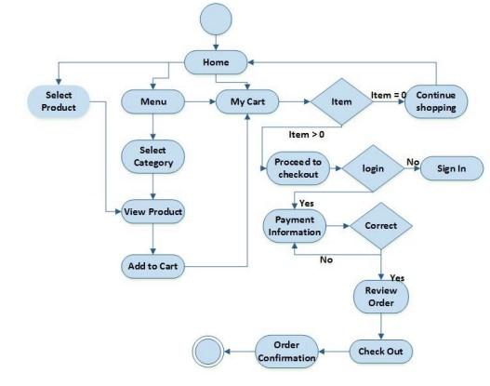

All users of the system are provided with below menu options: Home,

Menu, My Cart, UserAccount,AboutUs and Contact Web Ordering System Module Customers of the Web Ordering system will interact with the application through an easy to use top navigation menu.

* “Home” menu option: allows the users to see all food items offered with nice images as well as select an item to place an order
* “Menu”menu option: a ‘Drop-Down’ menu, allows users to see all food items per category. Items can then be added to the cart using a single button click.
* “My Cart (x)”menu option: - Allows users to see details of the items placed in the cart. Details include Item #, Product Name, Product Image, Product Description, Quantity, Unit Price, Total per item and final Total of the order. It also allows ‘Update’ and ‘Delete’ an item using single button click. Users can then use a ‘Proceed to checkout’ button to proceed further. - Once, Check Out button is selected, the user will be prompted for the Sign In/Sign Up process if not logged in else the user will be presented with a simple “Payment Information” form. Users will be asked to provide all required details in displayed text boxes and make appropriate Dropdown selections. Then, all this information can be saved using a ‘Save’ button. - Users will then be presented with a

“Review Order” page, which will display Payment Information along with Order details to review. Users can then use a ‘Check Out’ button to place an order. - Once an order is placed, user will be presented with an appropriate Order confirmation success/failure message.

* “MyAccount”: a “Drop Down” menu will display the edit profile, Sign In and Sign Out options.

## Non-functional Requirements

All of the application data is stored in a nosql database, and therefore a mongodb Database must also be installed on the host computer. This software is freely available and can be installed and run under most operating systems. The server hardware can be any computer capable of running both the web and database servers and handling the expected traffic. For a small scale restaurant that is not expecting to see much web traffic, an average personal computer may be appropriate. Once the site starts generating more hits, though, it will likely be necessary to upgrade to a dedicated host to ensure proper performance. The exact cutoffs will need to be determined through a more thorough stress testing of the system

# CHAPTER 3: ANALYSIS AND DESIGN

## User Requirements

The online ordering system must be quick and easy to navigate in addition to providing useful features for browsing, selecting and purchasing products. Required user interface features:

1. Navigation
2. Create customer account
3. Manage customer account
4. Browse items/product details
5. Add items to cart
6. Manage items in cart (remove, add, or customize)
7. Provide payment and delivery information
8. Place order

## Easy to Store and Retrieve Information

The system makes it easy to store and retrieve information of user order as required and does not involve storing information, It thus saves data of users which helps hotel, restaurants to prepare their order on time.

## Design

This Case study looks at the problem of setting up a fast food restaurant.

In existing system there are few problems:

* For placing any orders customers have to visit hotels or restaurants to know about food items and then place order and pay. In this method time and manual work is required.
* While placing an order over the phone, the customer lacks the physical copy of the menu item, lack of visual confirmation that the order was placed correctly.
* Every restaurant needs certain employees to take the order over phone or in-person, to offer a rich dining experience and process the payment. In today’s market, labor rates are increasing day by day making it difficult to find employees when needed. Hence, to solve this issue, what I propose is an “Online Food Order System, originally designed for small scale business like College Cafeterias, Fast Food restaurant or Take-Out, but this system is just as applicable in any food delivery industry. The main advantage of my system is that it greatly simplifies the ordering process for both the customer and the restaurant and also greatly lightens the load on the restaurant’s end, as the entire process of taking orders is automated.

***CHAPTER*  4:**

# SCREENSHOTS

## Login or sign in page

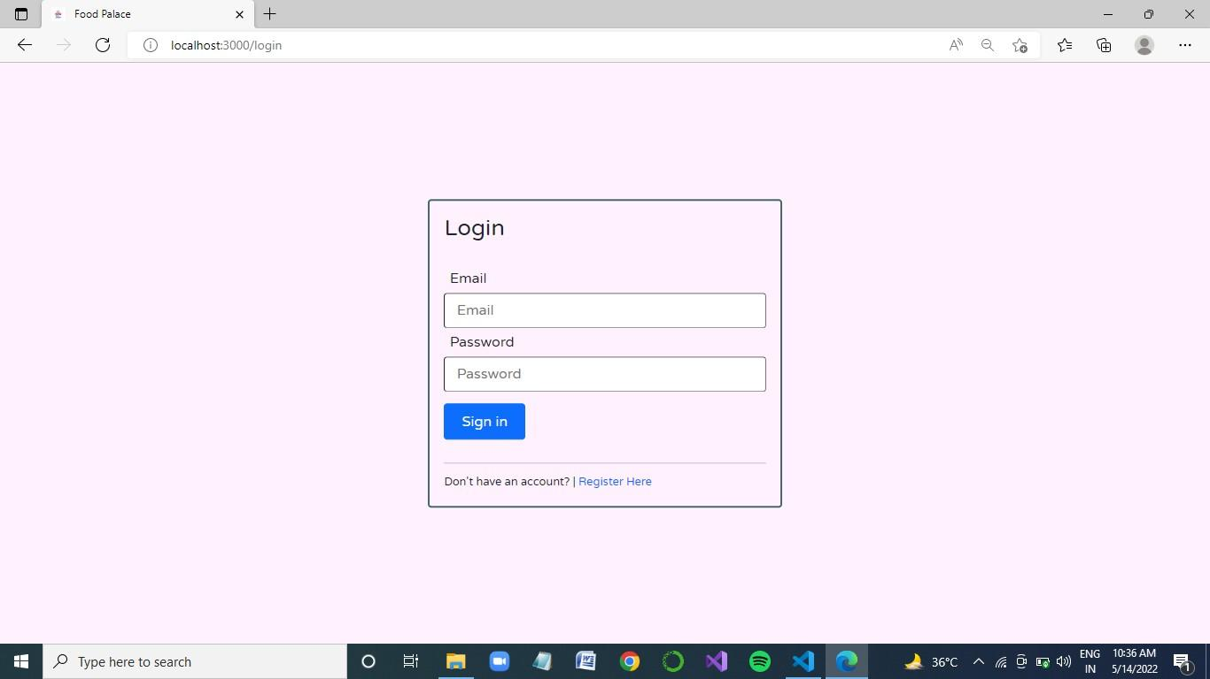

Users will be able to Login if it exists. It is necessary for users to login for ordering items.

## Home Page

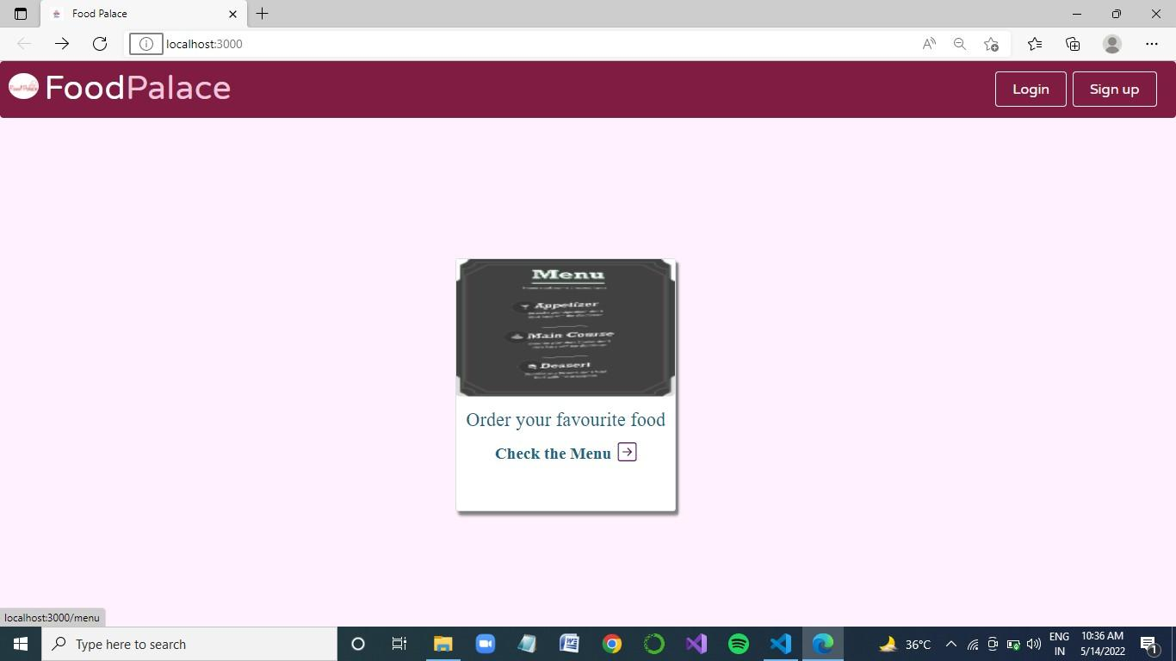

First Page. User will click to browse the menu.

## MenuItems

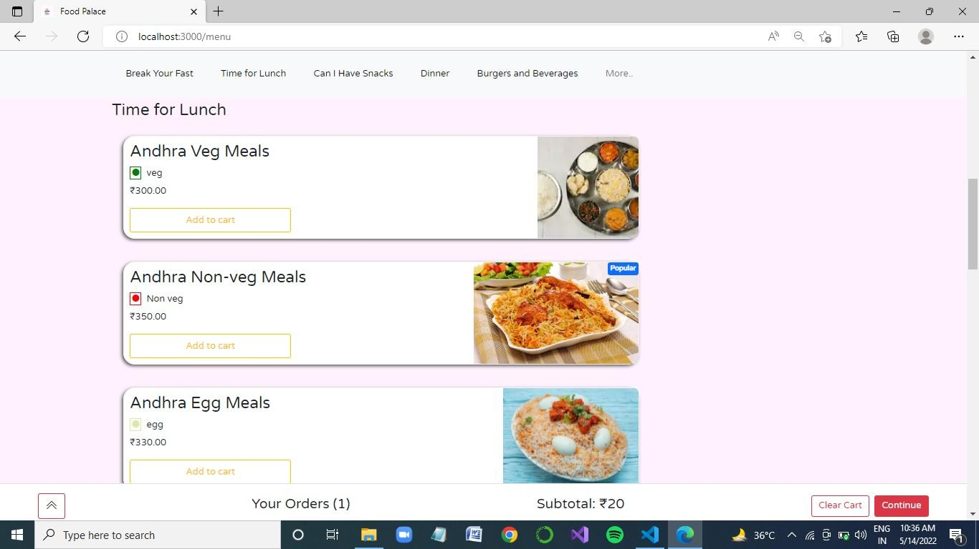

Available Items of restaurants

## Cart

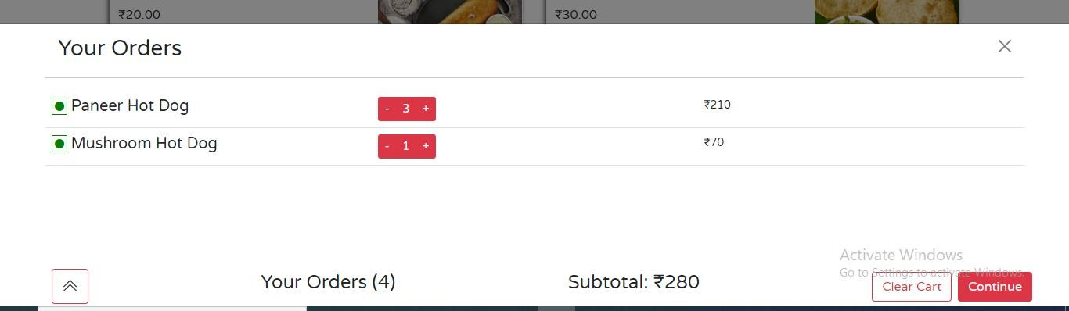

User’s Orders are displayed in the cart from where one can remove or increase the quantity of added food item.

# CHAPTER 5: CONCLUSION AND FUTURE SCOPE

## conclusion

Our project is only a humble venture to satisfy the needs to manage the restaurant work. Several user-friendly coding have also been adopted. This package shall prove to be a powerful package in satisfying the requirements of online food ordering systems. The objective of software planning is to provide a framework that enables the customers an easy interface for ordering their favourite food items.

An online food ordering system is developed where the customers can make an order for the food and avoid the hassles of waiting for the order to be taken by the waiter. Using the application, the end users register online, read the E-menu card and select the food from the e-menu card to order food online. Once the customer selects the required food item the chef will be able to see the results on the screen and start processing the food. This application nullifies the need of a waiter or reduces the workload of the waiter. The advantage is that in a crowded restaurant there will be chances that the waiters are overloaded with orders and they are unable to meet the requirements of the customer in a satisfactory manner. Therefore by using this application, the users can directly place the order for food to the chef online.

**Future Scope of the Project:**

In a nutshell, it can be summarized that the future scope of the project circles around maintaining information regarding:

* We can add excel reports in the future.
* We can give more advanced software for Online Food Ordering System including more facilities.
* We will host the platform on online servers to make it accessible worldwide
* Integrate multiple load balancers to distribute the loads of the system
* Create the master and slave database structure to reduce the overload of the database queries
* Implement the backup mechanism for taking backup of codebase and database on regular basis on different servers
* System. Enhancements can be done to maintain all the Food Item, Category, Customer, Order, Confirm Order.

The following section describes the work that will be implemented with future releases of the software.

* Customize orders: Allow customers to customize food orders
* Enhance User Interface by adding more user interactive features. Provide Deals and promotional Offer details to home page. Provide Recipes of the Week/Day to Home Page
* Payment Options: Add different payment options such as
* PayPal, Cash, Gift Cards etc. Allow to save payment details for future use.
* Allow to process an order as a Guest
* Delivery Options: Add delivery option
* Order Process Estimate: Provide customer a visual graphical order status
* bar
* Order Status: Show only Active orders to Restaurant Employees.
* Order Ready notification: Send an Order Ready notification to the customer
* Restaurant Locator: Allow to find and choose a nearby restaurant
* Integrate with In store touch screen devices like iPad

***Appendices***

This section includes figures for ER Diagram.

**ER Diagram**:

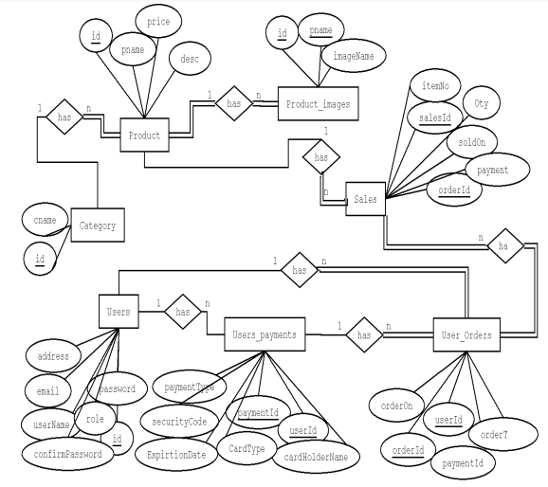

***Bibliography***

1. . http://getbootstrap.com/
2. .h[ttps://www.youtube.com/watch?v=oepmLGQP1m4&list=PLUoqTnNH](https://www.youtube.com/watch?v=oepmLGQP1m4&list=PLUoqTnNH2Xz_BUrjcahKWDhPcUj-FTOt)

[2Xz_BUrjcahKWDhPcUj-FTOt](https://www.youtube.com/watch?v=oepmLGQP1m4&list=PLUoqTnNH2Xz_BUrjcahKWDhPcUj-FTOt)

1. .https://www.youtube.com/watch?v=Ke90Tje7VS0
2. . https://developer.mozilla.org/en-US/docs/Web/JavaScript

5.<https://www.youtube.com/watch?v=VrQgmNY96wo>

6 .https://www.mongodb.com/cloud/atlas