AnsysWorkbenchBasicsGuide

# AnsysWorkbenchBasicsGuide

## Mechanical Engineering

**Techno India NJR Institute of Technology, Udaipur**

1

## Abstract

WiththeemergingimportanceofCFDandfiniteelementanalyses,itisofgreatnecessity that engineering students get a good base of knowledge on one of the most usedsoftware packages in the industry of simulation, ANSYS. This brief tutorial states a few simpleexamples of the main applications of the software package ANSYS and highlights some of thepossibleproblems studentsmayfaceduringtheirjourney indiscovering thisapplication.

The flow of information is structured that the reader gets an understanding of howimportant ANSYS is, and how it works and what type of machines are needed for the studentlevel research expected. Then the tutorial goes on with simple straight forward examples ofstructuralandfluidphysicssimulatedusingtheANSYSpackage.Eventually,thetutorialaddresses the most important problems generally faced by the students such as unsuccessfulmeshing,ordivergentsolutions.

## Disclaimer

Itisextremelyimportanttonotetwopointswhilefollowingthistutorial:

* The knowledge contained in this paper is by no means, accepted as mainstream, or anindustry best practice. It is merely the product of the experience of senior engineeringstudents who explored the program and desired to share their experience with thepackage.
* The choices and configurations in every example given are not to be considered as a –one size fits all – template. As the student grows in experience they are expected to tryother configurations, commit to trial and error procedures, and develop their owntroubleshootingskills inordertocreateworkingmodels.

## TableofContents

Abstract 2

Disclaimer 2

1. Introduction 5
2. Exercises 8
   1. StaticStructural –CantileverBeam 8
      1. ProblemsSpecifications: 8
      2. Startingandassigningmaterialproperties 9
      3. Geometry 11
      4. Model 12
      5. Setup 13
   2. Fluent–2D-Airfoil 16
      1. Methodology-AirdomainandBoundary 16
      2. Geometry 17
      3. Mesh 19
      4. Setup 21
      5. Changing theAngleofattack 27
   3. Fluent–3D-FiniteWing 34
      1. Geometry 34
      2. Mesh 39
      3. Setup 42
      4. CFDPost 47
      5. Tecplot 52
   4. Fluent–Internal flowthroughpipesandducts 57
      1. Geometry 57
      2. Mesh 60
      3. Setup 62
3. CommonProblems 67
   1. AutodeskAutocadcompatibilitywithAnsys 67
   2. Thesharptrailingedgesoftheairfoils 67
   3. GeneralMeshingProblems 68
   4. NamedSelectionProcess 69
   5. SolutionDivergence 69
   6. TemperaturesolutiondivergencewhileusingEnergyequation 69
   7. Scaling 69
   8. Hugevaluesofliftanddrag 72
4. RecommendedTopics 72
   1. DynamicandSlidingmesh 72
   2. Meshingtechniques–Gambit 72
   3. FluentModels 73
   4. Combiningthestructuralloadswiththeaerodynamicloads 73
   5. Cables 73
   6. Composite 73
5. UsefulLinks 74

## Introduction

ANSYS is a finite element analysis package used widely in industry to simulate theresponse of a physical system to structural loading, and thermal and electromagnetic effects.ANSYS uses the finite-element method to solve the underlying governing equations and theassociatedproblem-specificboundaryconditions.

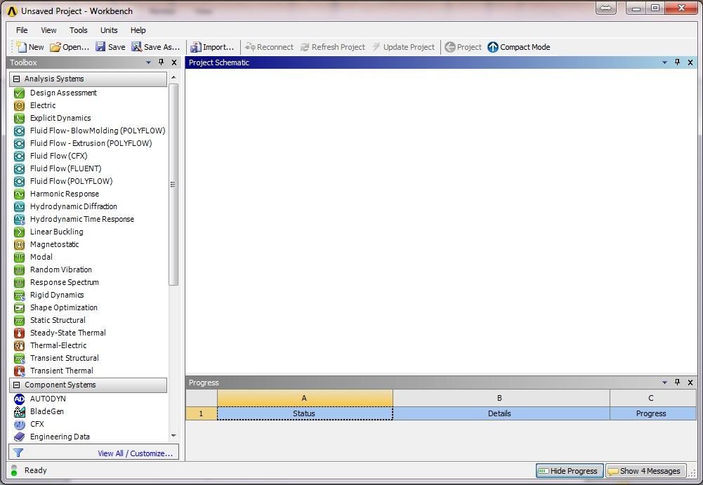

Thismanualincludestheprocedureofsolvingthe(staticstructural,Fluent)problems.

Eachoneoftheanalysissystemshasitsownprocedure.However,therearesomecommonstagesinall ofthesystems.

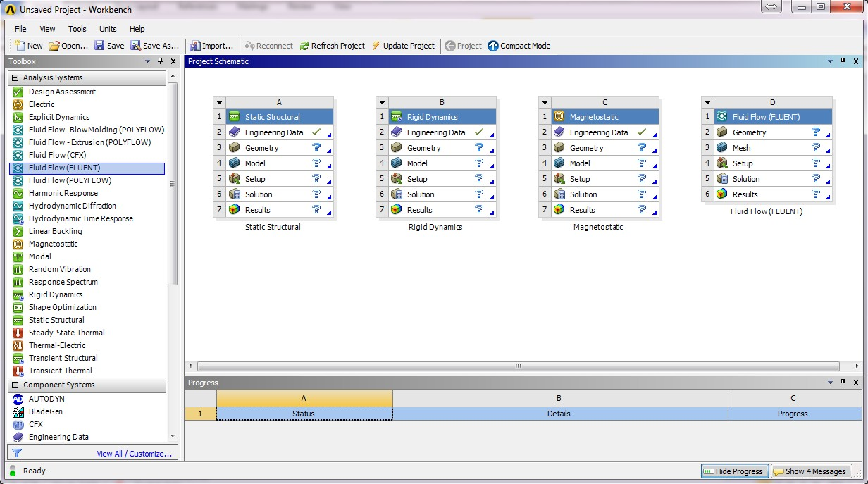

Foreachtypeofproblems,theprocedurecanbecompletedbygoingthroughthetreeone byoneuntilallthecellsgetmarked with .

Itishighlyrecommended tosurfonlineandhaveagood ideaaboutthe “mesh”orthe“grid”

* + Theimportanceofthemeshforthecomputer-aidedengineeringandsimulationsoftwarelikeANSYS.
  + Typesofmesh
  + Howtocontrolthemesh sizeandbasedonwhat the meshshouldbe modified
  + Howdoesmeshsizeaffectthequalityandreliabilityof the results?

Moreover,itisrecommended touseapcwithminimumspecificationsof:

* Processor:i5ori7
* Ram: 32 Gbs
* Harddisk:1TB
* Goodcoolingsystem(Important)

Thegeometryshouldbemadeonexternalmodelingsoftware(Solidworks,CatiaorRhino)andsavedinanindividualgeometryfilewithrecommendedextensions(Solidpartfile

.sldprt,IGESfile .igsorStepfile.stl).AutodeskAutocadis **not**compatiblewith Ansys.

**NOTE**: This manual provides a very brief idea and introduction the Ansys applications. Themanual is made for the beginners who are working on the application for the first time. It shouldguide the student to the basics of Ansys while he can develop himself with more advancedproblemsfromreal lifeandfromonlinesources.

## Exercises

### StaticStructural–CantileverBeam

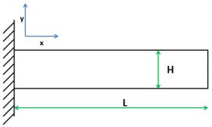

#### ProblemsSpecifications:

Findthestressandthe strainin thecantileverbeamwhere:

* L=1m
* H=0.2m
* Load=1KNDownwards,applied on thetop rightedge.
* The material properties are:Young's modulus E = 200 GPaPoissonratio=0.3

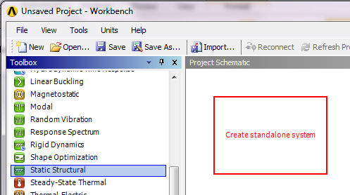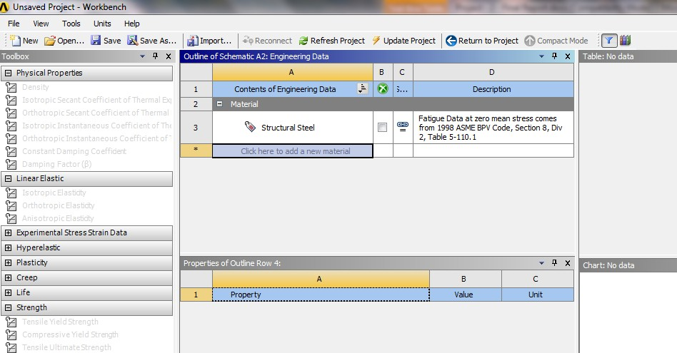

*\*\* Before starting, the geometryfile of the beam should be savedinanindividualfile*

*\*\*InANSYSWorkbenchwindow:*

*Drag (Static Structural) to theProjectSchematicinsidetheredsquare*

*\*\*DoubleClickon(EngineeringData) to configure and add thematerials that would be used inthe analysis along with theirproperties.*

*\*\*Theshownwindowwillappear where a new materialcanbeadded>>(clickheretoadd a new material)>> add(materialforthebeam)*

#### Startingandassigningmaterialproperties

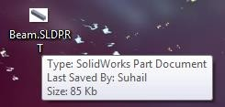

*\*\*IntheToolbox,thematerialproperties can be added from“Density”or“Isotropic*

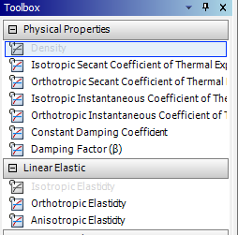

*Elasticity”. Double Clicking onthementionedoptionswillopennew fields in the outline wherethe fields have to be filled withthevaluesoftheproperties.*

***Note****: Try to find the desiredmaterial in the “EngineeringData Source” Library beforeaddinganewmaterial.Clickon*

*theicon >> select the type ofthe material and the materialswillappearinalist.Ifyouwantto add a material to yourprojectlist,clickon .*

*\*\* After you are done withaddingallthematerialsneededin the project, click on “ReturntoProject”*

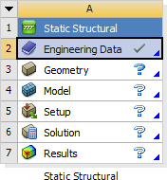

*\*\* The Engineering Data fieldshould be marked with aindicating that the process ofadding materials properties hasbeendone.*

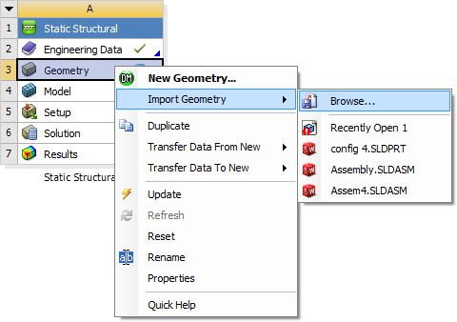

*\*\*RightClickon(Geometry)>>Import Geometry >> Browse >>Locate the geometry file*

***Note****: Simple geometry can beconstructedinAnsysGeometrywindow itself. However,complex geometry should beimported from 3D modelingsoftware like Solidworks, as ithasbeendoneinthisexercise.*

*\*\* Even though after locatingthe geometry file, the field willbemarkedwith , it is stillnecessary to do the followingstep.*

*\*\*Doubleclickon“Geometry”*

*>> Chose the units used whileconstructingthegeometryfiles*

*\*\* On the Tree Outline on theleft side >> Right Click on“Import” >> Generate. Hence,thegeometrywillappearinthegraphics window. After thisstep, close thegeometrywindow.*

#### Geometry

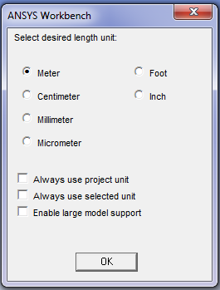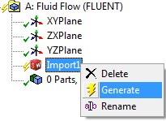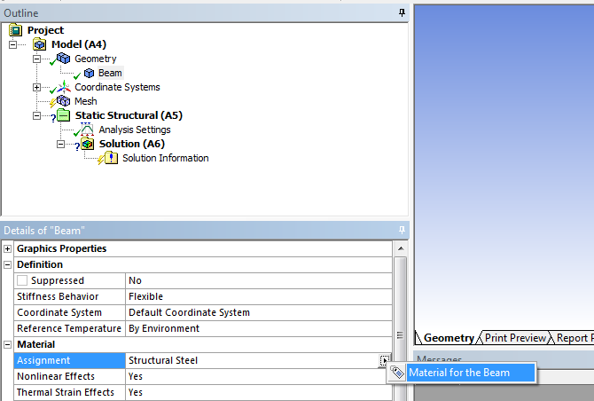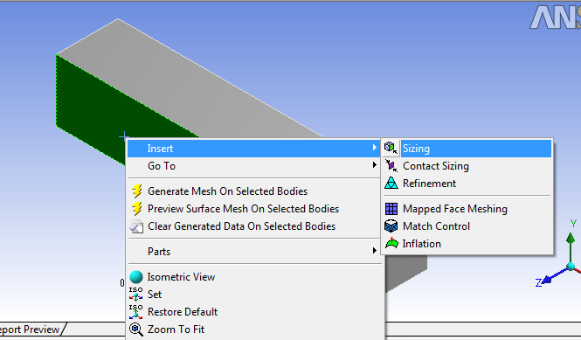

* + 1. **Model**

*\*\*Doubleclickon“Model”*

*\*\* On the outline window, expandthe “Geometry” tree by clicking on“+”, this tree should show you allthe parts in the project (will beclearwhen therearemultiplepartsintheproject).Moreover,thetree helps in assigning differentmaterial to different parts ormanaging the contact typebetween two parts (Frictional,Frictionless,etc).*

*\*\*Ontheoutlinewindow,click on“Mesh”. For generating the meshwiththe defaultsize, clickon*

*from the top bars. Foradvancedmeshoptions,adjustthe*

*\*se*tCtilnogsesGfreoomm“eDtreyt.aDilosuobflMeecslihc”k wonin“dMoewsh.”.*

***Note****: Thedefaultmeshisusuallyaverybasicgridwithnoattention*

*\*\*Inthe“MechanicalWindow”,*

*giventothedetailsofthe*

*on the Outline part, Right clickgeometry.Advancedmeshdetailson “Mesh” >> Insert >> Methodcanbeaddedby choosingthe*

*>>Automatic.Thenclickonthe*

*geometricaldetailandinsertingbodywhichisrepresentingthe*

*“sizing”asitisshowninthe figure.domain. Thenclick“apply”.*

*Thedetailscanbechosenusingthe*

*selectingicons.*



* + 1. **Setup**

*\*\*Aftersettingthematerialandgenerating the mesh, close the“Model” window. As it is clear,the first 3 stages have beenmarkedwith indicating thatthey are completed. Move to“Setup”.*

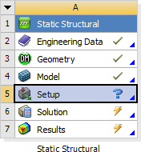

*\*\* In “Setup”, the loads, thesupports and the desiredsolution parameters should bedefined.Bymarkingthelocationon the geometry and adding aforce or a support, the “Setup”stage can be considered to bedone.*

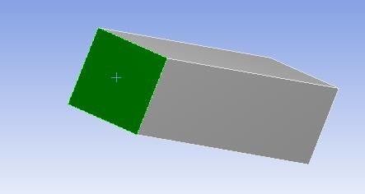

*\*\*Choosetheface where thecantileverbeamisfixedbyusing*

*the“Faceselectiontool” .*

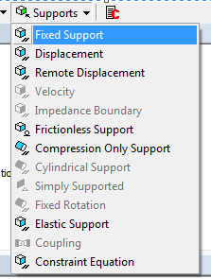

*\*\* Add the “Fixed Support” fromthe“SupportsList”.Hence,onthe“Outline” tree, the fixed supportwillbedisplayedunderthe“StaticStructural”list.*

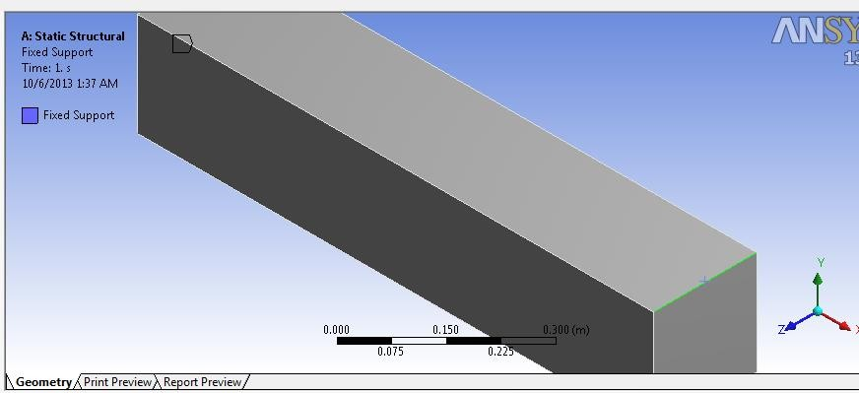

*\*\*Similarly,selectthetoprightedge ofthebeamusingthe*

*“EdgeSelectingTool” .*

*\*\* Add the force from the“Loads” list. In the “Details ofForce” window, change“DefinedBy”to“Components”and then set the “Y” directionforce to be “ - 1000 N” as it isshowninthefigure.*

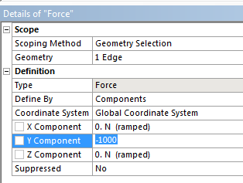

***Note****: The negative sign of theforce is because the force isdownwards.Alwaysmakesureyou check the coordinatesystem defaults directionsbefore settingthe forces.*

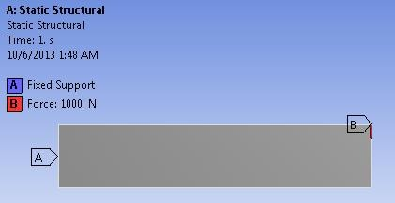

*\*\*Fromthe sideview,the*

*“Graphics window” should looklikethisafterclickingon“StaticStructural” on the “Outline”window.*

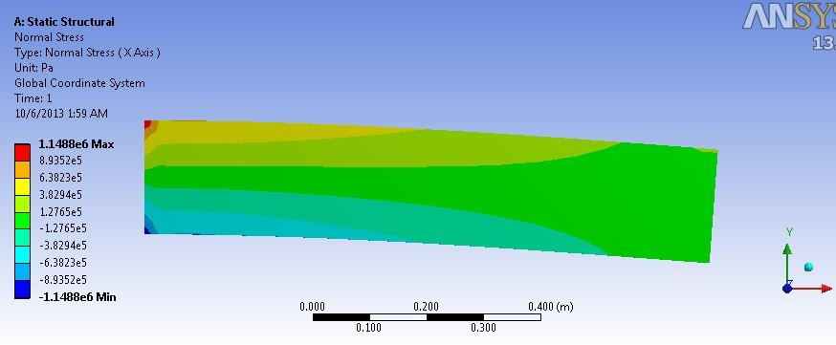

*\*\* To define the desired solutionparameters, click on “Solutions”anddefinealltheparametersneededtobefound.Theparameters can be chosen fromthe listsshowninthefigure.*

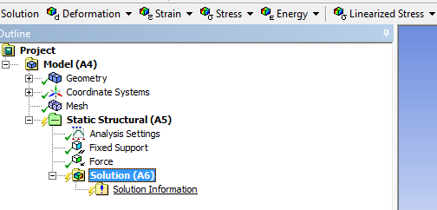

*\*\* After defining theinvestigationparameters,click*

*togettheresults.Toshowtheresultsofthedifferentparameters, use the list under“solutions” in the “Outline”window.*

***Note****: The previous procedurecan be considered one of thesimplest static structuralproblems. Practice more byfindingsolvedproblemsonlineand comparing your results tothegiven results.*

### Fluent–2D-Airfoil

#### Methodology -Air domainandBoundary

In aerospace applications, fluent is usually used to calculate the lift and the drag, presentthepressuredistribution,vorticity,velocity vectors,streamlines..etc.

Since computer resources management is a critical issue, the easiest and the leastresourceextensivemethodismentionedinthe manual wherethe propertiesare calculatedusing only one material (air) without going through the details of the wing material or the internalstructureofthewing.

Hence, a boundary of air has to be defined where it covers the wing while the gap in thematerial of the boundary (air) is representing the wing. In other words, the wing has to besubtracted from the air boundary leaving the air moving inside the boundary avoiding the gap.Thenextfigureis showingtheairboundaryandthesubtractedairfoil.

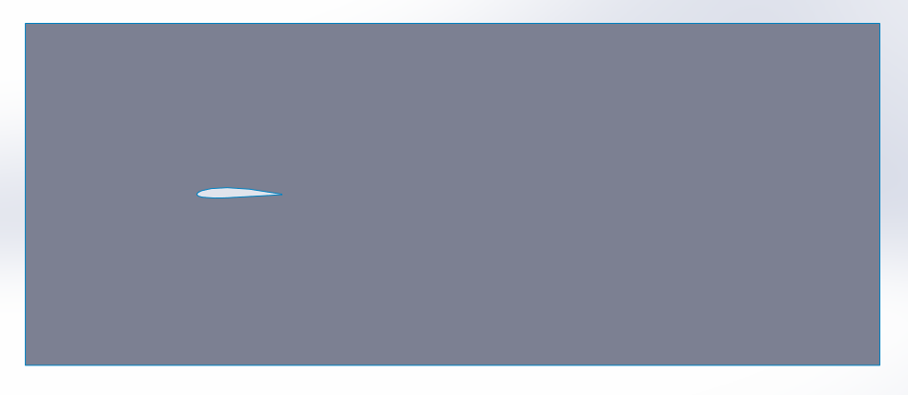

VelocityInlet

Air

PressureOutlet

Thegaprepresentingtheairfoil

For the 2D cases, the air domain and the airfoil subtraction should be done from themodeling software. In the 3D cases, the wing has to be constructed in the 3D modeling softwarewhilethedomainconstructionandthesubtractionprocessshouldbedoneinAnsysworkbench.

Generally, the inlet should be away from the leading edge with a distance equal to twiceof the airfoil chord length while the outlet should be 8 – 10 times the chord length. Moreover, thetop and the bottom of the boundary should be 4 – 6 times of the chord length away from theairfoil

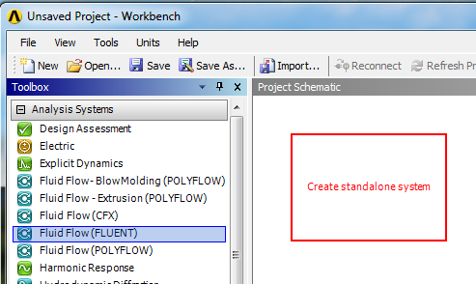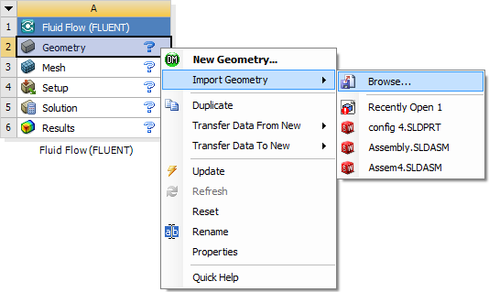

*\*\*Thegeometryfileshouldbesavedinanindividualfile*

*\*\*InANSYSWorkbenchwindow:*

*Drag (Fluid Flow (Fluent)) totheProjectSchematicinsidetheredsquare*

*\*\* Right Click on (Geometry) >>Import Geometry >> Browse >>Locate the geometry file*

#### Geometry

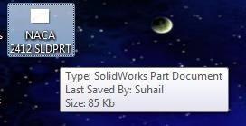

*\*\* Chose the units used whileconstructingthegeometryfiles*

*\*\*OntheTreeOutlineontheleft side >> Right Click on“Import”>> Generate*

*\*\*Afterthegeometryappears,close the geometry modelingwindow*



#### Mesh

*\*\*Doubleclickon“Model”*

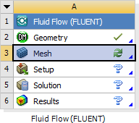

*\*\*Togeneratethemesh,click*

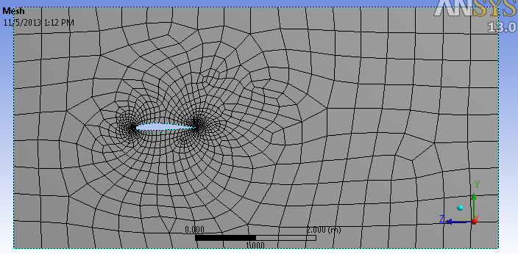***Note****:Thedefaultmesh isusuallyaverybasicgridwithnoattentiongiventothedetailsofthegeometry.Advancedmesh details can be added as itisexplainedbellow.*

*\*\*OntheOutlinepart,Leftclickon “Mesh”. Then on the “Detailsof Mesh” window Change thefollowings:*

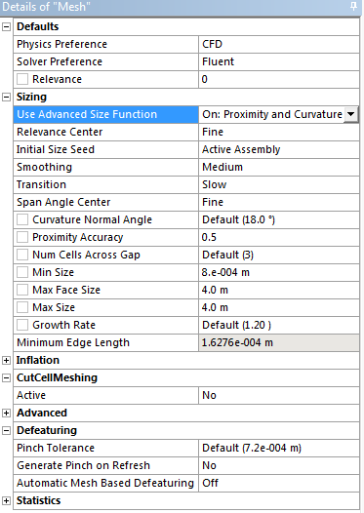

*Relevance>> controls thedensityofthemeshinregionscloser tothegeometry.*

*\*-*UCseloasedvGaenocmedetsriyz.eDfuounbctleiocnli>ck>oOnn“PMroexshim”.ityandCurvature*

* *RelevanceCenter>>Fine*
* *MinSize>>theminimumsize*

*\*o*ftIhnethmee“sMheeclehmaneinctasliWnminedtoewrs”,*

*-onMtahxefaOcuetlSinizeep>a>rtth,eRimghatxicmlicukm osinze“Mofetshhe”m>>esInhs****e****lretm>e>nMtseitnhod*

*>m>etAeurtsomatic.Thenclickonthe*

*bodywhichisrepresentingthe*

* *MaxSize>>equalto“Maxdomain. Then click “apply”.faceSize”*

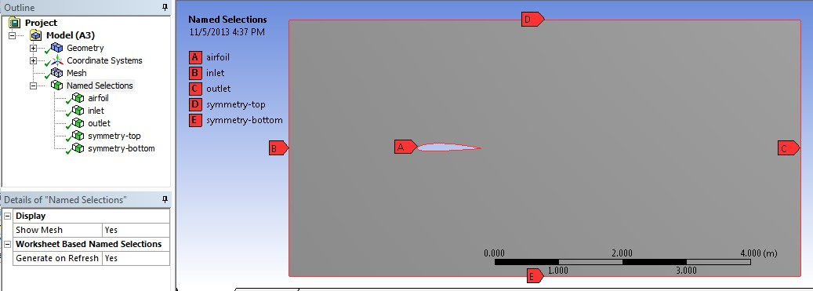

*\*\*Afterthemeshisgenerated.Choosetheedgechoosingtool.*

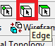

*\*\*Leftclick oneachedgeoftheboundary>>Right click >>Create Named Selection >>Name each edge according theorientation of the model. Makesure that the inlet is named“inlet”, the outlet is named“outlet”, and the other 2 sides’names start with “symmetry –(addname)”.*

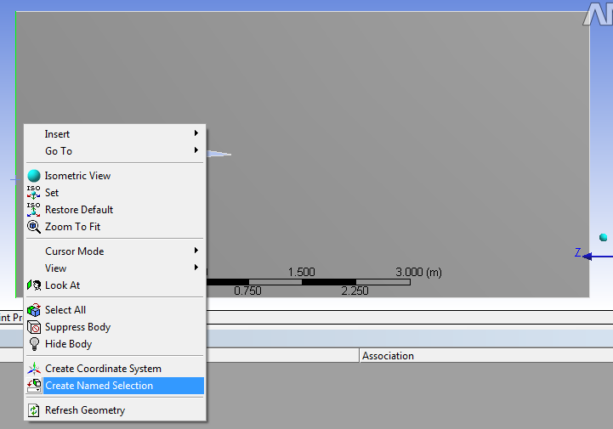

*\*\* After selecting each edgeseparately and assigning anamedselection,changethe*

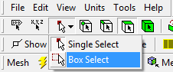

*selectiontypeto“Boxselection”asshown.*

*\*\* Hence, select the airfoil as itis shown. Then right click>>create named selection >> callit any name (avoid calling itInlet, Outlet and Symmetry), inthisexampleitiscalled“airfoilforeasierreference.*

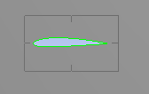

*\*\* After doing the namedselectionstep,thetreeoutlineshould look like the shownfigure. Notice all the namedselectionsarelisted.*

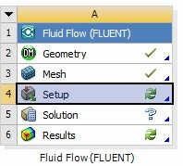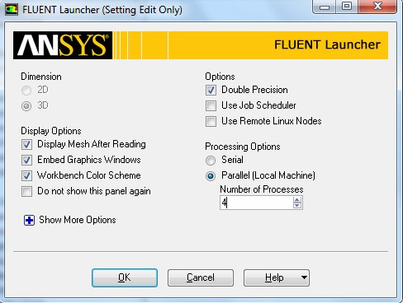

*\*\* Close the “MechanicalWindow”>>Rightclickon“Mesh”>> Update.*

*\*\*DoubleClick on“Setup”*

*\*\* Tick (Double Precision)>>Chose “Parallel” and chose thenumber of processors to be 4unless if more processors arelicensed.Inthecaseyourcomputer has less than 4processors,selectthemaximumamountofprocessorsavailable.*

#### Setup

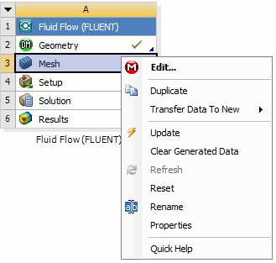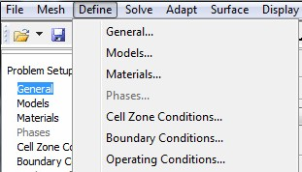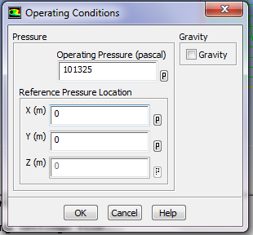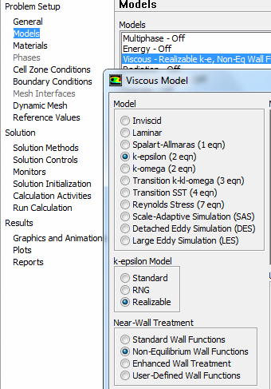

*\*\*Chosethe“Type”tobe:*

* *“PressureBased”forincompressibleflow*
* *“DensityBased”forcompressibleflow*

*\*\*Goto“Define”>>OperatingConditions.*

*\*\* Define the Static Pressure inthe operationaltitude.*

*\*\* In “Models” Section >>Doubleclickon“Viscous”andchose:*

* *Model:K-epsilon*
* *K-epsilonmodel:Realizable*
* *Near-Wall Treatment: Non-EquilibriumWallFunctions*

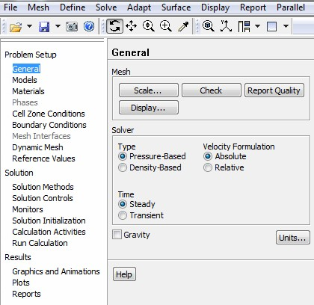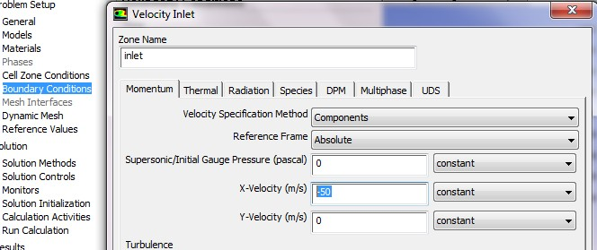

*\*\* In “Materials” Section >>DoubleClickon“air”>>setthedensity and the viscosityPressure intheoperationaltitude.*

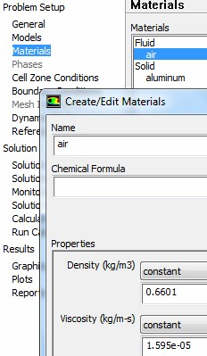

*\*\* In “Boundary Conditions”Section >> Double Click on“Inlet” >> Change “VelocitySpecification Method” to“Components” >> Insert thevalues of the flow velocity withrespect to the coordinatesystem(Noticeitis-50becausethe free stream is in thenegativeXdirection.*

*\*\*In“ReferenceValues”section*

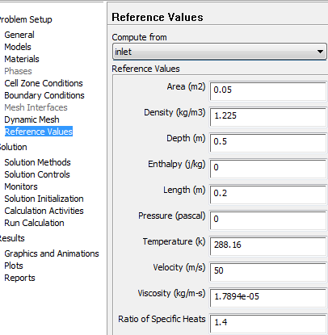

*>>Chose“Computefrom”tobe“inlet” >> Insert the flowconditions at the operatingaltitude. Moreover, insert:*

* *Area:thereferenceareaofthewing (the projection area fromthetopview)*

*Depth:thespanofthe2Dwing*

* *Length:MeanAerodynamicChordlength*

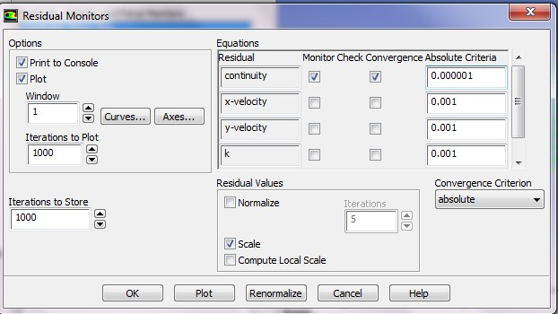

*\*\*In“Solution Methods”Section*

*>>Chose“Scheme”tobe“Coupled”.*

*\*\*In“Solution Controls”Section*

*>>Clickon“Limits”>>setthe“Maximum Turb. ViscosityRatio”tobe1e+20.*

*\*\* In “Monitors” section >>Double click on “Residuals” >>Tick on (Print, Plot) >> on theright side, remove the ticksfromalltheparametersexceptcontinuity. Moreover, changethe absolute criteria of thecontinuity to be 1e-6 as showninthefigure.*

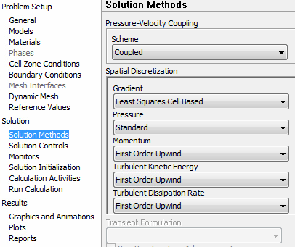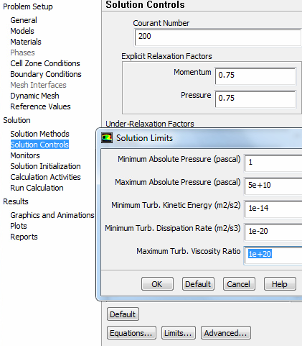

*\*\* In “Monitors” section >>Double click on “Drag” >> Tickon(Printtoconsole,Plot,Write) >> add (.txt) to the endof the file name >> Adjust theunitvectorwhichisrepresentingthedirectionofthe Drag force with respect tothecoordinatesystem(Noticeitis -1 in the X direction becausethe free stream is in thenegativeXdirection).*

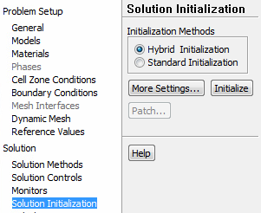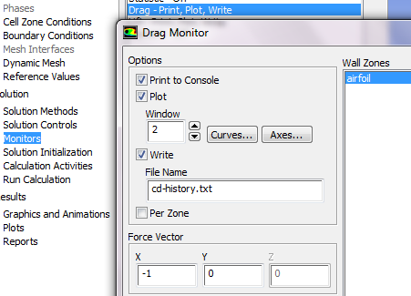

*\*\*Dothesameprocessfor“Lift”keeping in mind that the X andYforcevectorswillbedifferent.*

*\*\*In“SolutionInitialization”section >> Chose “HybridInitialization”.*

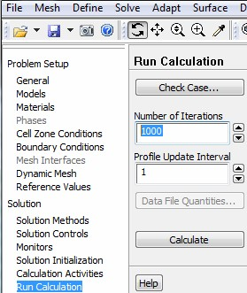

*\*\*In“RunCalculations”Section*

*>>Settherequirednumberofiterationsand“Calculate”.*

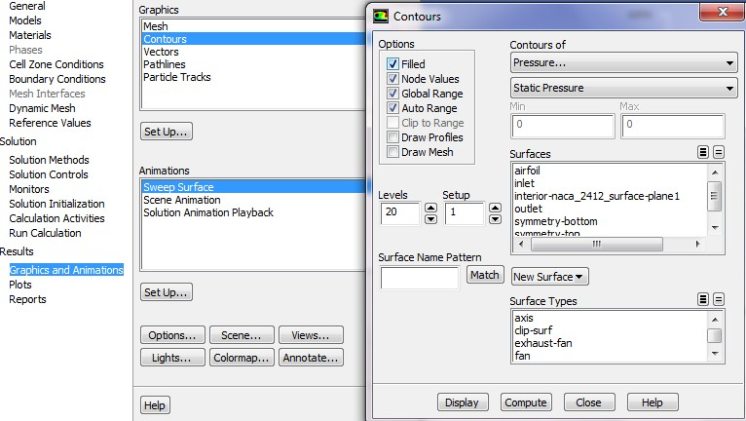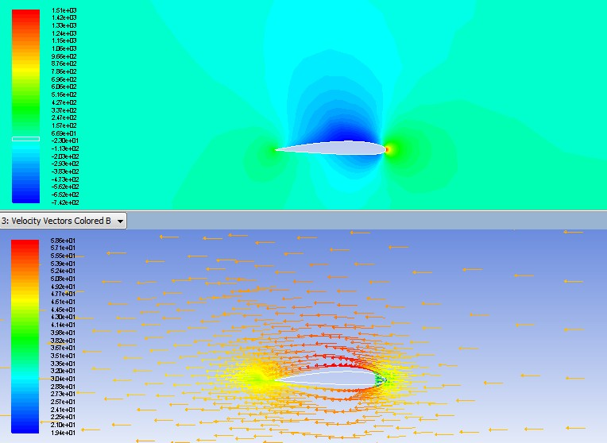

*\*\* The solution will completewhen the convergence (error)reachestothepre-definedlimit.The final Cl and Cdvalues aretheonesinthelastline.*

*\*\*Toviewthegraphicalresults,In“Results”chose“Graphicsand Animations” >> Doubleclickon“Contours”or“Vectors”*

*>> Chose therequiredspecificationsofthefigurefrom“Options”>> Display.*

*\*\*MoreresultscanbedisplayedusingCFDPostandTecplotasitwill be demonstrated in the 3Dsection.*

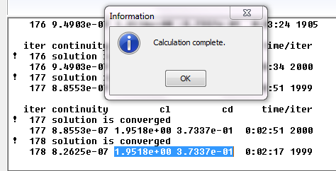

#### ChangingtheAngleofattack

In aerospace applications, the angle of attack is an important parameter where the testsusually includeastudyoftheliftandthedragunderdifferentanglesofattack.

There are 2 basic methods of changing the angle of attack where one of them is moreaccurate and time consuming while the other one is less accurate and less time consuming. Themost significantdifferencebetweenthetwo methodsis theshapeoftheenclosureduct.

##### Method1-Changingtheangleofattackusingthe3dmodellingsoftware

Theangleofattackanairfoilcanbechangedusingthe3Dmodellingsoftwareasitis

shown.

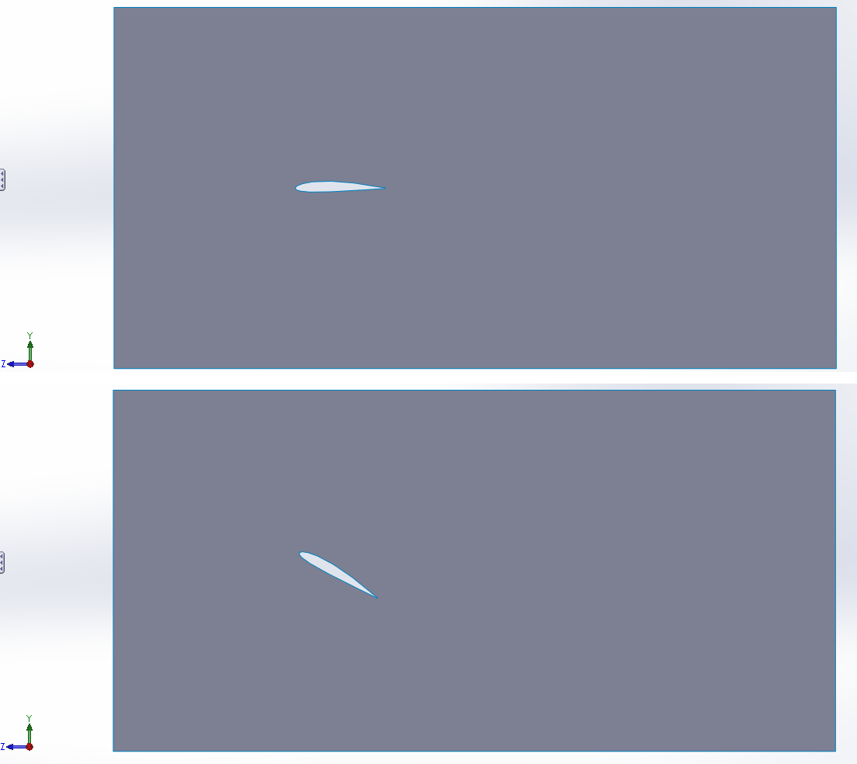

This method requires starting from the geometry modelling stage going through all thesteps of Ansys Fluent (Geometry – Mesh – Setup ... etc.). However, the shape of the containingduct can be rectangular as it is clear from the figure above. This method generates accurateresults.However,ittakes longersincethewholeprocesshastobedone.

##### Method2-ChangingtheangleofattackfromAnsysFluentsetup

The second method of changing the angle of attack is by changing the inlet velocityvectorswherethedefinedvelocitywillhavetherequiredmagnitudeanddirection.Theadvantageofthismethodologyisthetimesavedwherethechangingprocesscanbedoneinthe“Setup”stepofAnsysFluentwithoutre-doing thepreviousprocesses(GeometryandMesh).

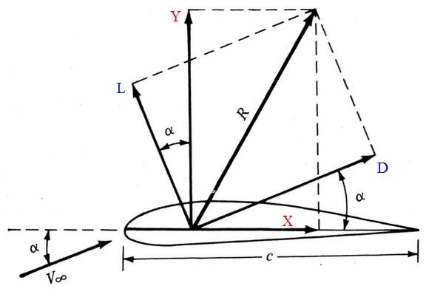

**Vx**

**Vy**

As it is shown in the figure, the velocity with an angle of attack can be resolved to twocomponents:

* + - * + Ydirection:𝑣𝑦=𝑉∞×sin𝖺
        + XDirection:𝑣𝑥=𝑉∞×cos𝖺

Hence, the velocity components can be entered to the “Boundary Conditions” whereansyswillautomaticallycalculatetheresultantvelocityandangle.

Forexample, ifthefree streamvelocityis80 m/sand theangleof attackis15º:

* + - * + 𝑣𝑦=80× 𝑠i𝑛15=20.706
        + 𝑣𝑥=80×𝑐𝑜𝑠15=77.274

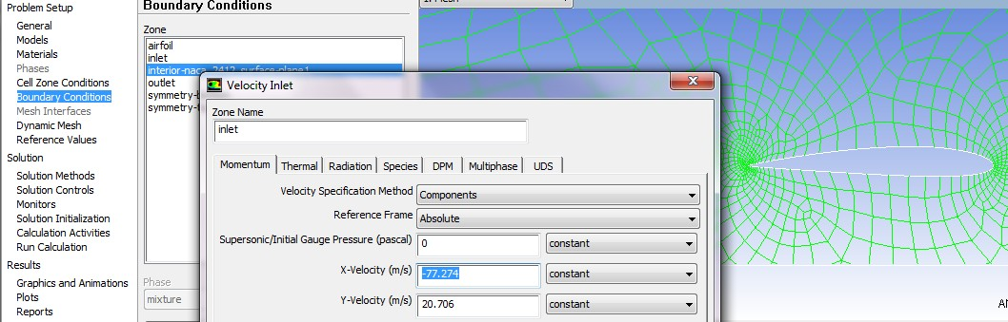

**Note:**ThevelocityinXdirectioniswitha(-)sign.Thisisduetothefactthatthegeometryhasbeendesignedin suchorientation wherethefreestreamhastobeinthenegativeXdirection.

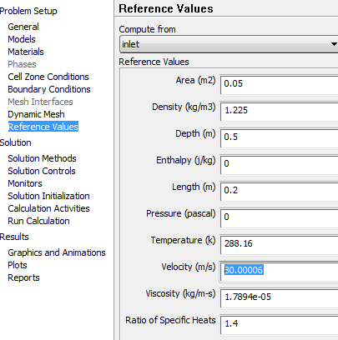**Note:**Aftereachchangeintheangleofattack,the“ReferenceValues”shouldbeupdatedtocomputefrom“Inlet”asitisshown.

|  |  |
| --- | --- |
|  | |
|  |  |
|  | |
|  |  |
|  | |

Afterupdatingthe“ReferenceValues”itcanbenoticedthatthevelocityhasbeenautomatically calculatedtobetheresultantvelocity.

Since the velocity has been defined using the components, the monitors ofthe lift andthedraghastobesettoreadtherequiredforcecomponents.



**Vx**

**Vy**

Asit is clear from the graph, with the existence ofthe angle of attack, the lift and thedrag are not exactly the pure forces on one of the Y or X axis. The lift and the drag can berepresentedbythefollowingequations:

* + 𝐿=(𝑌×cos𝖺)−(X ×sin𝖺)
  + 𝐷=(𝑌×sin𝖺)+ (X× cos𝖺)

Hence,thecoefficientsof XandYhaveto beenteredto the“Monitors”sectionwhere:

* + ForLift:(X:−sin𝖺,Y:cos𝖺)
  + ForDrag:(X:cos𝖺,Y:sin 𝖺)

Forexample,forfreestreamvelocityis80m/sandtheangleof attackis15º:

* + For Lift:(X: −sin15=−0.259,Y:cos15=0.966)
  + For Drag:(X:cos15=0.966,Y:sin15=0.259)

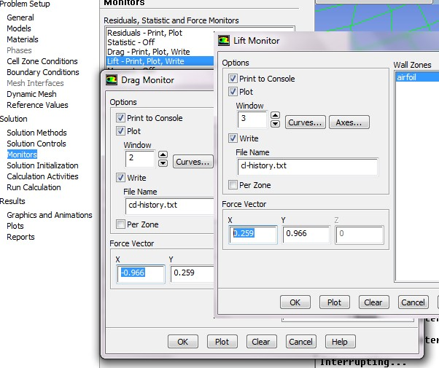

**Note:**All the coefficients in X direction havebeen inversed since the geometry has beendesigned in such orientation where the free stream has to be in the negative X direction, as ithasbeenmentionedpreviously.

For multiple angles of attack, the same process has to be repeated for each angle. It ispreferredtoconstructatablewiththerequiredvelocityvectorsandthemonitoringcoefficientsonMicrosoftExcel asitisshownbelow.

|  |  |  |  |  |  |  |  |  |
| --- | --- | --- | --- | --- | --- | --- | --- | --- |
|  | | | | | Monitors | | | |
|  |  | BoundaryConditions>Inlet | |  | **Drag** | | **Lift** | |
| **Velocitym/s** | **AOA** | **inletX** | **inletY** |  | **Y** | **X** | **Y** | **X** |
| 80 | **-5** | 79.696 | -6.972 |  | -0.087 | 0.996 | 0.996 | 0.087 |
|  | **0** | 80.000 | 0.000 |  | 0.000 | 1.000 | 1.000 | 0.000 |
|  | **5** | 79.696 | 6.972 |  | 0.087 | 0.996 | 0.996 | -0.087 |
|  | **10** | 78.785 | 13.892 |  | 0.174 | 0.985 | 0.985 | -0.174 |
|  | **15** | 77.274 | 20.706 |  | 0.259 | 0.966 | 0.966 | -0.259 |
|  | **20** | 75.175 | 27.362 |  | 0.342 | 0.940 | 0.940 | -0.342 |

Theprocesswhichhastoberepeatedforeachanglecanbeconcluded infewsteps:

1. BoundaryConditions>>Inlet>>Edit>>Changingthevelocityvectors
2. ReferenceValues>>Computefrom>> Inlet
3. Monitors>>LiftandDragmonitors

The method saves a lot of time in the case of testing many angles of attack. However, itis noticed from the figure below that the angles of attack of the flow changes before approachingthewingwhichcausesinaccurateresults.

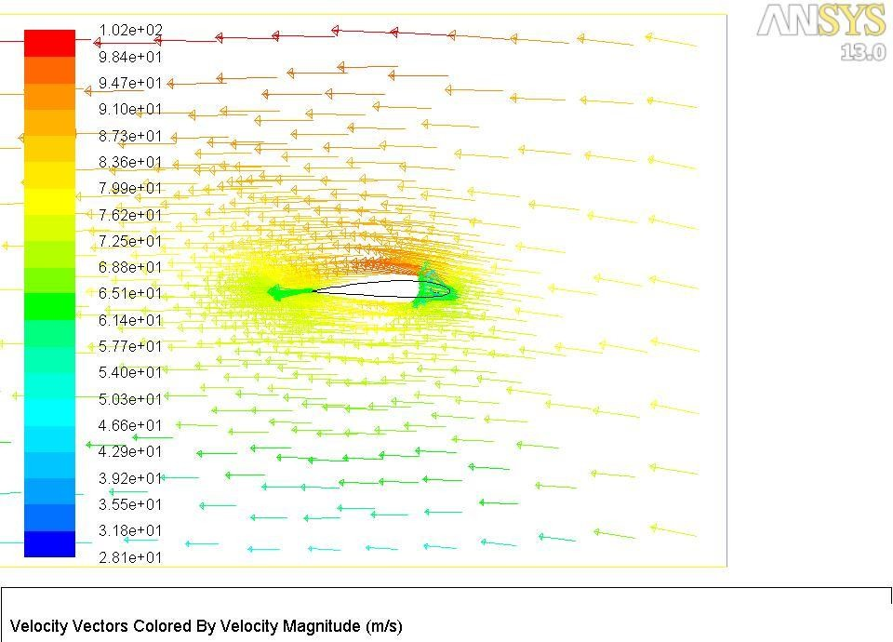

The best way to solve this problem is changing the enclosure duct from a rectangularshape to a C-duct shape. A circular inlet covering the whole model will insure that the angle ofattackis maintainedtocoverthewholewingwiththerequiredflowangleof attack.

**Note:** The most important step while constructing the C shaped inlet is making sure that thewhole model is included inside the C shaped inlet. It is recommended to keep the model ascloseraspossibletotheleadingpartoftheC shapedinlet.

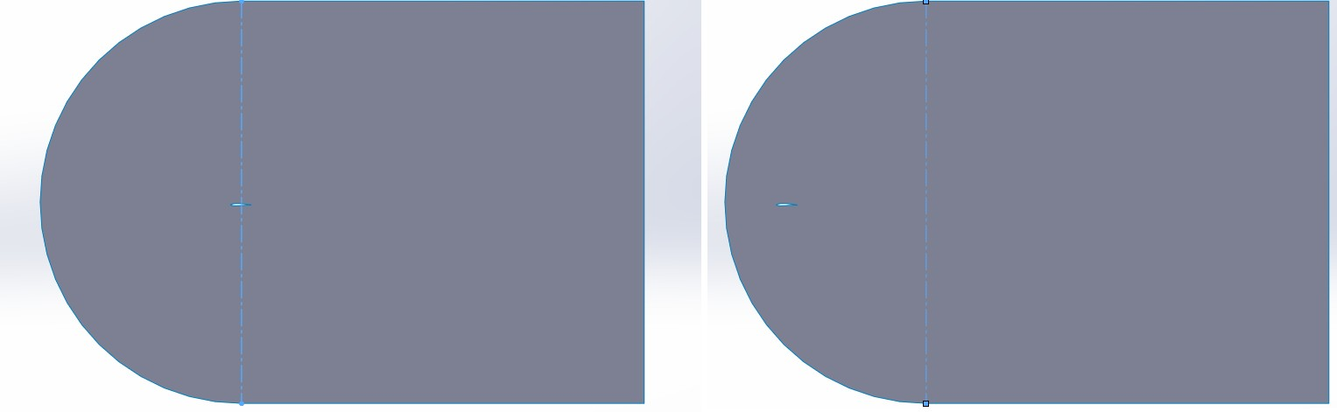

Hence,itisnoticeablethatthewholemodelisbeingcoveredwiththeflowapproachingwiththerequiredangleofattack.

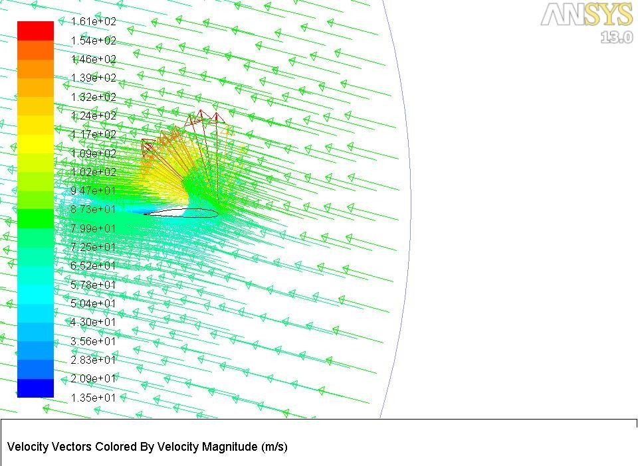

* + - 1. ***Comparisonbetweenthetwomethods***

|  |  |  |
| --- | --- | --- |
|  | **Method1** | **Method2** |
| **Enclosureshape** | Rectangular | Cduct |
| **Anglechangeusing** | 3Dmodellingsoftware | FluentSetup |
| **Timerequired** | More | Less |
| **Resultsaccuracy** | More accurate | Lessaccurate(Acceptable) |
| **DomainSize** | Smaller | Bigger |
| **Changingsteps** | Thewholeprocedure | Boundaryconditions–  ReferenceValues-Monitors |
| **Calculating Velocitycomponents** | Notrequired | Required |
| **LiftandDragMonitors** | Lift: (X:0,Y: 1)  Drag:(X:1,Y:0) | Lift: (X:−sin𝖺,Y:cos𝖺)Drag:(X:cos𝖺, Y:sin𝖺) |



*\*\*Thegeometryfileshouldbesavedinanindividualfile*

*\*\*InANSYSWorkbenchwindow:*

*Drag (Fluid Flow (Fluent)) totheProjectSchematicinsidetheredsquare*

*\*\*RightClickon(Geometry)>>Import Geometry >> Browse >>Locate the geometry file*

* 1. **Fluent–3D-FiniteWing**

#### Geometry

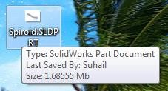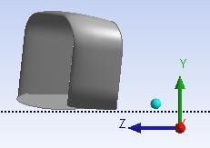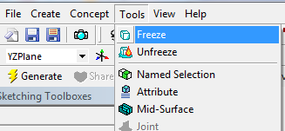

*\*\* Open Geometry by doubleclicking on “Geometry”. Chosethe units used whileconstructingthegeometryfiles*

*\*\*OntheTreeOutlineontheleft side >> Right Click on“Import”>> Generate*

*\*\*Afterthegeometryappears,goto: Tools>> Freeze*

*\*\* Click on the axis whichreorientstheviewtothesideview. InthiscaseitisXaxis.*

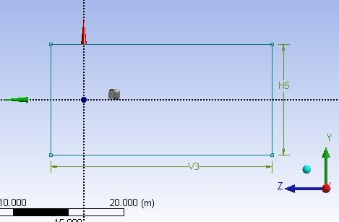

*\*\* On the Tree Outline, click onthe side view plane. In this caseitisYZPlane*

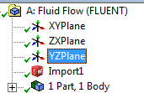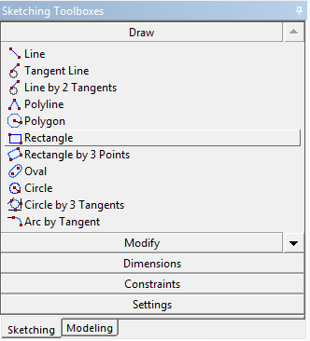

*\*\*OntheTreeOutlinewindow,Chose “Sketching”>> Draw >>draw a rectangle whichrepresents the side view of thetestdomainorthespace.*

*\*\* Fix the dimensions using“Dimensions” option on thesketchingtoolbarontheleftside. The side view of thedomain should look like thefigure.*

***Note****: In the C-Duct case, thecircle has to be drawn first,followed by the rectanglestartingexactlyfromthemiddleof the circle. The unwantedpartshavetobe trimmed.*

*\*\*Afterfixingthedimensions,*

*clickon tosetthedepth ofthedomain.*

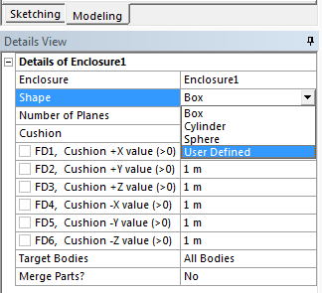

*\*\* Set the directions and thedepthofthedomainthenclick*

*.*

*\*\*Afterthesesteps,theTreeOutline should look like theshownfigure.*

*\*\*Aftergettingthepreviousoutline, go to Tools >>Enclosure.*

*\*\*Changethe“Shape”to“userdefined”*

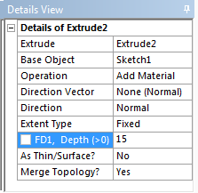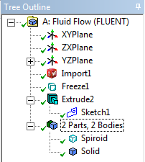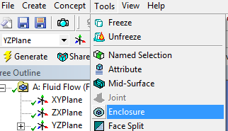

*\*\* For the cell “User DefinedBody”,Chose“solid”fromthe*

*Treeoutlineandclick“Apply”.*

*\*\*Click*

*.Theresulted*

*geometryshouldlooklikethe*

*shownfigure.*

*\*\*Goto“Create”>>Boolean.*

*\*\*Onthedetailsviewontheleftbottomcorner,change*

*“Operation”from“unite”to*

*“Subtract”.*

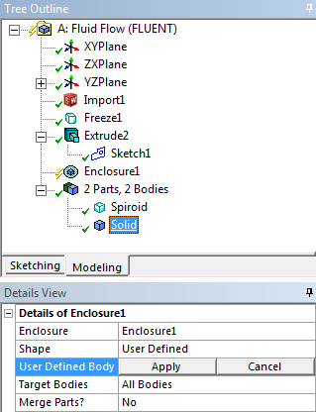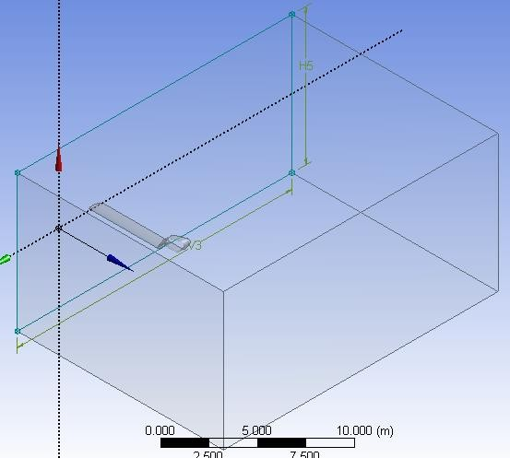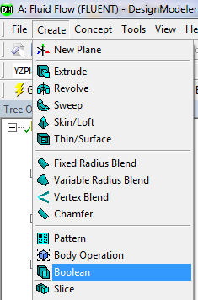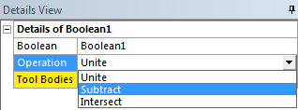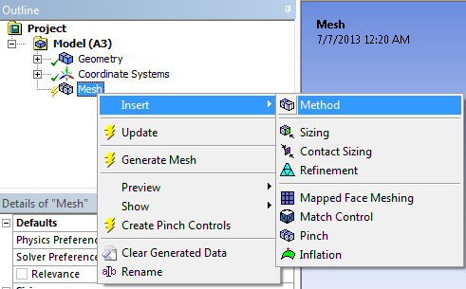

*\*\*Click*

*.TheTree*

*Outline shouldlookliketheshownfigure.Noticethatthereis only 1 Part, 1 Body while thegeometry “spiroid” has beensubtractedfromthe domain*

*“solid”.Moreover,“Solid”doesnotnecessarilymeanthatitissolid body, it is still thesurroundingair.*

*However, Ansys calls thegenerateddomain“solid”.Theobjectcanberenamedif*

*required.*

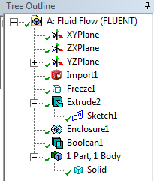

#### Mesh



*\*\*CloseGeometry.Doubleclickon“Mesh”.*

*\*\*Inthe“MechanicalWindow”,on the Outline part, Right clickon“Mesh”>>Insert>>Method*

*>>Automatic.Thenclickonthebody which is representing thedomain.Thenclick“apply”.*



*\*\*OntheOutlinepart,Leftclickon“Mesh”.Then on the “Details of Mesh” windowChangethefollowings:*



* *Relevance>>controlsthe densityofthemeshinregionscloser tothegeometry.*
* *Useadvancedsizefunction>>OnProximityandCurvature*
* *RelevanceCenter>>Fine*
* *MinSize>>theminimumsizeofthemeshelementsin meters*
* *MaxfaceSize>>themaximumsizeofthemesh elementsinmeters*
* *MaxSize >>equalto“Maxface Size”*
* *AutoMeshBasedDefeaturing>>OffThenclick .*



*\*\*Afterthemeshisgenerated.ChoosetheFacechoosingtool.*

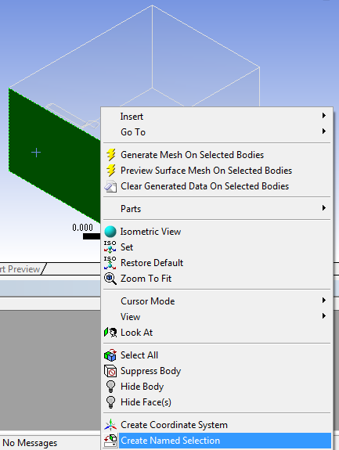

*\*\*Leftclickoneach faceinthegeometry>>Right click >> Create NamedSelection>>Name eachfaceaccordingtheorientation of the model. Make sure thatthe inlet is named “inlet”, the outlet isnamed “outlet”, and the other 4 sides’namesstartwith“symmetry–(name)”.*

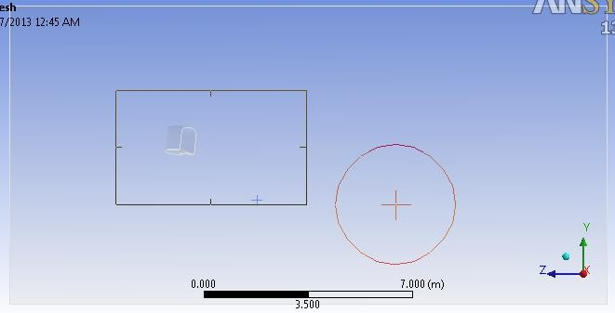

*\*\* After selecting each faceseparately and assigning anamedselection,changethe*

*selectiontypeto“Boxselection”asshown.*

*\*\* Hence, go to the side viewand select the model or thewing as it is shown. Then rightclick>>createnamedselection*

*>> call it any name (avoidcalling it Inlet, Outlet andSymmetry).*

*\*\* After doing the namedselectionstep,thetreeoutlineshould look like the shownfigure. Notice all the namedselectionsarelisted.*

*\*\* Close the “MechanicalWindow”>>Rightclickon“Mesh”>> Update.*

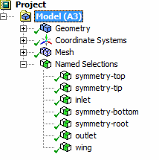

*\*\*DoubleClick on“Setup”*

*\*\* Tick (Double Precision)>>Chose“Parallel”andchoosethenumber of processors to be 4unless if more processors arelicensed.Inthe case yourcomputer doesnothave4processors, choose themaximum number of availableprocessors.*

*\*\*Chosethe“Type”tobe:*

* *“PressureBased)forincompressibleflow*
* *“DensityBased”forcompressibleflow*
  + 1. **Setup**

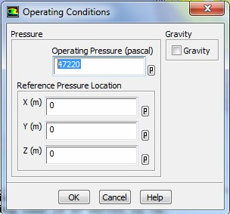

*\*\*Goto“Define”>>OperatingConditions.*

*\*\*DefinetheStaticPressureinthe operationaltitude.*

*\*\* In “Models” Section >>Doubleclickon“Viscous”andchose:*

* *Model:K-epsilon*
* *K-epsilonmodel:Realizable*
* *Near-Wall Treatment: Non-EquilibriumWallFunctions*



*\*\* In “Materials” Section >>DoubleClickon“air”>>setthedensity and the viscosityPressure intheoperationaltitude.*



*\*\* In “Boundary Conditions”Section >> Double Click on“Inlet” >> Change “VelocitySpecification Method” to“Components” >> Insert thevaluesoftheflowvelocitywithrespect to the coordinatesystem.*

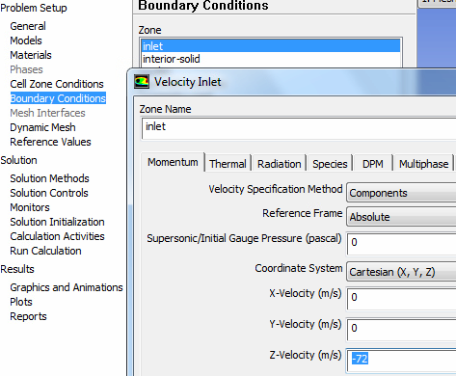

*\*\*In“ReferenceValues”section*

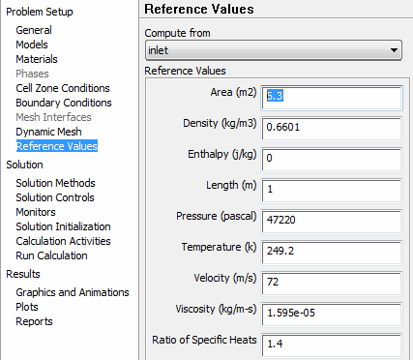

*>>Choose“Computefrom”tobe “inlet” >> Insert the flowconditions at the operatingaltitude.Moreover, insert:*

* *Area: the reference area of thewing(theprojectionarea)*
* *Length:MeanAerodynamicChordlength*



*\*\*In“Solution Methods”Section*



*>>Chose“Scheme”tobe“Coupled”.*

*\*\* Change the “Momentum”,“TurbulentKineticEnergy”and“TurbulentDissipationRate”to“SecondOrderUpwind”*



*\*\*In“Solution Controls”Section*

*>>Clickon“Limits”>>setthe“Maximum Turb. ViscosityRatio”tobe1e+20.*

*\*\* In “Monitors” section >>Double click on “Residuals” >>Tick on (Print, Plot) >> on theright side, remove the ticksfromalltheparametersexceptcontinuity. Moreover, changethe absolute criteria of thecontinuity to be 1e-6 as showninthefigure.*

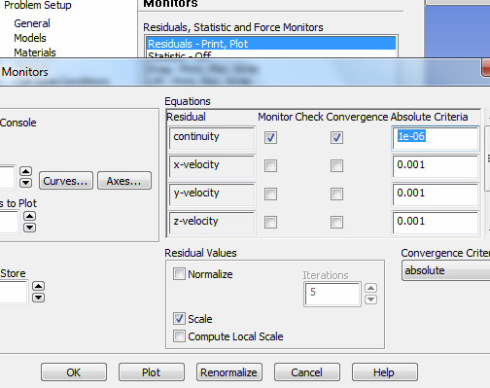

*\*\* In “Monitors” section >>Doubleclickon “Drag”>>Tickon (Print to console, Plot,Write) >> add (.txt) to the endof the file name >> Adjust theunitvectorwhich isrepresenting the direction ofthe Drag force with respect tothe coordinatesystem.*

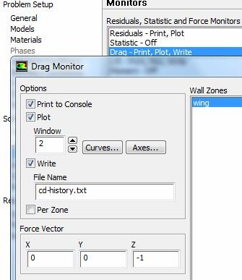

*\*\*In“SolutionInitialization”section >> Chose “HybridInitialization”.*



*\*\*In“RunCalculations”Section*

*>>Settherequirednumberofiterationsand“Calculate”.*

*\*\* The process can be paused,stoppedandsaved.Tocontinuesolving the problem, the setupshould be started from“Solutions” in the main Ansyswindow.*



*\*\*Theresultscanbefoundfromthesamewindowasitwasshown in the 2D case. Moreoptions can be found in CFDPost.*

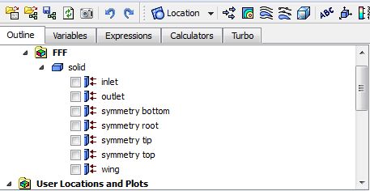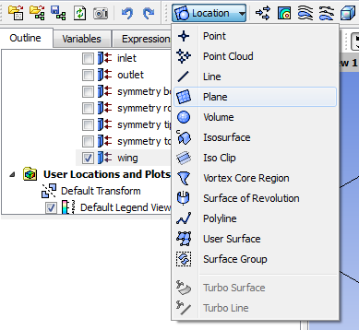

*\*\*Close“Setup”.Doubleclickon“Results”.*

*\*\* From the outline tree, theparts can be displayed orhidden.*

*\*\* In order to display pressuredistribution or velocity vectors,aplanehastobeconstructedatthe sectionasitisshown.*

* + 1. **CFDPost**

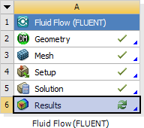

*\*\*Selecttheorientationoftheplanewhere:*

* *Method: select which planewill be parallel to the newconstructedplane(InthiscaseitisYZplane).*
* *X:Thedistancefromtheoriginto the plane. If the origin set tobe at the wing root in the 3dmodelling geometry, then Xmeans the span wise distancefromthewingroot.*

*Afterfixingthesettings,click“Apply”. The plane has beenconstructedasitisshown.*

*\*\*Ontheupperbar,*

1. *Velocityvectors*
2. *Contours(Pressure,Vortectiy,Turbulence… etc.)*
3. *Streamlines*

*\*\*Todisplaytheproperties,thePlane has to be selected as“Location”.*

# 12 3

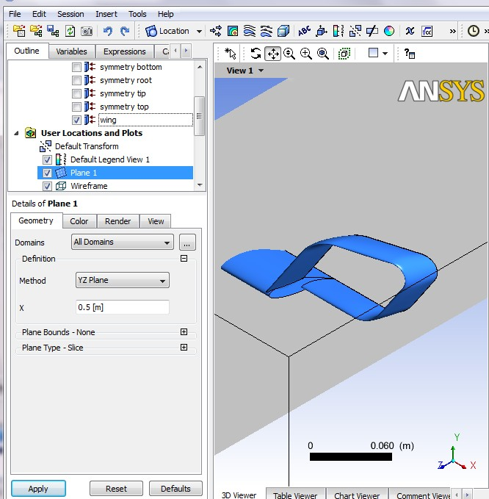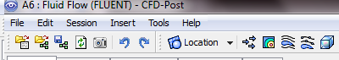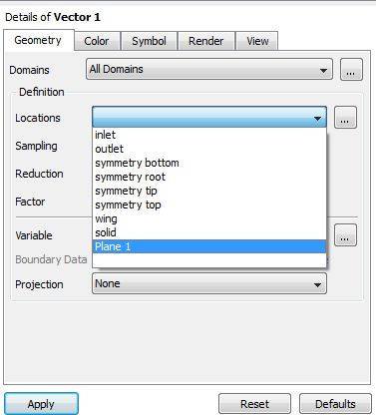

*\*\* In the condition of the 3Dstreamlines,ithastobedefinedto start from “Inlet”. In somecases, a custom plane has to beconstructed to define it as astarting plane of thestreamlines. This is useful whenit is needed to display thestreamlines over a specificregion.*

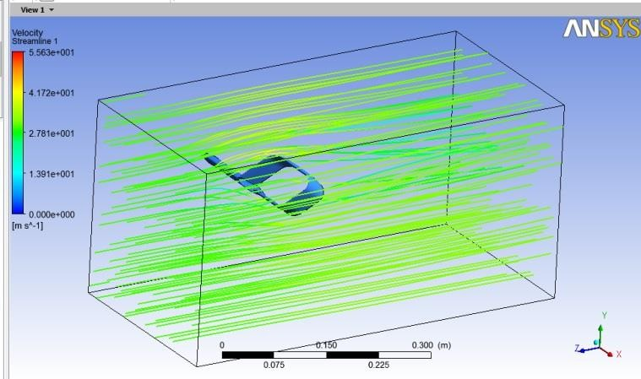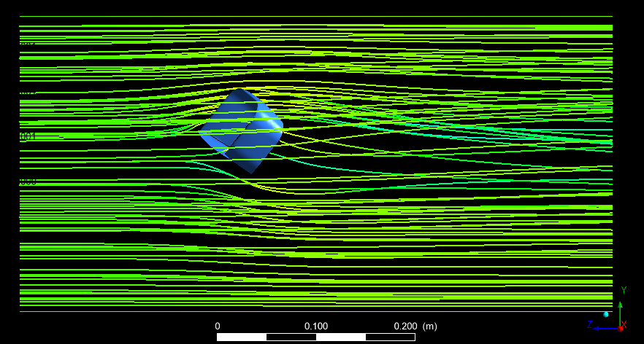

*\*\* For example, it is noticed inthe first figure that thestreamlines have been startedfromtheinletwhichledtocoverupthewholedomainareawith thestreamlines.*

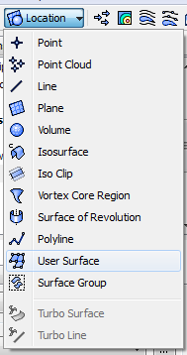

*\*\*Inordertodefinethestartingofthestreamlinestobeexactly projected on the wingarea;*

* *Location>>UserSurface*
* *Method>>TransformedSurface*

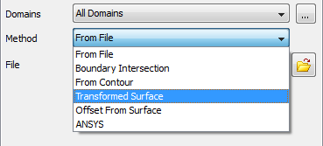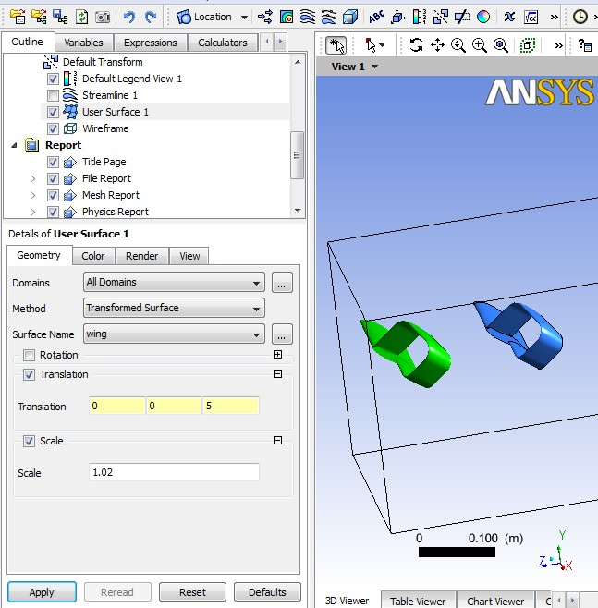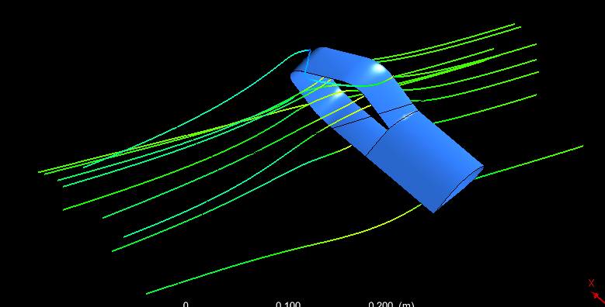

*\*\*Thesurfaceofthewingwillbe copied and transferredforward to use it as a startingplane ofthestreamlines:*

* *SurfaceName:Wing*
* *Activate“Transition”>>Movethe plane to the forwarddirection (In this case it is Zdirection).*
* *Activate“Scale”andusefactorof 1.02 (This step is to ensurethat the starting plane is a littlewider than the original wingarea. Hence it will be ensuredthat the streamlines will becoveringthe wholemodelwithoutgapsonthesides.*

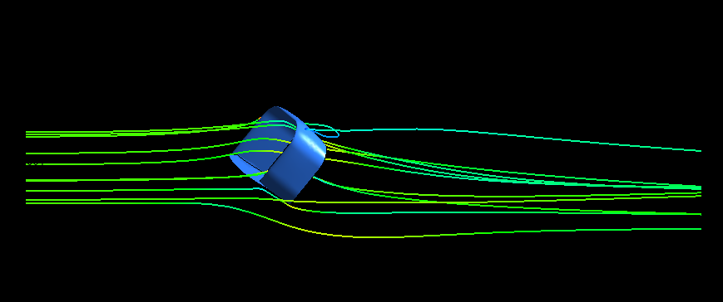

*\*\* Create “Streamlines” usingthe “User Surface” for “Startfrom”.Itisnoticedthatthelineshave been refined for a bettervisualization.*

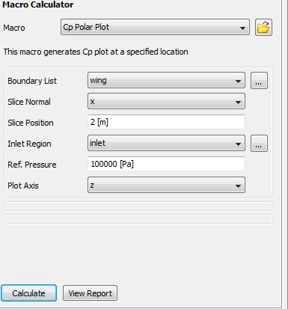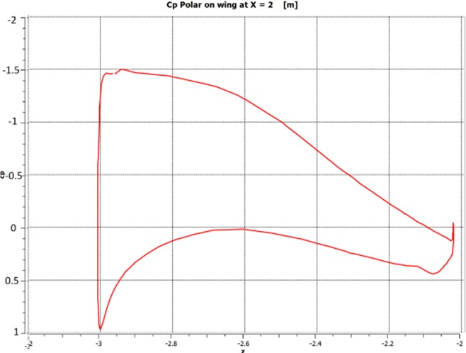

*\*\* A plot presenting the pressurecoefficientdistributionoverthewingsurfacecanbeplotted:*

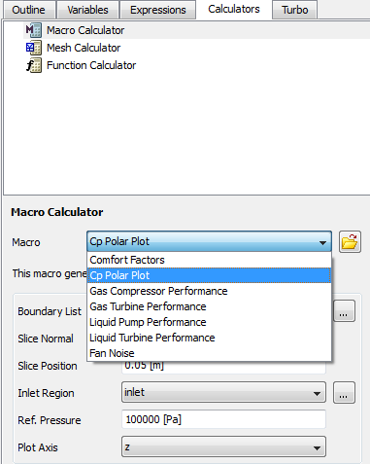

* *Calculators>>MacroCalculators>>Macro:(CpPolarPlot)*
* *BoundaryList:theobjectwherethepressure distributionhastobe*

*investigated.Inthiscaseitis“wing”.*

* *Slice Normal: to calculate thepressuredestitutionoveranairfoil,thewing has to be sliced at a specific span.The axis going through the span is thespan wise axis which is normal to theslice.Inthiscase it isXaxis.*
* *SlicePosition:thedistanceoftheslicefromtheorigin*
* *Plotaxis:thedirectioninwhichtheCpvariation is investigated (the chordwise direction). In this case it is Zdirection.*

*\*\*Chose“Calculate”then“ViewReport”.*

***Note****: the Y axis is oriented in a waywhere it shows the upper surface at thetop which leads to the fact that the YaxishasnegativevaluesofCpatthetopandthepositivevaluesatthebottom.*



* + 1. **Tecplot**

*\*\* More results can be presented usingTecplot.Inordertoimportthesolutiondatatotecplot:*

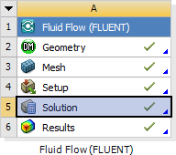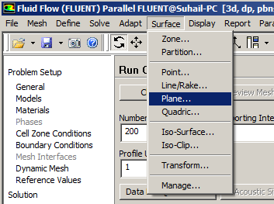

* *Open“Solutions”*
* *As it was explained in Ansys, planeshave to be constructed to show theresults. Hence, the plans have to beconstructed before exporting thesolutiondata becauseplanesconstructed using tecplot cannotrepresentthesolutiondataimportedfromAnys.*
* *To construct a new plane: Surface >>Plane*
* *In “Options”:PointandNormal:allowstheusertoassignapointandanaxis as references for creating theplane.*

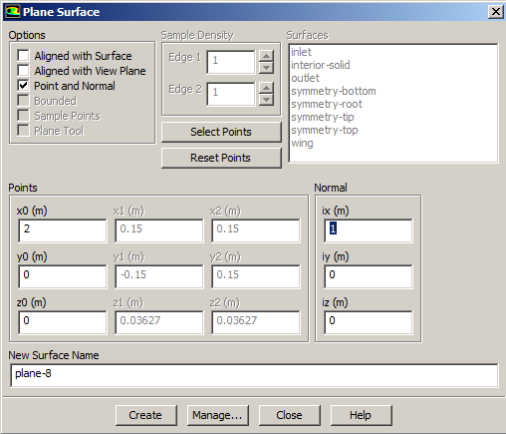

* *In“Points”:entertheposition ofthepoint through which the plan will bepassing*
* *In“Normal”:enter thedirectionvector for the axis which the plane hastobenormalto.*

***Note****: Theplanecanbecreatedwithanangle with respect to the axis byentering the direction vectors intomorethanonefield.*

* *Click“Create”*

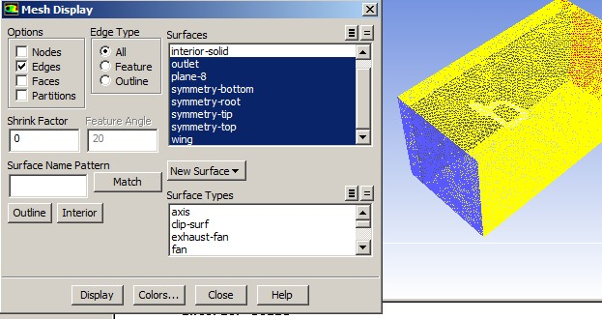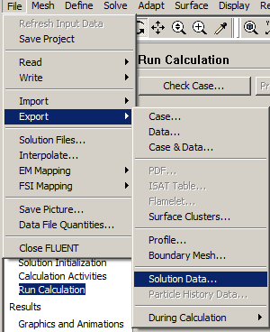

*\*\* In order to display the createdplane:*

* *Display>>Mesh*
* *Highlight(Plane#)>>Display*

***Note****: All the planes must becreatedbeforeexportingthesolutiondata*

*\*\*Inordertoexportthesolutiondatatotecplot:*

* *File>>Export>>SolutionData*

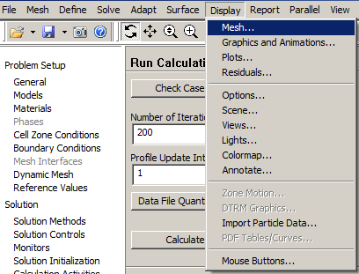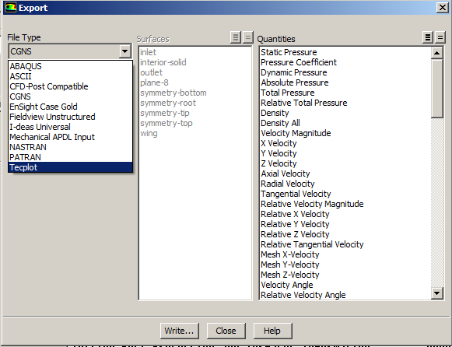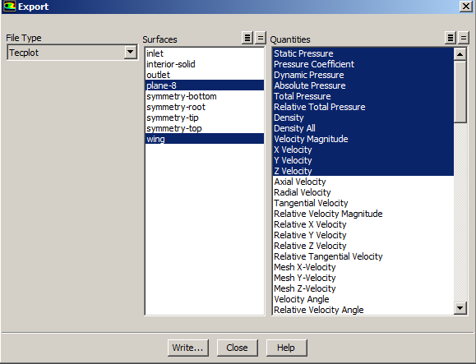

*\*\*In“Export”:*

* *FileTpye:Tecplot*
* *Surfaces:Chosethe“Wing”andall the plans needed to betransferredtotecplot.*
* *In “Quantities”: all the neededparametersshouldbehighlighted.Generally:*
  + *StaticPressure*
  + *PressureCoefficient*
  + *DynamicPressure*
  + *AbsolutePressure*
  + *TotalPressure*
  + *RelativeTotalPressure*
  + *Density*
  + *DensityAll*
  + *VelocityMagnitude*
  + *XVelocity*
  + *YVelocity*
  + *ZVelocity*
  + *VorticityMagnitude*
  + *Helicity*
  + *X-Vorticity*
  + *Y-Vorticity*
  + *Z-Vorticity*
  + *X–Coordinate*
  + *Y-Coordinate*
  + *Z -Coordinate*
* *Click“Write”.CloseAnsysaftertheimportisdone.*

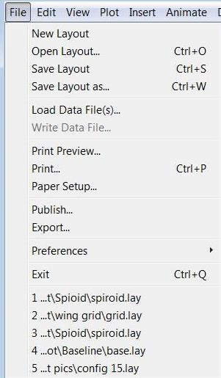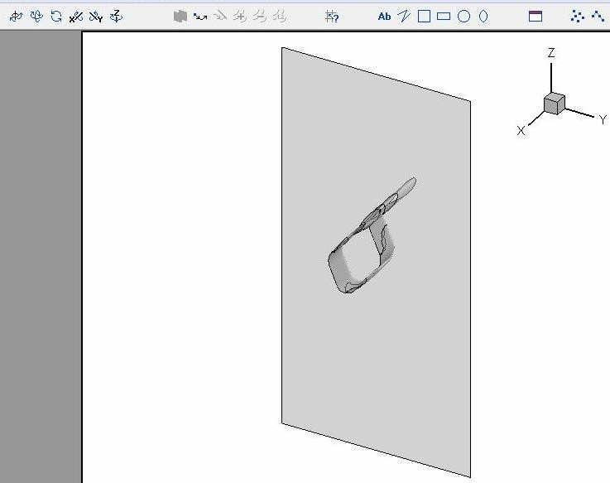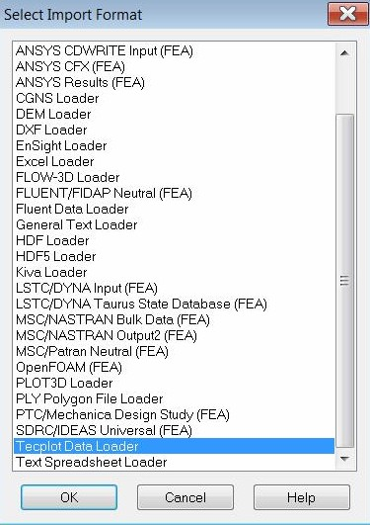

*\*\*InTecplot:*

* *File>>LoadDataFile(s)>>TecplotDataLoader*
* *Changethe“InitialPlotType”to:3DCartesian*
* *The model gets imported in adifferentorientation.Hence,ithasto be rotated using thecoordinators controllers shown inthefigure.*

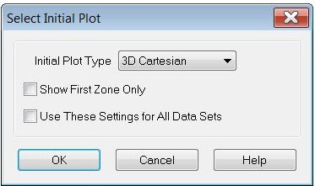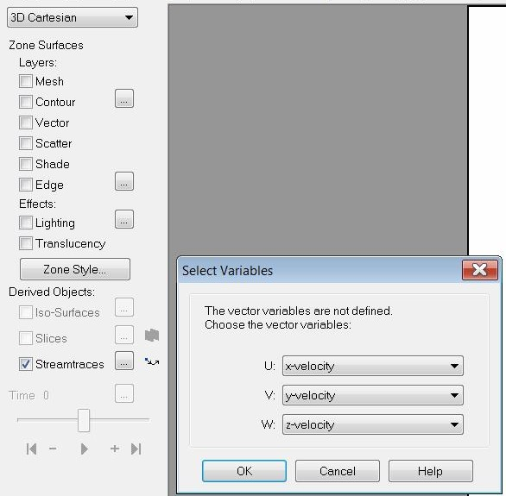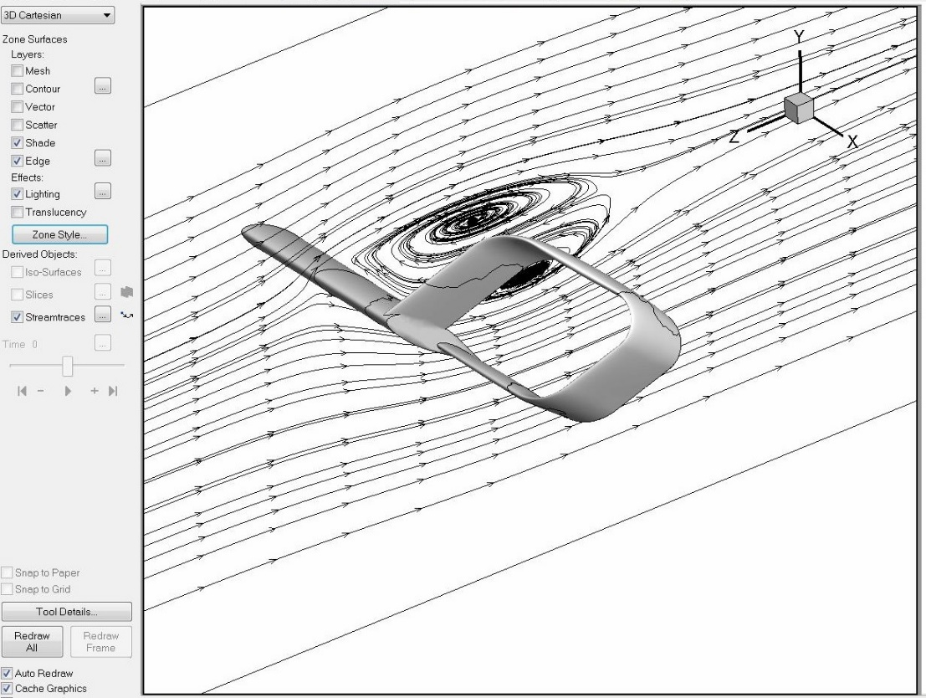

*\*\*Afterreorientingthegeometrytotherequiredposition:*

* *Chose“Streamtraces”:*
  + *U:X-velocity*
  + *V:Y-velocity*
  + *W:Z-velocity*

*\*\* Click on the sign showed in thefigure. This tool allows the user todrawalinewherethestreamlinescovers all the area passed by thedrawn line. Hence, the user cancontrolthe densityofthe lines.*

*Moreover,theconcentrationofthelines can be focused on a specificregion by drawing more than onelineat thatregion.*



*\*\*Thegeometryfileshouldbesavedinanindividualfile*

*\*\*InANSYSWorkbenchwindow:*

*Drag (Fluid Flow (Fluent)) totheProjectSchematicinsidetheredsquare*

*\*\*RightClickon(Geometry)>>Import Geometry >> Browse >>Locate the geometry file*

### Fluent–Internalflowthroughpipesandducts

* + 1. **Geometry**

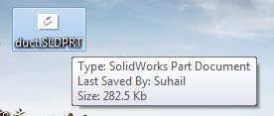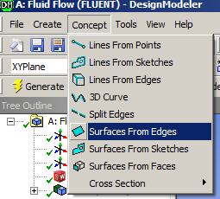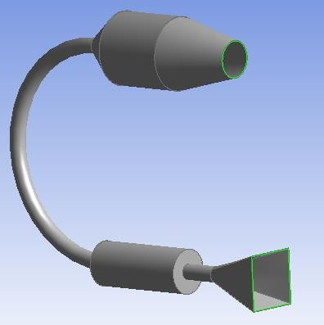

*\*\* Open Geometry by doubleclicking on “Geometry”. Chosethe units used whileconstructingthegeometryfiles*

*\*\*OntheTreeOutlineontheleft side >> Right Click on“Import”>> Generate*

*\*\* The duct geometry willappear. The inlets and theoutletshavetobedefinedassurfaces:*

* *Concepts>>SurfacesfromEdges*
* *Choosetheedgesoftheinletandtheoutlet*
* *Click“Apply”>>Generate*

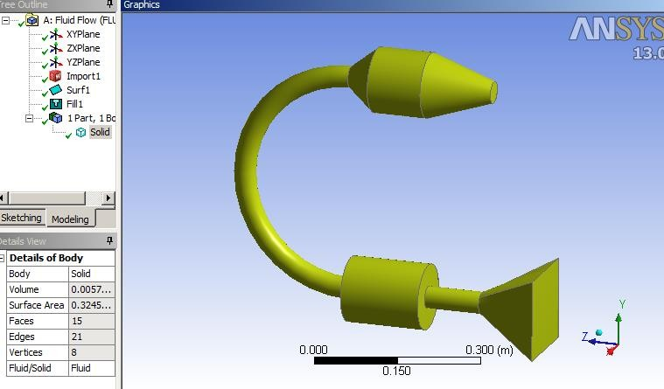

*\*\* After defining the surfaces,thewholeducthastobedefinedtobefilledwith material:*

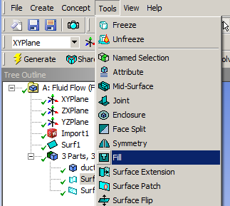

* *Tools>>Fill*

*\*\*In“DetailsofFill1”:*

* *Extraction Type:ByCaps*
* *PreserveSolid:*

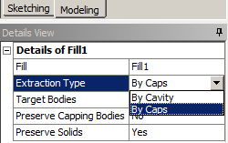

* *Choose“Yes”iftheoutersurface of the duct (the wall ofthe duct) is needed for theanalysis. For example, if there isheat transfer between the fluidand the wall and then betweenthe wall and the environmentlikethecase in theheatexchanger.*
* *Chose “No” if the ductwall is not needed. This savestheresourcesneededtoprocessthemesh ofthewall.*

*In this case, the wall is notrequired; hence, “No” will bechosenfor“PreserveSolids”>>Generate.*

*\*\* It can be noticed that theinternal shape of the duct hasbeendefinedasthematerial.*

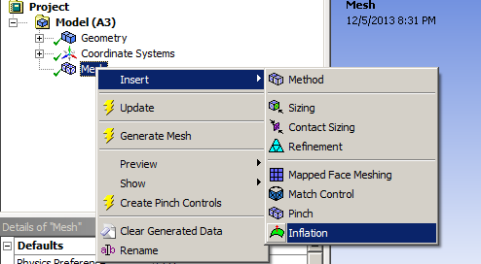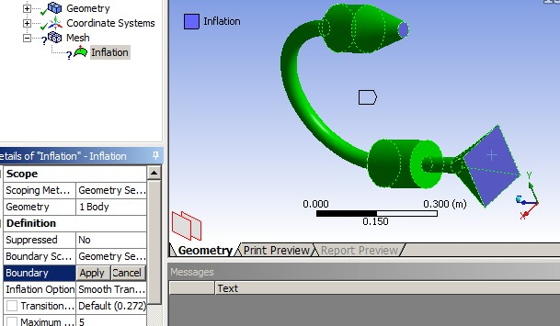

* + 1. **Mesh**

*\*\*ClosetheGeometryDesignModular>>DoubleClickon “Mesh”.*



*OntheOutlinepart,Rightclickon “Mesh”.Then on the “Details of Mesh” windowChangethefollowings:*

* *Relevance>>controlsthedensityofthemeshinregionsclosertothegeometry.*
* *Useadvancedsizefunction>>OnCurvature*
* *Relevance Center >> FineThenclick .*

***Note****:Sinceboundarylayerisimportantin*

*theinternalflowcases.Formoreaccuratestudy of the boundary layer, whether it isinternalflowor externalflow(For*

*\*e*xaCmlopseleG,tehoembeoturyn.dDaoryublaleyecrlicokverthe sounr“faMceeshof”.thewing),“Inflation”hastobe createdwhicharrangesmorerefinedmesh*

*fortheboundarylayerregion:*

* *Rightclickon“Mesh”>>Inflation*

*\*-*CIhnoothsee“GMeeocmhaentricya”ltoWbinedtohwe”w,holebody o>n>tAhpepOlyutlinepart,Rightclick*

*on“Mesh”>>Insert>>Method*

*>->ChAouotsoemaalltitch.eTfhaecnescleixcckeopnttheinletand*

*bthoedyouwtlheitchtoisbreetphree“sBenotuinndgatrhye”>>Apply*

1. *oTmheaoint.hTehreonptciloicnks“liakpep(lIyn”f.lationOption andNumberoflayersareuptotheuser)*

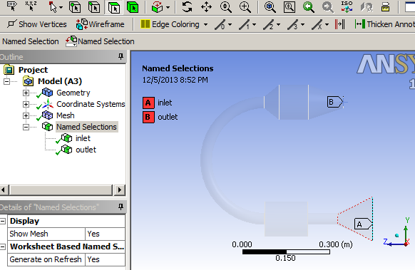

*\*\*Thedifferencecanbenoticedwhere the mesh is refined afterusinginflation(Right).*

*\*\*Afterthemeshisgenerated.ChoosetheFacechoosingtool.*

*\*\*Leftclick oninletsurface*

*>>Rightclick>>CreateNamedSelection>>Type“Inlet”*

*-Dothesamefor“Outlet”*

*\*\* After doing the namedselection step, the tree outlineshould look like the shownfigure.Noticetheinletandtheoutletarelistedand marked.*

*\*\* Close the “MechanicalWindow”>>Rightclickon“Mesh”>> Update.*

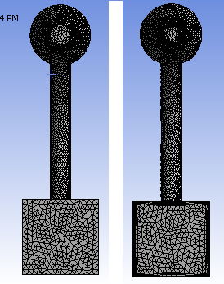

*\*\*DoubleClick on“Setup”*

*\*\* Tick (Double Precision)>>Chose “Parallel” and chose thenumber of processors to be 4unless if more processors arelicensed.Inthecaseyourcomputer does not have 4processors, then choose themaximumnumberofprocessorsavailable.*

*\*\*Chosethe“Type”tobe:*

* *“PressureBased)forincompressibleflow*
* *“DensityBased”forcompressibleflow*

#### Setup

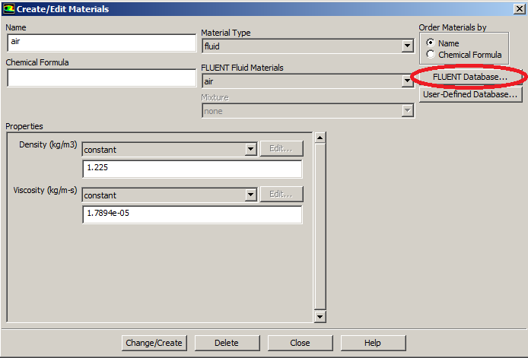

*\*\* In “Models” Section >>Doubleclickon“Viscous”andchose:*

* *Model:K-epsilon*
* *K-epsilonmodel:Realizable*
* *Near-Wall Treatment:EnhancedWallTreatment*

*\*\* More information aboutFluentModelscanbefoundon*

*<<*<http://aerojet.engr.ucdavis.edu/fluenthelp/html/ug/node1336.htm>>>

*\*\* In “Materials” Section >>Double Click on “air” >> set thedensity and the viscosity. Morematerials can be added from“FluentDatabase”.*

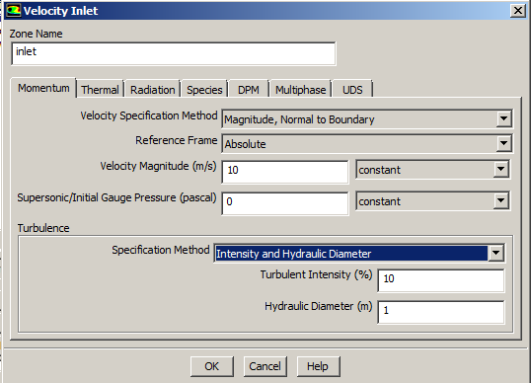

*\*\* In “Boundary Conditions”Section>>DoubleClickon“Inlet”*

*>> Change “Velocity SpecificationMethod”to“Magnitude,NormaltoBoundary” >> Insert the inlet flowvelocity*

*\*\* In the “Turbulence” section,enterthe“TurbulentIntensity”and“Hydraulic”Diameter”oftheinlet.*

***Note****: Turbulent Intensity andHydraulic are well knownparametersinfluiddynamics.Bothof them can be calculated usingsimple formulas. The formulas caneasily foundonline.*

*<<*<http://www.cfd-online.com/Wiki/Turbulence_intensity>>>

<<[http://en.wikipedia.org/wiki/Hydraulic](http://en.wikipedia.org/wiki/Hydraulic_diameter)

[_diameter](http://en.wikipedia.org/wiki/Hydraulic_diameter)>>



*\*\*In“Solution Methods”Section>>Choose“Scheme”tobe“Coupled”.*

*\*\* Change the “Momentum”,“TurbulentKineticEnergy”and“TurbulentDissipationRate”to“SecondOrderUpwind”*



*\*\*In“Solution Controls”Section*

*>>Clickon“Limits”>>setthe“Maximum Turb. ViscosityRatio”tobe1e+20.*

*\*\* In “Monitors” section >>Double click on “Residuals” >>Tick on (Print, Plot) >> on theright side, remove the ticksfromalltheparametersexceptcontinuity. Moreover, changethe absolute criteria of thecontinuity to be 1e-6 as showninthefigure.*

*\*\*In“SolutionInitialization”section >> Chose “HybridInitialization”.*

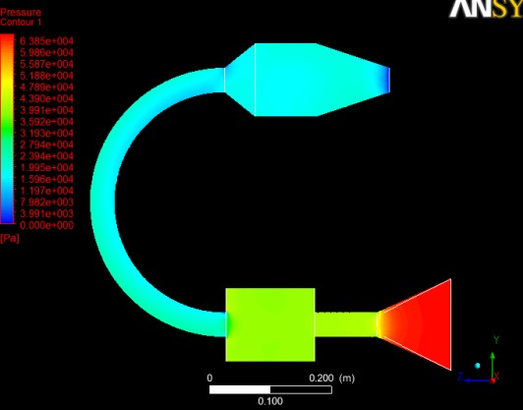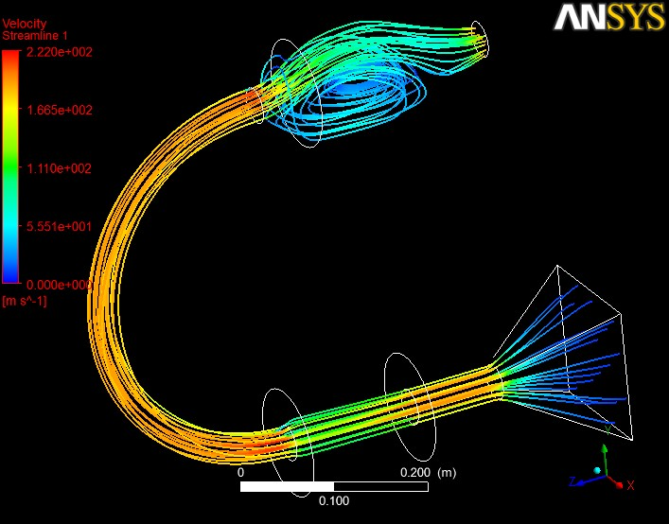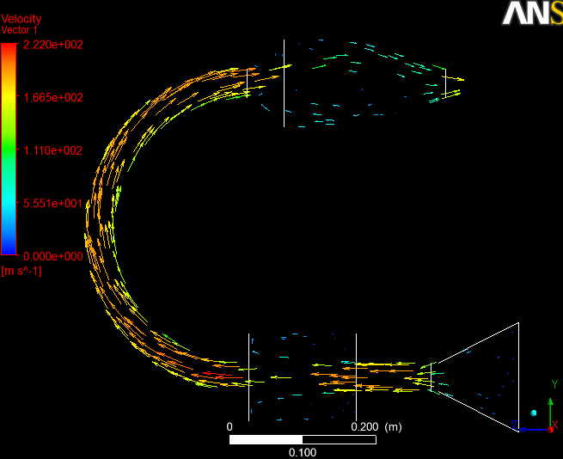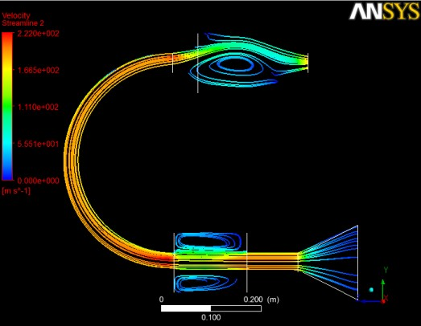

*\*\*In“RunCalculations”Section>>Settherequired number of iterations and“Calculate”.*

*\*\* The process can be paused, stopped andsaved.Tocontinuesolvingtheproblem,thesetup should be started from “Solutions” inthemain Ansyswindow.*

*\*\* The results can be found from the samewindowasitwasshowninthe 2Dairfoilcase.More options can be found in CFD Post as itwasshownin3D – Finitewingcase.*



## CommonProblems

### AutodeskAutocadcompatibilitywithAnsys

The 3d models constructed in Autodesk Autocad can be imported to Ansys if saved inIGES format. However, in the case of the multiple bodies, Ansys fails to define the contact typesontheboundaryelements.

This problem has been solved recently in the latest version of Ansys. However, if olderversions are used,itisbettertoconstructthe models usingSolidworks,Caita orRhinotoensurethattherewillbenogeometricalimportingproblems insomelaterstep.

### Thesharptrailingedgesoftheairfoils

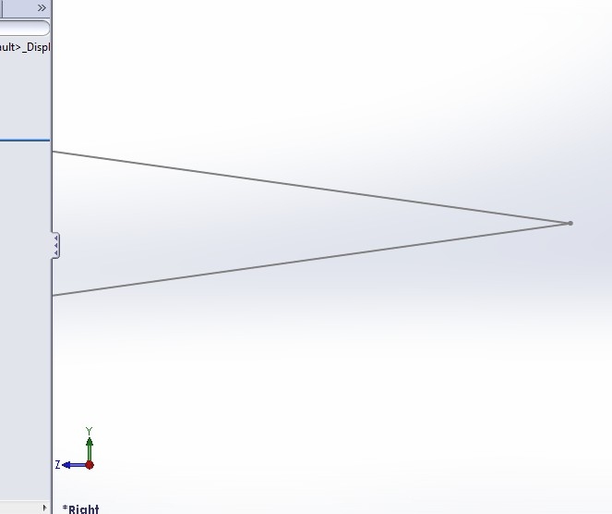The airfoils are usually constructed using the airfoil coordinates. The generated airfoilsusually haveverysharptrailingedgesasitis showninthefigurebelow.

.

The sharp trailing edge causes difficulties while meshing which might lead to the failureof generatinga good quality mesh. Since sharpedges cause sudden bending in the gridstructure,thequalityhastobesacrificedtogenerateagridwhichfitstheairfoil.Moreover,this

problemcancausea failureingeneratingtheinflationlayersconstructedtostudytheboundarylayer.

This problem can be solved by trimming a small part of the trailing edge (few millimeters)and closing the gap with a curve which has a starting portion parallel to at least one of the top orthebottomsurfaces.

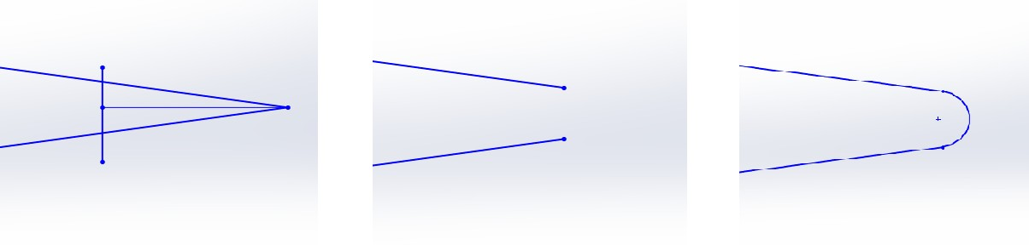

### GeneralMeshingProblems

Most of the meshing problems can be solved using custom sizing. When Ansys shows amesh failure due to a problematic geometry alert, the geometry can be displayed by (Right clickonthemessagefromthealertswindow>>ShowproblematicGeometry.Selectingtheproblematic component whether it is an edge or a face and assigning a cell size which is smallerenough to cover the details of the problematic geometry is the easiest way to solve the problemwithoutchangingthegeometry.

In some cases it is recommended to create a refinement for the mesh at certain points orlocations. For example, the leading edge of a wing if a type of micro vortex generators has beeninstalled on it. The refinement can be constructed by creating a solid part in the geometry stage(while drawing the domain). However, it shouldn’t be included in the “Boolean” process. Later, inthe meshing process, the solid part can be chosen (Right click on mesh >> Insert >> Sizing >>Type:Bodyofinfluence>> Chosethesolidwhichis coveringthedetailedgeometry).

However,insomecases,whenthegeometrycontainsahighorderofnurbs,thesmoothing has to be reduced in order to generate a mesh with acceptable quality. Althoughsimplifying the geometry will be a better option since a mesh with low quality might causeproblems in the solving process where the solution will not converge to the required margin oferror.

### NamedSelectionProcess

The named selection process (assigning names to the surfaces) is an important stagewhere the spellings of some words have to be maintained carefully. For example, inlet, outletand symmetry. These words are keywords where Ansys can define the surface as inlet if it hasbeennamedinlet.

The walls which are not supposed to have any friction or boundary layers (like the wall ofa domain for external flow) should be called “Symmetry”. This will direct Ansys to consider thewallasawall without“noslipcondition”oraboundarylayer.

### SolutionDivergence

Solutiondivergenceisadirectindicatorofthepoorqualityofthemesh.Whendivergenceisdetected,themeshhastoberefined orreconstructedwithnewsetting. Mostly:

* Smaller(MinSize)
* Higher(Relevance)
* Customsizingforedgesandfaces
* Inflationlayerforbetterstudyof the boundarylayer
* Simplifiedgeometry
* Widerdomain

### TemperaturesolutiondivergencewhileusingEnergyequation

When energy equation is being used, an unrealistic exit temperature could force thesolution to accelerate \ decelerate the flow out of proportion leading to a “temperature solutiondivergence”. Use common sense and experience when setting the initial guess for inlet and exittemperatures(only whenenergyequationis on,evenifthereis nocombustion).

### Scaling

When the model size is too big and the calculation process is too time consuming, it isrecommended to scale down the model in order to reduce the needed resources. However, asper the flow similarity conditions, the boundary conditions have to be calculated to match thenewscaledmodel.

Accordingtothetheoryofflowsimilarity, thetwoconditionswhich needtobesatisfiedare:

* + Geometricsimilarity–Thegeometriesbodiesneedtobesimilar
  + Dynamicsimilarity–ThesimilarityparametersbasedonwhichotherflowparameterswillbecalculatedareReynoldsnumberandMachnumber.

TheCLand CDvalueswillremain the sameforboth thegeometries.

This is an example if scaling a wing the 1/3rd of its original size. Maintaining the sameMach number and Reynolds number for the two geometries, and also using the initial parametervaluesfortherealgeometry,theparametersthatwerere-calculatedare:

* + Density
  + Velocity
  + ViscosityCoefficient
  + Pressure
  + Temperature

Thefollowingarethe calculationsthatweredone to computethe newparametervalues.

Forconvenience,thetemperatureT2=288.2K. Theothergiven parametersfortherealcase are:

|  |  |
| --- | --- |
| p1 | 0.28852kg/m3 |
| V1 | 237m/s |
| T1 | 217K |
| T2 | 288.2K |
| C1  C2 | 3 |
| µ1 | 4.7292×10−5kgm2/sec |

EquatingMachnumber,

M1=M2

V1=V2

√T1 √T2

V = V ×√T2

2 1 T1

288.2

=237√217=273.033m/sec

M2=M1

= 237

√(1.4x28x217)

=0.803

EquatingReynoldsnumber,

Re1=Re2

p1V1C1=p2V2C2

µ1 µ2

C1=3C2

p2 V1C1

T2 237x3

288.2

p1=V2C2

×√T1

=273.033√217 =3

p2=(0.28852)3=0.866kg/m3P2=p2RT2=71,717.97KPa

Re=p1V1C1=(0.28852x237x2.61)=3.662x106

1 µ1

0.000049272

µ=p2V2C2=5.674x10−5kgm2/sec

2 Re2

### Hugevaluesofliftanddrag

In some cases, the results show very huge or very small values for lift and drag eventhough the mesh has been refined and it can be considered as sufficient grid. Hence, theproblemcanbemostlyin theboundaryconditions,thereferencevaluesorthe monitors.

In the reference values, the area and the length have to be defined accurately. The areaistheprojectionareaofthemodelwhilethelengthisthelengthofthemodel.Moreover,theinlettemperaturehastobedoublechecked.

Furthermore, for an altitude different than the sea level, the density and the viscosity hasto be defined from the “materials” list and the pressure has to be defined in the “Operatingconditions”(Define>>OperatingConditions).

Finally, the reference values have to be updated to be computing from the inlet aftereachchangeinanyoftheparameters.

## RecommendedTopics

The recommended topics are basically the topics or the problems which has not beenexplainedorcoveredinthemanual.Sincesometopicscanbeconsideredasadvancedtopics,a lot of research and troubleshooting will be needed to get the correct and reliable procedure ofsolvingsuchproblems.

### DynamicandSlidingmesh

Dynamic andsliding meshes are types ofgrids where the geometry canchange itsshape or condition while running the calculations. For example, a wing flap changing its angle oracarspoilerchangingitsposition.

### Meshingtechniques–Gambit

Ansys uses ICEM meshing as a default meshing tool for all its products. However, it isrecommendedtocarryonastudyofcomparingthemeshingtechniquesandthequalitybetweenICEMandtheothermeshingtools likeGambit.

### FluentModels

Viscous models are used mostly for the aerospace related studies. However, there areother models which can be useful like (Multiphase, Energy, [Acoustics...](http://aerojet.engr.ucdavis.edu/fluenthelp/html/ug/node1350.htm) etc) which are related tothe engineering applications. For example, modelling heat exchangers, combustion chambers,mixingchambers,turbinesandcompressors.

### Combiningthestructuralloadswiththeaerodynamicloads

The aerodynamic loads can be calculated using fluent then transferred to the structuralanalysis to analyze the structural behavior. This study can be used to optimize the aerodynamicand the structural performance of an aircraft. However, the study will need very good computingresources.

### Cables

Modellingcables in Ansys has to be investigated.Since creating an actual cable in the3d modelling software and generating the mesh for such cable is very resources consumingmethodology, an alternative way has to be found.For example, replacing the cable with aspring.

### Composite

ModellingcompositematerialsinAnsysisawelldemandedtopic.Eventhoughthereisa special library in Ansys for composite materials (ACP), it is not available for all Ansys licenses.Hence, finding a methodology to model the composite materials in Ansys without using the ACPlibraryisaviabletopicofresearch.

## UsefulLinks

* Brief aboutmesh andgridtypes

<http://www.innovative-cfd.com/cfd-grid.html>

* AnsysModellingandMeshingGuide

<http://www.ewp.rpi.edu/hartford/users/papers/engr/ernesto/hillb2/MEP/Other/Articles/MeshingGuide.pdf>

* Fluent6.3userguide:

<http://aerojet.engr.ucdavis.edu/fluenthelp/index.htm>

* FluentModelsDetails

<http://aerojet.engr.ucdavis.edu/fluenthelp/html/ug/node1336.htm>

* CFDanalysisof VehicleAerodynamics

<http://www.youtube.com/watch?v=dZR7Wi70Vec>

* CFDanalysisofVehicleAerodynamics(CFXnotFluent)

<http://www.youtube.com/watch?v=6adO0mv-eWw>

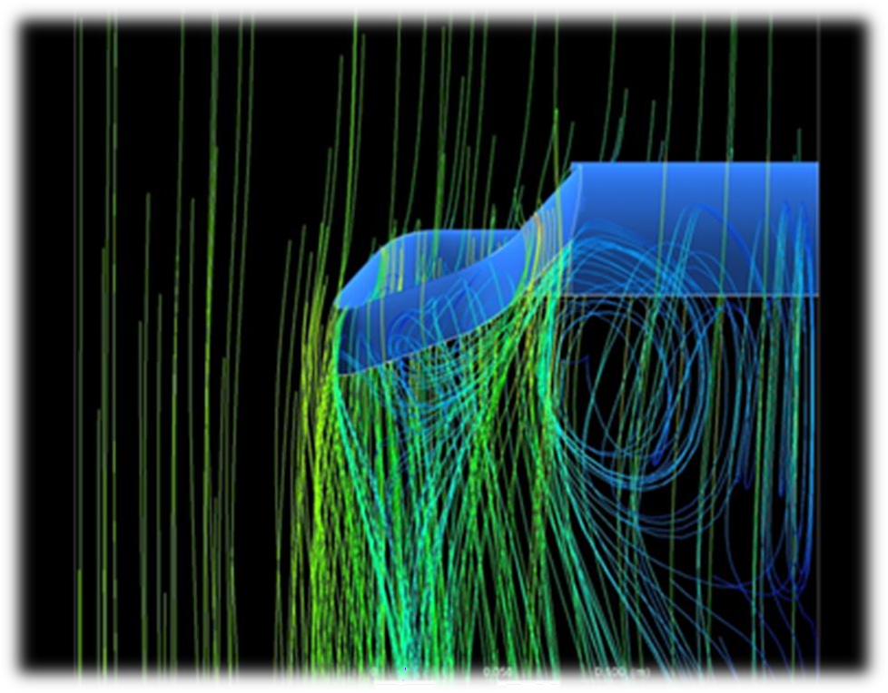*The EndGoodLuck=)*