|  |  |
| --- | --- |
|  | **Techno India NJR Institute of Technology**  **Bhamashah (RIICO) Industrial Area, Kaladwas, Udaipur**  **Department of Mechanical Engineering** |

|  |  |
| --- | --- |
| **ANSYS Sheet Instructor: KapilDungarwal** | |
| **Problem:- (1)** | |
|  |  |

**Shear force Diagram:**

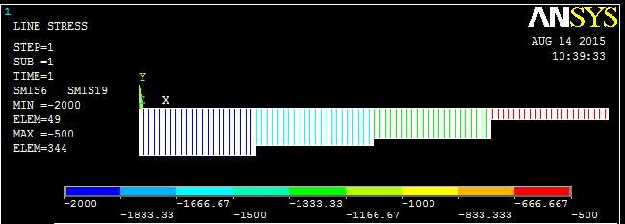

**Bending Moment Diagram:**

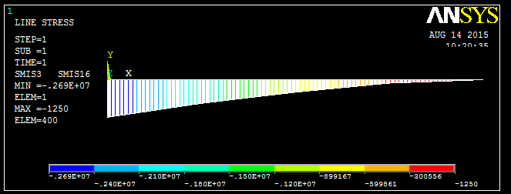

**Problem:- (2)**

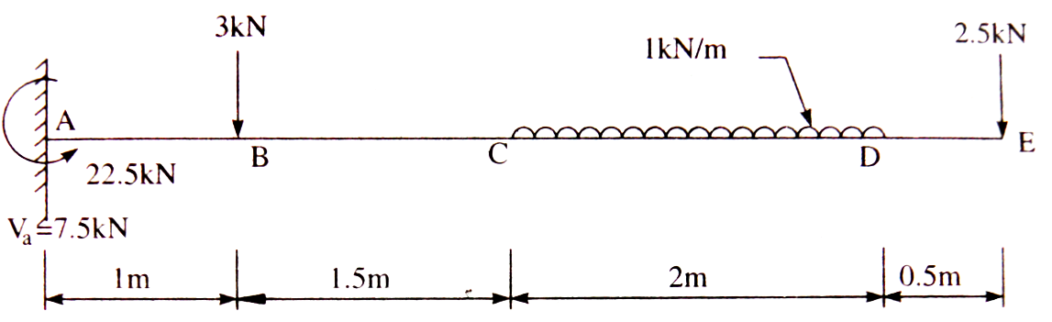

**Shear Force Diagram:**

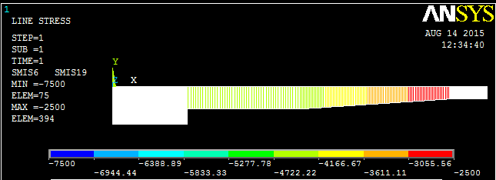

**Bending Moment Diagram:**

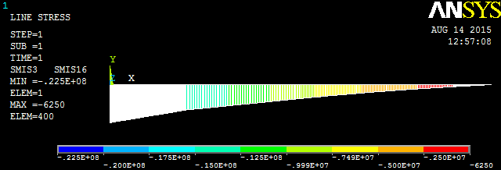

**Problem:- (3)**

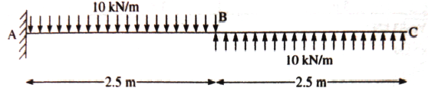

**Shear Force Diagram:**

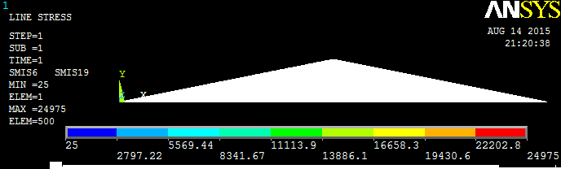

**Bending Moment Diagram:**

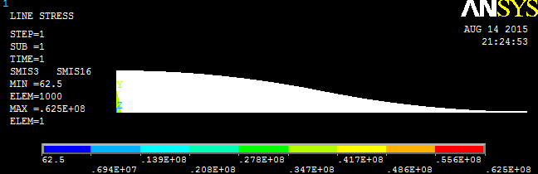

**Problem:- (4)**

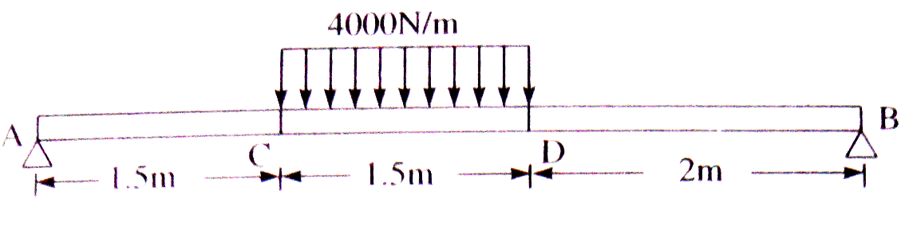

**Shear Force Diagram:**

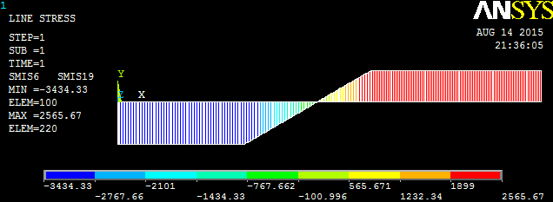

**Bending Moment Diagram:**

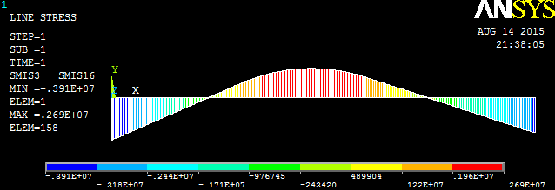

**Problem:- (5)**

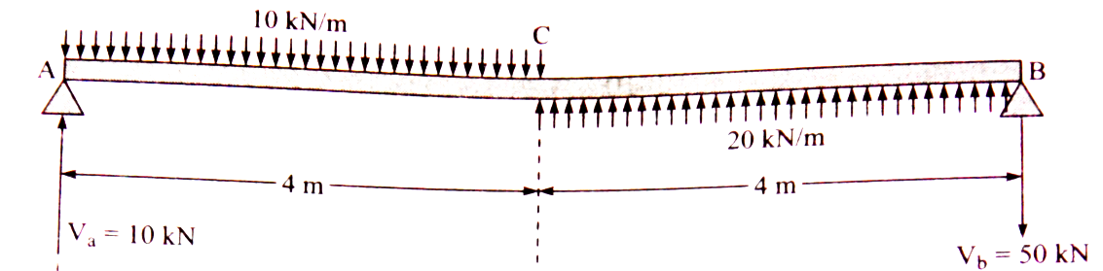

**Shear Force Diagram:**

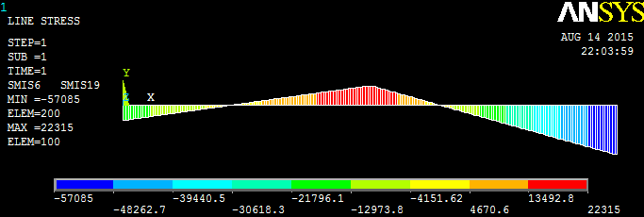

**Bending Moment Diagram:**

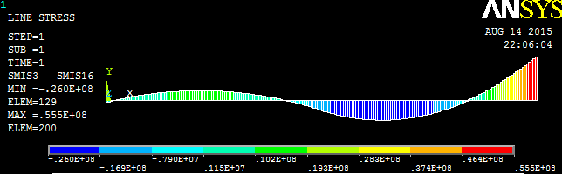

**Problem:- (6)** A bar consisting of three lengths. Find the stress in the three parts and the total extension of the bar for an axial pull of 40kN. Take $E=2*{10}^{5}$

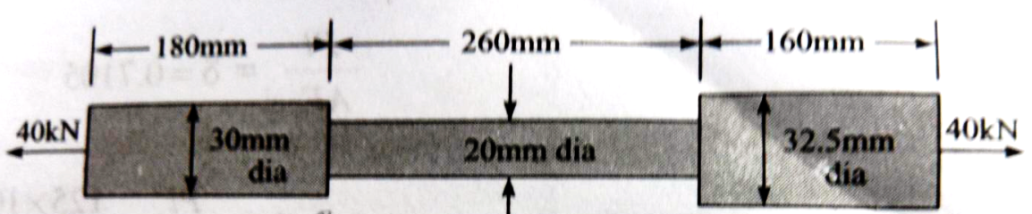

**Stress Diagram:**

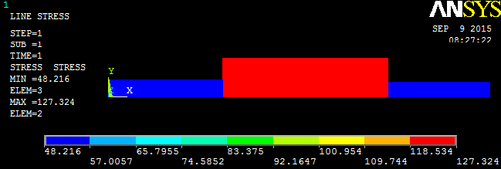

**Strain Diagram:**

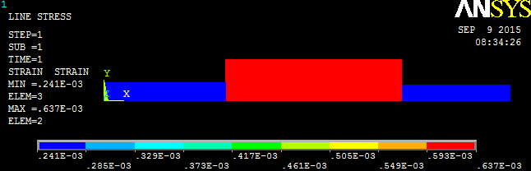

**Problem:- (7)**Consider the bar in fig. loaded as shown. Determine the nodal displacement, element stress and support reactions. Solve this problem by using ANSYS (APDL) Software.

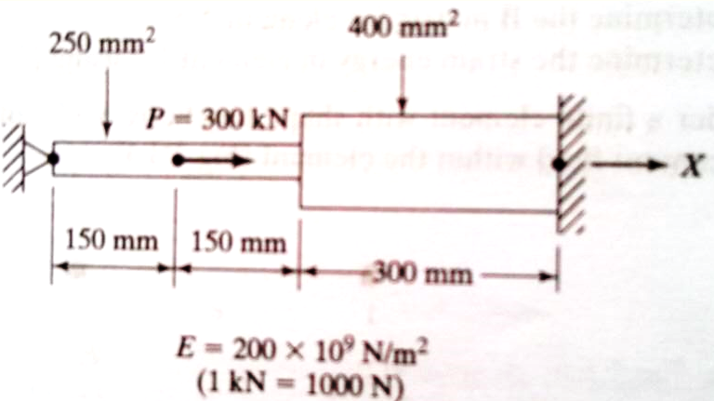

**Nodal Displacement Solutions:-**

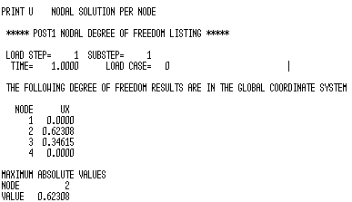

**Support Reactions Solutions:-**

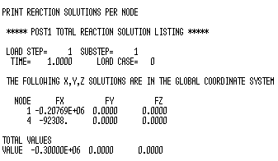

**Element Stresses Solution:-**

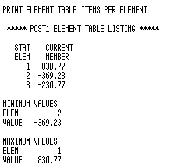

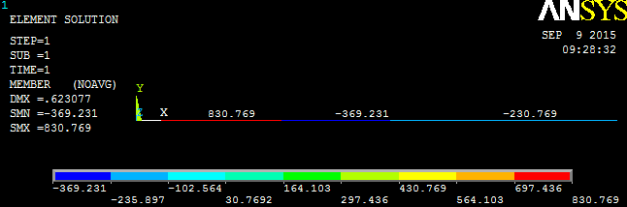

**Problem:- (8)**Consider the bar in fig. loaded as shown. Determine the nodal displacement, element stress and support reactions. Solve this problem by using ANSYS (APDL) Software.

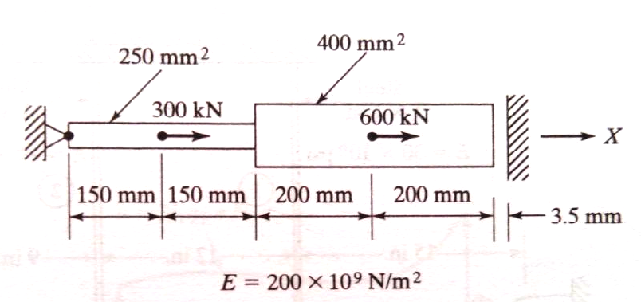

**Nodal Displacement Solutions:-**

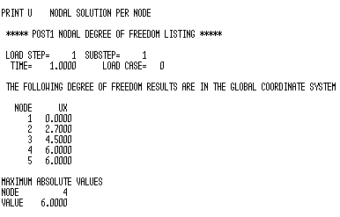

**Support Reactions Solutions:-**

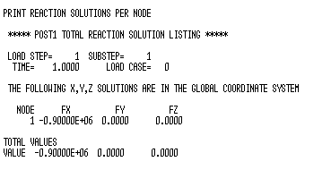

**Element Stresses Solution:-**

