**Techno India NJR Institute of Technology**



**Course File**

**Session:2022-23**

**Manufacturing Practices Workshop**

**(1FY3-25/ 2FY3-25)**

Mr. Harish Bairwa

(Assistant Professor)

**Department of Mechanical Engineering**

Manufacturing Practice Workshop

First year of the engineering is dedicated to learning basic concepts of almost every branch of engineering. The student learns basics of mechanics, computers, electrical, electronics and civil concepts during his/her first year of study as engineers. The Manufacturing Practice Workshop is designed to impart practical understanding of various Mechanical concepts that will come in use during rest of their engineering years. The Mechanical Workshop should help the student apply his or her knowledge of basic Mechanical concepts learnt during his first year.

**LIST OF EXPERIMENT**

|  |  |
| --- | --- |
| **S. No.** | **Title of Experiment** |
| 01. | To make a T‐lap joint as shown in Figure as per given dimensions. |
| 02. | To make a Bridle joint as shown in Figure as per given dimensions. |
| 03. | To prepare a sand mold, using the given Split-piece pattern |
| 04. | To prepare aluminum casting with the help of given wooden pattern. |
| 05. | To create a lap joint using gas welding and assess the quality of the joint. |
| 06. | To make a single v‐butt joint, using the given mild steel pieces by arc welding. |
| 07. | To make a double lap joint, using the given mild steel pieces and by arc welding |
| 08. | To demonstrate the processes of brazing, soldering, and gas cutting, highlighting their applications and differences |
| 09. | To make the turning and chamfering on the given metal work piece to get the required dimension. |
| 10. | To file the given two Mild Steel pieces in to a square shape of 48 mm side as shown in Figure |
| 11. | To Make a mechanical joint and soldering of joint on sheet metal as per dimensions. |
| 12. | To cut a square notch in a metal or plastic workpiece using a hacksaw and to drill a hole in the workpiece followed by tapping it. |

**EXPERIMENT NO. 1**

**OBJECTIVE**

To make a T‐lap joint as shown in Figure as per given dimensions.

**EQUIPMENT REQUIRED**

Carpenter's vice, steel rule, jack plane, try‐square, marking gauge, 25 mm firmer chisel, cross‐cut saw, tenon saw, scriber and mallet.

**FIGURE**

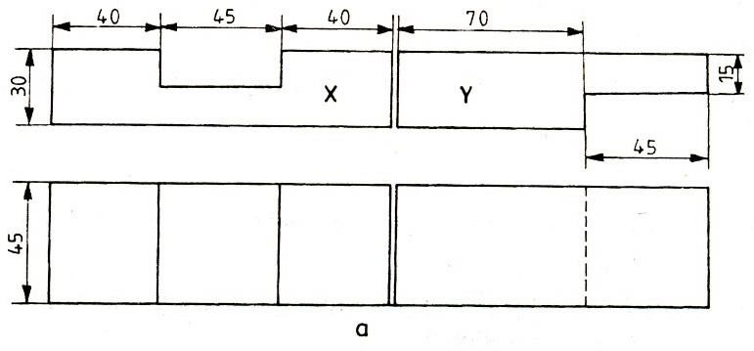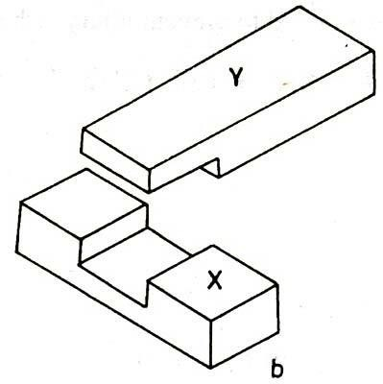

**Figure 1.1 ‐ : T‐ lap joint**

**PROCEDURE**

1. The given reaper is checked to ensure its correct size.
2. The reaper is firmly clamped in the carpenter's vice and any two adjacent faces are planed by the jack plane and the two faces are checked for squareness with the try square.
3. Marking gauge is set and lines are drawn at 30 and 45 mm, to mark the thickness and width of the model respectively.
4. The excess material is first chiseled out with firmer chisel and then planed to correct size.
5. The mating dimensions of the parts X and Yare then marked using scale and marking gauge
6. Using the cross‐cut saw, the portions to be removed are cut in both the pieces, followed by chiseling and also the parts X and Y are separated by cross‐cutting, using the tenon saw
7. The ends of both the parts are chiseled to the exact lengths.
8. A fine finishing is given to the parts, if required so that, proper fitting is obtained.
9. The parts are fitted to obtain a slightly tight joint.

**RESULT**

The T‐Lap joint is thus made by following the above sequence of operations.

**PRECAUTIONS**

1. Start the sawing outside the marking lines.
2. Grip the job piece properly in carpentry vice .
3. Always use sharp tools.
4. Use mallet hammer while chiseling.

_______________________________

(Signature of the Faculty with Date)

**EXPERIMENT No. 2**

**OBJECTIVE**

To make a Bridle joint as shown in Figure as per given dimensions.

**EQUIPMENT REQUIRED**

Try square, Pencil, Mortise marking gauge, Tenon saw or Pull saw, Coping saw  
Router with straight cutter

**FIGURE**

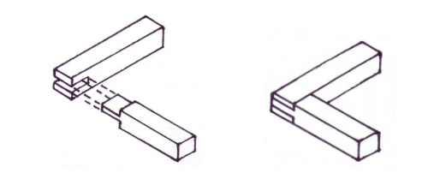

**Figure 2.1: Bridal Joint**

**PROCEDURE**

1. Start by marking the position of the joint on the tenon member with a try square and a sharp pencil.
2. Use the mortise member and the try square to mark the wood’s exact width on the tenon member.
3. Extend the lines all round the workpiece using the try square. They should meet exactly if the wood is square.
4. Mark the depth of the slot on the mortise member. You can make it a little deeper and then plane off the end once the joint is complete, to produce a neat finish.
5. Set a mortise marking gauge to the width of your chisel. The wood is 19mm thick, so I chose a 6mm wide chisel as closest to one third of its thickness.
6. Centralise the gauge and mark both sides of both components. Always work from the same face of the workpiece to minimise any inaccuracies.
7. To make the marked lines more clearly visible before cutting the joints, run a sharp pencil along them.
8. Fix the mortise member vertically in a vice. Using a fi ne-point saw, cut down on the waste side of the marked lines.
9. Use a coping saw to remove most of the waste from the slot. Take care not to cut beyond the base line.
10. Square off the base of the slot with a chisel, cutting down to the marked line and working from both sides of the wood.
11. Now cut the matching tenon Make sure the cuts are vertical and within the waste area. Don’t run over the gauged lines.
12. You can use a router to remove most of the waste. Fit a wide straight cutter and plunge down to the gauged lines in stages.

**RESULT**

The Bridal joint is thus made by following the above sequence of operations.

**PRECAUTIONS**

1. The Tools that are not being used should always be kept at their proper places.
2. Make sure that your hands are not in front of sharp edged tools while you are using them.
3. Use only sharp tools. A dull tool requires excessive pressure, causing the tool to slip.
4. Wooden pieces with nails, should never be allowed to remain on the floor.
5. Be careful when you are using your thumb as a guide in cross‐cutting and ripping.
6. Test the sharpness of the cutting edge of chisel on wood or paper, but not on your hand.

.

______________________________

(Signature of the Faculty with Date)

**EXPERIMENT NO. 3**

**OBJECTIVE**

To prepare a sand mold, using the given Split-piece pattern

Raw Material required

Moulding Sand, Parting Sand, Facing Sand, Baking Sand, Pattern, Bottom Board, Moulding Boxes.

**EQUIPMENT REQUIRED**

Molding board Drag and cope boxes Molding sand Parting sand Rammer , Strike-off bar, Bellows, Riser and sprue pins, Gate cutter, Vent rod, Draw spike, Wire Brush

**FIGURE**

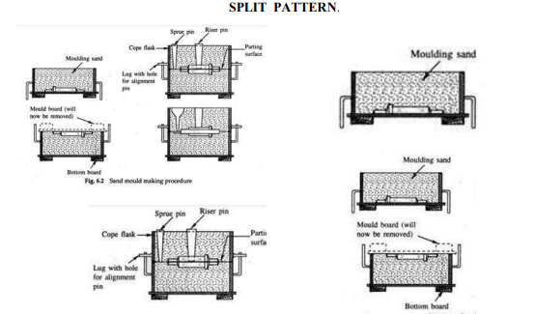

**Figure 3.1: Split Piece Pattern**

**PROCEDURE**

1. First a bottom board is placed either on the molding platform or on the floor, making the surface even.
2. The drag molding flask is kept upside down on the bottom board along with the drag part of the pattern at the centre of the flask on the board.
3. Dry facing sand is sprinkled over the board and pattern to provide a non-sticky layer.
4. Freshly prepared molding sand of requisite quality is now poured into the drag and on the split-pattern to a thickness of 30 to 50 mm.
5. Rest of the drag flask is completely filled with the backup sand and uniformly rammed to compact the sand.
6. After the ramming is over, the excess sand in the flask is completely scraped using a flat bar to the level of the flask edges.
7. Now with a vent wire which is a wire of 1 to 2 mm diameter with a pointed end, vent holes are in the drag to the full depth of the flask as well as to the pattern to facilitate the removal of gases during casting solidification. This completes the preparation of the drag.
8. Now finished drag flask is rolled over to the bottom board exposing the pattern.
9. Using a slick, the edges of sand around the pattern is repaired and cope half of the pattern is placed over the drag pattern, aligning it with the help of dowel pins
10. The cope flask on the top of the drag is located aligning again with the help of the pins of the drag box.
11. Dry parting sand is sprinkled all over the drag surface and on the pattern
12. Sprue of the gating system for making the sprue passage is located at a small distance of about 50 mm from the pattern. The sprue base, runners and in gates are also located as shown risers are also placed. Freshly prepared facing sand is poured around the pattern.
13. The moulding sand is then poured in the cope box. The sand is adequately rammed, excess sand is scraped and vent holes are made all over in the cope as in the drag.
14. The sprue and the riser are carefully withdrawn from the flask
15. Later the pouring basin is cut near the top of the sprue.
16. The cope is separated from the drag any loose sand on the cope and drag interface is blown off with the help of the bellows.
17. Now the cope and the drag pattern halves are withdrawn by using the draw spikes and rapping the pattern all around to slightly enlarge the mould cavity so that the walls are not spoiled by the withdrawing pattern.
18. The runners and gates are to be removed or to be cut in the mould carefully without spoiling the mould.
19. Any excess or loose sand is applied in the runners and mould cavity is blown away using the bellows.
20. Now the facing paste is applied all over the mould cavity and the runners which would give the finished casting a good surface finish.
21. A dry sand core is prepared using a core box. After suitable baking, it is placed in the mould cavity.
22. The cope is placed back on the drag taking care of the alignment of the two by means of the pins.
23. The mould is ready for pouring molten metal. The liquid metal is allowed to cool and become solid which is the casting desired.

**RESULT**

The sand mould using split piece pattern is made by following the above sequence of operations.

**PRECAUTIONS**

1. Place the moulding board on a horizontal surface.
2. The drag box is placed above the moulding board.
3. The mould box, pattern, tools and the table/floor are cleaned.
4. Sand should be rammed properly and evenly.
5. The pattern should be rapped gently and withdrawn carefully without damaging the mould cavity.

_______________________________

(Signature of the Faculty with Date)

**EXPERIMENT No. 4**

**OBJECTIVE**

To prepare aluminum casting with the help of given wooden pattern.

**EQUIPMENT REQUIRED**

Molding sand as desired, Aluminum (raw material), Mallet hammer, Riddle, Square and heart type trowel, Molding box, Runner, Rammer flat type, Solid pattern, Spure pin, Riser pin, Vent wire, Slick lifter, Gate cutter

**FIGURE**

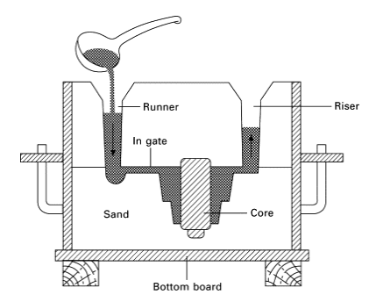

**Figure 4.1: Sand Mould Casting**

**PROCEDURE**

1. Collect the tools and material from lab assistant.
2. Prepare mounding sand of appropriate composition.
3. Take molding box and wooden pattern.
4. Prepare mould of given pattern.
5. Make runner and cut gate in the mould ,
6. Melt the aluminum in electric furnace by raising the temperature up to 820 ̊c.
7. After changing the aluminum in molten state switch off the furnace.
8. Pour the molten metal in to the mould through spure hole till the cavity is full.
9. After solidification take out the casting after breaking the mounding sand.

**RESULT**

The aluminum casting with the help of given wooden pattern made by following the above sequence of operations.

**PRECAUTIONS**

1. DON’T collect the water near the furnace.
2. You have not to throw wet metal in furnace.
3. Blow air through a crucible furnace before start.
4. Keep crucible in dry and warm place.
5. Heat up thoroughly before use.
6. Pouring should be continuous without any break.

_______________________________

(Signature of the Faculty with Date)

**EXPERIMENT NO. 5**

**OBJECTIVE**

To create a lap joint using gas welding and assess the quality of the joint.

To join two edges of metal pieces overlapping each other using arc welding

method

To join two edges of metal pieces overlapping each other using arc welding

method

To join two edges of metal pieces overlapping each other using arc welding

me

To join two edges of metal pieces overlapping each other using arc welding

method

To join two edges of metal pieces overlapping each other using arc welding

meth

**EQUIPMENT REQUIRED**

Two metal plates, Gas welding equipment (oxy-acetylene torch), Welding filler rod , Flux, Welding gloves, Safety goggles, Welding apron, Fire-resistant work surface, Vise, Measuring tools), Marker, Angle grinder or file for edge preparation

**FIGURE**

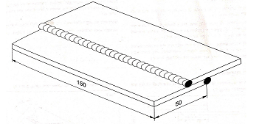

**Figure 5.1: Lap Joint**

**PROCEDURE**

1. **Preparation:**
2. Choose two metal plates of equal thickness and ensure they are clean and free of any contaminants or rust.
3. Measure and mark the desired location for the lap joint on both plates.
4. Use an angle grinder or file to prepare the edges of the plates by removing any rust or surface imperfections. Ensure that the edges are clean and have a slight bevel for better weld penetration.
5. Secure the two plates in a vise or with clamps, ensuring they overlap according to your marked lap joint location.
6. **Flux Application:**
7. Apply flux to the joint area on both plates. Flux helps prevent oxidation during welding and promotes a cleaner weld.
8. Ensure an even application of flux on both sides of the joint.
9. **Gas Welding:**
10. Set up the gas welding equipment (oxy-acetylene torch) according to the manufacturer's instructions.
11. Ignite the torch and adjust the flame to a neutral or slightly reducing flame.
12. Begin by tack welding the plates at a few points along the joint to hold them securely in place.
13. Weld along the entire length of the joint, moving the torch in a steady and controlled manner.
14. Add the filler rod into the molten pool to create a strong and consistent weld bead.
15. Ensure that the weld bead fully penetrates and bonds both plates.
16. Allow the joint to cool slowly.
17. Post-Weld Inspection:
18. Examine the completed lap joint for visual imperfections, such as cracks, porosity, or incomplete fusion.
19. Measure the width and depth of the weld bead.
20. Assess the overall quality of the weld, looking for any signs of weakness or inconsistency.Top of Form

**RESULT**

The Lap joint is thus made, using the tools and equipment as mentioned above.

**PRECAUTIONS**

1. Wear appropriate personal protective equipment, including welding gloves, safety goggles, and a welding apron.
2. Ensure proper ventilation in the welding area.
3. Keep a fire extinguisher nearby.
4. Handle the gas welding equipment with care and follow safety guidelines for oxy-acetylene torch operation.

_______________________________

(Signature of the Faculty with Date)

**EXPERIMENT NO. 6**

**OBJECTIVE**

To make a single v‐butt joint, using the given mild steel pieces by arc welding.

**EQUIPMENT REQUIRED**

Arc welding machine, Mild steel electrodes, Electrode holder, Ground clamp, flat nose Tong, Face shield, Apron, Hand gloves, Metallic work Table, Bench vice, Rough flat file, Try square, Steel rule, Wire brush, Ball peen hammer, Chipping hammer, Chisel and Grinding machine.

**FIGURE**

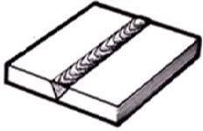

**Figure 6.1 : Single‐V butt joint**

**PROCEDURE**

1. Take the two mild steel pieces of given dimensions and clean the surfaces thoroughly from rust, dust particles, oil and grease.
2. Remove the sharp corners and burrs by filing or grinding.
3. One edge of each piece is beveled, to an angle 30˚.
4. The two pieces are positioned on the welding table such that, they are separated slightly for better penetration of the weld.
5. The electrode is fitted in to the electrode holder and the welding current is set to a proper value.
6. The ground clamp is fastened to the welding table. The machine is switched ON
7. Wearing the apron, hand gloves, using the face shield, the arc is struck and the work pieces are tack‐ welded at the ends and holding the two pieces together; first run of the weld is done to fill the root gap.
8. Second run of the welding is done with proper weaving and with uniform movement. During the process of welding, the electrode is kept at angle of 15˚ to 25˚ from vertical and in the direction of welding.
9. The slag formation on the weld is removed by chipping hammer.
10. Filing is done to remove spatters around the weld.

**RESULT**

The single v‐butt joint is thus made, using the tools and equipment as mentioned above.

**PRECAUTIONS**

The following precautions should be taken care of while performing the experiment:

1. Do not weld around combustible or inflammable materials, where sparks may cause a fire.
2. Never weld containers, which have been used for storing gasoline, oil or similar materials, without first having them thoroughly cleaned.
3. Check the welding machine to make sure that it is properly grounded and that all leads properly insulated.
4. Never look at the arc with the naked eye. The arc can burn your eyes severely. Always use a face shield while welding.
5. Prevent welding cables from coming in contact with hot metal, water, oil, or grease. Avoid dragging the cables around sharp corners.

_______________________________

(Signature of the Faculty with Date)

**EXPERIMENT NO. 7**

**OBJECTIVE**

To make a double lap joint, using the given mild steel pieces and by arc welding

**EQUIPMENT REQUIRED**

Arc welding machine, Mild steel electrodes, Electrode holder, Ground clamp, flat nose Tong, Face shield, Apron, Hand gloves, Metallic work Table, Bench vice, Rough flat file, Try square, Steel rule, Wire brush, Ball peen hammer, Chipping hammer.

**FIGURE**

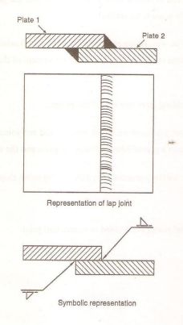

**Figure 7.1 : Lap Joint by Arc Welding**

**PROCEDURE**

1. Take the two mild steel pieces of given dimensions and clean the surfaces thoroughly from rust, dust particles, oil and grease.

2. Remove the sharp corners and burrs by filing or grinding and prepare the work pieces.

3. The work pieces are positioned on the welding table, to form a lap joint with the required over lapping.

4. The electrode is fitted in to the electrode holder and the welding current is set to a proper value.

5. The ground clamp is fastened to the welding table.

6. Wearing the apron, hand gloves, using the face shield and holding the over lapped pieces the arc is struck and the work pieces are tack‐welded at the ends of both the sides

7. The alignment of the lap joint is checked and the tack‐welded pieces are reset, if required.

8. Welding is then carried out throughout the length of the lap joint, on both the sides.

9. Remove the slag, spatters and clean the joint.

**RESULT**

The lap joint is thus made, using the tools and equipment as mentioned above

**PRECAUTIONS**

1. Use goggles, gloves in order to protect the human body.
2. Maintain the constant arc length

_______________________________

(Signature of the Faculty with Date)

**EXPERIMENT NO. 8**

**OBJECTIVE**

To demonstrate the processes of brazing, soldering, and gas cutting, highlighting their applications and differences.

**EQUIPMENT REQUIRED**

Brazing torch with appropriate gas (e.g., oxy-acetylene),Soldering iron and soldering wire

Brazing rods (e.g., copper, brass), Solder (lead-free solder), Metal pieces (copper or steel workpieces), Flux (for brazing and soldering), Safety goggles, Welding gloves, Workbench with a fire-resistant surface, Vise, Appropriate ventilation or fume extraction system

**PROCEDURE**

1. **Introduction:**
2. Begin with a brief introduction to brazing, soldering, and gas cutting techniques.
3. Explain the differences between these processes, including their applications and the types of joints they create.
4. **Brazing Demonstration:**
5. Place a metal piece securely in a vise or clamp.
6. Apply flux to the joint area on the metal piece.
7. Select an appropriate brazing rod based on the metal type.
8. Ignite the brazing torch and adjust the flame to the proper temperature.
9. Heat the joint area evenly until the base metal reaches the brazing temperature.
10. Introduce the brazing rod to the joint area, and it should melt and flow into the joint.
11. Allow the joint to cool and solidify.
12. Discuss the strength and characteristics of the brazed joint.
13. **Soldering Demonstration:**
14. Secure another metal piece in a vise or clamp.
15. Apply soldering flux to the joint area on the metal piece.
16. Heat the soldering iron to the appropriate temperature.
17. Touch the soldering iron to the joint area and introduce solder. It should melt and form a smooth joint.
18. Allow the joint to cool and solidify.
19. Discuss the differences between soldering and brazing, emphasizing the lower melting point of solder.
20. **Gas Cutting Demonstration:**
21. Explain the safety precautions related to gas cutting, including the need for proper ventilation and protective gear.
22. Place a metal piece on the workbench.
23. Attach the appropriate gas cutting nozzle to the torch.
24. Ignite the gas torch and adjust the flame to the cutting setting.
25. Preheat the metal until it reaches the ignition temperature.
26. Begin the gas cutting process, following the marked cutting line.
27. Allow the cut metal to cool before handling.
28. Discuss the applications of gas cutting, such as in metal fabrication and construction.

**RESULT**

The brazing, soldering and gas cutting process is discussed above.

_______________________________

(Signature of the Faculty with Date)

**EXPERIMENT NO. 9**

**OBJECTIVE**

To make the turning and chamfering on the given metal work piece to get the required dimension.

**EQUIPMENT REQUIRED**

Steel rule ,Vernier caliper ,Center lathe M/C , Single point cutting tool, Chuck key, Tool post key, Spanner , Cleaning brush

**FIGURE**

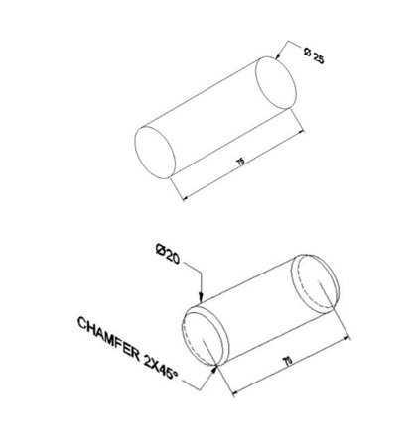

**Figure 9.1 : Turning And Chamfering on Workpiece**

**PROCEDURE**

1. The given work piece is checked for its given dimensions
2. The workpiece is held in the three jaw chuck. Chuck key is used to tighten the job rigidly ensuring centering of the work piece.
3. The single point cutting tool is fixed in the tool post of the lathe machine using Tool post key and spanners. Sometimes the packing material like hacksaw blade pieces, thick sheet paper materials can be used to set the tool appropriately pointing towards the center of the job.
4. Facing operation is done to obtain the required length of the job.
5. Turning operation is done to obtain the required diameter of the job.
6. Chamfering is done to remove sharp edges and corners of the workpiece by keeping the tool at an angle of 45 degrees to the lathe axis.
7. Finally the workpiece dimensions are checked to conform to the specification given in the drawing

**RESULT**

The job is thus made according to the given dimensions.

**PRECAUTIONS**

1. Work piece should be held firmly.
2. In rough turning operation do not over feed the tool, as it may damage the cutting point of the tool.
3. Exercise over hung of tool should be avoided as it results in chatter and causes rough machined surface.
4. It is important to ensure that during facing operation the cutting is performed from center point to the outer diameter of the work piece.

_______________________________

(Signature of the Faculty with Date)

**EXPERIMENT NO. 10**

**OBJECTIVE**

To file the given two Mild Steel pieces in to a square shape of 48 mm side as shown in Figure

**EQUIPMENT REQUIRED**

Bench vice, set of Files, Steel rule, Try‐square, Vernier caliper, Vernier height gauge, Ball‐peen hammer, Scriber, Dot punch, Surface plate, Angle plate and Anvil.

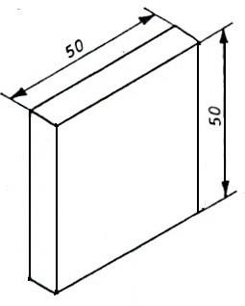**FIGURE**

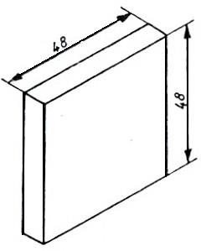

a.) Raw material b.) Finished job

**Figure 10.1: Square Filing**

**PROCEDURE**

1. The dimensions of the given piece are checked with the steel rule.
2. The job is fixed rigidly in a bench vice and the two adjacent sides are filed, using the rough flat file first and then the smooth flat file such that, the two sides are at right angle.
3. The right angle of the two adjacent sides is checked with the try‐square.
4. Chalk is then applied on the surface of the work piece.
5. The given dimensions are marked by scribing two lines, with reference to the above two datum sides by using Vernier height gauge, Angle plate and Surface plate.
6. Using the dot punch, dots are punched along the above scribed lines.
7. The two sides are then filed, by fitting the job in the bench vice; followed by checking the flatness of the surfaces.

As the material removal through filing is relatively less, filing is done instead of sawing.

**RESULT**

The square pieces of 48 mm side is thus obtained by filing, as discussed above

**PRECAUTIONS**

1. Keep hands and tools wiped clean and free of dirt, oil and grease. Dry tools are safer to use than slippery tools.
2. Do not carry sharp tools on pockets.
3. Wear leather shoes and not sandals.
4. Don’t wear loose clothes.
5. Do no keep working tools at the edge of the table.

.

_______________________________

(Signature of the Faculty with Date)

**EXPERIMENT NO. 11**

**OBJECTIVE**

To Make a mechanical joint and soldering of joint on sheet metal as per dimensions.

**EQUIPMENT REQUIRED**

Sheet metal pieces, Screwdriver or wrench, Soldering iron and soldering wire, Flux ,Safety goggles, Glove, Ventilated workspace or fume extractor, Heat-resistant surface, Metal file, Sandpaper, Ruler or calipers, Marker

**FIGURE**

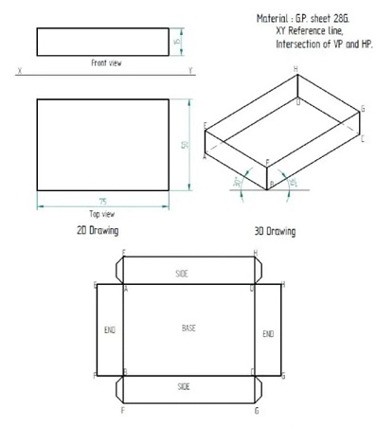

**Figure 11.1 : Rectangular Tray**

**PROCEDURE**

1. **The Preparation:**
2. Cut or obtain two pieces of sheet metal of equal size and thickness.
3. Measure and mark the positions where you want to create the mechanical joint. Consider using corner joints or lap joints for this experiment.
4. Choose the appropriate fasteners (nuts, bolts, screws) for your joint type.
5. **Creating the Mechanical Joint:**
6. Depending on your chosen joint type, drill holes or make slots at the marked positions on the sheet metal.
7. Align the two sheet metal pieces properly to form the joint.
8. Insert the fasteners (e.g., nuts, bolts, screws) through the holes or slots and secure them using a screwdriver or wrench. Ensure the joint is tight and secure.
9. File and sand the joint area to smooth any sharp edges or burrs.
10. **Soldering the Joint:**
11. Put on safety goggles and gloves to protect your eyes and hands.
12. Clean the joint area with sandpaper to remove any surface oxides or contaminants.
13. Apply a small amount of soldering flux to the joint area.
14. Heat the soldering iron to the appropriate temperature (as specified by the solder manufacturer).
15. When the soldering iron is heated, touch the soldering wire to the joint. The solder should melt and flow into the joint, creating a secure bond.
16. Allow the joint to cool and solidify.
17. Inspect the soldered joint to ensure it is smooth, even, and securely bonded.

**RESULT**

The mechanical joint and soldering of joint on sheet metal is thus made, using the sequence of operations as mentioned above.

**PRECAUTIONS**

1. Always wear safety goggles and gloves when working with metal, solder, and soldering equipment.
2. Work in a well-ventilated area or use a fume extractor to avoid inhaling soldering fumes.
3. Use a heat-resistant surface like a soldering mat to protect your work surface from damage.
4. Be cautious with the soldering iron, as it can get very hot.

_______________________________

(Signature of the Faculty with Date)

**EXPERIMENT NO. 12**

**OBJECTIVE**

To cut a square notch in a metal using a hacksaw and to drill a hole in the workpiece followed by tapping it.

**EQUIPMENT REQUIRED**

Metal, Hacksaw, Square file, Center punch, Drill press or handheld drill, Drill bits, Tap and tap handle, Safety goggles, Gloves, Ruler or calipers, Marker.

**PROCEDURE**

1. **Preparation**
2. Select the metal or plastic workpiece.
3. Measure and mark the location of the square notch and the hole to be drilled. Ensure precise measurements and alignment.
4. Secure the workpiece in a vise or clamp to prevent movement during the cutting and drilling processes.
5. **Cutting the Square Notch:**
6. Use a center punch to create an indentation at one corner of the marked square notch. This will serve as a starting point for your hacksaw blade.
7. Install a fine-toothed hacksaw blade into the hacksaw frame.
8. Align the hacksaw blade with the indentation and start cutting along the marked lines to create the square notch.
9. Periodically check your progress and ensure that the cut is straight and accurate.
10. Use a square file to refine the edges of the square notch and ensure it meets your desired specifications.
11. **Drilling the Hole:**
12. Replace the hacksaw blade with the appropriate drill bit for the hole size you've marked.
13. Align the drill bit with the center of the marked hole.
14. If using a drill press, secure the workpiece on the drill press table and drill the hole at a slow and steady speed. If using a handheld drill, ensure it is held perpendicular to the workpiece while drilling.
15. Remove any burrs or rough edges around the drilled hole.
16. **Tapping the Hole:**
17. Choose a tap size that matches the desired thread size.
18. Apply cutting oil to the tap to lubricate the threading process.
19. Insert the tap into the drilled hole and begin turning it clockwise to cut threads into the hole.
20. Continue tapping until you have achieved the desired thread depth.
21. Remove the tap carefully.

**RESULT**

The square notch and drill a hole on workpiece thus made by using the sequence of operations as mentioned above.

**PRECAUTIONS**

1. Wear safety goggles and gloves to protect your eyes and hands from debris and sharp edges.
2. Work in a well-ventilated area or wear a mask when cutting or drilling to avoid inhaling dust or particles.
3. Secure the workpiece in a vise or clamp to prevent movement and ensure safe and precise cutting and drilling.

_______________________________

(Signature of the Faculty with Date)