**Techno India NJR Institute of Technology**



**Course File**

**Session (2022-23)**

**Communication Skills (1FY1-04/ 2FY1-04)**

**Faculty Name – Dr.Rekha Tiwari**

**Associate Professor**

**Department of Basic Science and Humanities**

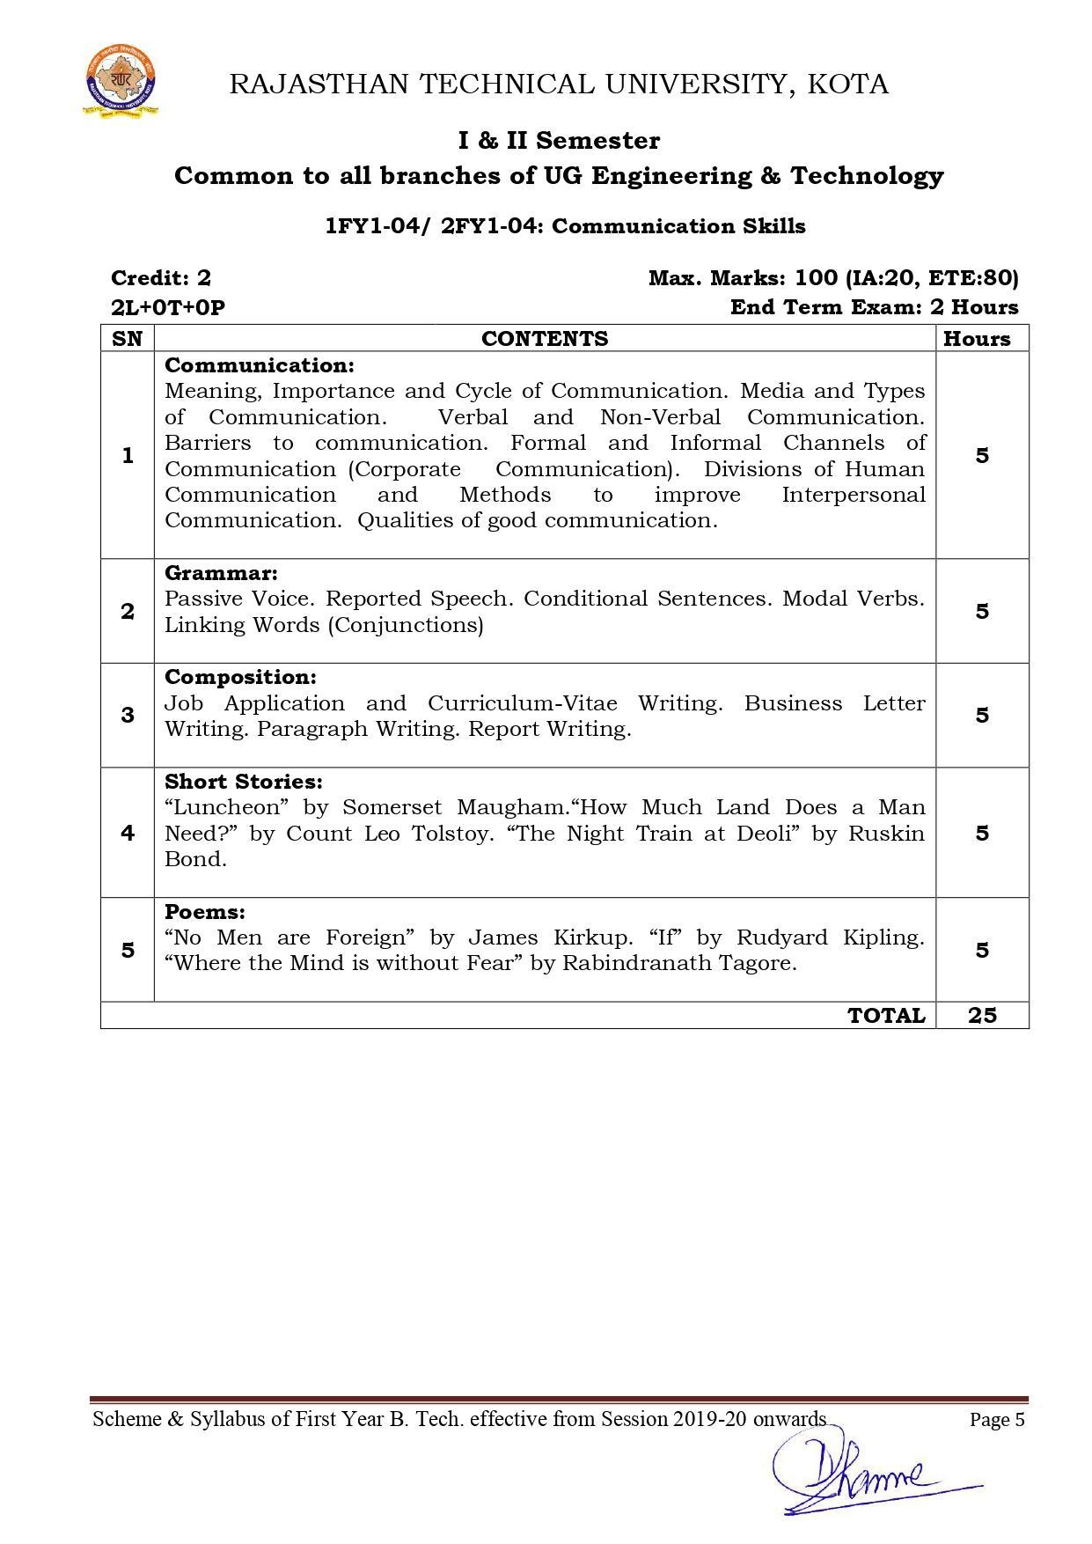

**Course Overview –**

Students will be able to learn various barriers related to communication and learn the basics of grammar. As most students do not belong to an English medium background, this course teaches them the basics of grammar and communication so as to improve their communication skills in future.

Students will be able to understand and develop communication skills and techniques which will felicitate their ability to work collaboratively with others.

Students will be able to use English grammar accurately that will increase their confidence in English writing and speaking.

Students will be able to invent, draft, organize, abstract, elaborate and synthesize their own and other's ideas in formatted way.

Students will be able to understand literary devices after reading poems and stories and also escalate art in all forms.

**Course Outcomes –**

1. Students will be able to understand and develop communication skills and techniques which will felicitate their ability to work collaboratively with others.
2. Students will be able to use English grammar accurately, which will increase their confidence in English writing and speaking.
3. Students will be able to invent, draft, organize, abstract, elaborate and synthesize their own and other's ideas in a formatted way.
4. Students will be able to understand literary devices and also appreciate art in all forms.
5. Students will be able to write, think, understand the value and importance of poems and stories.

**Course Outcome Mapping with Program Outcome –**

PO1 PO2 PO3 PO4 PO5 PO6 PO7 PO8 PO9 PO10 PO11 PO12

0 1 1 0 1 2 2 1 2 3 1 3

0 0 0 0 0 0 0 0 1 2 0 2

0 0 0 0 0 0 0 1 1 2 0 2

0 1 1 0 1 1 1 1 2 3 1 2

1 – Slight (low)

2 – Moderate (medium)

3 – Substantial (high)

**Course Module Lecture-wise –**

| Lecture No. | Unit | Topic |
| --- | --- | --- |
| 1 | 1 | Meaning and Importance of Communication. |
| 2 | 1 | Cycle of comm. Various types of communication. |
| 3 | 1 | Medium of communication. |
| 4 | 1 | Verbal and non-verbal comm. |
| 5 | 1 | Barriers to comm. |
| 6 | 1 | Channels of comm. |
| 7 | 1 | Corporate communication. |
| 8 | 1 | Divisions of Human communication – A. |
| 9 | 1 | Divisions of Human communication – B. |
| 10 | 1 | Interpersonal Communication. |
| 11 | 1 | Methods of Interpersonal communication. |
| 12 | 1 | Qualities of good communication. |
| 13 | 2 | Passive Voice. |
| 14 | 2 | Reported Speech. |
| 15 | 2 | Conditional Sentences. |
| 16 | 2 | Linking Verbs. |
| 17 | 2 | Modal Verbs (Conjunctions). |
| 18 | 3 | Job Application. |
| 19 | 3 | CV-Resume-Biodata writing. |
| 20 | 3 | Business Proposal/letter writing. |
| 21 | 3 | Paragraph writing. |
| 22 | 3 | Report writing. |
| 23 | 4 | Short story – Luncheon – A. |
| 24 | 4 | Short story – Luncheon – B. |
| 25 | 4 | How much Land does a man need? (A) |
| 26 | 4 | How much land does a man need? (B) |
| 27 | 4 | The night train at Deoli – A. |
| 28 | 4 | The night train at Deoli – B. |
| 29 | 5 | No men are foreign – A |
| 30 | 5 | No men are foreign – B. |
| 31 | 5 | If – A |
| 32 | 5 | If – B |
| 33 | 5 | Where the mind is without fear – A |
| 34 | 5 | Where the mind is without fear – B. |

**Text/Reference Books –**

1. Communication Skills, Pushplata & Sanjay Kumar, Oxford University Press, India.

2. The Written Word, Vandana Singh, Oxford University Press, India.

3. Current English Grammar and Usage with Composition, R. P. Sinha, Oxford University Press, India.

4. Rodriques M. V., ‘Effective Business Communication’, Concept Publishing Company, New Delhi, 1992 reprint (2000).

5. Bansal, R K and Harrison J B, ‘Spoken English’ Orient Longman, Hyderabad.

6. Binod Mishra & Sangeeta Sharma, ‘Communication Skills for Engineers and Scientists, PHI Learning Private Ltd, New Delhi, 2011.

7. Gartside L. ‘Modern Business Correspondence, Pitman Publishing, London.

**Assessment Methodology –**

1. Online quiz through Google forms after every chapter.
2. Practical exam in lab where they have to write various formal documents at a very basic level like formal letter, business proposal, resume-CV etc. once a week.
3. Assignments – 1 from each unit.
4. Midterm subjective paper where they have to write sample e-mails, formal letter, paragraph, critical appreciations of various texts each in poetry and short stories, meanings of difficult words and terms.
5. Final paper at the end of the semester subjective.

**Teaching and Learning Resources unit-wise –**

**Unit – 1**

Online reading: <https://www.zippia.com/advice/communication-skills/>

<https://www.thebalancecareers.com/communication-skills-list-2063779>

<https://www.skillsyouneed.com/ips/communication-skills.html>

Video Tutorials:<https://www.youtube.com/watch?v=o3s0HhAqJEo>

<https://www.youtube.com/watch?v=RPUPSWCIO9Y>

<https://www.youtube.com/watch?v=doAVuehH-L4>

<https://www.youtube.com/watch?v=-8cMOh5roUs>

Sample Quiz:<https://www.highspeedtraining.co.uk/hub/communication-skills-quiz/>

<https://www.vskills.in/practice/communication-skills-test>

**Unit – 2**

Online Reading:<https://www.towson.edu/ows/activepass.htm>

<https://www.ego4u.com/en/cram-up/grammar/conditional-sentences>

<https://dictionary.cambridge.org/grammar/british-grammar/reported-speech_2>

Video Tutorials:<https://www.youtube.com/watch?v=VxHCs9W7tW4>

<https://www.youtube.com/watch?v=W1_IRU6zx9g>

<https://www.youtube.com/watch?v=jcMjKxZzJl0>

Sample Quiz:<https://www.perfect-english-grammar.com/reported-speech-exercises.html>

<https://www.wallstreetenglish.com/exercises/direct-and-indirect-speech-exercises>

<https://classroom.google.com/c/MjQyNjA0MjUzODA1/a/MjQyNjA0OTA4Mzcw/details>

**Unit – 3**

Online Reading: <https://www.lkouniv.ac.in/site/writereaddata/siteContent/202004291614538778Savya-Sachi-Difference-between-Resume-CV-and-Biodata.pdf>

<https://www.thebalancecareers.com/how-to-format-a-business-letter-2062540>

<https://wts.indiana.edu/writing-guides/paragraphs-and-topic-sentences.html>

Video Tutorials:<https://www.youtube.com/watch?v=L1J9ZPVydrc>

<https://www.youtube.com/watch?v=_fP43gcBywU>

<https://www.youtube.com/watch?v=7xUTguLaaXI>

Sample Quiz:<https://quizizz.com/admin/quiz/56fbc81fbb00b31b0a1b9bfd>

<https://www.englishclub.com/business-english/resumes-cv-quiz.php>

<https://www.testprepreview.com/modules/reading1.htm>

**Unit – 4**

Online Reading: <https://www.jaroska.cz/elearning/anglictina/library%20luncheon.html>

<https://www.uvic.ca/research/centres/cisur/assets/docs/iminds/gam-how-much-land-a-man-needs.pdf>

<https://www.waterstones.com/book/night-train-at-deoli-and-other-stories/ruskin-bond/9780143432043>

Video Tutorials:<https://www.youtube.com/watch?v=430VOBMC4tg>

<https://www.youtube.com/watch?v=FD724EB3YV4>

<https://www.youtube.com/watch?v=4eWa3285leU>

Sample Quiz:<https://www.goconqr.com/en/quiz/3200025/-the-luncheon-william-somerset-maugham>

<https://classroom.google.com/c/MjQyNjA0MjUzODA1/a/MjQ5NzAyOTc5MDg5/details>

<https://quizizz.com/admin/quiz/57d61b40b70143a147c62831/how-much-land-does-a-man-need>

<https://wordwall.net/embed/edddef745b9c45a584ab6699ae02c41d?themeId=4&templateId=5>

**Unit – 5**

Online Reading:<https://www.successcds.net/learn-english/class-9/no-men-are-foreign-class-9-english-poem.html>

<https://nios.ac.in/media/documents/srsec302new/302EL10.pdf>

<https://www.poetryfoundation.org/poems/46473/if--->

Video tutorials: <https://www.youtube.com/watch?v=NvBm6Kq0fgI>

<https://www.youtube.com/watch?v=H_Kvbe1rwu4>

<https://www.youtube.com/watch?v=5Goe8K1QApA>

<https://www.youtube.com/watch?v=430VOBMC4tg>

<https://www.youtube.com/watch?v=mbthTKMCdp8>

<https://www.youtube.com/watch?v=DC8zC-WM9gQ>

Sample Quiz: <https://www.enotes.com/topics/if-kipling/quizzes>

<https://quizizz.com/admin/quiz/5f02f814cdce1b001bb7b7b0/where-the-mind-is-without-fear>

<https://www.learninsta.com/no-men-are-foreign-class-9-mcq-questions/>

**Practice Exercises**

**Unit I**

How is communication a social activity?

Define the term communication

How can we communicate with confidence? What skills are required for that?

Write a note on the media of communication

What are the various barriers in effective listening? How can they be overcome?

Why is the informal channel called the grapevine?

What is corporate communication?

What is selective perception?

What are goal conflicts?

What are the qualities of a good communicator?

Why should we be careful about our body language?

**Unit 2**

Passivise the following sentences

1. We have not used this machine for ages
2. We are trying to make our economy strong
3. They may ban this film
4. May God bless you

Convert these sentences into indirect speech

1. The doctor said to him, “you do not take rest.”
2. She will say ,”I prepared breakfast.”
3. A student said to me ,”Will you teach us today ?”
4. He said to his peon, “Bring me a glass of water. “

Put the verbs in brackets in correct form:

1. If I( find) your purse I (give) to you
2. I shall not wake unless I (hear) the bell
3. If you (pay) the fine you (not be) sent to prison
4. She will pass the examination provided she (study) sincerely

Insert appropriate modal verbs

1. You----not ask for more money now. (Prohibition)
2. He--------stop smoking.(advice)
3. -----------the Almighty shower his blessings on you.(wish)
4. She said that it -----------rain.(Possibility)

Choose the right alternative:

1. He will go neither to the water park-------------(nor/or)
2. No sooner did he receive the phone call----------he left for his son’s school.(when/than)
3. Both she ---------her mother will prepare dinner.(and/either/as soon as)
4. ------------he is rich, he wants to get more money.(though/than/because)

**Unit 3**

1. You are a B.Tech. A Faculty position in your branch is vacant in a college. Apply for this position. Invent necessary details.
2. What points should be kept in mind while writing a resume?
3. What are the different parts of a business letter ?
4. Write an inquiry letter to Ramesh Cloth Store, Ajmer , on behalf of Krishna Cloth Store, Jaipur.
5. What are the objectives and purposes when you are writing a sales promotion letter?
6. What are the basic requirements of a good paragraph in technical writing?
7. What are the features of a good report?
8. What are the different kinds of reports?

Unit 4

1. ‘Appearances are often deceptive’ .Comment with reference to the story ”The Luncheon’’
2. What were the several dishes the lady placed an order for?
3. Describe how greed ruins Pahom in the story “ How Much Land Does a Man Need “
4. Write a note on the central idea of the story?
5. Write a short summary of the story “ The Night Train at Deoli”
6. Give central theme of the story “ The Night Train at Deoli’

Unit 5

1. Write the central theme of the poem “ No Men are Foreign “
2. How does the poet suggest that all people on earth are the same ?
3. What is the theme of the poem” If “ by Rudyard Kipling ?
4. The words Triumph and Disaster begin with capital letters. Why ? Why Triumph and Disaster are referred to as imposters ?
5. Write a note on patriotism in “ Where the Mind is Without Fear “
6. What is the theme of the poem “ Where the Mind is Without Fear”

**Communication Skills Notes**

Introduction Communication skills are those skills which are needed to speak and write properly. A person who is able to speak appropriately whilst maintaining eye contact with the audience, uses varied vocabulary and articulate speech to suit the need of the audience is generally said to be an effective speaker. Similarly, an effective writer should be able to use written words in various styles and techniques to communicate his/her message and ideas to the readers. One should have the ability to listen carefully and write and speak clearly in any situation. Therefore good reading, writing, speaking and listening skills are essential for effective communication. As a student, you may study any language, but it is important that you are able to read, write, speak and listen well in order to communicate properly. Speaking more than one language can help you to communicate well with people around the world. Learning English can help you to communicate with people who understand English besides the language you have been exposed to speaking the language from early childhood, for example, your mother tongue. In the present time, a thorough knowledge of the language with communication skills is very important in any occupation or to set up a business. The word ‘Communication’ comes from the Latin word commūnicāre, meaning ‘to share’. Importance of communication Your ability to communicate clearly and share thoughts, feelings and ideas will help you in all your relationships. Communication skills are needed to: Inform: You may be required to give facts or information to someone. For example, communicating the timetable of an exam to a friend. Influence: You may be required to influence or change someone in an indirect but usually important way. For example, negotiating with a shopkeeper to reduce the price or helping a friend to overcome stress due to exam or any other reason. Express feelings: Talking about your feelings is a healthy way to express them. For example, sharing your excitement about doing well in your exams or sharing your feelings with your parents and friends. Elements of communication Communication is a two-way exchange of information, i.e., giving and receiving. Speaking and writing to someone are examples of giving information. Reading and listening to someone are examples of receiving information. Perspectives in communication Perspectives are ideas, views, or fixed ways of thinking. These sometimes affect our communication. For example, if you have a fixed idea that your teacher or father is strict, even when they are being friendly, you may think they are scolding you even though they are polite. In the same way, others may also have fixed ideas about you, which affect whatever you say to them.

**Factors Affecting Perspectives in Communication**

Factor How the factor can become a barrier

**Language** In case of use of incorrect words, unfamiliar language and lack of detail, language can act as a barrier to communicate what one wishes to convey. For example, language can act as a barrier when an Indian who only knows Hindi and Chinese who has the knowledge of Mandarin only want to interact with each other.

**Visual Perception**: Visual perception is the brain’s ability to make sense of what we see through our eyes. For example, completing partially drawn pictures with visual perception whereas they may be something else.

**Past Experience** Letting our earlier experience stop us from understanding or communicating clearly. For example, “This shopkeeper cheated me last time. Let me be careful or “I scored low marks in my Maths exam, so I am scared to ask and answer questions in class.”

**Prejudice:** Fixed ideas, such as thinking “No one in my class likes me” may stop a student from communicating openly in the class.

**Feelings**: Our feelings and emotions, such as lack of interest or not trusting the other person affect communication. For example “I am not feeling well, therefore, I don’t want to talk.”

**Environment** Noise or disturbance in the surroundings may make communication difficult. Example, talking to a friend in a function where there is loud music being played by the orchestra.

**Personal factors**:Personal factors include your own feelings, habits and ways of thinking. For example, fear, and low confidence may make communication difficult.

**Culture**: Signs’ which have a different meaning in different cultures, such as showing a thumb may mean ‘good job’ done for some people but may be insulting to others.

**Effective communication**

Effective communication can happen if we follow the basic principles of professional communication skills. These can be abbreviated as 7 Cs, i.e., Clear, Concise, Concrete, Correct, Coherent, Complete and Courteous.

There are different methods of communication, which include non-verbal, verbal and visual.

**Session 2: Verbal communication**

Verbal communication is the sharing of information by using words. It is what most people use as a method of communication. Verbal communication is important because if you do not use the right words, you will cause confusion and you will not be able to communicate what you want. The important forms of verbal communication are given below.

**Type of Verbal Communication**

**Oral or Spoken Communication:** Communication which involves talking Face-to-face conversation: When you can see the listener. For example, group discussion, talking to family members at home, conversation with the public through speeches, etc.

**Written Communication**: Communication which involves written or typed words. Writing letters, notes, email, etc. SMS (Short Message Service): These can be sent through a phone to a person or a group.

**Advantages of verbal communication**

Verbal communication is easy and quick. You can say what you want and get a quick response. It is an easier form of communication when you have to exchange ideas. You keep changing your communication as per the other person’s reply.

**Disadvantages of verbal communication**

The most common disadvantage of verbal communication is the cultural differences between the sender and receiver of the information. These differences may be due to the use of different languages, inability to understand the colloquial phrases used by the other individual, and the accent. Since verbal communication depends on words, sometimes the meanings become confusing and difficult to understand if the right words are not used.

**Public speaking**

Speaking in front of a large group makes most people nervous. You can use the 3Ps (Prepare, Practice, Perform) method to get over your fears, and become a confident and effective speaker.

**3Ps of Public Speaking**

**Prepare** Think about your topic Think about what your listeners need to know about the topic Think about the best way to make your listeners understand your topic Write what you plan to say

**Practice** Practice by yourself first, talk in front of a mirror Talk in front of your family and friends and ask them what they think Speak clearly, loudly and at the right speed (not very fast nor very slow)**Perform** Take a few deep breaths if you are feeling nervous Think about what you have prepared and start speaking confidently

**Basic listening Skill**

**Introduction**

Listening is the most critical communication skill. Students are involved in various

listening situations 65c/o to 90 c/o of the time, but most students have little or no listening

instruction. Little listening instruction may be due to the lack of preparation, time or material

.In addition, teachers may be uncertain whether they are good listeners themselves and may,

therefore, hesitate to teach this skill

“Listening is a fundamental language skill, but it is often ignored by

foreign and second language teachers “ (Rebeccal, 1993).

While the other three language skills receive direct instructional attention, teachers frequently

expect students to develop their listening capability by osmosis and without help.

So, the listening skill should be a major area of concern to teachers and students of a second

or foreign language, this is the concern of this chapter which tends to summarize what is

essential to be known about the listening process as it relates to foreign language learning.

It is intended to provide an overview of the key concepts and issues involved in

understanding listening, it discusses the nature and types of listening, some constraints or

difficulties faced by EFL learners in developing their listening comprehension abilities, and

some suggested guidelines to consider when teaching this skill.

The difference between "Hearing and Listening ":

As a suitable starting point for dealing with the listening skill in foreign language

teaching is to consider the following question: How is “Hearing” different from listening?

The two terms “hearing and listening are often used interchangeably, but there is an

important differences between them.

According to Stephen, Lucas, listening doesn’t mean we don’t hear, and they come to

explain the process of hearing to be a physiological one arguing that:

“It involves the vibration of sound wave on our eardrums and the firing of electro-

chemical impulses from the inner ear to the central auditory system of the brain, but

listening involves paying close attention to, and making sense of, what we hear.”

( Stephen, Lucas, 1998, 56)

“Although both hearing and listening involve sound perception, the difference

in terms reflects a degree of intention”

(Rost, 2002,27).

So, the listening process is guided by our intention which is psychologically an excitation of

nerve pathways in the brain to organise incoming stimuli in an efficient way with a

psychological terms, (Rost, 2002) quoted that:

“Intention is the initiation of involvement ..., it is used for organizing what is

heard and seen, to organize language in terms of topics (what the language is

about) and information value (what the language signal is relevant to us?).”

So listening and hearing are not synonymous. Hearing occurs when your ears pick up

sound waves being transmitted by a speaker, listening involves making sense out of what is

being transmitted (Hamilton, 1999) as he quoted:

“Hearing is with the cars, listening is with the mind”

The definition of listening:

Listening is a vital component of the oral communication, or the interactive process in

which the individual takes the roles of speaker and listener through a verbal and non verbal

component.

When examining the state of listening in FLT, it is noticed the lack of an agreement on an

exact definition (Witkin, 1990) as he argued

“No one theory about what listening is” (P7).

But, still this process can be defined variously and many definitions can be attributed to this

skill.

Listening is an essential part of the communication process. Students spent the

majority of each school day listening and much of what students know is acquired through

listening.

It is a term daily used without giving it much thought. Yet, listening is a vital mental

capacity one of the principal ways through which we understand and take part in the world

around us (Rost, 1994) as he quoted:

“Listening is considered to be a part of oracy, a capacity to

formulate Thought verbally and to communicate with others, so it is the skill that underlines all verbal communication”

It is suggested that listening can be done in a narrow and limited way, or it can be done in a

way that enriches communication (Goodith, 2001) , as it was said:

“Listening is not merely not talking...it means taking a

vigorous human interest in what is being told us. You can

listen like blank mall or like a splendid auditorium where

every sounds comes back fuller and richer”

( Miller, Goodith, 2001, 48 ).

Listening is the ability to identify and understand what the speaker is saying through

understanding his accent, pronunciation, grammar, vocabulary and grasping his meaning.

Those sub components of listening are well explained by (Rost,1994) as he draws a particular

list of components to master when dealing with this skill:

- Discriminating between sounds .

- Recognizing words.

- Identifying stressed words and grouping of words.

- Identifying functions(such as apologizing )in conversations

- Connecting linguistic cues to paralinguistic cues (intonation and stress) and to non

linguistic cues (gestures and relevant objects in the situation) in order to construct

meaning.

- Using background knowledge and context to predict and then to confirm meaning.

- Recalling important words, topics and ideas.

- Giving appropriate feed back to the speaker.

- Reformulate what the speaker has said.

Rost(1994) insists on the fact that students must deploy all these sub skills to realize a

successful process when he states:

"Successful listening involves an integration of these component skills .In this

sense, listening is a coordination of the component skills, not the individual

skills themselves. This integration of these skills constitutes a person's

listening ability"

The active nature of listening comprehension:

Listening comprehension is a cognitive, or rather an interactive process of constructing

meanings that the speaker intends, through the complete involvement of the hearer.

The active contribution of the listener's comprehension process comes not only through

using his linguistic knowledge but also his non linguistic sources, and of course the

communicative value of his involvement depends on the situation and the social relationship.

(Little Wood, 2000).

The listener must realize that comprehending the message word for word is not essential,

Since not every clue is equally important to the message. The listener has to seek the general

meaning to compensate his misunderstanding by continuing being involved in the

communication (Little Wood, 2000).

“More positive listening self concepts can be created by

helping students realize that word-for-word comprehension is

not necessary and that guessing and hypothesis testing are

valuable” (Rebecca L, 1993

**Bottom-up vs. top down processing**

It is motioned before that in the listening comprehension process; listeners need

two types of knowledge. Both linguistic and non- linguistic knowledge are involved;

linguistic knowledge consists of "phonology, lexis, syntax and discourse structure" and

the non-linguistic knowledge covers all comprehension features such as "topic, context,

general knowledge about the world and how it works" (Buck, 2001).

Many researchers into teaching listening comprehension have given insights into

how learners go through this process as well as how the two types of knowledge are

applied in it. As a result , a frequent distinction is made between two views;(top -down

and bottom-up processing) for the reason of understanding what our students are going

through as they learn to listen.

**Bottom up processing**

It is agreed that the language process has a definite order, it means from the lowest

level of detail to the highest level (Buck, 2001). The same view is directly implicated in

listening, precisely in the Bottom –up processing ,to assume that in this process the listener focuses and gives much importance to the smallest units of speech than the

individual words and after to phrases to combine them in order to achieve understanding

and build a hole (Harmer,2001).

He argues that:

"Without a good understanding of a reasonable proportion of the details

gained through some Bottom-up processing, we will be unable to get any clear

general picture of what the text is about"

(Harmer, 2001, 201)

Buck supports the above view quoting that:

"Listeners assume that acoustic input is first decoded into phonemes,

then this is used to identify individual words, then processing continues on to

the next higher stage, the syntactic level followed by an analysis of semantic

content to arrive at a literal understanding of the basic linguistic meaning .

Finally, the listener interprets that literal meaning in terms of communicative

situation to understand what the speaker means"

(Buck, 2001, 2)

Helgesen , Brown (1995) come to explain this processing simply by noting that:

"With Bottom-up processing, students start with the component parts:

words, grammar and the like"

(Helgeson,Brown,1995,x).

This process sees language comprehension to be a passage through consecutive stages;

the out put of one stage becomes the input of the coming next high stage (Buck, 2001).

**Top-down processing**

Many perspectives appear to indicate that the processing of different types of knowledge

doesn't occur in a fixed sequence and order. They come to reject the first view saying that it is

possible to understand the meaning of a word without decoding its sounds .This is due to the

interference of another type of knowledge (non linguistic one ) including knowledge of the

world around us and this is the concern of Top-down processing (Buck,2001).

"Top down process is the opposite of Bottom-up, students start from their

background knowledge"

(Helgesen, Brown, 1995, x).

To explain this process more , (Harmer,2001) indicates that in this processing , the

listener tends to get the message' general view and absorb the overall picture of the listening passage .This is helped if the listener has the ability to have appropriate expectations of what

is going to come across.

As a conclusion , to successfully realize the process of listening , it is better to suggest a

combination between the two processing "Bottom-up, top -down", and many specialists

argue that this interaction is the case almost immediately .

"Sometimes it is the individual details that help us to understand the whole;

sometimes it is our overview that allows us to process the details"

**Types of listeners:**

The listener differs from the speaker in terms of choice; it means that speakers have the

opportunity to choose the language they speak or use, and they succeed in achieving a real

communication through suitable strategies as using paraphrase or simplifying their messages.

The listener however can’t have any control over the language being listened to, so he has

to be able to construct meaning from any language directed at him (Little wood, 2000) as he

added that:

“It is therefore not enough that he should merely be able

to understand the same range of language that he can speak;

receptive repertoire must be matched not against his own

productive repertoire, but against the productive repertoire

of the native speakers he will needed to understand”

(Littlewood, 2000) (P65)

In the stream of LittleWood(2000) distinction between both speaker and listener’s

readiness in the communication process, and Since we are dealing with the listening skill and

tackling the different assessment scales in showing the degree of listening ability; ( Rost,

1994) distinguishes between three types of listeners;

**Competent listener:**

As the first type of listener, he is considered to have a high listening ability. The listener

in this category is capable of:

- Understanding all the types of speech, concerning those easy to be understood by

native listeners in the target community or the abstract.

In case speech is unintelligible, the listener can seek clarification easily, he is able to

depict whether his knowledge in a certain communication situations is enough to teach

an acceptable level of understanding or not, as well as being able to note where the

speaker is ambiguous and vague.

- In the different target culture’s settings and social contexts, the listener understands

and reacts appropriately.

- It is noted that competent listener is elected to perform well concerning any task

demanding oral comprehension (Rost, 1994).

**Listener of modest ability:**

Concerning the second type of listeners in L2, the listener is described to be able to

understand the majority of speech styles, some abstract, oral concepts but with need to

some kinds of repetitions and explanations.

- The listener can note where the speaker is standard in his speech and where

knowledge isn’t enough to reach the level of comprehension, but with confusion

about the source of difficulty in understanding (Rost, 1994).

- “The listener can react to the different contexts and social situations in the

target culture but often not appropriately. (Rost ,1994,138)

**Listener of limited ability:**

-The listener in this last type can understand only limited styles of speech. He is unable to

comprehend ambiguous concepts presented in the target language without being exposed to

non linguistic components. He always requires re-explanation, repetition and clarifications.

-He fails to attempt clarifications when speech is unintelligible, unable to discover where the

difficulty lies and he is confused about its source.

“The listener is unable to sustain understanding in an

interaction, display limited range of listener responses”

(Rost,1994,138)

**Types of listening**

**Extensive and intensive listening**

Different situations require different types of listening. In the classroom situation,

students can improve their listening abilities and gain valuable input by being engaged in the

listening process through a combination of extensive and intensive listening.

(Harmer, 1998).

Most researchers like to make the difference between "extensive and intensive"

listening .The two types are described by Harmer (1998) to have a special importance. They

provide students with the perfect opportunity to listen to other speakers than their teacher's

"They help them to develop their pronunciation and acquire good

speaking habits they absorb"

(Harmer, 1998,228).

**Extensive listening**

It occurs in a situation where the teacher encourages students to choose for themselves

what they listen to, using their own materials for the purpose of pleasure and language

improvement (Harmer, 1998).

It usually takes place outside the classroom and done for its own sake, this doesn't

mean that the teacher is not interested in this type at all, but he is attributed the general

guidance in the process.

Extensive listening materials differ, they can be found from different resources such

as recordings of stories, passages taken from books, television, radio.... All the mentioned

sources tend to treat spontaneous conversations, dialogues, interviews... ect

From what is clearly stated before , taped authentic materials can be considered as a

good tool for learners when dealing with extensive listening .According to Harmer (1998) ,

foreign language teachers can enrich their classes with effective input carrying out extensive

listening through a well chosen and appropriate tapes in different levels , genres and topics .

Creative teachers can recommend certain tapes and ask students to talk about the ones they

have enjoyed the most.

For the reason of encouraging this type of listening, students can be asked to

perform a list of tasks such as:

- To record their responses to what they have heard.

- To assess the level of difficulty.

- To summarize the content of the used material such us a tape.

- To ask students to write their comments in a special comments' boxes to consult

them and try to meet all the needs of the learners.

All these tasks aim "To give students more and more reasons to listen, if they can share their

information with colleagues, they will feel they have contributed to the progress of the

whole group". (Harmer, 1998, 229).

Consequently, extensive listening is an appropriate way for learners to be provided

by extra chances for the reason of constructing their linguistic bank.

**Intensive listening**

The other type of listening is the intensive one. It is practiced in every day situations

the, ability to listen intensively is considered to be an essential part of listening proficiency. It

refers to" the process of listening for precise sounds words, phrases, grammatical units

and pragmatic units"(Rost, 2002, 138).

EFL teachers in dealing with the intensive listening according to Harmer (1998),

prefer to use audio tapes as their favourite material in classroom since it gives students the

opportunity to listen to a variety of voices with different accents, different topics with different

genres, as well as it provides the learner with a significant source of language input.

As far as intensive listening is concerned, it invites the learners to meet different

characters especially when real people are talking in real life situations, interact with speakers,

Interrupt them and why not ask for clarification. This is what is called " live listening".

"Live listening" is among the good ways to carry out intensive listening. It can take many

forms; such as the teacher's reading aloud to a classroom. Students dealing with this task listen

to a natural spoken language of a written passage. In addition to other enjoyable activities like

storytelling, conversations and interviews. (Harmer, 1994)

Consequently, intensive and extensive listening are two important ways to ensure the

realization of listening in general and they have to be used appropriately.

**Listening and critical thinking:**

One of the ways listening can serve us is by enhancing our skills as critical thinkers.

We can identify four kinds of listening (Stephen, Lucas, 1998).

**Appreciative listening:**

Appreciative listening includes listening to music for enjoyment to speakers because you like

their styles, to your choices in theatre, television, radio, or films.

It is the response of the listener not the source of the message that defines appreciative

listening. Generally speaking we use appreciative listening when we seek information which

we will appreciate for example that which helps meet our need and goals.

(Stephen, Lucas, 1998) come to define this type of listening to be:

"Listening for pleasure or enjoyment, as when we listen to music, to a comedy, or

to an entertaining speech"

**Empathetic listening:**

Listening empathetically means that the listeners is seeking to understand beliefs, emotions

of other people in order to get them to expose these deep parts of themselves to us, so we need

to demonstrate our empathy in our demeanour towards them, by asking them sensitively to

encourage self disclosure.

"Empathic listening provides emotional support for the speaker, as when a

psychiatrist listens to a patient or when we lend a sympathetic ear to a friend in distress"

(Stephen, Lucas, 1998, 58)

**Comprehensive listening:**

After the stage of discriminating between the different sounds of a message, come this

type of listening which is the comprehensive one; seeking to make sense of these sounds. To

comprehend, the meaning requires first having a lexicon of words, all rules of grammar and

syntax in addition to the visual components of communication.

According to Stephen and Lucas (1998):

"Comprehensive listening is devoted for understanding the message of a speaker,

as when we attend a classroom lecture"

**Critical listening:**

The ability to listen critically is essential everywhere, we use in different contexts;

family, community... . There is practically no place you can go where critical listening is

unimportant. This type of listening deserves much more attention; it is listening to evaluate a

message for purposes of accepting or rejecting it (Stephen, Lucas, 1998).Critical listening in classroom aims at:

- Separate facts from opinions and help students to prevent opinions from

influencing their understanding of the facts.

- Evaluate speakers' qualifications, motives, biases and help students to understand

how to weight fact and arguments.

- Test ideas for effectiveness and appropriateness and help students to test ideas

they learn.

- Recognize the speaker's reasoning and help students to understand the speaker's

logic or lack of logic.(Rost ,1994).

**A. Multiple choice questions**

Read the questions carefully and circle the letter (a), (b), (c) or (d) that best answers the question.

1. What is the purpose of communication?

(a) Inform (tell someone about something)

(b) Influence (get someone to do something you want)

(c) Share thoughts, ideas, feelings

(d) All of the above

2. Which of the following methods are used to receive information from the sender through a letter? (a) Listening

(b) Speaking

(c) Reading

(d) Writing

3. How do you receive information on the phone?

(a) Listening

(b) Speaking

(c) Reading

(d) Writing

4. Choose the correct example of oral communication.

(a) Reports

(b) Newspapers

(c) Face-to-face conversation

(d) Notes

5. When we communicate verbally, we should use:

(a) difficult words

(b) simple words

(c) confusing words

(d) abbreviations

6. Why do we send emails?

(a) To reach on time

(b) To share documents and files

(c) To talk to each other

(d) To meet each other

7. The origin of the word communication is ____________

a) Communicate

b) Communicare

c) Compute

d) Computer

8. Types of words used for verbal communication?

A) Acronyms

B) Simple

C) Technical

D) Jargons

9. The first language which we learn or speak as a child ___________

A) Jargon

B) Dialect

C) Mother Tongue

D) Vernacular

10. Which of the following shows a positive facial expression?

A) Frowning while concentrating

B) Maintaining eye contact

C) Smiling continuously

D) Rolling up your eyes

11. By what method we can know what the receiver understood or got the message

A) transmitting

B) feedback

C) message

D) listening

12. What is a sentence?

A) A group of ideas.

B) A group of words that communicate a complete thought.

C) A set of rules to write correctly.

D) A set of words that is grammatically correct

13. Which type of word is generally not used in verbal communication.

A) Technical

B) Simple

C) Easy

D) Local Language

14. __________ can be presented by face

A) Gestures

B) Body Language

C) Para Language

D) Expressions

15. _____ are a group of words that together act as a grammatical units.

A) Imperative

B) Interrogative

C) Phrase

D) Exclamatory

16. Using abbreviations in communication leads to which type of communication barrier

A) Language/ Linguistic

B) Physical

C) Cultural

D) Organisational

17. which can be used to overcome the communication barrier

A) Using a translator

B) By writing a letter

C) Not communicating at all

D) Using your own language

18. Which of the following is NOT a communication barrier?

A) Linguistic barrier

B) Interpersonal barrier

C) Financial barrier

D) Organisational barrier

19. Straight body posture shows what?

A) Pride

B) Professionalism

C) Confidence

D) Humility

20. Which of the following is a positive facial expression?

A) Staring hard

B) Wrinkled forehead

C) Looking somewhere else

D) Nodding while listening

21. Which type of words should be used for good communication?

A) Acronyms

B) Technical

C) Jargons

D) Simple

22. Sending a letter is which type of communication?

A) Listening

B) Writing

C) Speaking

D) Reading

23. Which of the following is not an element of the communication cycle?

A) Channel

B) Receiver

C) Time

D) Sender

24. Written communication can be classified in which type of communication?

A) Non-verbal

B) Verbal

C) Visual

D) None of these

25. ......................... is the exchange of messages in the communication cycle.

A) Transmitting

B) Listening

C) Message

D) Feedback

26.The abilities to communicate properly are:

A) read

B) write

C) speak

D) all of these

27. Which of the following is an example of negative feedback?

A) You can dance better.

B) Your Dance was good but you can do better.

C) Your Dance skill is not really good. You have to practise more.

D) None of the above

28. ............ is not a communication barrier?

A) Language

B) Culture

C) Habits

D) Physical

29. The communication cycle does not include............

A) sender

B) message

C) receiver

D) programming

30. Which of the following is quick and clear method of communication

A) e-mail

B) notices/posters

C) face-to-face informal communication

D) business meetings

31. Which method is good for taking leave in the office.

A) Website

B) notices/posters

C) e-mail

D) business meetings

32. The word Commūnicāre means ______ in Latin.

A) to deliver

B) to share

C) to present

D) to sacrifice

33. To understand the message properly the receiver need to ____________ the message properly.

A) transmit

B) throw

C) listen

D) ignore

34. Keeping shoulders straight right and body relaxed is an example of:

A) Facial Expressions

B) Posture

C) Gesture

D) Eye contact

35. Aural communication is based on ...........

A) Body language

B) Language and tone of voice

C) Facial expressions

D) Listening and Hearing

36 .Visual communication are dependent on what factors?

A) Signs, symbols and pictures

B) Text messages

C) Posture

D) Body language

37. What is the final step in the communication cycle?

A) Encoding

B) Decoding

C) Feedback

D) Receiving

38. Which type of feedback supports student development from their current level of achievement?

A) Specific Feedback

B) Descriptive Feedback

C) Non-Specific Feedback

D) None of the above

39. If there is the absence of feedback then it will lead to ............

A Mistrust

B) Communication Barrier

C) Interference

D) None of the above

40. It is a word used in place of a noun that is

A) Pronoun

B) Verb

C) Adverb

D) Preposition

41. A word used to express emotion and is often followed by an exclamation mack is called

A) Preposition

B) Conjunction

C) Adverb 1996

D) Interjection

42. Which part of the sentence contains two independent clauses joined by conjunction?

A) Compound Sentences

B) Simple Sentences

C) Complex Sentences

D) Compound-Complex Sentences

43. The process in which the receiver interprets and understands the message is called .............

A) Decoding

B) Encoding

C) Feedback

D) None of these

44. ........... is an instance of non-verbal communication.

A) A speech

B) Proximity

C) A notice

D) An e-mail

45.Which of the following is an example of oral communication?

A) Newspapers

B) Letters

C) Phone call

D) e-mail

46. “Two girls talking over a phone” – is an example of....

A) interpersonal communication

B) written communication

C) small group communication

D) public communication

47. Pointing finger to something is an example of.....

A) Expressions

B) Gestures

C) Body Language

D) Para Language

48. which of the following includes the tone, speed and volume of voice

A) Eye Contact

B) Body Language

C) Para Language

D) Gestures

49.Which communication method does not require any language to understand?

A) Verbal

B) Non-Verbal

C) Visual

D) None of these

50. Which is the suitable method to overcome communication barriers?

A) Use visuals

B) Take the help of a translator

C) Always be respectful in other’s opinion

D) All the Above

**B. Match the columns**

Column A: Column B:

Communication Barriers Examples

1. Language A. Trying to read a book when somebody else is watching TV in the

same room.

2. Emotional B. In some cultures, wearing shoes and walking inside the kitchen is

considered rude and disrespectful.

3. Environmental C. Talking in Hindi when others know only Tamil.

4. Cultural D. Parent is not talking to the child.

**C. Short answer question**

1. Write down the seven factors affecting perspectives in communication.

2. Give an example of the following:

(a) Clear communication

(b) Complete communication

3. Write down the different types of verbal communication. Give an example for each type.

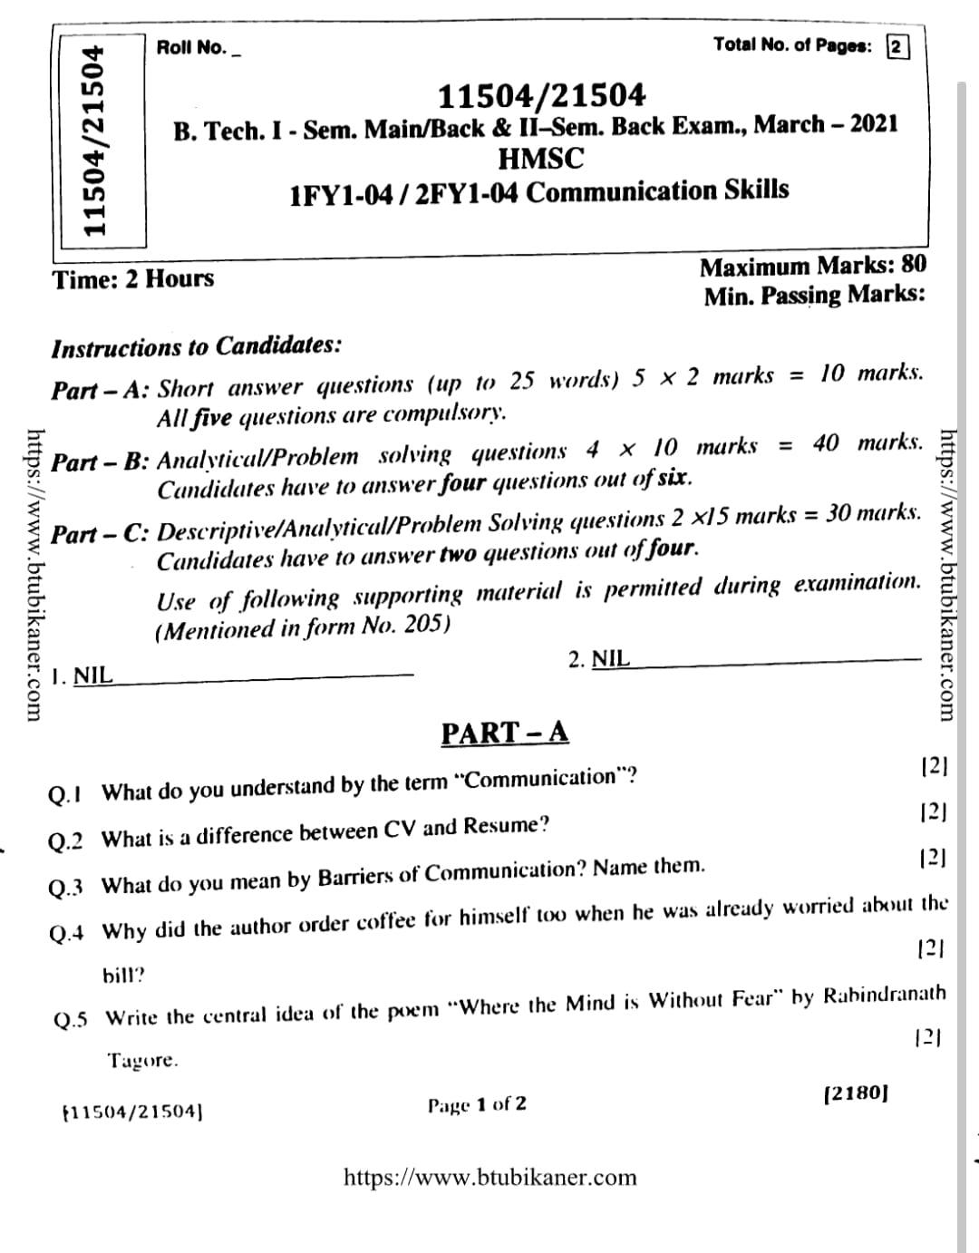

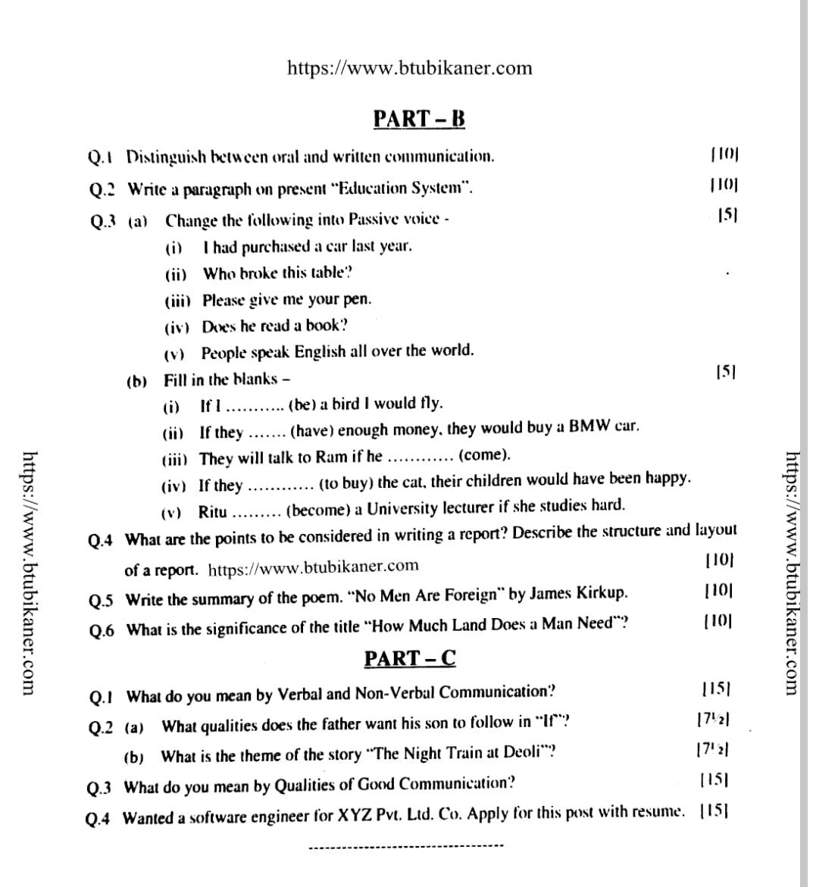

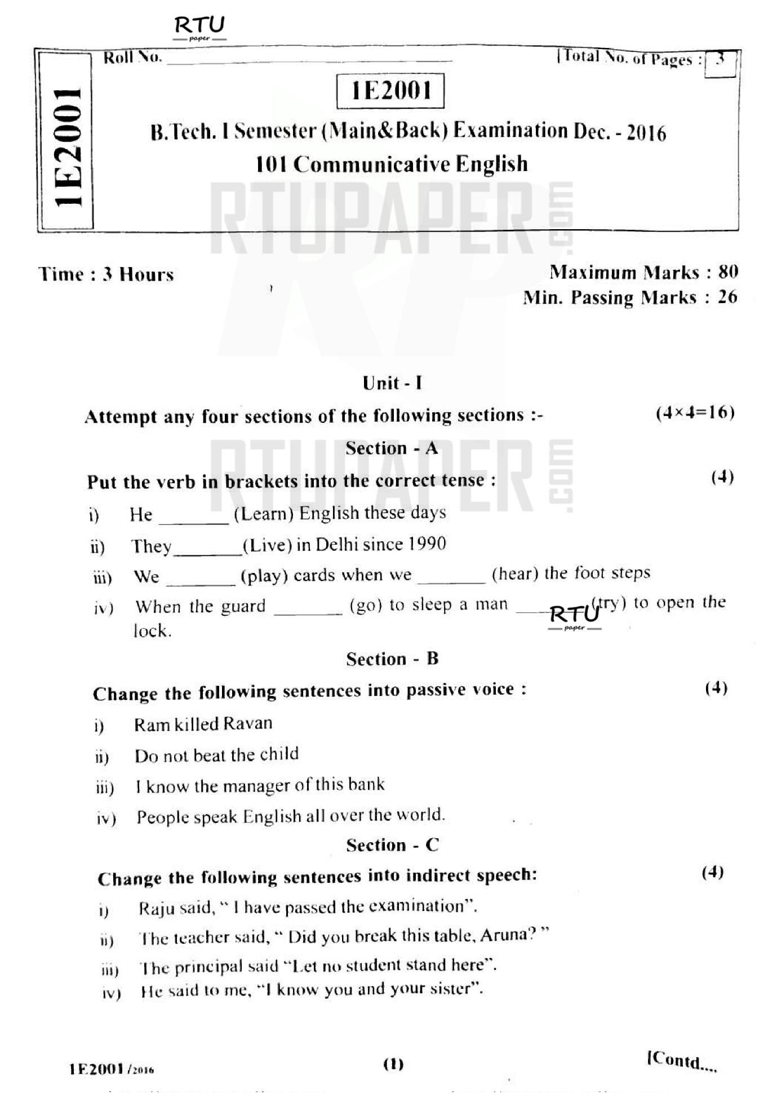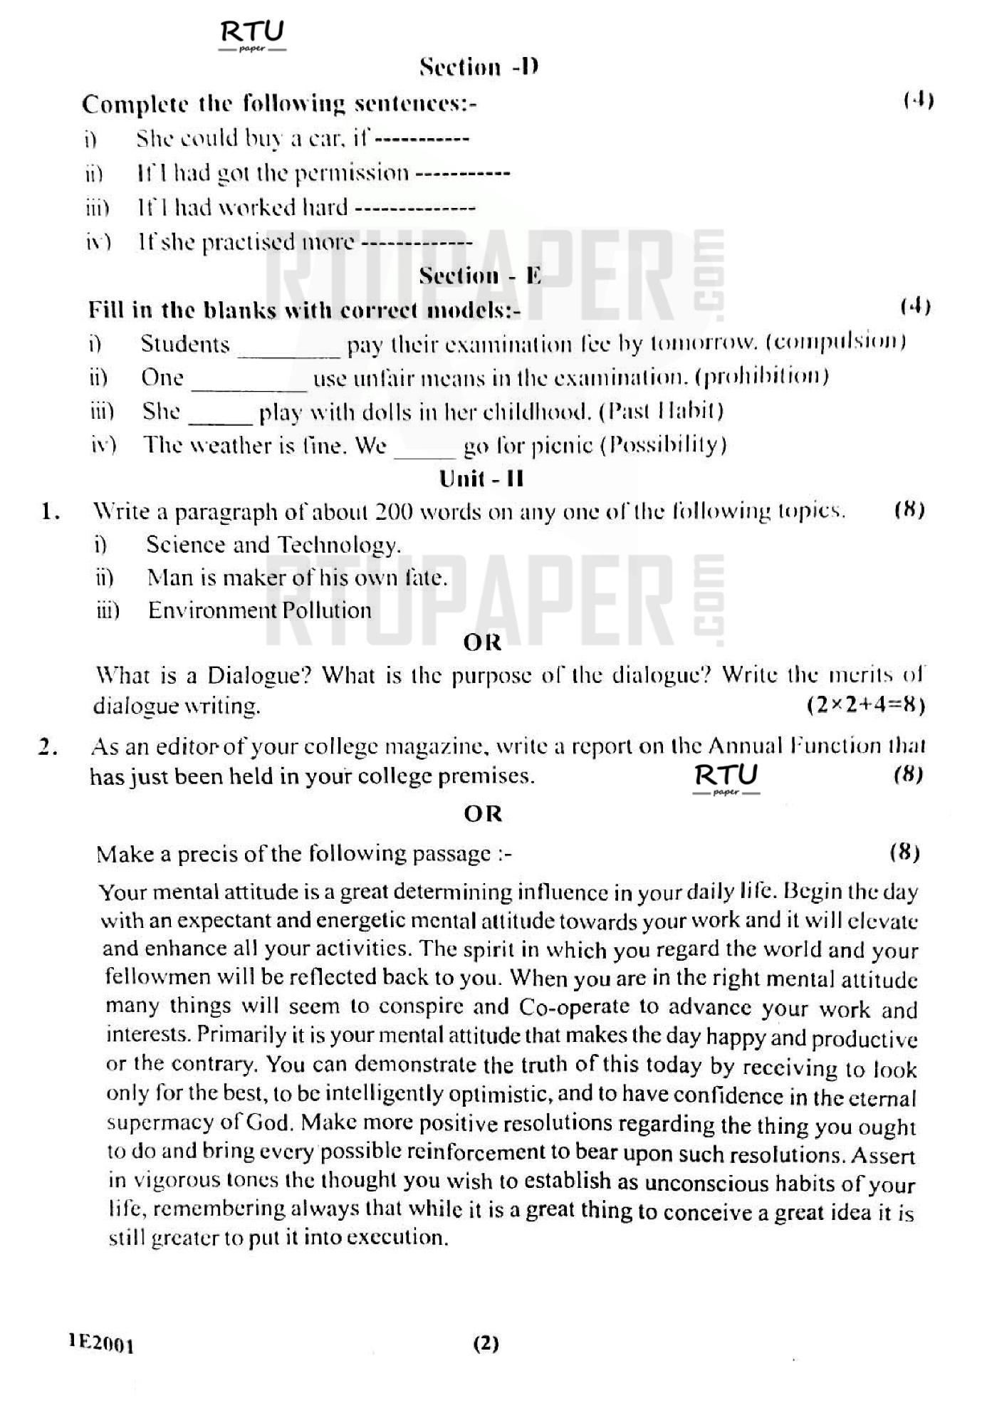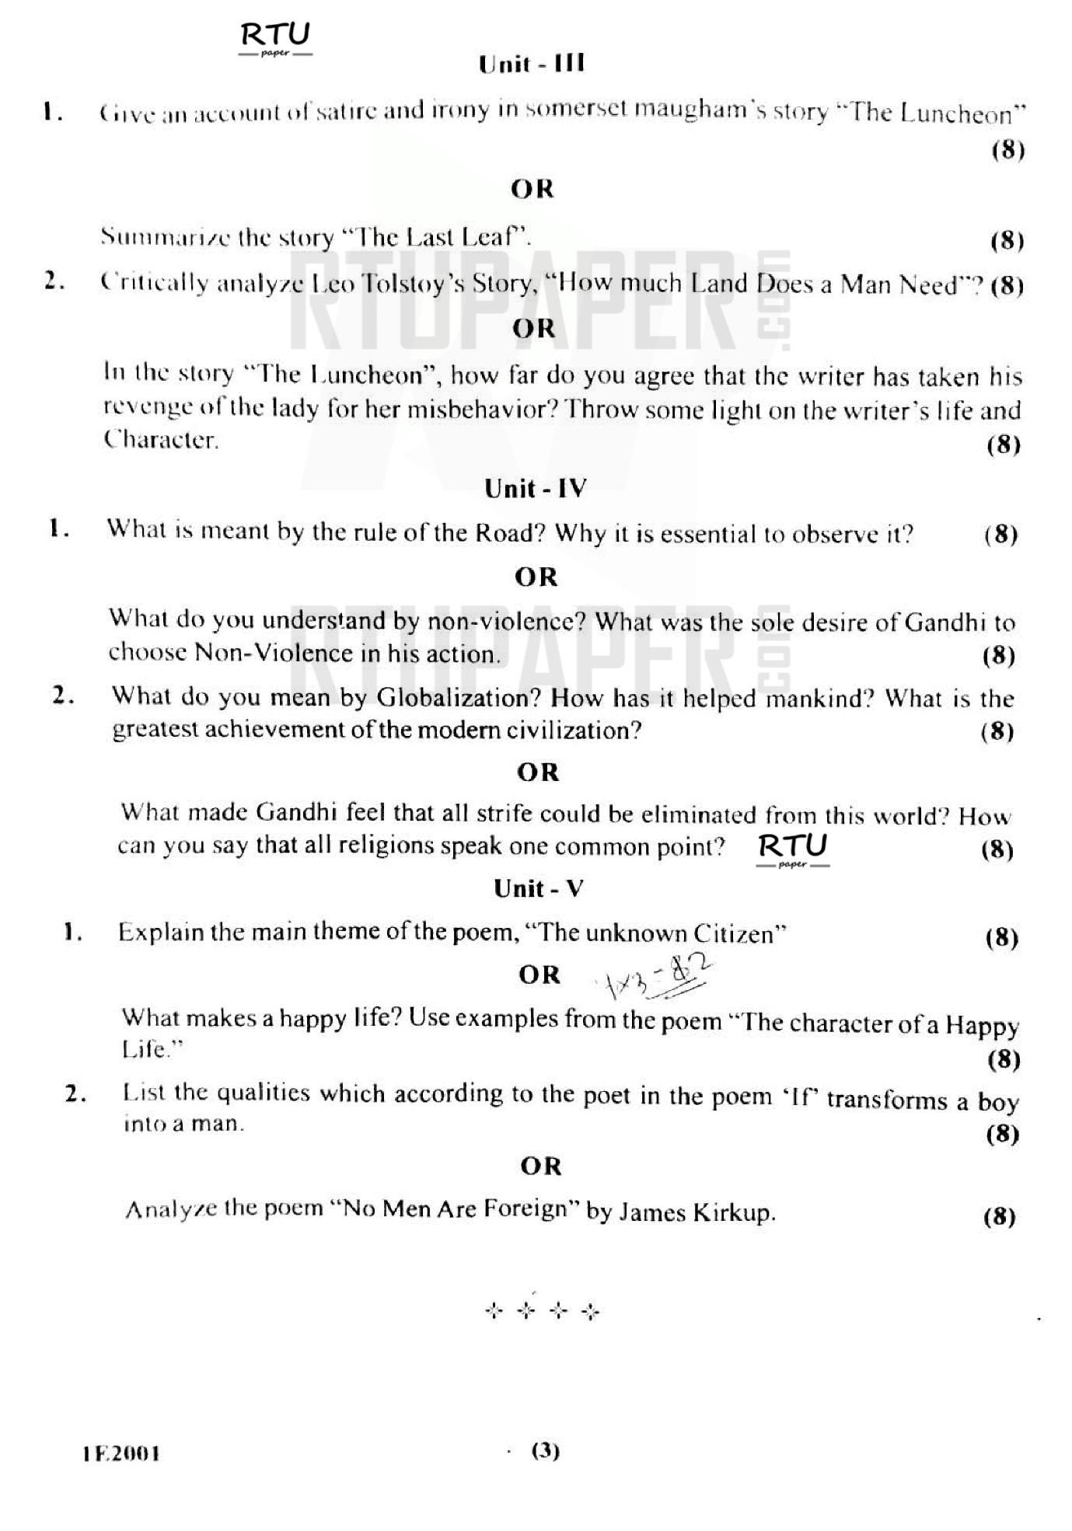

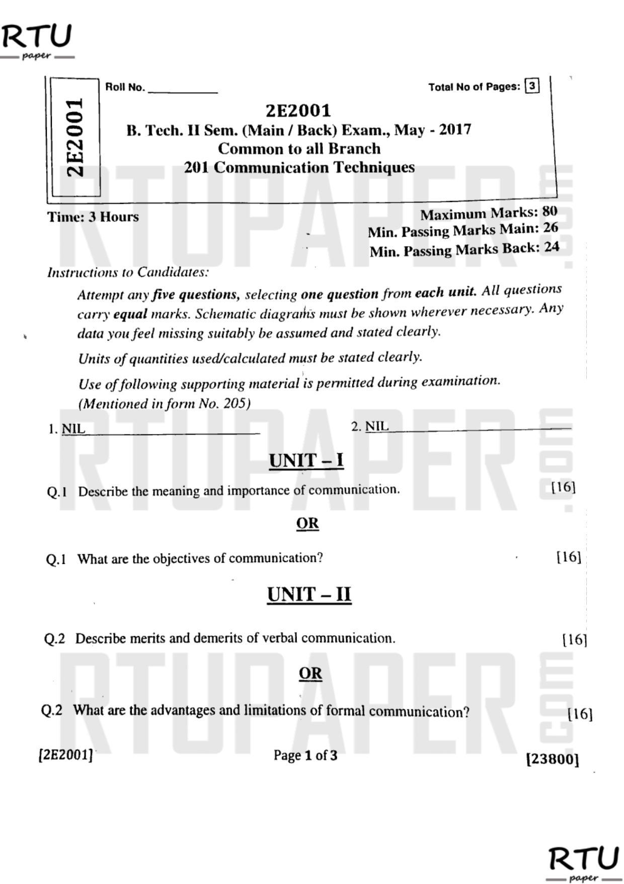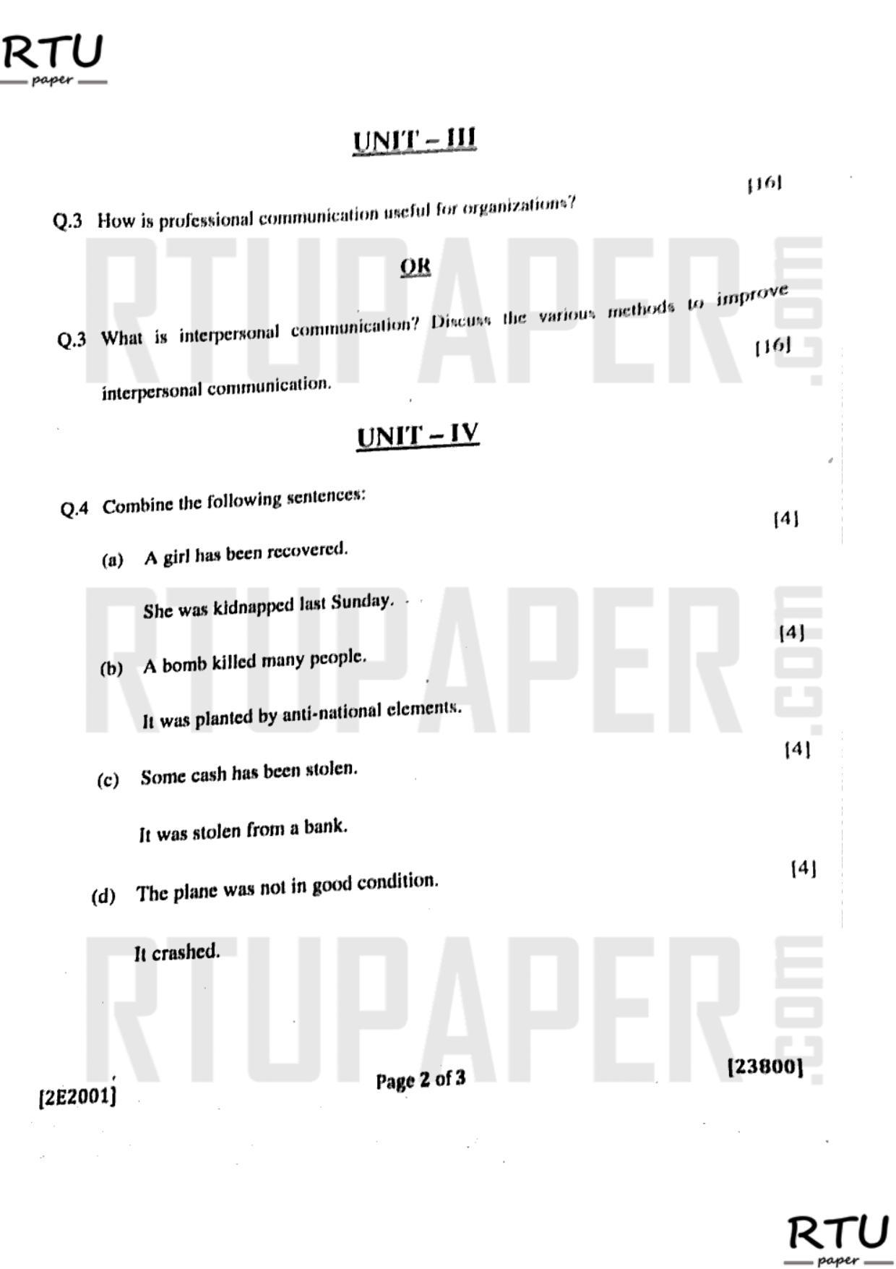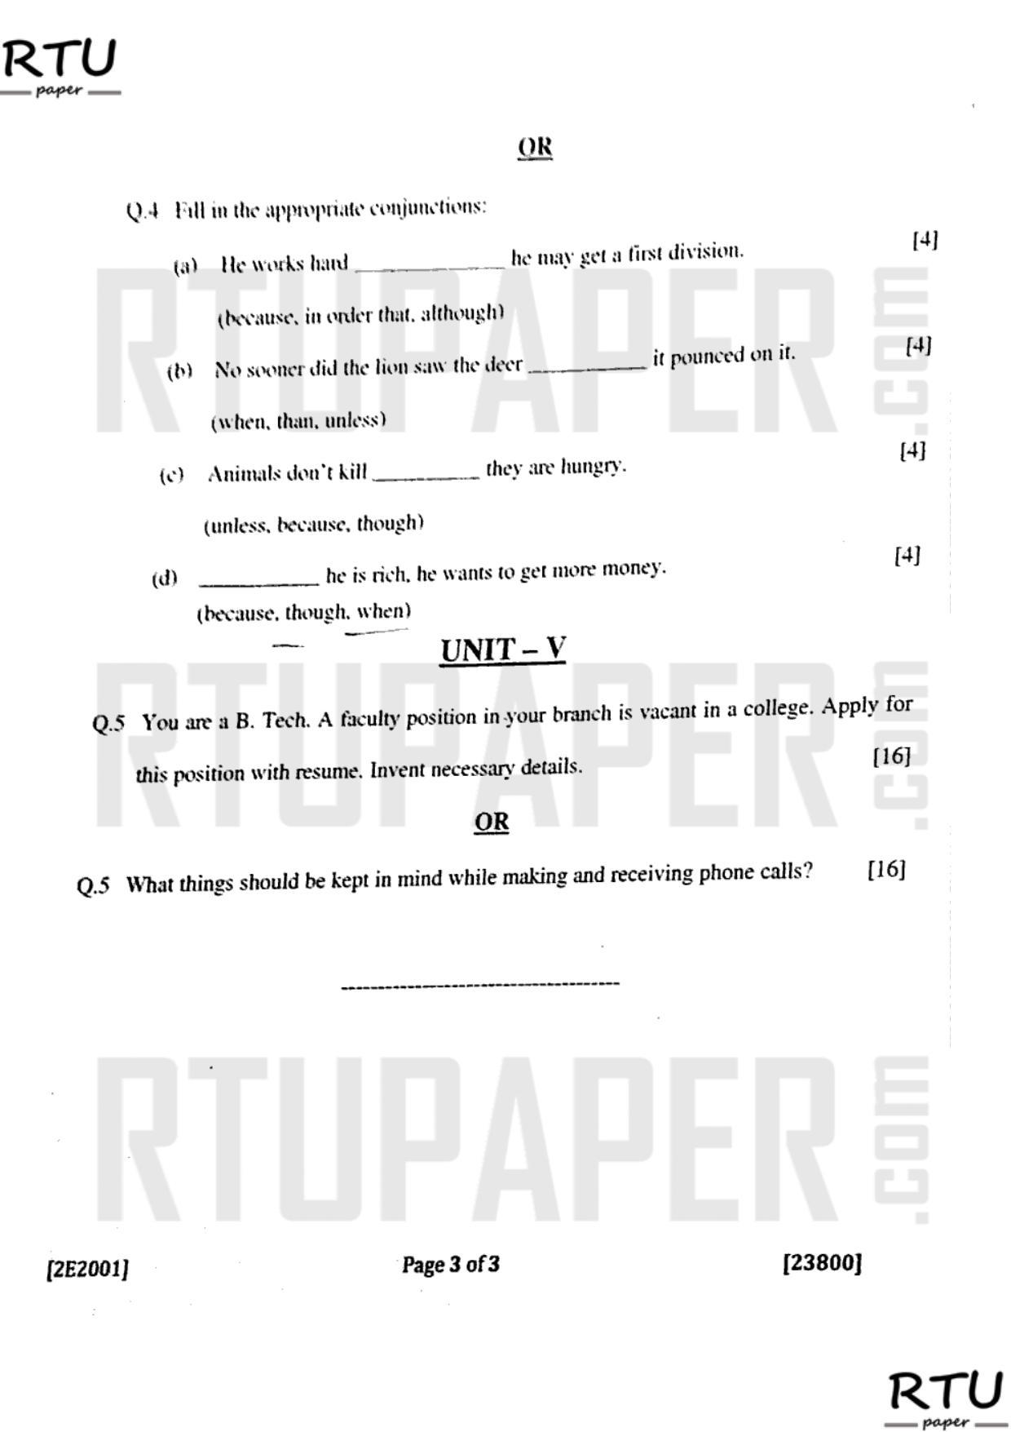

**TECHNO INDIA NJR INSTITUTE OF TECHNOLOGY, UDAIPUR**

**B. TECH 1st – YEAR (I SEM.) – MT-I   
Technical Communication(1FY1-04)**

**Time: 2 Hr Max. Marks: 70  
Note:**

1) The paper is divided into 2 parts: Part-A and, Part-B.

2) Part-A contains 10 questions and carries 2 mark each.

3) Part-B contains 5 questions. Each question is having two options and carries 10 markseach.

**Part- A (20 Marks)**

|  |  |
| --- | --- |
| **A.**Open the door- Change into Passive Voice | CO1 |
| B.Please give me some more time- Change into Passive Voice | CO1 |
| C. We have not need this machine for ages- Change into Passive Voice | CO1 |
| D. Hesays, “I am writing letters”– change into indirect speech | CO1 |
| E. He said, “The Earth revolves round the Sun” – change into indirect speech | CO2 |
| F. He said to me, “you have cheated me” – change into indirect speech | CO2 |
| G. Unless you---------a passport, you----- abroad (fill in the blanks (has, cannot go)) | CO2 |
| H. Make use of “unless”- if you do not play well, you cannot win this match. | CO2 |
| I. You---- not ask for more money now(Insert model verb (Prohibition)) | CO3 |
| J. Animals do not kill---- they are hungry(unless,because,although) - Use Conjunction | CO3 |

**Part- B (50 Marks)**

|  |  |
| --- | --- |
| 1. Define the term “communication”. How is communication a social activity? | CO1 |
| OR | |
| 1. Discuss the characteristics of Communication in detail. | CO1 |

|  |  |
| --- | --- |
| 1. 2.Why is downward communication regarded so important? What is its limitation? | CO1 |
| OR | |
| 2. What is lateral communication? How is it helpful to an organisation? | CO1 |

|  |  |
| --- | --- |
| 3.Explain the importance of upward communication along with its advantages & limitations. | CO2 |
| OR | |
| 3.How communication improves the level of motivation & moral of an Organisation? | CO2 |

|  |  |
| --- | --- |
| 4. Write a note on importance of oralcommunication and its limitations. | CO2 |
| OR | |
| 4. Explain the characteristics of Written communication. | CO2 |

|  |  |
| --- | --- |
| 5. What do you mean by body language? Discuss in details. | CO3 |
| OR | |
| 5. Write a note on the characteristics of written Communication | CO3 |

TECHNO INDIA NJR INSTITUTE OF TECHNOLOGY

MID TERM II Examination 2022-2023

B. Tech. I Year,Semester I

**Sub: Communication Skills (Code: 1FY1-04)**

**Time: 2.00Hr Max Marks: 70**

**Minimum marks: 25**

|  |  |  |  |
| --- | --- | --- | --- |
| **Q. No.** | **Question** | **Paper Marks** | **CO** |
| **PART-A (Compulsory)** | | | |
| 1 | Define lateral or Horizontal Communication | **10X2** | **CO1**  **CO1**  **CO1**  **CO1**  **CO1**  **CO2**  **CO3**  **CO4**  **CO5**  **CO5** |
| 2 | State advantage of effective Non-verbal Communication |
| 3 | What is Para Language? |
| 4 | What is Grapevine Phenomenon? |
| 5 | Define extra personal communication |
| 6 | Explain Modal Auxiliaries with examples |
| 7 | State purpose of writing a job application letter |
| 8 | What is the theme of the story “The Luncheon”? |
| 9 | How does the poet suggest in the poem “No Men are Foreign”that all people on earth are the same? |
| 10 | According to the poem “If”, what are the qualities that one should possess to become a perfect man? |
|  | | | |
| **PART-B (Attempt only 5out of 7)** | | | |
| Q.1 | Distinguish between Formal and Informal channels of Communication | **5X4** | **CO1**  **CO2**  **CO3**  **CO4**  **CO4**  **CO5**  **CO5** |
| Q.2 | Complete the following conditional sentences by using suitable verbs  a)If we had read the book, we ____(understand) the movie.  b) I____(arrive) on time, if I had not missed the train  c) If I have lots of money, I_____(buy) a big car  d) If I were you, I _____(go) back |
| Q 3 | Write a paragraph on ‘Effective ways to enhance Communicative Ability ' |
| Q 4 | Why does the author agree to take the lady for Luncheon? |
| Q 5 | What was Pahom’s physical condition when he was trying to run back to the starting point? |
| Q 6 | How does the poet suggest that all people on earth are the same in the poem ‘No Men are Foreign '? |
| Q 7 | Discuss the central idea of the poem ‘If’ by Rudyard Kipling |
|  | | | |
| **PART-C (Attempt only 3 out of 5) CO1** | | | |
| Q 8 | Describe various barriers of communication with examples | **3X10** | **CO1**  **CO2**  **C02**  **CO3**  **CO4**  **CO5** |
| Q 9 | a ) Change into Passive voice   * 1. Did you tell a lie?   2. Why did you help her?   3. The dog chases the ball   4. I’ am eating dinner   5. The teacher asked me a question about American History   b) Insert suitable modal  1.______I borrow your pen? (Permission)  2. You _____send this report to the Director by tomorrow (Compulsion)  3. It ______rain tonight ( Possibility)  4. Children _______obey their parents (moral obligation)  5. You ______not ask for more money now (Prohibition) |
| Q 10 | Write a letter of complaint to the General Manager, Udaipur Telecom District , Bharat Sanchar Nigam Ltd. Udaipur regarding billing error in August and September telephone bills |
| Q 11 | Give the character sketch of Pahom, the protagonist of ‘How much Land does a Man Need ' |
| Q 12 | Write the summary of the poem, ‘Where the Mind is Without Fear ' in your own words |