**Techno India NJR Institute of Technology**



**Course File**

**ENGINEERING MATHEMATICS-I**

Dr Rekha Lahoti

(Professor)

**Department of Basic Science**

**Notice: Academic Calendar 2022-23**

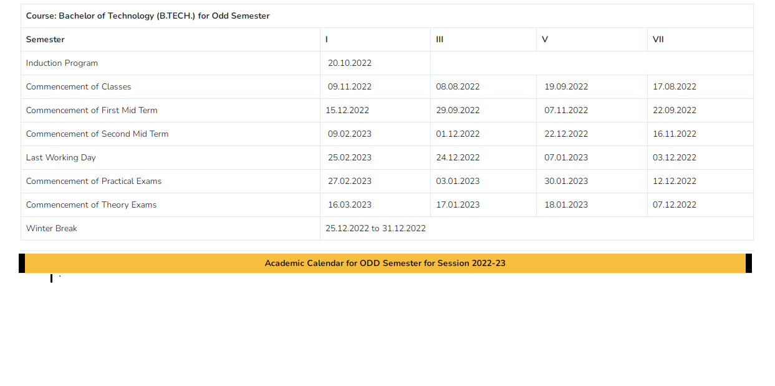



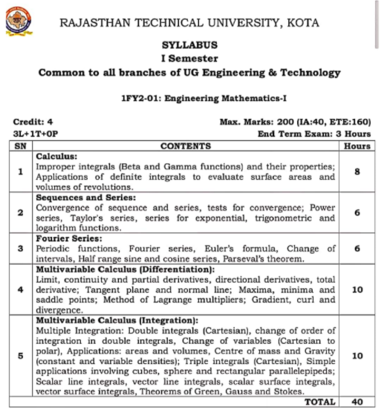

**Course Overview:**

Student should be able t learn and solve various calculus and integration related problems in differential sense of equations, they will be able to identify various methods to solve a common problem and various problems in general sense.

**Course Outcomes:**

|  |  |  |
| --- | --- | --- |
| **CO.NO.** | **Cognitive Level** | **Course Outcome** |
| 1 | Analysis | Students will be able to evaluate volume and surface area of the solid formed by revolution of different curves. Also calculate definite integral through Beta and Gamma functions. |
| 2 | Analysis | Students will be able to classify the concept of sequence, monotonic sequence, Cauchy’s sequence and infinite series . Also apply various method to test convergence and divergence of sequence and infinite series. |
| 3 | Analysis | Learner will be able to identify to express a function in term of a series of sine and cosine. |
| 4 | Analysis | Students will be able to evaluate maxima and minima of multivariable functions using the concept of partial differentiation. Also understand the concept of limit, continuity and differentiability of two variable function. |
| 5 | Analysis | Students will be able to evaluate double and triple integration and to apply the knowledge to determine area, volume, centre of mass and centre of gravity. Further understand vector differentiation and vector integration.. |

**Prerequisites:**

1. Fundamentals of mathematical reasoning.

2. Students should be efficient in identifying differential equation formats.

3. Students should be able to perform simple mathematical operations.

**Course Outcome Mapping with Program Outcome:**

|  |  |  |  |  |  |  |  |  |  |  |  |  |
| --- | --- | --- | --- | --- | --- | --- | --- | --- | --- | --- | --- | --- |
| **Course Outcome** | **Program Outcomes (PO’s)** | | | | | | | | | | | |
| **CO. NO.** | **Domain Specific (PSO)** | | | | | **Domain Independent (PO)** | | | | | | |
|  | **PO1** | **PO2** | **PO3** | **PO4** | **PO5** | **PO6** | **PO7** | **PO8** | **PO9** | **PO10** | **PO11** | **PO12** |
| CO1 | 2 | 2 | 0 | 1 | 0 | 0 | 0 | 0 | 0 | 0 | 0 | 1 |
| CO2 | 2 | 2 | 0 | 1 | 0 | 0 | 0 | 0 | 0 | 0 | 0 | 1 |
| CO3 | 2 | 2 | 0 | 1 | 0 | 0 | 0 | 0 | 0 | 0 | 0 | 1 |
| CO4 | 2 | 2 | 0 | 1 | 0 | 0 | 0 | 0 | 0 | 0 | 0 | 1 |
| CO5 | 2 | 2 | 0 | 1 | 0 | 0 | 0 | 0 | 0 | 0 | 0 | 1 |
| 1: Slight (Low) , 2: Moderate (Medium), 3: Substantial (High) | | | | | | | | | | | | |

**CO-PO Justification:**

|  |  |  |
| --- | --- | --- |
| **CO** | **PO** | **Justification** |
| CO1 | PO1 | To evalauate volume and surface area of the soild formed by revolution of different curve student must require the knowledge of mathematics, that’s why CO1 is moderately mapped with PO1. |
| PO2 | When a student calculate definite integral through beta and gamma function it requires an analysis of problem statement but it does not requires complex analysis so CO1 is mapped with PO2 with moderate level. |
| PO4 | Students are required to identify and solve problem based on either reactive management or proactive managemeant design that’s why CO1 is slightly mapped with PO4 . |
| PO12 | It is expected that this learning may useful in higher studies when one has to deal with the real life problem that’s why CO1is slightly mapped with PO12 . |

|  |  |  |
| --- | --- | --- |
| **CO** | **PO** | **Justification** |
| CO2 | PO1 | To understand convergence of sequence and series ,and test of convergence student must require the knowledge of mathematics, that’s why CO2 is moderately mapped with PO1. |
| PO2 | When a student calculate power series, taylor series trigonometric and logarithm function It requires an analysis of problem statement but it does not requires complex analysis so CO2 is mapped with PO2 with moderate level. |
| PO4 | Students are required to identify and solve problem based on either reactive management or proactive managemeant design that’s why CO2 is slightly mapped with PO4 . |
| PO12 | It is expected that this learning may useful in higher studies when one has to deal with the real life problem that’s why CO2 is slightly mapped with PO12 . |

|  |  |  |
| --- | --- | --- |
|  | **PO** | **Justification** |
| CO3 | PO1 | To identity to express a periodic functions ,fourier series and Eulers formula student must require the knowledge of mathematics, that’s why CO3 is moderately mapped with PO1. |
| PO2 | When a student calculate change of intervals, half range sine and cosine series it requires an analysis of problem statement but it does not requires complex analysis so CO3 is mapped with PO2 with moderate level. |
| PO4 | Students are required to identify and solve problem based on either reactive management or proactive managemeant design that’s why CO3 is slightly mapped with PO4 . |
| PO12 | It is expected that this learning may useful in higher studies when one has to deal with the real life problem that’s why CO3 is slightly mapped with PO12 . |

|  |  |  |
| --- | --- | --- |
| **CO** | **PO** | **Justification** |
| CO4 | PO1 | To evaluate maxima and minima of multivariable function using the concept of parial differentiation student must require the knowledge of mathematics, that’s why CO4 is moderately mapped with PO1. |
| PO2 | When a student understand the concept of limit and continuityof two variable function It requires an analysis of problem statement but it does not requires complex analysis so CO4 is mapped with PO2 with moderate level. |
| PO4 | Students are required to identify and solve problem based on either reactive management or proactive managemeant design that’s why CO4 is slightly mapped with PO4 . |
| PO12 | It is expected that this learning may useful in higher studies when one has to deal with the real life problem that’s why CO4 is slightly mapped with PO12. |

|  |  |  |
| --- | --- | --- |
| **CO** | **PO** | **Justification** |
| CO5 | PO1 | To evaluate double and triple integration and to apply the knowledge to determine area and volume student must require the knowledge of mathematics, that’s why CO5 is moderately mapped with PO1. |
| PO2 | When a student calculate center of mass and center of gravity and further understand vector differentiation vector differentiation It requires an analysis of problem statement but it does not requires complex analysis so CO5is mapped with PO2 with moderate level. |
| PO4 | Students are required to identify and solve problem based on either reactive management or proactive managemeant design that’s why CO5is slightly mapped with PO4 . |
| PO12 | It is expected that this learning may useful in higher studies when one has to deal with the real life problem that’s why CO5is slightly mapped with PO12 . |

**Course coverage module wise-**

|  |  |  |
| --- | --- | --- |
| **Lecture No.** | **Unit** | **Topic** |
| 1 | 1 | **Calculus:** Differentiation and integration revision:  Differentiation |
| 2 |  | Integration |
| 3 |  | Integration by Substitution |
| 4 |  | Integration of Rational Functions |
| 5 |  | Introduction of Improper Integrals Beta and Gamma Functions |
| 6 |  | Properties of Beta function |
| 7 |  | Relation between beta and gamma function and related questions |
| 8 |  | Surface area concept and |
| 9 |  | Related questions |
| 10 |  | Surface volume concept and |
| 11 |  | Related questions |
| 12 | 2 | **Sequence and series**: concept of sequence |
| 13 |  | Convergence of sequence |
| 14 |  | Test of convergence (Cauchy’s first and second theorem) |
| 15 |  | Concept of infinite series, limit and basic test (comparison test) |
| 16 |  | D’ Alembert ratio test, logarithmic ratio test, Rabbe’s test and Gauss test |
| 17 |  | Concept of power series , taylor series exponential series, trigonometric and logarithm function |
| 18 | 3 | **Fourier series:** concept of periodic function, Fourier series |
| 19 |  | Euler’s formula, Change of interval and related questions |
| 20 |  | Half range sine and cosine series and related questions |
| 21 |  | Parseval’s theorem. |
| 22 |  | Related questions |
|  |  |  |
| 23 | 4 | **Multivariable calculus(differentiation)-**,limit of afunction |
| 24 |  | Continuity of a function |
| 25 |  | Partial derivatives introduction |
| 26 |  | Partial derivatives questions |
| 27 |  | Euler’s Theorem and related questions |
| 28 |  | Approximate calculations introduction |
| 29 |  | Related questions |
| 30 |  | Total derivative |
| 31 |  | Maxima and Minima of one variable and two variable |
| 32 |  | Questions on Maxima and Minima of two variable |
| 33 |  | Word problems on Maxima and Minima of two variable |
| 34 |  | Maxima and Minima of more than two variables Lagrange’s Multipliers Method |
| 35 |  | Questions on Lagrange’s Multipliers Method |
| 36 | 4 | Concept of gradient curl and divergence |
| 37 |  | Related questions |
| 38 | 5 | **Multivariable calculus(integration**)- concept of double integral (Cartesian) |
| 39 |  | Change of order of integration |
| 40 |  | Change of variable( Cartesian to polar) |
| 41 |  | Area and volume  of Curve by double integration |
| 42 |  | Center of mass and gravity(constant and variable densities) |
| 43 |  | Triple integration(Cartesian) |
| 44 |  | Simple application involving cubes sphere and rectangular parallelpiped |
| 45 |  | Sclar line integral with related problem |
| 46 |  | Vector line integral with related problem |
| 47 |  | Scalar Surface Integral with related problems |
| 48 |  | vector Surface Integral with related problems |
| 49 |  | Green’s Theorem introduction |
| 50 |  | Related questions |
| 51 |  | Stokes Theorem introduction |
| 52 |  | Related questions |
| 53 |  | Gauss and stokes Theorem introduction |
| 54 |  | Related questions |

**TECHNO INDIA NJR INSTITUTE OF TECHNOLOGY UDAIPUR**

**BASIC SCIENCE**

**B.TEC 1-YEAR(1 –SEM)**

**SUBJECT-ENGINEERING MATHEMATICS**

**TUTORIAL SHEETS**

TUTORIAL CHAPTER –I

**Subject Code:** 1FY2-01 **Course** ENGINEERING MATHEMATICS-I **Year/Sem: 1st /1ST**

Q.1 Express $f\left(x\right)= \left|x\right| , -π<x<π$ as a fourier series and show that

$\frac{π^{2}}{8}=\frac{1}{1^{2}}+ \frac{1}{3^{2}}+ \frac{1}{5^{2}}+ ….$ CO113

Q.2 Find the half range sine series for $f\left(x\right)= x\left(π-x\right) , 0<x<π$ CO113

Q.3 Find the Fourier series to represent $x sin x$ for $-π≤x≤π$ CO113

TUTORIAL CHAPTER-II

**Subject Code:** 1FY2-01 **Course** ENGINEERING MATHEMATICS-I **Year/Sem: 1st /1ST**

Q.1 Evaluate $\int_{0}^{∞}{\frac{ x^{2}\left(1+x^{4}\right) }{{\left(1+x\right)}^{10}}dx}$ CO111

Q.2 Evaluate $\int_{0}^{∞}{\frac{dx}{1+x^{4}}}$. CO111

Q.3 Evaluate $\int_{0}^{π/6}{\cos^{4}3θ}\sin^{2}6θdθ$. CO111

TUTORIAL CHAPTER –III

**Subject Code:** 1FY2-01 **Course** ENGINEERING MATHEMATICS-I **Year/Sem: 1st /1ST**

Date: 20/01/2021

Q.1 Evaluate $\int_{0}^{∞}{\int_{x}^{∞}{\frac{e^{-y}}{y}dx dy }}$ CO115

Q.2 Evaluate $\int_{0}^{a}{\int_{0}^{\sqrt{a^{2}-x^{2}}}{y^{2}\sqrt{x^{2}+y^{2}}dxdy}}$ by changing to the polar coordinates. CO115

Q. 3 find the area between the parabolas $y^{2}=4ax and x^{2}=4ay$ CO115

TUTORIAL CHAPTER –IV

**Subject Code:** 1FY2-01 **Course** ENGINEERING MATHEMATICS-I **Year/Sem: 1st /1ST**

Q.1 Find the volume of the greatest rectangular parallelepiped inscribed in the ellipsoid whose equation is $\frac{x²}{a²}$ + $\frac{y²}{b²}$ + $\frac{z²}{c²}$ = 1. CO114

Q. 2 If $x^{x}y^{y}z^{z}$ = c, Show that at x = y = z, $\frac{∂²z}{∂x∂y}$ = -(x log(ex) )– 1  . CO114

Q.3 Find the maximum value of u, where $u = sin x sin y sin (x+y)$. CO114

TUTORIAL CHAPTER –V

**Subject Code:** 1FY2-01 **Course** ENGINEERING MATHEMATICS-I **Year/Sem: 1st /1ST**

Q.1 Find the constant ‘a’ so that $\vec{V}$ is a conservative field where . Calculate its potential and work done, in moving a particle from (1,2,-3) to (1,-4,2) in the field. CO115

Q.2 Verify Gauss’s Divergence theorem and show that :  CO115

Where $\vec{F}= \left(x^{3}- yz\right)i- {2x}^{2}yj+2k$, S is the surface of the cube bounded by the coordinate planes: x = y = z = 0; x = y = z = a. CO115

**ASSIGNMENT**

ASSIGNMENT–I

**Subject Code:** 1FY2-01 **Course** ENGINEERING MATHEMATICS-I **Year/Sem: 1st /1ST**

**Fourier series:**

Q.1 Find the Fourier series of the function $f\left(x\right)=x+ x^{2}$ in the internal $\left(–π , π\right)$ and show that $\frac{π^{2}}{6}=1+ \frac{1}{2^{2}}+ \frac{1}{3^{2}}+ ….$ CO113

Q.2 Find the Fourier series for the function defined as : CO113

$f\left(x\right)=\left\{\begin{aligned}-1, for-π≤x<0 \\ 0, for x=0 \\ 1, for 0<x≤π\end{aligned}\right.$ Hence prove that $\frac{π}{4}=1-\frac{1}{3}+ \frac{1}{5}-\frac{1}{7}+ …..$

Q.3 Express $f\left(x\right)= \left|x\right| , -π<x<π$ as a fourier series and show that CO113

$$\frac{π^{2}}{8}=\frac{1}{1^{2}}+ \frac{1}{3^{2}}+ \frac{1}{5^{2}}+ ….$$

Q.4 Find the half range sine series for $f\left(x\right)= x\left(π-x\right) , 0<x<π$ CO113

Q.5 Find the Fourier series to represent $x sin x$ for $-π≤x≤π$ CO113

Q.6 Find the Fourier series to represent $f\left(x\right)= x- x^{2} ,$ from $x=-1 to x=1$ CO113

Q.7 Find the half – range (i) cosine series (ii) sine series for

$f\left(x\right)= x , 0<x<2$ CO113

ASSIGNMENT CHAPTER –II

**Subject Code:** 1FY2-01 **Course** ENGINEERING MATHEMATICS-I **Year/Sem: 1st /1ST**

Q.1 Prove that $B\left(m,n\right)= \frac{Γm Γn}{Γm+n}$. CO111

Q.2 Evaluate $\int_{0}^{∞}{\frac{dx}{1+x^{4}}}$. CO111

Q.3 Evaluate $\int_{0}^{π/6}{\cos^{4}3θ}\sin^{2}6θdθ$. CO111

Q.4 Evaluate $\int_{0}^{∞}{\frac{ x^{2}\left(1+x^{4}\right) }{{\left(1+x\right)}^{10}}dx}$. CO111

ASSIGNMENT CHAPTER –III

**Subject Code:** 1FY2-01 **Course** ENGINEERING MATHEMATICS-I **Year/Sem: 1st /1ST**

Q.1 Evaluate $\int_{0}^{∞}{\int_{x}^{∞}{\frac{e^{-y}}{y}dx dy }}$ CO115

Q.2 Evaluate $\int_{0}^{a}{\int_{0}^{\sqrt{a^{2}-x^{2}}}{y^{2}\sqrt{x^{2}+y^{2}}dxdy}}$ by changing to the polar coordinates. CO115

Q. 3 find the area between the parabolas $y^{2}=4ax and x^{2}=4ay$ CO115

Q. 4 Change the order of integral $\int_{0}^{acosα}{\int_{x tanα}^{\sqrt{a^{2}+x^{2}}}{f\left(x,y\right)dxdy}}$ CO115

Q. 5 Evaluate by Change the order of integral $\int_{0}^{a}{\int_{\sqrt{ax}}^{a}{\frac{y^{2}}{\sqrt{y^{4}-a^{2}x^{2}}}dxdy.}}$ CO115

Q.6 Evaluate $\iint{xydxdy}$ where region of integration is positive quadrant of line x + y ≤ 1CO115

ASSIGNMENT CHAPTER –IV

**Subject Code:** 1FY2-01 **Course** ENGINEERING MATHEMATICS-I **Year/Sem: 1st /1ST**

Q.1 Find the volume of the greatest rectangular parallelepiped inscribed in the ellipsoid

whose equation is $\frac{x²}{a²}$ + $\frac{y²}{b²}$ + $\frac{z²}{c²}$ = 1. CO114

Q. 2 If $x^{x}y^{y}z^{z}$ = c, Show that at x = y = z, $\frac{∂²z}{∂x∂y}$ = -(x log(ex) )– 1  . CO114

Q.3 Find the maximum value of u, where $u = sin x sin y sin (x+y)$. CO114

Q.4 Verify Stoke's theorem for the function  integrated round the square in the plane z = 0, whose sides are along the lines  and. CO114

Q.5 (i) Prove that $∇^{2}\left(\frac{1}{r}\right)=0$ (ii) Find $curl\left[grad\left(x^{3}{+y}^{3}+z^{3}-3xyz\right)\right]$ CO114

ASSIGNMENT –V

**Subject Code:** 1FY2-01 **Course** ENGINEERING MATHEMATICS-I **Year/Sem: 1st /1ST**

Q.1 Find the constant ‘a’ so that $\vec{V}$ is a conservative field where . Calculate its potential and work done, in moving a particle from (1,2,-3) to (1,-4,2) in the field. CO115

Q.2 Verify Gauss’s Divergence theorem and show that :  CO115

Where $\vec{F}= \left(x^{3}- yz\right)i- {2x}^{2}yj+2k$, S is the surface of the cube bounded by the coordinate planes: x = y = z = 0; x = y = z = a. CO115

Q.3 Use Green's theorem to evaluate:  where C is the triangle enclosed by the lines  CO115

Q.4 *Expand $e^{x}\cos{y near the point\left(1,\frac{π}{4}\right)by Taylor^{'}stheorem.}$*  CO112

**Revised all course ASSIGNMENT 1**

**Answer all questions. Each question carries 5 marks**

1. Evaluate  -------- co-1
2. Prove that---------co-1
3. Define limit and continuity.
4. Show that double limit for $\frac{x^{2}}{x^{4}+y^{2}}$ does not exist at (0,0).
5. Find the equation of the tangent plane to $z=x\sqrt{x^{2}+y^{2}}$ + $y^{3}$ at (-4,3).
6. Evaluate **----------**co-1
7. Show that div grad . ------co-4
8. What is the necessary condition to exist maxima or minima of any function f(x,y) -----------------------------------------------------------------------------co-4
9. Explain the Leibnitz rule for convergence of Alternating series.-----------co-3
10. Find the region of integration of the double integral---------co-5
11. If  is a solenoidal vector, find a -----co-5
12. Find  for Fourier sine series of f(x) =2 where 0<x<1 .------co-3
13. Evaluate ------co-1
14. Evaluate by changing the order of integration ---------co-5

**Revised all course ASSIGNMENT 2**

**Answer all questions. Each question carries 5 marks**

1. By using Taylor’s Theorem Expand about x=2-----co-2
2. Evaluate:  , where C is the closed curve of the region bounded by y = x and y = x2 by using Green's theorem.-------co-5
3. Evaluate  by changing into polar co-ordianates-------co-5
4. If then prove that --------co-4
5. Evaluate:  and S is the surface of the plane
   1. in the first octant.---------co-5
6. Prove that -------co-4
7. Explain the power series in x and also find the values of x for which the series  +  + …… converges. ------co-3
8. In a triangle ABC, find the maxima and minima of u = sin A sin B sin C, where   
   A + B + C = $π$.---------co -4
9. Prove that**:** ------co-1
10. ----co-1
11. Expand  in Fourier series in $interval -π<x<π$.-------co-3
12. Verify Gauss Divergence Theorem for . Where S is the region bounded by and the plane ------co-5

**TECHNO INDIA NJR INSTITUTE OF TECHNOLOGY UDAIPUR**

**BASIC SCIENCE**

**B.TEC 1-YEAR (1 –SEM)**

**SUBJECT-ENGINEERING MATHEMATICS**

**Viva-voce**

**Unit 1 (C0-1)**

1-Define beta function.

2-Define gamma function

3 -write the legender duplication formula .

4- what is the relation between beta and gamma function.

5-write the gamma formula.

6-what is the sur face of revolution.

7-what is the volume of solid of revolution.

**Unit 1 (C0-2)**

1-what is the difference between sequence and series.

2-Define the real sequence.

3-Define the range of sequence.

4-Define the supremum and infimum of sequence.

5- write Cauchys first theorem on limit.

6-Define the taylor’s series, expotential series and trigonometric function.

**Unit 1 (C0-3)**

1-Define periodic function.

2-Define the fourier’s series.

3-write the Euier’s formula.

**Unit 1 (C0-4)**

1-Define the limit.

2- Define the continutity.

3- Define the tangent plane and normal line.

4-Define maxima ,minima and saddle points.

5-Define gradient, curl and divergence.

**Unit 1 (C0-5)**

1-Define Double integrals in Cartesian form

2-Define center of mass and gravity.

3-Define sphere and rectangular parallelepipeds.

4- Define scalar line integral.

5-Define green ,stokes and gauss theorems.

**TECHNO INDIA NJR INSTITUTE OF TECHNOLOGY UDAIPUR**

**BASIC SCIENCE**

**B.TEC 1-YEAR (1 –SEM)**

**SUBJECT-ENGINEERING MATHEMATICS**

**QUIZ QUESTION**

**Attempt all questions. Each question carries 1 mark. No negative marking.**

Q-1 What is the value of $Γ1/2$

1. 4
2. 6
3. ½

$√π$

**ANS - $√π$**

Q-2 $Γn Γ1-n$ is equal to ….

$\frac{Π}{sinsin nΠ }$

$π$

$\frac{2Π}{sinsin nΠ }$

2. None of these

**ANS - $\frac{Π}{sinsin nΠ }$**

Q-3 Write the formula of volume of soild of revolution and surface area of soild of revolution is…..

1. V= $\int_{a}^{b}{}πy^{2}$ dx and S = $\int_{a}^{b}{}2πyds$
2. V= $-\int_{a}^{b}{}πy^{2}$ dx and S = $-\int_{a}^{b}{}2πyds$
3. V= $-\int_{a}^{b}{}πy^{2}$
4. S = $-\int_{a}^{b}{}2πyds$

**ANS- V= $\int_{a}^{b}{}πy^{2}$ dx and S = $\int_{a}^{b}{}2πyds$**

Q-4 The sequence < ${(-1)}^{n}$ > is…

1. Convergent
2. Divergent
3. Oscillating infinitely
4. Infinite

**ANS – Oscillating infinitely**

Q-5 The sequence $\left\{\frac{3n^{2}+1}{3n^{2}-1}\right\}$ is….

1. Convergent
2. Divergent
3. Oscillating infinitely
4. Infinite

**ANS- Convergent**

Q-6 Find the period of the sinx

1. 2 $π$
2. 5 $π$
3. 3 $π$
4. None of these

**ANS - 2 $π$**

Q-7 Euler’s formulae are given by:

1. - $a_{0}$ = $\frac{1}{2π}\int_{-π}^{π}{}f\left(x\right)$ dx
2. $a_{n }$ == $\frac{1}{π}\int_{-π}^{π}{} cosnx f\left(x\right)$ dx
3. $b_{n }$ = $\frac{1}{π}\int_{-π}^{π}{} sinx f\left(x\right)$ dx

D) $a_{0}$ = $\frac{1}{2π}\int_{-π}^{π}{}f\left(x\right)$ dx $a_{n }$ == $\frac{1}{π}\int_{-π}^{π}{} cosnx f\left(x\right)$ dx

$b_{n }$ = $\frac{1}{π}\int_{-π}^{π}{} sinx f\left(x\right)$ dx

**ANS - $a_{0}$ = $\frac{1}{2π}\int_{-π}^{π}{}f\left(x\right)$ dx $a_{n }$ == $\frac{1}{π}\int_{-π}^{π}{} cosnx f\left(x\right)$ dx**

$b_{n }$**= $\frac{1}{π}\int_{-π}^{π}{} sinx f\left(x\right)$ dx**

Q -8 The Euler’s Theorem for homogeneous function is given by

A) x $\frac{∂z}{∂x}$ + $y\frac{∂z }{∂x}$ = nz

B) ) x $\frac{∂z}{∂x}$ + $y\frac{∂z }{∂x}$ = n

C) ) x $\frac{∂z}{∂x}$ + $y\frac{∂z }{∂x}$ =0

D) None of these

**ANS -x $\frac{∂z}{∂x}$ + $y\frac{∂z }{∂x}$ = nz**

Q-8 The necessary and sufficient condition for maxima and minima of function of two variable is….

1. r t - $s^{2}$ >0 and r < 0 then f (a ,b) is a maximum value
2. r t - $s^{2}$ >0 and r >0 then f (a ,b) is a minimum value
3. (1) r t - $s^{2}$ >0 and r < 0 then f (a ,b) is a maximum value

(2) r t - $s^{2}$ >0 and r >0 then f (a ,b) is a minimum value

1. All of above

**ANS – (1) r t - $s^{2}$ >0 and r < 0 then f (a ,b) is a maximum value**

**(2) r t - $s^{2}$ >0 and r >0 then f (a ,b) is a minimum value**

Q-9 Gauss’s Divergence Theorem is given by …..

1. $\int{}F. n$ ds = $\int{}(△.F)$ dv
2. $\int{}F. n$ ds = $\int{}(F)$ dv
3. $\int{}F. n$ ds = $\int{}(Curl.F)$ dv
4. Both A and B

**ANS – $\int{}F. n$ ds = $\int{}(△.F)$ dv**

Q10 – If f =x $y^{2}$ i+2 $x^{2}$ yz j – 3y $z^{2}$ k ,divf is at the pt(1,-1,1)

1. $y^{}$ + 2 $x^{2}$ z - 6yz
$y^{2} + 2x^{2} - 6yz$

2. $y^{2}$ + 2 $x^{2}$ z +6yz

$y^{2} + 2x^{2}z - 6yz$

**ANS - $y^{2}$ + 2 $x^{2}$ z - 6yz**

**Assessment Methodology:**

1. Online quiz after every topic completion.
2. Assignments one from each unit.
3. Midterm subjective paper where they have to write algorithms to perform different operations on different data structures as mentioned in the modules. (Twice during the semester)
4. Final paper at the end of the semester subjective.

**Teaching and Learning resources unit-wise:**

**Unit-1**

<https://www.classcentral.com/course/swayam-fourier-analysis-and-its-applications-22981>

[**https://nptel.ac.in/courses/111/101/111101153/**](https://nptel.ac.in/courses/111/101/111101153/)

**Unit-2**

<https://www.youtube.com/watch?v=m7ATbosllvs&list=PLhSp9OSVmeyI3uivqqHzrlomwD6gZx2-R>

**Unit-3**

<https://nptel.ac.in/courses/111/106/111106046/>

**Unit-4**

<https://www.youtube.com/watch?v=TrcCbdWwCBc&list=PLSQl0a2vh4HC5feHa6Rc5c0wbRTx56nF7>

**Unit-5**

<https://www.youtube.com/watch?v=PxCxlsl_YwY&list=PL4C4C8A7D06566F>

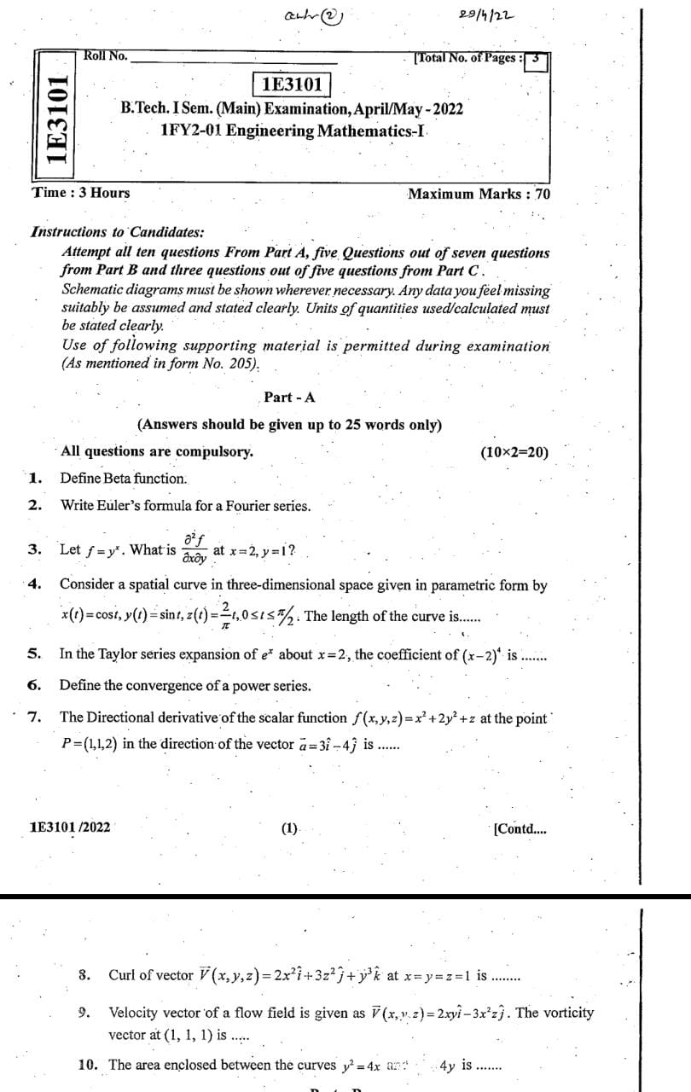

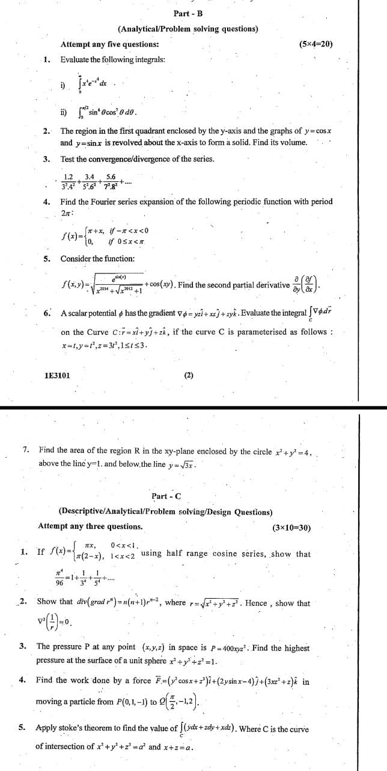

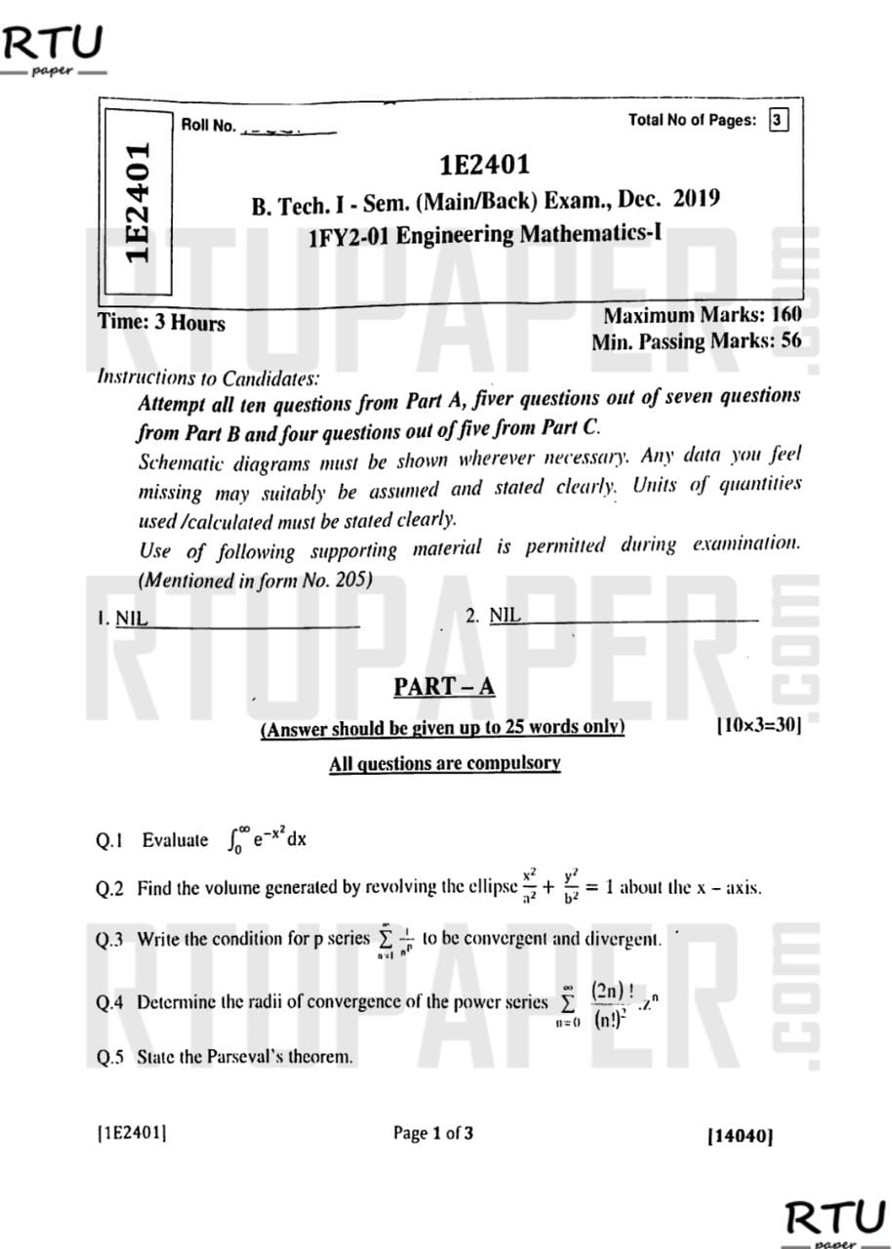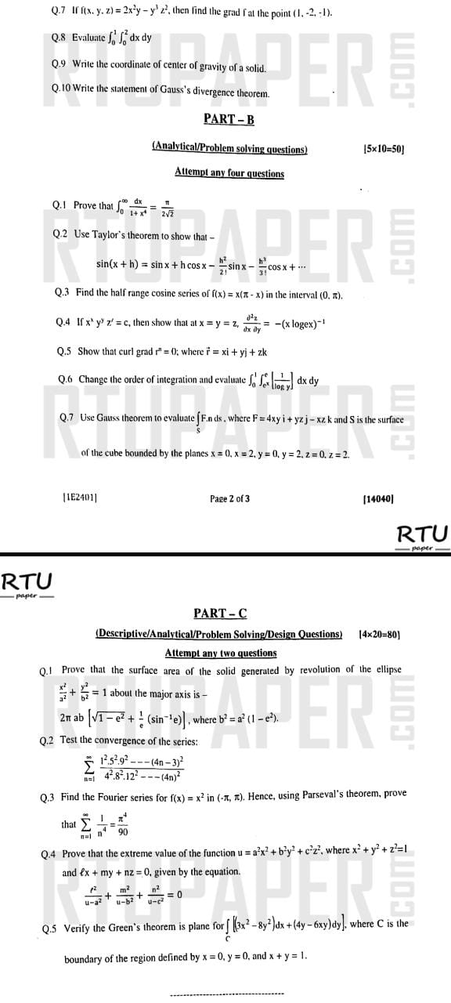

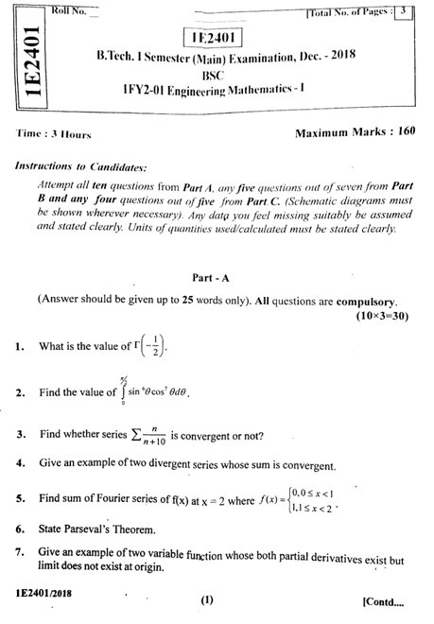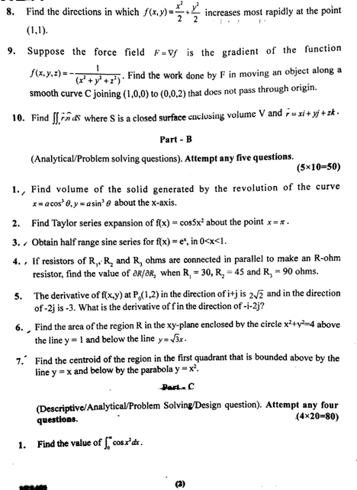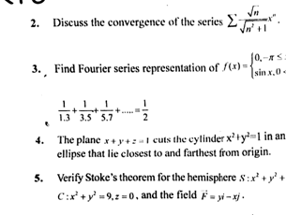

**TECHNOINDIANJRINSTITUTEOFTECHNOLOGY**

**B. TECH I – YEAR (I SEM.)**

**Engineering Mathematics I(1FY2-01)**

**Mid Term I**

**Max. Marks: 70 Time:2 Hrs**

**Note:**1) The paper is divided into 2 parts: Part-A and, Part-B  
2) Part-A contains 10 questions and carries 2 mark each.  
3) Part-B contains 5 questions. Each question is having two options and carries 10 marks each.

**PART – A**

|  |  |  |
| --- | --- | --- |
|  | Test the convergence of the following series $\sum{{(1+\frac{1}{n})}^{-n^{2}}}$ | [CO2] |
|  | Give the example of a series which is bounded, monotonically decreasing and divergent. | [CO2] |
|  | What do you mean by even and odd function. Check if f(x)=x $e^{x}$ is odd. | [CO3] |
|  | Find the value of a0  forin the interval | [CO3] |
|  | Write the statement of Parseval’s Formula of Fourier series. | [CO3] |
|  | Write Euler formula for Fourier series. | [CO3] |
|  | If then prove that | [CO4] |
|  | Evaluateif | [CO4] |
|  | Show that the vector r = xi+yj+zk is irrotational | [CO4] |
|  | Check it the critical point for the following function exists:  F(x,y)= $\frac{\sin^{-1}\left(y^{2}\right).(y^{2}+3y)sin⁡(y^{6}+7y)}{y^{9}+y^{10}}$ | [CO4] |

**PART – B**

|  |  |  |
| --- | --- | --- |
|  | Define the test of convergence of power series and also find the interval of convergence of logarithmic series | [CO2] |
| **OR** | | |
|  | Test for convergence of the series $\frac{2}{5}x+\frac{2.4}{5.8}x^{2}+\frac{2.4.6}{5.8.11}x^{3}+….with x>0$ | [CO2] |

|  |  |  |
| --- | --- | --- |
|  | Find the Fourier series for $f\left(x\right)=x\sin{x}, -π<x<π$ and deduce that $\frac{π}{4}=\frac{1}{2}+\frac{1}{1.3}-\frac{1}{3.5}+…$ | [CO3] |
| **OR** | | |
|  | If then prove that  If  then prove that | [CO4] |

|  |  |  |
| --- | --- | --- |
|  | Find Fourier series for $f\left(x\right)=x^{2}+x , -π≤x≤π$ | [CO3] |
| **OR** | | |
|  | Test the convergence of the series $\frac{1.2}{3^{2}4^{2}}+\frac{3.4}{5^{2}6^{2}}+\frac{5.6}{7^{2}8^{2}}+…$ | [CO2] |
|  |  |  |

|  |  |  |
| --- | --- | --- |
|  | Obtain the Fourier series for the function  in the interval $–1<x<1$ | [CO3] |
| **OR** | | |
|  | Show that $\left(π-x\right)=2\left[sinx+\frac{sin2x}{2}+\frac{sin3x}{3}+….\right], 0<x<2π$ Also find the sum of the series at x=0 and x= $2π$ | [CO3] |

|  |  |  |
| --- | --- | --- |
|  | a. if u= $\frac{\sin^{-1}\left(\frac{y}{x}\right)(\sqrt{x}+\sqrt{y})}{x^{3}+y^{3}}$ then show that $x\frac{∂u}{∂x}+y\frac{∂u}{∂y}=(-\frac{5}{2}u)$ b. Divide 120 into three part so the sum of their product taken 2 at a time is maximum. If x, y and z are three parts, find the value of x,y and z. | [CO4] |
| **OR** | | |
|  | a. Prove that $∇^{2}f\left(r\right)= \frac{d^{2}f}{dr^{2}}+\frac{2}{r}\frac{df}{dr}$ b. prove that $A=\left(x^{2}-yz\right)i+\left(y^{2}-xz\right)j+\left(z^{2}-xy\right)k$ is irrotational. Find the scalar potential function f. | [CO4] |

**TECHNO INDIA NJR INSTITUTE OF TECHNOLOGY, UDAIPUR**

**B. TECH 1st – YEAR (I SEM.) – MT-II**

Subject Name: Engineering Mathematics (**1FY2-01**)

**Time:** 3 Hrs **Max. Marks:** 70

**Note:**

1. The paper is divided into 3 parts: Part-A, Part-B and Part-C.
2. Attempt all ten questions from Part-A, Five questions out of seven questions from Part-B and three questions out of five questions from Part-C.

**Part- A**

**All questions are compulsory:** (10x2=20)

|  |  |  |
| --- | --- | --- |
|  | $$Evaluate \int_{0}^{∞}{e^{-x^{2}}x^{3} dx}$$ | CO1 |
|  | $Write the formula for surface and volume for solid of revoluation about y-axis$ | CO1 |
|  | Write the condition of converges and divergence of Logarithmic test | CO2 |
|  | Test whether the series 1- $\frac{1}{3!}+\frac{1}{5!}-\frac{1}{7!}+….$ | CO2 |
|  | $$find a_{0} in fourier series for f\left(x\right)=x^{2} , 0≤x≤2π$$ | CO3 |
|  | Write the formula of Fourier series for finite intervals | CO3 |
|  | Find $f\left(x,y\right)=\lim_{\begin{aligned}x→0 \\ y→0\end{aligned}}{{ (x}^{3}}{-y^{3})/(x-y)}$ | CO4 |
|  | Find $∇(x^{2}y+z^{3}x+y^{2}z^{2})$ | CO4 |
|  | Write the statement of Stoke’s theorem. | CO5 |
|  | A fluid’s velocity field is F = xi+zj+yk. Find the flow along the helix $r\left(t\right)=costi+sintj+tk,$ 0 $≤t≤\frac{π}{2}$ | CO5 |

**Part- B**

**Attempt** **any five questions:** (5x4=20)

|  |  |
| --- | --- |
| Q.1 a) $Prove that \int_{0}^{1}{\sqrt{1-x^{4}} dx=\frac{{\left(\left\lceil \frac{1}{4}\right.\right)}^{2}}{6\sqrt{2π}}}$ b) Find the value of $\left\lceil -\frac{5}{2}\right.$ | CO1 |

|  |  |
| --- | --- |
| Q.2 Test whether the series $\sum{{(-1)}^{n+1}(\sqrt{n+1 }}-\sqrt{n}$) is absolutely convergent or conditionally convergent. | CO2 |

|  |  |
| --- | --- |
| Q. 3 Find the half range sine series for the function f(x) = $\frac{l}{2}-x,$ for $0≤x≤l$ | CO3 |

|  |  |
| --- | --- |
| Q. 4 Find the volume and surface generated by revolving the cardioid $r=a(1+cosθ)$ about the initial line. | CO1 |

|  |  |
| --- | --- |
| Q.5 Evaluate $\iiint{\left(x^{2}+y^{2}+z^{2}\right)}$ dx dy dz over the first octant of the sphere $x^{2}+y^{2}+z^{2}= a^{2}$ | CO5 |

|  |  |
| --- | --- |
| Q.6 $Evaluate \int_{0}^{1}{\int_{0}^{\sqrt{2x-x^{2}}}{\sqrt{x^{2}+y^{2}}dx dy }}dy by change of order of integration.$ | CO5 |

|  |  |
| --- | --- |
| Q.7 Prove that $∇^{2}\left(\frac{1}{r}\right)=0$ | CO4 |

**Part-C**

**Attempt any three questions:** (3x10=30)

|  |  |
| --- | --- |
| Q.8 Find the volume of the solid formed by revolving the plane area enclosed by the loop the curve $y^{2}=x^{2}\left(1-x^{2}\right)about x-axis$ | CO1 |

|  |  |
| --- | --- |
| Q.9 Test for convergence of the series $\frac{1^{2}}{2^{2}}+\frac{1^{2}}{2^{2}}.\frac{3^{2}}{4^{2}}+\frac{1^{2}}{2^{2}}.\frac{3^{2}}{4^{2}}.\frac{5^{2}}{6^{2}}+…$ | CO2 |

|  |  |
| --- | --- |
| Q.10. Find the Fourier series to represent the following function f(x) = x sinx, $-π≤x≤π$, hence deduce that $\frac{π}{4}=\frac{1}{2}+\frac{1}{1.3}-\frac{1}{3.5}+….$ | CO3 |

|  |  |
| --- | --- |
| Q.11 Prove that $\frac{∂^{2}u}{∂x^{2}}+\frac{∂^{2}u}{∂y^{2}}=\frac{∂^{2}u}{∂ξ^{2}}+\frac{∂^{2}u}{∂η^{2}}$,  where $x=ξ\cos{α}-η\sin{α , y=ξ\sin{α+η\cos{α}}}$. | CO4 |

|  |  |
| --- | --- |
| Q.12 Verify Green’s theorem in a plane for  , where C is the region bounded by y2 = x and y=x2 | CO5 |