Course File
Subject Title/Subject Code : Basic Mechanical Engineering/2FY307
Semester II Year 1ST

Name of the Faculty: Mrs. Nisha Patel
E-mail id: nisha.patel@technonjr.org
Class Schedule
Total Number of Lectures:
i)Course Objective – Student will be able to gain fundamental knowledge of Thermodynamics, I.C. Engines, material selection for different devices/ components and steam formation and properties of steam.
______________________________________________________________
INDEX - COURSE FILE
S. No. | CONTENT / ITEM NO. | PAGE NO.
S. No. | CONTENT / ITEM NO. | PAGE NO. | Status
1 | Vision And Mission Of The Institute
2 | Vision And Mission Of The Department
3 | Program Educational Objective Of Department (PEO’s)
4 | Program Outcomes Of Department (PO’s)
5 | Course Outcome (COs)
6 | COs mapping with Pos and PSOs
7 | Academic Calendar
8 | Evaluation Scheme
9 | Course Syllabus
10 | Prescribed Books
11 | Copy Of Time Table
12 | Course Schedule Plan
13 | Assignment Sheet (Unit Wise)
14 | Quiz Questions (One From Each Unit)
15 | Question Papers Of Mid Term Exam-I
16 | Marks and Gap Analysis in Mid Term I
17 | Remedial Action Taken To Remove the Gaps after mid Term I
18 | Question Papers Of Mid Term Exam-II
19 | Gap Analysis in Mid Term II
20 | Remedial Action Taken To Remove the Gaps after mid Term II
21 | Model Question Paper With Key Solution
22 | University Question Paper (Last one year)
23 | Student Performance Report
24 | Result Analysis
VISSION & MISSION OF INSTITUTE

Vision

Mission

VISION & MISSION OF DEPARTMENT
Department Vision
Department Mission

PROGRAMME EDUCATIONAL OBJECTIVES (PEOs)

PROGRAM SPECIFIC OUTCOMES (PSO's)
PROGRAMME OUTCOMES (POs)

A student will develop:
PO01. ENGINEERING KNOWLEDGE: An ability to apply knowledge of Mathematics, Science and Engineering Fundamentals in Electronics and Communication Engineering.
PO02. PROBLEM ANALYSIS: ability to analyze and interpret data by designing and conducting experiments. Develop the knowledge of developing algorithms, designing, implementation and testing applications in electronics and communication related areas.
PO03. DESIGN/ DEVELOPMENT OF SOLUTION: An ability to Design a system Component or process to meet desired needs within realistic constraints such as economic, environmental, social, political, ethical, health and safety, manufacturability, and sustainability.
PO04. CONDUCTION OF INVESTIGATION OF COMPLEX PROBLEMS: Ability to Identify, formulate and solve engineering problems.
PO05. MODERN TOOL USAGE: An ability to use the techniques, skills and modern engineering tools necessary for engineering practice.
PO06. THE ENGINEERING AND SOCIETY: Broad education necessary to understand the impact of engineering solutions in a global, economic, environmental and societal context.
PO07. ENVIRONMENT & SUSTAINABILITY: Understand the impact of professional engineering solution in societal and environmental contexts, and demonstrate the knowledge of, and need of sustainable development.
PO08. ETHICS: An ability to understand the professional, social and ethical responsibility.
PO09. INDIVIDUAL AND TEAM WORK: Function effectively as an individual, and as a member or leader in diverse teams, and in multidisciplinary settings.
PO10. COMMUNICATION: An ability to Communicate effectively in order to succeed in their profession such as, being able to write effective reports and design documentation, make effective presentations.
PO11. PROJECT MANAGEMENT & FINANCE: Demonstrate knowledge and understanding of the engineering and management principles and apply these to one’s own work, as a member and leader in team, to manage projects and in multidisciplinary environment.
PO12. LIFE-LONG LEARNING: Recognize the need and an ability to engage in life-long learning.

COURSE OUTCOMES (COs) OF THE SUBJECT

CO No. | Mapping | Statement
1. | Analyze | Students will be able to understand introduction of mechanical engineering and develop knowledge about steam boilers, steam turbines and power plants.
2. | Understand | Students will be able to conclude basics of centrifugal, reciprocation pumps and Internal Combustion Engine. Students will be able to create knowledge of various types of refrigeration and air conditioning system with their applications.
3. | Analyze | Students will be able to analyze basics of different types power transmission systems such as belt, rope, gears and gear trains.
4. | Analyze | Students will be able to illustrate working of different manufacturing processes
5. | Understand | Students will be able to identify different engineering materials their, properties and various types of heat treatment processes

COS MAPPING WITH POs AND PSOs

Course Outcome | PO1 | PO2 | PO3 | PO4 | PO5 | PO6 | PO7 | PO8 | PO9 | PO10 | PO11 | PO12 | PSO1 | PSO2 | PSO3
CO1 | 3 | 2 | 1 | 1 | 0 | 0 | 0 | 2 | 1 | 0 | 1 | 2 | - | - | -
CO2 | 3 | 3 | 2 | 1 | 0 | 0 | 0 | 2 | 1 | 0 | 2 | 2 | - | - | -
CO3 | 2 | 2 | 2 | 1 | 0 | 0 | 0 | 2 | 1 | 0 | 2 | 2 | - | - | -
CO4 | 2 | 2 | 1 | 1 | 0 | 0 | 0 | 2 | 1 | 0 | 1 | 2 | - | - | -
CO5 | 2 | 1 | 1 | 1 | 0 | 0 | 0 | 2 | 1 | 0 | 1 | 2 | - | - | -

UNIVERSITY ACADEMIC CALENDAR

Academic Calendar for Even Semester for Session

Evaluation Scheme

FACULTY DETAILS:

Name of the Faculty : Mrs. Nisha Patel

Designation : Assistant Professor

Department : Mechanical Engineering

1. TARGET
a) Percentage Pass : 100%
b) Percentage I class: 60 %

2. METHOD OF EVALUATION

2.1. Continuous Assessment Examinations (Mid-Term 1, Mid-Term 2)

2.2. Assignments / Seminars

2.3. Mini Projects

2.4. Quiz

2.5. Semester Examination Others___________________________________________________

3. List out any new topic(s) or any innovation you would like to introduce in teaching the subject in this Semester.
1. Take the help of creative tools to stimulate creativity. Include slide presentations, demonstration or forms of visual exercises that will excite the young minds and capture their interest.

Signature of Faculty: Signature of HOD

UNIVERSITY SYLLABUS

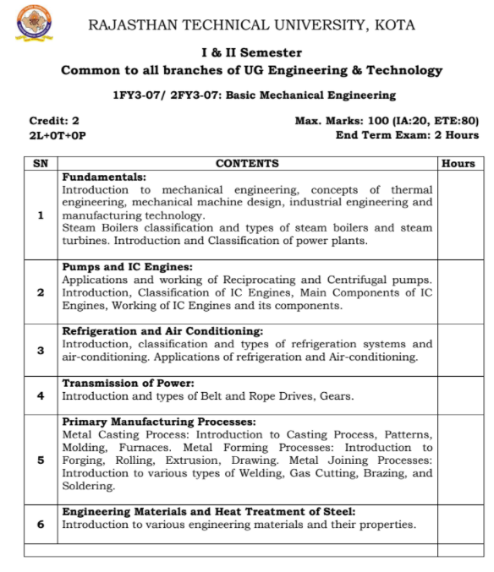

PRESCRIBED BOOKS

- Tata McGraw Hill Basic Mechanical Engineering.

Teaching and Learning resources:
- MOOC (NPTEL): -
https://drive.google.com/drive/u/1/folders/1gimy5aZo207_Oja05Hw6JE2qNjyotPOz.

- YouTube Videos Link –
https://www.youtube.com/c/TECHNICALCLASSES_TC

WEEKLY TIME TABLE OF THE TEACHER

First Time Table: with effect from (Date):

Day | 1 | 2 | 3 | 4 | 5 | 6 | 7
Monday
Tuesday
Wednesday
Thursday
Friday
Saturday

Revision: 1 with effect from (Date):

Day | 1 | 2 | 3 | 4 | 5 | 6 | 7
Monday
Tuesday
Wednesday
Thursday
Friday
Saturday

COURSE-PLAN
UNIT | Lect.  No. | TOPICS | Teaching Methods/ Teaching Aids
I | 1 | Introduction to mechanical engineering, concept of thermal engineering | White Board, PPT,
 | 2 | Mechanical machine design, industrial engineering | White Board, PPT, Demonstration
 | 3 | Steam boiler classification | White Board
 | 4 | Types of boilers | White Board
 | 5 | Steam turbines | White Board, PPT
 | 6 | Introduction and classification of power plant | White Board
 | 7 | Classification of power plant | White Board, PPT
 | 8 | Related questions | White Board
II | 9 | Pump and IC engines: Introduction of Pump, application and working centrifugal pump | White Board, PPT,
 | 10 | Application and working of Reciprocating pump | White Board, PPT, Demonstration
 | 11 | Introduction of IC engines | White Board
 | 12. | Classification of IC engines | White Board
 | 13 | Main components of IC engines | White Board, PPT
 | 14 | Functions of IC engines components | White Board
 | 15 | Working of IC engines | White Board, PPT
 | 16 | Related questions | White Board
III | 17 | Refrigeration and Air conditioning: Introduction | White Board, PPT,
 | 18 | Classification and types of refrigeration system | White Board, Demonstration
 | 19 | Types of Air-conditioning | White Board
 | 20 | Application of refrigeration and air conditioning | White Board
 | 21 | Numerical on refrigeration system | White Board, PPT
IV | 22 | Power Transmission: Transmission of power | White Board
 | 23 | Introduction and types of belt and rope drives | White Board, PPT
 | 24 | Introduction and types of gear | White Board
 | 25 | Numerical on belt and rope drives | White Board, PPT,
V | 26 | Primary manufacturing process: Introduction of Casting process, patterns | White Board, PPT, Demonstration
 | 27 | Moulding and furnaces | White Board
 | 28 | Metal forming process: introduction to forging and rolling | White Board
 | 29 | Basic concept about extrusion, drawing | White Board, PPT
 | 30 | Metal joining process: introduction to various type of welding | White Board
 | 31 | Gas cutting, Brazing and soldering | White Board, PPT
VI | 32 | Introduction of engineering materials | White Board
 | 33 | Heat treatment of steal | White Board, PPT,

Signature of Faculty: Signature of HOD

Mid Term Paper-I

TECHNO INDIA NJR INSTITUTE OF TECHNOLOGY, UDAIPUR
B. TECH 1nd – YEAR (I SEM.) – MT-II
BASIC MECHANICAL ENGINEERING( 1FY3-07)
Time: 2 Hr Max. Marks: 70
Note:
- The paper is divided into 2 parts: Part-A and, Part-B.
- Part-A contains 10 questions and carries 2 mark each.
- Part-B contains 5 questions. Each question is having two options and carries 10 marks each.
Part- A (20 Marks)
- Describe law of thermodynamics? (CO1)
- What is the principle of steam turbine ? (CO1)
- Principle of reciprocating pumps ? (CO2)
- Define compression ratio. Also give its formula? (CO2)
- Describe the Unit of refrigeration? (CO3)
- Define COP of refrigerator? (CO3)
- Why the transmission of power is required? (CO4)
- Write down the various engineering materials? (CO6)
- Write a short note on (CO5)
(i) Extrusion
(ii) Rolling
- Describe nitriding and cyaniding? (CO5)
Part- B (50 Marks)
1 Write down the difference between water tube boiler and fire tube boiler. (CO1)
OR
- Give comparison between impulse and reaction turbine. (CO1)

- Differentiate between two stroke and four stroke engine (CO2)
OR
- Differentiate between centrifugal and reciprocating pumps (CO2)

- Ice is formed at 0°C from water at 20°C, the temperature of refrigerant is 10°C. (CO3) Find the Ice formed per KWH, assume latent heat of ice is 334 kJ/kg. Assume working in perfect Carnot cycle.
OR
- What is air conditioning? Draw and describe different components used in it. (CO3)

- What is gear transmission? Describe different types of gear. (CO4)

OR
- Derive expression for the length of belt of open belt drive (CO4)

- What is metal casting? Describe different method of metal casting (CO5)
OR
- Give the working of welding process. (CO5)

Mid Term Paper-II

TECHNO INDIA NJR INSTITUTE OF TECHNOLOGY, UDAIPUR
B. TECH 1nd – YEAR (I SEM.) – MT-II
BASIC MECHANICAL ENGINEERING( 1FY3-07)
Time: 2 Hr Max. Marks: 70
Note:
- The paper is divided into 3 parts: Part-A , Part-B and Part-C.
- Part-A contains 5 questions and carries 2 mark each.
- Part-B contains 5 questions and carries 10 marks each.
- Part-C contains 3 questions and carries 15 marks each.
Part- A (10 Marks)
All questions are compulsory
- Describe law of thermodynamics? (CO1)
- Principle of reciprocating pumps ? (CO2)
- Define COP of refrigerator? (CO3)
- Why the transmission of power is required? (CO4)
- Write a short note on- (CO5)
(i) Extrusion
(ii) Rolling
Part- B (30 Marks)
Attempt any three questions
- Explain Locomotive boiler with neat sketch. (CO1)
- What is air conditioning? Draw and describe different components used in it. (CO3)
- What is gear transmission? Describe different types of gear. (CO4)
- What is metal casting? Describe different method of metal casting (CO5)
- Explain welding, soldering, brazing and drilling processes. (CO5)
Part-C (30 Marks)
Attempt any two question
1. (a) Write down the difference between water tube boiler and fire tube boiler. (CO1)
(b) Give comparison between impulse and reaction turbine. (CO1)
(c) Differentiate between two stroke and four stroke engine. (CO2)
2. (a) Ice is formed at 0°C from water at 20°C, the temperature of refrigerant is 10°C. (CO3)
Find the Ice formed per KWH, assume latent heat of ice is 334 kJ/kg. Assume working in perfect Carnot cycle.
(b) Derive expression for the length of belt of open belt drive (CO4)
3. (a) Explain working of an I.C Engine with their components. (CO2)
(b) Differentiate between centrifugal and reciprocating pumps. (CO2)
(c) Give introduction to various engineering material and their properties . (CO6)

Previous year paper:
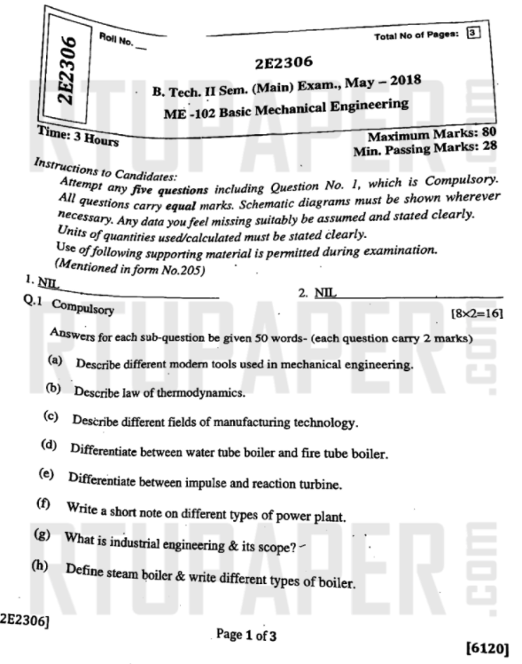
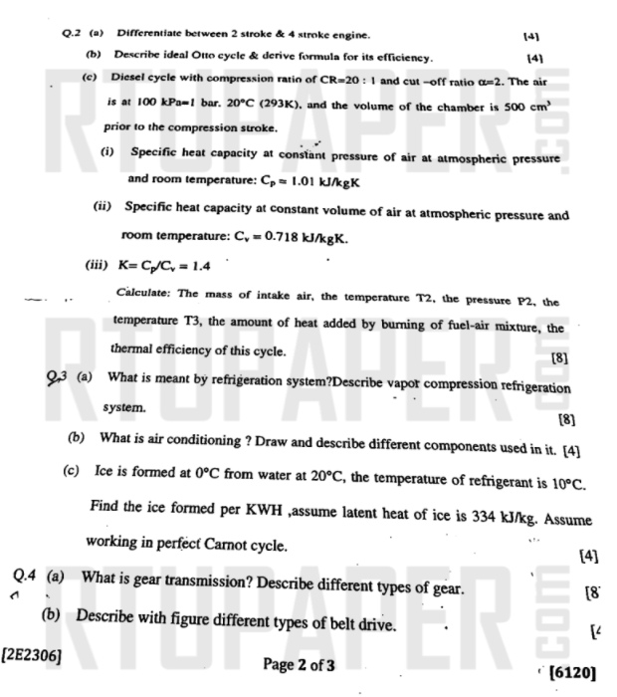
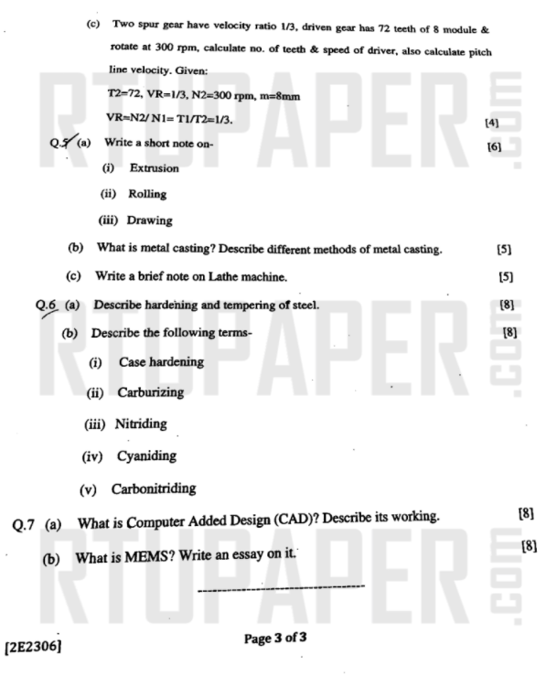

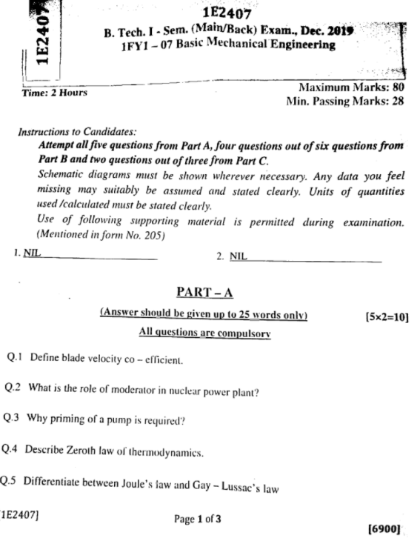
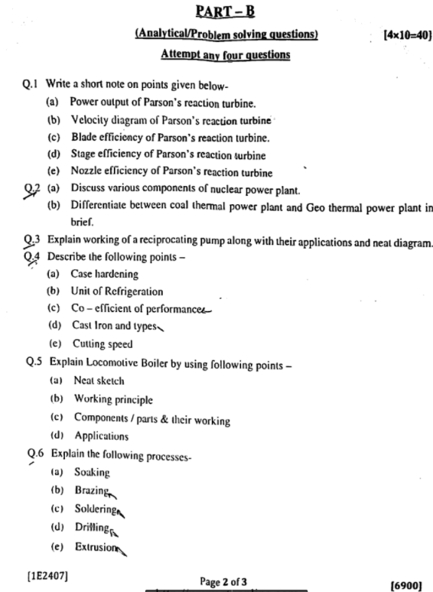
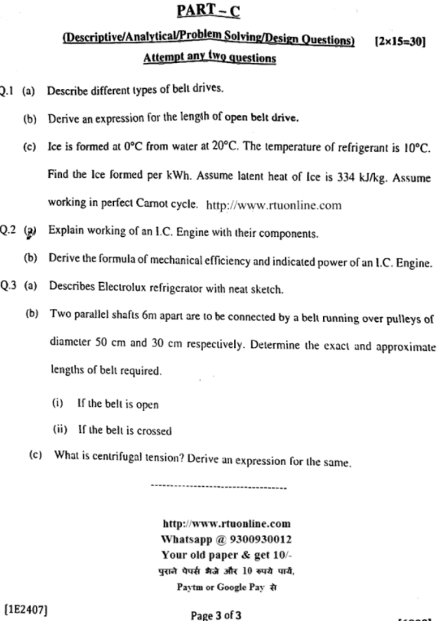

Marks and Gap Analysis of Mid-Term 1
S.No. | University Roll No. | Name of Student | Mid-Term 1  MM-32 | Remark  ( Remedial Class need or not – Y/N )
 | 21ETCCS001 | AARSH BHARTI | 61 | N
 | 21ETCCS002 | MS AASTHA DAKHERA | 68 | N
 | 21ETCCS003 | ABHISHEK PRAJAPAT | 60 | N
 | 21ETCCS004 | ABHISHEK SONI | 0 | Y
 | 21ETCCS005 | AKSHANSH SONI | 68 | N
 | 21ETCCS006 | AKSHAT SINGH CHOUHAN | 61 | N
 | 21ETCCS007 | ANIRUDH SINGH RAJPUROHIT | 60 | N
 | 21ETCCS008 | ANISH SINGHAL | 56 | N
 | 21ETCCS009 | ANJALI SONI | 65 | N
 | 21ETCCS010 | ANURAG MENARIA | 56 | N
 | 21ETCCS011 | ANUSHKA VIJAY | 63 | N
 | 21ETCCS012 | APURVA LODHA | 61 | N
 | 21ETCCS013 | ARUN LOHAR | 56 | N
 | 21ETCCS014 | ARVIND SINGH | 56 | N
 | 21ETCCS015 | ARVIND SUTHAR | 56 | N
 | 21ETCCS016 | AVANI JOSHI | 66 | N
 | 21ETCCS017 | AYAN KHAN | 63 | N
 | 21ETCCS018 | AYUSH JHOTA | 61 | N
 | 21ETCCS019 | AYUSH TALESARA | 65 | N
 | 21ETCCS020 | BHAVYA MEHTA | 68 | N
 | 21ETCCS021 | BHERU SINGH PANWAR | 63 | N
 | 21ETCCS022 | MS BHUMIKA VARDAR | 60 | N
 | 21ETCCS025 | CHINMAY MENARIA | 61 | N
 | 21ETCCS026 | DAKSH VYAS | 68 | N
 | 21ETCCS027 | DEEPAK DHAKAR | 54 | N
 | 21ETCCS029 | DHIREN SUHALKA | 56 | N
 | 21ETCCS030 | DHRUV BAGORA | 68 | N
 | 21ETCCS031 | DIKSHA AGARWAL | 68 | N
 | 21ETCCS032 | DINESH AUDICHYA | 60 | N
 | 21ETCCS033 | MS DIVYANSHI GAHLOT | 63 | N
 | 21ETCCS034 | DIVYANSHU MENARIA | 58 | N
 | 21ETCCS035 | DIVYANSHU SAHU | 61 | N
 | 21ETCCS036 | DURGA SANKAR DANGI | 61 | N
 | 21ETCCS037 | GAGAN MANGAL | 61 | N
 | 21ETCCS038 | GARVITA BAYA | 63 | N
 | 21ETCCS039 | GARVITA JAIN | 58 | N
 | 21ETCCS040 | GAZI AMAN KHAN | 59 | N
 | 21ETCCS041 | HARSH | 58 | N
 | 21ETCCS042 | HARSH SONI | 56 | N
 | 21ETCCS043 | HARSHAL PALIWAL | 59 | N
 | 21ETCCS044 | HARSHIT PUROHIT | 61 | N
 | 21ETCCS045 | HARSHIT SHARMA | 63 | N
 | 21ETCCS046 | HARSHITA RATHORE | 66 | N
 | 21ETCCS047 | HEET DOSI | 53 | N
 | 21ETCCS048 | MS HETAL SHARMA | 58 | N
 | 21ETCCS049 | JAHNAVI JOSHI | 68 | N
 | 21ETCCS050 | JAINIL JAIN | 65 | N
 | 21ETCCS051 | JASWANT SINGH RAO | 60 | N
 | 21ETCCS052 | JATIN VASHISHTHA | 63 | N
 | 21ETCCS053 | JAY JOSHI | 68 | N
 | 21ETCCS054 | JAYDEEP DANGI | 68 | N
 | 21ETCCS055 | JIGYASA CHATURVEDI | 65 | N
 | 21ETCCS056 | KAILASH JOSHI | 68 | N
 | 21ETCCS057 | KAMLESH KUMAR GHANCHI | 63 | N
 | 21ETCCS058 | KANISHKA PARMAR | 65 | N
 | 21ETCCS059 | KASHVI PANDEY | 68 | N
 | 21ETCCS060 | KHUSHAL PALIWAL | 68 | N
 | 21ETCCS061 | KHUSHI GAHLOT | 63 | N
 | 21ETCCS062 | KHUSHI VANAWAT | 65 | N
 | 21ETCCS063 | KRITESH SAHU | 0 | Y
 | 21ETCCS064 | KUNAL CHOUBISA | 63 | N
 | 21ETCCS065 | KUNAL MENARIA | 61 | N
 | 21ETCCS066 | KUNAL PALIWAL | 59 | N
 | 21ETCCS067 | KUNAL SHARMA | 63 | N
 | 21ETCCS068 | KUNIKA KADECHA | 0 | Y
 | 21ETCCS069 | LALITA DANGI | 63 | N
 | 21ETCCS070 | LAVISHA JAIN | 63 | N
 | 21ETCCS071 | LOKANTIK JAIN | 61 | N
 | 21ETCCS072 | LOKESH KHATIK | 58 | N
 | 21ETCCS073 | MAHAK BANSAL | 70 | N
 | 21ETCCS074 | MANSI GEHLOT | 63 | N
 | 21ETCCS075 | MAYANK KANERIYA | 63 | N
 | 21ETCCS076 | MAYANK MALIWAL | 63 | N
 | 21ETCCS078 | MITANSH JAIN | 58 | N
 | 21ETCCS079 | MOHAMMED OWAIS KHAN | 63 | N
 | 21ETCCS080 | MUNIRAJ SHARMA | 61 | N
 | 21ETCCS081 | NAVNEET ANAND | 63 | N
 | 21ETCCS082 | NEHAL DHING | 63 | N
 | 21ETCCS083 | NIHAL GAMOT | 0 | Y
 | 21ETCCS084 | NIPUN MALI | 60 | N
 | 21ETCCS085 | NISHA LOHAR | 66 | N
 | 21ETCCS086 | PRADHUMAN SINGH CHAUDHARY | 65 | N
 | 21ETCCS087 | PRANJAL SINGHVI | 65 | N
 | 21ETCCS088 | RAJAT PATIDAR | 56 | N
 | 21ETCCS089 | RIYA JAIN | 70 | N
 | 21ETCCS090 | ROHIN GANG | 56 | N
 | 21ETCCS091 | RUPAL SONI | 68 | N
 | 21ETCCS092 | SAHIL SOLANKI | 63 | N
 | 21ETCCS093 | SARGAM JAIN | 68 | N
 | 21ETCCS094 | SATYEN KHARADI | 63 | N
 | 21ETCCS095 | SHASHANK MENARIA | 65 | N
 | 21ETCCS096 | SHUBHAM DAS | 60 | N
 | 21ETCCS097 | SUDEEP ROY | 54 | N
 | 21ETCCS098 | SUMIT VASITA | 54 | N
 | 21ETCCS099 | SUYASH SONI | 68 | N
 | 21ETCCS100 | MS TANISHA KUMAWAT | 65 | N
 | 21ETCCS101 | TUSHAR YADAV | 56 | N
 | 21ETCCS102 | VAIBHAV GARG | 56 | N
 | 21ETCCS103 | VAIBHAV SONI | 65 | N
 | 21ETCCS104 | VARUN SHARMA | 65 | N
 | 21ETCCS105 | VEDANSHI PAREEK | 63 | N
 | 21ETCCS106 | VEDAS DIXIT | 63 | N
 | 21ETCCS107 | VIKRAM SINGH SISODIYA | 61 | N
 | 21ETCCS108 | VIMANYU P SHARMA | 65 | N
 | 21ETCCS109 | VISHAL KUMAWAT | 63 | N
 | 21ETCCS110 | VISHAL PUSHKARNA | 58 | N
 | 21ETCCS111 | VYOM BHATT | 63 | N
 | 21ETCCS112 | YASH JAIN | 58 | N
 | 21ETCCS113 | YASH JOSHI | 56 | N
 | 21ETCCS114 | YASH PURI GOSWAMI | 54 | N
 | 21ETCCS115 | YOGESH JAIPAL | 59 | N
 | 21ETCCS116 | MS YUVIKA CHOUDHARY | 63 | N
 | 21ETCCS117 | YUVRAJ SINGH KANAWAT | 56 | N
 | 21ETCCE001 | DEV VAISHNAV | 58 | N
 | 21ETCCE002 | HITESH SUTRADHAR | 56 | N
 | 21ETCCE004 | NAVED KHAN | 51 | N
 | 21ETCCE006 | PUSHPENDRA GEHLOT | 58 | N
 | 21ETCCE007 | SHALIN DAK | 56 | N
 | 21ETCCE009 | MS TAMANNA KUMAWAT | 61 | N
 | 21ETCEC001 | ABBAS HAKIMUDDIM FAKHRUDDIN | 49 | N
 | 21ETCEC002 | ABHISHEK KALAL | 54 | N
 | 21ETCEC003 | ABHISHEK RAJWANIYA | 58 | N
 | 21ETCEC004 | ALFEZ UMAR SHEIKH | 51 | N
 | 21ETCEC005 | DHAWAL PUROHIT | 61 | N
 | 21ETCEC006 | MS HIMANSHI SONI | 70 | N
 | 21ETCEC007 | JALAJ DASHORA | 58 | N
 | 21ETCEC008 | JATIN TAILOR | 58 | N
 | 21ETCEC009 | MANAV KUMAWAT | 70 | N
 | 21ETCEC010 | MOHIT GOUR | 58 | N
 | 21ETCEC011 | MURTAZA SAIFFUDDIN | 49 | N
 | 21ETCEC012 | NEELAM KATARIYA | 65 | N
 | 21ETCEC013 | RACHIT DUTT | 70 | N
 | 21ETCEC014 | SANIDHYA SHARMA | 56 | N
 | 21ETCEC016 | SHOAIB KHAN PATHAN | 65 | N
 | 21ETCEC017 | SNEHIL SHARMA | 58 | N
 | 21ETCEC018 | SUMIT ISRANI | 51 | N
 | 21ETCEC019 | YUVRAJ NAGDA | 58 | N
 | 21ETCME001 | DEEPAK PRAJAPAT | 65 | N
 | 21ETCME002 | JAY VERMA | 58 | N
 | 21ETCME003 | JOGENDRA MEENA | 49 | N
 | 21ETCME004 | SAHIL BHOI | 68 | N
 | 21ETCME006 | VIKRAM SINGH MADRECHA | 65 | N

*(Y, if obtained marks are <50%)

Signature of Faculty: Signature of HOD

Remedial Action Taken to Remove the Gaps (After Mid- Term 1)
S.no. | University Roll no. | Name of Student | Topics to be discussed in Remedial Class | Schedule Date of Remedial Class | Outcome  Achieved
 | 21ETCCS004 | ABHISHEK SONI
 | 21ETCCS063 | KRITESH SAHU
 | 21ETCCS068 | KUNIKA KADECHA
 | 21ETCCS083 | NIHAL GAMOT

Signature of Faculty: Signature of HOD

Mid Term Exam – II

Marks and Gap Analysis of Mid-Term II
Sr. No. | University Roll No. | Name of Student | Mid-Term 2  MM-32 | Remark  ( Remedial Class need or not – Y/N )
 | 21ETCCS001 | AARSH BHARTI | 61 | N
 | 21ETCCS002 | MS AASTHA DAKHERA | 68 | N
 | 21ETCCS003 | ABHISHEK PRAJAPAT | 61 | N
 | 21ETCCS004 | ABHISHEK SONI | 0 | Y
 | 21ETCCS005 | AKSHANSH SONI | 68 | N
 | 21ETCCS006 | AKSHAT SINGH CHOUHAN | 61 | N
 | 21ETCCS007 | ANIRUDH SINGH RAJPUROHIT | 61 | N
 | 21ETCCS008 | ANISH SINGHAL | 56 | N
 | 21ETCCS009 | ANJALI SONI | 65 | N
 | 21ETCCS010 | ANURAG MENARIA | 56 | N
 | 21ETCCS011 | ANUSHKA VIJAY | 63 | N
 | 21ETCCS012 | APURVA LODHA | 61 | N
 | 21ETCCS013 | ARUN LOHAR | 56 | N
 | 21ETCCS014 | ARVIND SINGH | 56 | N
 | 21ETCCS015 | ARVIND SUTHAR | 56 | N
 | 21ETCCS016 | AVANI JOSHI | 65 | N
 | 21ETCCS017 | AYAN KHAN | 63 | N
 | 21ETCCS018 | AYUSH JHOTA | 61 | N
 | 21ETCCS019 | AYUSH TALESARA | 65 | N
 | 21ETCCS020 | BHAVYA MEHTA | 68 | N
 | 21ETCCS021 | BHERU SINGH PANWAR | 63 | N
 | 21ETCCS022 | MS BHUMIKA VARDAR | 61 | N
 | 21ETCCS025 | CHINMAY MENARIA | 61 | N
 | 21ETCCS026 | DAKSH VYAS | 68 | N
 | 21ETCCS027 | DEEPAK DHAKAR | 54 | N
 | 21ETCCS029 | DHIREN SUHALKA | 56 | N
 | 21ETCCS030 | DHRUV BAGORA | 68 | N
 | 21ETCCS031 | DIKSHA AGARWAL | 68 | N
 | 21ETCCS032 | DINESH AUDICHYA | 61 | N
 | 21ETCCS033 | MS DIVYANSHI GAHLOT | 63 | N
 | 21ETCCS034 | DIVYANSHU MENARIA | 58 | N
 | 21ETCCS035 | DIVYANSHU SAHU | 61 | N
 | 21ETCCS036 | DURGA SANKAR DANGI | 61 | N
 | 21ETCCS037 | GAGAN MANGAL | 61 | N
 | 21ETCCS038 | GARVITA BAYA | 63 | N
 | 21ETCCS039 | GARVITA JAIN | 58 | N
 | 21ETCCS040 | GAZI AMAN KHAN | 58 | N
 | 21ETCCS041 | HARSH | 58 | N
 | 21ETCCS042 | HARSH SONI | 56 | N
 | 21ETCCS043 | HARSHAL PALIWAL | 58 | N
 | 21ETCCS044 | HARSHIT PUROHIT | 61 | N
 | 21ETCCS045 | HARSHIT SHARMA | 63 | N
 | 21ETCCS046 | HARSHITA RATHORE | 65 | N
 | 21ETCCS047 | HEET DOSI | 54 | N
 | 21ETCCS048 | MS HETAL SHARMA | 58 | N
 | 21ETCCS049 | JAHNAVI JOSHI | 68 | N
 | 21ETCCS050 | JAINIL JAIN | 65 | N
 | 21ETCCS051 | JASWANT SINGH RAO | 61 | N
 | 21ETCCS052 | JATIN VASHISHTHA | 63 | N
 | 21ETCCS053 | JAY JOSHI | 68 | N
 | 21ETCCS054 | JAYDEEP DANGI | 68 | N
 | 21ETCCS055 | JIGYASA CHATURVEDI | 65 | N
 | 21ETCCS056 | KAILASH JOSHI | 68 | N
 | 21ETCCS057 | KAMLESH KUMAR GHANCHI | 63 | N
 | 21ETCCS058 | KANISHKA PARMAR | 65 | N
 | 21ETCCS059 | KASHVI PANDEY | 68 | N
 | 21ETCCS060 | KHUSHAL PALIWAL | 68 | N
 | 21ETCCS061 | KHUSHI GAHLOT | 63 | N
 | 21ETCCS062 | KHUSHI VANAWAT | 65 | N
 | 21ETCCS063 | KRITESH SAHU | 0 | Y
 | 21ETCCS064 | KUNAL CHOUBISA | 63 | N
 | 21ETCCS065 | KUNAL MENARIA | 61 | N
 | 21ETCCS066 | KUNAL PALIWAL | 58 | N
 | 21ETCCS067 | KUNAL SHARMA | 63 | N
 | 21ETCCS068 | KUNIKA KADECHA | 54 | N
 | 21ETCCS069 | LALITA DANGI | 63 | N
 | 21ETCCS070 | LAVISHA JAIN | 63 | N
 | 21ETCCS071 | LOKANTIK JAIN | 61 | N
 | 21ETCCS072 | LOKESH KHATIK | 58 | N
 | 21ETCCS073 | MAHAK BANSAL | 70 | N
 | 21ETCCS074 | MANSI GEHLOT | 63 | N
 | 21ETCCS075 | MAYANK KANERIYA | 63 | N
 | 21ETCCS076 | MAYANK MALIWAL | 63 | N
 | 21ETCCS078 | MITANSH JAIN | 58 | N
 | 21ETCCS079 | MOHAMMED OWAIS KHAN | 63 | N
 | 21ETCCS080 | MUNIRAJ SHARMA | 61 | N
 | 21ETCCS081 | NAVNEET ANAND | 63 | N
 | 21ETCCS082 | NEHAL DHING | 63 | N
 | 21ETCCS083 | NIHAL GAMOT | 0 | Y
 | 21ETCCS084 | NIPUN MALI | 61 | N
 | 21ETCCS085 | NISHA LOHAR | 65 | N
 | 21ETCCS086 | PRADHUMAN SINGH CHAUDHARY | 65 | N
 | 21ETCCS087 | PRANJAL SINGHVI | 65 | N
 | 21ETCCS088 | RAJAT PATIDAR | 56 | N
 | 21ETCCS089 | RIYA JAIN | 229 | N
 | 21ETCCS090 | ROHIN GANG | 56 | N
 | 21ETCCS091 | RUPAL SONI | 68 | N
 | 21ETCCS092 | SAHIL SOLANKI | 63 | N
 | 21ETCCS093 | SARGAM JAIN | 68 | N
 | 21ETCCS094 | SATYEN KHARADI | 63 | N
 | 21ETCCS095 | SHASHANK MENARIA | 65 | N
 | 21ETCCS096 | SHUBHAM DAS | 61 | N
 | 21ETCCS097 | SUDEEP ROY | 54 | N
 | 21ETCCS098 | SUMIT VASITA | 54 | N
 | 21ETCCS099 | SUYASH SONI | 68 | N
 | 21ETCCS100 | MS TANISHA KUMAWAT | 65 | N
 | 21ETCCS101 | TUSHAR YADAV | 56 | N
 | 21ETCCS102 | VAIBHAV GARG | 56 | N
 | 21ETCCS103 | VAIBHAV SONI | 65 | N
 | 21ETCCS104 | VARUN SHARMA | 65 | N
 | 21ETCCS105 | VEDANSHI PAREEK | 63 | N
 | 21ETCCS106 | VEDAS DIXIT | 63 | N
 | 21ETCCS107 | VIKRAM SINGH SISODIYA | 61 | N
 | 21ETCCS108 | VIMANYU P SHARMA | 65 | N
 | 21ETCCS109 | VISHAL KUMAWAT | 63 | N
 | 21ETCCS110 | VISHAL PUSHKARNA | 58 | N
 | 21ETCCS111 | VYOM BHATT | 63 | N
 | 21ETCCS112 | YASH JAIN | 58 | N
 | 21ETCCS113 | YASH JOSHI | 56 | N
 | 21ETCCS114 | YASH PURI GOSWAMI | 54 | N
 | 21ETCCS115 | YOGESH JAIPAL | 58 | N
 | 21ETCCS116 | MS YUVIKA CHOUDHARY | 63 | N
 | 21ETCCS117 | YUVRAJ SINGH KANAWAT | 56 | N
 | 21ETCCE001 | DEV VAISHNAV | 61 | N
 | 21ETCCE002 | HITESH SUTRADHAR | 49 | N
 | 21ETCCE004 | NAVED KHAN | 54 | N
 | 21ETCCE006 | PUSHPENDRA GEHLOT | 58 | N
 | 21ETCCE007 | SHALIN DAK | 51 | N
 | 21ETCCE009 | MS TAMANNA KUMAWAT | 61 | N
 | 21ETCEC001 | ABBAS HAKIMUDDIM FAKHRUDDIN | 70 | N
 | 21ETCEC002 | ABHISHEK KALAL | 58 | N
 | 21ETCEC003 | ABHISHEK RAJWANIYA | 58 | N
 | 21ETCEC004 | ALFEZ UMAR SHEIKH | 70 | N
 | 21ETCEC005 | DHAWAL PUROHIT | 58 | N
 | 21ETCEC006 | MS HIMANSHI SONI | 49 | N
 | 21ETCEC007 | JALAJ DASHORA | 65 | N
 | 21ETCEC008 | JATIN TAILOR | 70 | N
 | 21ETCEC009 | MANAV KUMAWAT | 56 | N
 | 21ETCEC010 | MOHIT GOUR | 65 | N
 | 21ETCEC011 | MURTAZA SAIFFUDDIN | 58 | N
 | 21ETCEC012 | NEELAM KATARIYA | 51 | N
 | 21ETCEC013 | RACHIT DUTT | 58 | N
 | 21ETCEC014 | SANIDHYA SHARMA | 65 | N
 | 21ETCEC016 | SHOAIB KHAN PATHAN | 58 | N
 | 21ETCEC017 | SNEHIL SHARMA | 49 | N
 | 21ETCEC018 | SUMIT ISRANI | 68 | N
 | 21ETCEC019 | YUVRAJ NAGDA | 65 | N
 | 21ETCME001 | DEEPAK PRAJAPAT | 58 | N
 | 21ETCME002 | JAY VERMA | 56 | N
 | 21ETCME003 | JOGENDRA MEENA | 51 | N
 | 21ETCME004 | SAHIL BHOI | 58 | N
 | 21ETCME006 | VIKRAM SINGH MADRECHA | 56 | N
*(Y, if obtained marks are <50%)

Signature of Faculty: Signature of HOD

Remedial Action Taken to Remove the Gaps (After Mid- Term 1I)
Sr. No. | University Roll no. | Name of Student | Topics to be discussed in Remedial Class | Schedule Date of Remedial Class | Course Outcome
1. | 21ETCCS004 | ABHISHEK SONI
2. | 21ETCCS063 | KRITESH SAHU
3. | 21ETCCS083 | NIHAL GAMOT

Signature of Faculty: Signature of HOD
Model Question Paper
STUDENT PERFORMANCE REPORT
ROLL NO. | NAME | I-MID | II-MID | AVG | ASSIGNMENT | OUT OF MARKS  40
21ETCCS001 | AARSH BHARTI | 61 | 61
21ETCCS002 | MS AASTHA DAKHERA | 68 | 68
21ETCCS003 | ABHISHEK PRAJAPAT | 60 | 61
21ETCCS004 | ABHISHEK SONI | 0 | 0
21ETCCS005 | AKSHANSH SONI | 68 | 68
21ETCCS006 | AKSHAT SINGH CHOUHAN | 61 | 61
21ETCCS007 | ANIRUDH SINGH RAJPUROHIT | 60 | 61
21ETCCS008 | ANISH SINGHAL | 56 | 56
21ETCCS009 | ANJALI SONI | 65 | 65
21ETCCS010 | ANURAG MENARIA | 56 | 56
21ETCCS011 | ANUSHKA VIJAY | 63 | 63
21ETCCS012 | APURVA LODHA | 61 | 61
21ETCCS013 | ARUN LOHAR | 56 | 56
21ETCCS014 | ARVIND SINGH | 56 | 56
21ETCCS015 | ARVIND SUTHAR | 56 | 56
21ETCCS016 | AVANI JOSHI | 66 | 65
21ETCCS017 | AYAN KHAN | 63 | 63
21ETCCS018 | AYUSH JHOTA | 61 | 61
21ETCCS019 | AYUSH TALESARA | 65 | 65
21ETCCS020 | BHAVYA MEHTA | 68 | 68
21ETCCS021 | BHERU SINGH PANWAR | 63 | 63
21ETCCS022 | MS BHUMIKA VARDAR | 60 | 61
21ETCCS025 | CHINMAY MENARIA | 61 | 61
21ETCCS026 | DAKSH VYAS | 68 | 68
21ETCCS027 | DEEPAK DHAKAR | 54 | 54
21ETCCS029 | DHIREN SUHALKA | 56 | 56
21ETCCS030 | DHRUV BAGORA | 68 | 68
21ETCCS031 | DIKSHA AGARWAL | 68 | 68
21ETCCS032 | DINESH AUDICHYA | 60 | 61
21ETCCS033 | MS DIVYANSHI GAHLOT | 63 | 63
21ETCCS034 | DIVYANSHU MENARIA | 58 | 58
21ETCCS035 | DIVYANSHU SAHU | 61 | 61
21ETCCS036 | DURGA SANKAR DANGI | 61 | 61
21ETCCS037 | GAGAN MANGAL | 61 | 61
21ETCCS038 | GARVITA BAYA | 63 | 63
21ETCCS039 | GARVITA JAIN | 58 | 58
21ETCCS040 | GAZI AMAN KHAN | 59 | 58
21ETCCS041 | HARSH | 58 | 58
21ETCCS042 | HARSH SONI | 56 | 56
21ETCCS043 | HARSHAL PALIWAL | 59 | 58
21ETCCS044 | HARSHIT PUROHIT | 61 | 61
21ETCCS045 | HARSHIT SHARMA | 63 | 63
21ETCCS046 | HARSHITA RATHORE | 66 | 65
21ETCCS047 | HEET DOSI | 53 | 54
21ETCCS048 | MS HETAL SHARMA | 58 | 58
21ETCCS049 | JAHNAVI JOSHI | 68 | 68
21ETCCS050 | JAINIL JAIN | 65 | 65
21ETCCS051 | JASWANT SINGH RAO | 60 | 61
21ETCCS052 | JATIN VASHISHTHA | 63 | 63
21ETCCS053 | JAY JOSHI | 68 | 68
21ETCCS054 | JAYDEEP DANGI | 68 | 68
21ETCCS055 | JIGYASA CHATURVEDI | 65 | 65
21ETCCS056 | KAILASH JOSHI | 68 | 68
21ETCCS057 | KAMLESH KUMAR GHANCHI | 63 | 63
21ETCCS058 | KANISHKA PARMAR | 65 | 65
21ETCCS059 | KASHVI PANDEY | 68 | 68
21ETCCS060 | KHUSHAL PALIWAL | 68 | 68
21ETCCS061 | KHUSHI GAHLOT | 63 | 63
21ETCCS062 | KHUSHI VANAWAT | 65 | 65
21ETCCS063 | KRITESH SAHU | 0 | 0
21ETCCS064 | KUNAL CHOUBISA | 63 | 63
21ETCCS065 | KUNAL MENARIA | 61 | 61
21ETCCS066 | KUNAL PALIWAL | 59 | 58
21ETCCS067 | KUNAL SHARMA | 63 | 63
21ETCCS068 | KUNIKA KADECHA | 0 | 54
21ETCCS069 | LALITA DANGI | 63 | 63
21ETCCS070 | LAVISHA JAIN | 63 | 63
21ETCCS071 | LOKANTIK JAIN | 61 | 61
21ETCCS072 | LOKESH KHATIK | 58 | 58
21ETCCS073 | MAHAK BANSAL | 70 | 70
21ETCCS074 | MANSI GEHLOT | 63 | 63
21ETCCS075 | MAYANK KANERIYA | 63 | 63
21ETCCS076 | MAYANK MALIWAL | 63 | 63
21ETCCS078 | MITANSH JAIN | 58 | 58
21ETCCS079 | MOHAMMED OWAIS KHAN | 63 | 63
21ETCCS080 | MUNIRAJ SHARMA | 61 | 61
21ETCCS081 | NAVNEET ANAND | 63 | 63
21ETCCS082 | NEHAL DHING | 63 | 63
21ETCCS083 | NIHAL GAMOT | 0 | 0
21ETCCS084 | NIPUN MALI | 60 | 61
21ETCCS085 | NISHA LOHAR | 66 | 65
21ETCCS086 | PRADHUMAN SINGH CHAUDHARY | 65 | 65
21ETCCS087 | PRANJAL SINGHVI | 65 | 65
21ETCCS088 | RAJAT PATIDAR | 56 | 56
21ETCCS089 | RIYA JAIN | 70 | 229
21ETCCS090 | ROHIN GANG | 56 | 56
21ETCCS091 | RUPAL SONI | 68 | 68
21ETCCS092 | SAHIL SOLANKI | 63 | 63
21ETCCS093 | SARGAM JAIN | 68 | 68
21ETCCS094 | SATYEN KHARADI | 63 | 63
21ETCCS095 | SHASHANK MENARIA | 65 | 65
21ETCCS096 | SHUBHAM DAS | 60 | 61
21ETCCS097 | SUDEEP ROY | 54 | 54
21ETCCS098 | SUMIT VASITA | 54 | 54
21ETCCS099 | SUYASH SONI | 68 | 68
21ETCCS100 | MS TANISHA KUMAWAT | 65 | 65
21ETCCS101 | TUSHAR YADAV | 56 | 56
21ETCCS102 | VAIBHAV GARG | 56 | 56
21ETCCS103 | VAIBHAV SONI | 65 | 65
21ETCCS104 | VARUN SHARMA | 65 | 65
21ETCCS105 | VEDANSHI PAREEK | 63 | 63
21ETCCS106 | VEDAS DIXIT | 63 | 63
21ETCCS107 | VIKRAM SINGH SISODIYA | 61 | 61
21ETCCS108 | VIMANYU P SHARMA | 65 | 65
21ETCCS109 | VISHAL KUMAWAT | 63 | 63
21ETCCS110 | VISHAL PUSHKARNA | 58 | 58
21ETCCS111 | VYOM BHATT | 63 | 63
21ETCCS112 | YASH JAIN | 58 | 58
21ETCCS113 | YASH JOSHI | 56 | 56
21ETCCS114 | YASH PURI GOSWAMI | 54 | 54
21ETCCS115 | YOGESH JAIPAL | 59 | 58
21ETCCS116 | MS YUVIKA CHOUDHARY | 63 | 63
21ETCCS117 | YUVRAJ SINGH KANAWAT | 56 | 56
21ETCCE001 | DEV VAISHNAV | 58 | 61
21ETCCE002 | HITESH SUTRADHAR | 56 | 49
21ETCCE004 | NAVED KHAN | 51 | 54
21ETCCE006 | PUSHPENDRA GEHLOT | 58 | 58
21ETCCE007 | SHALIN DAK | 56 | 51
21ETCCE009 | MS TAMANNA KUMAWAT | 61 | 61
21ETCEC001 | ABBAS HAKIMUDDIM FAKHRUDDIN | 49 | 70
21ETCEC002 | ABHISHEK KALAL | 54 | 58
21ETCEC003 | ABHISHEK RAJWANIYA | 58 | 58
21ETCEC004 | ALFEZ UMAR SHEIKH | 51 | 70
21ETCEC005 | DHAWAL PUROHIT | 61 | 58
21ETCEC006 | MS HIMANSHI SONI | 70 | 49
21ETCEC007 | JALAJ DASHORA | 58 | 65
21ETCEC008 | JATIN TAILOR | 58 | 70
21ETCEC009 | MANAV KUMAWAT | 70 | 56
21ETCEC010 | MOHIT GOUR | 58 | 65
21ETCEC011 | MURTAZA SAIFFUDDIN | 49 | 58
21ETCEC012 | NEELAM KATARIYA | 65 | 51
21ETCEC013 | RACHIT DUTT | 70 | 58
21ETCEC014 | SANIDHYA SHARMA | 56 | 65
21ETCEC016 | SHOAIB KHAN PATHAN | 65 | 58
21ETCEC017 | SNEHIL SHARMA | 58 | 49
21ETCEC018 | SUMIT ISRANI | 51 | 68
21ETCEC019 | YUVRAJ NAGDA | 58 | 65
21ETCME001 | DEEPAK PRAJAPAT | 65 | 58
21ETCME002 | JAY VERMA | 58 | 56
21ETCME003 | JOGENDRA MEENA | 49 | 51
21ETCME004 | SAHIL BHOI | 68 | 58
21ETCME006 | VIKRAM SINGH MADRECHA | 65 | 56

Signature of Faculty: Signature of HOD

RESULT ANALYSIS
S.NO. | RTU ROLL NUMBER | NAME OF STUDENT | END TERM MARKS | SESSIONAL MARKS | TOTAL
S.NO. | RTU ROLL NUMBER | MAX MARKS | 70 | 30 | 100
Set Target Level |  |  | 60% | 75%
 | 21ETCCS001 | AARSH BHARTI | 34 | 26 | 60
 | 21ETCCS002 | MS AASTHA DAKHERA | 61 | 29 | 90
 | 21ETCCS003 | ABHISHEK PRAJAPAT | 29 | 26 | 55
 | 21ETCCS004 | ABHISHEK SONI | 0 | 0 | 0
 | 21ETCCS005 | AKSHANSH SONI | 41 | 29 | 70
 | 21ETCCS006 | AKSHAT SINGH CHOUHAN | 39 | 26 | 65
 | 21ETCCS007 | ANIRUDH SINGH RAJPUROHIT | 44 | 26 | 70
 | 21ETCCS008 | ANISH SINGHAL | 46 | 24 | 70
 | 21ETCCS009 | ANJALI SONI | 52 | 28 | 80
 | 21ETCCS010 | ANURAG MENARIA | 46 | 24 | 70
 | 21ETCCS011 | ANUSHKA VIJAY | 28 | 27 | 55
 | 21ETCCS012 | APURVA LODHA | 39 | 26 | 65
 | 21ETCCS013 | ARUN LOHAR | 51 | 24 | 75
 | 21ETCCS014 | ARVIND SINGH | 41 | 24 | 65
 | 21ETCCS015 | ARVIND SUTHAR | 46 | 24 | 70
 | 21ETCCS016 | AVANI JOSHI | 32 | 28 | 60
 | 21ETCCS017 | AYAN KHAN | 43 | 27 | 70
 | 21ETCCS018 | AYUSH JHOTA | 49 | 26 | 75
 | 21ETCCS019 | AYUSH TALESARA | 42 | 28 | 70
 | 21ETCCS020 | BHAVYA MEHTA | 61 | 29 | 90
 | 21ETCCS021 | BHERU SINGH PANWAR | 53 | 27 | 80
 | 21ETCCS022 | MS BHUMIKA VARDAR | 29 | 26 | 55
 | 21ETCCS025 | CHINMAY MENARIA | 29 | 26 | 55
 | 21ETCCS026 | DAKSH VYAS | 21 | 29 | 50
 | 21ETCCS027 | DEEPAK DHAKAR | 37 | 23 | 60
 | 21ETCCS029 | DHIREN SUHALKA | 16 | 24 | 40
 | 21ETCCS030 | DHRUV BAGORA | 61 | 29 | 90
 | 21ETCCS031 | DIKSHA AGARWAL | 46 | 29 | 75
 | 21ETCCS032 | DINESH AUDICHYA | 39 | 26 | 65
 | 21ETCCS033 | MS DIVYANSHI GAHLOT | 63 | 27 | 90
 | 21ETCCS034 | DIVYANSHU MENARIA | 25 | 25 | 50
 | 21ETCCS035 | DIVYANSHU SAHU | 49 | 26 | 75
 | 21ETCCS036 | DURGA SANKAR DANGI | 29 | 26 | 55
 | 21ETCCS037 | GAGAN MANGAL | 34 | 26 | 60
 | 21ETCCS038 | GARVITA BAYA | 53 | 27 | 80
 | 21ETCCS039 | GARVITA JAIN | 55 | 25 | 80
 | 21ETCCS040 | GAZI AMAN KHAN | 30 | 25 | 55
 | 21ETCCS041 | HARSH | 45 | 25 | 70
 | 21ETCCS042 | HARSH SONI | 41 | 24 | 65
 | 21ETCCS043 | HARSHAL PALIWAL | 50 | 25 | 75
 | 21ETCCS044 | HARSHIT PUROHIT | 44 | 26 | 70
 | 21ETCCS045 | HARSHIT SHARMA | 53 | 27 | 80
 | 21ETCCS046 | HARSHITA RATHORE | 42 | 28 | 70
 | 21ETCCS047 | HEET DOSI | 47 | 23 | 70
 | 21ETCCS048 | MS HETAL SHARMA | 45 | 25 | 70
 | 21ETCCS049 | JAHNAVI JOSHI | 41 | 29 | 70
 | 21ETCCS050 | JAINIL JAIN | 57 | 28 | 85
 | 21ETCCS051 | JASWANT SINGH RAO | 44 | 26 | 70
 | 21ETCCS052 | JATIN VASHISHTHA | 43 | 27 | 70
 | 21ETCCS053 | JAY JOSHI | 41 | 29 | 70
 | 21ETCCS054 | JAYDEEP DANGI | 46 | 29 | 75
 | 21ETCCS055 | JIGYASA CHATURVEDI | 37 | 28 | 65
 | 21ETCCS056 | KAILASH JOSHI | 26 | 29 | 55
 | 21ETCCS057 | KAMLESH KUMAR GHANCHI | 23 | 27 | 50
 | 21ETCCS058 | KANISHKA PARMAR | 62 | 28 | 90
 | 21ETCCS059 | KASHVI PANDEY | 61 | 29 | 90
 | 21ETCCS060 | KHUSHAL PALIWAL | 41 | 29 | 70
 | 21ETCCS061 | KHUSHI GAHLOT | 58 | 27 | 85
 | 21ETCCS062 | KHUSHI VANAWAT | 52 | 28 | 80
 | 21ETCCS063 | KRITESH SAHU | 0 | 0 | 0
 | 21ETCCS064 | KUNAL CHOUBISA | 28 | 27 | 55
 | 21ETCCS065 | KUNAL MENARIA | 34 | 26 | 60
 | 21ETCCS066 | KUNAL PALIWAL | 45 | 25 | 70
 | 21ETCCS067 | KUNAL SHARMA | 33 | 27 | 60
 | 21ETCCS068 | KUNIKA KADECHA | 57 | 23 | 80
 | 21ETCCS069 | LALITA DANGI | 53 | 27 | 80
 | 21ETCCS070 | LAVISHA JAIN | 48 | 27 | 75
 | 21ETCCS071 | LOKANTIK JAIN | 49 | 26 | 75
 | 21ETCCS072 | LOKESH KHATIK | 25 | 25 | 50
 | 21ETCCS073 | MAHAK BANSAL | 45 | 30 | 75
 | 21ETCCS074 | MANSI GEHLOT | 63 | 27 | 90
 | 21ETCCS075 | MAYANK KANERIYA | 58 | 27 | 85
 | 21ETCCS076 | MAYANK MALIWAL | 38 | 27 | 65
 | 21ETCCS078 | MITANSH JAIN | 40 | 25 | 65
 | 21ETCCS079 | MOHAMMED OWAIS KHAN | 38 | 27 | 65
 | 21ETCCS080 | MUNIRAJ SHARMA | 44 | 26 | 70
 | 21ETCCS081 | NAVNEET ANAND | 33 | 27 | 60
 | 21ETCCS082 | NEHAL DHING | 38 | 27 | 65
 | 21ETCCS083 | NIHAL GAMOT | 0 | 0 | 0
 | 21ETCCS084 | NIPUN MALI | 44 | 26 | 70
 | 21ETCCS085 | NISHA LOHAR | 62 | 28 | 90
 | 21ETCCS086 | PRADHUMAN SINGH CHAUDHARY | 42 | 28 | 70
 | 21ETCCS087 | PRANJAL SINGHVI | 37 | 28 | 65
 | 21ETCCS088 | RAJAT PATIDAR | 36 | 24 | 60
 | 21ETCCS089 | RIYA JAIN | 2 | 98 | 100
 | 21ETCCS090 | ROHIN GANG | 31 | 24 | 55
 | 21ETCCS091 | RUPAL SONI | 46 | 29 | 75
 | 21ETCCS092 | SAHIL SOLANKI | 48 | 27 | 75
 | 21ETCCS093 | SARGAM JAIN | 46 | 29 | 75
 | 21ETCCS094 | SATYEN KHARADI | 48 | 27 | 75
 | 21ETCCS095 | SHASHANK MENARIA | 47 | 28 | 75
 | 21ETCCS096 | SHUBHAM DAS | 39 | 26 | 65
 | 21ETCCS097 | SUDEEP ROY | 15 | 23 | 38
 | 21ETCCS098 | SUMIT VASITA | 17 | 23 | 40
 | 21ETCCS099 | SUYASH SONI | 46 | 29 | 75
 | 21ETCCS100 | MS TANISHA KUMAWAT | 52 | 28 | 80
 | 21ETCCS101 | TUSHAR YADAV | 36 | 24 | 60
 | 21ETCCS102 | VAIBHAV GARG | 46 | 24 | 70
 | 21ETCCS103 | VAIBHAV SONI | 52 | 28 | 80
 | 21ETCCS104 | VARUN SHARMA | 52 | 28 | 80
 | 21ETCCS105 | VEDANSHI PAREEK | 48 | 27 | 75
 | 21ETCCS106 | VEDAS DIXIT | 38 | 27 | 65
 | 21ETCCS107 | VIKRAM SINGH SISODIYA | 39 | 26 | 65
 | 21ETCCS108 | VIMANYU P SHARMA | 22 | 28 | 50
 | 21ETCCS109 | VISHAL KUMAWAT | 28 | 27 | 55
 | 21ETCCS110 | VISHAL PUSHKARNA | 40 | 25 | 65
 | 21ETCCS111 | VYOM BHATT | 43 | 27 | 70
 | 21ETCCS112 | YASH JAIN | 35 | 25 | 60
 | 21ETCCS113 | YASH JOSHI | 41 | 24 | 65
 | 21ETCCS114 | YASH PURI GOSWAMI | 37 | 23 | 60
 | 21ETCCS115 | YOGESH JAIPAL | 40 | 25 | 65
 | 21ETCCS116 | MS YUVIKA CHOUDHARY | 58 | 27 | 85
 | 21ETCCS117 | YUVRAJ SINGH KANAWAT | 31 | 24 | 55
 | 21ETCCE001 | DEV VAISHNAV | 30 | 25 | 55
 | 21ETCCE002 | HITESH SUTRADHAR | 41 | 24 | 65
 | 21ETCCE004 | NAVED KHAN | 11 | 22 | 33
 | 21ETCCE006 | PUSHPENDRA GEHLOT | 35 | 25 | 60
 | 21ETCCE007 | SHALIN DAK | 11 | 24 | 35
 | 21ETCCE009 | MS TAMANNA KUMAWAT | 39 | 26 | 65
 | 21ETCEC001 | ABBAS HAKIMUDDIM FAKHRUDDIN | 16 | 21 | 37
 | 21ETCEC002 | ABHISHEK KALAL | 15 | 23 | 38
 | 21ETCEC003 | ABHISHEK RAJWANIYA | 25 | 25 | 50
 | 21ETCEC004 | ALFEZ UMAR SHEIKH | 38 | 22 | 60
 | 21ETCEC005 | DHAWAL PUROHIT | 44 | 26 | 70
 | 21ETCEC006 | MS HIMANSHI SONI | 45 | 30 | 75
 | 21ETCEC007 | JALAJ DASHORA | 40 | 25 | 65
 | 21ETCEC008 | JATIN TAILOR | 40 | 25 | 65
 | 21ETCEC009 | MANAV KUMAWAT | 70 | 30 | 100
 | 21ETCEC010 | MOHIT GOUR | 40 | 25 | 65
 | 21ETCEC011 | MURTAZA SAIFFUDDIN | -21 | 21 | 0
 | 21ETCEC012 | NEELAM KATARIYA | 42 | 28 | 70
 | 21ETCEC013 | RACHIT DUTT | 50 | 30 | 80
 | 21ETCEC014 | SANIDHYA SHARMA | 56 | 24 | 80
 | 21ETCEC016 | SHOAIB KHAN PATHAN | 52 | 28 | 80
 | 21ETCEC017 | SNEHIL SHARMA | 55 | 25 | 80
 | 21ETCEC018 | SUMIT ISRANI | 48 | 22 | 70
 | 21ETCEC019 | YUVRAJ NAGDA | 35 | 25 | 60
 | 21ETCME001 | DEEPAK PRAJAPAT | 57 | 28 | 85
 | 21ETCME002 | JAY VERMA | 25 | 25 | 50
 | 21ETCME003 | JOGENDRA MEENA | 14 | 21 | 35
 | 21ETCME004 | SAHIL BHOI | 56 | 29 | 85
 | 21ETCME006 | VIKRAM SINGH MADRECHA | 47 | 28 | 75

TOTAL | PASS | FAIL | ABSENT | PASS %
142

Indirect Assessment:

Overall Teacher Self Assessment (at the completion of course) in terms of course objective and outcomes

__________________________________________________________________________________
__________________________________________________________________________________
______________________________________________________________________________________________________________________________________________________________________

Methodology to identify bright student
___________________________________________________________________________________
____________________________________________________________________________________

Efforts to keep students engaged
____________________________________________________________________________________
____________________________________________________________________________________
____________________________________________________________________________________
____________________________________________________________________________________

