Techno India NJR Institute of Technology



Course File Hydraulics Engineering (4CE4-06)

Session 2022-23

Jitendra Choubisa
(Assistant Professor)
Department of CE


RAJASTHAN TECHNICAL UNIVERSITY, KOTA

SYLLABUS
II Year-IV Semester: B.Tech. (Civil Engineering)

4CE4-06: HYDRAULICS ENGINEERING
Credit: 3 Max. Marks: 150 (IA:30, ETE:120)

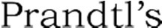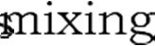3L+0T+0P End Term Exam: 3 Hours

SN | CONTENTS | Hrs.
1 | Introduction: to scope, objective and outcome of subject | 1
2 | Dimensional Analysis & Models: Dynamical Similarity and Dimensional Homogeneity Model experiment, geometric, Kinematic and Dynamic  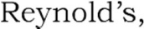  Distorted river models and undistorted models, proper choice of scale ratios. Scale effect. Principle of dimensional analysis Rayleigh method, Buckingham theorem. | 4
3 | Turbulent flow 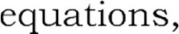 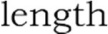 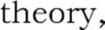  Equations of velocity distribution and friction coefficient  Boundary Layer Theory: Concept of boundary layer, laminar and turbulent boundary layers, boundary layer thickness, von Karman integral equation, laminar sub-layer, hydro-dynamically smooth and rough boundaries, separation of flow and its control, cavitation. | 6
4 | Open channel Flow Uniform, Non-Uniform and variable flow. Resistance equations of Chezy and Manning. Section factor for uniform flow. Most Efficient rectangular, triangular and trapezoidal sections. Velocity distribution in open channels. | 5
5 | Gradually varied flow in Prismatic channels. Specific energy of flow. Critical depth in prismatic channels. Alternate depths. Rapid, critical and sub critical Flow Mild, steep and Critical Slopes. Classification of surface curves in prismatic channels and elementary computation | 4
6 | Rapidly varied flow: Hydraulic jump or standing wave in rectangular channels. Conjugate or sequent depths Losses in jump, location of jump. velocity distribution in open channels. Energy correction factor. Moment correction factor | 4
7 | Impact of free Jets: Impact of a jet on a flat or a curved vane, moving and stationary vane.  Introduction of Hydraulic machine Type of pumps and turbine and its brief description. Draft tube and its principle | 3

Syllabus of 2nd Year B. Tech. (AG) for students admitted in Session 2017-18 onwards. Page 7

RAJASTHAN TECHNICAL UNIVERSITY, KOTA

SYLLABUS
II Year-IV Semester: B.Tech. (Civil Engineering)

8 | Hydrology: Definition, Hydrologic cycle, Application to Engineering problems, measurement ofrainfall, rain gauge, peak flow, flood frequency method, catchment area formulae, Floodhydrograph, Rainfall analysis, Infiltration, Run off, Unit hydrograph and its determination,Estimation of run off. | 8
9 | Ground Water: Aquifers and its types, Confined and unconfined aquifer,  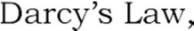 | 3
10 | Canal Hydraulics: Types of canals, parts of canal irrigation system, channel alignment,assessment of water requirements, estimation of channel losses, design of channels, regime andsemi theoretical  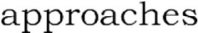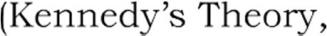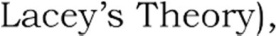  siltcontrol in canals. | 4
 | TOTAL | 42

Syllabus of 2nd Year B. Tech. (AG) for students admitted in Session 2017-18 onwards. Page
Course Overview:
Hydraulic engineering, as a sub-discipline of civil engineering, is concerned with the flow and conveyance of fluids. This course consists of the topic like viscous fluid flow, laminar and turbulent flow, boundary layer analysis, dimensional analysis, open channel flows, flow through pipes, and computational fluid dynamics. The objective of this course is to introduce various hydraulic engineering problems like open channel flows and hydraulic machines.
Hydraulic engineering is a sub-discipline of Civil Engineering. It deals with the flow of fluid, typically water and sewage conduits and uses the force of gravity for the movement of the same. It is used extensively in the construction of dams, bridges, canal, sewers etc. Hydraulic engineering uses fluid mechanics as its foundation, to deal with problems of collection, storage, segregation, measurement, transport, control and use of water.

Course Outcomes:

CO. NO. | Cognitive Level | Course Outcome
1 | Comprehension | Students will be able to analyze the process of deriving equation by using dimensional methods.
2 | Analysis | Students will analyze the problems related to flow of fluids in channel.
3 | Synthesis | Students will be able to explain and remember the different types of turbines & pumps used.
4 | Synthesis | Student will be able to create economic sections for fluid channels.
5 | Synthesis | Students will be able to remember the concepts of Hydrology.

Prerequisites:
- Student must have knowledge of basics of Fluid Mechanics.
- Students with basic knowledge of mathematical geometry can understand the topics clearly.
- Students with understanding of basic physics principle can grasp the topics of this course.
- Students with basic calculation methodologies can perform surveying calculations.

Course Outcome Mapping with Program Outcome:
Course Outcome | PO1 | PO2 | PO3 | PO4 | PO5 | PO6 | PO7 | PO8 | PO9 | PO10 | PO11 | PO12 | PSO1 | PSO2 | PSO3
CO245.1 | 3 | 3 | 3 | 2 | 1 | 2 | 1 | 1 | 1 | 1 | 1 | 1 | 1 | 2 | 1
CO245.2 | 3 | 2 | 3 | 1 | 1 | 2 | 1 | 1 | 1 | 1 | 1 | 1 | 1 | 2 | 1
CO245.3 | 3 | 2 | 3 | 2 | 1 | 1 | 1 | 1 | 1 | 1 | 1 | 1 | 1 | 2 | 1
CO245.4 | 3 | 3 | 3 | 3 | 2 | 1 | 1 | 1 | 2 | 1 | 1 | 3 | 2 | 2 | 1
CO245.5 | 3 | 3 | 2 | 3 | 2 | 1 | 2 | 1 | 2 | 1 | 1 | 3 | 1 | 2 | 1
CO245 (AVG) | 3 | 2.6 | 2.8 | 2.2 | 1.4 | 1.4 | 1.2 | 1 | 1.4 | 1 | 1 | 1.8 | 1.2 | 2 | 1

Course Coverage Module Wise:

Lecture  No. | Unit | Topic
1 | 1 | INTRODUCTION: Objective, scope and outcome of the course.
2 | 2 | DIMENSIONAL ANALYSIS & MODELS: Dynamical similarity and dimensional homogeneity model experiment. Geometric, kinematic and dynamic similarity.
3 | 2 | Reynold’s, Froude’s, Weber’s, Euler and Mach numbers. Distorted river models and
4 | 2 | Scale effect. Principle of dimensional analysis Rayleigh method.
5 | 2 | Buckingham theorem
6 | 3 | TURBULENT FLOW: Reynolds equations, Prandtl’s mixing length theory
7 | 3 | Equations of velocity distribution and friction coefficient.
8 | 3 | Boundary Layer Theory: Concept of boundary layer, laminar and
9 | 3 | Boundary layer thickness, Von Karman integral equation, laminar sub-layer.
10 | 3 | Hydro-dynamically smooth and rough boundaries
11 | 3 | Separation of flow and its control, cavitation.
12 | 4 | OPEN CHANNEL FLOW: Uniform, Non-Uniform and variable flow, Resistance
13 | 4 | Section factor for uniform flow. Most Efficient rectangular section
14 | 4 | Most Efficient trapezoidal section and its numerical.
15 | 4 | Most Efficient triangular section and its numerical.
16 | 4 | Velocity distribution in open channels.

17 | 5 | GRADUALLY VARIED FLOW: Specific energy of flow. Critical depth in prismatic
18 | 5 | Numerical based on specific energy of flow
19 | 5 | Rapid, critical and sub critical Flow Mild, steep and Critical Slopes.
20 | 5 | Classification of surface curves in prismatic channels and elementary computation
21 | 6 | RAPIDLY VARIED FLOW: Hydraulic jump or standing wave in rectangular  Channels.
22 | 6 | Conjugate or sequent depths, Losses in jump, location of jump.
23 | 6 | Numerical based on above topics. Velocity distribution in open channels.
24 | 6 | Energy correction factor. Moment correction factor
25 | 7 | IMPACT OF FREE JETS: Impact of a jet on a flat or a curved vane, Moving and
26 | 7 | Introduction of Hydraulic machine: Type of pumps and its brief description.
27 | 7 | Type of turbine and its brief description. Draft tube and its principle
28 | 8 | HYDROLOGY: Definition, Hydrologic cycle, Application to Engineering problems
29 | 8 | Measurement of rainfall, rain gauge.
30 | 8 | Peak flow, flood frequency method.
31 | 8 | Catchment area formulae, Flood hydrograph.
32 | 8 | Rainfall analysis, Infiltration, Run off.
33 | 8 | Numerical based on above topics.
34 | 8 | Unit hydrograph and its determination
35 | 8 | Estimation of run off.
36 | 9 | GROUND WATER: Aquifers and its types, Confined and unconfined aquifer
37 | 9 | Darcy’s Law, hydraulic conductivity
38 | 9 | Transmissivity, well hydraulics and numerical.
39 | 1  0 | CANAL HYDRAULICS: Types of canals, parts of canal irrigation system,  Channel
40 | 1  0 | Assessment of water requirements. Estimation of channel losses and Numerical.
41 | 1  0 | Design of channels, regime and semi theoretical approaches (Kennedy’s Theory)
42 | 1  0 | Design of channels, regime and semi theoretical approaches (Lacey’s Theory), Cross

TEXT/REFERENCE BOOKS
- Fluid Mechanics & Hydraulics by Dr. K.R, Arora, Standard Publishers & Distributers, Delhi.
- Fluid Mechanics & Hydraulics by Dr. R.K. Bansal, Laxmi Publications (P) Ltd.
- Fluid Mechanics & Hydraulics by Modi & Seth, Standard Publishers & Distributers, Delhi.
- Fluid Mechanics & Machinery by C.S.P.Ojha, R.Berndtsson and
P.N. Chandramauli, Oxford Publishers, Delhi.

Course Level Problems (Test Items):

CO.NO. | Problem description
1 | - Explain the types of flows in open channel.  - Discuss the concept of alternate depths and critical depths.  - Explain the concept of most economic section for open channel flow.
2 | - Write and explain working of turbines.  - Explain the concept of specific speed of pumps and turbines.  - Discuss the types of turbines used with their application areas.
3 | - Explain the types of dimensional methods.  - State what is Buckingham’s Pi Theorem.

Assessment Methodology:
  - Practical exam in lab where they have to analyze the problem statement. (Once in a week)
  - Assignments one from each unit.
  - Midterm subjective paper based on topics as mentioned in the modules. (Twice during the semester)
  - Final paper at the end of the semester subjective.

TEACHING AND LEARNING RESOURCES UNIT-WISE
- NPTEL Hydraulics Engineering Lecture Link: https://nptel.ac.in/courses/105/105/105105203/
- Buckingham’s Pi-Theorem: https://en.wikipedia.org/wiki/Buckingham_%CF%80_theorem
- Rayleigh’s Theorem:
https://en.wikipedia.org/wiki/Rayleigh%27s_method_of_dimensional_analysis#:~:text=Rayleigh 's%20method%20of%20dimensional%20analysis%20is%20a%20conceptual%20tool%20used,w as%20named%20after%20Lord%20Rayleigh.
- Most Economical Section:

https://unacademy.com/lesson/most-efficient-triangular-and-circular-channel-sections- hydraulics-engineering-in-hindi/RKEGX1TS



SUBJECT: HYDRAULICS ENGINEERING

Faculty Name: Jitendra Choubisa

TUTORIAL SHEET – 01
MARKS-30 DUE DATE: 01/June/2022

Each question carries equal marks
Q1. Explain Buckingham Pi theorem with example.
Q2. What do you understand by Dimensional Homogeneity? Explain with example. Q3. State what Dimensionless number are and explain each of them.

Note: Attempt all of the above questions and make a clear pdf and upload on google classroom’s specific assignment before the due date.

SUBJECT: HYDRAULICS ENGINEERING

Faculty Name: Jitendra Choubisa

TUTORIAL SHEET – 02
MARKS-30 DUE DATE: 05/June/2022

Each question carries equal marks
Q1.

Q2. Explain what the types of similarities considered in Model analysis are?

Q3.
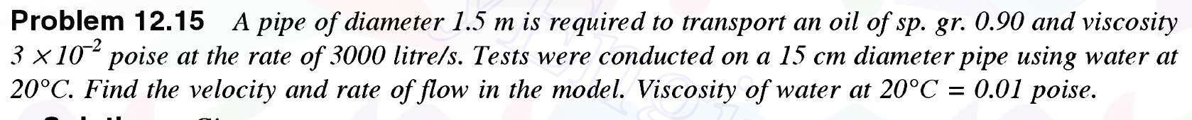

Note: Attempt all of the above questions and make a clear pdf and upload on google classroom’s specific assignment before the due date.

SUBJECT: HYDRAULICS ENGINEERING

Faculty Name: Jitendra Choubisa

TUTORIAL SHEET – 03
MARKS-30 DUE DATE: 10/June/2022

Each question carries equal marks
Q1. Explain Reynold’s experiment for turbulent flow.

Q2. Derive the formulae for loss of head due to friction in pipes.

Q3. Write about Shear Stress in turbulent flow.

Note: Attempt all of the above questions and make a clear pdf and upload on google classroom’s specific assignment before the due date.

TECHNO INDIA NJR INSTITUTE OF TECHNOLOGY, UDAIPUR

B. TECH 2nd – YEAR (IV SEM.) – MT-I
HYDRAULICS ENGINEERING (4CE4-06)
Time: 2 Hr Max. Marks: 70

Note:
  - The paper is divided into 2 parts: Part-A and, Part-B.
  - Part-A contains 10 questions and carries 2 mark each.
  - Part-B contains 5 questions. Each question is having two options and carries 10 marks each.
Part- A (20 Marks)
A. | Explain Fundamental Dimensions. | CO1
B. | Explain what is Modal Analysis? | CO1
C. | What do you understand by dynamic Similarity? | CO1
D. | What do you mean by Dimensionless Number? | CO1
E. | What do you mean by a Most Economical Section? | CO2
F. | Explain Reynold number for open channel flow with formulae. | CO2
G. | What hydro-dynamically smooth boundary means? | CO2
H. | What laminar & turbulent flow means. | CO2
I. | Write chezy’s formula and explain its terms. | CO3
J. | Write condition for most economic rectangular section. | CO3

Part- B (50 Marks)
1. The efficiency η of a fan depends upon density ρ, dynamic viscosity μ,  angular velocity ω, diameter D of the rotor and discharge Q. Express η in terms of dimensional parameters. (Take D, ω, ρ as repeating variable). | CO1
OR
1. Define what Rayleigh’s method of dimensional analysis is. The time period  (t) of a pendulum depends upon the length (L) of the pendulum and acceleration due to gravity (g). Derive the expression for the time period. | CO1

2. What do you mean by Dimensionless numbers? Write any 4 dimensionless  number with their respective formulas and their applications. | CO1
OR
2. Write down the types of similarity in modal analysis. Explain the types of  forces present in a fluid flow with their respective formulas. | CO1

3. Derive the condition for most economical trapezoidal channel section. | CO2
OR
3. Find the bed slope of trapezoidal channel of bed 4 m, depth of water 3 m and side slope of 2 horizontal to 3 vertical, when the discharge through the  channel is 20m3/s. Take manning’s constant N = 0.03. | CO2

4. What do you mean by Boundary layer flow? Explain the terms laminar  boundary layer, turbulent layer & laminar sub-layer with diagram. | CO2

OR
4. What do you understand by Hydro dynamically smooth and rough  boundaries? | CO2

5. Write what are the types of flow in channel. Explain the chezy’s formulae for  the friction losses in pipe. | CO3
OR
5. Explain the turbulent flow by Prandtl’s mixing length theory. | CO3

TECHNO INDIA NJR INSTITUTE OF TECHNOLOGY, UDAIPUR

B. TECH 2nd – YEAR (IV SEM.) – MT-II
HYDRAULICS ENGINEERING (4CE4-06)
Time: 2 Hr Max. Marks: 70

Note:
  - The paper is divided into 2 parts: Part-A and, Part-B.
  - Part-A contains 10 questions and carries 2 mark each.
  - Part-B contains 5 questions. Each question is having two options and carries 10 marks each.
Part- A (20 Marks)
K. | Explain what steady and Uniform flow types are? | CO3
L. | Write what is a Laminar Flow. | CO3
M. | Explain Critical, Sub critical and Super critical flow. | CO3
N. | Explain what a chezy’s formula is. | CO3
O. | What makes a section most economical? | CO4
P. | Explain specific energy. | CO4
Q. | What do you understand by Hydraulic jump? | CO4
R. | Explain what draft tube is. | CO4
S. | What do you understand by rain gauge? | CO5
T. | What is a contour canal? | CO5

Part- B (50 Marks)
2. Derive the formula for discharge through open channel by Chezy’s Formula. | CO3
OR
6. A flow of water of 150 liters per second flows down in a rectangular flume of width 700 mm and having adjustable bottom slope. If Chezy's constant C is 60, find the bottom slope necessary for uniform flow with a depth of flow  of 400 mm. | CO3

7. Derive the condition for most economical trapezoidal channel section. | CO3
OR
2. A rectangular channel carries water at the rate of 400 liters/s when bed slope  is 1 in 2000. Find the most economical dimensions of the channel if C = 50. | CO3

8. What do you understand by specific energy and explain specific energy  curve. | CO4
OR
3. Explain critical depth, critical velocity with their respective formulas. | CO4

9. Derive conditions for maximum discharge for a given value of specific  energy. | CO4
OR
4. Derive expression for depth of hydraulic jump. | CO4

10. Explain various types of Rain gauges used in Hydrology. | CO5

OR
5. A channel section has to be designed for the following data : Discharge Q = 30 cumecs  Silt factor f = 1.00 Side slope ½ : 1  Find also the longitudinal slope. | CO5

MULITPLE CHOICE QUESTIONS

- A pitot tube is used to measure
  - pressure
  - difference in pressure
  - velocity of flow
  - None of these.

- The thickness of a sharp crested weir is kept less than
  - one-third of the height of water on the sill
  - one-half of the height of water on the sill
  - one-fourth of the height of water on the sill
  - two-third of the height of water on the sill
  - None of these.

- The property of steam function ψ is:
  - ψ is constant everywhere on any stream line
  - the flow around any path in the fluid is zero for continuous flow
  - the rate of change of ψ with distance in an arbitrary direction, is proportional to the component of velocity normal to that direction
  - the velocity vector may be found by differentiating the stream function
  - All the above.

- The maximum vacuum created at the summit of a syphon is
  - 1 m of water
  - 7.4 m of water
  - 5.5 m of water
  - None.

- If the atmospheric pressure on the surface of an oil tank (sp. gr. 0.8) is 0.1 kg/cm2, the pressure at a depth of 2.5 m, is
  - 1 metre of water
  - 2 metres of water
  - 3 metres of water
  - 3.5 metres of water
  - 4.0 metres of water.

- The total pressure force on a plane area is equal to the area multiplied by the intensity of pressure at its centroid, if
  - area is horizontal
  - area is vertical
  - area is inclined
  - All the above.

- If the volume of a liquid weighing 3000 kg is 4 cubic metres, 0.75 is its
  - specific weight
  - specific mass
  - specific gravity
  - None of these.

- Bernoulli's equation assumes that
  - fluid is non-viscous
  - fluid is homogeneous
  - flow is steady
  - flow is along the stream line
  - All the above.

- A syphon is used
  - to connect water reservoirs at different levels intervened by a hill
  - to supply water to a town from higher level to lower level
  - to fill up a tank with water at higher level from a lower level
  - None of these.

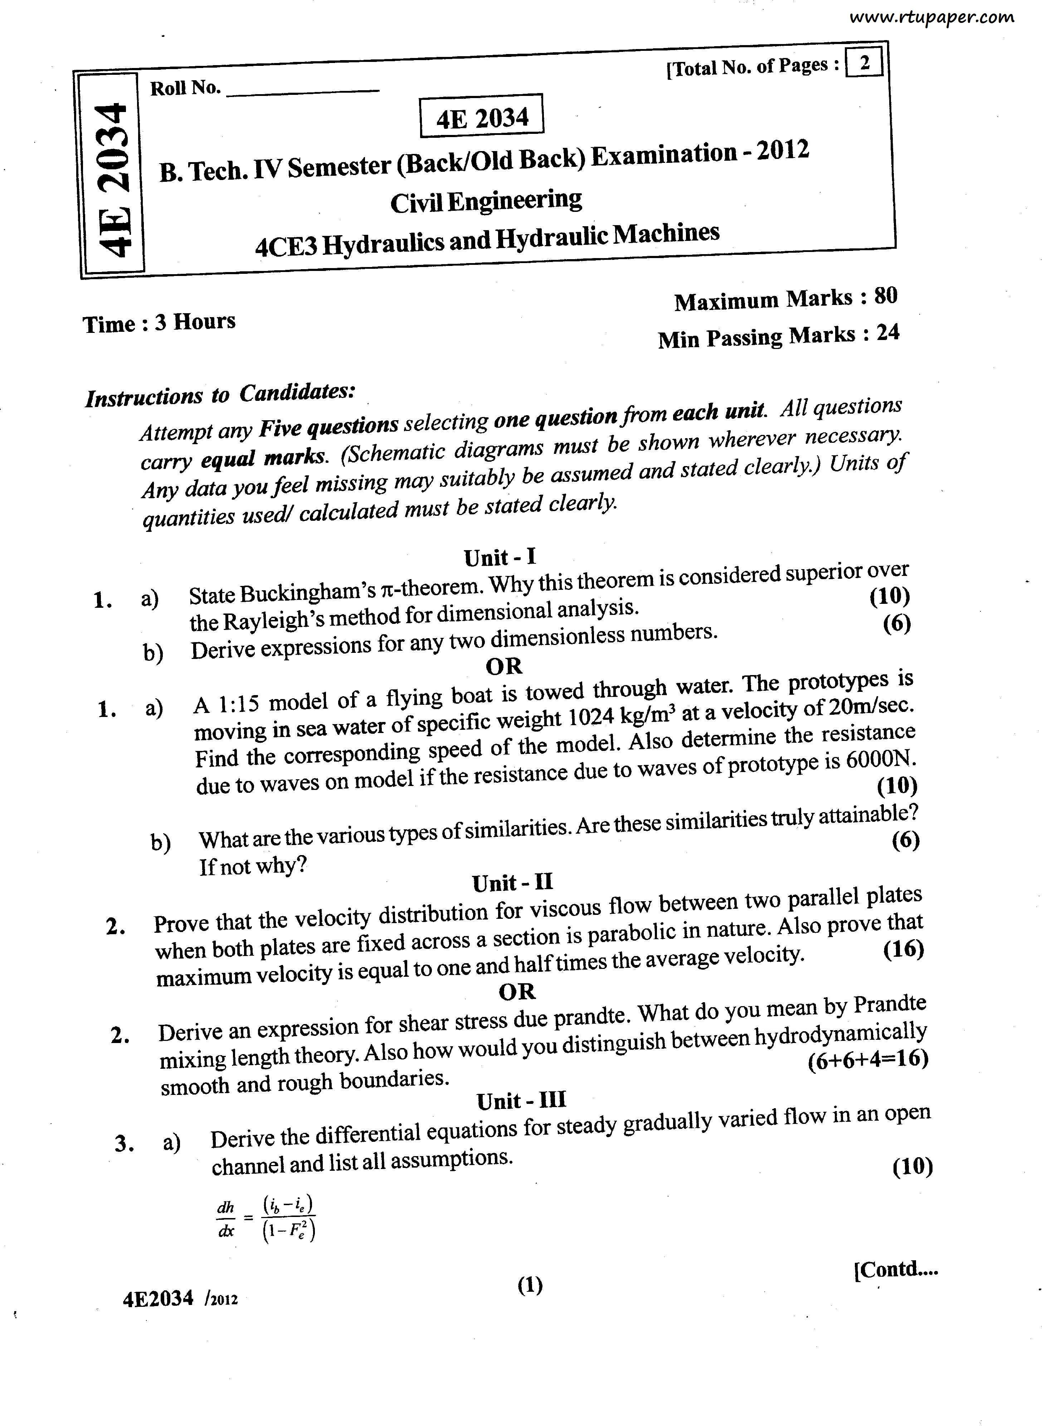

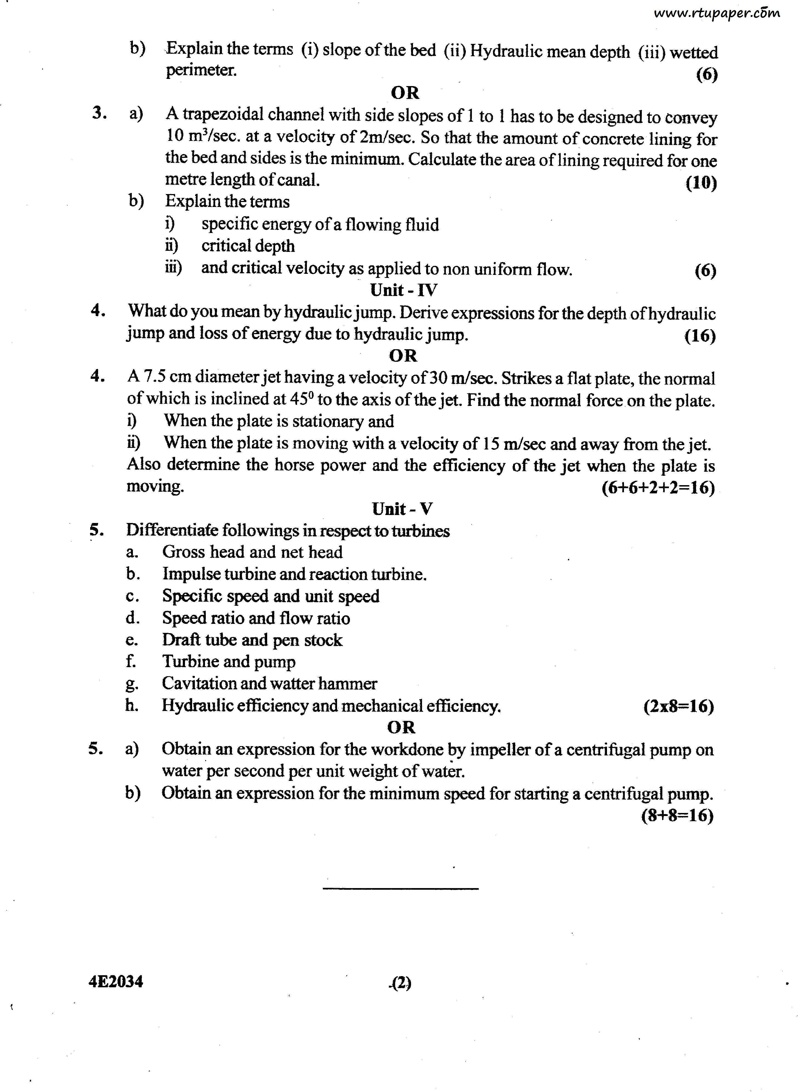

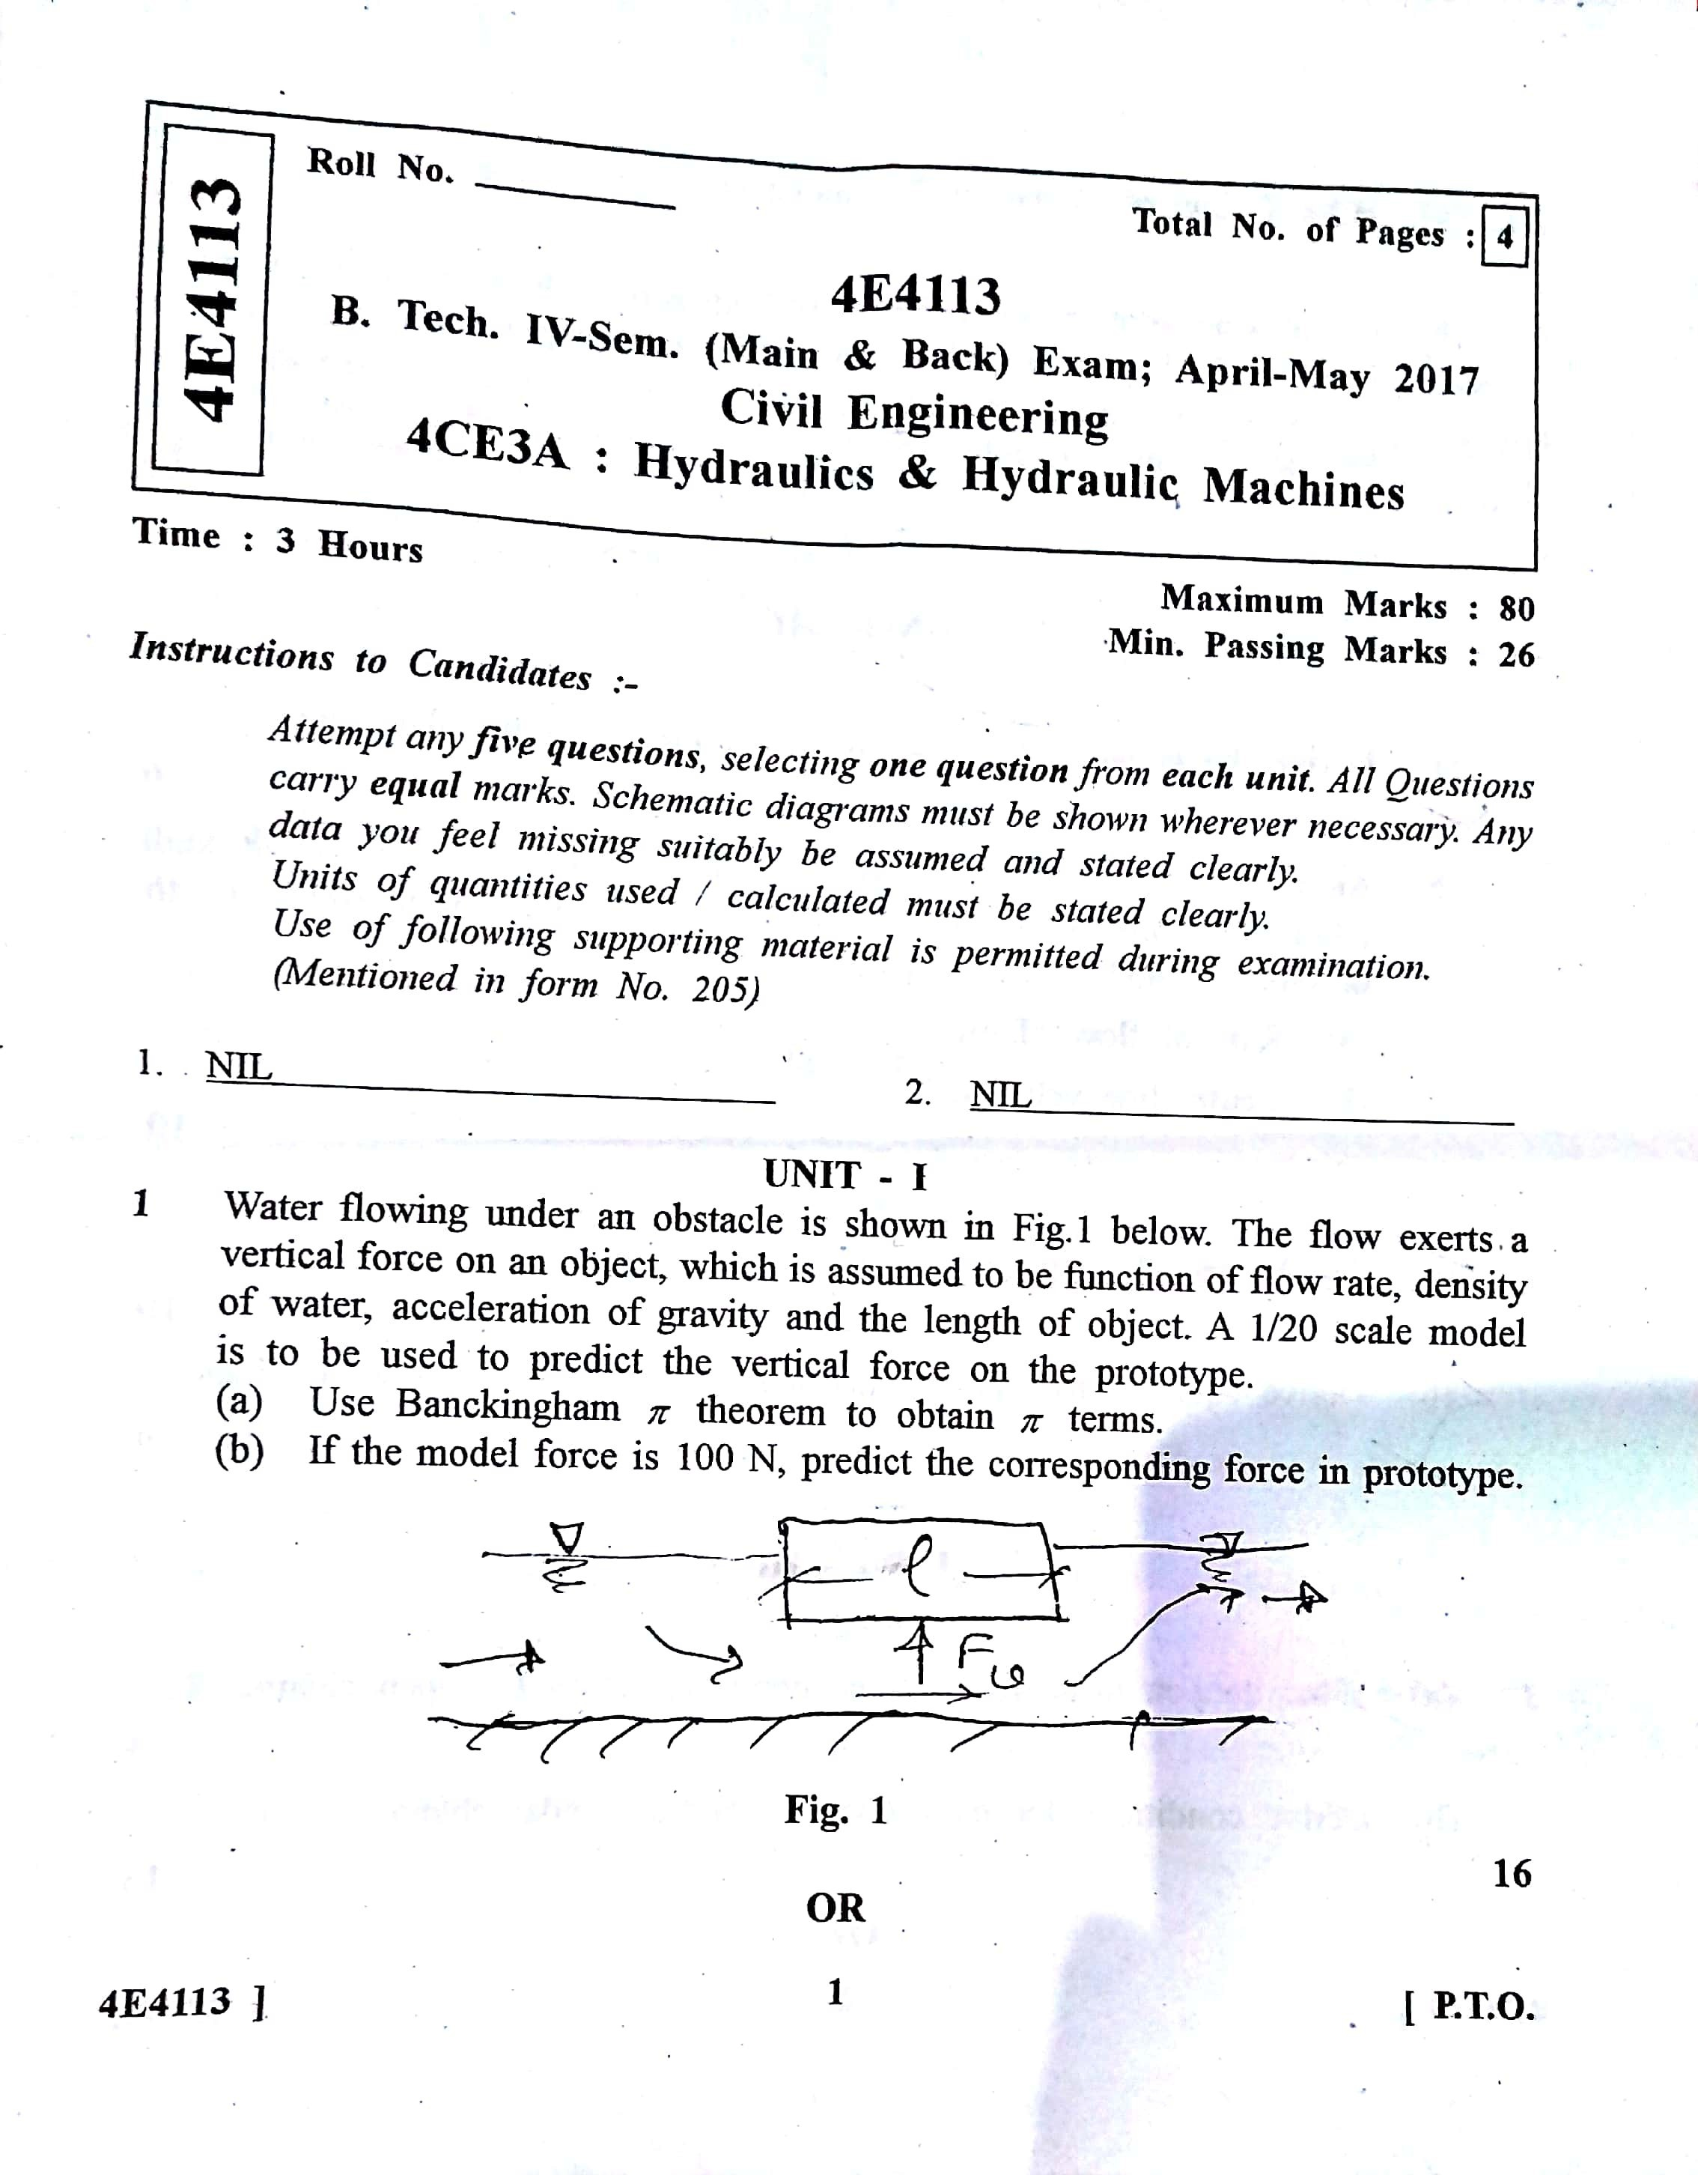

Scanned by CamScanner

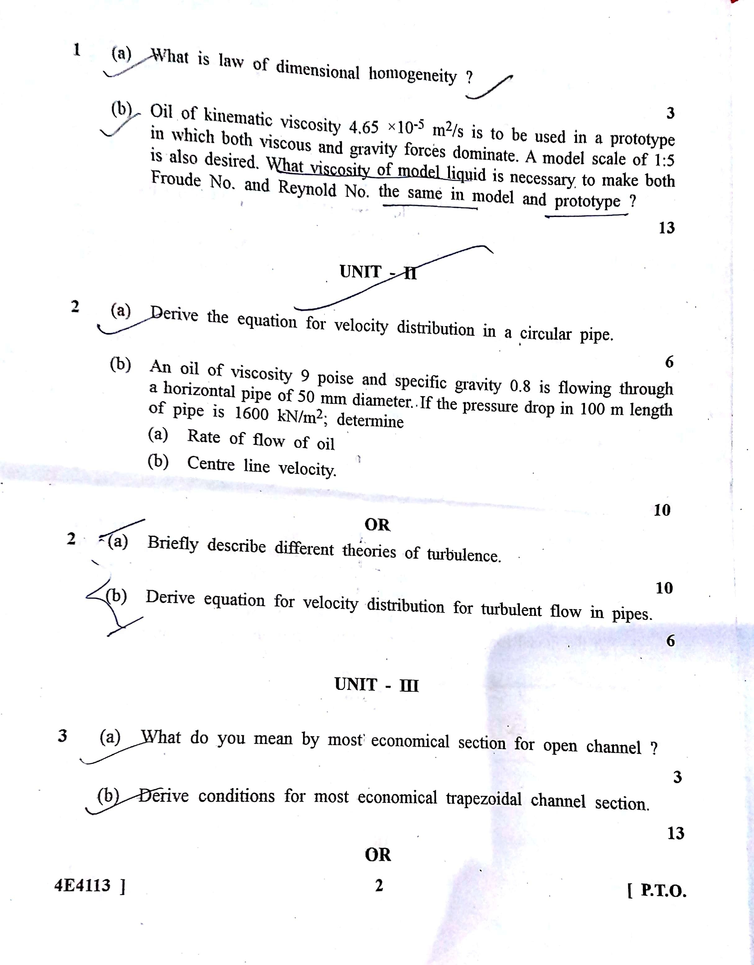

Scanned by CamScanner

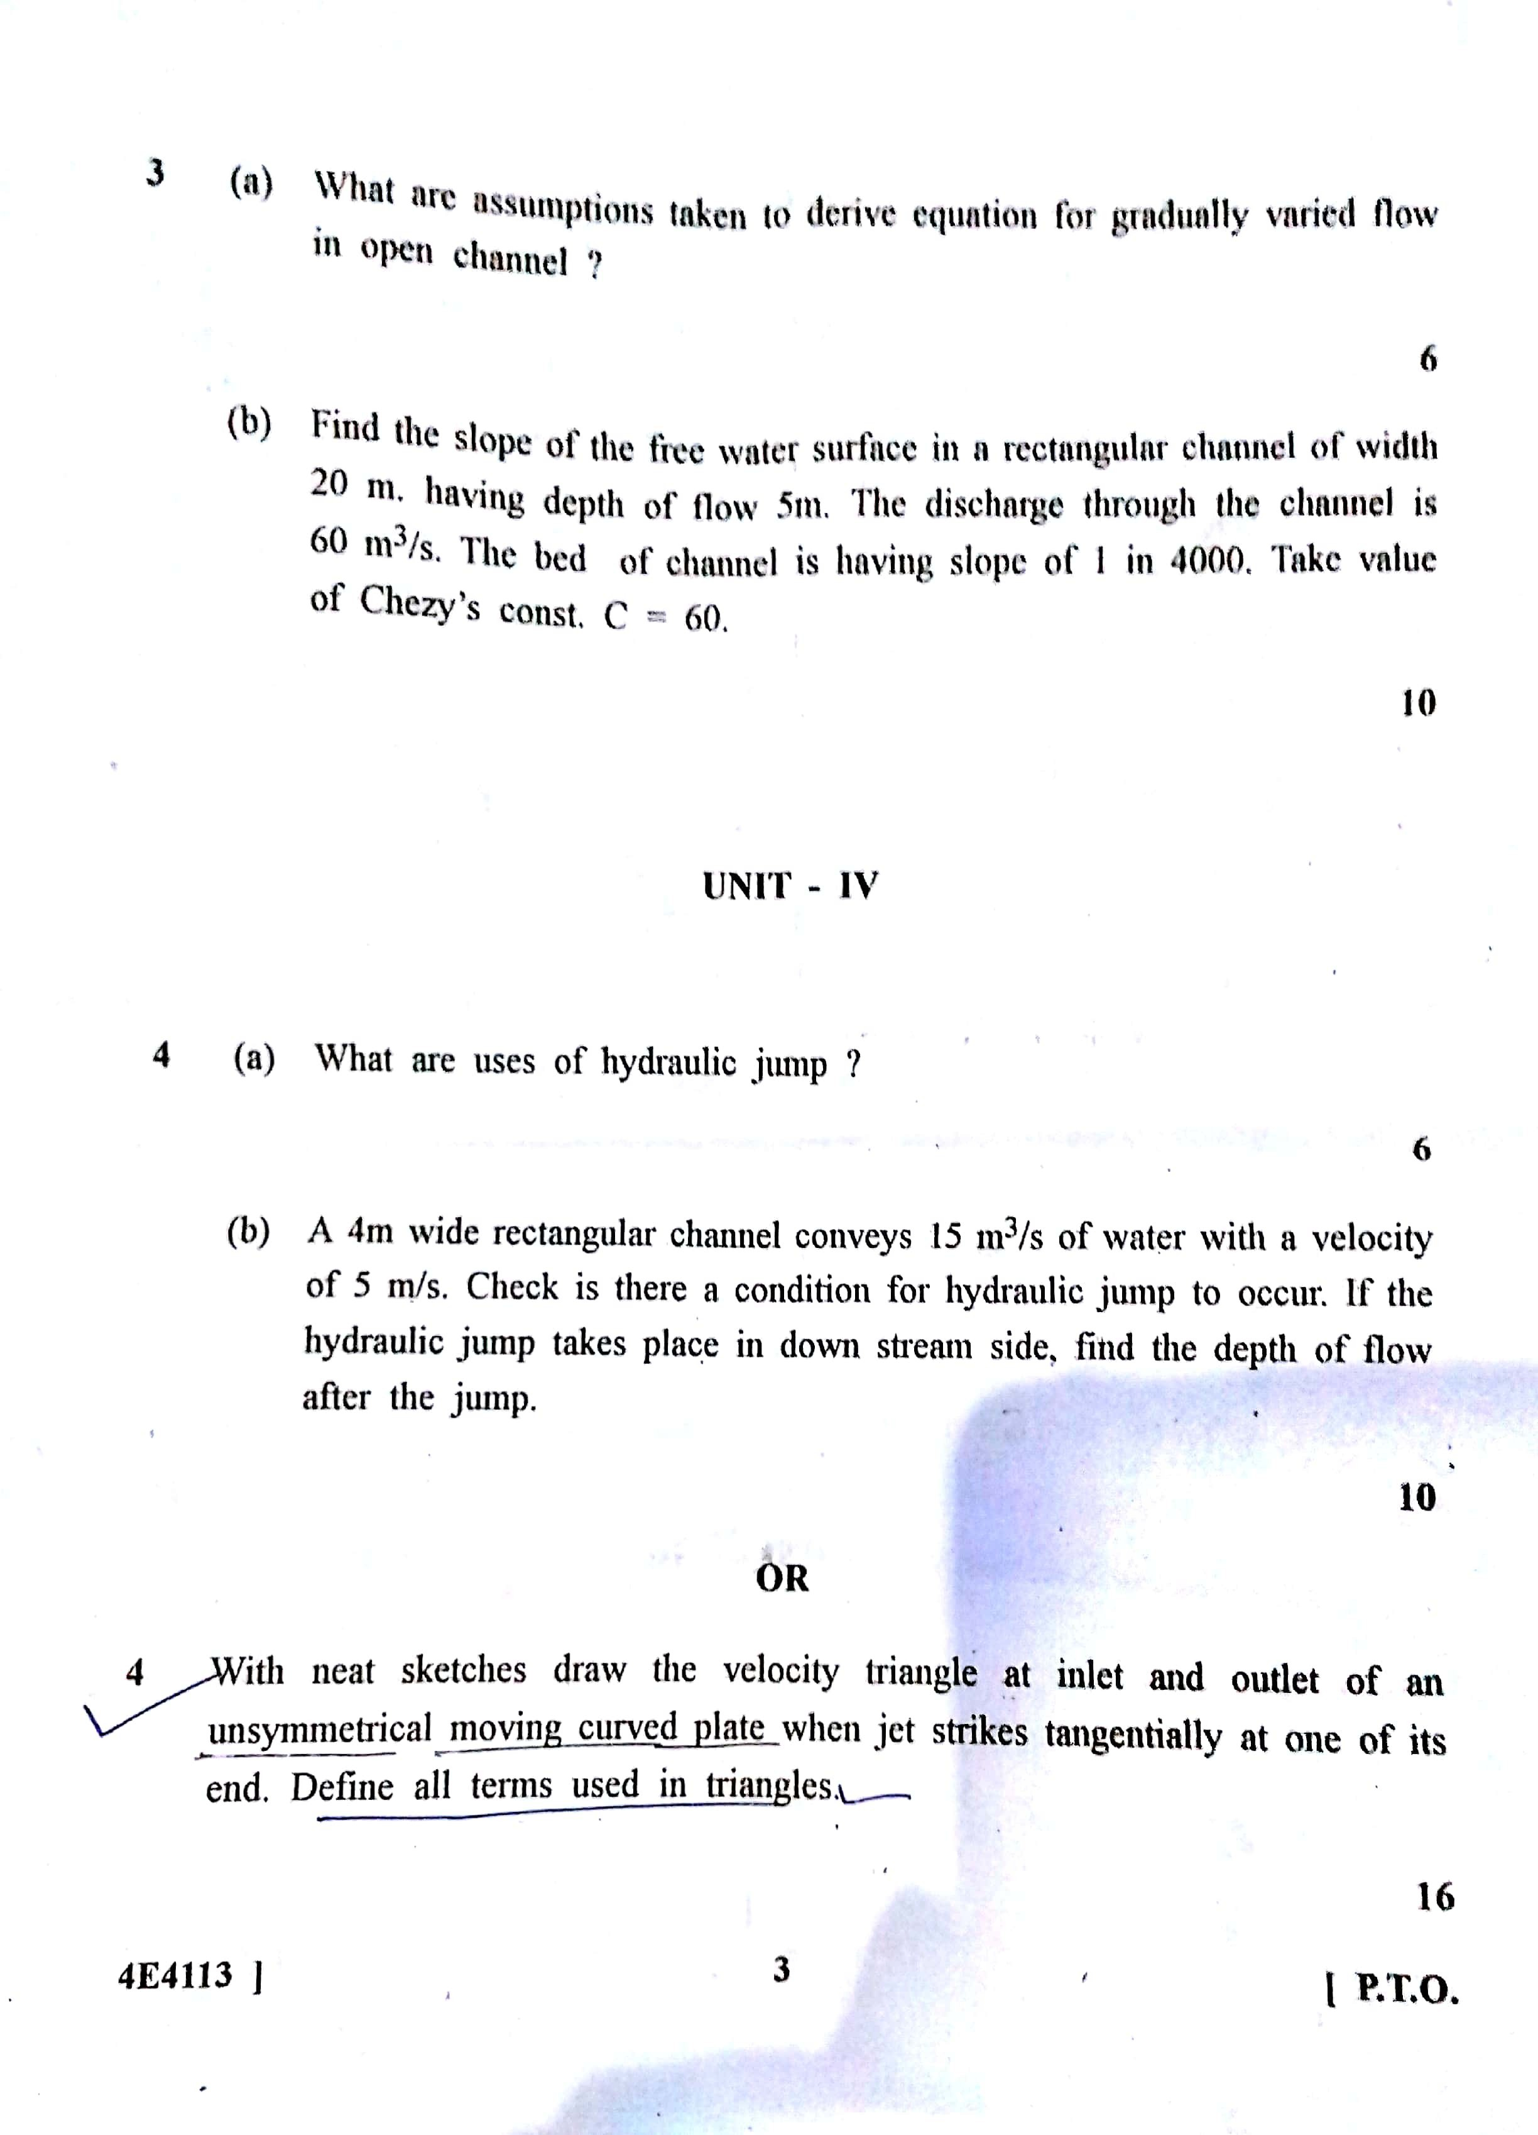

Scanned by CamScanner

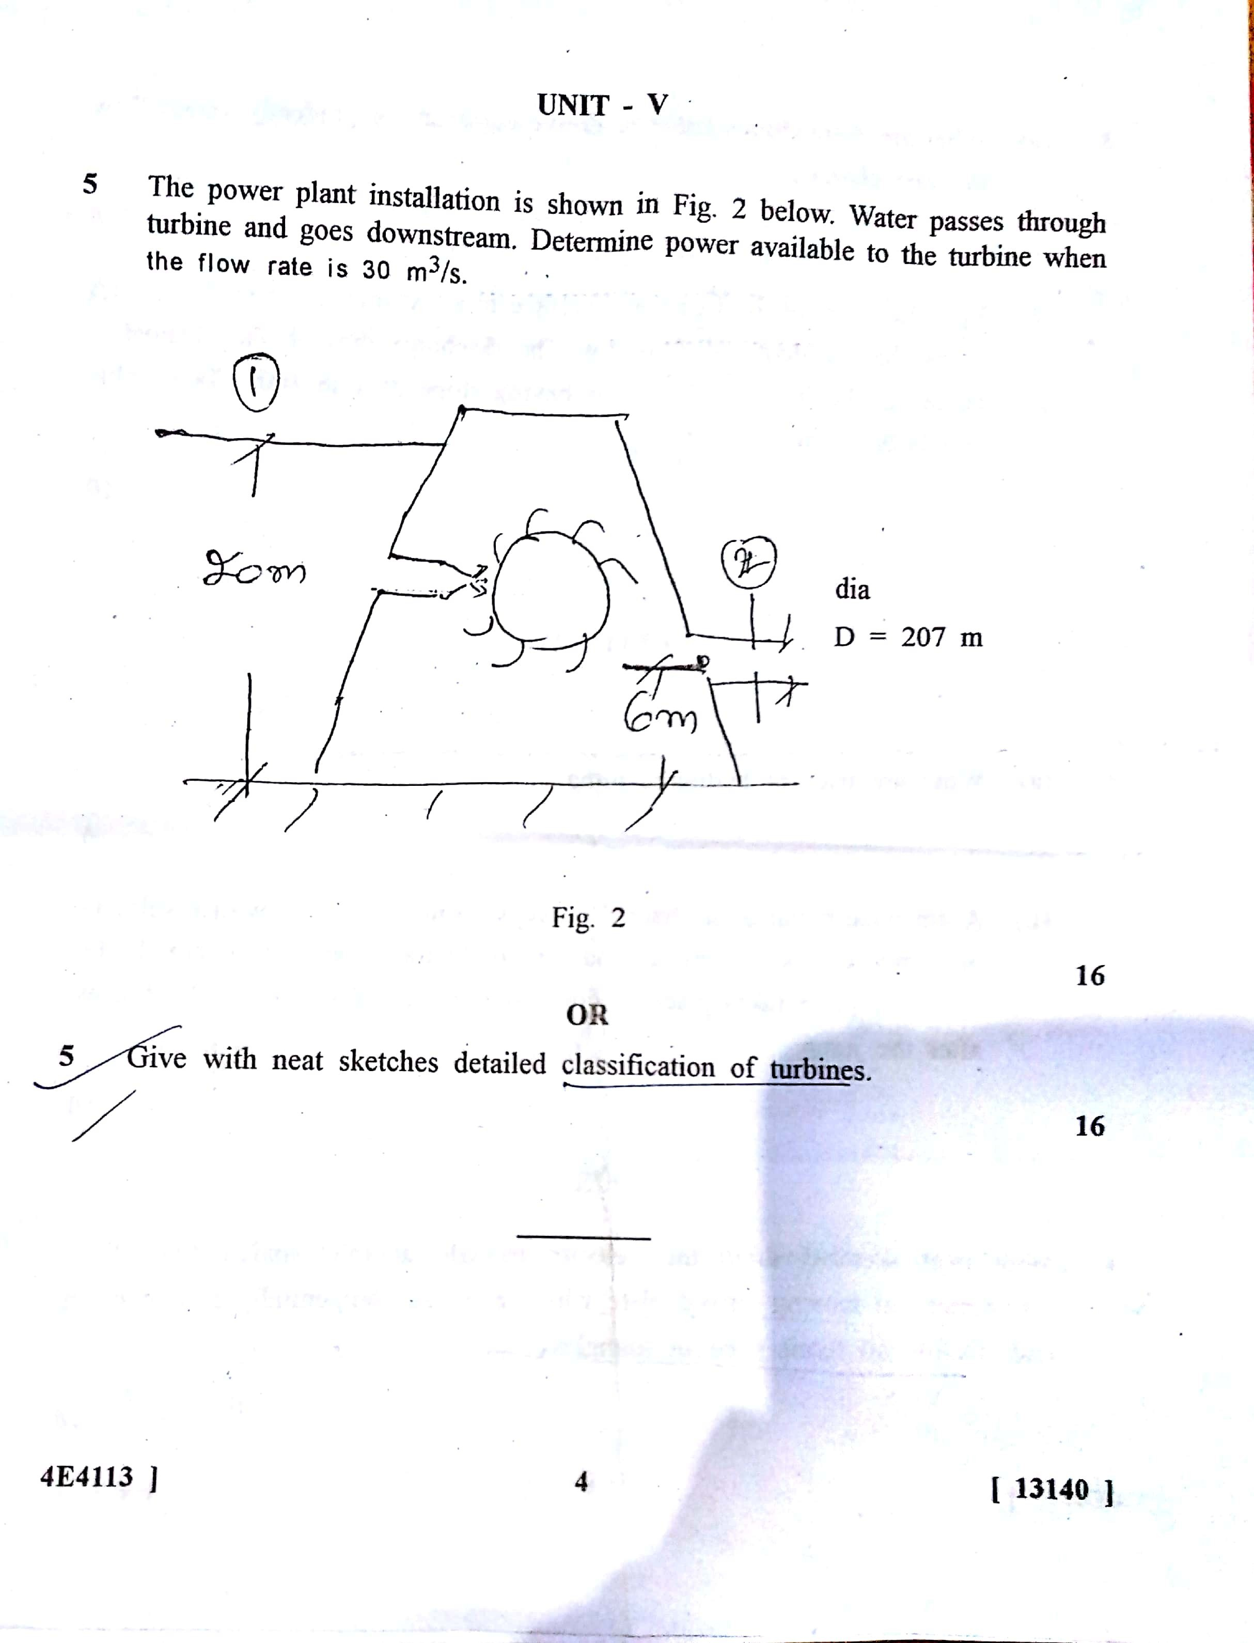

Scanned by CamScanner

