Techno India NJR Institute of Technology



**Course File**

**Geographic information System and Remote Sensing (6 CE 5-16)**

**2022-23**

Nishit Jain (Assistant Professor) **Department of CE**

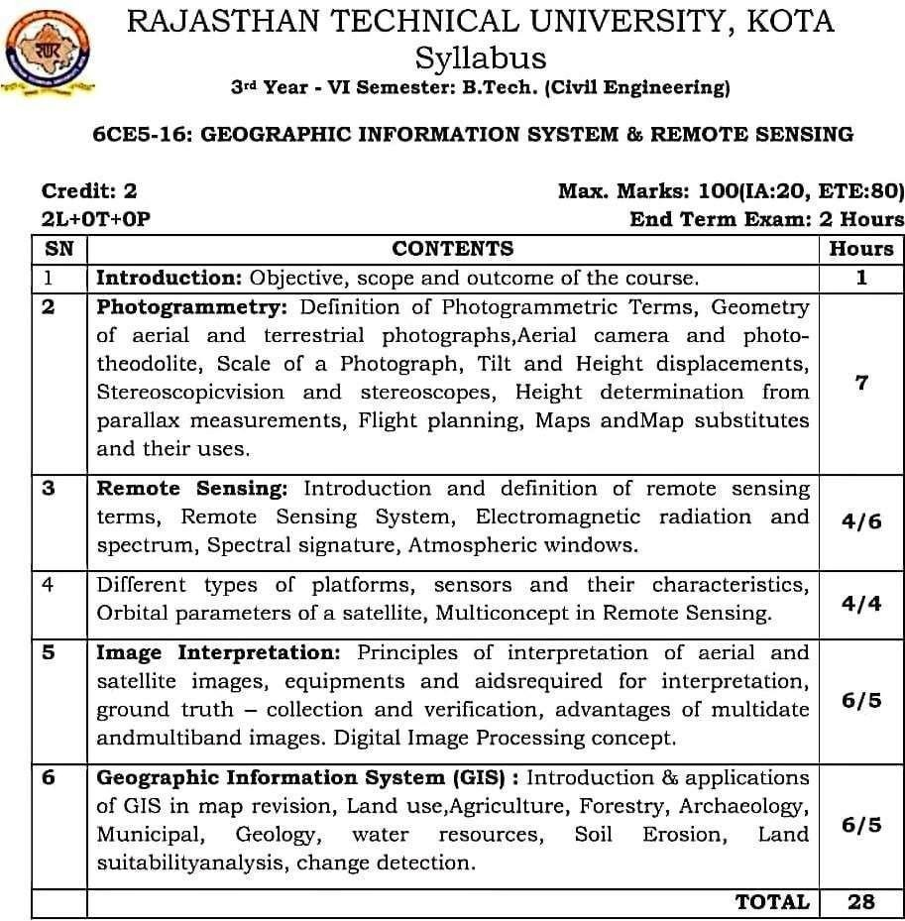

### Course Overview:

Student will learn basics of RS and GIS from this 28-hour course. They will be able to work on Remote sensing Software and find a **continuous and constant source of information about the Earth**, and geographic information systems (GIS) are a methodology for handling all this geographic data. They will study the spatial distribution of uncertainty in categorical maps. Nowadays Geographic Information System and Remote Sensing are playing a crucial role in our environmental development, raw materials assessment, urbanization, study of watershed, survey and management of cultivable land, study of forestry, geological structure, disaster management and supervision

Rs and Gis is the basic requirement for the job role of Research Engineer in the companies like Geo Climate Risk Solutions, Geo Infosys etc.

#### Course Outcomes:

|  |  |  |
| --- | --- | --- |
| **CO. NO.** | **Cognitive Level** | **Course Outcome** |
| 1 | Synthesis | Student will be able to Understand the basic concept of Remote Sensing and know about different types of satellite and sensors. |
| 2 | Application | Student will be able to Apply the concepts of Photogrammetric and its applications such as determination of heights of objects on terrain. |
| 3 | Comprehension | Students will be able to Express the principles of aerial and satellite remote sensing, Able to comprehend the energy interactions with earth surface features, spectral properties of water bodies. |
| 4 | Analysis | Students will be able Illustrate spatial and non-spatial data features in GIS and understand the map projections and coordinates systems |
| 5 | Synthesis | Students will be able Develop knowledge on conversion of data from analogue to digital and working with GIS software. |

**Prerequisites:**

1. Prepare Geographic Information Systems and the geographic space with concepts and terms commonly used to build operating models in GIS
2. Use diverse techniques and instruments adequately to measure, locate and find bearings on a map and in a field.
3. Photo-interpret basic environmental and socioeconomic variables using photographs taken in Spain.
4. Compute knowledge of remote sensing and GIS in different civil engineering applications.
5. Compute an image visually and digitally with digital image processing techniques.

### Course Outcome Mapping with Program Outcome:

|  |  |  |  |  |  |  |  |  |  |  |  |  |  |  |  |
| --- | --- | --- | --- | --- | --- | --- | --- | --- | --- | --- | --- | --- | --- | --- | --- |
| **Course Outcome** | **PO1** | **PO2** | **PO3** | **PO4** | **PO5** | **PO6** | **PO7** | **PO8** | **PO9** | **PO10** | **PO11** | **PO12** | **PSO1** | **PSO2** | **PSO3** |
| **CO367.1** | 3 | 1 | 2 | 1 | 1 | 2 | 2 | 1 | 1 | 1 | 1 | 1 | 1 | 1 | 0 |
| **CO367.2** | 3 | 2 | 2 | 1 | 1 | 1 | 1 | 1 | 1 | 1 | 1 | 2 | 1 | 1 | 0 |
| **CO367.3** | 3 | 1 | 2 | 1 | 1 | 2 | 2 | 1 | 1 | 1 | 1 | 1 | 1 | 1 | 0 |
| **CO367.4** | 1 | 1 | 1 | 1 | 3 | 1 | 1 | 1 | 1 | 1 | 1 | 1 | 1 | 1 | 0 |
| **CO367.5** | 1 | 1 | 1 | 1 | 3 | 1 | 1 | 1 | 1 | 1 | 1 | 1 | 1 | 1 | 0 |
| **CO367 (AVG)** | 2.2 | 1.2 | 1.6 | 1 | 1.8 | 1.4 | 1.4 | 1 | 1 | 1 | 1 | 1.2 | 1 | 1 | 0 |

**Course Coverage Module Wise:**

|  |  |  |
| --- | --- | --- |
| **Lecture**  **No.** | **Unit** | **Topic** |
| 1 | **1** | **INTRODUCTION:** Objective, scope and outcome of the course |
| 2 | **2** | **PHOTOGRAMMETRY:** Definition of Photogrammetric Terms, Geometry of aerial and terrestrial photographs |
| 3 | 2 | Aerial camera and photo theodolite, Scale of a Photograph |
| 4 | 2 | Tilt and Height displacements, Stereoscopic vision and stereoscopes |
| 5 | 2 | Height determination from parallax measurements |
| 6 | 2 | Flight planning |
| 7 | 2 | Maps and Map substitutes and their uses |
| 8 | **3** | **REMOTE SENSING:** Introduction & definition of remote sensing terms |
| 9 | **3** | Remote Sensing System |

|  |  |  |
| --- | --- | --- |
| 10 | **3** | Remote Sensing System |
| 11 | **3** | Electromagnetic radiation and spectrum |
| 12 | **3** | Spectral signature, Atmospheric windows |
| 13 | **4** | DIFFERENT TYPES OF PLATFORMS, sensors and their characteristics |
| 14 | **4** | Different types of platforms, sensors and their characteristics |
| 15 | **4** | Orbital parameters of a satellite |
| 16 | **4** | Multi concept in Remote Sensing |
| 17 | **5** | **IMAGE INTERPRETATION**: Principles of interpretation of aerial and Satellite images. |
| 18 | **5** | Equipment’s and aids required for interpretation |
| 19 | **5** | Ground truth – collection and verification |
| 20 | **5** | Advantages of multidate and multiband images |
| 21 | **5** | Digital Image Processing concept |
| 22 | **6** | **GEOGRAPHIC INFORMATION SYSTEM (GIS) :** Introduction &  applications of GIS in map revision |
| 23 | **6** | Geographic Information System (GIS) |
| 24 | **6** | Geographic Information System (GIS) |
| 25 | **6** | Land use, Agriculture, Forestry, Archaeology, Municipal |
| 26 | **6** | Geology, water resources, Soil Erosion |
| 27 | **6** | Land suitability analysis, change detection |
| 28 |  | Revision of course work |
| 29 |  | Revision of course work |
| 30 |  | Revision of course work |

TEXT/REFERENCE BOOKS

1. Floyd F. Sabins, Remote Sensing Principles and Interpretation, W.H. Freeman and Co.2007.
2. Lillisand T.M and Kiefer R.W, Remote Sensing and Image Interpretation, John Wiley and Sons, 2008.
3. Paul R. Wolf: Elements of Photogrammetry, with Air Photo Interpretation and Remote Sensing, McGraw Hill International Book Company, 2000

**Course Level Problems (Test Items):**

|  |  |
| --- | --- |
| **CO.NO.** | **Problem description** |
| **1** | Q 1. Remote sensing system.  Q 2. Electromagnetic radiation [E M R].  Q 3. Signatures and electromagnetic spectrum.  Q 4. Atmospheric windows.  Q 5. Types of remote–sensing and scattering. |
| **2** | Q 1. Sensors & their characteristics.  Q 2. Detail of orbital parameters.  Q 3. Inclination, semi major and semi minor axis.  Q 4. Multi concepts of remote sensing.  Q 5. Detail information about ground-based platforms. |
| **3** | Q 1. Space borne platforms detail information.  Q 2. What is photogrammetric?  Q 3. Types of photogrammetric.  Q 4. Close – range photogrammetric, plan – table photogrammetric.  Q 5. Geometry of Aerial and Terrestrial photographs. |
| **4** | Q 1. Aerial camera detail information.  Q 2. 6 km highway covers 2 km on an Air photo. Calculate the scale. |
|  | Q 3. Focal length is 158 mm and altitude above ground level (AGL) is 8600 m, Calculate the scale.  Q 4. Height or Relief Displacement.  Q 5. Flight planning for aerial photographs. |
| **5** | Q 1. Height measurement from parallel.  Q 2. Stereoscopic viewing.  Q 3. Tilt of a photographs.  Q 4. GIS application in Agriculture.  Q 5. Image Interpretation.  Q 6. Ground truth in Remote sensing.  Q 7. GIS application in Forestry. |

### Assessment Methodology

1. Assignments one from each unit.
2. Midterm subjective paper where they have to write algorithms to perform different operations on different data structures as mentioned in the modules. (Twice during the semester)
3. Final paper at the end of the semester subjective.

### Teaching and Learning resources unit-wise:

**Unit-1 Photogrammetry** Video Tutorials:

https://[www.youtube.com/watch?v=_mOG_lpPnpY](http://www.youtube.com/watch?v=_mOG_lpPnpY) https://[www.youtube.com/watch?v=f6RotlJ9qcQ](http://www.youtube.com/watch?v=f6RotlJ9qcQ)

Theory concepts:

<http://www.nitjsr.ac.in/course_assignment/CE04CE1402Survey-II%20(Photogrammetry).pdf>

Sample Quiz:

https://testbook.com/objective-questions/mcq-on-photogrammetry--5eea6a0839140f30f369d70f

### Unit-2

**Remote Sensing**

Video Tutorials: https://[www.youtube.com/watch?v=qGBA_RVM-t0](http://www.youtube.com/watch?v=qGBA_RVM-t0) Theory concepts: https://nptel.ac.in/courses/105/108/105108077/

Sample Quiz:

https://[www.objectivebooks.com/2017/11/remote-sensing-objective-questions-](http://www.objectivebooks.com/2017/11/remote-sensing-objective-questions-) and.html

### Unit-3

**Platforms**

Video Tutorials: https://[www.youtube.com/watch?v=Yt54A2KIXp8](http://www.youtube.com/watch?v=Yt54A2KIXp8) Theory concepts:

https://[www.patnauniversity.ac.in/e- content/social_sciences/geography/MAGeog71.pdf](http://www.patnauniversity.ac.in/e-content/social_sciences/geography/MAGeog71.pdf) Sample Quiz:

https://[www.discountpdh.com/principles-electromagnetic-spectrum-satellite-platforms-quiz](http://www.discountpdh.com/principles-electromagnetic-spectrum-satellite-platforms-quiz)

### Unit-4

**Image Interpretation**

Video Tutorials: https://[www.youtube.com/watch?v=WgAo-4y_q04](http://www.youtube.com/watch?v=WgAo-4y_q04)

Theory concepts:

https://[www.nateko.lu.se/sites/nateko.lu.se/files/um-](http://www.nateko.lu.se/sites/nateko.lu.se/files/um-) flygbilderintro2image_interpretation_2016_english_v3.pdf

Sample Quiz: <http://web.pdx.edu/~jduh/courses/Archive/geog481w07/Questions_Schedule.htm>

### Unit-5

**GIS**

Video Tutorials: https://[www.youtube.com/watch?v=Z1eiKW8TwVw](http://www.youtube.com/watch?v=Z1eiKW8TwVw) Theory concepts: https://openjicareport.jica.go.jp/pdf/12086922_04.pdf Sample Quiz:

https://study.com/academy/practice/quiz-worksheet-geographic-information-systems.html

# Assignment No. 1

#### SUB: RS & GIS

* 1. What is Photogrammetric and their types?
  2. Write down two advantages of photographic mapping?
  3. Equipment needed for photo interpretation?
  4. Write Example of active remote sensing?
  5. Define Radiometer?
  6. Write definition of remote sensing and explain its types also?
  7. Explain remote sensing system?
  8. Explain ground truth in remote sensing?
  9. Write about remote sensing platform?
  10. Discuss about application of GIS in urban planning?
  11. Write application of GIS water resource?
  12. Explain digital image processing and its advantages?
  13. Explain Image interpretation and its elements?

Assignment No. 2

#### RS&GIS

1. What is Photogrammetric and their types?
2. Write formula for shadow height method and parallax height measurement?
3. Equipment needed for photo interpreting?
4. What is semi major axis
5. What is eccentricity
6. What is scale of photograph?
7. What is scattering, reflectance and absorption?
8. What do you mean by remote sensing?
9. What is basic difference between active and passive device?
10. Write two disadvantages of remote sensing?
11. Write definition of remote sensing and explain its types also?
12. Please explain atmospheric window?
13. Explain remote sensing system?
14. Explain electromagnetic radiation and its properties?
15. Explain GIS and its applications in details
16. Compare aerial photograph and terrestrial photograph?
17. Effect of atmosphere in electromagnetic radiation?
18. Explain Image interpreting and its elements?
19. What are the uses of photogrammetric?
20. Explain ground truth in remote sensing?
21. Write about remote sensing platform?

## Objective Type Questions

* 1. Remote sensing uses which of the following waves in its procedure?
     1. Electric field
     2. Sonar waves
     3. Gamma- rays
     4. Electro-magnetic wave (D)
  2. Which of the following is not a principle of remote sensing?
     1. Interaction of energy with satellite
     2. Electromagnetic energy
     3. Electro-magnetic spectrum
     4. Interaction of energy with atmosphere (a)
  3. Which of the following is not a principle of remote sensing?
     1. Interaction of energy with satellite
     2. Electromagnetic energy
     3. Electro-magnetic spectrum
     4. Interaction of energy with atmosphere (c)
  4. Which of the following is not a classification of scattering principle?
     1. Faraday scattering
     2. Rayleigh scattering
     3. Mie scattering
     4. Non-selective scattering (a)
  5. Which of the following can act as an example for air-borne platform?
     1. LISS-III
     2. Dakota
     3. MOS
     4. LISS-II (b)

**Midterm Question Paper**

#### TECHNO INDIA NJR INSTITUTE OF TECHNOLOGY, UDAIPUR

**B. TECH 3rd – YEAR (VI SEM.) – MT-I**

## Geographical information system and remote sensing

(**6CE5-16**)

**Time:** 2 Hr **Max. Marks:** 70

#### Note:

1. The paper is divided into 2 parts: Part-A and, Part-B.
2. Part-A contains 10 questions and carries 2 mark each.
3. Part-B contains 5 questions. Each question is having two options and carries 10 marks each.

Part- A (20 Marks)

|  |  |  |
| --- | --- | --- |
| A. | Define Photogrammetric. | CO1 |
| B. | What is aerial photograph? | CO1 |
| C. | What is scale of photograph? | CO1 |
| D. | What is a plan? | CO1 |
| E. | What is a map? | CO2 |
| F. | What is oblique photo? | CO2 |
| G. | What is close range photogrammetric? | CO2 |
| H. | What is oblique photograph? | CO2 |
| I. | What is distortion? | CO3 |
| J. | What is tilt of photograph? | CO3 |

Part- B (50 Marks)

|  |  |
| --- | --- |
| 1. Explain the types of photogrammetric. | CO1 |
| OR | |
| 1. Explain the scale of photograph in detail. | CO1 |

|  |  |
| --- | --- |
| 2. Explain stereoscopic vision and stereoscope. | CO1 |
| OR | |
| 2. Explain what is parallax and its types in regard to height measurement. | CO1 |

|  |  |
| --- | --- |
| 3. Explain the flight planning for aerial photography. | CO2 |
| OR | |
| 3. Explain what maps are and write use of it. | CO2 |

|  |  |
| --- | --- |
| 4. Explain the types of remote sensing system. | CO2 |
| OR | |
| 4. What do you understand by Electromagnetic radiation (EMR). | CO2 |

|  |  |
| --- | --- |
| 5. Explain what electromagnetic spectrum is. | CO3 |
| OR | |
| 5. Write what are Spectral signatures. | CO3 |

#### TECHNO INDIA NJR INSTITUTE OF TECHNOLOGY, UDAIPUR

**B. TECH 3rd – YEAR (VI SEM.) – MT-II SUB: RS&GIS (6CE5-16)**

**Time:** 2Hr. **Max. Marks:**70

**Note:**

1. The paper is divided into 2 parts: Part-A and, Part-B.
2. Part-A contains 10 questions and carries 2 mark each.
3. Part-B contains 5 questions. Each question is having two options and carries 10 marks each.

#### Part- A (20 Marks)

|  |  |  |
| --- | --- | --- |
| A. | What is Photogrammetric and their types? | CO3 |
| B. | Write down two advantages of photographic mapping? | CO3 |
| C. | Equipment needed for photo interpretation? | CO4 |
| D. | Write Example of active remote sensing? | CO4 |
| E. | Define Radiometer? | CO4 |
| F. | What is scale of photograph? | CO4 |
| G. | What is do you mean by scanners? | CO5 |
| H. | What do you mean by Rayleigh’s scatter? | CO5 |
| I. | What is basic difference between active and passive device? | CO5 |
| J. | Write two disadvantages of remote sensing? | CO5 |

**Part- B (50 Marks)**

|  |  |  |
| --- | --- | --- |
| 1 | 1. Write definition of remote sensing and explain its types also? 2. Please explain Atmospheric window? | CO3 |
| **OR** |
| 1. Explain remote sensing system? 2. Explain electromagnetic radiation and its properties? |
| 2 | A. Discuss Various Technology used in Aerial Photograph? | CO4 |
| B. What are the use of photogrammetric? |
| **OR** |
| A. Compare aerial photograph and terrestrial photograph? |
| B. Define effect of atmosphere in electromagnetic radiation? |
| 3 | A. Explain ground truth in remote sensing? | CO4 |
| B. Write about remote sensing platform? |
| **OR** |
| A. What is multidate and multi band aerial photography? |
| B. Explain multiple concept in remote sensing? |
| 4 | A. Discuss about application of GIS in urban planning? | CO5 |
| B. Write application of GIS water resource? |
| **OR** |

|  |  |  |
| --- | --- | --- |
|  | A. Explain GIS and its application with advantages? |  |
| B. Discuss GIS uncertainties? |
| 5 | A. Explain digital image processing and its advantages? | CO5 |
| B. Explain Image interpretation and its elements? |
| **OR** |
| A. What is sensors and explain its characteristics? |
| B. Explain Concept of image processing? |

