Techno India NJR Institute of Technology



**COURSE FILE**

**Project planning and Construction Management**

**(8CE4-01)**

**Session 2022-23**

Rakesh yadav (Assistant Professor) **Department of CE**

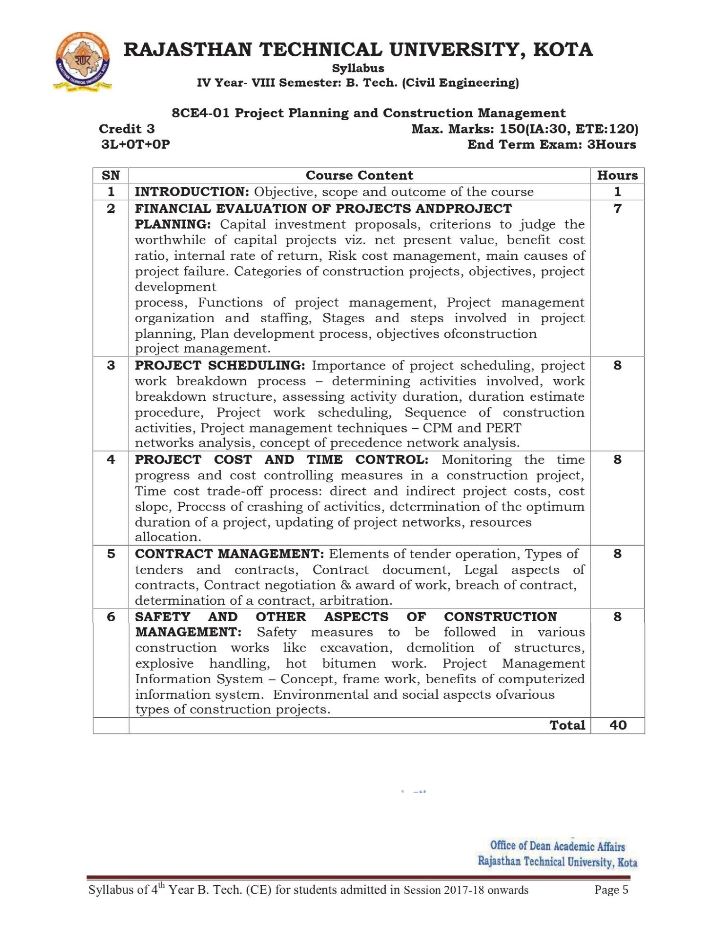

**Course Overview:**

Student will learn basics of PPCM from these 40 hours course. It

Introduces the

Basic learning requirements for the civil engineer project manager and makes the

Appreciation for the qualitative nature of the construction project management. The

philosophy of the course

is more on system approach contrary

to majority of

mechanics-based subject. emphasized.

Also, need for construction industry has been

**PPCM** plays a significant

role in ensuring that all Company’s or

Programme’s

Projects are aligned with strategic vision and objectives, and meet operational, cost, budget, and time-related targets. Student should learn and develop problem solving abilities using PPCM in order to get a good job in top civil engineering company.

**Course Outcomes:**

|  |  |  |
| --- | --- | --- |
| **CO. NO.** | **Cognitive Level** | **Course Outcome** |
| 1 | Comprehension | Students will be able to understand construction risk management, the roles and responsibilities of all constituencies involved in the design and construction process. |
| 2 | Comprehension | Students will be able to understand concept of network analysis CPM and PERT methods and network rules and regulations |
| 3 | Synthesis | Students will be able to design a network diagram to create the project schedules, Critical path, slack in between activities using CPM & PERT techniques. |
| 4 | Comprehension | Students will be able to Identify the project cost and time control using network techniques. |
| 5 | Analysis | Students be able to Analyze about the contract management. |

**Prerequisites:**

* Students will be able to compute construction risk management and identify the roles and responsibilities of all constituencies involved in the design and construction process.
* Students will be able to understand concept of network analysis CPM and PERT methods and network rules and regulations
* Students will be able to design a network diagram to determine the duration of project, Critical path, slack in between activities using CPM & PERT techniques.
* Students will be able to analyze the project cost and time control u i g ne ork techniques.

s

n

t

w

* Students be able to Analyze about the contract management.

**Course Outcome Mapping with Program Outcome:**

a

b

e

t

o

n

a

**O**

|  |  |  |  |  |  |  |  |  |  |  |  |  |
| --- | --- | --- | --- | --- | --- | --- | --- | --- | --- | --- | --- | --- |
| **Course Outcome** | **Program Outcomes (PO’s)** | | | | | | | | | | | |
| **CO. NO.** | **Domain Specific (PSO)** | | | | | **Domain Independent (PO)** | | | | | | |
|  | **PO1** | **PO2** | **PO3** | **PO4** | **PO5** | **PO6** | **PO7** | **PO8** | **PO9** | **P 10** | **PO11** | **PO12** |
| CO401.1 | 3 | 2 | 2 | 2 | 2 | 2 | 2 | 1 | 2 | 1 | 1 | 1 |
| CO401.2 | 2 | 2 | 2 | 2 | 1 | 2 | 2 | 1 | 2 | 1 | 2 | 1 |
| CO401.3 | 3 | 2 | 2 | 2 | 2 | 2 | 2 | 1 | 2 | 1 | 1 | 1 |
| CO401.4 | 2 | 2 | 2 | 2 | 2 | 1 | 1 | 1 | 2 | 3 | 3 | 2 |
| CO401.5 | 2 | 2 | 2 | 2 | 2 | 1 | 1 | 1 | 2 | 3 | 3 | 2 |
| CO401 (AVG) | 2.4 | 2 | 2 | 2 | 1.8 | 1.6 | 1.6 | 1 | 2 | 1.8 | 2 | 1.4 |
| 1: Slight (Low), 2: Moderate (Medium), 3: Substantial (High) | | | | | | | | | | | | |

**Course Coverage Module Wise:**

|  |  |  |
| --- | --- | --- |
| **Lecture No.** | **Unit** | **Topic** |
| 1 | **1** | **FINANCIAL EVALUATION OF PROJECTS AND PROJECT PLANNING:**  Students should be able to understand of capital investment proposals, criterions to judge the worth whileness of capital projects. |
| 2 | 1 | Students should be able to compute net present value, benefit cost ratio, internal rate of return |
| 3 | 1 | Students should be able to compute risk cost management, main causes of project failure. |
| 4 | 1 | Students should be able to write Categories of construction projects, objectives, project development process |
| 5 | 1 | Students should be able to functions of project management, Project management organization and staffing |
| 6 | 1 | Students should be able to identify stages and steps involved in project planning |
| 7 | 1 | Students should be able to identify stages and steps involved in project planning |
| 8 | 2 | **PROJECT SCHEDULING**:  Students should be l u derst nd Importance of project scheduling |

|  |  |  |
| --- | --- | --- |
| 9 | 2 | Students should be able to identify project work breakdown process and determine activities involved |
| 10 | 2 | Students should be able analyze work breakdown structures, assessing activity duration. |
| 11 | 2 | Students should be able write duration estimate procedure and Project work scheduling |
| 12 | 2 | Students should be able to apply project management techniques- CPM network analysis |
| 13 | 2 | Students should be able to apply PERT network analysis |
| 14 | 2 | Students should be able create a network diagram using PERT network analysis |
| 15 | 2 | Students should be able create a network diagram using PERT network analysis |
| 16 | 3 | **PROJECT COST AND TIME CONTROL:**  Students should be able to understand monitoring the time progress |
| 17 | 3 | Students should be able to identify of cost controlling measures in a construction project. |
| 18 | 3 | Students should be able to write time cost trade-off process: direct and indirect project costs, cost slope |
| 19 | 3 | Students should be able to write process of crashing of activities |
| 20 | 3 | Students should be able to write process of crashing of activities |
| 21 | 3 | Students should be able to compute the optimum duration of project |
| 22 | 3 | Students should be able to schedule updating of project networks |
| 23 | 3 | Students should be able to write recourse’s allocation |
| 24 | 4 | **CONTRACT MANAGEMENT:**  Students should be able to write element of tender operation |
| 25 | 4 | Students should be able understand types of tenders |
| 26 | 4 | Students should be b e r t t pes of contracts |
| 27 | 4 | Students should b a e write cont a t documents, Legal aspects of Contracts |

a

l

w

i

e

y

e

bl

r

c

d



|  |  |  |
| --- | --- | --- |
| 28 | 4 | Students should be able practice Contract negotiation |
| 29 | 4 | Students should be able understand breach of contracts |
| 30 | 4 | Students should be able analyze the Contracts |
| 31 | 4 | Students should be able analyze Arbitration |
| 32 | 5 | **SAFETY AND OTHER ASPECTS OF CONSTRUCTION MANAGEMENT:**  Students should be able to identify causes and preservation of accidents at construction sites |
| 33 | 5 | Students should be able understand the safety management |
| 34 | 5 | Students should be able identify demolition of structures |
| 35 | 5 | Students should be able understand explosive handling |
| 36 | 5 | Students should be able identify hot bitumen works |
| 37 | 5 | Students should be able understand project management information System: Concept, frame work |
| 38 | 5 | Students should be able identify benefits of computerized information systems |
| 39 | 5 | Students should be able understand environmental aspect of various types of construction projects |
| 40 | 5 | Students should be able understand social aspect of various types of construction projects |

# TEXT/REFERENCE BOOKS

* 1. Project management with CPM/PERT by B.C. Punmia, Laxmi Publication (P) Ltd.
  2. Construction Project Management by K.K Chitkara, Tata Mc Graw Hills.
  3. Project Management by Modder & Phillph, CBS Publishers.
  4. Project Planning and Control by Punmia and Khandelwal K.K., Laxmi Publication (P) Ltd.
  5. Project Management by Choudhary S., Tata McGraw Hill Publishing Company Limited, New

Delhi.

**Course Level Problems (Test Items):**

|  |  |
| --- | --- |
| **CO.NO.** | **Problem description** |
| **1** | 1. Describe the net present value and benefit cost ratio. 2. Write down the importance of the project planning and enlist the stages involved in project planning. 3. List out the responsibilities of project manager in construction project. |
| **2** | 1. Explain work breakdown structure with of an example. 2. Discuss term “project scheduling and its importance in construction projects. 3. Explain Programme and review technique and distinguish between   Positive slack, zero slack and negative slack. |
| **3** | 1. Describe the cost controlling measures in a construction project. 2. Write about the time cost trade-off process: direct and indirect project costs. 3. Explain resource updating and discuss about its implementation. |
| **4** | 1. Write down the rules for inviting and processing tenders. 2. List out the required contract documents and write about Legal aspects of Contracts. |
| **5** | 1. Discuss the social and environmental aspect of various types of construction projects 2. Mention the safety measures for scaffolding, ladder framework. |

**Assessment Methodology:**

* + 1. Assignments one from each unit.
    2. Online Quiz at Google classroom
    3. Midterm subjective paper where they have to write algorithms to perform different operations on different data structures as mentioned in the modules. (Twice during the semester)
    4. Final paper at the end of the semester subjective.

# TEACHING AND LEARNING RESOURCES UNIT-WISE:

1. **FINANCIAL EVALUATION OF PROJECTS AND PROJECT PLANNING**

# VideoTutorials:

https://nptel.ac.in/courses/105/104/105104161/

https://nptel.ac.in/courses/110/104/110104073/

https://drive.google.com/drive/folders/19nJ_FMwWjvaFvGaoelrtNCklGrHXaAX2

# Theory concepts:

https://drive.google.com/drive/folders/10lSi6iQ3ReHDUL-6_Oy1h7jzKuiwxDlA

https://drive.google.com/drive/folders/13WBog5benU3wAJ5lsyNRITyoYE_JJBP0

# Sample Quiz:

https://global.oup.com/us/companion.websites/9780199397150/student/chapter14/multiplechoice

/

# PROJECT SCHEDULING:

**VideoTutorials:**

https://nptel.ac.in/courses/105/104/105104161/

https://drive.google.com/drive/folders/19nJ_FMwWjvaFvGaoelrtNCklGrHXaAX2

# Theory concepts:

https://drive.google.com/drive/folders/10lSi6iQ3ReHDUL-6_Oy1h7jzKuiwxDlA

https://drive.google.com/drive/folders/13WBog5benU3wAJ5lsyNRITyoYE_JJBP0

https://[www.interventions.org/pertcpm.html](http://www.interventions.org/pertcpm.html)

# Sample Quiz:

https://[www.vskills.in/practice/cpm-pert-test](http://www.vskills.in/practice/cpm-pert-test) https://[www.courseya.com/pert-and-cpm-mcq/](http://www.courseya.com/pert-and-cpm-mcq/)

# PROJECT COST AND TIME CONTROL

**VideoTutorials:**

https://nptel.ac.in/courses/105/104/105104161/

https://drive.google.com/drive/folders/19nJ_FMwWjvaFvGaoelrtNCklGrHXaAX2

# Theory concepts:

https://drive.google.com/drive/folders/10lSi6iQ3ReHDUL-6_Oy1h7jzKuiwxDlA

https://drive.google.com/drive/folders/13WBog5benU3wAJ5lsyNRITyoYE_JJBP0 https://[www.interventions.org/pertcpm.html](http://www.interventions.org/pertcpm.html)

**Sample Quiz:** https://[www.vskills.in/practice/cpm-pert-test](http://www.vskills.in/practice/cpm-pert-test) https://[www.courseya.com/pert-and-cpm-mcq/](http://www.courseya.com/pert-and-cpm-mcq/)

# PREVIOUS YEAR QUESTION PAPERS:

