**Techno India NJR Institute of Technology**



**Course File**

**Software Engineering (3CS4- 07)**

Kriti Jain

(Assistant Professor)

**Department of CSE**

# Course Scheme: Software Engineering

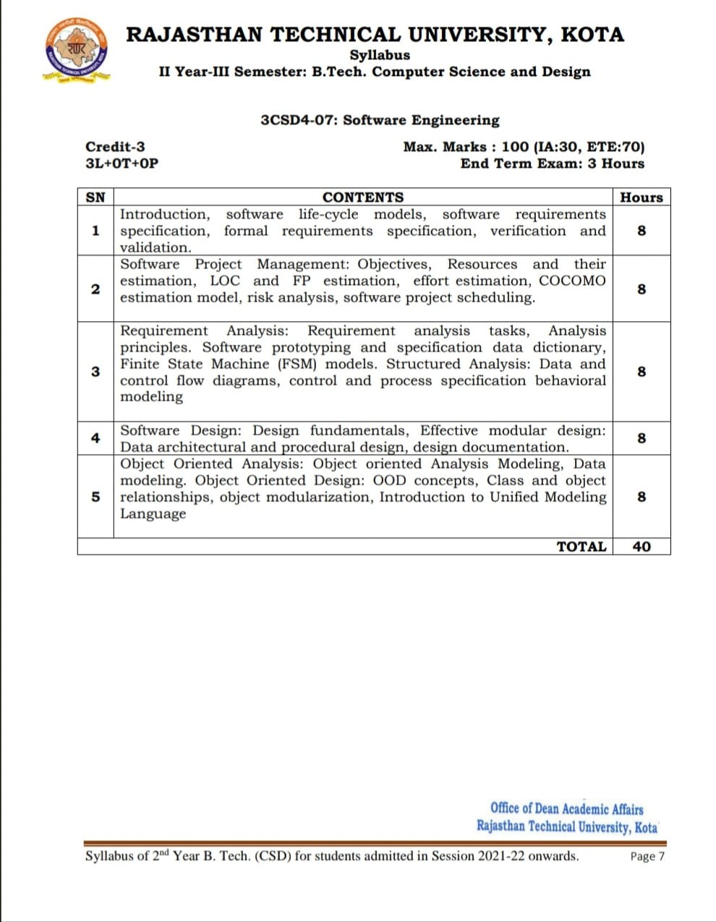

**Note: L: Lecture; T: Tutorial; Cr: Credits; ETE: End Term Exam; IA: Internal Assessment**

# Course Overview

Our mission is to prepare students in software engineering with a thorough understanding of subject concepts and experiential learning opportunities to apply that knowledge to solve real-world problems using software development and evolution, specify, abstract, verify and validate solutions to large-size problems, to plan, develop and manage large software and learn emerging trends in software engineering.

Software Engineering (SE) is core subject in world of Computer Engineering (Software) and Application, which creates base for the development in field of software. SE comprises the core principles consistent in software construction and maintenance, fundamental software processes and life-cycles, mathematical foundations of software engineering, requirements analysis, software engineering methodologies and standard notations, principles of software architecture and re-use, software quality frameworks and validation, software development, and maintenance environments and tools.

## Objectives

* To introduce the students with basic principles of Software Engineering
* To learn the Software Engineering concepts, methodologies and best practices
* To train the students on Software Engineering principles and approach used in Industry

## Consequences (Outcomes)

* Learn basic principles of SE to solve problems regarding SRS, Design, Testing and Implementation in software development.
* Understand Software Engineering concepts, methodologies and best practices to provoke, analyze and specify software requirements through a productive working relationship with project team.
* Learn Software Engineering principles and approach used in industry to evaluate the impact of potential solutions to software problems in a global development culture, using their knowledge of contemporary issues and emerging trends, models, tools, and techniques.

## 

## Course Outcomes:

| **3CS407** | **Cognitive Level** | **Software Engineering Year of study: 2022-23** |
| --- | --- | --- |
| CO23407.1 | Knowledge | Student will be understand fundamental concepts in software engineering, SDLC, software requirements specification, formal requirements specification and verification |
| CO23407.2 | Application | Students will learn about Software Project Management and be able to calculate the cost based on line of code. |
| CO23407.3 | Application | Students will be able to prepare various documents such as requirement analysis (SRS) and Structured analysis. |
| CO23407.4 | Knowledge | Students will learn fundamental software design and Effective modular design. |
| CO23407.5 | Synthesis | Students will be able to design UML diagrams for a given requirement specifications. |

| **Software Engineering Year of study: 2020-21** | | | | | | | | | | | | | | | |
| --- | --- | --- | --- | --- | --- | --- | --- | --- | --- | --- | --- | --- | --- | --- | --- |
| **Course Outcome** | **PO1** | **PO2** | **PO3** | **PO4** | **PO5** | **PO6** | **PO7** | **PO8** | **PO9** | **PO10** | **PO11** | **PO12** | **PSO1** | **PSO2** | **PSO3** |
| **CO23407.1** | 2 | 2 | 0 | 2 | 0 | 0 | 0 | 0 | 0 | 0 | 0 | 1 | 3 | 3 | 3 |
| **CO23407.2** | 2 | 2 | 1 | 2 | 0 | 0 | 0 | 0 | 0 | 0 | 0 | 1 | 3 | 3 | 3 |
| **CO23407.3** | 2 | 2 | 1 | 2 | 0 | 0 | 0 | 0 | 0 | 0 | 0 | 1 | 2 | 2 | 0 |
| **CO23407.4** | 2 | 2 | 1 | 2 | 0 | 1 | 0 | 0 | 0 | 0 | 0 | 1 | 3 | 3 | 3 |
| **CO23407.5** | 2 | 2 | 1 | 2 | 2 | 1 | 0 | 0 | 0 | 0 | 0 | 1 | 3 | 3 | 1 |
| **C23407 (AVG)** | 2.00 | 2.00 | 0.80 | 2.00 | 0.40 | 0.40 | 0.00 | 0.00 | 0.00 | 0.00 | 0.00 | 1.00 | 2.80 | 2.80 | 2.00 |

**Note**: Relationship Matrix between Objectives and Outcome need to be furnished during the course implementation period.

## Prerequisites

* Understanding of programming and object oriented concept
* Aware with design engineering concepts and implementation
* Thoughtfulness of problem understanding & solving and information gathering

# Course Syllabus: Software Engineering

## Theory Classes

## Lecture Plan: (43 Hours)

| **Date** | | **Hrs (T)** | **Unit** | **Lecture Title** |
| --- | --- | --- | --- | --- |
| **From** | **To** |
|  |  | 1 | **1** | **Subject Introduction** |
|  |  | 3 | Software Engineering Introduction; Software life-cycle models |
|  |  | 3 | Software requirements specification |
|  |  | 1 | Verification and validation. |
|  |  | **1** | **2** | **Introduction to Software Project Management** |
|  |  | 1 | Software Project Management: Objectives & Resources. |
|  |  | 2 | Resources & size estimation (LOC and FP estimation). |
|  |  | 1 | Effort estimation |
|  |  | 2 | COCOMO estimation model |
|  |  | 1 | Risk analysis |
|  |  | 1 | Software project scheduling. |
|  |  | **1** | **3** | **Introduction to Requirement Analysis** |
|  |  | 2 | Requirement analysis tasks & Analysis principles |
|  |  | 1 | Software prototyping and specification data dictionary |
|  |  | 2 | Finite State Machine (FSM) models. |
|  |  | 1 | Structured Analysis: Data and control flow diagrams |
|  |  | 1 | Control and process specification behavioral modeling |
|  |  | **1** | **4** | **Introduction to Software Design & its importance** |
|  |  | 2 | Design fundamentals |
|  |  | 2 | Effective modular design: Data architectural and procedural design |
|  |  | 2 | Design documentation |
|  |  | **1** | **5** | **Introduction to Object Oriented Analysis** |
|  |  | 2 | Object oriented Analysis Modeling |
|  |  | 2 | Object oriented Analysis Modeling & Data modeling |
|  |  | 1 | Object Oriented Design: OOD concepts |
|  |  | 1 | Class and object relationships & object modularization |
|  |  | 2 | Object modularization & Introduction to Unified Modeling Language |
|  |  | **2** | **ALL** | **Course Summarization** |

# Learning Resources

## Text Books/Reference Books

* Software Engineering: A Practitioner's Approach by Roger S. Pressman, Tata McGraw Hills. ISBN: 9339212088
* Software Engineering by Ian Summerville. ISBN: 9332582699
* Software Engineering: A Precise Approach by Pankaj Jalote. ISBN: 9788126523115
* Software Engineering Fundamental By Ali Behforooz, Frederick J Hudson, Oxford University Press. ISBN: 0195681460

## Online References

* ***Slides*** of **Ian Summerville**   
  <https://iansommerville.com/software-engineering-book/slides/>
* ***Notes*** by [**www.geeksforgeeks.org**](http://www.geeksforgeeks.org)   
  <https://www.geeksforgeeks.org/software-engineering/>
* NPTEL ***Videos***   
  <https://nptel.ac.in/courses/106/105/106105182/>

## Teaching Resources

* Presentations, during classroom discussion, will be available on Google in PDF format
* Various online and offline resources will be shared during course compilation

# Assessment

## Internal

* Online Quiz during course compilation with tools like Kahoot, Google forms etc.
* Assignment Submission through Google Classroom after every Unit of Syllabus.
* Case studies and Problem Scenario discussion after every topic
* Presentation and Report on Final Assignment

## External

* As per Rajasthan Technical University – Kota’s guidelines
* Previous Years Question Papers are available on [www.rtu.ac.in](http://www.rtu.ac.in) or Examination Cell of [www.technonjr.org](http://www.technonjr.org)

**Last year question paper:**

