**Techno India NJR Institute of Technology**

Department of Electronics and Communication Engineering



B.Tech. IV Semester

Lab: Analog and Digital Communication Lab (4EC4-21)

Session 2022-23

Hitesh Sen

(Associate Professor)

**Department of ECE**

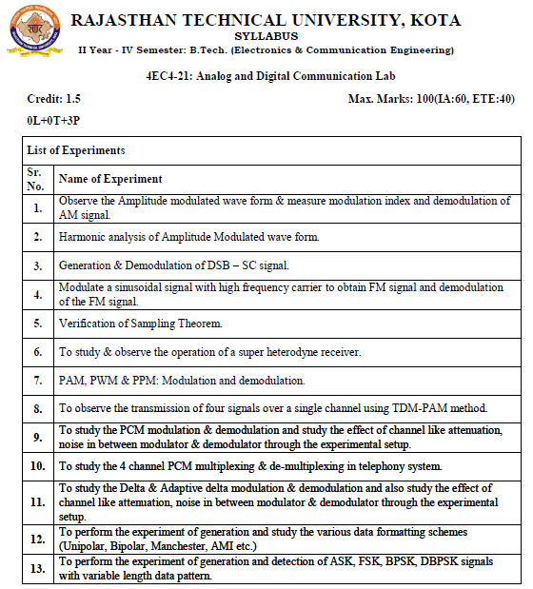

|  |
| --- |
| **Course Outcomes:** |

|  |  |  |
| --- | --- | --- |
| **CO.NO.** | **Cognitive Level** | **Course Outcome** |
| 1 | **Comprehension** | Understand different analog modulation schemes and evaluate modulation index |
| 2 | **Application** | Able to understand the principle of superhetrodyne receiver |
| 3 | **Analysis** | Develop time division multiplexing concepts in real time applications |
| 4 | **Synthesis** | Develop and able to comprehend different data formatting schemes |
| 5 | **Evaluation** | Comprehend and analyze the concepts of different digital modulation techniques in communication. |

|  |
| --- |
| **Course Outcome Mapping with Program Outcomes:** |

|  |  |  |  |  |  |  |  |  |  |  |  |  |
| --- | --- | --- | --- | --- | --- | --- | --- | --- | --- | --- | --- | --- |
| **Course Outcome** | **PO1** | **PO2** | **PO3** | **PO4** | **PO5** | **PO6** | **PO7** | **PO8** | **PO9** | **PO10** | **PO11** | **PO12** |
| **CO1** | 3 | 2 |  | 1 |  |  |  |  |  |  |  |  |
| **CO2** | 3 | 2 | 1 | 0 |  |  |  |  |  |  |  |  |
| **CO3** | 3 | 3 | 2 | 2 | 1 |  |  |  |  |  |  |  |
| **CO4** | 3 | 3 | 2 | 2 | 1 |  |  |  |  |  |  |  |
| **CO5** | 3 | 3 | 2 | 2 | 1 |  |  |  |  |  |  |  |
| **C36402 (AVG)** | 2.25 | 1.75 | 2.25 | 1.00 | 2.00 | 0.00 | 0.00 | 0.00 | 0.00 | 0.00 | 0.00 | 0.00 |

|  |
| --- |
| **Experiment List** |

|  |  |
| --- | --- |
| **S.N.** | **List of the Experiment** |
| 1 | To study SCILAB and communication tool box. |
| 2 | To generate AM wave using Matlab Software |
| 3 | To generate AM wave and plot it’s frequency spectrum using Matlab Software. |
| 4 | Generation of the AM wave for different value of modulation index (m<1, m = 1 and  m>1) using Matlab Software. |
| 5 | To generate FM wave and plot it’s frequency spectrum using Matlab Software. |
| 6 | To generate PM wave and plot it’s frequency spectrum using Matlab Software. |
| 7 | To generate Amplitude Modulation (AM) wave and determine Modulation Index  ‘ma’ and demodulate amplitude modulated wave using kit. |
| 8 | Study of Super heterodyne AM receiver. |
| 9 | To generate PAM, PWM and PPM wave and its plot using Matlab Software. |
| 10 | To generate AM Wave using EMONA kit. |

**Sample Programs:**

**Exp.1- Matlab Code to generate AM Wave**

clc;

clear all;

t=[0:0.01:10];

fm = 0.25;// Modulating signal frequency

fc = 10;// Carrier signal frequency

ma=1.0 // Modulation index

// Message or modulating signal 14

mt = sin(2*%pi*fm*t);

subplot (3,1,1);

plot(t,mt)

title('Message signal: m(t) = Am*sin(2*pi*fm*t)');

xlabel('Time (t in sec --->');

ylabel('Amplitude (A in Volts)');

xgrid;

// Sinusoidal Carrier Signal

ct = sin(2*%pi*fc*t);

subplot(3,1,2);

plot(t,ct)

title('Carrier signal: c(t) = Ac*sin(2*pi*fc*t)');

xlabel('Time (t in sec --->');

ylabel('Amplitude (A in Volts)');

xgrid;

// AM-DSB/SC Modulated signal

yt = mt.*ct; //(array operator)

subplot(3,1,3)

plot(t,yt, t,mt,'r',t,-mt,'r')

title('AM-DSB/SC Modulated signal: y(t) = m(t).*c(t)');

xlabel('Time (t in sec --->');

ylabel('Amplitude (in Volts)');

xgrid;

// AM-DSB/FC Modulated signal

//plot2d(x,y,5): positive intezer gives the colour &

//negative intezer gives the marker

figure(2);

subplot (3,1,1);

plot(t,mt)

title('Message signal: m(t) = Am*sin(2*pi*fm*t)');

xlabel('Time (t in sec --->');

ylabel('Amplitude (A in Volts)');

xgrid;

subplot(3,1,2);

plot(t,ct)

title('Carrier signal: c(t) = Ac*sin(2*pi*fc*t)');

xlabel('Time (t in sec --->');

ylabel('Amplitude (A in Volts)');

xgrid;

st=ct.*(1+ma*mt);

subplot(3,1,3); 15

plot(t,st, t,(1+ma*mt),'r',t,-(1+ma*mt),'r');

title('AM-DSB/FC Modulated signal: s(t) = (1+ma*m(t)).*c(t)');

xlabel('Time (t in sec --->');

ylabel('Amplitude (A in Volts)');

xgrid;

**Result or Output:**

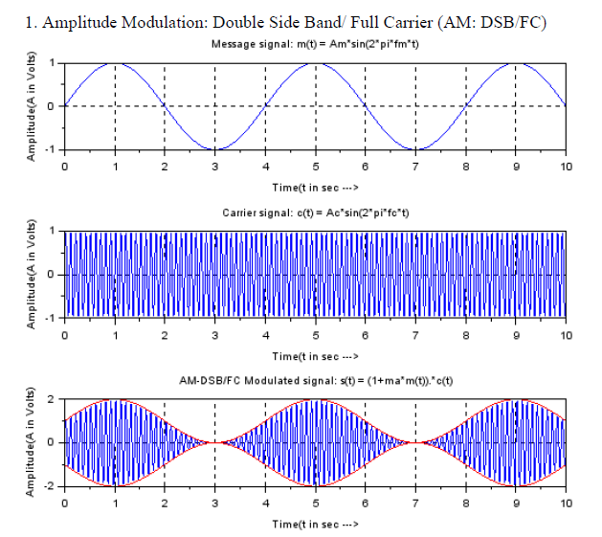

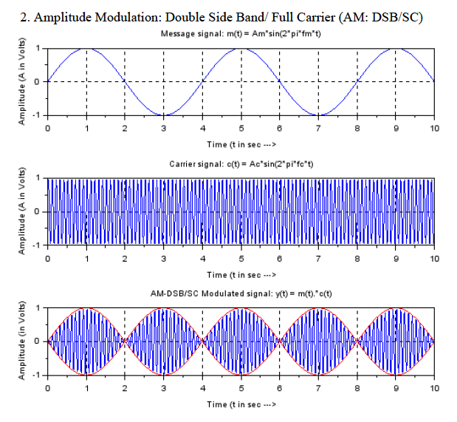

**Exp.2- Matlab Code to generate AM Wave and its frequency spectrum**

clc;

clear all;

close ;

t=[0:0.01:10];

fm = 0.25;// Modulating signal frequency

fc = 10;// Carrier signal frequency

ma=1.0 // Modulation index

mt = sin(2*%pi*fm*t); // Message or modulating signal

ct = sin(2*%pi*fc*t); // Sinusoidal Carrier Signal

st=ct.*(1+ma*mt);

subplot(3,1,1); plot(t,mt)

title('Message signal: m(t) = Am*sin(2*pi*fm*t)');

xlabel('Time (t in sec) --->'); ylabel('Amplitude (A in Volts)'); xgrid;

subplot(3,1,2); plot(t,ct)

title('Carrier signal: c(t) = Ac*sin(2*pi*fc*t)');

xlabel('Time (t in sec) --->'); ylabel('Amplitude (A in Volts)'); xgrid;

subplot(3,1,3); plot(t,st, t,(1+ma*mt),'r',t,-(1+ma*mt),'r');

title('AM-DSB/FC Modulated signal: s(t) = (1+ma*m(t)).*c(t)');

xlabel('Time (t in sec) --->'); ylabel('Amplitude (A in Volts)'); xgrid;

MF=fft(mt);

CF=fft(ct);

SF=fft(st);

N=size(t,'*');

F=1/0.01*(0:(N/2))/N;

n=size(F,'*');

figure

subplot(2,1,1); plot(t,mt)

title('Message signal: m(t) = Am*sin(2*pi*fm*t)');

xlabel('Time (t in sec) --->'); ylabel('Amplitude (A in Volts)'); xgrid;

subplot(2,1,2); plot(F,abs(MF(1:n)));

title('Spectrum of Modulating Signal');

xlabel('Frequency(f in Hz) --->'); ylabel('Absolute Magnitude'); xgrid

figure

subplot(2,1,1); plot(t,ct)

title('Carrier signal: c(t) = Ac*sin(2*pi*fc*t)');

xlabel('Time (t in sec) --->'); ylabel('Amplitude (A in Volts)'); xgrid;

subplot(2,1,2); plot(F,abs(CF(1:n)));

title('Spectrum of Carrier Signal');

xlabel('Frequency(f in Hz) --->'); ylabel('Absolute Magnitude'); xgrid

figure

subplot(2,1,1); plot(t,st, t,(1+ma*mt),'r',t,-(1+ma*mt),'r');

title('AM-DSB/FC Modulated signal: s(t) = (1+ma*m(t)).*c(t)');

xlabel('Time (t in sec) --->'); ylabel('Amplitude (A in Volts)'); xgrid;

subplot(2,1,2); plot(F,abs(SF(1:n)));

title('Spectrum of Modulated Signal');

xlabel('Frequency(f in Hz) --->'); ylabel('Absolute Magnitude'); xgrid

**Result or Output:**

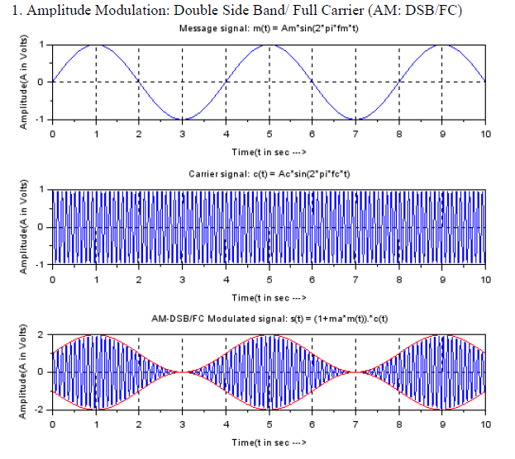

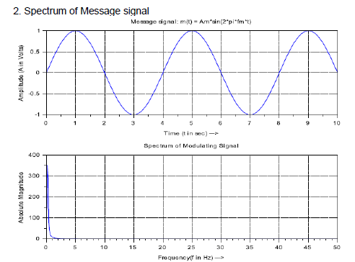

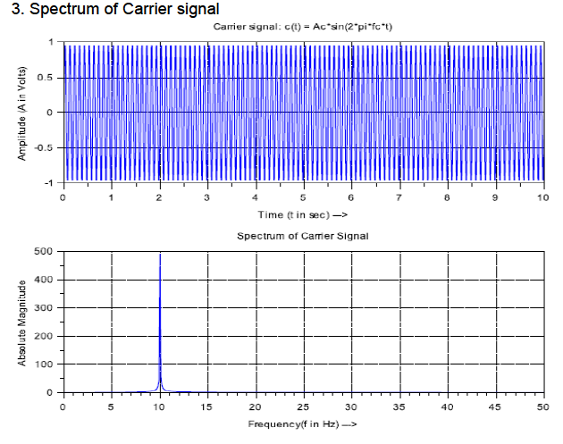

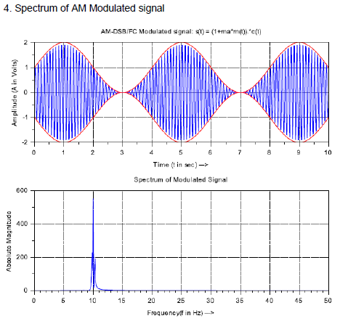

**Exp.3- Matlab Code to generation AM wave for different value of modulation index (m<1, m = 1 and m>1)**

**//Amplitude modulation ----with different Modulation Index**

Ac=1;//Carrier Amplitude

Fc=0.4;//Carrier frequency

Fm=0.02;//%baseband frequency

Fs=10;//sampling

**// Under different modulation Index**

m1=0.25; m2=0.75; m3=1.0; m4=1.25; m5=0.25;

t=0:1/Fs:200;

mt=cos(2*%pi*Fm*t);

mt1=cos(2*%pi*Fm*t);

vc=Ac.*cos(2*%pi*Fc*t);

st1=vc.*(1+m1*mt);

st2=vc.*(1+m2*mt);

st3=vc.*(1+m3*mt);

st4=vc.*(1+m4*mt);

figure(1);

subplot(3,1,1);

plot(t,mt1);

title('\ Modulating Signal');

xlabel('time (s)');

ylabel('amplitude');

xgrid

subplot(3,1,2);

plot(t,vc);

title('\ Carrier Signal');

xlabel('time (s)');

ylabel('amplitude');

xgrid

subplot(3,1,3);

plot(t,st3);

title('\ 100% AM Modulated Signal');

xlabel('time (s)');

ylabel('amplitude');

xgrid

figure(2);

**// Under Modulation (m = 0.25)**

subplot(2,2,1);

plot(t,st1,t,Ac*(m1*mt+ones(1,length(mt))),'r', t,-Ac*(m1*mt+ones(1,length(mt))),'r');

title('m =0.25 Under Modulation: s(t) = vc(t)*(1+ m1*m(t)');

xlabel('time (s)');

ylabel('amplitude');

xgrid

**// Under Modulation (m = 0.75)**

subplot(2,2,2);

plot(t,st2,t,Ac*(m2*mt+ones(1,length(mt))),'r', t,-Ac*(m2*mt+ones(1,length(mt))),'r');

title('m =0.75 Under Modulation: s(t) = vc(t)*(1+ m1*m(t)');

xlabel('time (s)');

ylabel('amplitude');

xgrid

**// Critical (or 100% or m =1.0) Modulation**

subplot(2,2,3);

plot(t,st3,t,Ac*(m3*mt+ones(1,length(mt))),'r', t,-Ac*(m3*mt+ones(1,length(mt))),'r');

title('m =1.0 Critical Modulation: s(t) = vc(t)*(1+ m1*m(t)');

xlabel('time (s)');

ylabel('amplitude');

xgrid

**// Over Modulation (m = 1.25)**

subplot(2,2,4);

plot(t,st4,t,Ac*(m4*mt+ones(1,length(mt))),'r', t,-Ac*(m4*mt+ones(1,length(mt))),'r');

title('\m =1.25 Over Modulation: s(t) = vc(t)*(1+ m1*m(t)');

xlabel('time (s)');

ylabel('amplitude');

xgrid

**Result or Output:**

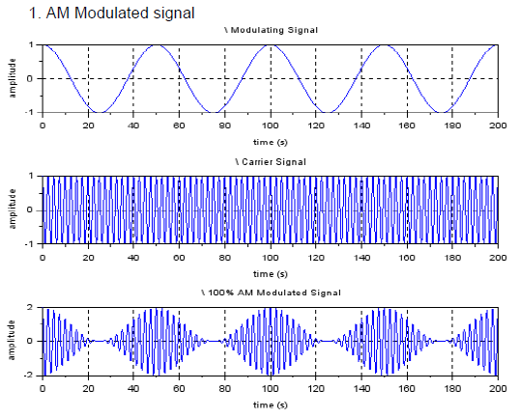

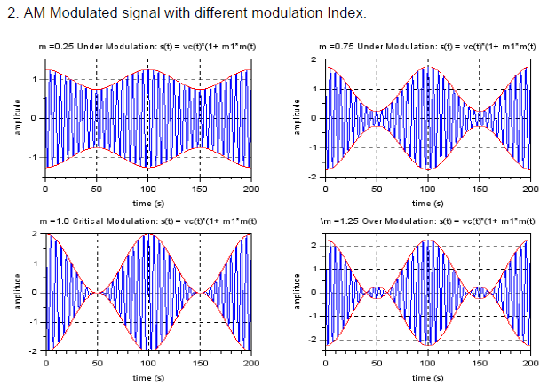

**Exp.4- Matlab Code to generate FM Wave and its frequency spectrum**

//The frequency modulated waveform in time domain.

clc

clear all

close

// setting

vc=1;// Amplitude of carrier

vm=1;// Amplitude of modulating signal

fm=25;// Modulating signal frequency

fc=500;// Carrier signal frequency

mf=10;mp=10;// modulation indices of FM and PM

// x-axis:Time(second)

t=0:0.00001:0.09999;//Declare time interval

f=0:10:99990;//Declare frequency interval

N=size(t,'*');

F=1/0.00001*(0:(N/2))/N;

n=size(F,'*');

n_s=(n-1)/50;

// y-axis:Voltage(volt)

wc=2*%pi*fc;

wm=2*%pi*fm;

ct = vc*cos(wc*t);//carrier signal

mt = vm*cos(wm*t);//modulating signal

FM = vc*cos((wc*t)+10*sin(wm*t));//Frequency modulated signal

PM = vc*cos((wc*t)+10*cos(wm*t));//phase modulated signal

CF=fft(ct);

MF=fft(mt);

FMF=fft(FM);

PMF=fft(PM);

//Plot modulating signal carrier signal and its spectrum

figure(1);

subplot(221);

plot(t,mt);

title('Modulating Signal');

xlabel('Time(second)');

ylabel('Amplitude');

xgrid;

subplot(222);

plot(t,ct);

title('Carrier Signal');

xlabel('Time(second)');

ylabel('Amplitude');

xgrid;

subplot(223);

plot(F(1:n_s),abs(MF(1:n_s)));

title('Msg Signal Spectrum');

xlabel('Freq(Hz)');

ylabel('Magnitude');

xgrid;

subplot(224);

plot(F(1:n_s),abs(CF(1:n_s)));

title('Carrier Signal Spectrum'); xlabel('Freq(Hz)'),ylabel('Magnitude'); xgrid;

figure(2);

subplot(211); plot(t,mt);

title('Modulating Signal');

xlabel('Time(second)');

ylabel('Amplitude');

xgrid;

subplot(212);

plot(t,FM);

plot(t,mt,'r');

xlabel ('Time(second)'),

ylabe l('Amplitude');

title('FM time-domain');

xgrid;

//Plot figure in time - frequency domain

figure(3);

subplot(211);

plot(t,FM);

plot(t,mt,'r');

xlabel('Time(second)');

ylabel('Amplitude');

xgrid;

title('FM time-domain');

xgrid;

subplot(212);

plot(F(1:n_s),abs(FMF(1:n_s)));

title('FM Freq-domain');

xlabel('Freq(Hz)');

ylabel('Magnitude');

xgrid;

**Result or Output:**

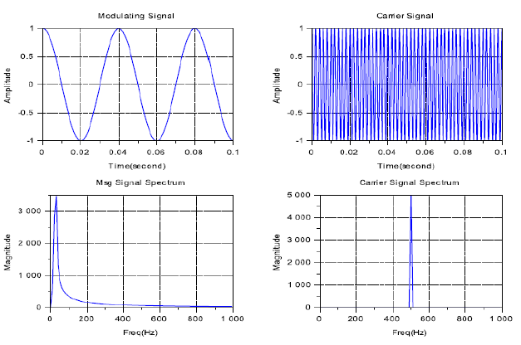

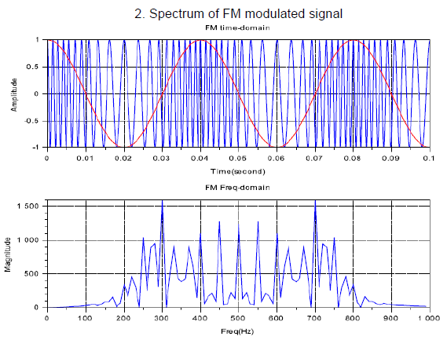

**Exp.4- Matlab Code to generate PM Wave and its frequency spectrum**

//The Phase modulated waveform in time domain and frequency domain.

clc

clear all

close

// setting

vc=1;// Amplitude of carrier

vm=1;// Amplitude of modulating signal

fm=25;// Modulating signal frequency

fc=500;// Carrier signal frequency

mf=10;mp=10;// modulation indices of FM and PM

// x-axis:Time(second)

t=0:0.00001:0.09999;//Declare time interval

N=size(t,'*');

F=1/0.00001*(0:(N/2))/N;//Declare frequency interval

n=size(F,'*');

n_s=(n-1)/50;

// y-axis:Voltage(volt)

wc=2*%pi*fc;

wm=2*%pi*fm;

ct = vc*cos(wc*t);//carrier signal

CF=fft(ct); //carrier signal spectrum

mt = vm*cos(wm*t);//modulating signal

MF=fft(mt); //modulating signal spectrum

FM = vc*cos((wc*t)+10*sin(wm*t));//Frequency modulated signal

FMF=fft(FM); //Spectrum of Frequency modulated signal

PM = vc*cos((wc*t)+10*cos(wm*t));//phase modulated signal

PMF=fft(PM); //Spectrum of phase modulated signal

//Plot modulating signal carrier signal and its spectrum

figure(1);

subplot(211);

plot(t,mt);

title('Modulating Signal');

xlabel('Time(second)');

ylabel('Amplitude');

xgrid;

subplot(212);

plot(t,PM);

plot(t,mt,'r');

xlabel('Time(second)');

ylabel('Amplitude');

title('FM time-domain');

xgrid;

//Plot figure in time - frequency domain

figure(2);

subplot(211);

plot(t,PM);

plot(t,mt,'r');

xlabel('Time(second)');

ylabel('Amplitude');

xgrid;

title('PM time-domain');

xgrid;

subplot(212);

plot(F(1:n_s),abs(PMF(1:n_s)));

title('PM Freq-domain');

xlabel('Freq(Hz)');

ylabel('Magnitude');

xgrid;

**Result or Output:**

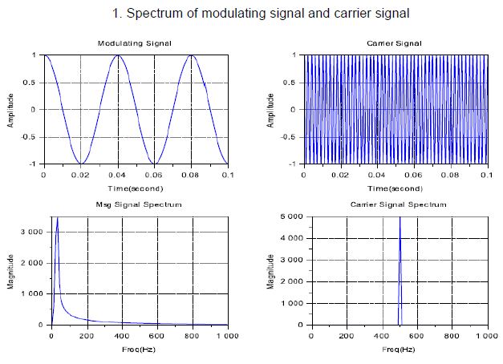

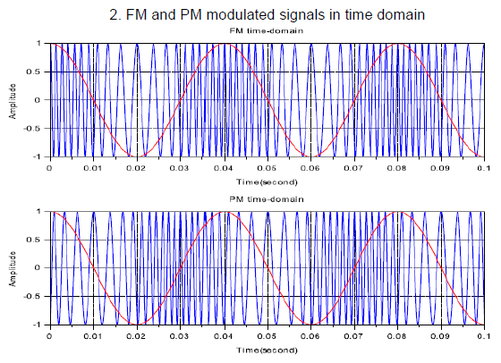

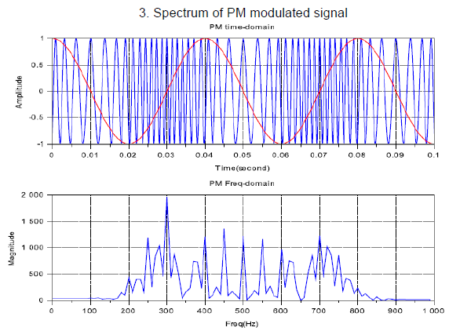

|  |
| --- |
| **VIVA** |

Q.1 What is Amplitude Modulation?

Q.2 What is sampling? What is sampling theorem?

Q.3 What are the disadvantages of analog communication?

Q.4 What happens in over modulation?

Q.5 What are different types of analog modulation?

Q.6 What is need for modulation?

Q.7 What are the advantages of PAM and PWM?

Q.8 What is frequency modulation?

Q.9 What are the advantages of digital communication?

Q.10 What are the different types of digital communications?

Q.11 How to convert an analog signal into digital signal?

Q.12 Define pulse amplitude modulation?

Q.13 What is amplitude shift keying?

Q.14 What is phase shift keying?

Q.15 What is frequency shift keying?

Q.16 Why ASK is also called On-Off keying?

Q.17 What is the bandwidth of BPSK signal?

Q.18 Compare ASK, PSK and FSK?

Q.19 What is Nyquist Rate?

Q.20 Draw block diagram of analog communication system.

Q.21 With the help of a block diagram, explain the process of converting analog signal to digital signal?

Q.22 Discuss the functions of a sampler and quantizer?

Q.23 Which types of Coding techniques are familiar to you?

Q.24 Discuss in detail about the aliasing effect and explain how it is rectified?

Q.25 Illustrate about Phase Shift keying (PSK) technique?

Q.26 Give the differences between Bit Rate and Baud Rate?

Q.27 List down the advantages and disadvantages of digital communication techniques?

Q.28 Write down any 6 different digital modulation techniques you know?

Q.29 What is aliasing?

Q.30 How can aliasing be avoided?

Q.31 What do you mean by FM and classify FM?

Q.32 What is synchronization in communication?

Q.34 What is the function of band pass filter in communication?

Q.34 What are the advantages of SSB over DSB-SC?

Q.34 Wha do you mean by inter symbol interference?

Q.35 Why we use MSK?

Q.36 Why we use ADM (Adaptive Delta Modulation)?

Q.37 What is the drawback of delta modulation?